Research Practices

Intro (100)
During this essay I will be discussing the research that has been done to find my dissertation topic and question. I will be discussing the topics of Women in film, sex in film and the Superhero genre. I have researched into these topics, images and thinkers by using books and journals. I have used this research to also begin creating my major project, I have followed the chosen themes to create a short film. By the end of this essay I will have come up with a proposal for my dissertation question, which will be questioning the themes that I have chosen.

1st keyword: Women (600)
My first keyword that I have chosen is women, I have researched into the representation of women in film, women working in film and women as an audience. While researching into the representation of women in film, it’s easy to see that there is a lack of representation when it comes to women of different ethnicities, ages and sexual orientation. For example “74% of major female characters were white”, this proves that there is a lack of representation for women of different ethnicities such as women of colour and asian women. This is a major problem that the film industry has, especially since the female audience is growing in multiple
genres, therefore there should be more representation on screen and behind the scenes. This is proven again as “Women are 52% of the moviegoers and 50% of the ticket buyers”, if the
Percentage of women watching films is over half of the audience shouldn't there be more of a positive representation or at least any representation for minorities?
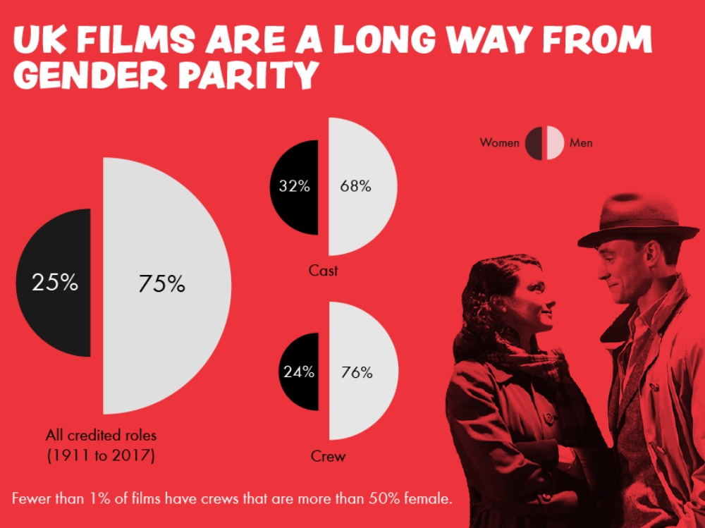
As for women working in film, there is also a lack of representation in the industry for example “95.7% of all directors were male and 4.3% were female”, in other words for every 22 male directors hired there is only one woman hired. These figures are shocking, in such a male dominated industry there is no wonder there is a lack of representation and unrealistic female characters as women have no say in these decisions. As for the representation of women in film, most female characters are portrayed as either sexual objects or fearful weak characters. This point is proven in the book Film and Theory: An Anthology by Robert Stam and Toby Miller as it says “bodies of women figured on the screen have functioned traditionally as the primary embodiments of pleasure, fear and pain”. This shows that women are put into a box when it comes to film and only play stereotypical weak roles. This stems back to the lack of women working in film, as there is no one to write a realistic female character. This is proven as only 11% of women are writers in the industry equating to 83% of films having no female writers.
This graph from BFI demonstrates that lack of representation of women in film in front and behind of the camera. The first graph shows that 75% of credited film roles are given to men, leaving the other 25% to women. This would answer the question as to why female minorities are given such little representation as there are not enough roles to go around. Another graph shows that men take up 76% of crew in the film industry, leaving women with only 24%. The picture also states that “fewer than 1% of films have crews that are more than 50% female”. This statistic really highlights the problem that the film industry is a male dominated industry. These statistics have stayed the same from 1911-2017, this is a shocking statistic as it shows that the film industry has not changed with modern times and is still not giving women more recognizable roles or even any roles at all in film.

2nd keyword: sexualisation (500)
For my second key word I have decided to focus on the topic of sex in film. The sexualisation of women starts from a young age with G,PG and PG 13 movies (between the years of 2006-2009). It is found that 24% of female characters are seen to be wearing revealing and provocative clothing, compared to that of only 4% of men. Having been taught these ideas from a young age many girls put an emphasis on beauty and makes the sexualisation of women normal.
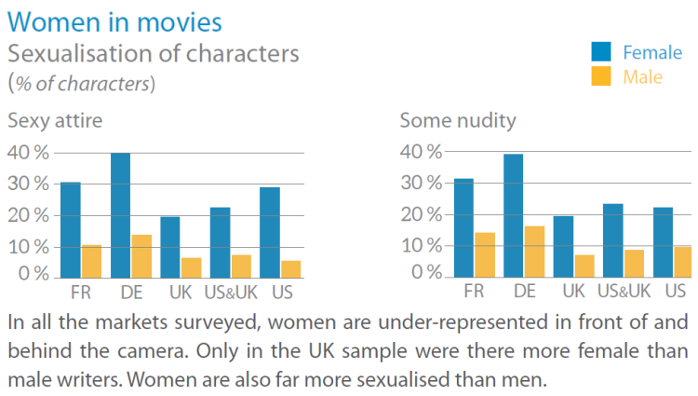
This graph from European parliamentary research service blog shows the percentage of the sexualisation of characters in films. There is a huge difference between the sexualisation of women and men, with women showing a bigger amount of sexualisation in film, with the highest being 40% which is a huge percentage. This easily highlights the clear discrimination against women in film, clearly demonstrating that this is a huge problem in the industry.
Although another side of the argument is that the sexualisation of men in film has risen throughout the years. For example, since 2007 the hypersexualisation of men has risen increasingly. The figures have risen 4.6% since 2007 as now 8% of male characters were seen in sexualised clothes. The film industry in India also has a bad reputation for the oversexualisation and lack of women roles in the film industry. For example, “gender ratio of 6.2 males to every one female in the film industry in India”, this proves the lack of roles women in in the Indian film industry. As for the hypersexualisation of women in the Indian film industry, an article states “35 percent of women characters in Indian movies are shown with some nudity”. Although a study in 2018, shows that “40 films in 2018 featured a female in a lead or co-lead role, which is an increase from 2017 which only had 32 films that featured a woman in the spotlight”. This is a huge win when it comes to discussing the representation of women in film, especially when comparing it to the previous years we've discussed before. Even better, 11 of those films featured a woman of colour or minority as a lead or co role.
3rd keyword: superheroes (600)
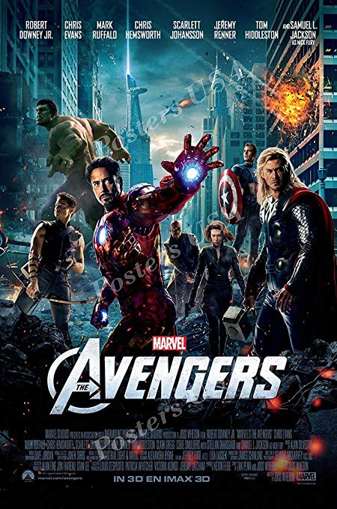
For my third and final keyword I have decided to research into the genre of Superhero films. For a long time in this genre, the male superhero was seen as the epitome of strength and leadership, while women took a back seat and were seen as love interests or weaker than their male counterparts. As Pollitt (1991) said “boys are the norm, girls the variation; boys are central, girls peripheral; boys are individuals,girls types. Boys define the group, it’s story and it’s code values. Girls exist only in relation to boys”. There is a lack of female representation in this genre with women only making up 12% of superhero comic characters. Over half of these superhero franchises have white male leads and the other half consist of almost all of a white and male cast. There is a clear lack of representation here, not only for women in general but especially for women of colour and other minorities. This only teaches the younger generation who watch these films bad stereotypes such as women are not as strong as men, dysfunctional and often abusive relationships and the minorities who watch these films get no representation at all. An easy way to spot the sexualisation of women is to just compare their appearance to their male counterparts. The men can be seen in strong outfits and power poses, whereas the women are seen wearing promiscuous outfits which are unrealistic to fight in and often seen in sexualised poses. For example, if you study the avengers poster the men are seen in mid battle wearing costumes made from strong materials to represent their own strength. Whereas if you look at Black widow, she is wearing a black leather catsuit to show off her curves and is staring straight into the camera posing unlike her male counterparts. This proves that the female superhero is there for the male gaze and not to empower women. It is important to remember that white male writers create the characters of women and characters of minorities, therefore it is impossible for them to truly write a realistic character and someone for people to look up to. Therefore, women should begin writing and creating their own characters and stories to ensure that we are being represented in a positive light rather than a negative stereotype. Although throughout the years there have been some positive representation of women, for example Wonder woman said in 1945 “if I married you ,steve, i’d have to pretend that im weaker than you are to make you happy and that is something no woman should do”. Not only does this bring women up and show that they are just as strong as men, it fights what would have been a social issue at the time where men we’re seen as stronger than women. It also fights the stereotype of women having to be married, which would have been seen as the norm at the time and also fights that stereotype.

Major project

For my major project I decided to focus on a film that revolved around a character sexual interest fighting with their morals. My film will follow the story of Hannah, a struggling student who is in desperate need of money to support her terminally ill mother. After trying and failing to earn money by getting jobs, Hannah decides to try something more radical. She decides to try out being a sugar baby, where young women talk to older men online and receive money from them. This is a moral dilemma for Hannah as she is unsure if this is a morally correct way to earn money.

How this brought me to my question
This brought me to my question as my films plot questions the woman’s right to use her body and sexuality as she pleases or to follow societal norm by bring shames by her body and sexuality. I will also ensure that I have a high percentage of females on my crew to fight against the industries norms by not giving demanding roles to women. My film will also include an actress, which will also be fighting the industries societal norms by having a woman as a leading character.

Dissertation question
For my dissertation question I would like to discuss how the lack of representation and sexualisation of women in films will cause a decrease in women working in film.

Bibliography

2017 STATISTICS
In-text: (Womenandhollywood.com, 2019)
Your Bibliography: Womenandhollywood.com. (2019). 2017 Statistics. [online] Available at: https://womenandhollywood.com/resources/statistics/2017-statistics/ [Accessed 13 May 2019].

INFOGRAPHIC: WOMEN IN UK FEATURE FILM 1911-2017
In-text: (British Film Institute, 2019)
Your Bibliography: British Film Institute. (2019). Infographic: Women in UK feature film 1911-2017. [online] Available at: https://www.bfi.org.uk/news-opinion/news-bfi/features/infographic-women-uk-film-1911-2017 [Accessed 13 May 2019].

MPAA REPORT 2016: 52% OF MOVIE AUDIENCES ARE WOMEN & OTHER TAKEAWAYS
In-text: (Womenandhollywood.com, 2019)
Your Bibliography: Womenandhollywood.com. (2019). MPAA Report 2016: 52% of Movie Audiences Are Women & Other Takeaways. [online] Available at: https://womenandhollywood.com/mpaa-report-2016-52-of-movie-audiences-are-women-other-takeaways-12320da989b4/ [Accessed 13 May 2019].

RAMOS, D. AND RAMOS, D.

Study Finds Significant Increase In Representation For Females & People Of Color In Top Grossing Films Of 2018
In-text: (Ramos and Ramos, 2019)
Your Bibliography: Ramos, D. and Ramos, D. (2019). Study Finds Significant Increase In Representation For Females & People Of Color In Top Grossing Films Of 2018. [online] Deadline. Available at: https://deadline.com/2019/02/usc-annenberg-inclusion-initiative-dr-stacy-l-smith-women-people-of-color-film-inclusion-representation-diversity-1202555340/ [Accessed 13 May 2019].

SEXUALISATION OF WOMEN IN MOVIES
In-text: (prezi.com, 2019)
Your Bibliography: prezi.com. (2019). Sexualisation of Women in Movies. [online] Available at: https://prezi.com/2zxjxagbmpc-/sexualisation-of-women-in-movies/ [Accessed 13 May 2019].

STAM, R. AND MILLER, T.

Film and theory
In-text: (Stam and Miller, 2000)
Your Bibliography: Stam, R. and Miller, T. (2000). Film and theory. Malden, Mass.: Blackwell.

WOMEN IN THE MOVIES – SEXUALISATION OF CHARACTERS
In-text: (European Parliamentary Research Service Blog, 2019)
Your Bibliography: European Parliamentary Research Service Blog. (2019). Women in the movies – Sexualisation of characters. [online] Available at: https://epthinktank.eu/2018/03/06/gender-equality-in-the-eus-digital-and-media-sectors/women-in-the-movies-sexualisation-of-characters/ [Accessed 13 May 2019].

‘INDIAN FILMS RANK HIGH ON SEXUALISATION OF WOMEN’
In-text: (The Hindu, 2019)
Your Bibliography: The Hindu. (2019). ‘Indian films rank high on sexualisation of women’. [online] Available at: https://www.thehindu.com/news/international/world/indian-films-rank-high-on-sexualisation-of-women/article6439345.ece [Accessed 13 May 2019].

COCCA, C.

Superwomen
In-text: (Cocca, n.d.)
Your Bibliography: Cocca, C. (n.d.). Superwomen.

Womenandhollywood.com. (2019). 2017 Statistics. [online] Available at: https://womenandhollywood.com/resources/statistics/2017-statistics/ [Accessed 13 May 2019].
Stam, R. and Miller, T. (2000). Film and theory. Malden, Mass.: Blackwell.
Available at: https://www.bfi.org.uk/news-opinion/news-bfi/features/infographic-women-uk-film-1911-2017 [Accessed 13 May 2019].
The Hindu. (2019). ‘Indian films rank high on sexualisation of women’. [online] Available at: https://www.thehindu.com/news/international/world/indian-films-rank-high-on-sexualisation-of-women/article6439345.ece [Accessed 13 May 2019].
Cocca, C. (n.d.). Superwomen.

