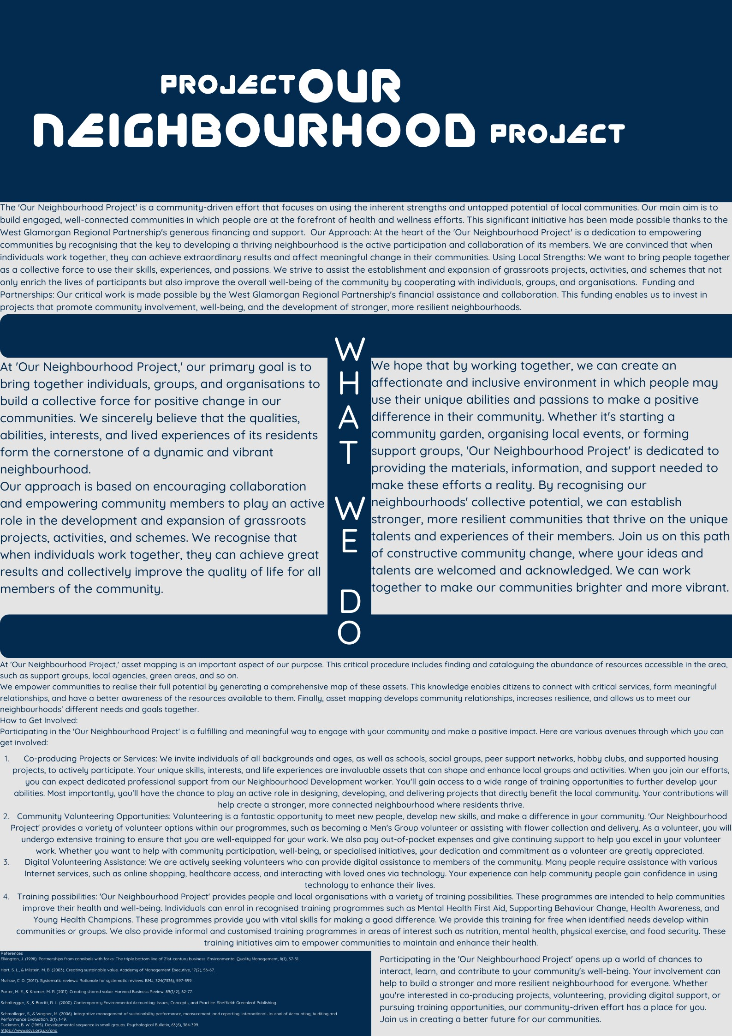

References
Elkington, J. (1998). Partnerships from cannibals with forks: The triple bottom line of 21st-century business. Environmental Quality Management, 8(1), 37-51.

Hart, S. L., & Milstein, M. B. (2003). Creating sustainable value. Academy of Management Executive, 17(2), 56-67.

Mulrow, C. D. (2017). Systematic reviews: Rationale for systematic reviews. BMJ, 324(7336), 597-599.

Porter, M. E., & Kramer, M. R. (2011). Creating shared value. Harvard Business Review, 89(1/2), 62-77.

Schaltegger, S., & Burritt, R. L. (2000). Contemporary Environmental Accounting: Issues, Concepts, and Practice. Sheffield: Greenleaf Publishing.

Schmalleger, S., & Wagner, M. (2006). Integrative management of sustainability performance, measurement, and reporting. International Journal of Accounting, Auditing and Performance Evaluation, 3(1), 1-19.
Tuckman, B. W. (1965). Developmental sequence in small groups. Psychological Bulletin, 63(6), 384-399.
https://www.scvs.org.uk/ona

