

Social Epidemiology and Public Health Development
Analytical Report

Student Name: Nevyana Nikolova / ID: 2111481
Module: Social Epidemiology and Public Health Development
Module Code: LCHS7000
Lecturer: Dr. Jolly Nwankwo

Table of Contents

Task 1 4
Inequalities in Maternal Health Outcomes for Black Women in the UK 4
1.Ethnicity and inequalities in pregnant Black women 4
2. Contextual Background and Underlying Factors 4
3. Social Issues 5
4. National Response to Reduce Health Inequalities 7
5. Organisations that Support Black women 7
6. Conclusion 8
Task 2 Epidemiological Analysis of Childhood Obesity in Barking and Dagenham, London 9
1. Childhood Obesity in The UK 9
2. Public Health Measures 11
3. Key Determinants and Risk Factors 12
4. Health Needs Assessment and Population at Risk 12
5. Epidemiological Surveillance and Monitoring Systems 13
6. Public Health Impact 14
7. Design of Health Intervention Program 14
8. Proposed Intervention Programme Components 15
9. Evaluation of Proposed Interventions 16
10. Strengths and Weaknesses of Epidemiological Approach 16
11. Conclusion 17
12. References 17

Task 1 Inequalities in Maternal Health Outcomes for Black Women in the UK

1.Ethnicity and inequalities in pregnant Black women

The latest MBRRACE-UK report shows that Black women are 3.7 times (MBRRACE-UK perinatal mortality surveillance, 2025) more likely than White women to die during pregnancy or within six weeks after birth. Black women face higher rates of severe maternal complications, including postpartum haemorrhage and the need for intensive care. These disparities are not biological, (Five X More,2025) they arise from systemic racism, social determinants of health, and barriers within the healthcare system.

2. Contextual Background and Underlying Factors

2.1 Disease/Illness Rates
2.1.1 Higher Maternal Mortality Rates
Maternal mortality disparities in the UK, Based on the latest MBRRACE-UK Report
Maternal Mortality Ratio by Ethnic Group / Deaths per 100,000 maternities

BLACK WOMEN: ████████████████████ 34.0% 3.7x higher risk
MIXED ETHNICITY: ████████████ 20.5% 2.2x higher risk
ASIAN WOMEN: ██████████ 18.2% 2.0x higher risk
WHITE WOMEN: █████ 9.2%

2.1.2 What Causes This Inequality and How to Overcome the Challenges
Black women frequently experience bias and neglect in maternity care, with evidence showing their symptoms, such as pain, bleeding or headaches, are more likely to be dismissed or minimised by healthcare professionals (Birthrights, 2025). To address this, the Continuity of Carer model should be strengthened, ensuring women, particularly those at higher risk, are supported by the same small team of midwives throughout pregnancy. This approach builds trust, improves communication, and helps clinicians recognise changes in health more quickly (Black Maternity Experiences Report 2025; Five X More, 2025).

2.2 Higher Rates of Severe Maternal Morbidity
Hospital Episode Statistics, 2025 (HES) reveal that Black women are, for instance, up to 83% more likely to experience a severe perineal tear. (Maternity Services Monthly Statistics, Final July 2025, Provisional August 2025, official statistics)
Black Women vs. White Women in the UK, 2025 According to Maternity Services Monthly Statistics, Final July 2025, Provisional August 2025, official statistics.

Severe perineal tears (3rd/4th degree)
Black Women: █████████████████ 83% higher risk
White Women: █████████ Baseline

Postpartum haemorrhage (severe)
Black Women: █████████████ 65% higher risk
White Women: █████████ Baseline

Unplanned ICU admissions
Black Women: ███████████████ 78% higher risk
White Women: █████████ Baseline

2.2.1 Inequality Causes and Overcoming Challenges
Severe maternal morbidity among Black women often results from an accumulation of suboptimal care, where small clinical oversights or a “cascade of intervention” escalate into serious complications (Five X More, 2025). Implicit bias can contribute to less vigilant monitoring during labour, while the higher prevalence of conditions such as hypertension and fibroids requires more careful management; when these conditions are not optimally controlled, the physical stress of labour increases risk.
To address these challenges, enhanced safety bundles, standardised, evidence-based protocols for emergencies like PPH and pre-eclampsia, should be widely adopted and audited to ensure consistent care (Perinatal Mental Health, 2025). Co-producing care plans with Black women, particularly those with known risk factors, ensures their concerns are heard, documented, and acted upon, strengthening person-centred and safer maternity care (Five X More, 2025).

2.3 Higher Rates of Perinatal Mental Ill-Health
Research indicates (MBRRACE-UK, 2025) that Black women are at an increased risk of conditions such as postnatal depression and post-traumatic stress disorder (PTSD) following childbirth. The MBRRACE-UK report has highlighted that suicide is a leading cause of maternal death in the UK.

2.3.1 What Causes This Inequality and Its Solution
Black women are more likely to experience traumatic births, including life-threatening complications, emergency interventions, and a sense of loss of control (Perinatal Mental Health, 2025). To address this, the Five X More Report (2025) recommends integrating specialist perinatal mental health midwives into maternity teams. These trained midwives, ideally from diverse backgrounds, can provide initiative-taking mental health screening, early support, and timely referrals to specialist services, helping reduce trauma and improve outcomes.

3. Social Issues

3.1 Racial Bias and Discrimination in Healthcare
Black women's reports of pain, bleeding, headaches, or other warning signs are more likely to be minimised or disbelieved by healthcare professionals. This leads to critical delays in diagnosing conditions like pre-eclampsia, postpartum haemorrhage, and embolisms, according to Saving Lives, Improving Mothers' Care 2024.

3.1.2 Inequality and Its Causes
Mandatory anti-racism and implicit bias training is needed for all maternity staff, going beyond basic awareness to address structural racism through ongoing, assessed, case-based learning (Five X More Charter, 2025). Black households face higher poverty rates and are more likely to live in deprived areas with poorer environments and limited access to healthy food or green spaces (Listening to All Women, 2025; NHS UK, 2025).
To help address these barriers, maternity services should identify socioeconomic vulnerability early and integrate social prescribers or link workers who can connect women to financial, housing and food support (Black Maternity Experiences Report, 2025).

3.2 Cultural and Communication Barriers
3.2.1 Feeling Unheard and Dismissed
According to The Five X More (2025), Black women report feeling "unheard" or "talked down to" by clinicians. When a woman's concerns, questions, or preferences regarding her birth plan are repeatedly dismissed, it fosters a profound sense of distrust and disengagement from maternity services.

3.2.2 Overcoming the Challenges
Maternity services should guarantee 24/7 access to professional interpreters, ensuring women are informed of this right from their first appointment (Five X More, 2025). Equally, patient information and care pathways should be co-produced with Black women and community organisations to ensure materials are clear, culturally relevant, and accessible (Black Maternal Health, 2025).

4. National Response to Reduce Health Inequalities

A cornerstone of this is NHS England's Equity and Equality Guidance, which mandates that local maternity systems implement targeted actions to reduce mortality rates for women from Black ethnic backgrounds. A key strategic initiative is the rollout of the Continuity of Carer model, a policy designed to ensure that women, particularly those from high-risk groups, are assigned to the same small team of midwives throughout their pregnancy. The government (NHS UK, 2025) has funded the Maternity Disparities Taskforce, bringing together experts, charities, and clinicians to explore the root causes of inequality.

5. Organisations that Support Black women

An organisation addressing this crisis is Five X More, grassroots, volunteer-led campaign group founded and led by Black women. Their overarching role is to eradicate the maternal health disparity through empowerment, evidence-based advocacy, and awareness. Their primary goal is to reduce the maternal mortality rate for Black women in the UK by ensuring their voices are heard and acted upon at a national level.

6. Conclusion

The evidence shows that Black women in the UK continue to face deeply rooted and preventable inequalities in maternal health. Higher rates of maternal mortality, severe complications, and mental ill-health are not due to biological differences but arise from systemic racism, socioeconomic disadvantage, and gaps in maternity care. Addressing these disparities requires committed national action, culturally safe and continuous care, and the meaningful involvement of Black women in shaping services that meet their needs. With strengthened policies, better training, and community-led organisations such as Five X More driving change, the UK can move towards a fairer and safer maternity system for all women.

Task 2 Epidemiological Analysis of Childhood Obesity in Barking and Dagenham, London

- Childhood Obesity in the UK

Childhood obesity represents a critical and escalating public health challenge in the United Kingdom, defined as excessive body fat accumulation that presents significant health risks during childhood and across the life course (NHS Digital, 2025). This epidemiological analysis examines childhood obesity in Barking and Dagenham, an outer London borough characterised by elevated levels of socioeconomic deprivation, ethnic diversity, and among the highest childhood obesity prevalence rates in England. According to the Royal College of Paediatrics and Child Health, 2025 around 70% of obese adolescents remain obese into adulthood, leading to an increased lifetime risk of cardiovascular diseases, including hypertension, coronary heart disease, and stroke (National Statistic, 2025).
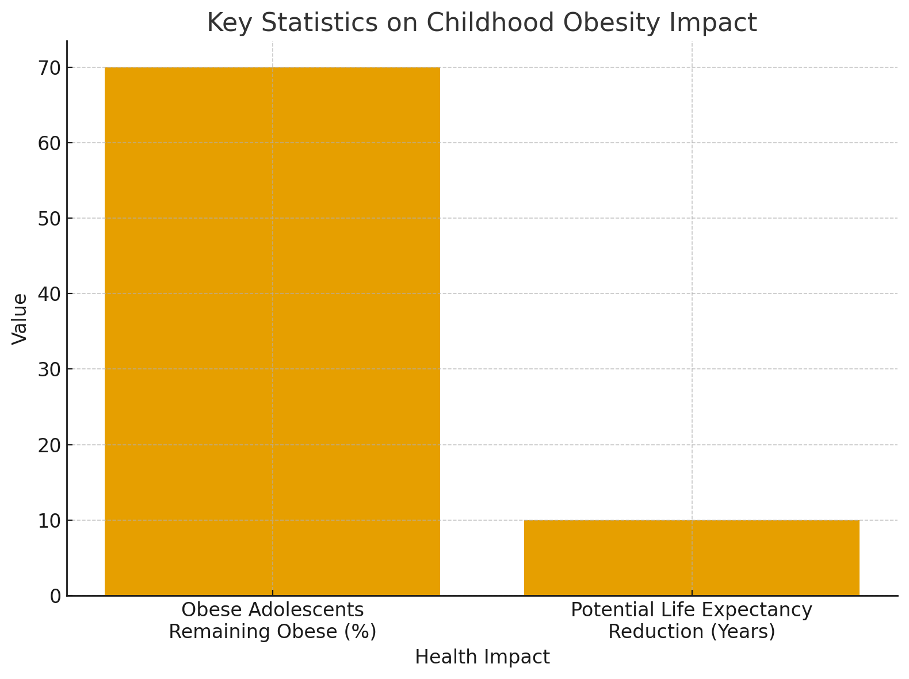

Data Source: (National Statistics, 2025)

1.1 Worldwide Statistics
Globally, according to WHO 2025, 35 million children under the age of five were overweight in 2025, while over 390 million children and adolescents aged 5-19 years were overweight in 2025 (WHO, 2025).
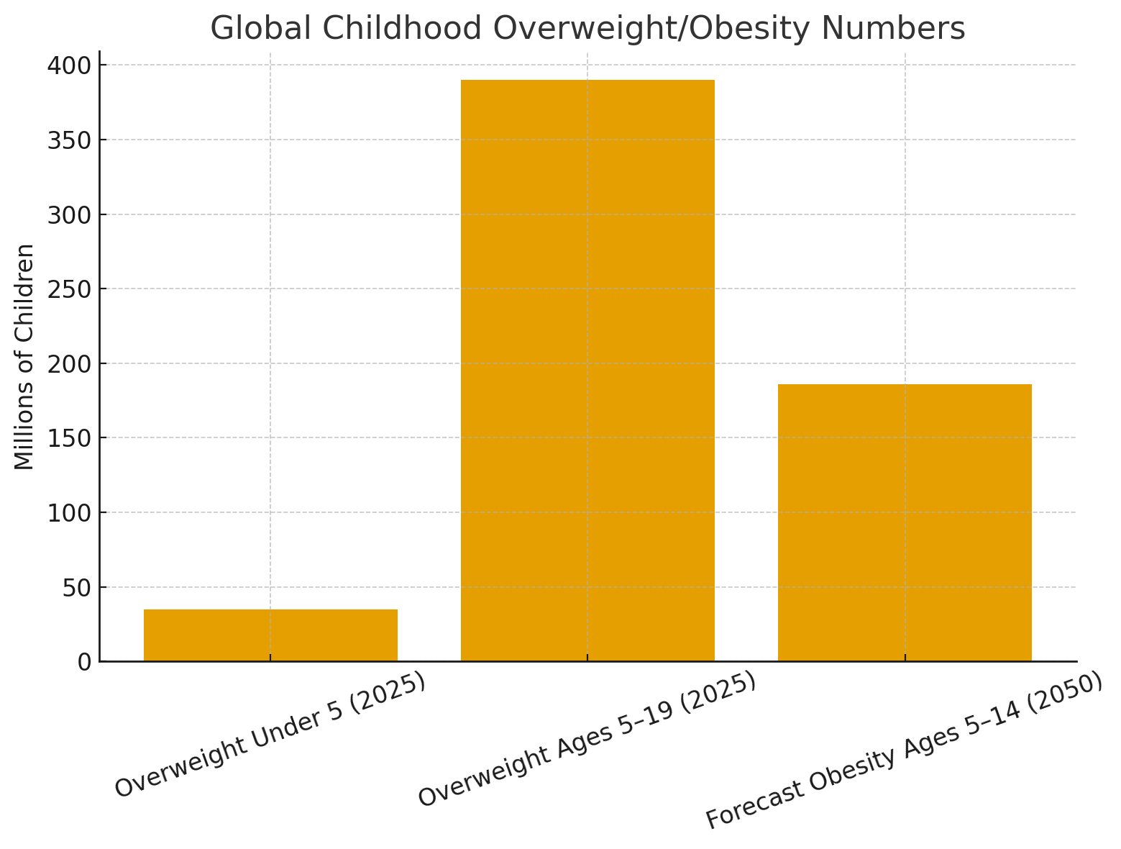
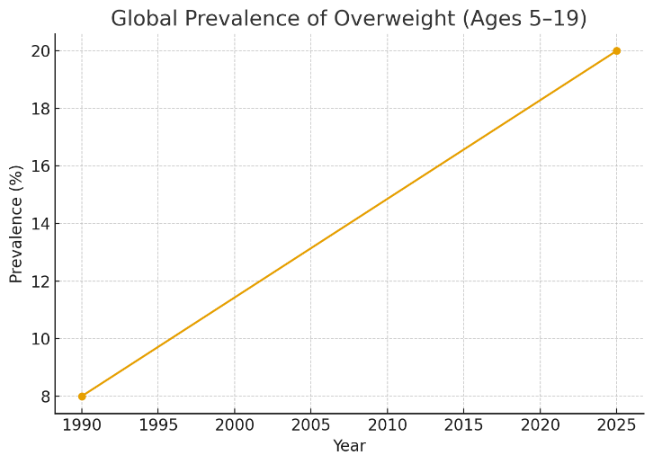
Data Source: (WHO, 2025)

1.2 Prevalence in the UK
Barking and Dagenham has the highest proportion of childhood obesity out of all London boroughs at 29.3% (GOV.UK, 2025).

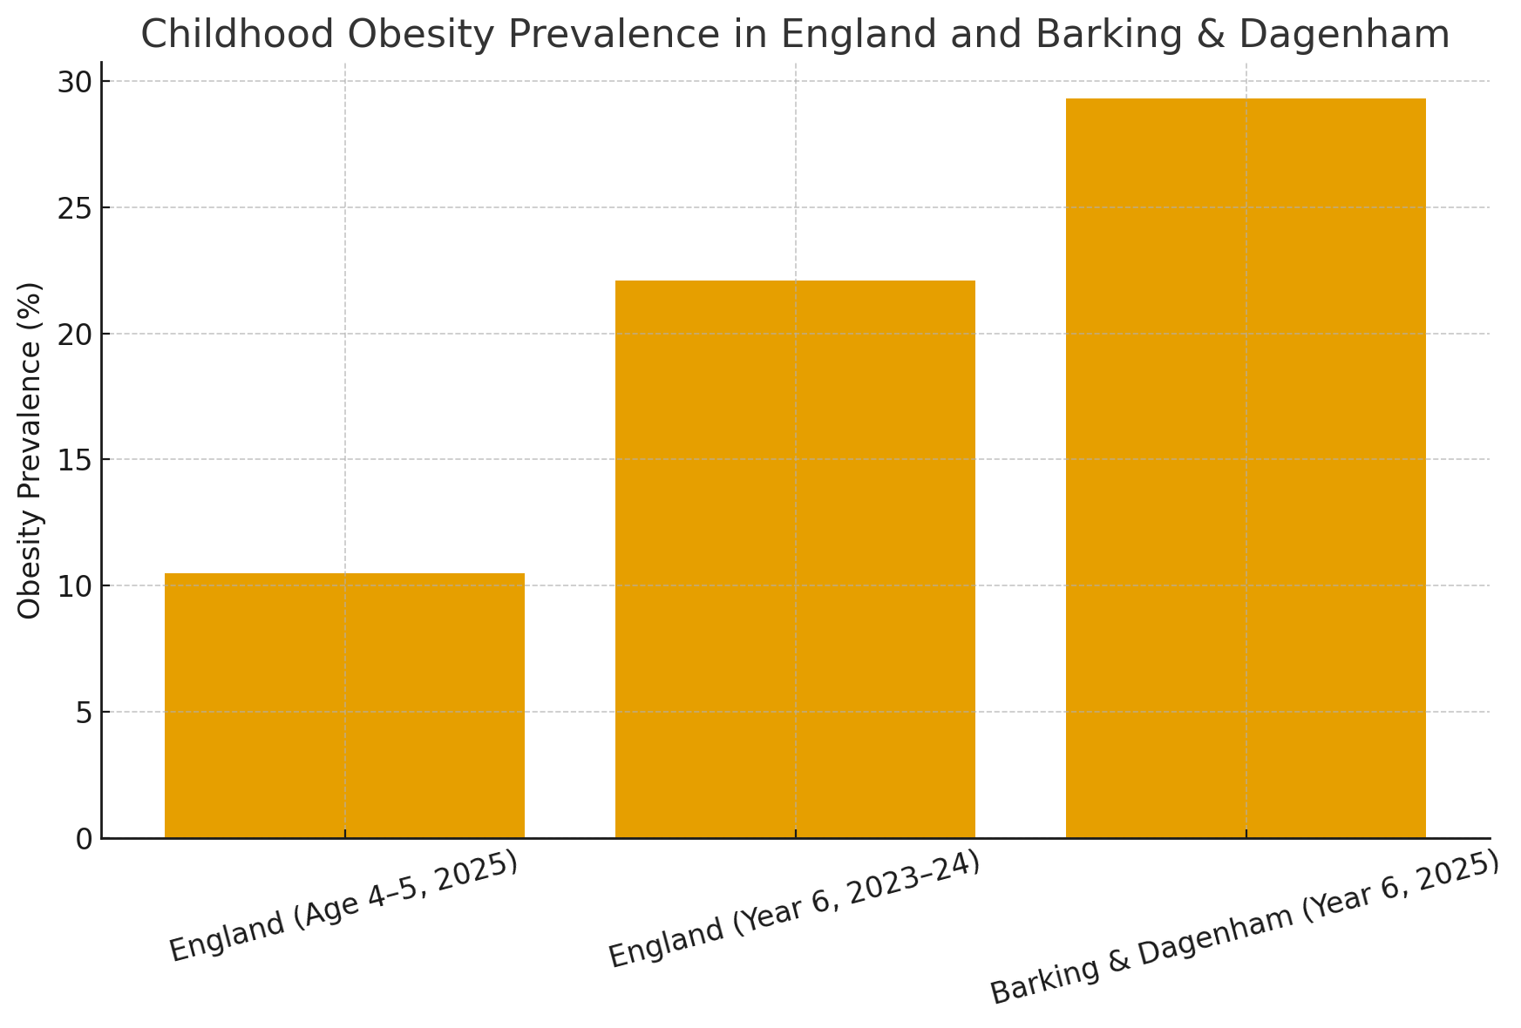
Data source: (National Child Measurement Programme, GOV.UK, 2025)

- Public Health Measures

2.1 The Three P's Prevention Framework
Primary Prevention in Barking and Dagenham encompasses early care and education, and school-based programs which emphasise and support healthy eating and physical activity, together with other community-level programs (NHS UK, 2025).

Secondary Prevention The primary means for tackling the issue in Barking and Dagenham has been through the delivery of individualised weight management programmes (NHS UK, 2025). Focus on supporting children who were at higher risk of disease due to their unhealthy weight (LBBD, 2025).

Tertiary Prevention of childhood obesity in Barking and Dagenham focuses on managing established obesity and preventing associated complications. For children with severe or persistent obesity, pharmacologic therapies may be considered within a structured, multidisciplinary programme involving healthcare providers and dietitians (Barking and Dagenham Post, 2025).

- Key Determinants and Risk Factors

3.1 Parental weight status
Children with one or more parents living with obesity are significantly more likely to become overweight or obese themselves, due to a combination of shared genetics, household eating patterns, and lifestyle norms (GOV.UK, 2025).

3.2 Physical activity and sedentary patterns
Low active travel, limited organised sports participation, and high household screen time contribute to increased obesity risk. (PMC, 2025).

3.3 Economic constraints
According to the Barking and Dagenham Post 2025, Low-income families, particularly relevant in Barking and Dagenham, face financial, time, and resource barriers to purchasing healthy food and engaging in physical activity, reinforcing intergenerational obesity risks (Nuffield Trust, 2025).

- Health Needs Assessment and Population at Risk

4.1 Geographic Variation
Barking and Dagenham has the highest proportion of childhood obesity out of all London boroughs at 29.3% in Year 6, representing a significantly elevated burden compared to London's average of 24% (Trust for London, 2025). Within the borough, considerable differences exist between schools, with having up to 70% of children considered overweight or obese (LBBD, 2025), indicating the need for hyper-local interventions.

4.2 Age-Specific Prevalence
The prevalence of obesity increases from reception to Year 6 indicating that the transition through primary school represents a critical window for weight gain (GOV.UK, 2025). New indicators show the proportions of children moving from a healthy weight in reception to overweight in Year 6 and those who remained healthy weight providing insights into obesity trajectories (Fingertips, 2025).

- Epidemiological Surveillance and Monitoring Systems

5.1 National Child Measurement Programme (NCMP)
The monitoring of childhood obesity in Barking and Dagenham relies primarily on the National Child Measurement Programme, supplemented by local surveillance systems. The NCMP is a nationally mandated public health programme that provides data to monitor the patterns and trends, and the prevalence, of underweight, healthy weight, overweight and obesity in children as well as data on child height (GOV.UK, 2025). Every year, more than one million children are measured, with annual participation rates consistently high at around 95%, and over 99% of eligible schools taking part (LGA, 2025).

5.2 Data Collection and Analysis
According to the borough’s 2024–27 needs assessment, over the 3 years 2022/23–2024/25, the proportion of Reception-age children in Barking and Dagenham who were overweight or obese was 25.5%, compared with the England average of 22.1 (LBBD.GOV.UK). For Year 6 children (10–11 years), over the same period, the percentage overweight or obese in Barking and Dagenham was 46.2%, above the England average of 35.8% and the London average. (Fingertips, 2025).

5.3 Local Surveillance Mechanisms
Local authorities share information on school-level child overweight and obesity prevalence over a 3-year average compared with local and national averages with schools through bespoke NCMP school feedback letters (GOV.UK, 2025). The provision of feedback letters to parents about their child's weight status following measurement has been recommended by the Department of Health and Social Care since 2008 (NCBI Bookshelf, 2025).

- Public Health Impact

6.1 Short-term consequences
In the short term, children with obesity require more frequent healthcare use, including GP appointments, specialist referrals and treatment for sleep apnoea and early metabolic issues, resulting in higher direct NHS costs (Public Health England, 2025). Nationally, obesity-related illness costs the NHS billions each year, with a substantial proportion linked to conditions that begin in childhood (Scarborough et al., 2025).

6.2 Long-term consequences
According to Cardiovascular Diabetology, 2025, Paediatric obesity is increasingly associated with early type 2 diabetes, non-alcoholic fatty liver disease, and cardiovascular disease, with insulin resistance leading to altered glucose metabolism and adverse cardiovascular biomarkers (PMC, 2025).

- Design of Health Intervention Program

7.1 Multi-Component School-Based Interventions
Multicomponent interventions show the greatest impact for primary prevention; the early childhood and school-based interventions should integrate behavioural and environmental approaches focusing on dietary intake and physical activity using a systems-level approach (Academy of Nutrition and Dietetics, 2025).

7.2 Family-Cantered Secondary Prevention
Secondary prevention and tertiary prevention/treatment should emphasise sustained family-based, developmentally appropriate approaches that include nutrition education, dietary counselling, parenting skills, behavioural strategies, and physical activity promotion (Academy of Nutrition and Dietetics, 2025).

7.3 Environmental and Policy Interventions
Evidence supports food promotion strategies, the use of health impact assessments in local planning, and breastfeeding promotion (Food Active, 2024). Robust regulation of the food industry is needed rather than relying on voluntary agreements, with evidence supporting taxation of unhealthy products and potential subsidies for healthier options (Barking and Dagenham Post, 2025).

- Proposed Intervention Programme Components

8.1 Universal Prevention (Primary)
Implementation of comprehensive school food standards, incorporation of physical activity into daily routines including the Daily Mile, restriction of unhealthy food marketing near schools, improvement of access to green spaces and safe play areas (Barking and Dagenham Post, 2025).

8.2 Targeted Prevention (Secondary)
Initiative-taking follow-up of children identified as overweight through NCMP, family-based weight management programmes adapted to local cultural contexts (NHS UK, 2025). Enhanced support for high-risk groups, including ethnic minorities and low-income families, and training for primary care professionals in childhood obesity management.
8.3 Clinical Management (Tertiary)
Establishment of specialist paediatric obesity services for severe cases, multidisciplinary team approach including dietitians, psychologists, and exercise specialists, coordination with diabetes prevention services, and clear referral pathways from primary care to specialist services (NHS UK, 2025).

- Evaluation of Proposed Interventions

For childhood obesity interventions in Barking and Dagenham, process evaluation should assess the extent to which programmes effectively reach children and families across the borough’s diverse demographic groups, including those living in the communities disproportionately affected by obesity (LBBD, 2025; Public Health England, 2025). This includes monitoring participation rates by age, sex, ethnicity, and deprivation quintile to ensure equitable access. Evaluation examines the fidelity of implementation across school, early years, and community settings, ensuring programmes are delivered as intended and in line with evidence-based practice (Public Health England, 2025). Stakeholder satisfaction, capturing the views of parents, children, schools, community partners and healthcare providers, is routinely measured to identify strengths and areas for improvement (NHS Digital, 2025).

10. Strengths and Weaknesses of Epidemiological Approach

The National Child Measurement Programme (NCMP) provides Barking and Dagenham with a reliable surveillance system for tracking childhood obesity, with participation levels mirroring national rates, around 95% of eligible children measured and over 99% of schools taking part (LGA, 2025). More than half of parents of overweight or obese children in the borough underestimate their child’s weight status, and NCMP feedback has had limited success in shifting parental perceptions or prompting healthier behaviours (NCBI Bookshelf, 2025, Public Health)

- Conclusion

Childhood obesity in Barking and Dagenham affects 29.3% of Year 6 children, disproportionately impacting deprived and ethnic minority groups, and increases lifelong risk of diabetes and cardiovascular disease (Public Health England, 2025). Addressing it requires a whole-systems approach combining prevention, behaviour change, environmental and policy interventions, and culturally targeted support. NCMP data enables monitoring, while success depends on political commitment, adequate resources, multi-sector collaboration, and community engagement, and investing in both a moral and economic imperative.

12. References

Barking and Dagenham Post (2025) Call for early action to tackle 'alarming' rise of childhood obesity. Available at: https://www.barkinganddagenhampost.co.uk/news/national/25282192.call-early-action-tackle-alarming-rise-childhood-obesity/ (Accessed: 6 December 2025).
Barking and Dagenham Post (2025) Government funding to help tackle child obesity in Barking and Dagenham. Available at: https://www.barkinganddagenhampost.co.uk/news/health/20906941.government-funding-help-tackle-child-obesity-barking-dagenham/ (Accessed: 6 December 2025).
Big Issue (2025) How one of the UK's most deprived neighbourhoods is tackling the cost-of-living crisis. Available at: https://www.bigissue.com/news/social-justice/how-one-uk-most-deprived-neighbourhoods-tackling-cost-of-living-crisis/ (Accessed: 6 December 2025).
Bircher, J. and Kuruvilla, S. (2025) ‘Defining health by addressing individual, social, and environmental determinants’, Journal of Public Health Policy, 35(3), pp. 363–386.
Birthrights (2025) Birthrights' evidence forms part of Health and Social Care Select Committee's Black Maternal Health Report. Available at: https://birthrights.org.uk (Accessed: 3 November 2025).
Birthrights (2025) Dr Kate Whitehouse: On racial disparities, MBRRACE data and UK vs US maternity systems. Available at: https://birthrights.org.uk (Accessed: 3 November 2025).
Bucares, L. et al. (2012) ‘Ethnic density effects on physical morbidity, mortality, and health behaviours’, American Journal of Public Health, 102(12), pp. e33–e66.
Contemporary Health (2025) Childhood Obesity in England Reaches Highest Level Since Pandemic. Available at: https://www.contemporaryhealth.co.uk/childhood-obesity/childhood-obesity-england-2024-25/ (Accessed: 6 December 2025).
Department of Health and Social Care (2025) Childhood obesity: applying All Our Health. Available at: https://www.gov.uk/government/publications/childhood-obesity-applying-all-our-health (Accessed: 6 December 2025).
Five X More (2025) Black Maternity Experiences Report 2025. Available at: https://fivexmore.org/black-maternity-experiences-report-2025 (Accessed: 3 November 2025).
Food Active (2025) Position Statement: Childhood Obesity. Available at: https://foodactive.org.uk/wp-content/uploads/2025/01/Position-Statement-Childhood-Obesity-updated_Oct24.pdf (Accessed: 6 December 2025).
GOV.UK (2025) National Child Measurement Programme. Available at: https://www.gov.uk/government/collections/national-child-measurement-programme (Accessed: 6 December 2025).
GOV.UK (2025) National Child Measurement Programme: operational guidance 2025. Available at: https://www.gov.uk/government/publications/national-child-measurement-programme-operational-guidance (Accessed: 6 December 2025).
GOV.UK (2025) Obesity profile: statistical commentary, November 2025. Available at: https://www.gov.uk/government/statistics/obesity-profile-november-2025-update (Accessed: 6 December 2025).
House of Commons Health and Social Care Committee (2025) Black Maternal Health. Available at: https://committees.parliament.uk (Accessed: 3 November 2025).
Local Government Association (2025) Childhood obesity - The role of local authorities. Available at: https://www.local.gov.uk/topics/children-and-young-people/childhood-obesity (Accessed: 6 December 2025).
Local Government Association (2025) Obesity crisis: Type 2 diabetes in children up by half in five years. Available at: https://www.local.gov.uk/about/news/obesity-crisis-type-2-diabetes-children-nearly-half-five-years (Accessed: 6 December 2025).
London Borough of Barking and Dagenham (2025) A New Strategic Approach to Healthy Weight in Barking & Dagenham. Available at: https://lbbd.moderngov.co.uk/mgAi.aspx?ID=97927 (Accessed: 6 December 2025).
London Sport (2025) Barking and Dagenham Area Profile February 2024. Available at: https://londonsport.org/wp-content/uploads/2024/04/Barking-and-Dagenham.pdf (Accessed: 6 December 2025).
Maternal Mental Health Alliance (2025) Listening to all women and birthing people. Available at: https://maternalmentalhealthalliance.org (Accessed: 3 November 2025).
NCD Risk Factor Collaboration (2025) ‘Child-to-adult body size change and risk of type 2 diabetes and cardiovascular disease’, Diabetologia, 66, pp. 1299–1311.
NHS Digital (2025) Maternity Services Monthly Statistics. Available at: https://digital.nhs.uk (Accessed: 3 November 2025).
NHS Digital (2025) National Child Measurement Programme. Available at: https://digital.nhs.uk/services/national-child-measurement-programme (Accessed: 6 December 2025).
NHS Digital (2025) National Child Measurement Programme, England, 2024/25. Available at: https://digital.nhs.uk/data-and-information/publications/statistical/national-child-measurement-programme/2024-25-school-year (Accessed: 6 December 2025).
NPEU (2025) Saving Lives, Improving Mothers' Care 2024. Available at: https://www.npeu.ox.ac.uk (Accessed: 3 November 2025).
Nuffield Trust (2025) Examining the link between local authority characteristics and childhood obesity. Available at: https://www.nuffieldtrust.org.uk/resource/examining-the-link-between-local-authority-characteristics-and-childhood-obesity (Accessed: 6 December 2025).
Office for Health Improvement and Disparities (2025) National Child Measurement Programme: Guidance. Available at: https://www.gov.uk/government/publications/national-child-measurement-programme-guidance (Accessed: 6 December 2025).
Øversveen, E. and Eikemo, T.A. (2018) ‘Reducing social inequalities in health’, Scandinavian Journal of Public Health, 46(1), pp. 1–5.
Parliamentary Office of Science and Technology (2025) Childhood obesity in the UK. Available at: https://researchbriefings.files.parliament.uk/documents/POST-PN-0737/POST-PN-0737.pdf (Accessed: 6 December 2025).
Public Health England (2024) Obesity Profile. Available at: https://fingertips.phe.org.uk/profile/national-child-measurement-programme (Accessed: 6 December 2025).
Redsell, S.A. et al. (2025) Weighing Children in Reception and Year 6. NCBI Bookshelf. Available at: https://www.ncbi.nlm.nih.gov/books/NBK590044/ (Accessed: 6 December 2025).
Spinosa, J. et al. (2025) ‘Parents' experiences and views on the National Child Measurement Programme in England’, BMC Public Health, 19, 1479.
Thorn, J.C. et al. (2024) ‘The economic impact of childhood obesity on the UK health service’, BMC Public Health, 24, 1745.
Trust for London (2025) London's Poverty Profile: Barking and Dagenham. Available at: https://www.trustforlondon.org.uk/data/boroughs/barking-and-dagenham-poverty-and-inequality-indicators/ (Accessed: 6 December 2025).
University of Leicester (2025) MBRRACE-UK perinatal mortality surveillance. Available at: https://timms.le.ac.uk (Accessed: 3 November 2025).
Viner, R.M. et al. (2025) ‘The role of child mental health in overweight and obesity development’, Paediatric Research. Available at: https://www.nature.com/articles/s41390-025-03835-0 (Accessed: 6 December 2025).
Wahi, G. et al. (2020) ‘Cardiovascular morbidity, diabetes and cancer risk in children with severe obesity’, Cardiovascular Diabetology, 19, 188.
White, J. et al. (2025) ‘Childhood Obesity, Diabetes, and Cardiovascular Disease Risk’, JCEM, 108(12), pp. 3051–3066.
Wiley Subscription Services, Inc. (2016) ‘Factors associated with maternal mortality at advanced maternal age’, BJOG, 124(8), pp. 1225–1233.
World Health Organization (2024) Obesity and overweight. Available at: https://www.who.int (Accessed: 6 December 2025).
World Health Organization (2025a) Aid cuts threaten progress in ending maternal deaths. Available at: https://www.who.int (Accessed: 3 November 2025).
World Health Organization (2025b) Maternal mortality ratio. Available at: https://www.who.int (Accessed: 3 November 2025).
World Health Organization (2025c) Perinatal mental health. Available at: https://www.who.int (Accessed: 3 November 2025).
World Obesity Federation (2025) ‘Global and national prevalence of child obesity’, The Lancet, 405(10475), pp. 397–410.
Zubery, D. et al. (2025) ‘Tackling inequalities in diabetes care: Barking and Dagenham CCG’, London Journal of Primary Care, 10(5), pp. 122–127.

