

“The emergence of virtual organizations and Virtual Management at Volvo: Navigating Challenges and Opportunities in the Global Automotive Landscape”

Student Name: Pradip Hasmukhbhai Dhameliya
Student Id: 2321877
Module Name: Strategic Management (LCMB7003)
Name of Lecturer: Amare Desta
Submission Date: 23rd August, 2024

Executive Summary
In the increasingly cutthroat global automotive industry, this report provides a critical evaluation of Volvo Company's adoption of virtual management practices. In planning, creating, and managing virtual organisations, it looks at the opportunities and problems Volvo faces. At Volvo, the rise of virtual organisations has sped up the development of electric vehicles and improved customer engagement, but it has also created challenges for managing global supply chains and striking a balance between innovation and tradition. Volvo has found opportunities in flexible work arrangements and global talent acquisition, but it has also faced challenges in technology integration, performance measurement, and restructuring when designing virtual organisations. Overcoming cultural and communication barriers and utilising diverse viewpoints and data-driven decision-making are all part of leading virtual teams at Volvo. Volvo's virtual supply chain management, virtual customer experience, and virtual innovation hub initiatives are highlighted in a case study analysis. According to the report's conclusion, Volvo is leading the automotive industry's digital transformation through its adoption of virtual management practices, which provides useful insights for other organisations making comparable changes.

Table of Contents
1. Introduction 4
2. The Emergence of Virtual Organizations at Volvo 4
2.1 Challenges: 4
2.2 Opportunities: 5
3. Designing Virtual Organizations at Volvo 5
3.1 Challenges: 5
3.2 Opportunities: 6
4. Leading Virtual Teams at Volvo 7
4.1 Challenges: 7
4.2 Opportunities: 7
5. Case Study Analysis: Volvo's Virtual Management Implementation 8
6. Conclusion 9
7. References: 10
8. Appendix 1 11
9. Appendix 2 12
10. Appendix 3 13

The Emergence of Virtual Organizations and Virtual Management at Volvo: Navigating Challenges and Opportunities in the Global Automotive Landscape

Introduction
Recent years have seen tremendous changes in the automotive sector, with virtual organizations (VOs) and virtual management techniques emerging as major forces behind this transformation. This report assesses the adoption and application of virtual management strategies by Volvo Company, a prominent player in the global automotive industry, critically. The main objective will be to analyze the unique obstacles and possibilities that Volvo encounters when organizing, structuring, and managing its workforce in a highly competitive worldwide commercial landscape.
Volvo started its transition to virtual management well in advance of the global pandemic, but the events of 2020 hastened this change. The Volvo Group Annual and Sustainability Report (2023) states that a large percentage of the company's workforce, especially those in non-manufacturing roles, quickly transitioned to working remotely. This change was a component of Volvo's larger plan to become more inventive, flexible, and sensitive to the needs of the world market.
The company's adoption of virtual management practices has been fueled by its "Connected Vehicle" initiative, which aims to integrate digital technologies into its vehicles. This project calls for smooth communication between teams that are spread out geographically, which calls for a strong virtual management system (Volvo Group, 2023).
The advent of virtual organizations at Volvo, the difficulties and possibilities in creating such frameworks, the difficulties of managing virtual teams, and a case study examination of Volvo's virtual management procedures are all covered in this report. We hope to shed light on these areas so that you can understand how Volvo is managing the shift to virtual management and setting itself up for success in the quickly changing automotive sector.

The Emergence of Virtual Organizations at Volvo
A number of factors, such as the need for international cooperation, the drive for innovation in electric and driverless vehicles, and the goal of operational efficiency, have contributed to Volvo's shift to virtual organizations. At Volvo, the introduction of VOs has brought about opportunities as well as challenges.

Challenges:
- Global Supply Chain Management: Managing its intricate global supply chain is one of the biggest obstacles Volvo faces with its virtual management approach. "Virtual teams in the automotive industry face particular challenges in coordinating complex, interdependent tasks across global supply chains," Bartsch et al. (2021). Volvo has had to create advanced digital platforms that allow manufacturers, suppliers, and designers worldwide to collaborate in real time and share data.
- Finding a Balance Between Innovation and Tradition: Making the switch to virtual management techniques is made more difficult by Volvo's history as a traditional automaker. "Traditional industries face additional hurdles in virtual management adoption, as they must reconcile established practices with new digital workflows," Contreras et al. (2020). Volvo has had to reorganize its organizational structure in order to establish virtual innovation hubs that can function in addition to its conventional manufacturing units.

Opportunities:
- Accelerated Electric Vehicle Development: Volvo's commitment to becoming a fully electric car company by 2030 (Volvo Group, 2023) has been significantly facilitated by virtual management practices. Hafermalz and Riemer (2020) note that "virtual teams can leverage diverse global expertise to accelerate innovation in emerging technologies." Volvo has created virtual design studios where engineers and designers from different continents collaborate in real-time on electric vehicle prototypes.
- Enhanced Customer Engagement: Volvo has leveraged virtual management to improve customer engagement through digital platforms. The company has developed virtual showrooms and online configuration tools that allow customers to explore and customize vehicles from anywhere in the world. As highlighted by Panteli et al. (2020), "Virtual customer engagement platforms can provide valuable data insights for product development and marketing strategies."
- Agile Reaction to Market Disruptions: Volvo has been able to react more quickly to industry issues like shortages of semiconductors and changing customer preferences thanks to its virtual management approach. "Virtual organizations can more quickly reconfigure resources and teams in response to market disruptions," Raghuram et al. (2019).

Designing Virtual Organizations at Volvo
At Volvo, the process of designing virtual organizations has been intricate, entailing substantial modifications to work procedures, technology infrastructure, and organizational structure. Opportunities and obstacles have been presented by this process:

Challenges:
- Organizational Structure: In order to facilitate virtual operations, Volvo had to restructure its organizational structure. This has meant switching to a more networked organizational structure with cross-functional teams that can be quickly put together and taken apart in accordance with project requirements. "Designing effective virtual organizations requires a shift from hierarchical structures to more flexible, network-based arrangements," Wang et al. (2021).
- Technology Integration: One of Volvo's biggest challenges has been putting in place the technical framework required for virtual operations. This entails putting in place collaborative software platforms, guaranteeing reliable and secure IT systems, and offering sufficient technical support for remote employees. "The success of virtual organizations heavily depends on the seamless integration of advanced communication and collaboration technologies," Liu et al. (2021).
- Knowledge Management: For Volvo, it has been essential to design systems for efficient knowledge management and sharing in a virtual setting. "Virtual organizations must develop robust knowledge management systems to ensure that information flows effectively across geographically dispersed teams."
- Performance measurement: Volvo has found it difficult to modify its performance management systems for use in a virtual setting. It is possible that traditional metrics are less useful for evaluating remote workers' performance. "Virtual organizations require new approaches to performance measurement that focus on outcomes rather than inputs or processes.”

Opportunities:
- Flexible Work Arrangements: The design of virtual organizations has allowed Volvo to offer more flexible work arrangements to its employees. This has potential benefits for employee satisfaction and work-life balance. Ferreira et al. (2021) note that "flexible work arrangements in virtual organizations can lead to increased job satisfaction and productivity."
- Cost Reduction: The shift to virtual operations has presented opportunities for cost reduction at Volvo, particularly in terms of real estate and facilities management. The Volvo Group Annual and Sustainability Report (2023) highlights significant cost savings achieved through the reduction of physical office space.
- Global Talent Acquisition: The design of virtual organizations has allowed Volvo to access a global talent pool, particularly in specialized areas such as software development and artificial intelligence. Contreras et al. (2020) suggest that "virtual work arrangements can be a key differentiator in attracting and retaining top talent in competitive industries."
- Sustainability: The design of virtual organizations aligns with Volvo's sustainability goals. Reduced employee commuting and decreased need for physical office space contribute to the company's environmental objectives. The Volvo Group Annual and Sustainability Report (2023) highlights that the shift to virtual work has contributed to a significant reduction in the company's carbon footprint.
- Innovation Acceleration: The design of virtual innovation hubs has allowed Volvo to accelerate its innovation processes, particularly in areas such as electric and autonomous vehicles. "Virtual organizations can facilitate rapid prototyping and testing of new ideas by bringing together diverse expertise from around the globe," Hafermalz and Riemer (2020).

Leading Virtual Teams at Volvo
At Volvo, managing virtual teams brings special opportunities and challenges.

Challenges:
- Communication: One of the biggest challenges facing Volvo's leaders is ensuring efficient communication in virtual teams. "Leaders in virtual environments must develop new communication strategies to overcome the lack of face-to-face interaction," Bartsch et al. (2021). Volvo has to spend money on training initiatives to assist leaders in honing their online communication abilities.
- Building Trust: It is important but difficult to build and preserve trust in virtual teams. "Trust-building in virtual teams requires deliberate effort from leaders, as traditional trust-building mechanisms may not be available." The executives of Volvo have had to create new plans for building trust in a virtual setting.
- Cultural Management: Managing cultural differences in a virtual setting presents a challenge for Volvo's leaders, as their teams are dispersed across multiple nations. "Leaders of virtual teams must develop high levels of cultural intelligence to effectively manage diverse, geographically dispersed teams," Wang et al. (2021).
- Work-Life Balance: In a virtual world where it can be difficult to distinguish between work and personal life, Volvo's leaders need to support team members in maintaining a healthy work-life balance. "Leaders play a crucial role in setting expectations and norms around work hours and availability in virtual teams," Liu et al. (2021).

Opportunities:
- Diverse Perspectives: Volvo's executives can take advantage of a variety of viewpoints from around the world thanks to virtual teams. "Virtual team leadership can facilitate the integration of diverse viewpoints, potentially leading to more innovative solutions to," Hafermalz and Riemer (2020).
- Flexible Leadership: Volvo is able to adopt more adaptable leadership strategies thanks to the virtual environment. "Virtual team leadership can be more adaptable, allowing leaders to tailor their approach to the specific needs of team members and projects," Contreras et al. (2020).
- Data-Driven Leadership: Volvo's executives can use data to inform decisions thanks to virtual team management. "Virtual team leaders can use digital tools to gather and analyze team performance data, enabling more informed leadership decisions."
- Development of Global Leadership Talent: Volvo can cultivate global leadership talent by managing virtual teams. Regardless of where they work, the organization can give high-potential employees leadership opportunities, resulting in a more diverse pipeline of future leaders.

Case Study Analysis: Volvo's Virtual Management Implementation
Volvo's adoption of virtual management techniques provides insightful information about the opportunities and difficulties associated with this change in the automotive sector:
Virtual Innovation Hub: Volvo established a fully virtual "Innovation Hub" in 2021 with the goal of creating technologies for electric and driverless vehicles. This hub unites software developers, designers, and engineers from all over the world to work exclusively virtually. Volvo now plans to be entirely electric by 2030, having expedited its electric vehicle development timeline due to the initiative (Volvo Group, 2023).
Coordinating across time zones and guaranteeing secure data sharing for confidential technological information were among the difficulties encountered. Nonetheless, Volvo was able to quickly put together a team of elite talent from different nations thanks to the hub's virtual nature, which would not have been possible in a conventional setting.
Virtual showroom experience: Volvo quickly created a virtual showroom experience in response to the pandemic, enabling customers to browse and customize cars online. This program not only kept sales going during lockdowns but also yielded useful information about consumer preferences (Volvo Group, 2023).
Developing a virtual experience that was on par with physical showroom quality was a challenge. Nonetheless, the chance to compile comprehensive information about consumer interactions has helped Volvo improve its line of products and advertising tactics.
Virtual Supply Chain Management: To enable real-time visibility into inventory levels, production schedules, and logistics operations throughout its global network, Volvo deployed a cloud-based supply chain management system. Volvo's ability to respond to supply chain disruptions and optimize its operations has improved with the system, despite the initial implementation being difficult and requiring significant training and process changes (Volvo Group, 2023).
These case studies show how Volvo has used virtual management to push innovation, improve customer satisfaction, and boost operational effectiveness while overcoming the difficulties that come with integrating technology and changing organizational structures.

Conclusion
Volvo has made a substantial change to the way it conducts business in a highly competitive global marketplace by implementing virtual management techniques. Although there are constant obstacles to overcome, including managing intricate international supply chains, striking a balance between innovation and tradition, and maintaining strong leadership in remote teams, there are also significant opportunities for increased innovation, improved customer engagement, and more environmentally friendly operations.
The ability of the organization to consistently modify its leadership, planning, and design strategies in response to the changing needs of virtual management will determine how well it navigates this shift. Volvo's virtual management strategies will be critical in determining how the company is positioned in the global automotive industry as it moves closer to becoming a fully electric vehicle manufacturer and a leader in sustainable mobility.
By adopting virtual management, Volvo is leading a revolutionary change in the automotive industry rather than merely adjusting to a new way of working. The company's experience can help other organizations better understand how to manage virtual workforce complexity in a global setting. Volvo's approach to virtual management will probably serve as a model for innovation and adaptability in the automotive industry and beyond, as the lines between physical and virtual work continue to blur.

References:
Bartsch, S., Weber, E., Büttgen, M. and Huber, A., (2021). Leadership matters in crisis-induced digital transformation: how to lead service employees effectively during the COVID-19 pandemic. Journal of Service Management, 32(1), pp.71-85.
Contreras, F., Baykal, E. and Abid, G., (2020). E-leadership and teleworking in times of COVID-19 and beyond: What we know and where do we go. Frontiers in Psychology, 11, p.590271.
Ferreira, R., Pereira, R., Bianchi, I.S. and da Silva, M.M., (2021). Decision factors for remote work adoption: Advantages, disadvantages, driving forces and challenges. Journal of Open Innovation: Technology, Market, and Complexity, 7(1), p.70.
Hafermalz, E. and Riemer, K., (2020). Interpersonal connectivity work: Being there with and for geographically distant others. Organization Studies, 41(12), pp.1627-1648.
Liu, Y., Wang, M., Chang, C.H., Shi, J., Zhou, L. and Shao, R., (2021). Work-at-home during COVID-19: Future time perspective and job crafting as boundary conditions. Applied Psychology, 70(1), pp.76-110.
Panteli, N., Rapti, A. and Scholarios, D., (2020). 'If he just knew who we were': Microworkers' emerging bonds of attachment in a fragmented employment relationship. Work, Employment and Society, 34(3), pp.476-494.
Raghuram, S., Hill, N.S., Gibbs, J.L. and Maruping, L.M., (2019). Virtual work: Bridging research clusters. Academy of Management Annals, 13(1), pp.308-341.
Volvo Group, (2023). Annual and Sustainability Report 2022. Available at: https://www.volvogroup.com/en/investors/reports-and-presentations/annual-reports.html .
Wang, B., Liu, Y., Qian, J. and Parker, S.K., (2021). Achieving effective remote working during the COVID‐19 pandemic: A work design perspective. Applied Psychology, 70(1), pp.16-59.
Zeike, S., Choi, K.E., Lindert, L. and Pfaff, H., (2020). Managers' well-being in the digital era: Is it associated with perceived choice overload and pressure from digitalization? An exploratory study. International Journal of Environmental Research and Public Health, 17(10), p.3407.

Appendix 1
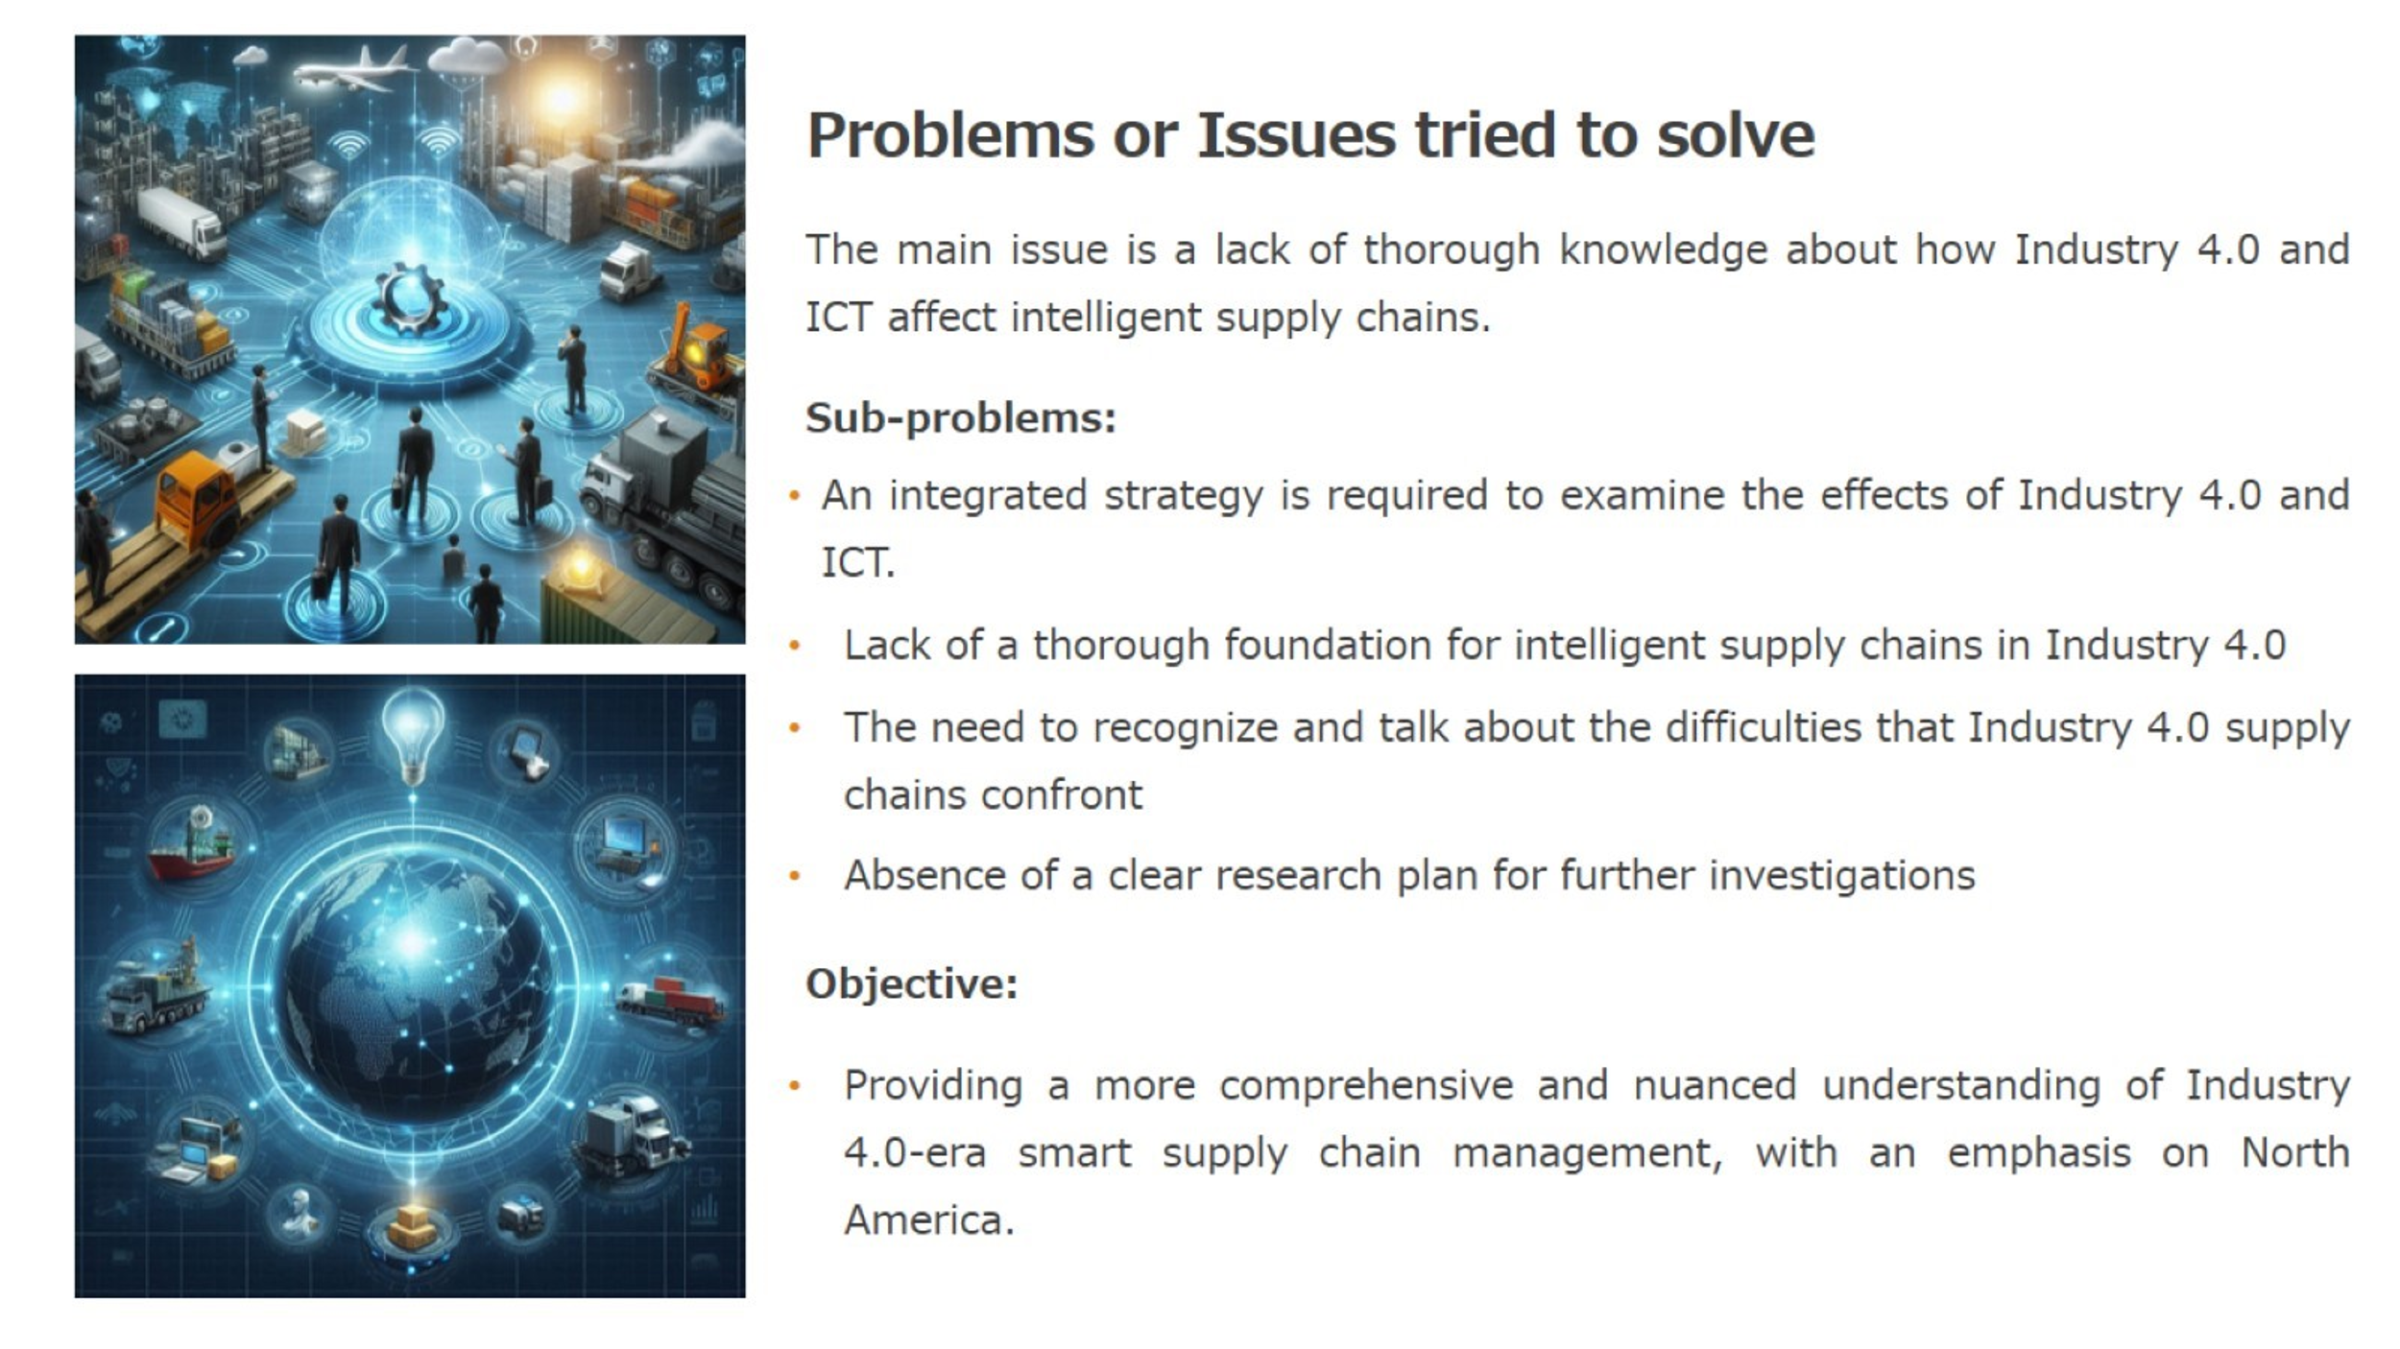

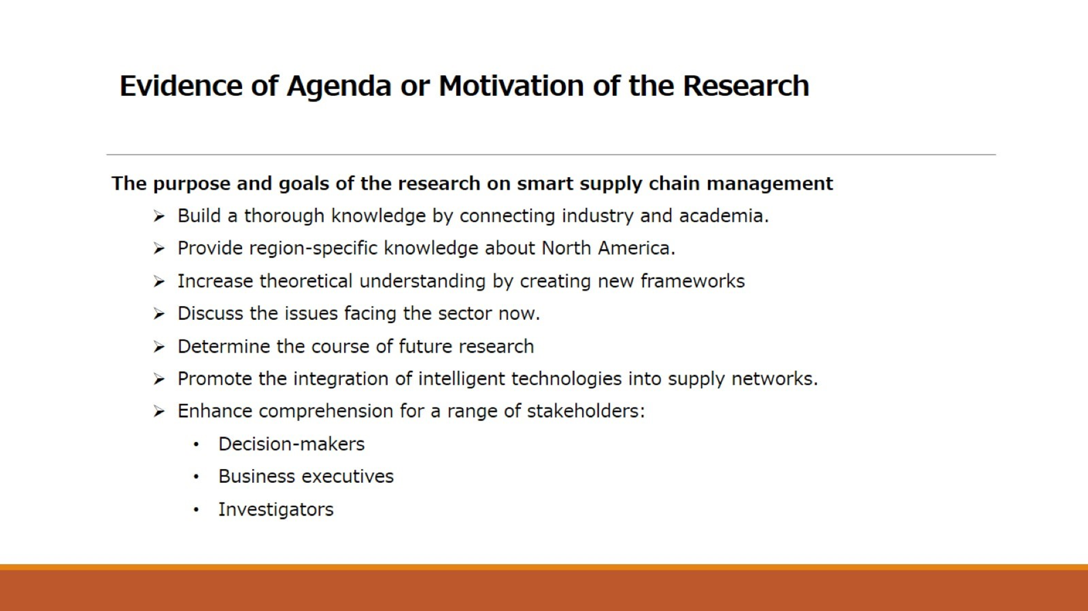

Appendix 2: Precis
This academic study looks at how supply chain management (SCM) has been transformed by emerging information and communication technologies (ICT) within the context of the Industry 4.0 paradigm. The analysis presents a multifaceted view of the developments and difficulties in smart supply chain management (SSCM) by integrating national policy frameworks, current research initiatives, and academic literature.
The authors stress the critical role that supply chains play in the manufacturing and service industries, pointing out that these chains have an impact on the strategic goals of supply network stakeholders. The COVID-19 pandemic has highlighted the importance of having flexible and robust supply chains. The emergence of intelligent supply chains has been accelerated by Industry 4.0, which is defined by technologies like big data analytics, blockchain, and the Internet of Things (IoT). These supply chains optimise performance by seamlessly integrating customer demands across manufacturing and distribution.
By enabling cyber-physical systems that align production stages with customer demands, the Industry 4.0 paradigm improves horizontal integration throughout value creation networks. The foundation of smart manufacturing is this integration, which depends on clever supply chains for effective production and prompt delivery. Smart supply chains are made possible by advanced ICT, which unites diverse partners' processes into a cohesive, intelligent ecosystem.
The research uses a tripartite methodology that includes a review of the literature on ICT-assisted supply chains, an analysis of national strategies in North America, and an examination of research projects supported by significant national councils. Using a combination of theoretical frameworks and practical insights from ongoing research and national initiatives, this approach produces a holistic perspective.
The writers stress how important it is for national research initiatives and plans to take into account changes in research paths and technology. Through a close examination of these resources, the study fills a vacuum in the literature by providing a thorough overview of cutting-edge technologies and future development roadmaps in SSCM, which frequently overlooks the fusion of academic insights with national strategies and applied research.
In order to implement smart supply chains, the paper outlines several challenges, such as developing resilience against major disruptions, ensuring adaptability to changing markets, and integrating advanced ICT across decision-making echelons. Prospective research avenues include investigating the impact of particular ICT technologies on supply chain operations, creating multi-level intelligence frameworks, and devising plans for smooth technology integration into current architectures.
The study concludes that by enabling smart supply chain development, Industry 4.0 technologies greatly improve supply chain performance. SSCM's current state and future prospects are thoroughly examined through the synthesis of national strategies, ongoing research, and academic literature. This highlights the critical role of advanced ICT in transforming supply chains to meet modern demands within the Industry 4.0 paradigm.
The main ideas of the paper are summarised in this summary, which also covers the methodology of the review, the challenges that have been identified, and the directions that future research in smart supply chain management within the context of North American Industry 4.0 will go. The all-encompassing strategy emphasises how important it is for advanced ICT to change supply chains in order to fulfil the demands of contemporary manufacturing and service operations. This is because advanced ICT fosters intelligent, networked systems that improve performance by integrating customer needs throughout the entire production and distribution process.

Appendix 3: Summary
“Smart supply chain management in Industry 4.0: the review, research agenda and strategies in North America”
Summary
Introduction
The vital role that emerging information and communication technologies (ICT) play in enhancing supply chain performance within the Industry 4.0 framework is examined in the paper "Smart supply chain management in Industry 4.0: the review, research agenda and strategies in North America" by Zhang et al. (2023). Understanding how digitalization and automation affect supply chains has become essential for academics and industry professionals as global industries adopt these technologies more and more. The authors acknowledge that current reviews of ICT-assisted smart supply chains mostly draw from scholarly research, which may leave out important perspectives from business and government. Zhang et al. (2023) suggest an integrated strategy that fills this gap by integrating a thorough literature review, a major national research council's research status, and an analysis of North American national strategies. The goal of this thorough approach is to give a more comprehensive understanding of intelligent supply chain management in the context of Industry 4.0.
Two major facets of the paper will be examined in this report:
- The issue or problem in the field of smart supply chain management that the paper seeks to address or clarify.
- The motivation or overarching goal of the research, as stated in the paper.
Determining the Issue or Problem
Zhang et al., (2023) primarily seek to address the deficiency of a thorough knowledge of the ways in which Industry 4.0 and associated ICT impact intelligent supply chains, as well as the ways in which these supply chains develop with the assistance of cutting-edge technologies. This is a serious problem because the review works that have been done so far on ICT-enabled smart supply chains mostly focus on academic literature, which means that valuable perspectives from business and government may be overlooked.
Within this more general issue, the writers pinpoint a number of crucial sub-issues:
- The need for a more coordinated strategy when investigating how Industry 4.0 and ICT affect intelligent supply networks. The research status from significant national research councils in North America, an examination of current national strategies, and a thorough literature review are all combined in this paper to address this.
- The absence of a comprehensive framework for comprehending, within the context of Industry 4.0, the composition and operation of smart supply chains. A smart supply chain hierarchical framework with multi-level intelligence is introduced by the authors as a solution to this (Zhang et al., 2023).
- The necessity of recognising and talking about the difficulties that Industry 4.0's supply chains are facing. This is important for researchers trying to fill in knowledge gaps as well as practitioners looking to adopt new technologies.
- The lack of a defined research agenda for upcoming studies in this area. By talking about "future research directions," the paper seeks to address this (Zhang et al., 2023).
The purpose of this paper is to provide a more thorough and nuanced understanding of smart supply chain management in the Industry 4.0 era, specifically in the context of North America, by addressing these sub-issues.
Research Objectives and Motivation for the Researchers
Numerous salient features of the paper's abstract suggest the purpose and inspiration for this investigation:
- Creating a more comprehensive understanding of smart supply chains: The authors' choice to integrate a review of academic literature with an examination of national strategies and research council priorities points to a desire to bridge the gap between academia and industry. By bridging the gap between theoretical research and real-world application, this method seeks to improve the relevance and applicability of the findings for audiences in academia and business.
- Focus on North America: The deliberate attention to North American tactics and studies suggests a desire to offer insights that are pertinent to the region. The authors may have done this out of a desire to boost the region's competitiveness in global supply chain innovation or because they recognise the particular opportunities and challenges that exist in the North American context.
- The development of theoretical frameworks: Zhang et al.'s, (2023) presentation of "a smart supply chain hierarchical framework with multi-level intelligence" shows a desire to advance our knowledge of smart supply chains theoretically. This framework might aid in the conceptualization of smart supply chain structure by practitioners and act as a basis for further research.
- Handling present issues: Zhang et al.'s (2023) discussion of "the challenges faced by supply chains under Industry 4.0" shows that the writers are driven to pinpoint and possibly resolve current issues that the sector is facing. Their goal to make their research immediately applicable to supply chain experts and decision-makers is indicated by their practical focus.
- Shaping future research: The paper's mention of "future research directions" (Zhang et al., 2023) implies that there is a desire to direct and shape the course of this field's research. This suggests a plan to actively influence the direction of intelligent supply chain research in addition to summarising the body of current knowledge.
- Encouragement of smart technology adoption: Zhang et al.'s, (2023) emphasis on how "smart technologies has led to so-called smart supply chains" raises the possibility of encouraging the integration and adoption of these technologies in supply chain management. A conviction in the potential advantages of these technologies for enhancing supply chain performance may be the driving force behind this.
- Improving comprehension for various stakeholders: Zhang et al., (2023) state that knowledge of these technologies and their impacts is "essential to practical and academic communities," indicating a desire to produce research that is beneficial to a variety of stakeholders, including policymakers, business professionals, and researchers.
Conclusion
The study by Zhang et al., (2023) fills in a major knowledge vacuum about smart supply chain management in the context of Industry 4.0, especially in North America. The goal of the authors' combination of academic literature review and analysis of national strategies and research priorities is to offer a more thorough and practically relevant examination of the ways in which emerging ICT impacts smart supply chains.
The study is driven by a number of goals, such as bridging the knowledge gap between academic theory and industry practice, advancing theoretical frameworks, addressing real-world issues, influencing future research directions, encouraging the adoption of smart technologies, and improving comprehension for a variety of stakeholders.
This paper is positioned to make a potentially significant contribution to the academic understanding and practical application of smart supply chain management in the era of Industry 4.0 due to its integrated approach to studying smart supply chains, as well as its introduction of a new hierarchical framework, discussion of challenges, and recommendations for future research directions.
Reference
Zhang, G., Yang, Y. and Yang, G. (2023) 'Smart supply chain management in Industry 4.0: the review, research agenda and strategies in North America,' Annals of Operation Research, 322(2), pp. 1075–1117. https://doi.org/10.1007/s10479-022-04689-1.

