

Student: Antoaneta Vazova

ID number: 2123847

Module: Introducing the Modern Workplace

Module code: LCBB4003

Assignment 1

Lecturer: Aparna Venkatesan

TABLE OF CONTENTS

- Introduction…..…………………………………………………………………………………page 3

- Main Body………………………………………………………………………………………. page 3

- Maslow’s hierarchy of needs…………………………………………………………….page 4

- Team development – Tuckman 5 stages……………………………………………page5

- Conclusion….…………………………………………………………………………………….page 7

- References………………………………………………………………………………………..page 9

- INTRODUCTION

The worldwide economic situation in the last decade has been characterised by a strong dynamics, constant changes, instability, and increasingly difficult predictability. In parallel, modern technologies are developing at a pace faster than ever before. For part of the population this global picture gives rise to a sense of isolation, a sense of alienation and a need to search and create alternative ways of coping with life. These processes naturally give rise to socio- political and economic trends towards seeking new approaches such for as basis of human interaction, based on possible direct communication, mutual assistance, and readiness for sharing goods, knowledge and resources as this process is greatly facilitated by the facilities the means of modern technologies.
In recent years, the business world has seen a shift thanks to the emergence of shared workspaces, which have evolved from an alternative to a proven workplace format. Its driving force in the beginning was freelancers and new companies. One of these new companies is WeWork which was established in 2010. It is a business offering one of the best shared workspaces with an impressive and carefully designed layout that aims to increase productivity while providing relaxation elements to integrate into the work process, making it a pleasure.
The shared spaces sector was adopted with great success. The number of locations of shared workspaces in the world has increased tenfold in a period of 6 years, which reflects and proportionally their inhabitants, which have risen from 43 thousand to 1.2 million. Surveys show that statistics are not slowing down. By 2020, the number of people visiting shared workspaces should have reached a staggering 3.8 million, and by 2022, it will rise to 5.1 million.
(Yuong , H. (December 15, 2021) https://startups.co.uk/premises/offices/wework-review/)

This report aims to introduce you to the working structure of WeWork and how the entire workplace organisation affects employees’ behaviours.

- MAIN BODY – The factors in WeWork that influence the
employees ’behaviours.

The WeWork business model has been built precisely on this demand: the company offers shared workspaces for co-working, builds physical and virtual offices for entrepreneurs and companies, from different sectors and domains.
(Pereira, D. (18.07.2022), https://businessmodelanalyst.com/wework-business-model/
  - Maslow’s hierarchy of needs is a theory of psychology explaining human motivation. 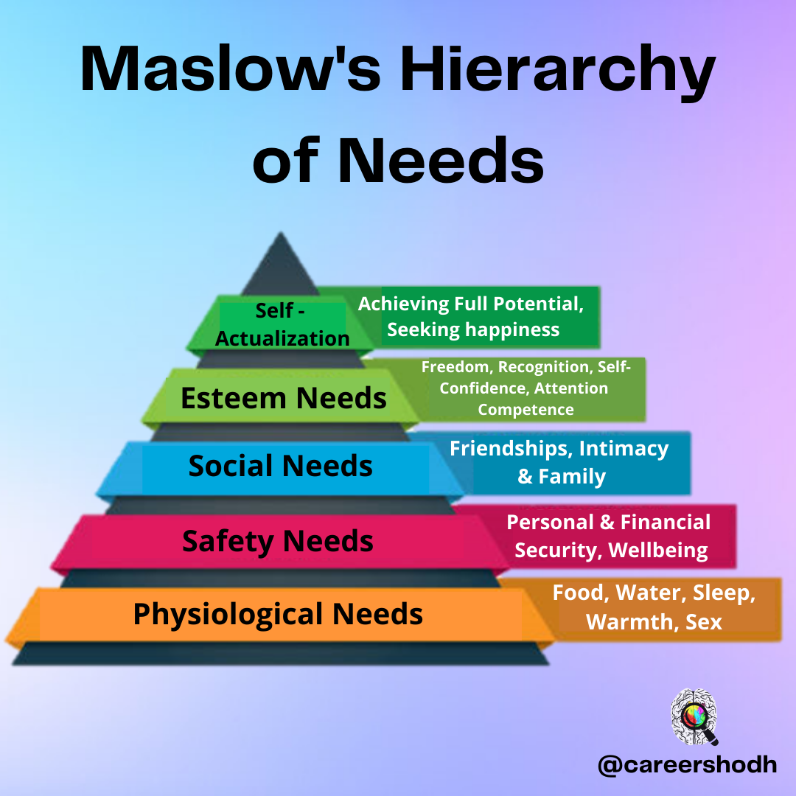
( Niwlikar,B. (February 24, 2022)https://www.careershodh.com/maslows-need-hierarchy-theory-of-motivation/)
Intrinsic motivation refers to stimulation for personal satisfaction or fulfilment. The theory states that people are motivated to fulfil their needs in a hierarchical order- physiological and existential needs, belongingness, and self-esteem. The ultimate goal, according to this theory is to reach the fifth level of the hierarchy: self- actualisation. (Maslow, A. (1943) “A theory of human motivation”, Psychological Review, 50 (4), pp. 370-396.)
When the WeWork was launched, the goal was to build more than beautiful and shared spaces. A community begins to build a place where you join as an “ME” and become part of the greater “WE”. Happy employees, a place where we redefine success as measured by personal fulfilment, not just the bottom line. The community is the catalyst of this start-up building on the sense of belonging. Inspired by the fact that everyone does what they love that everything happens with a team effort, there is empathy, cohesiveness, and support. Consistent customer trust, the sense of stability, caring for each other, makes the work extremely rewarding and every single member of the team valuable. Adam Neumann the founder of WeWork is one of the leaders who has the quality to affect the audience. He manages to convince all his employees that by working for the company they will reach perfection; they will climb to the top of pyramid working 24/7 in the offices. He creates all the conditions for them to feel like at home and important, that they lack nothing. Including, he organises non- stop parties, and before each one he gives a memorable speech, with the help of which he inspires his employees more and more. In this way, the productivity of the workers is activated, and they have the same goals as the company and become very dedicated to the work they do. During the Covid pandemic, the American start-up for shared office space is offering some of its employees $100 a day if they feel comfortable coming to work in the office amid the coronavirus epidemic.
(Hogarty, S.(Septembre 30, 2021) https://www.wework.com/ideas/professional-development/creativity-culture/what-is-company-culture-and-why-its-important#why-is-company-culture-important-benefits-and-advantages)

  - Team development – Tuckman 5 stages:

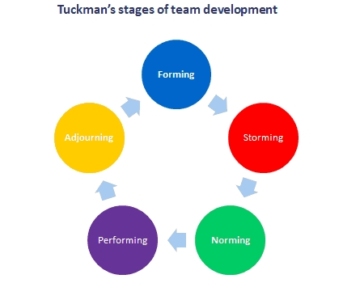
( Bonebright, D.A. 40 years of storming: a historical review of Tuckman's model of small group development Human Resource Development International, volume 13, issue 1, p. 111 – 120, Posted: 2010)

- Forming

Starting to build a community from scratch means you only have yourself and your colleagues. Your team is the heart of the company, and you are the ones who define the values, culture, and types of interactions you would like to develop in the company community. The team dynamics you maintain in your crew will affect the dynamics you will see in the community in the future. If there are unresolved or unspoken issues, conflicts and inconsistencies within your team and result in a volatile, defensive, and mistrustful group of people who do not feel connected to each other. Tuckman’s theory in five stages clearly emphasises the need to follow the various stages in order to achieve a positive outcome.
Gathering a team Adam Neumann very successfully manged to make the participants have to overcome the uncertainty of the new situation (unfamiliar environment, meeting new people, different from the expected behaviour, etc.). Therefore, it causes group members to study each other’s behaviour. He is aware that the team leader is being watched critically. In this phase, the search for ideas, the definition of topics and work tasks takes place on a rational level, and the definition of roles and the formulation of rules are performed on an emotional level.
Skilfully directing each team meeting for expeditious, efficient, and effective achievement of goals and devoting time to discussing the way of cooperation with the goal of improvement is another profitable approach in the company. Pay particular attention to the correct methodical approach, namely that the exact objectives are written down and the work tasks are distributed.

- Storming

The employee’s behaviours in WeWork changes because they try to overcome uncertainty around personal emotions. Emotional relationships and struggles for supremacy begin to be established, opinions collide, changing groups are formed. Next comes the inevitable testing of the team leader’s skills. In the phase, there is resistance to the work task on a rational level and resistance to the team leader on an emotional level. Conflicts arise. This is a critical phase for the team, because if acceptable compromises are not found and made, the existing unity breaks down, general consensus is difficult to achieve, and the group disintegrates instead of becoming a team. If the conflicts and differences in interests are approached constructively, the next phase will consolidate what has been achieved. Adam Neumann is a very good manipulator and manages to control the emotions in the team and turn them to his advantage. As a successful leader he takes care of his employees to stay and be motivated to continue, encourages them constantly and helps the team to overcome critical moments. Therefore, he develops the following successful processes- creates a preliminary attitude and preparation for this difficult stage. He constantly stimulates his workers for conversations and discussions of new ideas.

- Norming

Gradually, the employee’s behaviours are quite naturally influenced by the positive environment. The atmosphere at work becomes more pleasant and relaxed.A sense of empathy develops. The team begins to successfully work out the ground rules from an emotional point of view to the final roles. This means that the skill level of the team members is determined, a “natural hierarchy” is created, the norms, roles and distribution of work tasks are established. Conditions for real cooperation are created, thanks to which problems and conflicts are approached with routine, individual differences are valued, trust in the team grows. There is clarity around individual responsibility and a shared empathy for team responsibility. The team has its own image that can identify it in the organisational space. The office starts to turn into a cosy space that you don’t want to leave, it has everything you need, even more. There is a constant supply of food and drinks, places where you can sleep so you don’t waste time getting home. Almost every night there are parties, because of which the office puts a beer machine, slot machines and pool tables. WeWork manages to become the family that you need, the sense of belonging and significance.

- Performing

The team is built. It can work effectively and deal successfully with conflicts and tensions; makes constructive decisions and skilfully uses the entire team potential to achieve the set goals. Team roles and communication between participants help accomplish work tasks. Information and ideas are shared. Therefore, the problems are solved, and work gets done, team members support each other, there is greater tolerance, and everybody acts more flexibly. In this phase, the step-by-step implementation of the work task, the pursuit of the goal and decision- making are carried out at a rational level. On an emotional level, it becomes clear that empathy, constructive and joint management of the work tasks is much more successful. One of the stimulating processes in WeWork is the leader towards promoting the work of the team by its leader, delegating management tasks, agreeing on goals and decisions.

- Adjourning

In March 2019, WeWork announced it was going public through a merger with special purpose BowX Acquisition. The deal was valued at $9 billion. Soft Bank retained a majority stake in the company after the merger, prompting the departure of co-founder Adam Neumann as chief executive and a major restructuring of senior management. WeWork ended up laying off thousands of employees and selling off several businesses it had acquired during Neumann’s tenure when the team achieved all its goals and it was time to disband, that’s when everyone continues to work, but on other tasks and projects are initiated. From an organisational perspective, it is important to consider that team members may be sensitive about the topic of their group breaking up because they have worked together and formed close relationships. As the team breaks up, they may feel insecure or threatened.

5. CONCLUSION

Tuckman’s model and Maslow’s theory emphasise the contribution of each participant and the outstanding role of the leader for successful team building.
A successful team is one that overcomes various problems in the process of its construction, has proven that it can cope with the tasks, added sustainability in achieving the set goal and achieved enviable results. It has self- assessed as a team and received external evaluation of its work; therefore, it has gained confidence that it is able to deal with emerging problems in complex situations. Because of this, it can also be assigned new tasks. This sounds too challenging for the worker, because on the one hand, he has to prove his ability to work and on the other hand, to cope well under new circumstances. In order to be able to achieve all of this, the team must have a very solid foundation to operate on. It is based on the following characteristic of successful teams: have strong commitment of team members to the added goals and to each other; collective spirit; empathy; cohesion and trust in the team that provoke to accept new challenges. Such a work style that makes team members feel comfortable and committed to the team cause, striving for personal and team improvement. Today, companies have ways to measure the performance of their employees, just like any other factor that can affect the prosperity of the company. There is one aspect that is always considered and that is the mental health of the employees. It is surprising that so many companies invest in the mental well- being of their workers.

6. REFERENCES:

Bonebright, D.A. 40 years of storming: a historical review of Tuckman's model of small group development Human Resource Development International, volume 13, issue 1, p. 111 – 120, Posted: 2010)

Cassidy, K. Tuckman revisited: Proposing a new model of group development for practitioners, Posted: 2007
Chapter 8 of Mullins, L. J. (2019) Organisational behaviour in the workplace.12th Ed.Harlow: Person Education Limited.

Niwlikar,B. ( 24.02. 2022), https://www.careershodh.com/maslows-need-hierarchy-theory-of-motivation//)

Pereira, D. (18.07.2022), https://businessmodelanalyst.com/wework-business-model/

Yuong , H. (15.12.2021) https://startups.co.uk/premises/offices/wework-review/

(Hogarty, S.( 30.09.2021) https://www.wework.com/ideas/professional-development/creativity-culture/what-is-company-culture-and-why-its-important#why-is-company-culture-important-benefits-and-advantages

https://www.coworkingresources.org/blog/the-wework-business-model (Accessed on 2. 01. 2023)

