University of Wales Trinity Saint David
Wales Institute of Science &Art

Suspension Kinematic and Performance Analysis
Vehicle / Motorsport Technology
ACHA4004 / ACHA4012

Calum Campbell 2001090
Date (10/21)
Contents
1 Introduction 1
2 Laboratory Sessions 2
2.1 Equipment 2
2.2 Methodology 5
2.3 Results 6
3 WinGeo Kinematic Simulation 10
3.1 Methodology 10
3.2 Kinematic Results and Discussion 11
3.3 Roll Centre Migration 15
4 Suspension Calculations 17
4.1 Calculations 17
4.2 Discussion 17
5 Validation 18
6 Conclusion 19
7 References 20

Table 1 - Lab Data 6
Table 2 - WinGeo Ride data based off ride height change 11
Table 3 - WinGeo Suspension Raw Data 12
Table 4 - Roll centre migration scenario. 15

Figure 1: Height Gauge and DTI A&B 2
Figure 2: Camber Gauge 2
Figure 3: Lab Session set up and Damper Adjustment 3
Figure 4: Corner Unsprung Mass on Scale 3
Figure 5: Hydraulic Press and DTI to Measure Deflection 4
Figure 6 - Laptop measuring force on spring and spring compressor 4
Figure 7 - Camber vs Ride Height 7
Figure 8 - Toe change Vs Ride Height 7
Figure 9 - Spring Compression Vs Wheel Deflection 8
Figure 10 - Spring Deflection vs Applied Force 8
Figure 11 - Tyre Deflection Vs Applied Force 9
Figure 12 - WinGeo Van Diemen Front View 10
Figure 13 - WinGeo Van Diemen Offset View 10
Figure 14 - WinGeo and Measured Camber vs Ride height 11
Figure 15 - WinGeo Camber Vs Roll 12
Figure 16 - WinGeo Spring vs Wheel Deflection Vs measured Data 13
Figure 17 - WinGeo Toe steer Vs Roll 13
Figure 18 - WinGeo Toe Change vs Ride Height Against Measured Data 14
Figure 20 - Roll Centre Migration close up 16

Introduction
This technical report has been produced to demonstrate the kinematic effects of suspension. Showing how changing variables of the suspension geometry and applied forces directly affect handling characteristics of a single seater Formula Ford Van Diemen race car. The front suspension features a double wishbone, pushrod onboard monoshock suspension set up.
Using WinGeo, in which a 3D model of the Van Diemen single seater was used to compare data sets collected from the lab session vs a simulation.

Laboratory Sessions

Equipment
Shown in the figures below is the equipment used during the testing of the suspension geometry which included:
- Two dial test indicators (DTI’s)
- Vernier calliper
- Camber gauge
- Height gauge
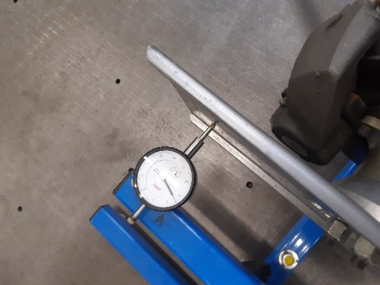
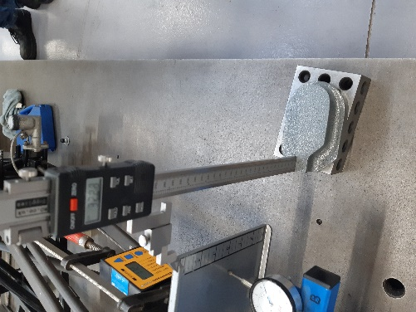
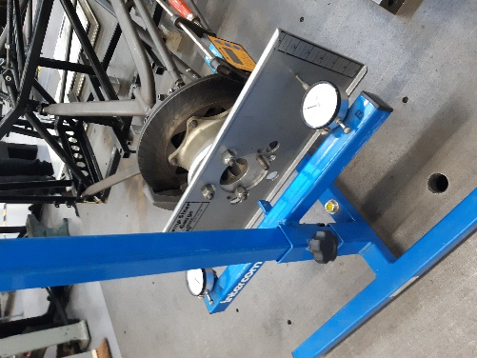
Figure 1: Height Gauge and DTI A&B

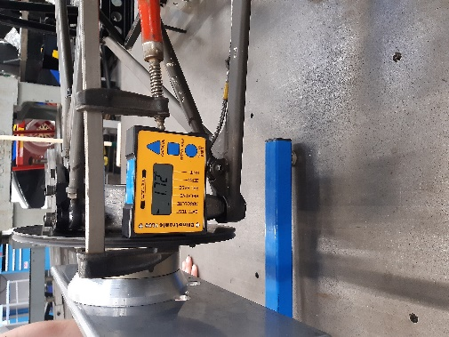
Figure 2: Camber Gauge

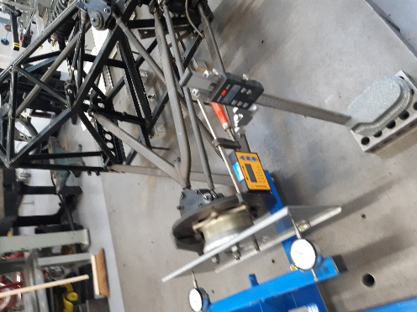
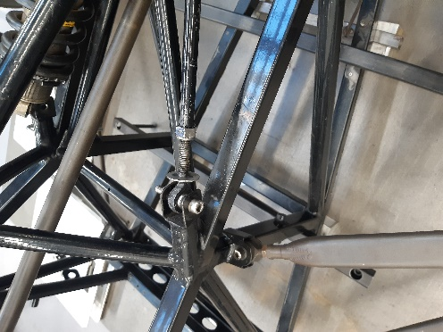
Figure 3: Lab Session set up and Damper Adjustment

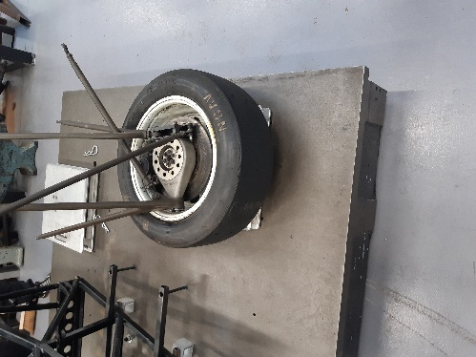
Figure 4: Corner Unsprung Mass on Scale

Further figures show the equipment used for the tyre deflection test and spring compression test, which were:
- A Hydraulic press
- One DTI (mm)
- A laptop to measure force applied
- Spring compressor
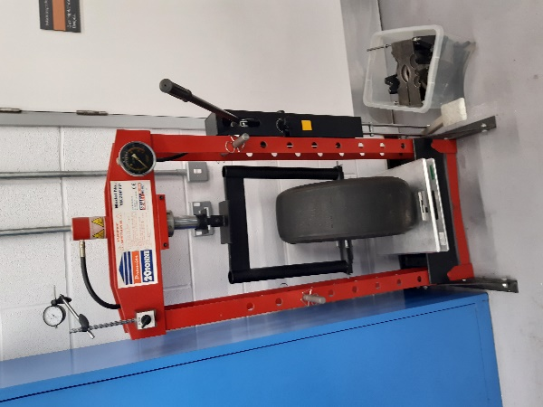
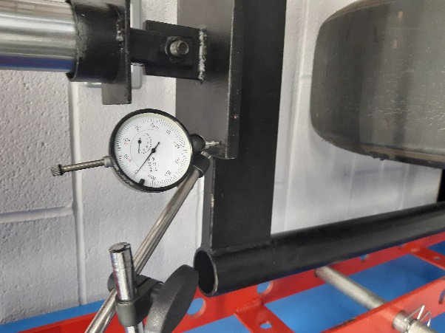
Figure 5: Hydraulic Press and DTI to Measure Deflection

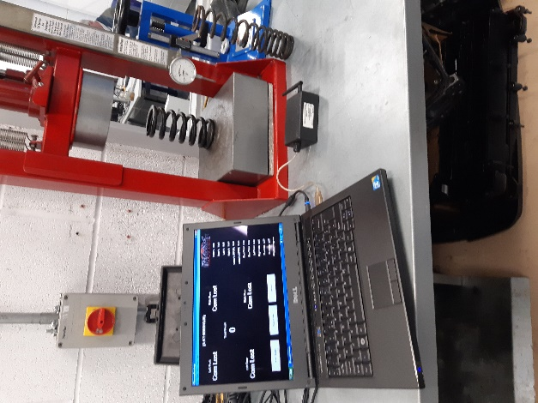
Figure 6 - Laptop measuring force on spring and spring compressor

Methodology
Data was gathered on the van Diemen suspension geometry using equipment in figures 1,2 and 3. The front wheel of the van Diemen was set to -20mm to simulate the suspension at full droop with a height gauge then Zeroed to record the change in height.

A camber gauge was fixed to accurately record the deviation in camber (measured in degrees).

Two DTI’s were used on an end plate mounted to the wheel hub to record any change in toe (μm)
The damper length was changed by rotating the fixed nut 2 full rotations clockwise while measuring the distance from the fixed nut to the washer as shown in figure 3, taking readings from the DTi’s, camber gauge and height gauge each time.

A scale was used to weigh the Sprung and Unsprung mass of the corner of the race car, as shown in figure 4.

A tyre was placed into a hydraulic press with a DTI fixed to it to measure the deflection of the wheel when placing the press under load, 7 readings were taken in 2mm increments from 0mm to 14mm and recording the force readings in kg at each stage, see figure 5 for reference.

The spring placed into a spring compressor equipped with another DTI measuring in inches. The spring was compressed in 0.1inch increments up to 1 inch compression, at each reading, a force value measuring in lbs was taken to calculate the force applied.

The values recorded from each of the aforementioned measuring equipment and tests was then recorded and placed into a table, see table 1 in 2.3 Results section.

Results
In Table 1 below, the white sections are the recorded raw data from the lab sessions, while the greyed sections are the data inputted through calculations of the raw data gathered. However, in the approximate ride height section of the table, the results have been corrected to show the true height value rather than an approximate height to gather more accurate data during analysis.
Table 1 - Lab Data
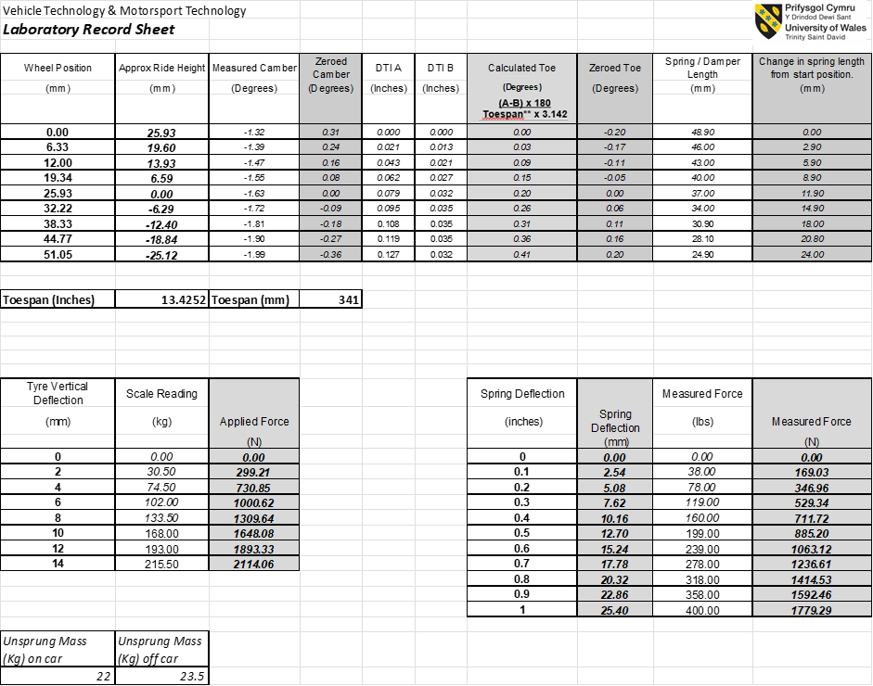

Through the calculated sections of Table 1, graphs showing a visual depiction of the results were able to be produced in excel.

Figure 7 - Camber vs Ride Height
Figure 7 demonstrates a liner correlation between camber and ride height, showing that as the wheel is moved up towards the chassis (bump), the camber becomes more negative in value. The opposite can be said for lowering the wheel in relation to the chassis (rebound).

Figure 8 - Toe change Vs Ride Height

Figure 8 outlines a linear correlation of toe vs ride height. As the wheel undergoes bump, the toe is linearly more positive in degrees (toe out). Opposingly, during rebound the Toe change is linear as the wheel moves towards a negative angle (toe in).

Figure 9 - Spring Compression Vs Wheel Deflection
Figure 9 enabled calculation of the motion ratio (MR), which is D1/D2, where D1 is the distance from the control arm inner pivot point to the spring centreline, and D2 is the distance from the control arm inner pivot point to the bell crank.
This provides the gradient which is 0.467 MR in a positive linear correlation.

Figure 10 - Spring Deflection vs Applied Force
In figure 10, spring deflection was put into a graph versus the amount of force the spring was under at each distance of compression, providing a very linear graph.
Furthermore, from the data the spring rate was calculated by firstly converting from inches and lbs as shown in Table 1, into mm and newtons to enable the calculation of the spring rate in N/m, which is the measured force/spring deflection equalling 70.003N/mm or converted to 70003N/m.

Figure 11 - Tyre Deflection Vs Applied Force
Figure 11 shows a near linear correlation of the force in Newtons the tyre went under when compressed by a set distance in Millimetres while the tyre pressure was at 10PSI. The tyre stiffness can be calculated by dividing the applied force by the deflection distance, providing a tyre stiffness of 151.004N/mm, converting to SI units makes this 151004N/m.

WinGeo Kinematic Simulation

Methodology
WinGeo is a geometry software using real world calculations and dimensions to get Realtime values for multiple variables relating to suspension geometry. WinGeo was utilised by taking the provided 3D model of the Van Diemen and putting the simulation through scenarios and recording the outcomes in tables and graphs.

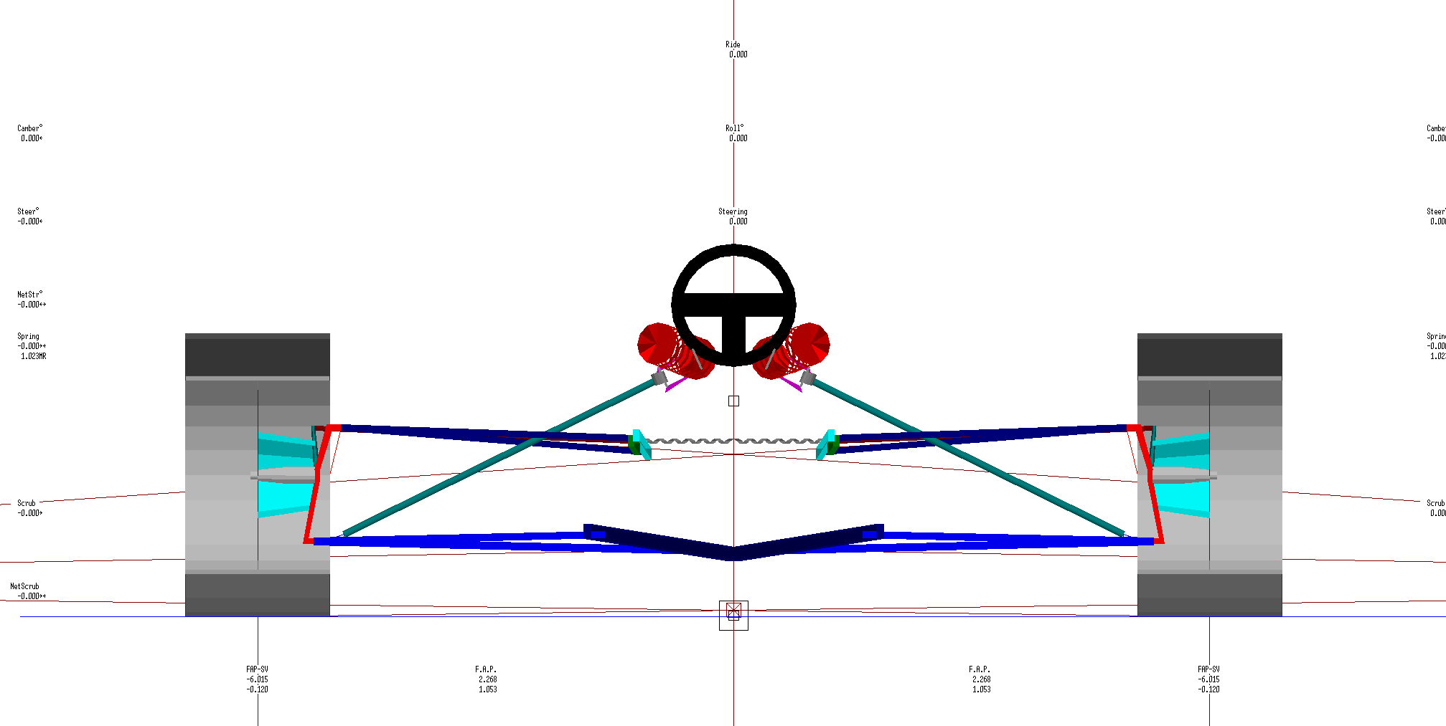
Figure 12 - WinGeo Van Diemen Front View

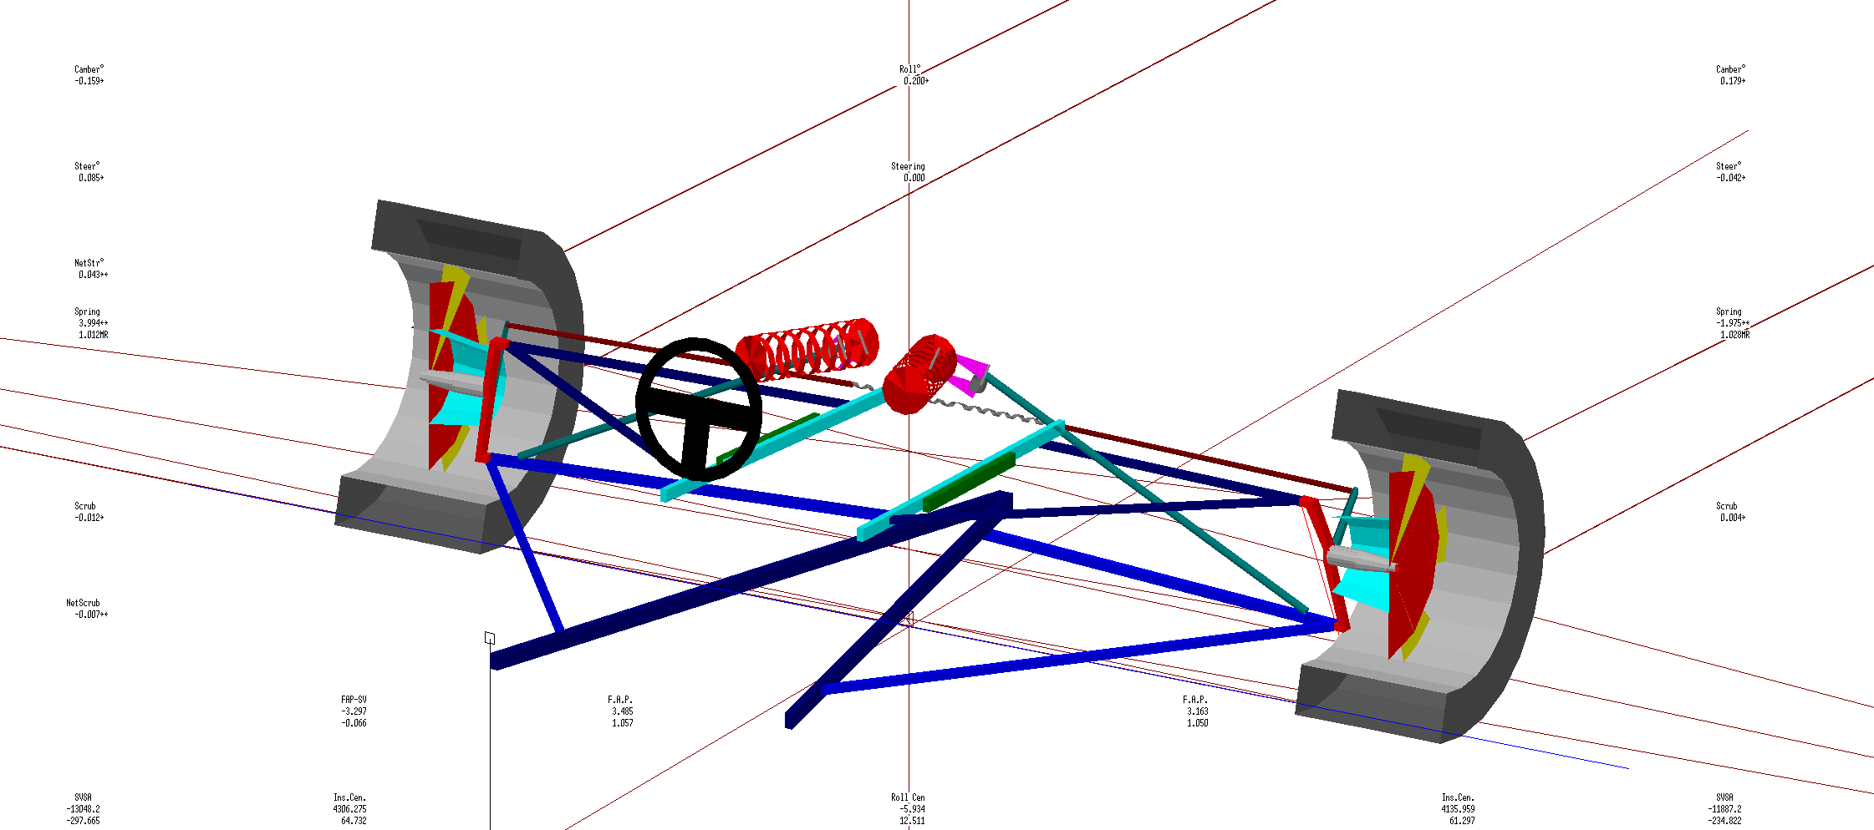
Figure 13 - WinGeo Van Diemen Offset View

Kinematic Results and Discussion
A table was created by changing just the ride height in increments of 5mm. Starting with the model at -25mm (bump) and increasing up to +25mm (rebound).
Table 2 - WinGeo Ride data based off ride height change
From this data various graphs were created to see the correlations, while also comparing it to the data gathered in the Lab Session.

Figure 14 - WinGeo and Measured Camber vs Ride height
Figure 14 provides a linear, positive correlation which is comparable to the measured data. However, there is a difference of 0.5 degrees at the ride heights lowest and highest points relative to the chassis of -25mm and +25mm.

Figure 15 - WinGeo Camber Vs Roll
Figure 15 portrays how the camber changes when the vehicle is undergoing roll with no steering input. Figure 15 shows a near mirror image of the right vs left wheel camber with the camber increasing roughly 0.087 degree with each 0.1 degree of roll.

During the WinGeo experiment, further information was gathered to access the characteristics of the suspension.
Table 3 - WinGeo Suspension Raw Data

Figure 16 - WinGeo Spring vs Wheel Deflection Vs measured Data
Table 3 provided the information to calculate the WinGeo simulations motion ratio compared to the measured lab data.
Figure 16 displays the motion ratio of the WinGeo simulation is 1.0241MR. The WinGeo ratio is 0.5571 more than the measured value during the lab session.

Figure 17 - WinGeo Toe steer Vs Roll
Figure 17 shows the effect roll has upon the steer angle, showing that as more roll is induced, Steer_R will undergo more toe out, whereas Steer_L will mirror this and toe in.

Figure 18 - WinGeo Toe Change vs Ride Height Against Measured Data
Figure 18 depicts the toe change vs the ride height of the WinGeo data and the measured data. The measured data is 0.34 degrees different at the suspensions lowest and highest points in relation to ride height.

Roll Centre Migration
Roll centre migration (RCM) is a theoretical point at which the chassis will roll. A simulation of this was created in WinGeo placing the vehicle through a set of defined conditions to provide the RCM.

The scenario implemented is shown below:

Table 4 - Roll centre migration scenario.
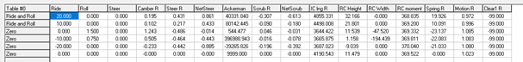

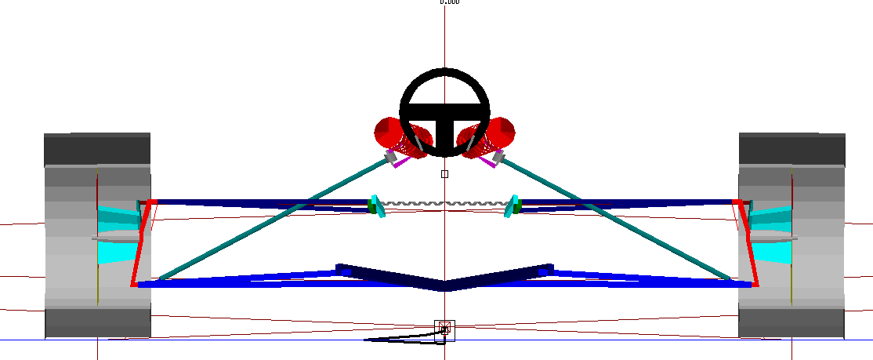
Figure 20 - Roll Centre Migration close up
Figure 20 shows the RCM. RCM is stated to have an immediate effect on a vehicle’s handing, unlike other suspension components which require some initial roll to affect the handling characteristics. Due to this, RCM is a slightly controversial topic in the professional industry with 2 contrasting views.

1) They are a simulated result which do not exist in real world conditions so are actually not important – what is important is to know all of the loads in the suspension system so one can calculate the behaviour characteristics of the suspension.

2) Although they do not exist, they are points which explain the suspension behaviour and can be used to predict the overall characteristics of the system without needing to know all of the load values, allowing the gain of a general understanding of how the suspension will behave.

Due to the lack of information to calculate the rest of the suspensions load values, the RCM can be used to predict how the suspension will behave. However, should all these variables have been available, then the RCM would not be as relevant due to the practical values being available rather than the theoretical RCM.

Suspension Calculations

Calculations
Equations were used to calculate additional data from Table 1.
To calculate Wheel rate (KW), the equation used was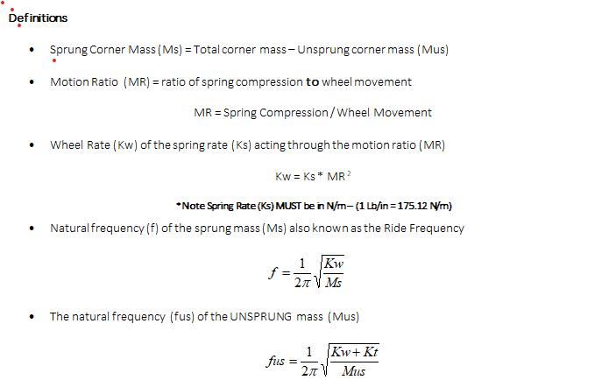.
Therefore $70003X{0.467}^{2}=15266.9$

The natural sprung frequency was calculated using the corner mass of 115KG via the equation:
Therefore $\frac{1}{2π} \sqrt{\frac{15266.9}{115}=}1.83378 Hz$

The final calculation was for unsprang mass frequency which was:
Therefore $\frac{1}{2π}\sqrt{\begin{aligned}15266.9+\frac{151004.2857}{115}=10.2467 Hz \\ \end{aligned}}$

Discussion
The table below details the sprung ride frequency values that can be expected by various types of vehicles, the higher the frequency the stiffer the ride is. Consequently, the Van Diemen’s sprung ride frequency align perfectly within its set category.
Sprung Ride Frequency | Vehicle Type
0.5 – 1.5 Hz | Passenger car
1.5 – 2.0 Hz | Low and moderate downforce race cars
3.0 – 5.0+ Hz | High downforce race cars
((Race Engineering: Racing car ride frequency ranges, 2021)

Validation
Through comparison of the available data, the WinGeo MR is over double that of the measured data, meaning that the spring travel is also twice as much in comparison. The simulated data provided a difference in camber and toe when compared to the measured data.
Although the WinGeo motion ratio is double that of the measured data, this would only affect the spring travel and ride comfort. The toe and camber difference are a result of the instant centres pivot point. Due to taking multiple readings in the lab session it would be prudent to state that the length or angle of one of the WinGeo’s wishbone or mounting points is incorrect when compared to that of the measured data, resulting in a different arc for the wheel to travel through creating the exponential change in both camber and toe.

Conclusion

In conclusion, this report has provided 2 sets of data through practical testing and simulation data, compared the results and presented a valid concept as to the reason behind the variations in results.

References
(Race Engineering: Racing car ride frequency ranges. (2021, 01). Retrieved from Your data driven: https://www.yourdatadriven.com/race-engineering-racing-car-ride-frequency-ranges/

