HTML & CSS Web Development
Author: Patrick Frank Atkinson (1811357)
ACCA4018 – Internet Technology and Security
Faculty of Architecture, Computing and Engineering
Date of submission: 3rd May 2019 at 15:00

Abstract
This report outlines the development of a website on a topic of the author’s choosing. It provides background research into topics areas that are pertinent to the subject area, such as the technologies and best practices that will be used in the development process. It covers the purpose, design and implementation of the website. The final product is subsequently evaluated against web standards and best practices in areas such as accessibility and Search Engine Optimisation (SEO). Finally, the author gives their conclusion based on these evaluations and suggests areas for future work.

Contents
1. Introduction 1
2. Related work 1
2.1. HTML5 1
2.2. CSS 1
2.3. Search Engine Optimisation (SEO) 2
2.4. Accessibility 3
3. Requirements 3
4. Implementation 4
4.1. Initial website design 4
4.2. Construction of the website 4
4.3. Screenshots of final pages 5
4.4. Validation of code 11
4.4.1. HTML validation 11
4.4.2. CSS validation 12
5. Evaluation 12
5.1. Accessibility 12
5.2. Design, usability and content 13
5.3. Search Engine Optimisation (SEO) 14
6. Conclusion and future work 14
6.1. Conclusion 14
6.2. Future work 15
7. Glossary 16
8. Reference list 17
9. Further reading 19
10. Appendices 20
10.1. Appendix A – wireframes of page layout 20
10.2. Appendix B – CSS validation warnings 21

Introduction
The assignment brief is that a website be created on a subject of the author’s choosing. The website must have a minimum of five web pages built using the HTML5 and CSS web standards. This report begins with background research on topics relevant to the brief, followed by a description of the website’s purpose and documentation of its implementation. Following this, the website is evaluated with various tools. The final section is the author’s conclusion and subsequent suggestions for future work.

Related work
This section consists of research into some of the technologies (HTML5 and CSS) and practices (Search Engine Optimisation and ensuring accessibility) that will be used in the creation of the website.

HTML5
Hyper Text Markup Language (HTML) is a markup language that defines the content and general layout of a webpage. HTML is decoded by a web browser which then renders the content on-screen for the user [1].
HTML5 is the fifth major iteration of the HMTL standard and exists in two standards; ‘HTML 5.2 Recommendation’ by the World Wide Web Consortium (W3C) and ‘HTML Living Standard’ by WHATWG. Whilst W3C and WHATWG have worked together on the core HTML5 specification, the two groups have different philosophies for development of specifications. W3C’s specifications are more traditional ‘snapshot’ specifications that are static and revised less regularly. WHATWG’s specification is considered a ‘living’ set of documents that are regularly updated [2]. HTML5 was published as a ‘W3C Recommendation’ on 28th October 2014 [3], nearly fifteen years after HTML 4.01 was made a ‘W3C Recommendation’ [4].

CSS
Cascading Style Sheets (CSS) are used in conjunction with HTML to control the styling and layout of the elements defined in the HTML. Using CSS has numerous advantages over inline styling, including:
- The ability to use the same stylesheet for multiple webpages, resulting in more consistent styling between pages and more easily implemented cross-site styling changes [5];
- Separation of content and presentation markup, which improves the readability and maintainability of the code [6];
- Options for displaying content based on the device it is accessed on, which can improve the usability and accessibility of the web page [5][7].
The current iteration of CSS is CSS3, although this is not a formal standard. The standardisation process of CSS consists of numerous smaller components, called ‘modules’, that individually undergo standardisation at various levels. The CSS Working Group periodically creates ‘snapshots’ of the specifications, stating the aim of the snapshots is to ‘help implementors distinguish between the parts of CSS that at ready for production and the parts that are still experimental [8].’

Search Engine Optimisation (SEO)
Search Engine Optimisation is the use of various methods to increase the ranking of a website in search engines [9]. Search engines create an index of all the web pages they discover. This discovery is carried out by web robots (also known as ‘crawlers’) which are pieces of automated software that ‘crawl’ the internet and index the pages they find. New pages are found by the crawlers following links, reading sitemaps and robots.txt files [12][13]. The main area that can be developed to improve the ranking of a website is the on-site SEO. Information held within the <title> tag is typically used as the display title in search engine results pages (SERPs) [12], and information in the <meta> tags on a web page can provide keywords for search queries, as well as descriptive text that may be displayed below the display title in SERPs [13].
Another recommendation to improve on-site SEO is giving meaningful names to documents and directories in the website’s structure to ensure URLs are more descriptive. This is useful as some search engines include the URL in the details displayed for search results [11][13]. There are also files that can be added to the structure of a website to manage how it is crawled by web robots. A sitemap can be created that lists the URLs in the website that should be crawled. This can include additional meta data about the URLs, such as when the page was last updated and the typical update frequency of the page [14]. The robots.txt file mentioned earlier in this section can be used to prevent web robots from crawling all, or some, parts of a website. These rules can target all, or particular, web robots. The robots.txt file can also include a reference to any sitemaps in the website’s structure [10]. However, robots.txt files rely on the web robots complying with the Robots Exclusion Protocol (REP). Some web robots do not comply and, instead ignore robots.txt files and crawl the entire website [15].
The on-site search engine optimisation of the author’s website will be assessed later in this report.

Accessibility
W3C have developed a set of guidelines for ensuring web content is presented in a manner that is more accessible for users with disabilities. This often has a positive side-effect of also improving usability for other groups of users [16]. The first version of the guidelines (WCAG 1.0) was given ‘W3C Recommendation’ status on 5th May 1999 and was primarily focussed on HTML [17]. WCAG 2.0 reached ‘W3C Recommendation’ status on 11th December 2008 and established the four principles of accessibility which specify content should be [18]:
- Perceivable;
- Operable;
- Understandable; and
- Robust.
The current version of the guidance, Web Content Accessibility Guidelines (WCAG) 2.1, was given ‘W3C Recommendation’ status on 5th June 2018 and further develops the four principles from WCAG 2.0. The website’s accessibility will be assessed later in this report.

Requirements
The author has chosen to create a website that provides basic information about the 2019 Formula 1 season. The intended audience is people that may not have a great deal of knowledge about Formula 1 but would like to spectate during the year. The intention is that the website will introduce this audience to the sport. Information on the website will include details of the drivers and teams competing in 2019, information about the venues of the events and a gallery page containing images of some of the 2019 events that have taken place so far.

Implementation
This section covers the implementation of the website. This includes the initial design and construction of the website, screenshots of the final pages and results of the validation of the HTML and CSS markup.

Initial website design
The author created wireframes of the pages prior to beginning construction of the website. This was done after review of Bootstrap framework (outlined in the next section) to establish which components could be utilised in the design of the website. A scanned copy of the wireframes can be found in Appendix A.

Construction of the website
The website is constructed using HTML5 and CSS as required by the brief. The website makes use of the Bootstrap framework (v4.2.1) alongside the author’s custom stylesheet. Several of the components included in the framework are utilised in the construction of the website to ensure more consistent styling across the pages. As an example, the ‘Card’ component [19] is used on the home, teams and drivers pages. Other components used include ‘Modal’, ‘Navs’, ‘Navbar’, ‘Jumbotron’ and ‘Forms’. Where changes to the Bootstrap styling were required, the custom stylesheet is used to override the Bootstrap styling rather than amending the original Bootstrap stylesheet. This was done with the intention that the Bootstrap framework can be upgraded without having to copy amendments to the new versions of the stylesheets. The styling for the timeline on the calendar page (‘CSS3 Timeline’ by Krishna Babu) was sourced online and incorporated into the author’s custom stylesheet. The link to the source is included in annotations in the stylesheet.
The website is designed to be well suited to a variety of screen sizes and browsers. This is largely due to the Bootstrap framework being developed with this as a consideration. The custom stylesheet has been reviewed using ‘Autoprefixer CSS online’ [20]. This tool adds vendor-specific versions of certain properties (such as the ‘flex’ property) to ensure compatibility across various browsers.

Screenshots of final pages
Screenshots of the pages within the website can be found in Figures 1 to 9 on the following pages.
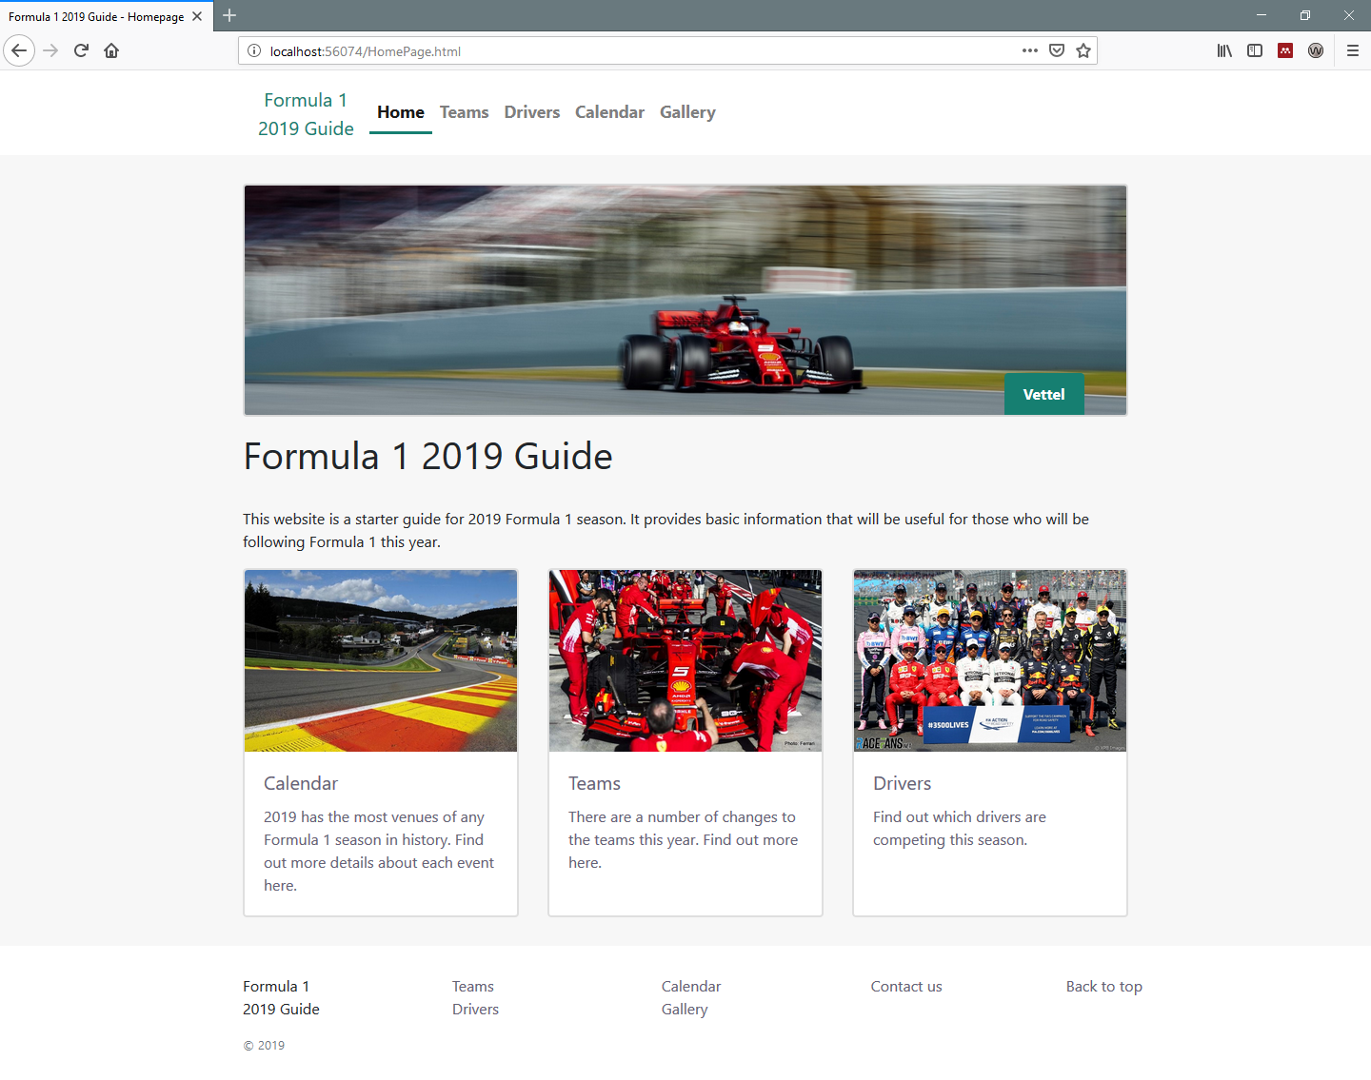
Figure 1: Homepage screenshot
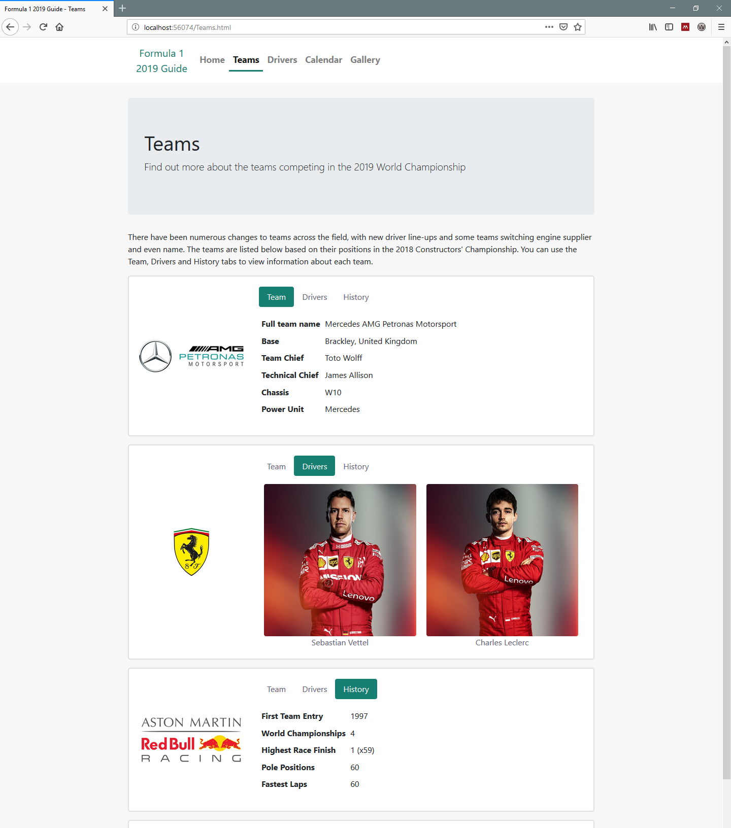
Figure 2: Teams page screenshot showing the three tabs on each card
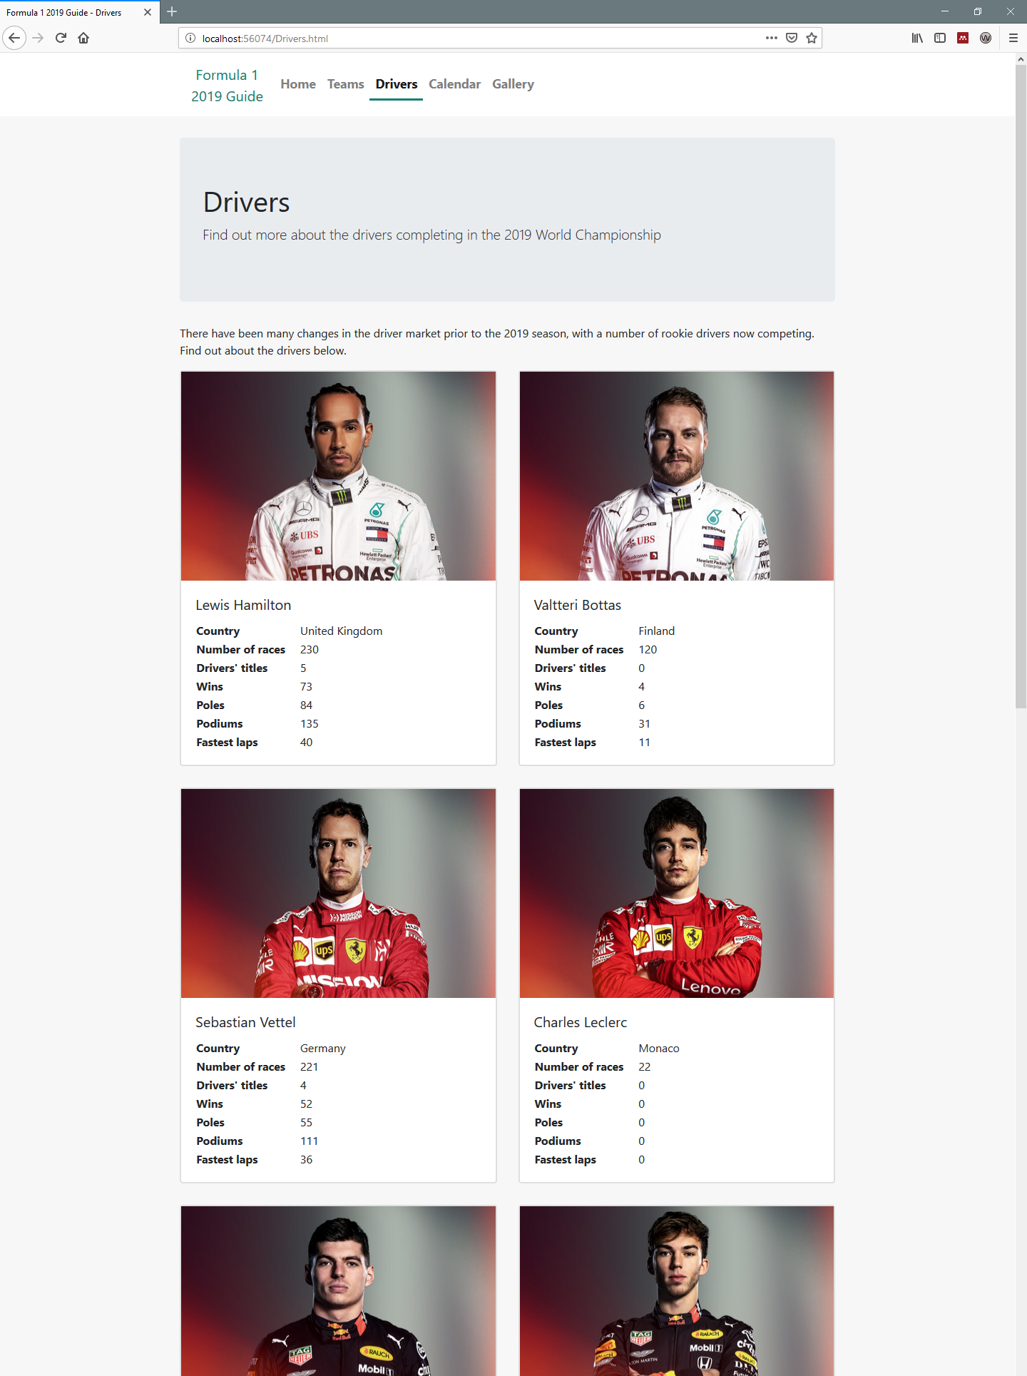
Figure 3: Drivers page screenshot
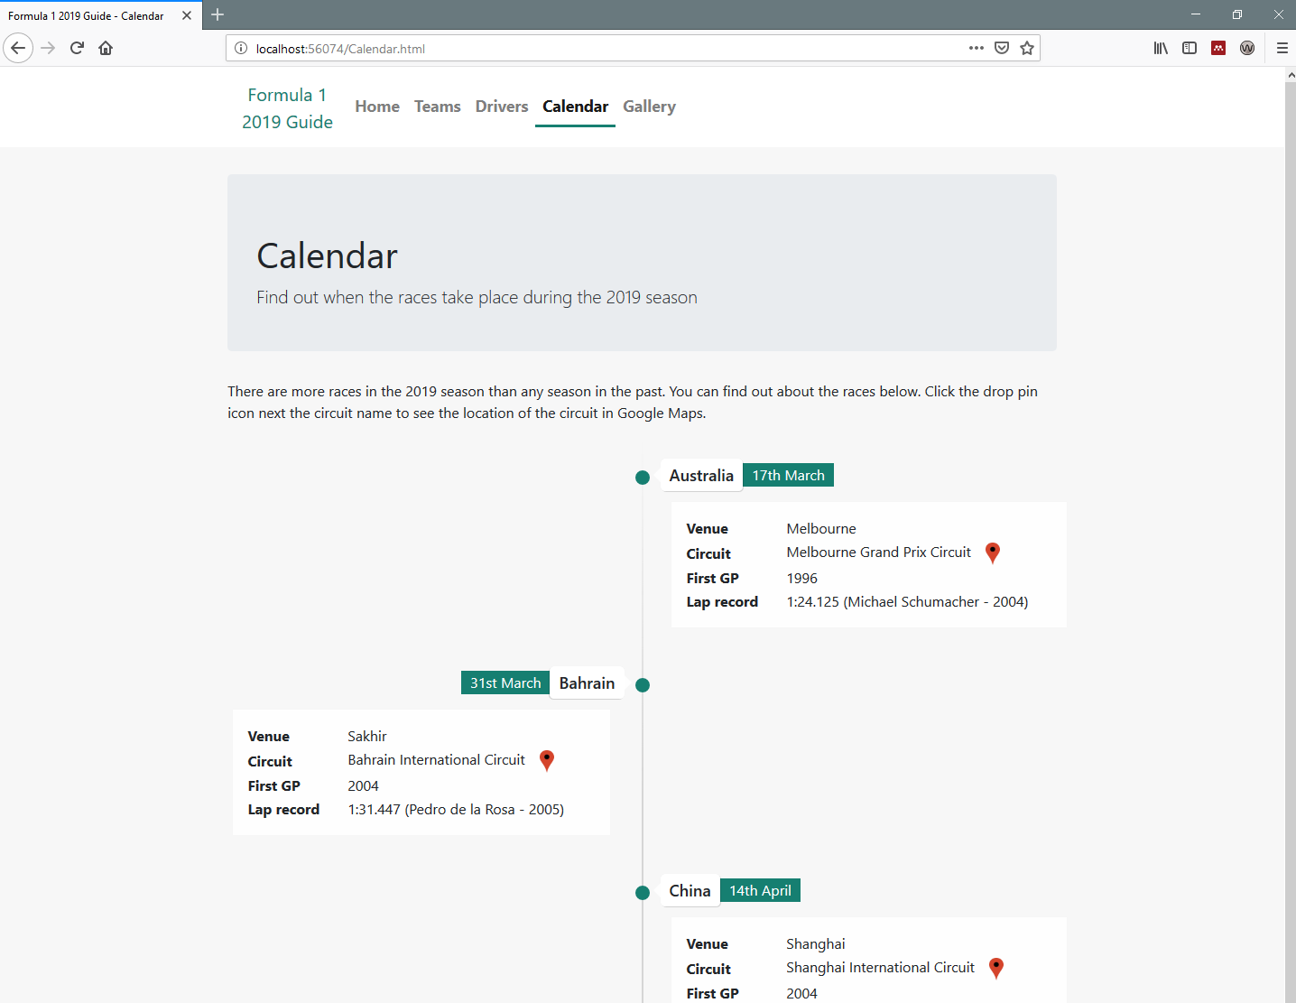
Figure 4: Calendar page screenshot
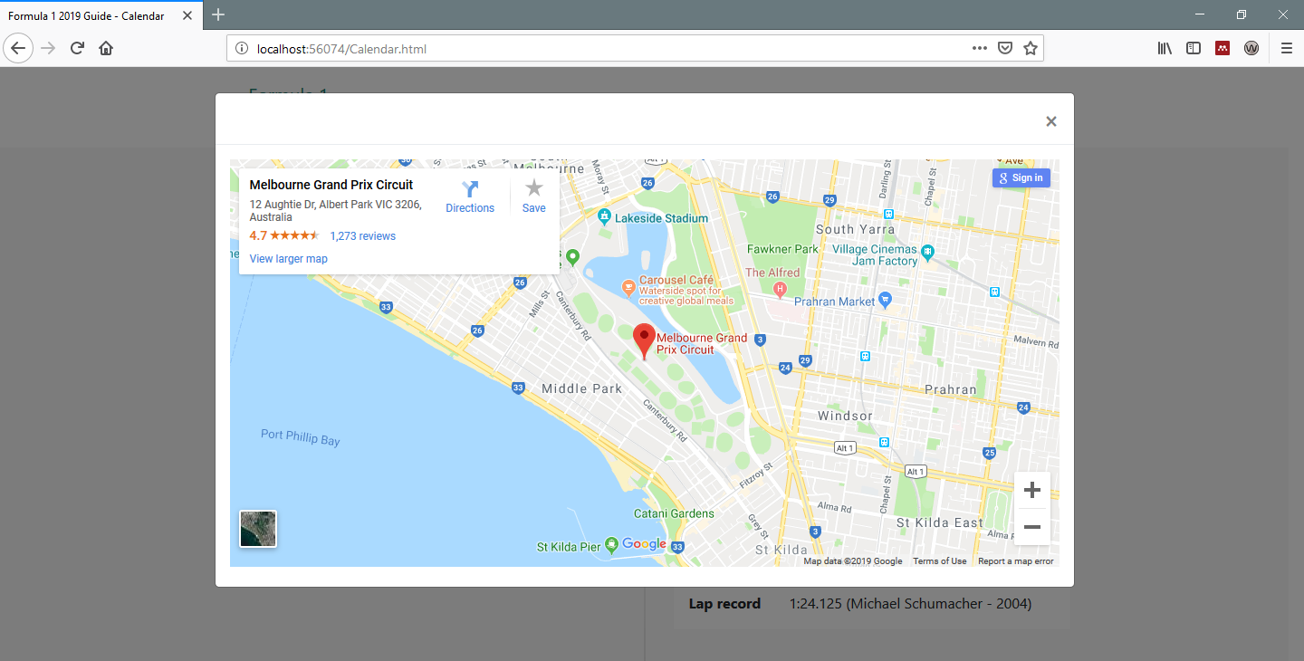
Figure 5: Calendar page location ‘modal’ screenshot

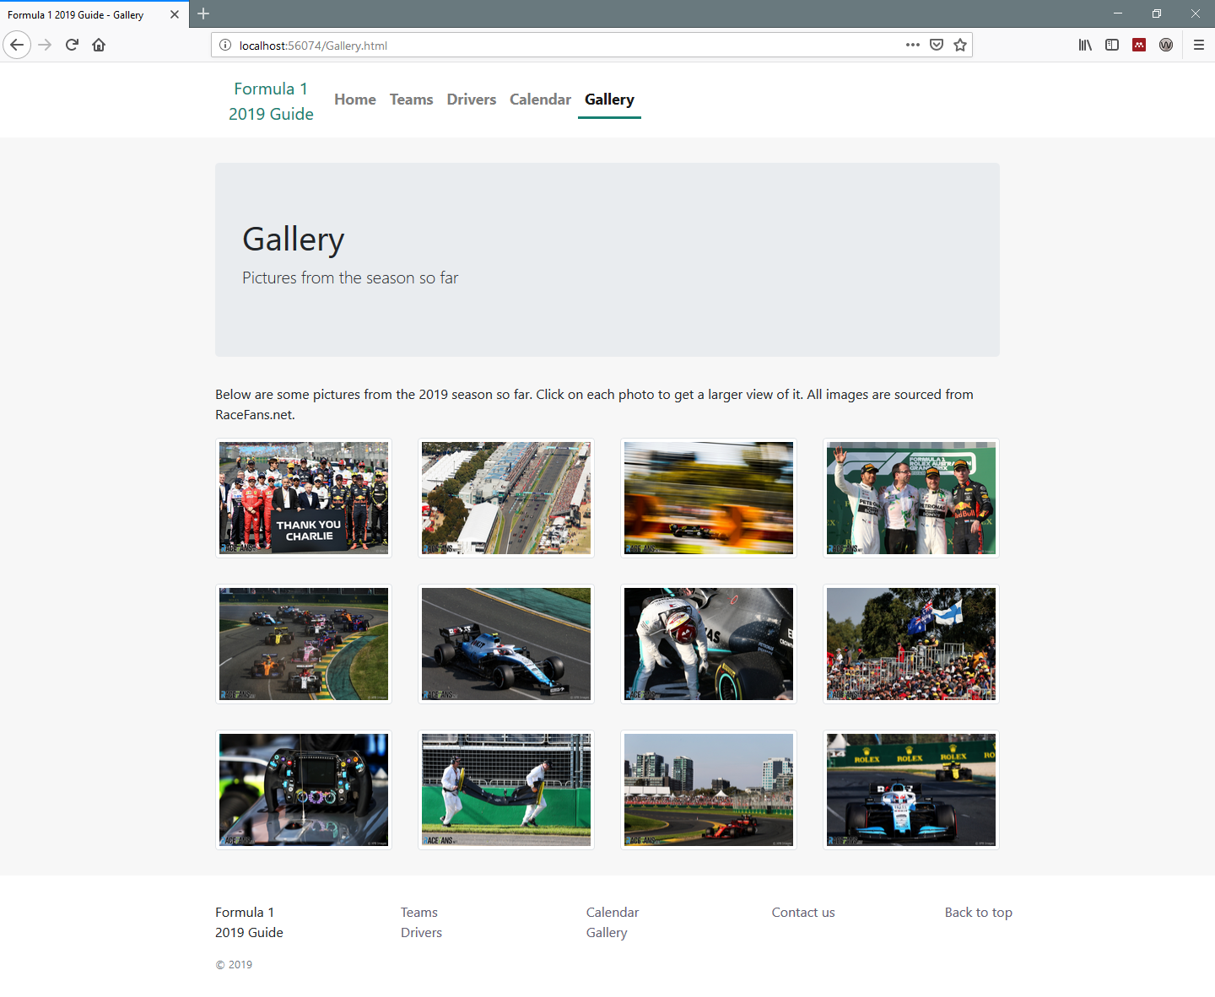
Figure 6: Gallery page screenshot
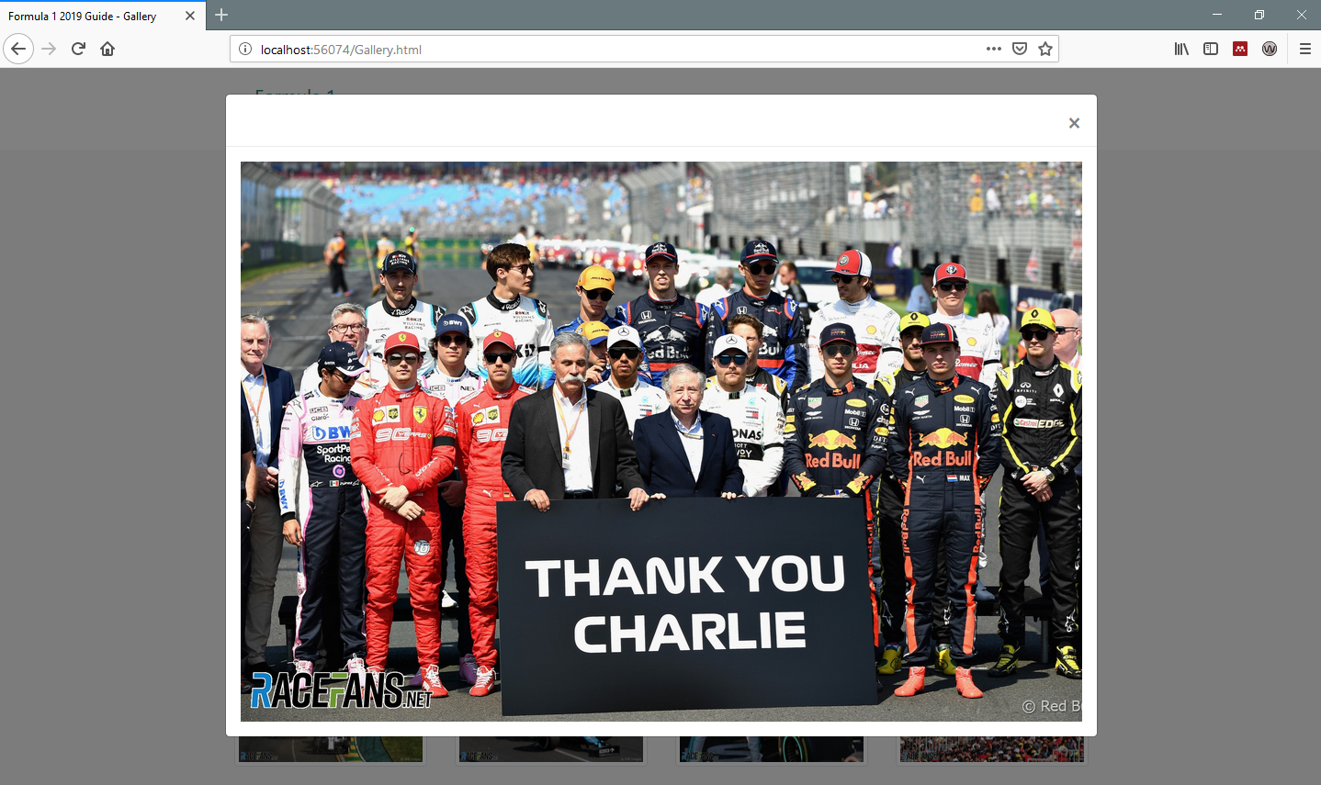
Figure 7: Gallery page ‘modal’ screenshot
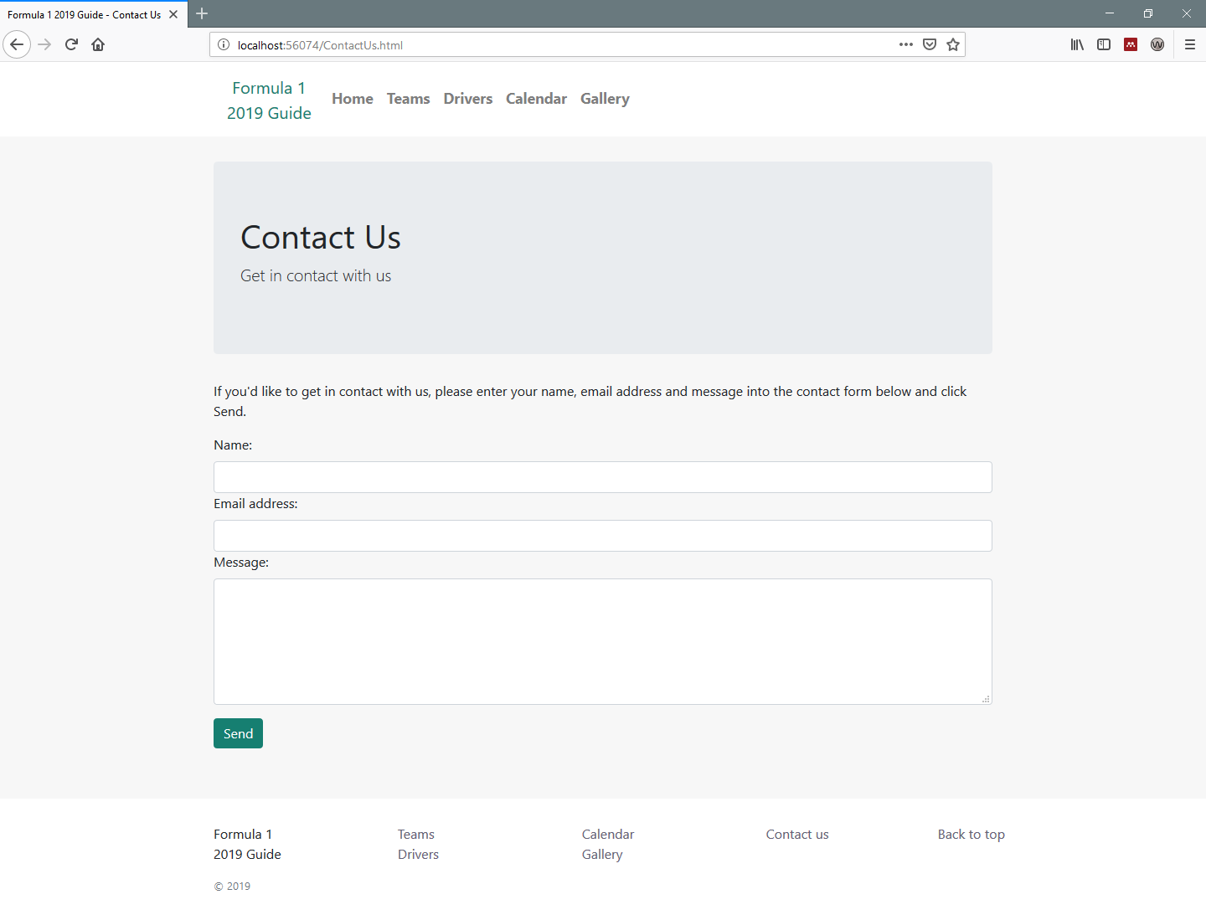
Figure 8: Contact us page screenshot
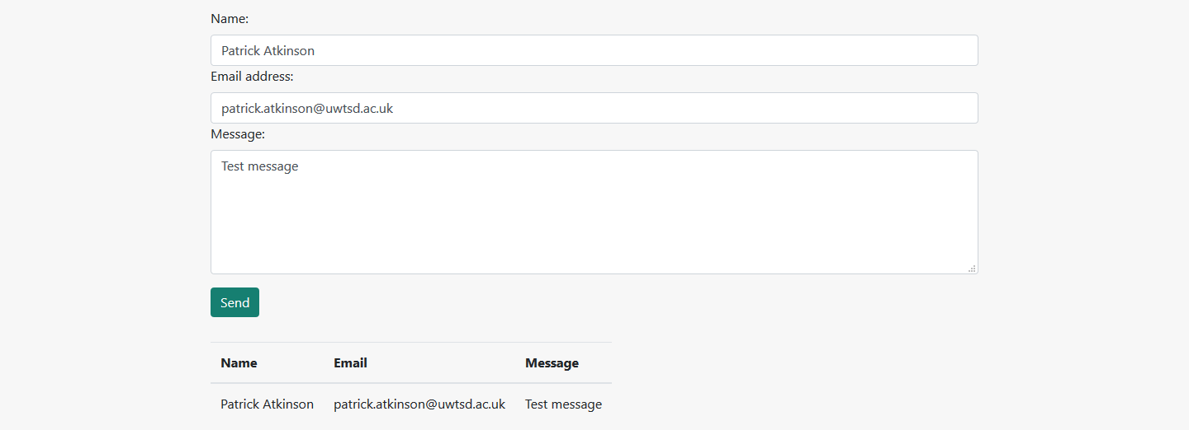
Figure 9: Contact us page table after POST

Validation of code
One stipulation of the brief is that HTML and CSS markup of the website should be validated against the web standards using online validation tools. The two validators to be used are:
- W3C’s Markup Validation Service (http://validator.w3.org) – used for validating the HTML markup; and
- W3C’s CSS Validation Service (http://jigsaw.w3.org/css-validator/) – used for validating the CSS markup.

HTML validation
Figure 10 shows the results of validating the HTML for the homepage.
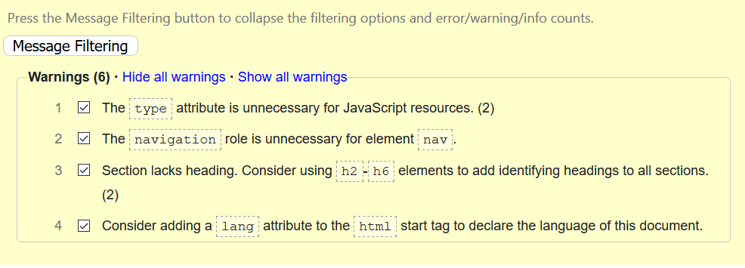
Figure 10: Results of the HTML validation
Warnings 1 and 3 were duplicated. Table 1 shows the steps taken to resolve the warnings. The markup was re-validated after the changes were made and the final check showed no errors or warnings.
Warning number | Resolution
1 | Removed the attribute type="text/javascript" from the <script> tags
2 | Removed the navigation role from the <nav> element
3 | Changed the <section> tags to <div> tags
4 | Added the attribute lang="en-gb" to the <html> tag
Table 1: steps taken to resolve HTML errors

CSS validation
The author’s custom stylesheet was validated using the previously mentioned CSS validator. There were no errors found, although there were thirty warnings, all of which related to vendor-specific prefixes added by the ‘Autoprefixer CSS online’ tool. The author has chosen to leave these prefixes in place to improve cross-browser compatibility. A screenshot of the full list of warnings can be found in Appendix B.

Evaluation
This section gives the author’s evaluation of their website. The evaluation involves analysis of the website’s accessibility, design, usability, content and on-site Search Engine Optimisation.

Accessibility
Below is a brief assessment of the website against the four principles from the WCAG.
Perceivable – text alternatives are provided for elements. Time-based media can be paused. Content can be presented in different ways with no loss of information. Content is easily identified and separated from the background.
Operable – the website can be traversed using a keyboard. Time-based media can be paused. There is no content that is designed in a way known to trigger seizures or physical reactions. The website is designed to be easily navigated. The website can be operated with inputs beyond keyboard.
Understandable – content is readable and understandable. The website presents and operates in a predictable way. Errors in inputs are identified to the user.
Robust – the markup is designed to account for multiple user agents.
The author also conducted accessibility testing on the website using the WAVE Accessibility Extension in Firefox. There were two alerts that were listed for all the pages and one other alert for the Drivers page. The alerts and the action taken for each of them is outlined in Table 2.
Alert | Action taken
Missing first level heading | Apart from the homepage, all pages had a ‘jumbotron’ containing a <h2> tag. These were changed to <h1> tags. A <h1> tag was also added to the homepage.
Redundant link to the homepage | Research into whether a homepage link should be included in site navigation suggests there is no consensus on what best practice is [21][22]. The author has taken the decision to leave the ‘redundant’ homepage link in place.
Skipped heading level | The driver names in the driver cards were using <h5> tags and there were no heading levels between the <h1> tag in the ‘jumbotron’ and the <h5> tags. The <h5> tags were changed to <h2> tags and the styling amended in the custom stylesheet.
Table 2: accessibility alerts and actions taken
The extension also assessed the contrast levels between the foreground and background colours of elements on the pages. Initial assessment indicated that elements using the primary colour of the website as the background colour with white text did not have a sufficiently high contrast ratio. A darker shade of the same colour was used to rectify this issue on all pages.

Design, usability and content
It is the author’s opinion that the website has a consistent design across the pages, largely due to usage of the Bootstrap framework. All pages have the same header and footer, and all pages except the homepage use a ‘jumbotron’ to introduce the page. As previously highlighted, the ‘Card’ component from the Bootstrap framework is used across multiple pages in vertical and horizontal forms. The same colour scheme is used throughout the website and image sizes are kept consistent if multiple images are used in the same type of element (for example, in the gallery). As previously mentioned, the website arranges the content based on screen size. An example of this is the site navigation, which collapses and displays a ‘hamburger’ menu button if the screen is below a certain width. In addition, the use of vendor-specific properties in the stylesheets should ensure compatibility across multiple browsers.
With regards to the HTML and CSS markup, the author has attempted to ensure the code is easy to read and maintain. Child elements, combination selectors and pseudo-class selectors are indented to indicate their relationship to other elements and selectors. There are also annotations throughout the markup to provide a description of the purpose of the markup.
The text content of the page is largely made up of data and is therefore presented in tables. The remainder of the content is image based. Were the website to be further developed, articles could be added to provide more content and variety for the audience.

Search Engine Optimisation (SEO)
The author has put the previously discussed SEO strategies in place where possible. Meta data, including page descriptions and keywords, have been added to each page using the <meta> tag. Each page has a unique title that includes both the website name and the name of the page. The filenames of the pages have meaningful names, resulting in URLs that indicate the content of the page.
The author has created an example sitemap for the website (sitemap.xml in the root of the website folder). The sitemap does not work in its current form as it is using www.example.com as the hostname. This would need to be amended to an appropriate hostname were the website to be hosted. The author has also created a robots.txt file in the same location. It is configured to allow crawlers full access to the website and includes a reference to the sitemap.

Conclusion and future work

Conclusion
The author believes the website to be well-presented, with consistent styling across the pages and the content generally being presented appropriately based on the size of the viewport being used. Analysis of the website’s construction using validation tools to identify accessibility and markup errors suggest it is well constructed, with no errors and few alerts being outputted by the tools. The HTML and CSS markup are annotated to ease future maintenance, and the folder structure and file naming conventions of the website are chosen to be logical and meaningful. On-site SEO strategies have been added across the website to enhance the ability of search engines to index the website and display it in SERPs.

Future work
The majority of the development of the website was carried out using Mozilla Firefox as the test browser. Whilst vendor-specific prefixes were added to the custom stylesheet to provide compatibility across various browsers, more thorough testing would need to be carried out to guarantee that this is the case. Testing was done with a variety of browser window sizes to check the flexibility of the website’s styling. However, this was only done on Windows 10 computers and not mobile devices. Cursory testing of the website using the mobile browser emulator in Firefox indicates there may be some styling elements that require review, such as the ‘Back to top’ link shown in the page footer in Figure 11. Were the website to be hosted, the SEO could be further scrutinised. There are several online tools, such as Sitechecker, that can used to provide more in-depth analysis of a website’s SEO.
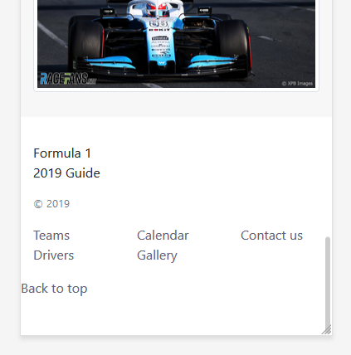
Figure 11: Page footer in mobile browser emulator
As previously mentioned, additional content could also be added to the website to provide greater variety for the intended audience.

Glossary
Acronym | Term
CSS | Cascading Style Sheet
HTML | Hyper-Text Markup Language
REP | Robots Exclusion Protocol
SEO | Search Engine Optimisation
SERP | Search Engine Results Page
W3C | World Wide Web Consortium
WCAG | Web Content Accessibility Guidelines
WHATWG | Web Hypertext Application Technology Working Group

Reference list
[1] “Introduction to HTML,” W3CSchools. [Online]. Available: https://www.w3schools.com/htmL/html_intro.asp. [Accessed: 14-Apr-2019].
[2] P. Bright, “HTML5 specification finalized, squabbling over specs continues | Ars Technica,” Ars Technica, 2014. [Online]. Available: https://arstechnica.com/information-technology/2014/10/html5-specification-finalized-squabbling-over-who-writes-the-specs-continues/. [Accessed: 01-Apr-2019].
[3] “HTML5 is a W3C Recommendation | W3C News,” W3C, 2018. [Online]. Available: https://www.w3.org/blog/news/archives/4167. [Accessed: 01-Apr-2019].
[4] “HTML 4.01 Specification,” 1999. [Online]. Available: https://www.w3.org/TR/html401/. [Accessed: 01-Apr-2019].
[5] R. York, Beginning CSS: Cascading Style Sheets for Web Design, 2nd ed. Wiley Publishing, Inc, 2007.
[6] “CSS Advantages,” CoreLangs.com. [Online]. Available: http://www.corelangs.com/css/basics/advantages.html. [Accessed: 01-Apr-2019].
[7] J. Robbins, Learning Web Design 4th Edition, 4th ed. O’Reilly Media, Inc., 2012.
[8] “All CSS specifications,” W3C. [Online]. Available: https://www.w3.org/Style/CSS/specs#css-2018. [Accessed: 01-Apr-2019].
[9] D. Johansson, “Search Engine Optimization and the Long Tail of Web Search,” 2016.
[10] “Robots.txt File | Learn SEO - Moz,” Moz. [Online]. Available: https://moz.com/learn/seo/robotstxt. [Accessed: 12-Apr-2019].
[11] “Search Engine Optimization (SEO) Starter Guide - Search Console Help,” Google Help Center. [Online]. Available: https://support.google.com/webmasters/answer/7451184?hl=en. [Accessed: 12-Apr-2019].
[12] “Title Tag [2019 SEO] - Moz,” Moz. [Online]. Available: https://moz.com/learn/seo/title-tag. [Accessed: 12-Apr-2019].
[13] “URL Structure | SEO Best Practices - Moz,” Moz. [Online]. Available: https://moz.com/learn/seo/url. [Accessed: 13-Apr-2019].
[14] “sitemaps.org - Home,” sitemaps.org. [Online]. Available: https://www.sitemaps.org/index.html. [Accessed: 13-Apr-2019].
[15] “About /robots.txt,” robotstxt.org, 2007. [Online]. Available: http://www.robotstxt.org/robotstxt.html. [Accessed: 13-Apr-2019].
[16] “Web Content Accessibility Guidelines (WCAG) 2.1,” 2018. [Online]. Available: https://www.w3.org/TR/WCAG21/. [Accessed: 10-Apr-2019].
[17] G. Sims, “What is WCAG 2.1? Let’s understand the history of WCAG first.,” Deque Blog, 2017. [Online]. Available: https://www.deque.com/blog/what-is-wcag-2-1-history/. [Accessed: 10-Apr-2019].
[18] “Introduction to Understanding WCAG 2.0 | Understanding WCAG 2.0,” W3C. [Online]. Available: https://www.w3.org/TR/UNDERSTANDING-WCAG20/intro.html#introduction-fourprincs-head. [Accessed: 10-Apr-2019].
[19] “Cards · Bootstrap.” [Online]. Available: https://getbootstrap.com/docs/4.3/components/card/. [Accessed: 10-Apr-2019].
[20] “Autoprefixer CSS online.” [Online]. Available: https://autoprefixer.github.io/. [Accessed: 10-Apr-2019].
[21] M. Brody, “The UX case against the home button | Webdesigner Depot,” Webdesigner Depot, 2015. [Online]. Available: https://www.webdesignerdepot.com/2015/08/the-ux-case-against-the-home-button/. [Accessed: 13-Apr-2019].
[22] H. Loranger, “Best Practices for Homepage Links on websites,” Nielsen Norman Group, 2017. [Online]. Available: https://www.nngroup.com/articles/homepage-links/. [Accessed: 13-Apr-2019].

Further reading
S. Lee, W. Jang, E. Lee, and S. G. Oh, “Search engine optimization: A case study using the bibliographies of LG Science Land in Korea,” Libr. Hi Tech, vol. 34, no. 2, pp. 197–206, 2016.

Appendices

Appendix A – wireframes of page layout
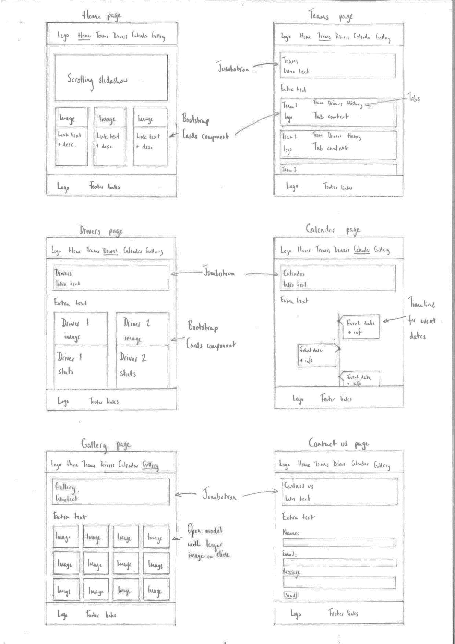

Appendix B – CSS validation warnings
A screenshot of the warnings returned by the CSS validator.


