Student Name: Krystal Gardner  Student ID: 2027750  Module Title: Foreign Languages & cultural Awareness  Module Code : BHIM5003  Lecturer : Heidi Prosser  Date: 30/01/2024 | 
ASSIGNMENT 1: PORTFOLIO
(4 Components)

Component 1: Professional Reflection (500 words +/- 10%)

Weighting: 25%
During dinner service at my hotel restaurant whilst I was training to be a waitress, I faced a cultural misunderstanding with an Indian customer. As I reached the table to take their order, I smiled and started presenting our evening specials. However, as I described the components for each dish, the guest became increasingly bewildered and requested a vegetarian menu. Confused by their reaction, I later heard from a colleague that the guest adhered to a stringent Hindu dietary practice known as "vegetarianism," which forbids the ingestion of meat, fish, and eggs. My lack of knowledge of this cultural standard resulted in a misunderstanding, jeopardising the guest's dinner experience.
My lack of awareness about Hindu eating customs and traditions led to cultural misunderstanding. Vegetarianism is more than just a dietary preference in Hindu culture; it is frequently a firmly held religious or cultural belief. My presumption that the guest would be open to our usual menu options ignored their cultural background and dietary requirements. Furthermore, linguistic difficulties may have increased the misunderstanding by losing nuances in communication during translation.
Developing cross-cultural competency is crucial for successfully navigating varied guest encounters in the hospitality sector, based on my experience. To avoid similar cultural misunderstandings in the future, I identify the following abilities and behavioural adjustments that I need to prioritise.
I must proactively educate myself on the cultural practices and food preferences of guests from various backgrounds, particularly those found in regions typically represented among hotel guests. This includes learning about religious dietary restrictions, traditional cuisines, and dining rituals (Nguyen, N. T., & Bélanger, J. 2018). so that I may meet guests' requirements and preferences in a respectful and suitable manner.
I must develop active listening skills and show empathy to guests by carefully learning their requirements and preferences. Instead of making assumptions based on my own cultural experience, I should approach each conversation with an open mind and a desire to learn from the guest's point of view. By attentively listening to their problems and preferences, I can effectively modify the eating experience to match their needs.
I need to improve my communication abilities, such as language proficiency and expressive clarity, in order to communicate effectively with guests from various cultural and linguistic backgrounds. This could include learning simple words or greetings in languages widely spoken by visitors (Kwantes, C. T., & Kuo, B. C. 2018)., as well as improving my ability to deliver information effectively and politely across language boundaries.
Finally, the experience of dealing with a cultural misunderstanding with an Indian guest emphasises the value of cross-cultural competency in the hospitality sector and how this can ruin a customer’s experience and also could result in them not returning and leaving bad reviews (Gertner, D., & Verma, R. 2019). By emphasising skill development in cultural awareness, active listening, empathy, and communication, I hope to build pleasant guest experiences that honour, and respect varied cultural backgrounds and preferences.
References:
Gertner, D., & Verma, R. (2019). The impact of cultural intelligence on hospitality service performance: The mediating role of empathy. Journal of Hospitality and Tourism Management, 38, 97-106
Kwantes, C. T., & Kuo, B. C. (2018). Cultural intelligence and diversity in the hospitality industry: A review and synthesis. International Journal of Hospitality Management, 73, 77-87.
Nguyen, N. T., & Bélanger, J. (2018). Food service employees' cross-cultural competence: A mixed-methods investigation. International Journal of Hospitality Management, 68, 59-68.

Component 2: Training Plan (500 words +/- 10%)

Weighting: 25%

Identified cultural misunderstanding (in a few words):
A cultural misunderstanding occurred during dinner service with an Indian guest, who demanded a vegetarian menu due to their Hindu dietary practice of vegetarianism. My lack of knowledge of this cultural standard harmed the guest's dining experience, as I was unaware of the Indian dietary norms.
Training plan (Why/What//Who/Where/When):
In the hospitality sector, offering outstanding service entails more than just meeting visitors' fundamental needs; it also includes recognising and respecting their cultural origins and preferences. Recent experiences have highlighted the significance of cultural competence, especially when dealing with dietary differences like vegetarianism (Triandis, H. C. 2018). This training plan seeks to provide all staff members at the Hotel with the information and abilities required to properly handle similar circumstances in the future, ensuring that every client has a positive and accommodating dining experience.

Objectives:
To raise staff awareness and comprehension of various cultural eating patterns, with an emphasis on vegetarianism.
Develop effective communication tactics for detecting and addressing guests' dietary preferences in a respectful manner.
To develop empathy and cultural sensitivity among staff members who serve clients from various ethnic origins.

Training Content:

Cultural understanding and awareness.
An overview of prevalent cultural eating customs from around the world, with an emphasis on differences in preferences and limits.
In-depth look into vegetarianism, including its importance in many cultures and the reasons behind its acceptance.
To improve customers' eating experiences, consider considering their cultural origins and dietary preferences (Hemalatha, M., & Sathish, M. 2019).

Effective Communication Strategies
Training in active listening skills to effectively detect guests' food preferences and requirements.
Role-playing activities that simulate settings in which guests may have unique food requirements, such as vegetarianism, to practise sensitive communication.
Empathy and Cultural Sensitivity
Strategies for clearly and professionally communicating menu alternatives and meeting dietary preferences.
Training sessions focused on establishing empathy for guests from various ethnic origins.
A discussion of cultural characteristics and their consequences for understanding visitors' requirements and preferences.
Case studies and group activities focus on real-life examples of cultural misunderstandings and the need of cultural sensitivity in addressing them.

Menu Knowledge and Adaptability
Comprehensive menu training in the hotel restaurant, including vegetarian options and alternatives for customers with dietary needs.
Collaboration with the culinary team to ensure menu items are clearly labelled and customisable to meet different dietary needs.
Regular updates and briefings on menu changes or seasonal specials to keep personnel aware and ready to answer visitors' dietary questions.

Implementation:
Conduct interactive training sessions for all staff members, including waiters, hosts, chefs, and kitchen workers, to ensure that all training information is covered.
Provide instructional materials and resources, such as handbooks and online modules, for on-going learning and reference.
Monitor staff performance and visitor input to determine the training program's efficacy and areas for improvement.
We can improve service quality and provide memorable dining experiences for all visitors by providing our employees with the knowledge, skills, and attitudes required to understand and accommodate varied ethnic dietary requirements (De Backer, C. J. S., Hudders, L., & Poels, K. 2015). Renewing our commitment to providing inclusive and exceptional hospitality via continuous learning and cultural competency.

References:
De Backer, C. J. S., Hudders, L., & Poels, K. (2015). Exploring the link between religious and cultural beliefs, self-brand connections, and brand evaluations among Muslim consumers. Journal of Business Research, 68(2), 224-232.
Hemalatha, M., & Sathish, M. (2019). Sustainable food practices: Exploring the role of vegetarianism in global warming. International Journal of Management, 10(6), 26-32.
Triandis, H. C. (2018). Culture and social behaviour. Routledge.

Component 3: Student Self-Reflection (500 words +/- 10%)

Weighting: 25%
As a waitress in a hotel restaurant, I encountered a cultural misunderstanding with an Indian guest. This highlights the necessity of cultural knowledge in the hospitality sector. I will use Gibbs' Reflective Cycle for self-reflection to critically analyse my understanding of cultural awareness, how it has grown over time, and the lessons learnt from this experience.
Concrete Experience:
During dinner service, I approached a table to take an order from an Indian visitor. Despite my kind approach, the guest seemed perplexed as I presented our specials, eventually demanding a vegetarian menu. This uneasiness stemmed from my lack of awareness of Hindu culinary customs, which jeopardised the guest's dining experience.

Description:
I enthusiastically greeted the guest as I do with every customer introduced myself said I would be their server for the evening and introduced our specials as many people ask about specials, I was uninformed of their dietary preferences. As I mentioned the components in the specials, the guest appeared confused and requested a vegetarian menu, which surprised me.
Feelings:
Initially, I felt humiliated that I was unaware and made an uneducated assumption. I was also angered by the misunderstanding. I also wondered why the guest hadn't communicated their dietary preferences earlier, but on reflection, I realised it was my responsibility as a waitress to anticipate and accommodate such needs proactively, and working in the hospitality industry requires making customers to feel welcome and wanting to return, resulting in loyal customers which is also good for branding standards as some people come in not just for food as they are guest with the hotel but as they hear word of mouth about the food and service.

Evaluation:
This experience emphasised the significance of cultural knowledge and originality in the hospitality industry and also made me think I need to re-evaluate my way of thinking. Additionally, it's important to inquire about dietary restrictions to avoid assumptions that can lead to unhappy guest (Hofstede, G. 2001). I recognised that my ignorance of not knowing the requirements of Hindu food norms harmed the guest's eating experience and reflected negatively on the restaurant and also myself which was upsetting as I would want every guest to feel satisfied with their experience.
Analysis:
My understanding of the issue has greatly improved over time. Initially, cultural awareness appeared to be an abstract term, but real-life encounters like this one helped me realise its practical importance in assuring guest contentment and sustaining the establishment's reputation.

Conclusion:
This experience emphasised the need of learning about diverse cultural traditions, including eating preferences. It's more than just avoiding mistakes it's also about creating welcoming surroundings in which all guests feel welcomed and respected and wanting to return (De Backer, C. J. S., Hudders, L., & Poels, K. 2015).

Action Plan:
I aim to increase cultural understanding by learning about traditions (Hemalatha, M., & Sathish, M. 2019). relevant to our guests. I will attend training events, read literature, and seek advice from colleagues if unsure to make sure that I am better prepared to manage similar situations in the future if they ever do occur.

References:
De Backer, C. J. S., Hudders, L., & Poels, K. (2015). Exploring the link between religious and cultural beliefs, self-brand connections, and brand evaluations among Muslim consumers. Journal of Business Research, 68(2), 224-232.
Hemalatha, M., & Sathish, M. (2019). Sustainable food practices: Exploring the role of vegetarianism in global warming. International Journal of Management, 10(6), 26-32
Hofstede, G. (2001). Culture's consequences: Comparing values, behaviours, institutions, and organizations across nations. Sage.

Component 4: Training Presentation (6 Slides)

Weighting: 25%
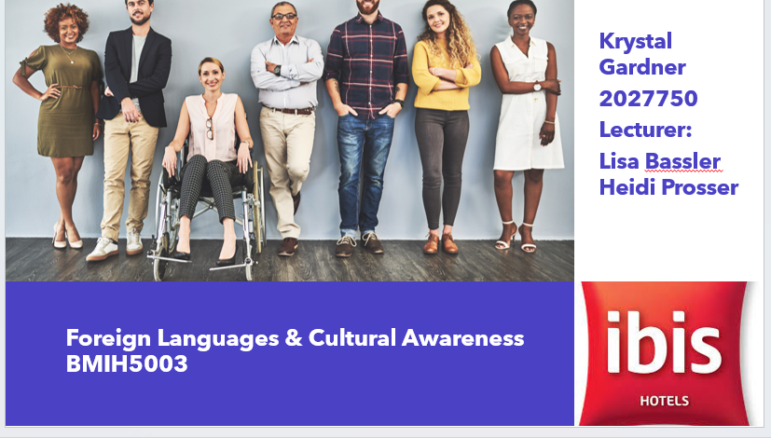
[Content Slide 1] 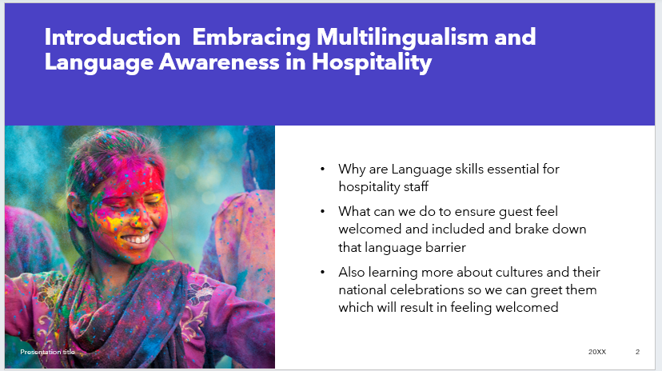

[Content Slide 2]
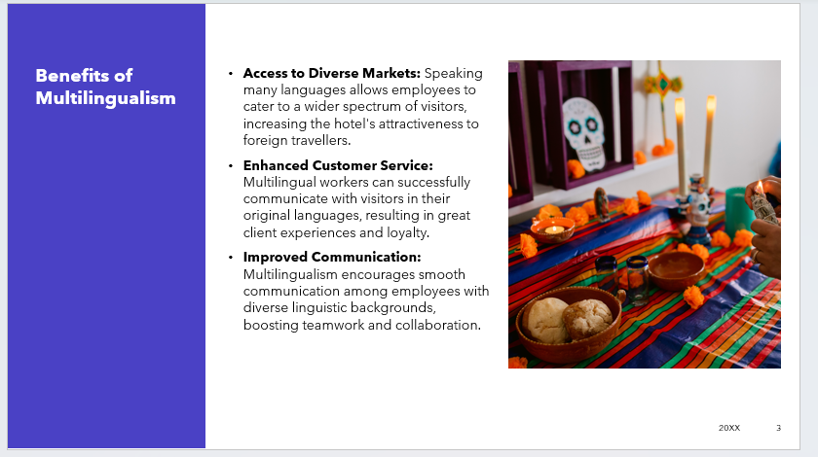

[Content Slide 3]
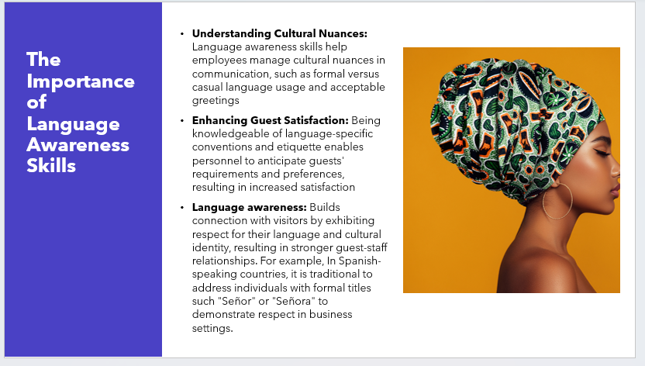

[Content Slide 4] 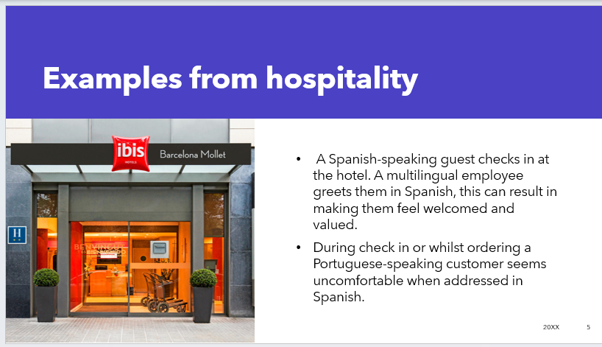

[Content Slide 5]
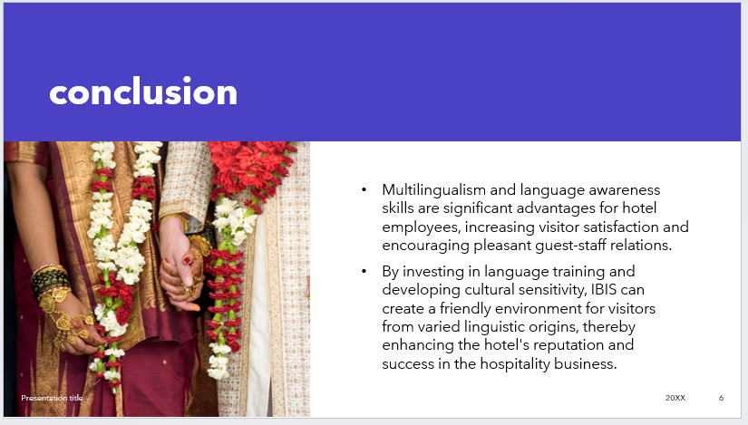
References (no screenshots):
Acorr (2019). Hotel Barcelona: Ibis Hotels for a Weekend Break or Business Trip in Barcelona. [online] ibis.accor.com. Available at: https://ibis.accor.com/gb/city/hotels-barcelona-v0299.shtml [Accessed 14 Jan. 2024].
Ferreira, A., & Fernández, F. M. (2019). Multilingualism in the Hospitality Industry: Challenges and Opportunities. Multilingual Matters.
García, O. (2009). Bilingual Education in the 21st Century: A Global Perspective. John Wiley & Sons.
Gómez-Rodríguez, A. M. (2014). Spanish Language and Sociocultural Identity in the United States. Springer.
IBIS Consulting Group (2024). Cultivating the Mindset for Cultural ‘Competency’. [online] IBIS Consulting Group. Available at: https://www.ibisconsultinggroup.com/insight/cultivating-mindset-cultural-competency/ [Accessed 18 Jan. 2024].
Lewis, M. P., Simons, G. F., & Fennig, C. D. (Eds.). (2016). Ethnologue: Languages of the World. SIL International.
Media, J.D. (2019). 60% of Hospitality Workers Are Non-Native Speakers and Can Misunderstand Common Business English Words. [online] Eat. Drink. Sleep. Available at: https://eat-drink-sleep.com/2019/06/14/60-of-hospitality-workers-misunderstand-common-business-english-words/ [Accessed 16 Jan. 2024].
Pym, A., & Grin, F. (2017). The Economics of the Multilingual Workplace. Routledge
Wikipedia Contributors (2023). Ibis (hotel). [online] Wikipedia. Available at: https://en.wikipedia.org/wiki/Ibis_%28hotel%29 [Accessed 14 Jan. 2024].

