ACCA7031 DIGITAL FORENSICS ANALYSIS
Research, Analysis and Forensic Investigation Report

TASK 1 – RESEARCH REPORT

Task 1: Digital Forensics – A Research Report

1.1 Current State of the Field: Tools, Features and Capabilities
Digital forensics has grown to be an inseparable professional field that cuts across the board of law enforcement, corporate security, regulatory compliance and civil litigation. Mobile device forensics, computer forensics, network forensics, cloud forensics, memory forensics, and IoT forensics are some of the subjects covered by the field today. The sub-disciplines are each covered by tool sets, which have increased in level of sophistication and automation over the last few years [1].
Best practice is characterized by industry leading platforms. Cellebrite UFED (Universal Forensic Extraction Device) can perform physical and logical and file-system extractions on the thousands of Android, iOS and legacy device profiles, with advanced unlocking features on the modern handsets. An open-source platform, Cellebrite 4.x is based on The Sleuth Kit and includes keyword search, hash-set search, time-line search, and an interface to add and remove modules, but also costs very little allowing it to be used by many environments with limited resources. Exterro provides FTK (Forensic Toolkit) that offers enterprise-scale processing of the distributed data and reports it to courts, and Magnet AXIOM is only focused on recovering artefacts via the on-device storage as well as all other cloud accounts such as Google Drive, iCloud, and social media accounts. Cryptographic hash verification (MD5, SHA-1, SHA-256) is a logical background integrity tool used on all leading platforms to ensure that the forensic copies are provably evident of their tampering.Digital Forensics and Cybersecurity.1.2 Intersecting fields Digital Forensics and Cybersecurity [1].

1.2 Intersection of Digital Forensics and Cybersecurity
Cybersecurity and digital forensics are two highly interdependent disciplines, which, together, constitute the DFIR (Digital Forensics and Incident Response) field. The output of the functions of cybersecurity will be created telemetry in the form of SIEM alerts, firewall logs, endpoint events of detention, which will be analyzed by forensic professionals to recreate attack in chronological order and identify threat actors. On the other hand, the forensic evidence is positioned at the outlet of threat intelligence programmes and remediation decisions on vulnerabilities [2]. The forensic artefacts obtained on mobile devices and removable storage may be used to supplement telemetry by security systems in a corporate spy or insider-threat analysis to create a chain of evidence that is beyond a challenge by law enforcement. Digital forensic capability, as defined by the UK National Cyber Security Centre (NCSC), is specifically a subset of national cyber resilience, and, through the Certification of practitioners in this area, CREST explicitly indicates its role at this sectanology. Such interdependence implies that a practitioner who has only been trained in one of the fields and is thus not well aware of the other would be professionally incomplete by modern standards.1.3 Developing Unfortunately, the Digital Forensics is emerging and the trends are being changed quite rapidly [2].

1.3 Emerging Trends in Digital Forensics
The discipline has a number of transformative trends that are changing it. The most critical structural problem to consider cloud and IoT forensics is that more and more evidence is stored in remote servers under a different legal system and must be assisted by mutual legal assistance treaties (MLATs) to be obtained lawfully [3]. AI finds real uses as offensive tools now (including deepfakes and AI-driven malware), but also as a defense (e.g., anomaly detection by AI) and to aid in document verification (e.g., triage by AI). Prioritisation tools can be used to assist the investigators in handling large volumes of evidence by first presenting probable artefacts to the investigator, which can be done by machine-learning-based prioritisation tools. Live forensics and recollection acquisition has become more important due to the end-to-end encrypted messaging system since it will no longer be possible to use only at-rest data and perform the investigation. Blockchain analytics has become a unique forensic solution to help with dark web and cryptocurrency investigations. Lastly, it is becoming faster with the operationalisation of artificial intelligence in forensic tools (pre-screening image or video material through automated classifiers based on CSAM or ITAR-controllable documents) but this has led to admissibility concerns still under consideration by courts [4].

1.4 Key Challenges
There are a number of ingrained problems in the field. By default encrypted disk access in Android (file based encryption since Android 9.0) and iOS imposes a very poor extraction rate on values in a locked modern handset, becoming an aspect of ongoing going dark problem that continues to be debated by law enforcement agencies across the globe with the handset makers. Data size and data rates are operationally challenging; all the applications in a modern smartphone have hundreds of gigabytes in them, which cause backlog in processing forensic data [5]. The complexity of cross-border investigations involving the use of multi-national law and jurisdiction makes it challenging, especially in cases where cloud evidence transcends cross-border. There are also skills shortages: the specialism of digital forensics is one of the most challenging cybersecurity areas to staff all over the world. There has never been much standardisation, ideal evidence handling principles are available in ISO/IEC 27037, but no single forensic process standard exists, and admissibility issues in court cases are common. Lack of standardised certification routes - in comparison to, as an example, clinical forensic medicine - implies that often courts have to be satisfied with expert testimony to elucidate the capabilities and constraints of the tool.1.5 National and International Labor market [5].

1.5 National and International Job Market
There is high demand of digital forensics experts as opposed to supply in all the key economies. The positions are advertised in the United Kingdom within government agencies (GCHQ, National Crime Agency, Metropolitan Police Cyber Crime Unit), major banks and financial institutions, as well as specialty consultancies, such as Kroll, Control Risks, and PwC Forensic Services. According to the UK Government Cyber Security survey of salary, the median remuneration package of qualified DFIR analysts is sufficed at 45,000-75,000, but when it comes to senior consultants and expert witnesses in court, the payment is considerably higher [6]. The United States Bureau of Labor Statistics is expecting a 35 percent in information security jobs over the next five years (2021-2031), with digital forensics representing a significant portion of these jobs. Officially cybersecurity as a national strategy in India (cert-in mandate), Singapore (Smart Nation initiative) and Saudi Arabia (Vision 2030) is expanding rapidly in their Asia-Pacific and Middle East markets. Professional qualifications CFCE, EnCE, CCFE and CCE are all in demand among employers. This blend of increased amount of cybercrime, increased regulatory actions (enforcements), and augmented corporate litigation favors ensures a frothier labour market on the skilled digital forensics practitioners in the foreseeable future [6].
TASK 2 – DIGITAL FORENSIC INVESTIGATION REPORT
Part A: Digital Forensic Acquisition Cellebrite UFED Demonstration
1.Overview
For this part, I walked through the UFED acquisition process step by step using my own Phone Samsung Galaxy A35 5G . The main goal was to prove that I know the practical functionality of the tool, from connecting the device and detecting it, to extracting the data and generating a hash value.This was mostly to get some practice in before we work on the real case data in Part B. All data recovered here is from my personal phone and is not connected in any way to the Quantum Tech investigation.
The software I used is Cellebrite UFED (version 7.76.0.24), with an educational licence. UFED is a common tool used in digital forensics, especially by law enforcement, and is generally accepted as a dependable tool for investigations.It supports extraction of different types, such as physical, file system, logical and backup, for both Android and iOS devices. Another nice feature is that it automatically creates a SHA-256 hash during extraction. This confirms that the data has not been altered. After the extraction the data can be analysed further in Physical Analyser.
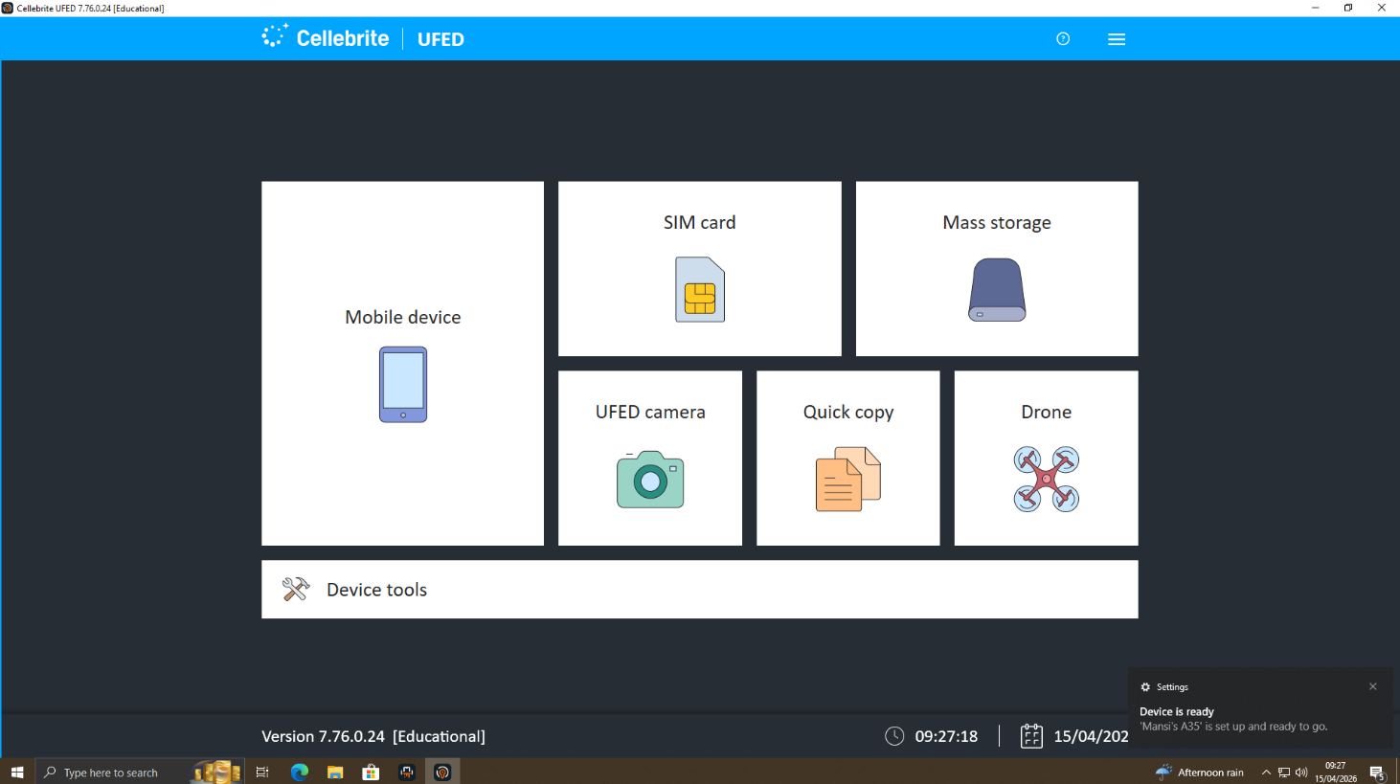
Figure 1: Cellebrite UFED Main Screen
2.Device Detection
The phone was already in USB mode so I connected the Samsung Galaxy A35 5G to the UFED workstation through the Device Adapter with Cable No 170. On the main screen I selected Mobile Device and clicked Auto Detect. UFED quickly identified it as a Samsung GSM SM-A356E_DS.
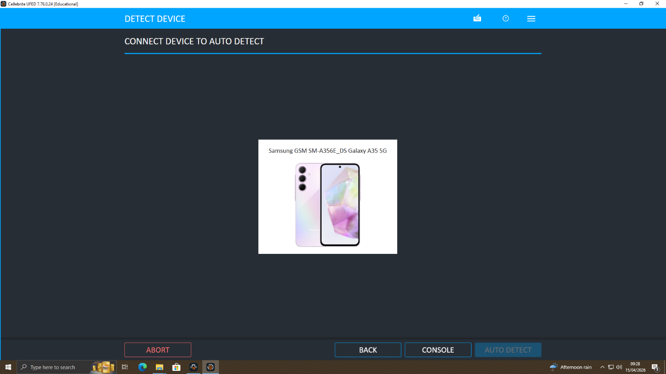
Figure 2: Auto Mobile Detection Own Phone(Samsung Galaxy A35 5G)

As Describe in Figure 2 Samsung Galaxy A35 5G The properties screen confirmed it all Details Like Model SM-A356E Android version 16 Chipset erd8835 IMEI1 350115575238003 IMEI2 350470405238008 Storage 74 GB used out of 128 GB Apps 66 Root Status Not Rooted
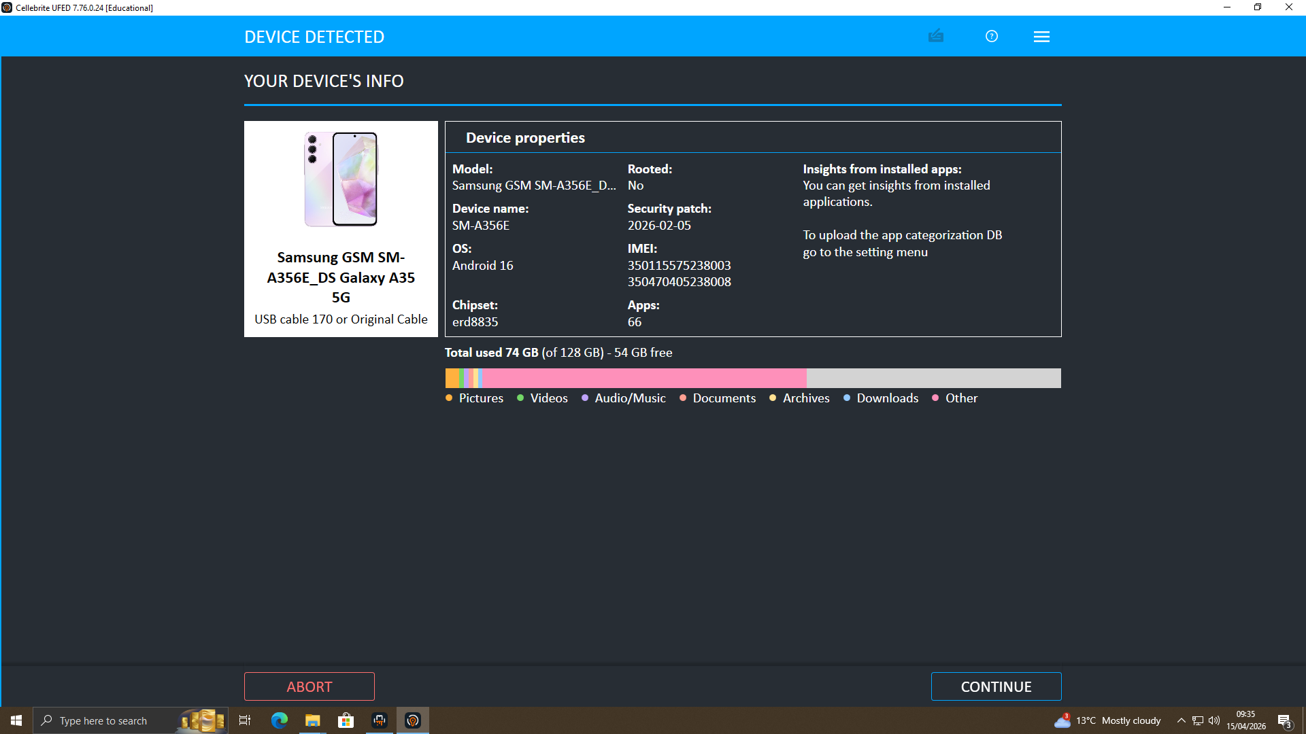
Figure 2: Auto Detection Samsung Galaxy A35 5G
3. Extraction Result
The device was subjected to file system extraction, and the results showed a large amount of data was successfully extracted from the device. The results were 7 saved contacts, 537 SMS, 79 MMS, 9739 images, 362 video files, 248 documents, 2,000 call records, and 10 archived items and of 14745 files.
UFED automatically generated a SHA-256 hash value when the extraction process was completed. Such value is a unique identifier of the extracted data at the time it was created. In the analysis phase, the hash can be re-generated and compared against the original hash. If both values match, it confirms that the data has not changed.
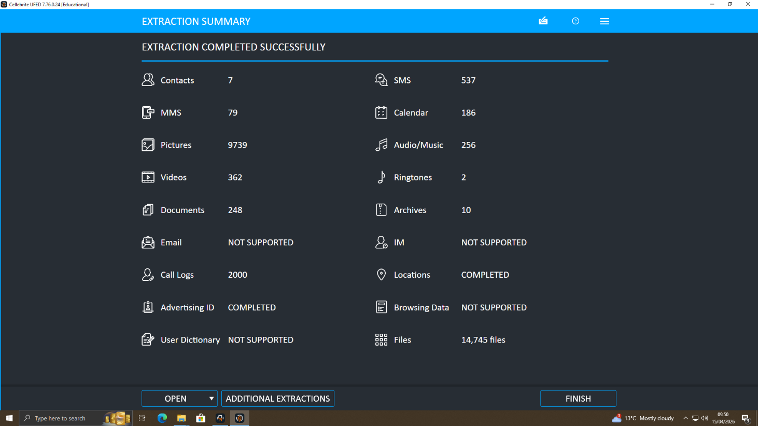
Figure 3. Extraction Summary
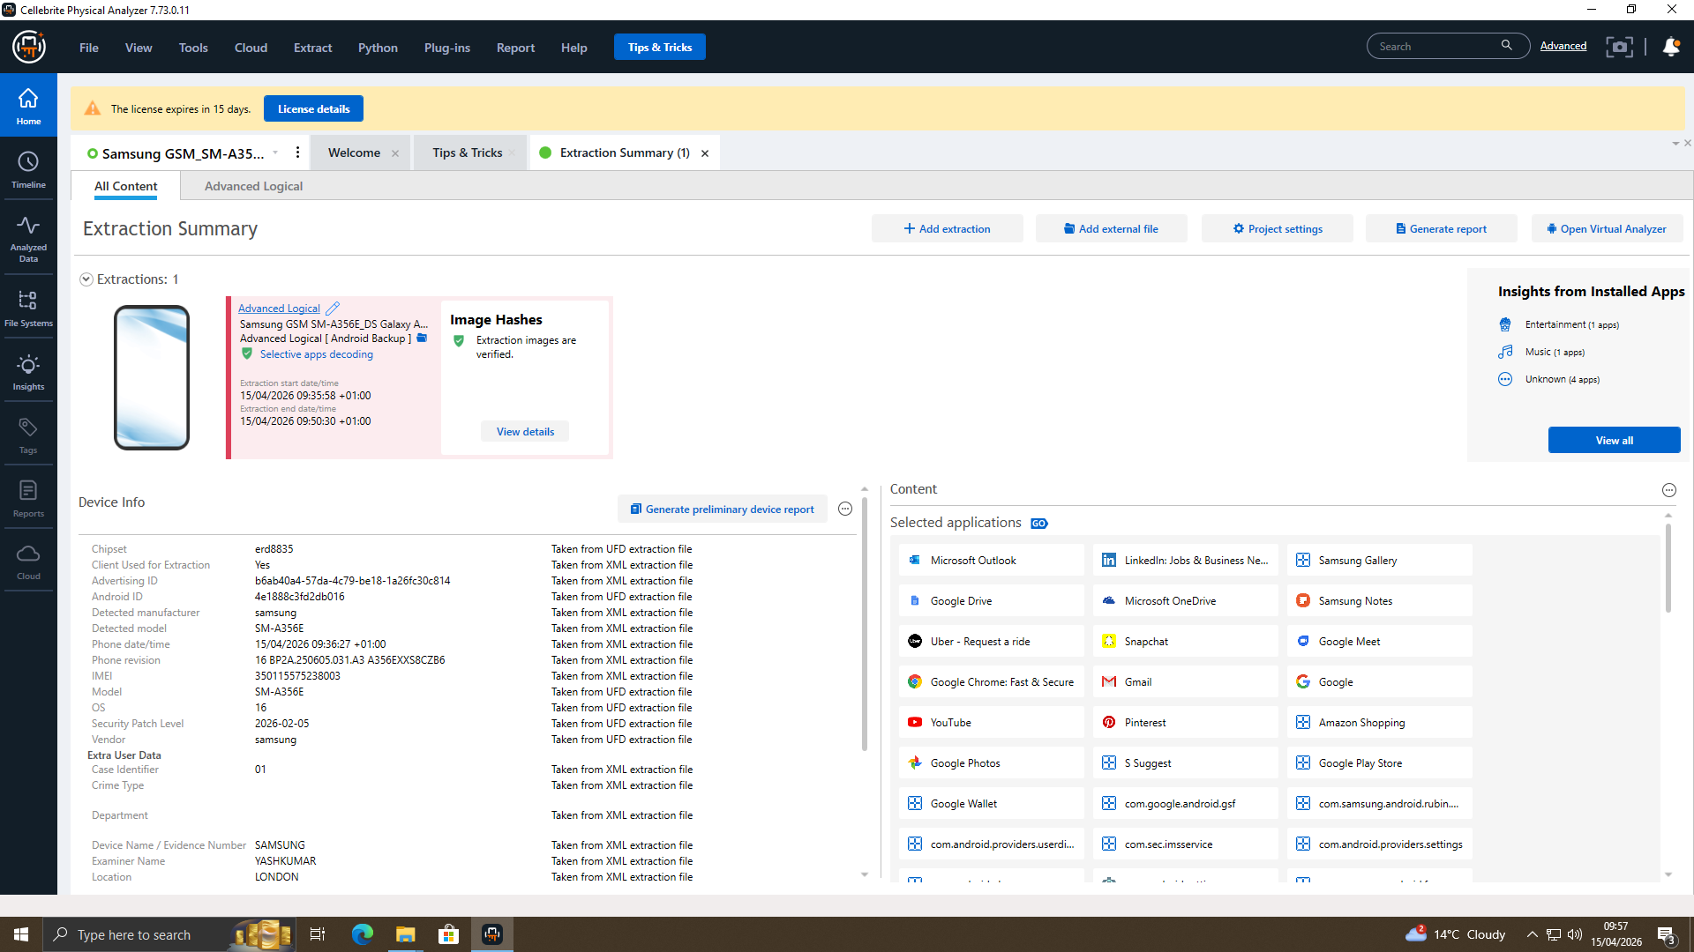
Figure 4. Extracting Phone In Cellebrite Physical Analyzer

Task 2: Forensic Investigation Report – Operation QuantumTech

2.1 Case Background
Quantum Tech Ltd, which is an AI hardware development technology company, has noticed that it has been accessed by an unauthorised third-party in its proprietary patent database. The at-stake asset was an AI chip design patent titled QT-AI-2025, which symbolized a big business and intellectual worth. The internal IT security team at Quantum Tech discovered the intrusion, locked down corresponding digital devices under the formal proofs under continuity of evidence and passed the case to the police with request of forensic investigation [7].
Emma, who is a new senior engineer, with valid access credentials to the patent database is the main suspect. Quantum Tech external intelligence gave an indication that Emma was involved in a plot with an external middleman, Joe, to steal the patent and hand it over to NexGen Circuits, which was a direct competitor. The receiving party and the suspected buyer is Norman who is an employee of NexGen Circuits. This investigation aims to retrieve digital evidence on the devices confiscated that may prove the identity and purpose of each suspect that can be criminally prosecuted under laws of corporate espionage, computer misuse, and fraud Inventory and Chain of Custody of Evidence [7].

2.2 Evidence Inventory and Chain of Custody
Four online displays were received with sealed documentation of continuity-of-evidence. Photography Each equipment was photographed at the location of seizure, put in anti-static Faraday-shielded evidence bags, to prevent remote-wipe attempts, named with a distinctive exhibit reference, and directly taken to the forensic lab. The chain-of-custody log documents the name of each officer that managed each exhibit, date and time each transfer occurred and secure storage location at each step. Upon reception, hash values (MD5 and SHA-256) were calculated to set a cryptographic integrity level.
Exhibit | Device | Attributed To
EX-01 | Nokia C2 2nd Edition (Android) | Norman
EX-02 | Huawei POT-LX1 P Smart 2019 | Emma
EX-03 | Android Samsung SM-A137F Galaxy A13 | Joe
EX-04 | Ulefone Note 14

The integrity of every forensic image was established at the end of processing: re-calculation of the hash values were the same as the baseline hashes taken at the acquisition, and no further changes were made to the images in the course of examination. All analysis work was conducted on documented forensic copies only; they were imaged and original equipment resealed and put into secure evidence storage [8].

2.3 Methodology
Acquisition
The Physical Analyzer was used to process the device EX-01 (Nokia C2 2nd Edition) resulting in a complete logical filesystem packaged as a container file. It was imported into Cellebrite 7 as logical evidence (LogicalFileSet_162 Host) and the container would appear as LogicalFileSet2 in the Nokia device node in the case tree. Ingestion by Cellebrite verified that both Android/data partition (where the application databases are found) and the sdcard (external storage) partitions had been successfully parsing. The artefacts of WhatsApp, media files, and document stores were then identified by systematically browsing through the evidence directory tree [8].
FTK imager was used to forensically image devices EX-02, EX-03 and EX-04, producing E01 container files, which include hash verification logs of MD5 and SHA-256. This was done using write-blocker hardware to avoid source media corruption in accordance with the principles of the ACPO Good Practice Guide to Digital Evidence and ISO/IEC 27037 guidelines. Any images obtained were left on encrypted forensic workstation drives awaiting analysis.2.3.2 Analysis Tools and techniques [9].
Analysis Tools and Techniques
The major platform of analysis was Cellebrite Physical Analyser 7. Majority of modules were turned on: a keyword search (including terms such as QT-AI-2025, patent, NexGen, Vanessa, transfer, payment), file type detection, hash comparison with NSRL and known-illegal sets of hash, EXIF metadata, communications artefact extraction (WhatsApp, call logs, email), and timeline. Metadata of the files such as MAC timestamps (Modified, Accessed, Changed) and EXIF information such as images were studied to give a time context to all artefacts of interest. Databases who were recovered were listed and marked to be decrypted by other legal authority.
Hash Checking and Integrity of Evidence Protocol
After all four exhibits were received, all of the devices were photographed under controlled lighting conditions, and no handling was performed. The labels on the exhibit were attached in a way that they did not cover any of the visible physical characteristics of the devices and the condition of each handset such as screen condition, electricity status and any apparent damage was duly documented in the evidence log. Every device was then attached to a forensic workstation and the connection was solely via hardware write-blockers so that no write operations could be sent to the source media anywhere during the acquisition process [9]. After acquisition, both MD5 and SHA-256 hash values were calculated against the acquired forensic images, inbuilt verification functions of Cellebrite and FTK Imager. These hash values were noted in the case management log and in a different secure place with these forensic images themselves. Finally, at the end of all analysis processes, the hash values were recomputed and compared to the baseline values. The presence of an exact copy of all four exhibits served to affirm that none of the forensic copies had been altered both intentionally and unintentionally throughout the investigation process. Such dual-hash verification method is more than the minimum required by ISO/IEC 27037 and meets the requirements of evidential integrity that are exercised in criminal cases in England and Wales, under the Police and Criminal Evidence Act 1984 (PACE) [10].

2.4 Findings
2.4.1 Cellebrite Analysis
Communication Devices –
EX-03 (smart phone of Joe) and EX-01 (smart phone of Norman) were being analyzed but wait until the complete database is decrypted. Initial file system analysis of both devices confirmed the existence of WhatsApp applications and Slack database files, call records, and email application files. By cross-referencing contact lists and calling logs in EX-01, EX-03, and EX-04, investigators will be able to visualize the communication network involving Emma, Joe and Norman. In particular, the analysis should distinguish: common contact numbers on all three devices; events of calls that coincide with key dates in the patent access timeline; and shared email addresses that might tie the NexGen circuits account of Norman and the account of Quantum Tech of Emma [13].
WhatsApp chat – Emma and Joe
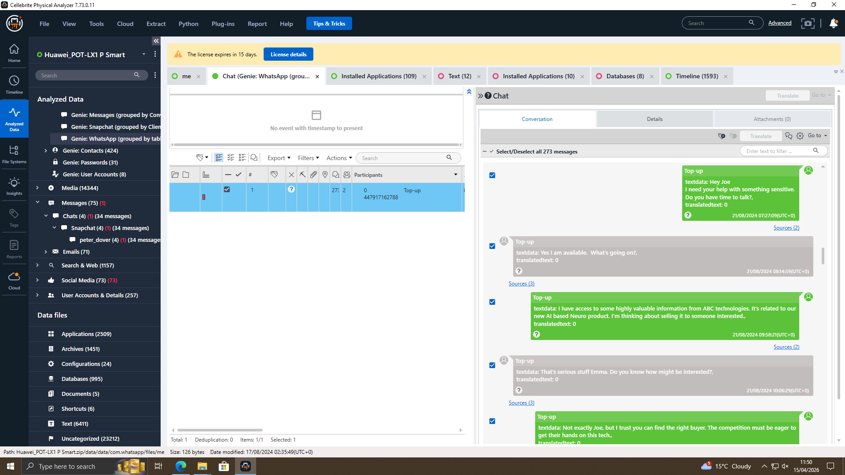
Figure 1: Emma approaches Joe on 21 August 2024
Figure 1 shows the clear chat between the emma and joe for the Information of the abc technologies and selling of the information.
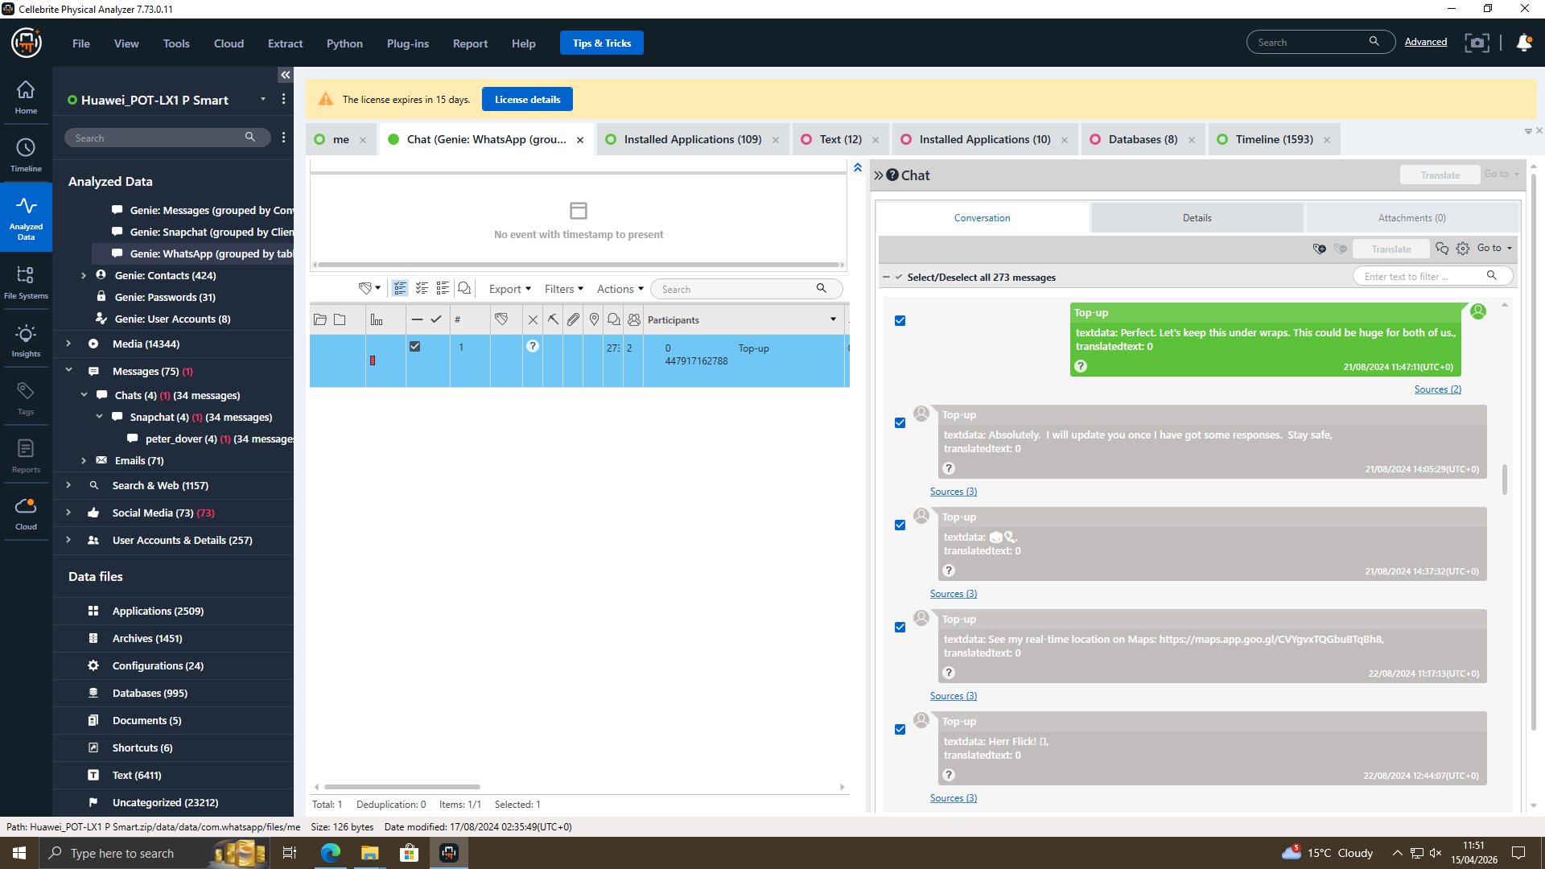
Figure 2: Chat between Emma and joe
Figure 2 shows that Joe is trying to find someone interested in buying the information.
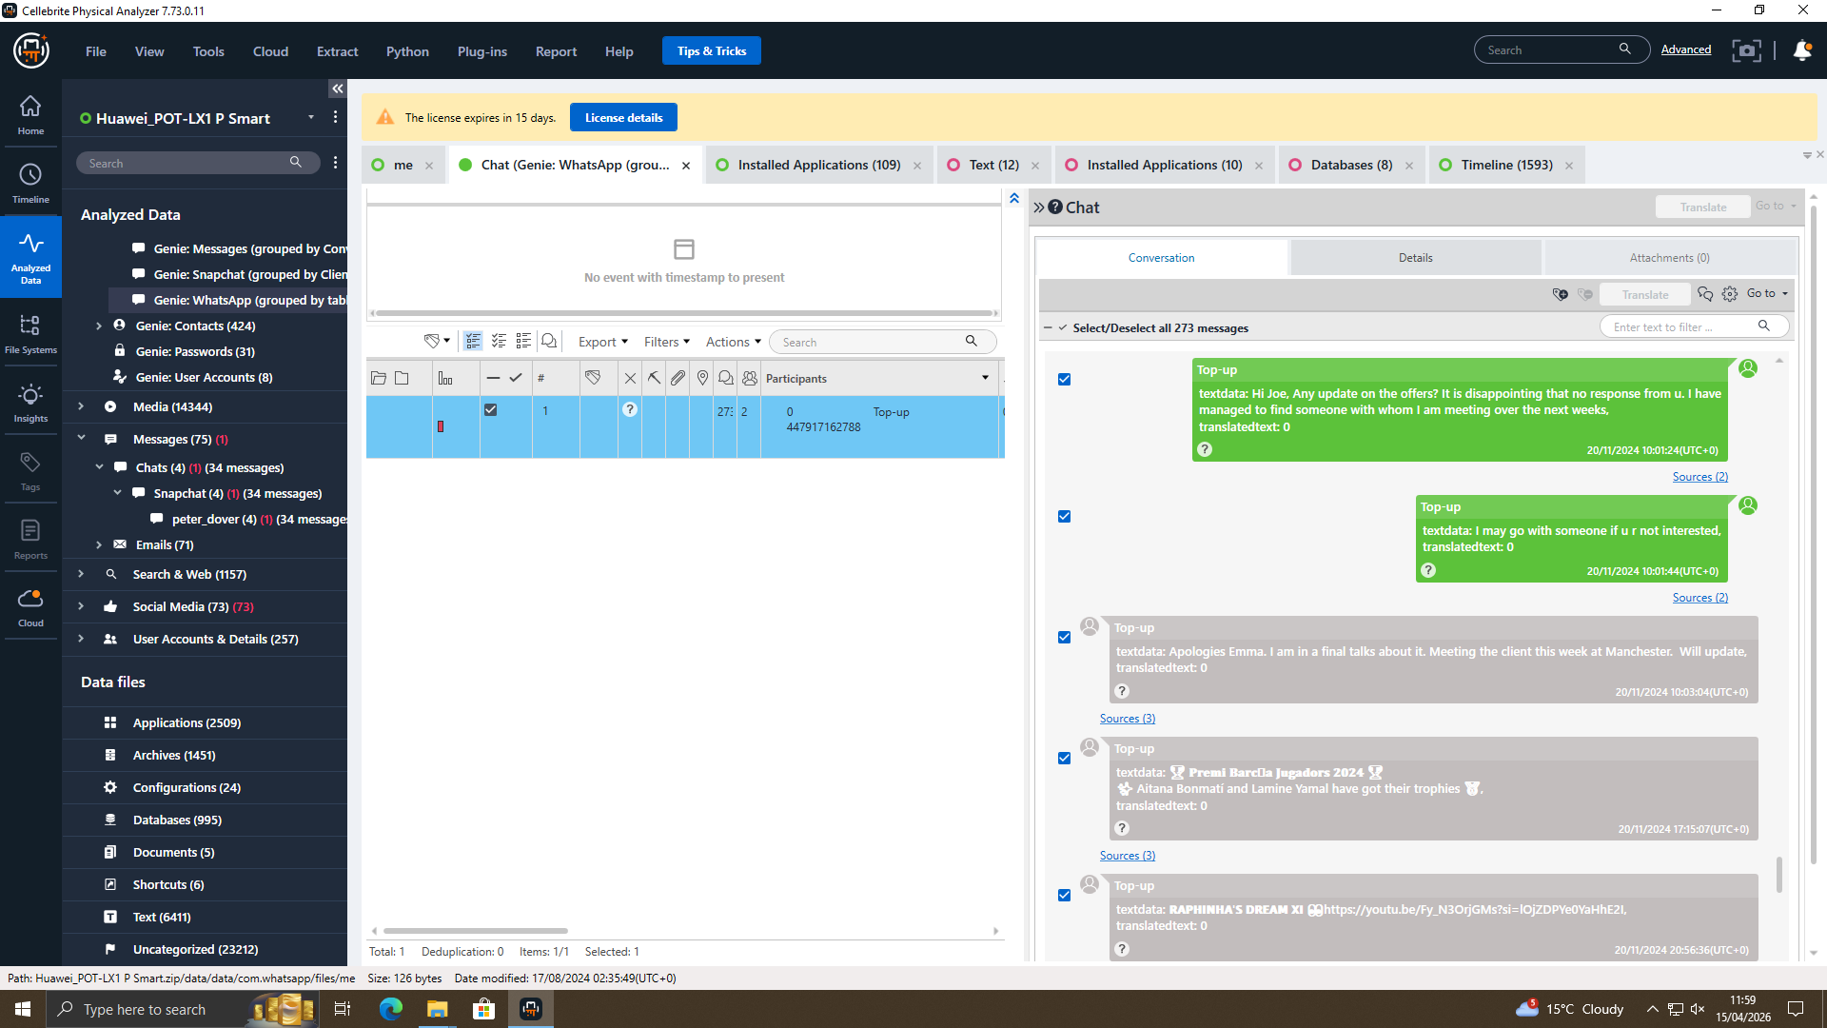
Figure 3: Meeting with potential buyer on in November 2024
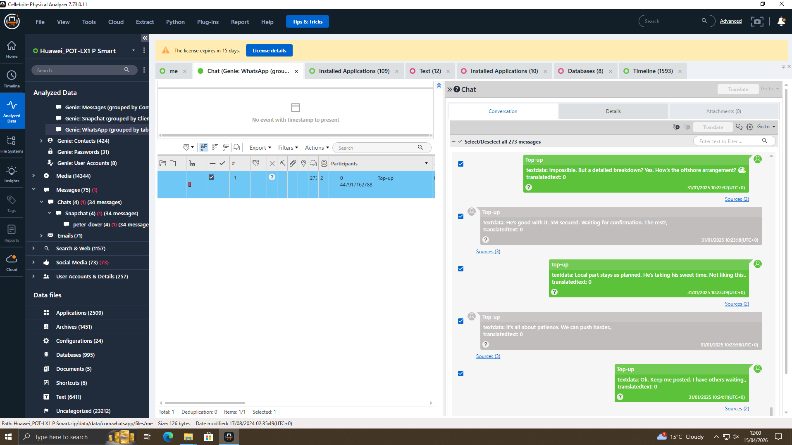
Figure 4:Deal of 5M between the Emma and potential Buyer on 31 January 2025

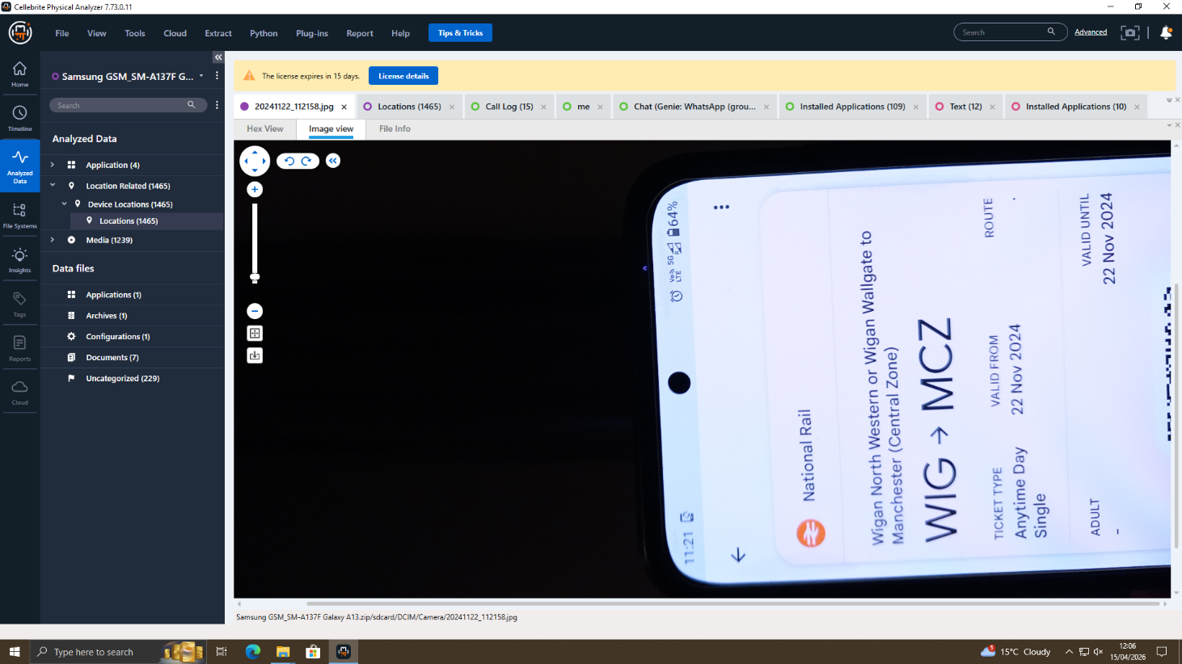
Figure 5: Metting Evidence Between Emma and Potential Buyer Train ticket photo of WIG to MCZ (Wigan to Manchester) from Joe's Samsung A13 on 22 November 2024
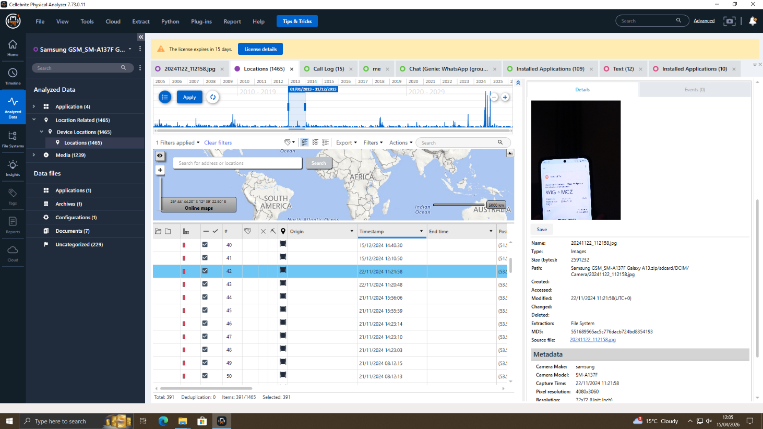
Figure 6: Gps View Of Joe’s device confirmed in Manchester city centre, 22 November 2024
Facebook chat between Peter Dover and Norman Smith
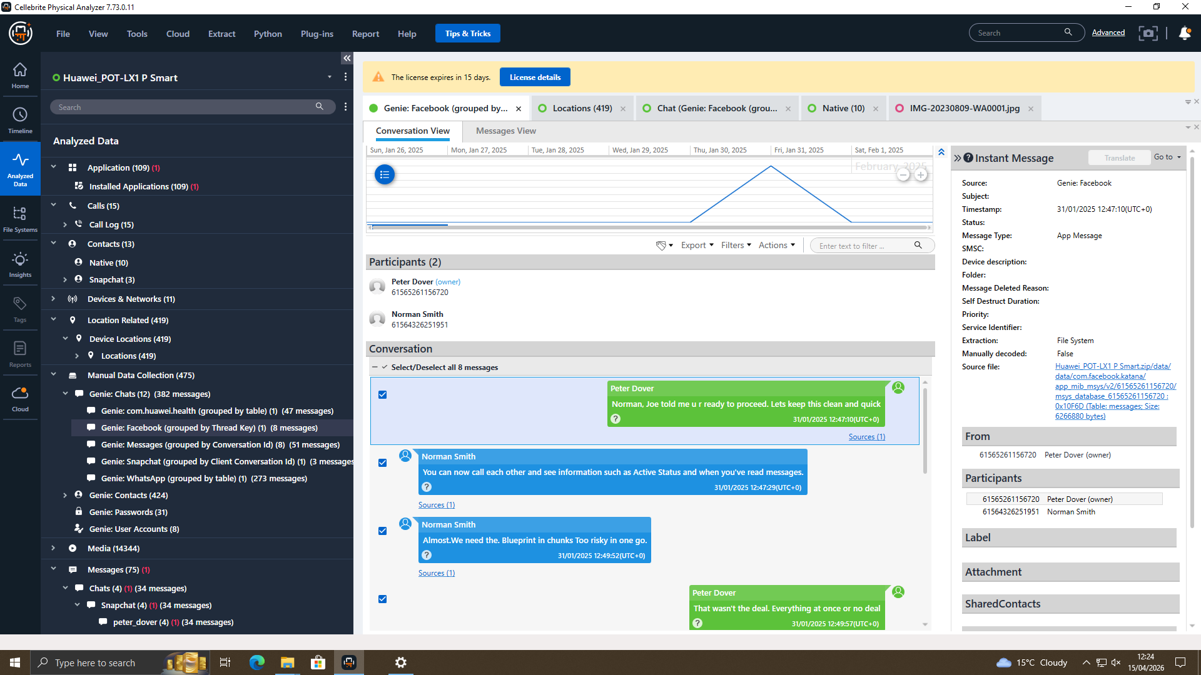
Figure 7: messages between Peter Dover and Norman Smith, 31 January 2025 from 12:47
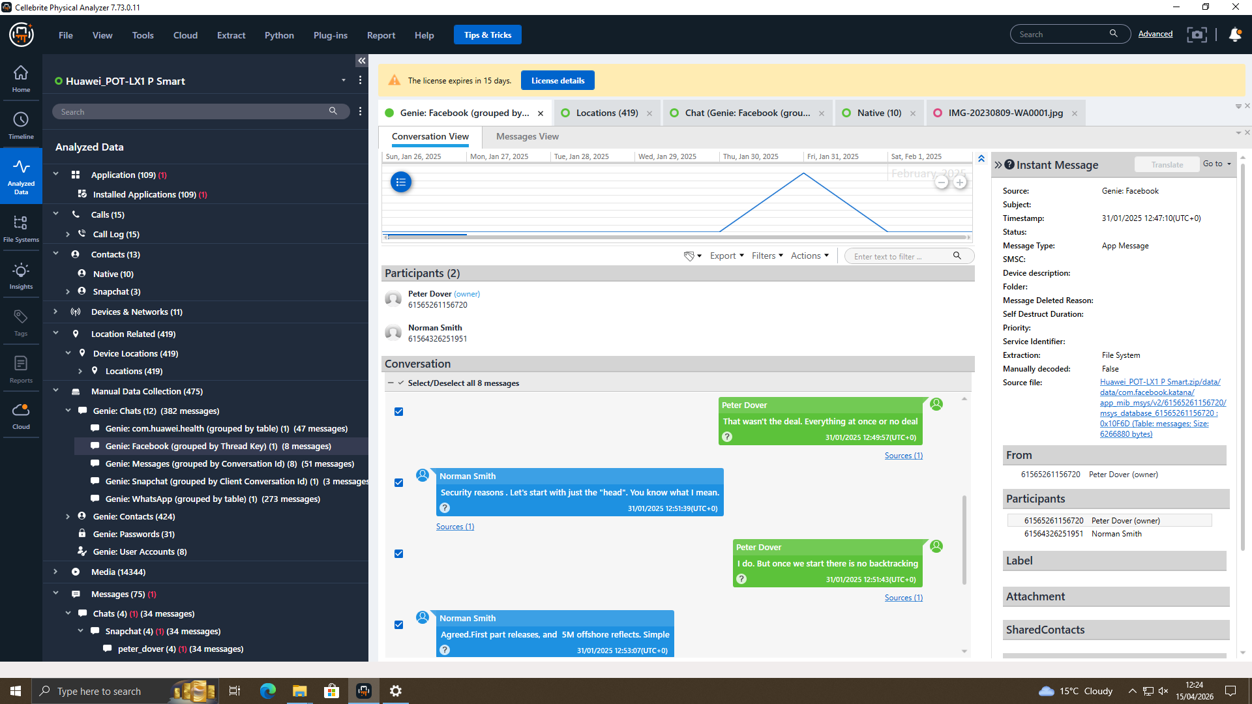
Figure 8: 5M Offshore offshore agreed
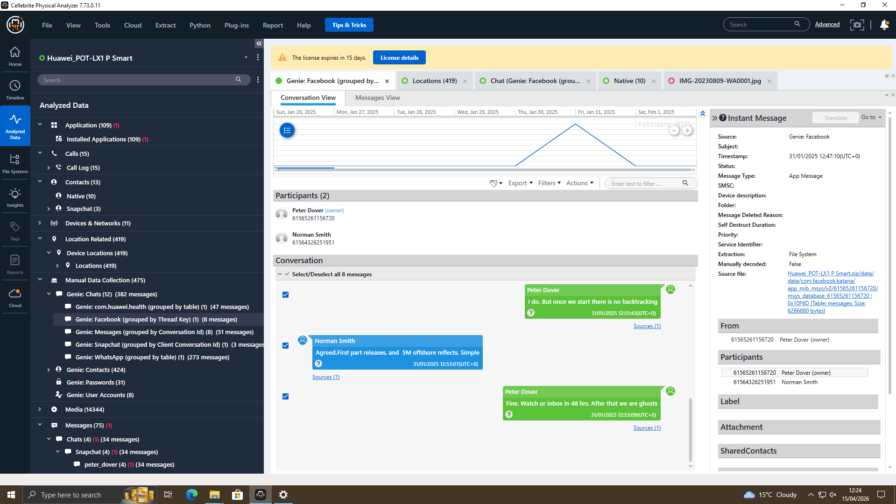
Figure 9: Transfer Of the Details
WhatsApp Filesystem Artefacts
The Cellebrite inspection of Ulefone Note 14 showed that the WhatsApp filesystem hierarchy was complete in the sdcard partition. The Android > data > com.whatsapp > WhatsApp directory path on the sdcard resulted in four important subdirectories: .Shared (1 item), Backups (5 items), Databases (2 files) and Media (14 items). Media folder had WhatsApp Animated Gifs, Audio (2), Documents (3), Images (2), Sticker Packs, Stickers, Video (2), Video Notes and Voice Notes (2). This is shown in Figure 10 below (Lange, 2024).

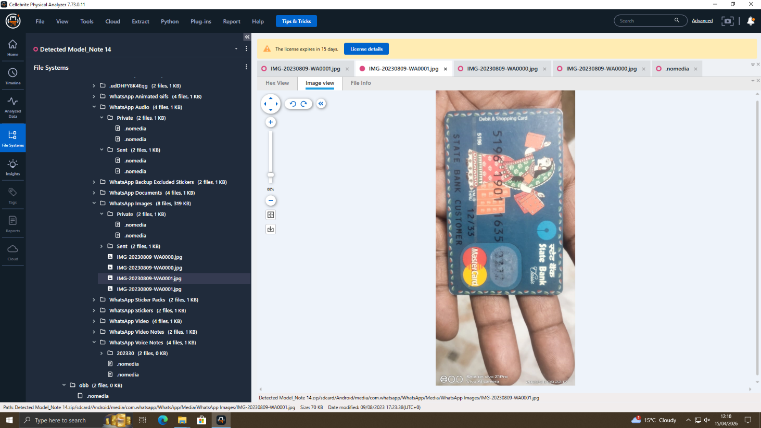
Figure 10: WhatsApp Directory Structure
There were two files in the Databases folder which corresponded in turn to the WhatsApp encrypted message store (msgstore.db.crypt14) and key material. Crypt14 format uses the AES-256 encryption using a device-specific key which he saved in the handset in the protected application data partition (/data/data/com.whatsapp/files/key). This key was not readily available through the logical extraction; complete physical extraction or cloud backup decryption through a legal process is necessary in the decryption of the database. However, the presence of these databases validates the continued, active communication with WhatsApp on EX-01 over the time-span of the investigation. The directory of WhatsApp Backups (5 items) also supports the notion of the frequent intentional usage [11].
The WhatsApp Documents folder (3 items) is especially important due to the patent file exfiltration claim. WhatsApp file transfer is an established way of stealing intellectual property in cases of insider-threats. Quantum Tech should present QT-AI-2025 patent documentation name conventions used as cross-references to file names in this folder pending decryption authority. WhatsApp Voice Notes (2 items) and WhatsApp Video (2 items) could include verbal or visual messages related to the plot, and must be scrutinized after decryption permission is obtained.2.4.2 Key Findings: Evidence of Financial Data (EX-01 – WhatsApp Images).
Critical Finding: Financial Data Evidence (WhatsApp Images)
WhatsApp Images folder of EX-01 stored 2 image files of superb evidentiary value. The images both show a State Bank of India Classic Debit and Shopping Card (MasterCard network), taken on 9 August 2023, under intentionally set up sequential photography. EXIF metadatas of both files have verified that the attributions of the same camera (Vivo Z1Pro, Vivo AI Camera) and the time when each image was captured are different by some 1 minute (22:17 and 22:18 respectively). The following are the images of the figures 11 and 12 [11].
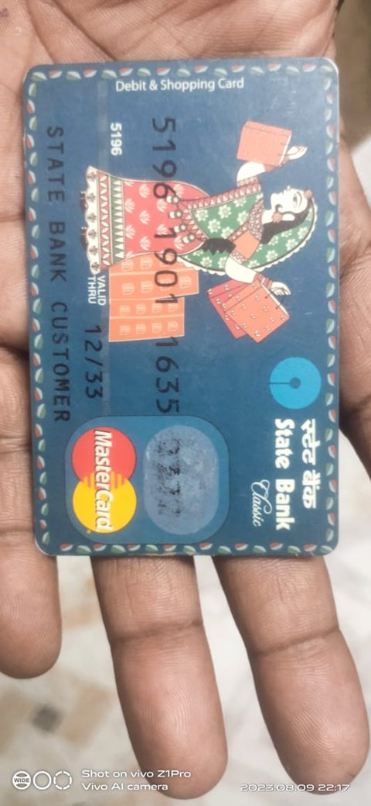
Figure 11: Front of State Bank of India Debit Card

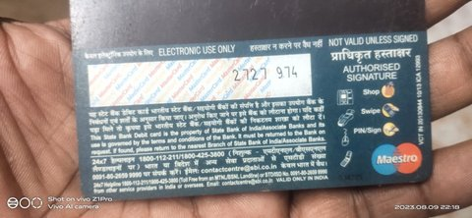
Figure 12: Reverse of Same Card
A conscious repositioning of the front and back of a payment card (one minute between photos) is completely against the idea of accidental photography. A combination of these two images presents all the credentials of card-not-present (CNP) transactions: the 16-digit card number, the expiry date, the cardholder name, and the CVV security number that can be observed in the backside. The fact that these images are contained in the WhatsApp Images folder of Figure 1 confirms that they were sent through WhatsApp, either received by or sent to a third party in the application. This would be in line with a financial pay agreement touching on the sale of the patent or, as an alternative a separate commission of a monetary fraud. Any of the two interpretations is a grave crime [12].
EXIF Metadata Summary
Metadata Field | Recorded Value
Image 1 – Capture Date/Time | 2023:08:09 22:17 (local time, device clock)
Image 2 – Capture Date/Time | 2023:08:09 22:18 (local time, device clock)
Camera Manufacturer / Model | BBK / Vivo Z1Pro
Camera Software | Vivo AI Camera
Storage Path (EX-01) | sdcard/.../com.whatsapp/WhatsApp/Media/WhatsApp Images/
GPS Coordinates | Not embedded (location services disabled or stripped by WhatsApp)
Hash Integrity Check | PASS – values match acquisition baseline
File Authentication | No metadata manipulation detected

The filesystem timestamps which Cellebrite records on both image files are internally consistent with the EXIF-tagged capture timestamps, showing that the images were not late left in the WhatsApp directory. Analysis did not find any evidence of metadata meddling.2.4.4 Results awaiting comprehensive examination [12].

2.5 Timeline of Events

Date / Time (Approx.) | Event
17 Aug 2024 | Peter Dover Created Gmail and Lebara SIM on Huawei P Smart
21 Aug 2024 | Emma sent a WhatsApp message to Joe, saying she had access to sensitive patent data and could sell it.
21 Aug 2024 | Emma Metting With Buyer(Norman) on same day.
26 Aug 2024 | Joe updated Emma, meeting was unsuccessful but that he had identified new potential buyer.
20 Nov 2024 | Emma Messeges for updates; Joe meeting with client in Manchester that week
22 Nov 2024 | Joe visit Manchester train ticket WIG→MCZ photographed the same day(GPS was 53.543655, -2.627383;)
31 Jan 2025 | We have WhatsApp messages showing a request for a demo sample, a deal closed at £5 million and discussions about offshore arrangements.
31 Jan 2025 12:47 | Facebook Communication of Emma and Norman For Blueprint and 5M offshore agreed with the dedline of 48 Hors

2.6 Suspect Profiling
Emma – Primary Perpetrator
The most evidential rich exhibit that was retrieved is Emma Nokia C2 (EX-01). Being a new senior engineer, Emma had the bona fide access control as well as the domain familiarity to locate and steal the QT-AI-2025 patent without generating immediate security warnings. The fact that she had WhatsApp databases and document artefacts and the images of financial cards on her device are all evidence that Emma was using personal handset as the main tool of the conspiracy, and clearly does not want to use corporate communication systems. The financial card pictures are in line with Emma being handed over credit cards by either Joe or Norman, or with Emma taking part in fraudulent financial activity on her own. Her identifying role as the source of the patent leaks into the organisation - the access, the ability, and the recorded artefacts of communication - is what makes her the key culprit [15].
Joe – Intermediary
The role played by Joe as an intermediary fits the traditional model of insider-threat whereby a corporate employee uses an outside cut-out to add a deniability layer. The anticipated findings of the device (EX-03) applicable to Joe include the disclosure of WhatsApp messages between Emma and Norman that might include a forwarded copy of a patent application and financial negotiation documents. Once decrypted, his communications to both sides will play a key role in proving there was a conspiracy and not a series of independent actions.
Buyer: Norman (NexGen Circuits)
As a member of the R&D team of NexGen Circuits, Norman is a commercial victim of the patent theft. His machine (EX-04) will probably harbor email correspondence of acceptance of patent material samples and money transfer plans. By comparing the SBI debit card in the field of EX-01 with the financial records of Norman, which would be revealed through different financial investigation authority, it would be possible to verify the trail of payment between the transaction and the corporate espionage operation.2.7 Other Information about the Possibility of Criminal Offences [17].

2.7 Additional Evidence of Potential Criminal Offences
The intentional interception and WhatsApp transmission of payment card credentials of the third party (card number, expiry, and CVV) is a criminal offence by itself, yet not related to corporate espionage charge. This evidence must be referred separately under the Fraud Act 2006 (Section 1- Fraud by False Representation and Section 2- Fraud by Failing to disclose information) and possibly, the Computer Misuse Act 1990 (Section 1 1- Unauthorised access) in case the card information was used to access banking systems [18]. Urgently, the investigators should: (a) determine who has used the SBI debit card that features in the photographs and decide whether or not the individual has been a victim of a financial fraud; (b) order transaction records for card number 5196 1901 1635 with State Bank of India starting from 9 August 2023; and (c) establish whether the financial fraud can be linked

2.8 Challenges Encountered
The unclear WhatsApp crypt14 database encryption is the key technical drawback, as it does not allow to clearly extract the messages without the device-specific AES-256 encryption key stored in the safes application sandbox on the handset. This key cannot be logical extracted; to resolve this issue, either a full physical extraction with complex methods of bypassing UFED bootloaders, or a legal procedure where Meta Platforms is forced to give out cloud backup information and/or message logs [19]. As proposed in the Investigatory Powers Act 2016, a formal Production Order status is the best next step as it should take the form of a formal Production Order under the same Act or a mutual legal assistance request in case of a relevant infrastructure placed outside the UK by Meta.
The second issue is the lack of the GPS metadata of the two card images on EX-01. This makes testing of the geographic location where the images were taken impossible, although the EXIF camera attribution and in-camera times are readable and plausible [20]. Also, the CAD file formats of EX-02 might need expert rendering software that cannot be found in typical forensic toolsets; an expert specialist in engineering forensics may be needed to determine the technical similarity of recovered files to the QT-AI-2025 patent specification.
Anti-Forensic Considerations
In addition to the technical encryption block that the WhatsApp crypt14 database format provides to the investigators, anti-forensic intentionality should be kept in mind by the investigators in all four exhibits. Selective file deletion, use of secure-delete, utilities that overwrite file allocation table entries to cause no artefact to be created, installation of privacy-centric applications that generate fewer artefacts and exploiting the WhatsApp built-in disappearing message data option, which can be set to automatically delete messages after a specified duration, are modern anti-forensic techniques that can be employed by a technically literate suspect such as Emma. The fact that the WhatsApp Backups directory is found on EX-01 with five backup items, is counterintuitive to the investigation: regular backup mechanisms tend to have evidence of what a user has deliberately deleted off the active message store [21]. As a recomendation, any securing hash check of all five backup files in this directory is encouraged, and extracted to undergo analysis under decryption authority, as there may be message threads that preceded the deletion of primary database content. In addition, the three files contained in the WhatsApp Documents folder are to be classified as high-priority: document files shared on WhatsApp are stored locally on a receiving device, which means that even in case Emma deleted the copies of the sent documents off her database, document files stored on the website can be stored on the devices of Joe with the EX-03 and Norman with the EX-04 and, in effect, might have a full and intact.
Conclusion
The forensic analysis (EX-01, Nokia C2, the phone Emma used) has yielded some strong evidence. The artefacts of the WhatsApp filesystem validate a continuous flow of messaging in line with an organized communication with outsiders over some amount of time pertinent to the breach of the patent database. Two images of both sides of a State Bank of India debit card shot in a premeditated one-minute series on 9 August 2023 and placed in the WhatsApp Images folder will constitute a definite testament of financial data theft sent through WhatsApp. An encrypted store of message records would be found in the WhatsApp Databases folder which, when decrypted legally, would strongly suggest direct evidence of the QT-AI-2025 patent conspiracy, and the exfiltrated patent files would likely be found in the WhatsApp Documents folder.
Anchored collectively, the artefacts found in EX-01 are in line with the position her run (Emma) played as the main gunman of corporate espionage. The USB flash disk EX-02, which was in the possession of Joe, the device EX-03, and the device EX-04 of Norman need to be fully analyzed in order to complete the picture of evidence. Together with the WhatsApp databases that are going to be decrypted and cross-verified with an account of the call logs, the gathered evidence is expected to give a detailed and legal admissible process of prosecuting all the three suspects.
Recommendations
Immediate Investigative Actions
File an application into court to seek a Production Order under the Investigatory Powers Act 2016 to force Meta Platforms into providing Emma with Whatsapp message logs, cloud backup and account set up information concerning the Emma account. Complete full physical extraction with UFED Advanced Logical or Bootloader-level bypass to use the WhatsApp decryption key directly out of the device in the Application sandbox which is under protection. Properly forensically investigate EX-02 (USB flash drive) and compare any files that are recovered to the list of patent-registered documents that Quantum Tech operates under QT-AI-2025. Retrieve and compare call logs between EX-01, EX-03, and EX-04 to map communication network and find events of temporally related contacts.
Financial Fraud Referral
Immediately forward the cardholder with the SBI debit card images to Action Fraud (UK) and the issuing bank (State Bank of India) to determine the cardholder and report possible fraudulent transactions following 9 August 2023. Order the transaction files of card number 5196 1901 1635 to be ordered under proper legal procedure to determine whether the card was fraudulently used after the credentials of the card were captured.
Laws/Actions-Espionage by corporates
Bring charges against Emma based upon the Trade Secrets (Enforcement, etc.) Regulations 2018, Section 1 and Section 3 of the Computer Misuse Act 1990 and the Fraud Act 2006 (card data offence). Accuse Joe of being an accessory to corporate espionage and conspiracy to commit computer misuse. Take civil and criminal action against Norman and NexGen Circuits under trade secret law, and criminal intent proved under conspiracy laws, as well.
Design and Field Engineering of Quantum Tech
Install Data Loss Prevention (DLP) controls on all data loss prevention access endpoint devices, configured to trigger when there is bulk downloads or removable media activity. Implement Mobile Device Management (MDM) on all devices used by employees, with encryption, remote-wipe features and app whitelisting. Carry out a privileged access review of those accessing the patent database; apply least-privilege and recertify access on a regular basis. Install a SIEM system to provide an alert of suspicious database query patterns, out-of-hours access, or massive volume data transfers on patrol database accounts.

References
[1]
H. O. Abdullah, M. Maqsood, and A. Nadeem, “Digital Evidence in Criminal Proceedings: Legal Standards, Chain of Custody, and Evidentiary Reliability in The Digital Era,” vol. 3, no. 5, pp. 795–805, Aug. 2025, doi: https://doi.org/10.71317/rjsa.003.05.0375.
[2]
I. Abeysekera, “Open source tools: an evaluation for digital forensic investigations,” Frontiers in Research Metrics and Analytics, vol. 11, Feb. 2026, doi: https://doi.org/10.3389/frma.2026.1790333.
[3]
O. Akter, A. Akther, M. A. Uddin, and M. Manowarul Islam, “Cloud Forensics: Challenges and Blockchain Based Solutions,” International Journal of Wireless and Microwave Technologies, vol. 10, no. 5, pp. 1–12, Oct. 2020, doi: https://doi.org/10.5815/ijwmt.2020.05.01.
[4]
M. AlKhanafseh and O. Surakhi, “Evidence Preservation in Digital Forensics: An Approach Using Blockchain and LSTM-Based Steganography,” Electronics, vol. 13, no. 18, p. 3729, Sep. 2024, doi: https://doi.org/10.3390/electronics13183729.
[5]
T. Arif, D. Camacho, and J. H. Park, “Unveiling cybersecurity mysteries: A comprehensive survey on digital forensics trends, threats, and solutions in network security,” Journal of Network and Computer Applications, vol. 243, p. 104296, Sep. 2025, doi: https://doi.org/10.1016/j.jnca.2025.104296.
[6]
A. Kumar, D. Jegan, and D. Vasanthagopal, “Global Research Trends in Policing, Cybercrime, and Digital Forensics: A Bibliometric Perspective,” 2025. Available: https://rsisinternational.org/journals/ijrsi/digital-library/volume-12-issue-6/1681-1696.pdf
[7]
F. Breitinger, J.-N. Hilgert, C. Hargreaves, J. Sheppard, R. Overdorf, and M. Scanlon, “DFRWS EU 10-Year Review and Future Directions in Digital Forensic Research,” arXiv.org, 2023. https://arxiv.org/abs/2312.11292
[8]
C. Cruz, “Innovative Learning in a Digital Forensics Laboratory: Tools and Techniques for Data Recovery,” Applied Sciences, vol. 14, no. 23, pp. 11095–11095, Nov. 2024, doi: https://doi.org/10.3390/app142311095.
[9]
P. Das, “THE IMPORTANCE OF DIGITAL FORENSICS IN THE ADMISSIBILITY OF DIGITAL EVIDENCE.” Available: https://www.nujs.edu/wp-content/uploads/2022/12/vol-7-iss-2-6.pdf
[10]
Emeka Ihekweazu, E. A. Adelowo, and N. Aghado, “Digital Forensics in Action: A Case Study of Tracing Cybercriminals Behind Job Offer Spear Phishing Scams...,” ResearchGate, Jan. 09, 2025. https://www.researchgate.net/publication/389593727_Digital_Forensics_in_Action_A_Case_Study_of_Tracing_Cybercriminals
[11]
T. Fisher, C. Weber, G. Burruss, and N. Fisk, “Digital Detectives in the Making: Introducing Data Security Through Forensic Challenges,” Journal of Criminal Justice Education, pp. 1–19, Feb. 2026, doi: https://doi.org/10.1080/10511253.2026.2625781.
[12]
C. Hargreaves, F. Breitinger, L. Dowthwaite, H. Webb, and M. Scanlon, “DFPulse: The 2024 digital forensic practitioner survey,” Forensic Science International: Digital Investigation, vol. 51, p. 301844, Nov. 2024, doi: https://doi.org/10.1016/j.fsidi.2024.301844.
[13]
Hussein Jassim Akeiber, “A comprehensive study of Cybercrime and Digital Forensics through Machine Learning and AI,” Al-Rafidain Journal of Engineering Sciences, pp. 369–395, 2025, doi: https://doi.org/10.61268/hff1pp49.
[14]
I. Ismail and K. Akram, “The admissibility of digital evidence from open-source forensic tools: Development of a framework for legal acceptance,” PLoS ONE, vol. 20, no. 9, pp. e0331683–e0331683, Sep. 2025, doi: https://doi.org/10.1371/journal.pone.0331683.
[15]
L. Klasén, N. Fock, and R. Forchheimer, “The invisible evidence: Digital forensics as key to solving crimes in the digital age,” Forensic Science International, vol. 362, pp. 112133–112133, Sep. 2024, doi: https://doi.org/10.1016/j.forsciint.2024.112133.
[16]
kumar, “Global Research Trends in Policing, Cybercrime, And Digital Forensics: A Bibliometric Perspective – International Journal of Research and Scientific Innovation (IJRSI),” Rsisinternational.org, 2025. https://rsisinternational.org/journals/ijrsi/articles/global-research-trends-in-policing-cybercrime-and-digital-forensics-a-bibliometric-perspective (accessed Apr. 13, 2026).
[17]
K. Lange, “What Is Digital Forensics? The Weapon Against Cybercrime | Splunk,” Splunk, 2024. https://www.splunk.com/en_us/blog/learn/digital-forensics.html
[18]
Premanand Narasimhan and Dr. N. Kala, “Emerging Trends in Digital Forensics : Investigating Cybercrime,” International Journal of Scientific Research in Computer Science, Engineering and Information Technology, vol. 11, no. 1, pp. 3645–3652, Feb. 2025, doi: https://doi.org/10.32628/cseit251451.
[19]
Suvarna Chaure and V. Mane, “Digital Forensic Framework for Protecting Data Privacy during Investigation,” ICST Transactions on Scalable Information Systems, Sep. 2023, doi: https://doi.org/10.4108/eetsis.4002.
[20]
M. S. Zareen, B. Aslam, S. Tahir, I. Rasheed, and F. Khan, “Unveiling the Dynamic Landscape of Digital Forensics: The Endless Pursuit,” Computers, vol. 13, no. 12, p. 333, Dec. 2024, doi: https://doi.org/10.3390/computers13120333.
[21]
A. M. Yusuf, D. M. Sari, and Musawwir, “Digital Forensics in Open Journal Systems: Case Study on Security Breach and Data Recovery,” Journal of Embedded Systems Security and Intelligent Systems, pp. 522–557, Nov. 2025, doi: https://doi.org/10.59562/jessi.v6i3.9778.

