Chemistry Lab Report 2 – Titration
UWTSD
James Cawte (2313853) – Ordnance Munitions & Explosives

17/03/2024

Contents
Introduction: 2
Purpose of the experiment: 2
Hypotheses: 2
Variables: 2
Materials & Method: 2
Results: 3
Discussion: 4
Conclusion: 4

Introduction:

Purpose of the experiment:
The purpose of the titration is to determine the concentration of an acid or alkaline. In this example the acid of unknown concentration was hydrochloric acid (HCl). It was reacted with a standard solution of sodium hydroxide (NaOH).

Hypotheses:
By titrating a known amount of NaOH, the number of moles required to reach the endpoint can be found and subsequently used to calculate the molarity of HCl.

Variables:
Independent – Precision with which the test is conducted
Dependant – Volume of titrant used when the indicator changes colour
Control:
- Standard solution used
- Volume of unknown solution
- Volume of indicator added to the unknown solution
- Method of adding the base
- Cleaning process of all apparatus before experiment begins

Materials & Method:
Materials & Equipment:
- Hydrochloric acid (HCl) – unknown solution
- Sodium hydroxide (NaOH) – standard solution
- Phenolphthalein indicator
- 1 Burette (50mL)
- Burette stand with clamp
- 1 pipette (10mL) with pipette filler
- 3x Erlenmeyer flasks (100mL)
- 1 small funnel
- 1 plastic pipette
- 1 wash bottle with deionised water
- 1 graduated cylinder (10mL)
- 1 white background (tile or paper)
- 1 Beaker for waste
- Gloves
- Lab Coat
- Safety Goggles
Method:
- With the deionised water, wash the pipette then rinse with a small amount of HCl; discard the washings.
- With the deionised water, wash the burette then rinse with a small amount of NaOH; discard the washings.
- With the deionised water, wash the Erlenmeyer flasks.
- Use the small funnel to fill the burette with standard NaOH solution; run some of the solution through the tap and note the starting value of the bottom of the meniscus.
- Using the pipette filler, place 25 mL of HCl in the three Erlenmeyer flasks.
- Add 3 drops of phenolphthalein to each flask and swirl gently.
- Using the tap of the burette, run the NaOH solution into the first flask of HCl until it changes to a pink colour. Note the volume of NaOH remaining and calculate the amount used.
- If necessary, refill the burette with NaOH.
- Repeat step 7 but this time get within 2 mL of the previous used amount run the burette very slowly, so it is just dripping. While it drips, continuously swirl the flask so that the solutions mix. The reading from this should be correct to 0.05 mL (one drop).
- Repeat step 9 until you have a satisfactory reading.

Results:
FLASK | 1 rough titration | 2 | 3
V_{HCl} (mL) from pipette | 25.00 | 25.00 | 25.00
Initial burette reading | 20.00 | 6.70 | 26.70
Final burette reading | 39.65 | 26.70 | 46.65
V_{NaOH} (mL) | 19.65 | 20.00 | 19.95
Moles of NaOH | 2.03x10⁻³ | 2.05x10⁻³ | 2.05x10⁻³
Moles of HCl | 2.03x10⁻³ | 2.05x10⁻³ | 2.05x10⁻³
Molarity of HCl | 0.081 | 0.082 | 0.082
Table 1 – Table of Results
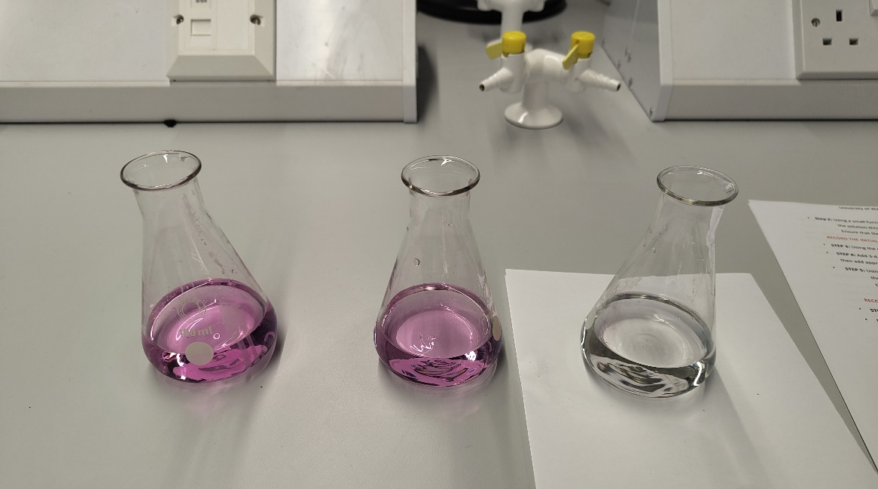
Results of each titration (Left to right)

Discussion:
The reaction taking place is as follows:
HCl (aq) + NaOH (aq) NaCl (aq) + H₂O (l)
This shows that it is a 1 to 1 ratio of reactants required therefore however many moles of the standard solution are used, it will react with an equal number of moles of the unknown solution. Combining this fact with the phenolphthalein indicator, the exact number of moles of NaOH required to neutralize 25 mL of HCl can be found. The volume of NaOH required to neutralize the HCl was found to be 19.95 mL and the molarity of NaOH is 0.1026 molL⁻¹. The equation for molarity is Molarity (molesL⁻¹) = Number of Moles / Volume (L) (M=n/v). The equation can be rewritten with n as the subject: n=Mv. As it is established that number of moles of acid (n_{A}) equals the number of moles of base (n_{B}), the equation can be written as M_{A}V_{A}=M_{B}V_{B}, where M_{A} & M_{B} are the molarities of the acid and base respectively and V_{A} & V_{B} are the volumes of the acid and base respectively.
Substituting data from the table of results:
0.1026 x 19.95x10⁻³ = M_{B} x 25x10⁻³
(0.1026 x 19.95x10⁻³) / (25x10⁻³) = M_{B}
M_{B} = 0.082 molL⁻¹
Some limitations of the experiment include:
- Human error when measuring the values on the burette or pipettes.
- The standard solution is presumed to have a known molarity but may have degraded over time or be slightly different concentration.
- Accurately determining the end point is difficult due to the time required for the drip to fully mix with the solution.

Conclusion:
To summarize, the experiment showed that the molarity of the HCl solution was 0.082 molL⁻¹. The hypothesis was accurate.

