Alexandra Paunescu
2125393
1969 Word Count
Financial Management for the Hotel Industry BMIH5007
Tristan Hawkins
Comparison of Corinthia Hotels and Ibis Hotels
Executive Summary
This report offers a comprehensive analysis of the financial management strategies and practices of Corinthia Hotels and Ibis Hotels. The comparison focuses on four critical aspects, including total revenue, market positioning, growth prospects, and their dedication to corporate social responsibility (CSR).
The key findings include:
Total Revenue: Corinthia Hotels demonstrated a remarkable recovery post-pandemic, returning to 95% of pre-pandemic revenue levels, while Ibis Hotels, as part of the Accor Group, increased revenue significantly, indicating a strong financial recovery and growth.
Market Position: Corinthia targets the luxury market segment, emphasising quality and exclusivity. In contrast, Ibis, which is owned by Accor, caters to a broader market and is struggling to maintain market share due to increased competition in the economy hotel sector.
Growth Potential: Corinthia is strategically expanding in high-value global locations, whereas Ibis is aggressively expanding its global presence by developing new hotels.
CSR Initiatives: Both companies are committed to CSR, with Ibis investing heavily through the ALL Heartist Fund and Corinthia implementing effective local and global community support initiatives.
The report concludes with tailored recommendations for each hotel group, advising Corinthia to scale its CSR activities and continue strategic global expansion, while Ibis should diversify its CSR initiatives and implement innovative market penetration strategies.
This analysis sheds light on the operational strategies and future plans of these two major players in the hospitality industry.
Introduction
This report conducts a detailed comparison of two well-known hospitality companies: Corinthia Hotels and Ibis Hotels. The objective is to fully assess the financial management tactics and procedures of two organisations. The assessment will concentrate on crucial factors that impact their fiscal performance and long-term viability. The analysis will focus on key metrics such as total revenue, market share, potential for development, and financial dedication to Corporate Social Responsibility (CSR). The objective of this analysis is to achieve a deeper understanding of how these organisations strategically operate through the competitive hospitality industry, generate income, increase their market presence, and fulfil their social and environmental obligations. The report compiles data and information from a variety of credible sources, making strategic recommendations tailored to each hotel group's specific market position and operational goals.
Comparative Analysis
Total Revenue
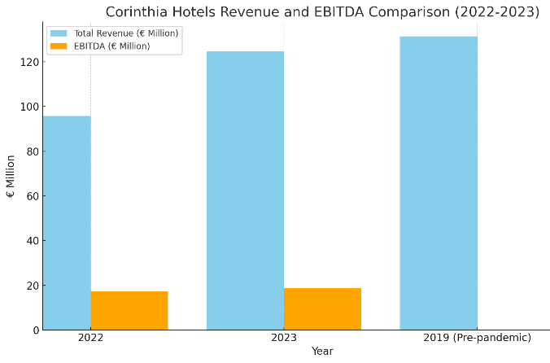
Corinthia Hotels
As of June 30, 2023, Corinthia Hotels, which is operated by International Hotel Investments p.l.c. (IHI), had a total revenue of €124.8 million. During the first half of 2023, the hotel group's revenue totaled €124.5 million, which is a significant 30% increase compared to the same period in the previous year, when it was €95.8 million. It is important to note that the revenue during the first half of 2023 reached 95% of pre-pandemic levels from 2019. The hotel group's EBITDA for the same period was €18.78 million, slightly higher than the €17.3 million recorded in the previous year. This increase in revenue and EBITDA is influenced by several factors, including inflationary pressures, rising energy costs, exchange rate movements, and pre-opening costs for new hotels.
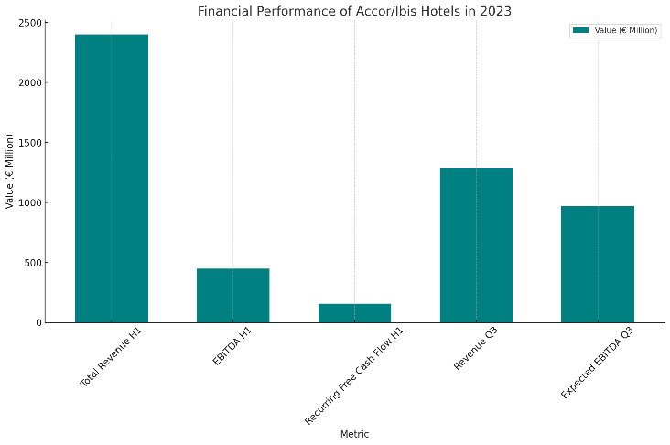
Ibis Hotels (Part of Accor Group)
Ibis Hotels, owned by the Accor Group, showed a robust performance in the first half of 2023. The total revenue for this period was €2402 million, a significant 35% increase from the first half of 2022 since the total revenue was €4224 million, the EBITDA (Earnings Before Interest Taxes Depreciation and Amortisation) was €675 million, and the recurring free cash flow was €373 million. The Accor Group's revenue breakdown shows that the Premium Midscale and Economy Division, which includes Ibis Hotels, contributed €1418 million to the total, representing a 34% increase on a like-for-like basis. Furthermore, the Luxury & Lifestyle Division added €1020 million, representing a 40% increase in like-for-like sales. Ibis Hotels' overall performance as part of the Accor Group indicates a strong recovery and growth trajectory, with the group opening 114 new hotels (14500 rooms) in the first half of 2023. As of June 30, 2023, the total portfolio included 805436 rooms across 5487 hotels, with a pipeline of 217000 rooms across 1262 hotels, indicating a net unit growth rate of 2% to 3% for the year (IFR, 2023).
Comparative Analysis
When comparing the two, Ibis Hotels has a larger scale of operation and higher total revenue, reflecting its position within the larger Accor Group (IFR, 2023). According to annual reports, Ibis Hotels' growth rate will outpace that of Corinthia Hotels in the first half of 2023, in both revenue and expansion. However, given Corinthia's smaller scale of operations in comparison to the Accor Group, its near-complete recovery to pre-pandemic revenue levels is noteworthy. When evaluating these two groups' financial performance, it is important to consider the different scales shown in their annual reports.
Market Position
Corinthia Hotels
Corinthia Hotels, founded in 1962, has grown into a well-known name in luxury travel, with nine properties worldwide, and caters to a specific audience seeking high-end services and exclusive experiences. According to Zamborsky and Kruesi (2018), the brand's market strategy focuses on quality, luxury, and unique guest experiences while expanding its footprint in key global locations. The commitment to luxury is evident in its investment in technology and innovation, as well as its Corinthia Discovery loyalty programme, which provides guests with unique benefits. Corinthia's market positioning emphasises luxury, quality, and authenticity, appealing to travellers seeking unique and upscale experiences.
Ibis Hotels (Part of Accor Group)
Ibis Budget Hotels, a member of the Accor Hotels Group, has a significant market share in the budget hotel segment worldwide, with a strong presence in 18 countries, including over 20 locations in Australia. Ibis is well-known for its affordability and basic, high-quality services, and it effectively competes with brands such as Holiday Inn Express and Travelodge. While Ibis offers reasonably priced accommodations, it faces competition from other lodging options such as Airbnb and budget hotels. Despite these challenges, its strong brand recognition and international network help it maintain its position in the budget hotel industry, particularly among cost-conscious travellers looking for dependable and accessible lodging options (Cheng, 2020).
Comparative Analysis
- Market Share and Growth: Ibis Hotels, as part of Accor's extensive network, has a broader market presence compared to Corinthia Hotels. However, Ibis faces challenges in market share retention due to stiff competition in the economy and midscale segments.
- Customer Demographics: Corinthia likely targets a more upscale demographic, focusing on luxury and exclusivity, while Ibis, operating in the economy to midscale segments, caters to a wider and more cost-conscious customer base.
- Brand Perception: Corinthia’s brand is likely associated with luxury and exclusivity, while Ibis is seen as a more accessible, value-oriented option.
- Strategic Focus: Ibis is actively addressing market challenges by diversifying and refreshing its brand, and streamlining operations, indicating a dynamic approach to market positioning.
In conclusion, while Corinthia Hotels appears to target a niche, luxury market, Ibis, under the Accor umbrella, caters to a broader, more diverse customer base but faces its own set of challenges in a highly competitive market segment.

Growth Potential of Corinthia Hotels and Ibis Hotels
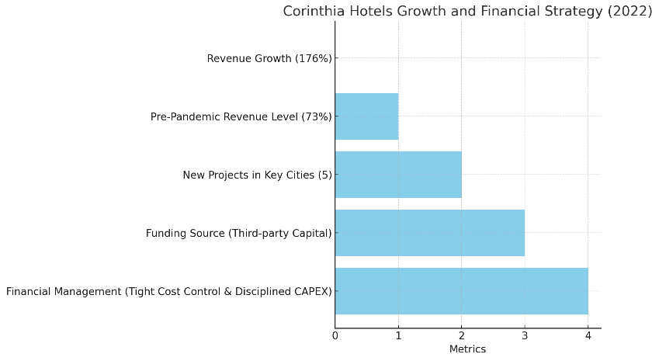
Corinthia Hotels
Corinthia Hotels is currently experiencing a significant growth trajectory, as evidenced by a 176% increase in revenues over the same period last year, which will reach 73% of pre-pandemic levels in 2019. The company is focusing on expanding its global presence, with ongoing projects in key cities including Doha, Rome, New York, Bucharest, and the Grand Hotel Astoria in Brussels. Furthermore, plans are underway to build a new resort in Malta on the former Hal Ferh site (IHI, 2022). As Wang (2022) demonstrates in his journal, this expansion strategy reflects Corinthia's desire to increase its presence in both existing and new markets. These projects are primarily funded through third-party capital, indicating a strategic approach to financial management and investment. According to IHI (2022), the group also focuses on tight cost control and disciplined capital expenditure (CAPEX), resulting in a strong financial position with significant cash and bank balances.
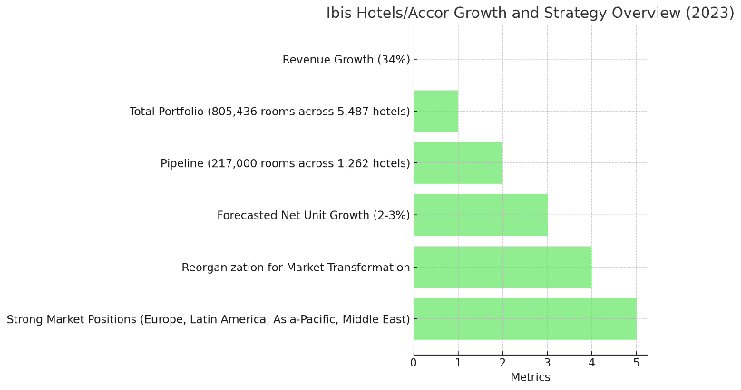
Ibis Hotels (Part of Accor Group)
According to IFR (2023), Accor's extensive portfolio comprises 805,436 rooms across 5,487 hotels, with a pipeline of 217,000 rooms across 1,262 hotels. Ibis Hotels, which is part of Accor's "Premium Midscale and Economy" division, has the potential for strong growth. In the first half of 2023, the division's revenue increased by 34% on a like-for-like basis. According to Accor (2023), net unit growth in 2023 was expected to range between 2% and 3%. This expansion is part of a reorganisation effort to address market transformations and customer needs more effectively, with a focus on specialised teams, operational process simplification, and industrialisation to drive growth. The division has established strong market positions in the Middle East, Europe, Ibero-America, and Asia-Pacific.
Comparative Analysis
- Expansion Strategies: According to Fenech's (2023) publication, Corinthia Hotels is actively expanding in major global cities and developing a new resort, indicating a strategy for targeted growth. According to Dumolin and Gicomel (2020), Ibis Hotels, which is owned by Accor, continues to grow its global presence with a significant pipeline of new projects, indicating a more aggressive expansion strategy.
- Market Opportunities: Both hotel groups are capitalising on opportunities in key global markets, with Corinthia focusing on specific high-value projects and Ibis expanding its economy and midscale offerings across multiple regions according to annual reports.
- Potential Barriers: Ibis faces challenges from rapid development in the economy hotel sector and cultural shifts in customer preferences according to Dumulin and Gicomel (2020), while Corinthia has to manage the complexities of funding and executing high-value projects in diverse locations as is shown in Fenech (2023) publication.
Corinthia Hotels is focusing its expansion strategy on high-value locations, while Ibis Hotels, as part of Accor, is expanding more aggressively across multiple global markets. Both approaches reflect their market positions and long-term growth goals.

Financial Commitment to CSR: Corinthia Hotels vs. Ibis Hotels (Accor Group)
Corinthia Hotels
Corinthia Hotels exhibits an outstanding dedication to Corporate Social Responsibility through a multitude of initiatives. They have continued to support Just a Drop, an international water charity, by contributing to projects that provide clean water to communities in Cambodia, Tanzania, Zambia, Uganda, and Kenya. Over the last four years, this initiative has had a significant impact on more than 45,000 children and families. Corinthia has also participated in several local community support activities, such as donating food and essential supplies to various organisations and contributing to environmental and social welfare projects, according to Insider's (2022) application. Their CSR efforts reflect a commitment to both global and local communities, with a focus on human and environmental well-being.
Ibis Hotels (Part of Accor Group)
According to Turner's (2020) publication, Ibis Hotels, which is a part of the Accor Group, has contributed €76 million to the ALL Heartist Fund. This fund promotes community, sustainability, and ethical practices, and the contribution demonstrates the company's financial commitment to Corporate Social Responsibility (CSR). Accor has set ambitious sustainability goals, such as reaching net-zero carbon emissions by 2050 and reducing single-use plastics in their hotels (Jones, 2023).These initiatives are critical components of Accor's overall CSR strategy, demonstrating their commitment to environmental sustainability and social responsibility.
Comparison and Impact on Financial Sustainability and Brand Value
- Investment Scale: Accor's financial commitment, as indicated by the allocation to the ALL Heartist Fund, is substantial, demonstrating a significant investment in CSR initiatives.
- Focus Areas: While Corinthia Hotels focuses on water aid, local community support, and environmental initiatives, Accor (Ibis Hotels) emphasizes broader sustainability goals and community support on a larger scale.
- Impact on Brand Value: Both Corinthia and Ibis Hotels enhance their brand value through these CSR initiatives. Corinthia’s involvement in local and global causes fosters a positive brand image as a socially responsible and community-focused entity. Similarly, Accor’s extensive investment in CSR initiatives contributes to a perception of the company as an environmentally conscious and ethically responsible organisation.
- Financial Sustainability: These CSR initiatives likely contribute to the financial sustainability of both hotel groups by building brand loyalty, improving customer perception, and potentially leading to cost savings in operations, especially in the long term.
In conclusion, both Corinthia Hotels and Ibis Hotels (Accor Group) demonstrate a strong commitment to CSR, although with different focuses and levels of investment. These efforts not only boost their brand value and reputation but also help them achieve long-term financial sustainability by aligning with changing consumer expectations and global sustainability goals.
Recommendations
Corinthia Hotels
Expanding CSR activities with an emphasis on employee welfare is advisable for Corinthia Hotels. Implementing initiatives like extensive training, competitive health benefits, and equitable wages can boost employee satisfaction and retention. A practical example is Hilton's "Thrive at Hilton" initiative, which focuses on providing employees with a supportive work environment, fostering personal growth, and well-being. This strategy not only elevates the customer experience but also reinforces Corinthia's reputation as a brand that values its workforce, meeting consumer expectations for ethical employment practices.
Ibis Hotels (Accor Group)
Ibis should diversify its CSR initiatives by focusing on local communities. This strategy, as highlighted by Akbari et al. (2021), has the potential to significantly increase brand loyalty and strengthen connections with local markets. For example, collaborating with local non-governmental organisations (NGOs) on environmental projects or community welfare programmes can demonstrate Ibis' commitment to social responsibility, which resonates strongly with customers who prioritise ethical and sustainable practices in their accommodation choices.
Reference List

1. Accor Group, 2023. Interim Financial Report As Of June 30, 2023. https://group.accor.com/-/media/Corporate/Investors/Documents-financiers/2023/07-27-H1/Interim_Financial_Report_2023_Accor_vDef.pdf
2. Accor Group, 2023. Solid Acrivity Growth Raised Full-year Guidance. 27 July 2023. H1 2023 RevPAR up 38% vs H1 2022 Demand expected to remain strong for the coming months https://press.accor.com/solid-activity-growthraised-full-year-guidance/?lang=en
3. Accor, 2023. 2023 Interim Financial Report. file:///V:/Descarcari/Interim_Financial_Report_2023_Accor_vDef%20(2).pdf
4. Akbari, M., Nazarian, A., Foroudi, P., Seyyed Amiri, N. and Ezatabadipoor, E., 2021. How corporate social responsibility contributes to strengthening brand loyalty, hotel positioning and intention to revisit?. Current Issues in Tourism, 24(13), pp.1897-1917. https://westminsterresearch.westminster.ac.uk/download/7c73d164928a7b6a4ebfd1d4c9c32987a90e004cc6b05bb2ae37aa67ed0ff2b4/508275/How%20Corporate%20Social%20Responsibility%20Contributes%20to%20Strengthening%20Brand%20Loyalty.pdf
5. Anning-Dorson, T. and Nyamekye, M.B., 2020. Be flexible: turning innovativeness into competitive advantage in hospitality firms. International Journal of Contemporary Hospitality Management, 32(2), pp.605-624.
6. Cheng, J., 2020. Research and Suggestions on Declining Market Shares of Ibis Budget Hotels. https://www.scirp.org/journal/paperinformation?paperid=97885
7. Corinthia Group, 2021. Overview of our recent CSR Activities. https://www.corinthiagroup.com/insider/overview-of-our-recent-csr-activities/#:~:text=Corinthia%20continued%20its%20sponsorship%20of,without%20access%20to%20clean%20water.
8. Corinthia Hotel, 2023. We are Corinthia. A family of uplifting destinations. https://www.corinthia.com/en-gb/our-story/
9. Dumoulin, R. and Giacomel, A., 2020. Disruption and the strategy of hotel groups. Shapes of Tourism Employment: HRM in the Worlds of Hotels and Air Transport, 4, pp.9-21.
10. ElAlfy, A., Palaschuk, N., El-Bassiouny, D., Wilson, J. and Weber, O., 2020. Scoping the evolution of corporate social responsibility (CSR) research in the sustainable development goals (SDGs) era. Sustainability, 12(14), p.5544. https://www.mdpi.com/2071-1050/12/14/5544/pdf
11. Fenech, R., 2023. Corinthia to inaugurate seven new hotels by 2026. International Hotel Investments has Obtained Approval for a €60 million bond issue. https://whoswho.mt/en/corinthia-to-inaugurate-seven-new-hotels-by-2026#:~:text=Upcoming%20plans,Asia%20(Maldives%20in%202026).
12. IHI, 2022. International Hotel Investments P.L.C. Company Announcement. https://cdn.borzamalta.com.mt/download/announcements/IHI339.pdf
13. Insider Plus, 2022. Corinthia’s unfailing compassion in tough times. https://insider.ihiplc.com/corinthias-unfailing-compassion-in-tough-times/
14. International Hotel Investment p.l.c, 2023. Interim Financial Statement (unaudited) For the six-month period, 1 January 2023 to 30 June 2023. https://www.corinthiagroup.com/wp-content/uploads/2023/08/IHI-Interim-Financial-Statements-30-June-2023.pdf
15. Jones, P., 2023. Towards Net-Zero Emissions in the Global Tourism Industry. Athens Journal of Tourism, 10(2), pp.125-136. https://eprints.glos.ac.uk/12810/1/2023-10-2-3-Jones.pdf
16. Pascual-Fernández, P., Santos-Vijande, M.L., López-Sánchez, J.Á. and Molina, A., 2021. Key drivers of innovation capability in hotels: implications on performance. International Journal of Hospitality Management, 94, p.102825.
17. Turner, M., 2020. Accor Creates “ALL Heartist Found” for COVID-19 Victims. https://www.luxurytraveladvisor.com/hotels/accor-creates-all-heartist-fund-for-covid-19-victims
18. Wang, J., 2022. Building competitive advantage for hospitality companies: The roles of green innovation strategic orientation and green intellectual capital. International Journal of Hospitality Management, 102, p.103161. https://www.sciencedirect.com/science/article/abs/pii/S0278431922000238
19. Zámborský, P. and Kruesi, M.A., 2018. Global Hotel Alliance: Strategy Discovery Moving East. SAGE Publications: SAGE Business Cases Originals.
20. Graphs created in https://charts.livegap.com/

