TASK 1

Agile software development emerged as a response to the limitations of the traditional waterfall method, gaining popularity for its adaptability, flexibility, and emphasis on collaboration. By enabling shorter iterations on deliverables, agile practices foster continuous feedback, leading to improved software development outcomes [2, 16]. Grounded in the Agile Manifesto, these methodologies prioritize customer collaboration, adaptability, and delivering working software over rigid processes and documentation [8, 15].
Agile methods align with these principles, with prominent examples including Test-Driven Development (TDD) [1-7], Feature-Driven Development (FDD) [3,10], and Behavior-Driven Development (BDD) [9-14]. While these methodologies share a foundation in building software incrementally and iteratively, they differ significantly in their history, purpose, advantages, and disadvantages. A deeper investigation is necessary to explore these differences and their implications for modern software development.

The concept of Test-Driven Development (TDD) originated in the late 1950s during NASA's work on the Mercury project. It was later reintroduced and popularized in 2003 by Kent Beck as a core practice of Extreme Programming (XP) [2,4].
TDD is an agile testing approach in which automated tests are created iteratively before the actual code is written. This method contrasts with traditional software development, often referred to as Test Last Development (TLD), where testing typically occurs only after coding is complete. In TDD, the process begins with writing a test for a specific functionality in the system, which then serves as both a guide and a validation tool for the subsequent code development. As a result, bugs are identified and resolved earlier, unnecessary or obsolete code is reduced, and cleaner, more maintainable code is produced [1, 2, 4].
TDD is believed to be governed by the principles of avoiding duplication and writing a failing test, followed by writing the code needed to make the test pass [2].
In practice, this can be broken down into five main steps (Fig. 1) [2]:

  - Write a failing test: Start by writing a test for a functionality. Since the functionality doesn't exist yet, the test will fail.
  - Implement code to pass the test: Write just enough code to pass the test.
  - Run the test: Confirm that the test passes with the current code.
  - Refactor code: Improve and clean up the code without changing its behaviour.
  - Repeat: Continuously repeat this cycle as you develop the functionality.

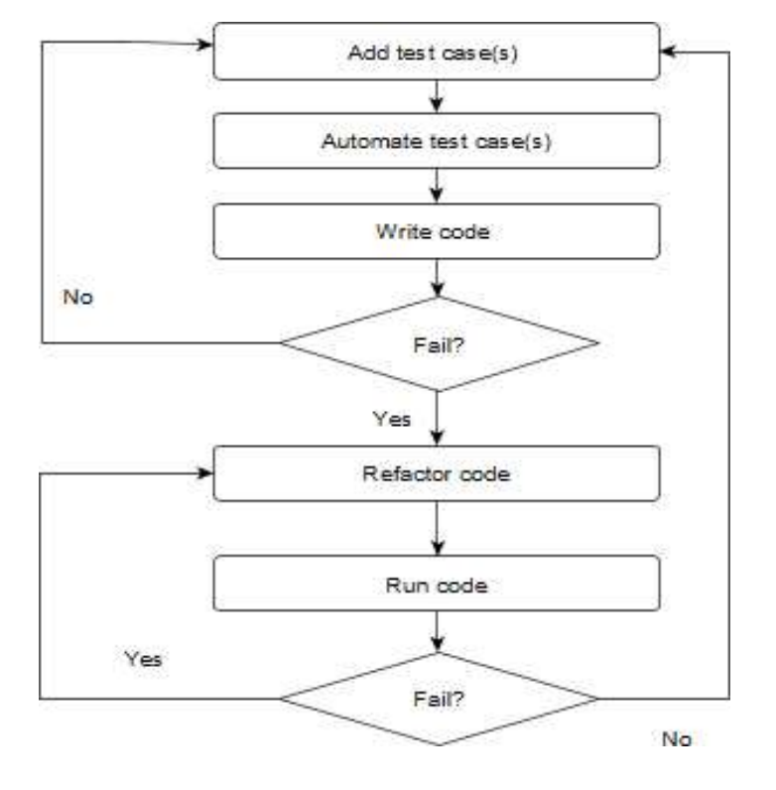
Figure 1: The TDD Workflow [4]

This iterative process enhances the quality of unit tests, produces superior code, and provides increased test coverage while preserving core functionality [5]. TDD offers a range of additional benefits. It enables developers to work in an agile manner, allowing them to build, iterate, and make adjustments in a structured process while receiving rapid feedback. This approach provides the flexibility needed to adapt to business changes that might otherwise lead to messy code and slower progress [1, 5]. As a result, TDD can accommodate both ambiguous and well-defined requirements [5].
TDD also streamlines continuous integration and supports Agile practices, such as unit testing and user stories [5]. Additionally, it can be particularly valuable in refining product design during the early stages of development [4].
Furthermore, TDD is accessible to developers of all skill levels [5], although it may require additional expertise in testing for those who are less familiar with it [2]. However, this challenge can be viewed as an opportunity to enhance programming skills, enriching developers’ knowledge and insights into the world of software development [5].

The main drawbacks of Test-Driven Development (TDD) are its potential to consume significant time and resources, which can be directly compared to traditional Test-Last Development (TLD) [2, 4, 5]. This consumption of time and effort can divert developers’ attention from building new features or advancing projects, as they spend time on the repetitive tasks involved in TDD [6]. Indeed, the repetition itself can be demotivating, especially for new developers. Furthermore, the large volume of test code that needs constant maintenance adds to the challenge [6].
TDD can also pose significant challenges for experienced professionals, particularly when developers lack the necessary knowledge and competencies in testing. This gap can prevent them from creating efficient and effective automated tests [6]. Additionally, TDD can be difficult to implement in projects requiring synchronization between different functionalities and components [2].
There is also debate around whether the potential benefits of TDD stem from the order of writing tests and code, or whether it is the short, well-defined tasks that promote steady development and improve overall quality and productivity, rather than the test-first approach itself [7].

BDD is an agile technique introduced in the early 2000s to address gaps left by TDD [3, 4]. It builds on TDD principles but operates at a higher level, shifting the focus from testing to defining and verifying the system's expected behaviour [13]. By allowing software teams to specify requirements using structured natural language to express expected behaviour, BDD facilitates communication and understanding between technical and non-technical stakeholders within the team [3, 4]. The main goal of BDD is to define sets of behaviours the system should expect from a user [13]. Traditional methods of clarifying requirements often led to miscommunication and ambiguity between stakeholders and technical teams, making effective collaboration challenging. By employing natural language, BDD addresses these issues, ensuring the entire team shares a common understanding and narrative [13, 14].
A key pattern in BDD is the "Given-When-Then" format, which describes scenarios as follows [13]:
  - Given – the context or initial situation
  - When – an event occurs
  - Then – the expected outcome
This structure helps define expected software behaviour. The scenarios can also serve as test cases. By adding "glue code" that directly connects the scenario to the test, the software can be verified to ensure it behaves as expected [3, 4, 13].

The steps involved in BDD include (Fig. 3) [13]:
  - Requirement gathering and analysis – This step involves understanding and analyzing the requirements.
  - Creation of user stories – User stories are created by business analysts based on the gathered requirements.
  - Testing strategy – A brainstorming session is held to select the testing strategy, with all team members, including business stakeholders and clients, deciding on the approach.
  - Definition of system behaviour – The behaviour is typically defined using Gherkin.
  - Development and testing phase – The system is developed, followed by the testing phase. This is also where refactor of the code can occur.
  - Automation – The results are evaluated by running the BDD script file to see if they pass the test cases defined in the scenario.

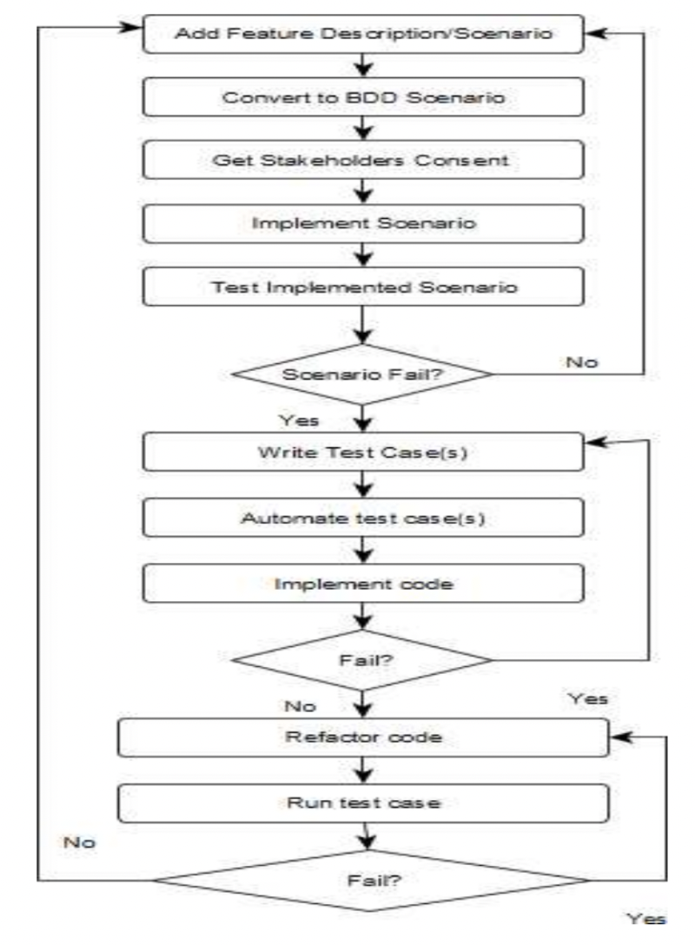
Figure 3: BDD workflow [3]

BDD tests are also versatile and can be performed at various stages of the development phase [13]. Indeed, one of the benefits of using BDD is that it identifies potential issues early in the development process [14]. By collaborating with other developers and stakeholders, misunderstandings and issues can be identified early on, saving resources such as time and effort. The communication aspect of BDD also improves collaboration and enhances code quality [13, 14].Moreover, BDD encourages the development of automated tests, which help ensure that new features do not compromise the functionality of existing code [14].

However, there are also potential drawbacks. Similar to TDD, BDD can pose a steep learning curve, particularly for inexperienced developers. Extracting scenarios from user requirements can be complex, and if not done properly, it may lead to poorly defined or duplicate scenarios. This can result in redundant work or undermine the benefits of collaboration, as much time may be spent trying to understand what the test cases are meant to validate. The need for constant communication to ensure alignment, the intensive time required to map scenarios to code, and the cost considerations can make BDD challenging to scale for large software projects [13, 14].

Feature-Driven Development (FDD) was introduced in 1997 by Jeff De Luca and Peter Coad during a large, complex project that posed significant challenges. This experience led to the development of FDD as a practical approach to managing complexity and delivering incremental value within defined timeframes. FDD is one of the Agile development methodologies that emphasizes short iterations (typically two weeks) to produce functional deliverables [2, 8, 10, 11, 12]. The core idea of FDD is to control software development by focusing on business requirements [2, 8].
FDD works especially well with large teams, where challenges arise due to varying levels of skill, talent, and discipline among team members. FDD addresses these challenges by holding specific events and activities to promote communication and by clearly defining roles and responsibilities, all while ensuring high output throughout the project [2, 8].To accomplish this, six key roles are allocated in FDD, with flexibility in their distribution—multiple members can share a single role, or one member can take on multiple roles [2,11].
  - Project Manager: Responsible for administrative decisions and ensuring a supportive working environment.
  - Chief Architect: Approves the requested software designs to align with the overall system architecture.
  - Development Manager: Oversees the team and ensures smooth execution of development activities.
  - Chief Programmer: Leads small developer teams and selects the features to be implemented during each iteration.
  - Class Owner: Responsible for designing, coding, and testing specific features assigned to them.
  - Domain Expert: A specialist with deep knowledge of the specific business domain who understands how the business operates and its needs.

FDD follows a five-step process, with the first three steps executed sequentially and the last two steps executed iteratively (Fig. 2)

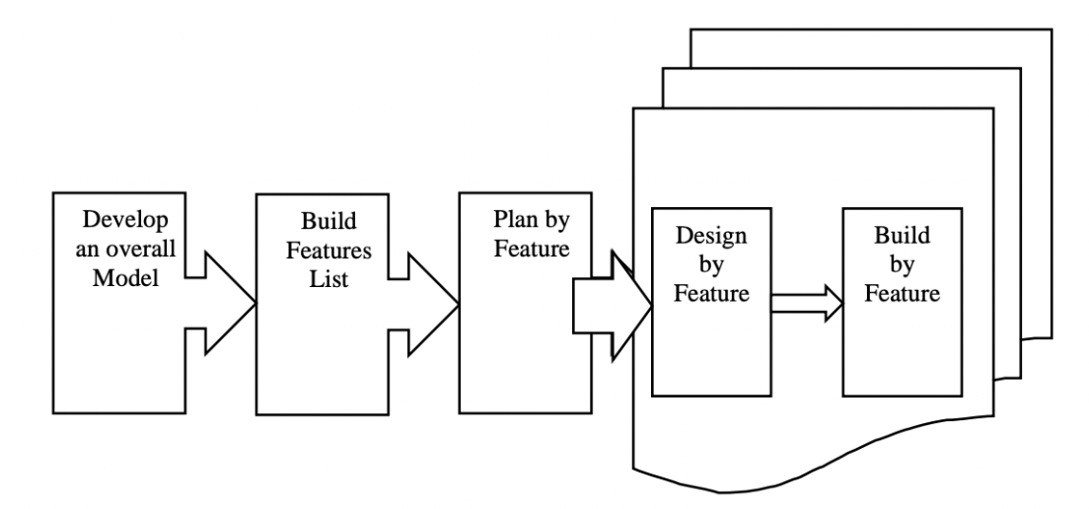

Figure 2: FDD Workflow [10]

  - Develop a Model: In the first step, all team members collaboratively define the overall project context and scope. Models are brainstormed and generated to represent various approaches, and the optimal model for meeting the project's requirements is chosen.
  - Build a Feature List: Using the model created in the previous step, a comprehensive list of features that users need is constructed. This list is reviewed and validated by customers and business experts to ensure it aligns with their expectations and requirements.
  - Plan by Feature: The features from the previous step are prioritized based on customer needs. The plan includes a schedule with major milestones for each feature. The project manager, development manager, and chief programmers are involved in this step. Chief programmers assign specific features to individual developers, referred to as "class owners."
  - Design by Feature: In this iterative process, which typically lasts up to two weeks, the chief programmers and class owners collaboratively create a design package and sequence diagrams for each class. These designs are reviewed for approval before development begins.
  - Build by Feature: This is the final step, where coding, code inspection, and testing are performed. Once a feature is successfully developed and validated, it is integrated into the main build. The process then repeats with the next feature.

If there are any late changes to the prerequisites or business needs, these can be accommodated because designing and building features in FDD is an iterative process [9, 11]. This makes FDD highly adaptive. The short iterations, typically lasting one to four weeks, enable quick feedback from customers. Additionally, constant feedback within the team and clear accountability for each member ensure that high-quality deliverables are produced after each phase [2, 11].
However, FDD is not without its limitations. It relies heavily on highly skilled experts for designing and modelling, and a lack of such expertise can result in subpar deliverables. Furthermore, FDD provides no standardized guidance on requirement gathering, analysis, or risk management. The documentation process can also become more intricate due to detailed modelling and frequent iterations, requiring frequent updates to documents. Finally, the lead software engineer faces significant overhead, often juggling multiple roles such as facilitator, coach, and lead originator [2, 9, 10].

TDD, BDD, and FDD are agile methodologies used in iterative development, and they are not inherently exclusive, as they focus on different aspects of the development process. For instance, TDD addresses the "how" of development by writing tests first, ensuring high test coverage, and avoiding redundant code, which leads to high-quality code [2]. Since TDD primarily involves developers, it is particularly beneficial for projects where code quality is paramount.
While some research suggests that BDD can lead to higher customer satisfaction and potentially reduce development time compared to TDD [3], these improvements are largely due to BDD being a refinement of TDD [4]. BDD adds a layer of behaviour-focused development and collaboration, enhancing alignment with user needs and streamlining the development process [3, 13]. BDD excels in projects where there is heavy collaboration between technical and non-technical stakeholders, particularly when the focus is on the "why" of a feature. It is especially effective for applications where critical user experience is paramount [14].
FDD, on the other hand, focuses on the "what' of the development and is designed for large-scale projects, where features need to be broken down to manage complexity. Developing features incrementally and iteratively, with feedback incorporated between increments, increases the likelihood of completing large-scale projects effectively [9].

To conclude, TDD, BDD, and FDD are agile practices that enable individuals and teams to build software products iteratively and effectively. While these methodologies all aim to improve code quality and streamline agile processes, each has its own focus. TDD is specifically centered on the code level of software development, with effective testing and test coverage at its core. BDD, on the other hand, emphasizes cross-collaboration and bridges the gap between technical and non-technical stakeholders in building the product. FDD focuses on breaking down large-scale software projects into smaller, manageable features, allowing for better project management. However, each of these methodologies can have a steep learning curve, and if not implemented correctly, they may lead to a loss of time and resources, thus forfeiting their intended advantages. Ultimately, when properly applied, these agile practices can greatly enhance software development efficiency and ensure high-quality, user-centric products.

TASK 2

Software systems require continuous updates to adapt to evolving business requirements and emerging technologies. Consequently, software becomes increasingly complex, fragile, and difficult to maintain. Reusing software components can help reduce development costs for new systems, while also enhancing maintainability by eliminating the need to rebuild components from scratch. The shift to object-oriented programming in the mid-1990s facilitated the creation of reusable components to address these challenges [2]. There are several key attributes used to evaluate object-oriented design, including cohesion, coupling, data hiding, and information hiding [1-19]. Object-oriented design emphasizes high cohesion and low coupling, while promoting both data and information hiding [3]. Understanding why this approach is effective requires further investigation.

Coupling is a measure of the interdependence between software components, i.e., the degree to which one component relies on another [3][10]. Different levels of interdependence between software components exist, ranging from the loosest to the tightest coupling, as follows [3]:
- Data Coupling: Occurs when simple data is exchanged between interconnected components.
- Stamp Coupling: Occurs when a portion of a data structure is passed between components.
- Control Coupling: Happens when one component passes control information to another, typically in the form of parameters or flags.
- External Coupling: Happens when two components are connected through an external environment, such as interacting via an input/output device.
- Common Coupling: Occurs when interacting components share and access global data.
- Content Coupling: Occurs when one component directly accesses and modifies the internal data or implementation of another module.
While coupling is generally undesirable, especially if it leans toward the tight end, in most cases, it is not entirely avoidable [10]. Therefore, loose coupling is preferred.
Cohesion is a measure of the relative functional strength of a component, i.e., how closely the parts of a component work together to achieve a common goal [3][10]. Cohesion can be categorised from the lowest to the highest as follows [3][10]:
- Logical Cohesion: Occurs when elements within the component are related logically, but perform different tasks.
- Temporal Cohesion: Occurs when tasks are grouped together because they need to be executed within the same time frame or sequence.
- Procedural Cohesion: Occurs when tasks are grouped together because they follow a specific sequence or process.
- Communication Cohesion: Occurs when tasks are grouped together because they operate on the same set of data or data structure.
- Sequential Cohesion: Occurs when the output of one element is used as input for another element within the component.
- Functional Cohesion: Occurs when the component performs a single, well-defined task.
Loose coupling and high cohesion are highly desired because they are associated with desirable traits of software, including maintainability, reusability, reliability, scalability, and testability [1-10]. In essence, software with high-quality characteristics tends to have loose coupling and high cohesion.

Higher cohesion and low coupling are essential factors in improving software maintainability and reusability. High cohesion ensures that related functions and responsibilities are grouped within the same module, reducing the effort required for maintenance [1]. Low coupling, on the other hand, minimises dependencies between modules, which contributes to a system's overall quality [2]. Together, these characteristics reflect internal quality factors that enhance software modularity, making the system easier to understand, maintain, and extend.

Additionally, high cohesion and loose coupling also enhance interoperability, enabling seamless communication and integration across diverse platforms and devices. This interoperability facilitates system expansion, thereby improving scalability—an essential factor for the Internet of Things (IoT), cloud service providers, and various applications. For instance, in IoT, high cohesion ensures that each component performs a specific task, and loose coupling allows different components to connect and interact with each other while minimising interdependencies. This design approach simplifies the addition of new devices or services, promoting scalability.

In contrast, when modules lack cohesion, they perform unrelated tasks, leading to increased complexity and difficulty in maintenance. Similarly, tight coupling creates strong interdependencies, which can increase the risk of errors and system failures. Modifying one part of the system may require changes elsewhere, thereby increasing code anomalies [7]. Such tightly coupled systems are difficult to maintain, test, and reuse, demanding significant time and effort due to the increased dependencies between components and classes [8].

As software complexity increases, achieving low coupling and high cohesion becomes more challenging. Interconnected components and the expanding responsibilities of individual modules make the system harder to manage [6]. This increased complexity can negatively affect maintainability and overall software quality, making the system more prone to failures, which in turn raise time, cost, and resource demands [4][9]. Despite these challenges, maintaining low coupling and high cohesion can reduce complexity by creating more modular components, ultimately leading to higher-quality systems [4][9]. This is why coupling remains a key principle in object-oriented programming [6].

Data hiding, also known as data encapsulation, is a fundamental concept in object-oriented programming. It involves hiding the internal data of objects and exposing only essential data or methods through well-defined interfaces, ensuring that users can access only relevant information [11, 12] (Fig. 1). This approach helps protect the internal structure of objects from unauthorized access or unintended modification, thereby enhancing data integrity and security. By controlling access, encapsulation ensures that data can only be modified in controlled ways, which contributes to better maintainability [11–13]. Most programming languages implement encapsulation using access modifiers, which define the scope of classes, variables, and methods, as well as getter and setter methods, which provide controlled access to private attributes [13].

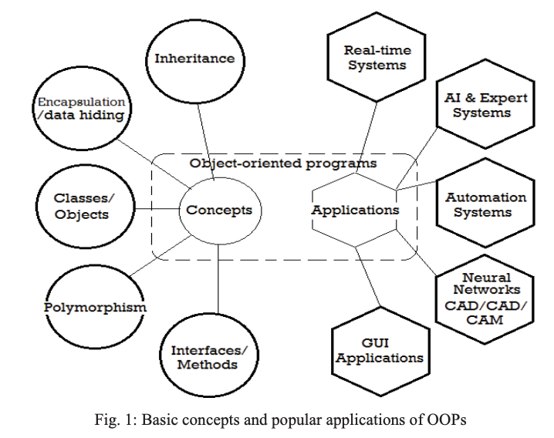

Encapsulation often leads to information hiding, where the internal functionality of an object is abstracted. This prevents direct access to the object’s internal state, ensuring that only the necessary operations are exposed. The principle of information hiding, proposed by David Parnas in 1972, also suggests breaking down systems into modules with minimal dependencies on one another, increasing modularity. Each module’s design decisions are hidden from others, improving system flexibility and comprehensibility. This principle directly supports the creation of microservices—modular services that can be developed and maintained independently. By adhering to information hiding, microservices systems can benefit from shorter development times and increased flexibility [14,15].
The increased modularity in microservices also reduces system complexity, making it less prone to errors and system failures. Scalability is also improved as individual faulty modules can be debugged or replaced without disrupting the entire system. Furthermore, with greater modularity, different individuals can work on separate modules, enhancing collaboration and leading to shorter development times [14]. Additionally, the separation between internal and external system components allows for easier changes to the internal structure without affecting other parts of the system, resulting in simpler refactoring and better system maintenance [13].

Encapsulation and information hiding are also crucial in the design patterns of object-oriented programming. Common patterns, such as the factory pattern, façade pattern, and observer pattern, rely on encapsulation to hide complexity behind well-defined interfaces, leading to more scalable and maintainable codebases [17-19].
In the factory pattern, for instance, the instantiation logic of the superclass is encapsulated, allowing the client class to decouple from the implementation details. This also leads to greater flexibility, as modifications to the creation logic will not affect the client code [17].
Similarly, in the façade pattern, a high-level interface is provided to hide the complexity of the underlying subsystem, simplifying the system and making it easier to use and understand [18].
Likewise, in the observer pattern, one object notifies its dependent objects (observers) by calling their methods. The details of these methods do not need to be known by the notifying object, promoting loose coupling and enhancing scalability [19].
However, while these patterns can enhance code organisation and maintainability, their improper application may introduce unnecessary complexity and overhead [18].

To conclude, loose coupling, high cohesion, data hiding, and information hiding are important aspects of software development. Low coupling and high cohesion often work in tandem, as they improve reliability, maintainability, and scalability in software applications. In short, they enhance the quality of the software. In contrast, their reverse—tight coupling and low cohesion—introduces more complexity and the risk of code anomalies to the system, making them undesirable. As software applications become more complex as they mature, maintaining loose coupling and high cohesion becomes increasingly challenging. Data hiding and information hiding are important not only for data integrity and security but also to promote modularity and scalability in systems such as microservices. Applying these principles consistently throughout the software development process ensures a more resilient, adaptable, and efficient system that can better meet evolving demands.

