Student Self Evaluation Form

This section repeats in brief the common assessment criteria detailed on previous pages. The extent to which these are demonstrated by you determines your mark. Using these criteria, tick the box that best indicates the level of achievement you feel you have achieved with regard to each of them.

Common Assessment Criteria Applied
Common Assessment Criteria Applied | REFER |  | D |  | C | B | A
 | OUTRIGHT FAIL | UNSATISFACTORY | SATISFACTORY |  | GOOD | VERY GOOD | EXCELLENT
1. Subject Knowledge and Understanding (which includes using research-informed literature and knowledge and understanding of the subject) |  |  |  |  |  |  | x
2. Intellectual Skills (Analysis) |  |  |  |  |  |  | x
3. Pedagogic and Professional Applications  (Practical Application and Deployment) |  |  |  |  |  | x
4. Key Transferable Skills |  |  |  |  |  | x
PLEASE COMMENT ON AREAS IN WHICH YOU FEEL THAT YOU HAVE PERFORMED WELL |  |  |  | PLEASE COMMENT ON AREAS you feel that you need TO DEVELOP
Research  Referencing  Critical analysis |  |  |  | What not to include.

Student Number | 1700279
Date | 13 April 2018
Module Title | The Enquiring Teacher
Module Number | ECPP7001

Word Count: 6094

Written assignment based on a small-scale research project. Research Question: “Is Think, Trio, Share an effective strategy for accessing and developing prior knowledge within a Key Stage 2 setting?”

Introduction
This essay will describe a research project carried out in two primary schools in Wales, identify the research process and discuss subsequent conclusions leading to possible recommendations for future practitioners. After witnessing the power of collaborative learning in a primary classroom on many occasions, I identified this as an area that I would like to explore in more detail. I was interested to know how a pedagogic collaborative model might be improved to enhance the children’s learning.
During discussions with my research partner, who also held an interest in the subject, we discovered that both of our schools already practiced a similar co-operative learning technique, Think, Pair, Share (Lyman, 1981). The children in my class knew this as Talk Partners, however the same process was followed, i.e. the children were asked a question and allotted a short amount of individual think time to consider their responses, they were then asked to pair with talk partners to discuss their ideas in more depth and synthesise their answers; the answers were then shared with the class as a whole. In each school, the model was used mainly at the start of the lesson to access and develop prior knowledge.
In general, the children in my class responded well to this activity suggesting that they enjoyed working with their peers and presenting their responses back to the class. There was often an odd number of pupils in the class as the class had an odd number of pupils in total, as a result, some groups became trios instead of pairs. My research partner explained that the same scenario happened in her class mainly due to absences and so we concluded that we would like to investigate the impact of this third person on the collaborative learning group. Following further discussion, we refined and arrived at our research question “Is Think, Trio, Share an effective strategy for accessing and developing prior knowledge within a Key Stage 2 setting?”
My school is a Church of Wales primary school in the centre of a town with 442 pupils aged three to eleven years including 49 pupils in the part-time nursery provision. My class is a Year 3 class in a Key Stage 2 setting consisting of 27 children in total.
My research partner’s school is an inner-city primary school with 353 pupils on roll aged three to eleven years. This includes around 53 pupils in the two part-time nursery classes. Also within a Key Stage 2 setting, the class is a Year 5 / Year 6 class consisting of 26 pupils in total.
The first stage of the research would involve the pupils in my class utilising an adapted version of a collaborative technique with which they were already familiar and comfortable with using i.e. Talk Partners.
Think, Pair, Share is a form of group work or ‘active learning’ (Bonwell & Eison, 1991 cited in Davidson & Major, 2014: 8) devised by Dr. Frank Lyman.
To learn more about this area of study, I referred to books, journals, government documents and educational blogs, looking for literature about collaborative learning. During the course of this investigation, I soon discovered that the term cooperative learning was used alongside and sometimes instead of the term collaborative learning.
Ireland’s Primary Professional Development Service defines the difference as,
When children are working in pairs/groups, they are working collaboratively. Co-operative learning is a form of collaborative learning, in which the group works together to maximise their own and each other’s learning… It could be said that in collaborative learning, the children are working in a group, whereas in co-operative learning they are working as a group!
(Primary Professional Development Service, date unknown/no date: 2).

And yet, in Scotland, the two words are used alongside each other to denote the same practice ‘collaborative or cooperative learning is a growing feature of the day-to-day work of Scottish schools as they implement Curriculum for Excellence’ (The Learning Curve, 2009: 7).
Davidson & Major (2014: 8) succinctly describe this dilemma, ‘unfortunately, the terminology associated with group-learning approaches has become so entangled that it is difficult to distinguish between them, and there are unclear and even muddled messages in the literature.’
Based upon this understanding, I then broadened my research scope to encompass collaborative learning, cooperative learning and group work. Consequently, for the purposes of this essay, I will also use the terms ‘collaborative’ and ‘cooperative’ interchangeably when describing group work and cultures within classrooms.
Cooperative or collaborative learning has many supporters. According to Hattie (2012: 88) ‘cooperative learning is certainly a powerful intervention’ and Marzano (2012 cited in Nottingham, 2013: 27) states that ‘organizing students in cooperative learning groups has a powerful effect on learning (effect size 0.78).’
Slavin (1981) and Johnson and Johnson (1984) state that ‘the use of cooperative learning structures promotes student involvement and increases verbal interaction, resulting in positive effects on attitude and achievement’ (Cited in Lyman, 1988: 19).
In contrast, some teachers believe
that group work will interrupt or lead to slow coverage of the curriculum; that it will involve the loss of control, increased noise, disruption and off-task behaviour; and beliefs that children cannot work together and are unable to learn from one another or that it is only the more able that can benefit from group work.
(Baines et.al., 2014: 16).

However, Christie and his peers (2004: Introduction) stated at their annual conference that ‘research has established beyond dispute that interaction between learners is a powerful and natural mechanism for promoting enhanced clarity of conception and articulation.’
Furthermore, Tienken and his colleagues (Tienken et.al., 2009: 43) describe Lyman’s Think, Pair, Share model as an ‘effective strategy to increase student participation.’
Ahmed and Awad (2017: Abstract) agree, ‘think-pair-share strategy plays a positive role in improving students’ oral communicative skills, creating a cooperative learning environment and enhancing students’ motivation to learn better.’
Lyman describes his model as ‘a multi-mode discussion cycle’ that ‘combines the benefits of wait time and cooperative learning’ (MacTighe and Lyman,1988: 19).

The process of Think, Pair, Share is shown below:
- The teacher asks a question and the pupils are given a short time to think individually about the responses.  - The pupils pair up with another pupil to discuss the answers to the question.  - The teacher asks each pair in turn to share their ideas with the whole class. | 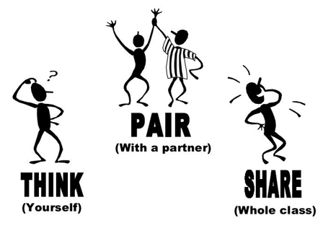  (Google Images, 2018)

Our research would involve creating a trio instead of a pair at step 2 of the process as we were interested in discovering the impact the additional person might have on the Think, Pair, Share model. To paraphrase the Primary Professional Development Service (date unknown/no date: 2), it would increase the interactions between the participants from two to six which may prove more challenging, however, it would encourage a greater depth in the scope of contributions.
See below an image depicting the number of interactions in direct correlation to the number of participants in group work:
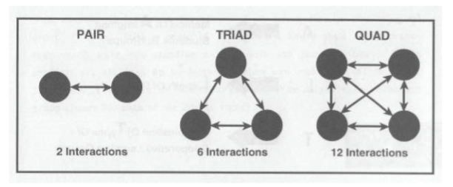
(Primary Professional Development Service, date unknown/no date: 2).
According to Marzano (2012 cited in Nottingham, 2013: 27), ‘cooperative groups should be kept to pairs or at the most groups of 3-4.’
It would be interesting to discover if the third person in the research would enrich or hamper the learning process and how the children would feel and behave with an additional member in the group. Would the children remain ‘on task’ and continue to learn from each other (Vygotsky, 1978 cited in Papatheodorou et.al., 2012: 9) or would the additional person have a disruptive impact on the dynamics of the group?
Before we examine the research methodology employed in this study, let us first consider the question “why do we research?” Hattie (2009:22) believes that ‘the biggest effects on student learning occur when teachers become learners of their own teaching. ‘Whereas professor David Hargreaves claimed that a great deal of educational research ‘clutters up academic journals which virtually nobody reads’ (The Independent, 9 April 1998, cited by Welsh Government, 2015: 6).
See below a model showing the varying views about research:
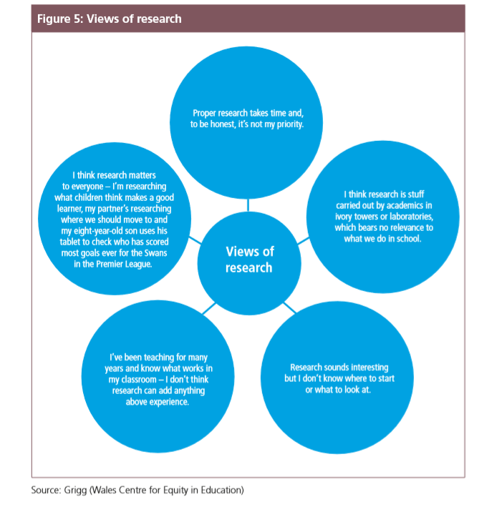
(Cited by Welsh Government, 2015: 6)
Nevertheless, according to Donaldson (2015: 71) sound pedagogy ‘…requires high-quality teachers with a sound understanding of the ‘why’ and ‘how’ of teaching as well as the ‘what’.’
It would seem then that to become effective teachers, we must first understand how children learn from our teaching techniques before we can move the children’s learning forward.
The research methodology to be employed in this project would be Lesson Study. Lesson Study is a form of action research that was developed in Japan, enabling collaboration and reflection amongst educational practitioners. The teachers select their own research question, thus creating ownership and based upon the evidence collated from their own data analysis, the teachers incorporate the voice of the pupil to enhance the quality of their teaching (UWTSD, 2018).
Lesson study has many supporters (Robinson et al 2009; Triwaranyu 2007; Fernandez 2002) and has been incorporated into the Welsh Government’s strategy for Continuing Professional Development (CPD). In the new professional standards, the role of the teacher as a Professional Learner is positioned as one of the key values and dispositions as shown in the model below:
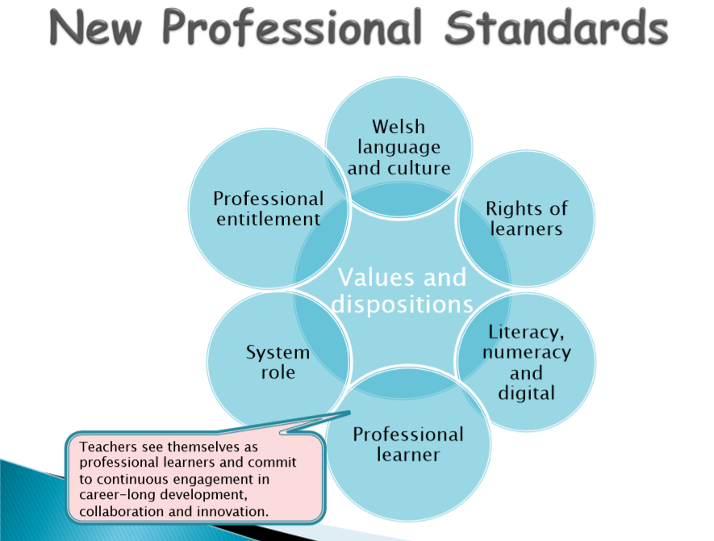
(UWTSD: 2018, 12)
However, following a Lesson Study project, the Education Endowment Foundation (2017) claims ‘the project found no evidence that this version of Lesson Study improves maths and reading attainment at KS2.’ Weston counter-argues (2017) that the Foundation then proceeds to state ‘this result does not show that all activities related to Lesson Study are ineffective.’ (2017) The report also recognises the value that the teachers placed on the project, seeing it as ‘useful professional development, valuing the opportunity to collaborate with colleagues in a structured way’ (2017).

According to Triwaranyu (2007:49), ‘lesson study is an approach that responds to teachers' desire to work together, focuses on student learning, concentrates on classroom issues, and improves teachers' knowledge and skills.’

Indeed, his model below shows the many advantages of Lesson Study:
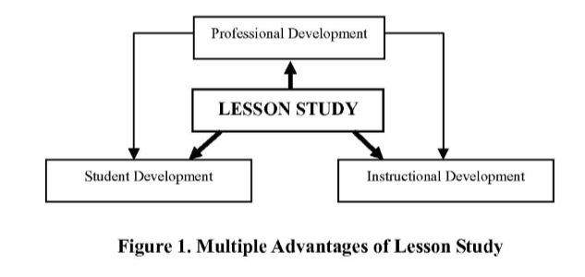
(Triwaranyu: 2007, 50)

Ideally, the lesson study process should consist of three lesson study cycles, however, due to the time constraints of the P.G.C.E. course and the parameters of the assignment, this research project consisted of two lesson study cycles. The standard Lesson Study process is shown below:
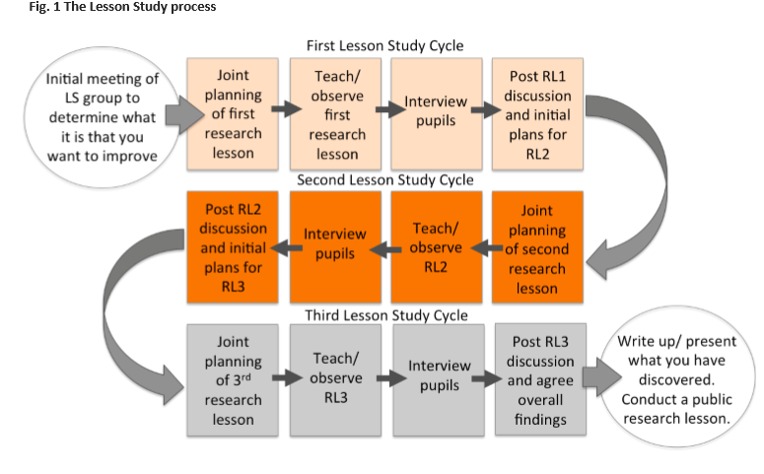(Dudley, 2014: 5)
Within the Lesson Study model, we would use the non-participant observation and focus interview research methods to capture the data. Each of these methods would provide us with qualitative data, from which we could draw evidence to inform our future practice. As opposed to quantitative data, ‘qualitative data tends to be associated with small-scale studies’ (Denscombe, 1998: 175), however, it must be noted that ‘a distinction between qualitative research and quantitative research is far from watertight’ (Denscombe, 1998: 173).
One of the disadvantages of direct observation is the risk of ‘inherent subjectivity’ (Mac Naughton et.al., 2010: 316), however, it does enable the researcher to view the participants in their natural setting (Welsh Government, 2015: 27); it is the ‘least obtrusive way of collecting evidence’ (Mac Naughton et.al., 2010: 316) and offers ‘one of the most versatile ways of gathering information’ (Simpson & Tuson, 1995: 3).
We would carry out two separate Think, Trio, Share activities during each research lesson; one would be conducted at the start and the other towards the end of the lesson and we designed an observation form to inform our evidence-based research. The key difference between traditional observation and Lesson Study observation, to paraphrase Dudley (2015:10), is that it is the ‘pupils’ learning’ and not the ‘teacher’s teaching’ that is the focus of the observer’s attention.
The observation forms asked the following questions in relation to the pupils in the Think, Trio, Share groups:
- Are they engaged?
- Are they communicating?
- Are they on task?
- Are they taking it in turns sharing ideas?
- Are children listening and responding?
- Are they accessing and developing their prior knowledge?

Although interviews are ‘time consuming ‘ (Bell, 2008: 157; Denscombe, 1998: 136), they do offer the most flexible approach for data collection (Denscombe, 1998: 136) facilitating direct interaction with the respondents (Denscombe, 1998: 136) and, according to Bell (2008: 162), the use of focus groups is ‘undoubtedly valuable when in-depth information is needed’. We would carry out the focus interviews with three pre-identified target pupils at the first opportunity, in line with Dudley’s guidance (2014: 12), directly after each research lesson. According to Mac Naughton and his colleagues, ‘selecting representative samples is quite complex’ (2010:27). ‘Generally speaking, more data means more time in the collection phase and more time analysing the results’ (Mac Naughton et.al., 2010: 27).
Due to the use of qualitative data instead of quantitative, the time parameters and resources of the project, the target group could not be too large and in accordance with the Lesson Study model (Dudley, 2014: 4), we would select three pupils from each class to participate in the focus group interviews.
The focus group was chosen as a sample of broadly representative pupils with differing levels of literacy. In line with Norwich and Jones’ (2014: 26) guidance we chose ‘case pupils who represent a straightforward sample of the learners in the class as a whole or who may typify groups of learners in the class.’
Opening the interview with some ‘warm-up’, non-threatening questions with the view to putting the interviewees at their ease, (Mukherji and Albon, 2012: 129), we would then ask the following semi-structured, open-ended questions to capture the pupil voice in the form of qualitative data:
- Do you like using Think, Trio, Share? Why?
- Did you think it was beneficial having the additional person during Think, Trio, Share? Why?
- Do you feel like you learnt more from Think, Trio, Share rather than individual thinking? Why?
- Would you use Think, Trio, Share again? Why?
The teacher in each lesson study would pose the questions to the interviewees and the non-participant observer would take the notes, attempting as much as possible to record the answers verbatim. This would enable the teacher to ‘focus…attention on the interviewee, give appropriate eye contact and non-verbal communication’ (Blaxter et.al., 2007: 172) whilst remaining neutral (Denscombe, 1998: 115). This approach would also be less distracting for the children and provide an ‘instant record’ (Blaxter et.al., 2007: 173) of the interview. The non-participant observer would then type up the notes and share them with the teacher. By taking the notes during the interviews in this way, we were able to avoid the risk of forgetting and omitting key details (Blaxter et.al., 2007: 173).
The room we chose for the interviews was the PPA room as it was quieter than their classroom which overlooked the playground. It would also be lunch-time and other children might be moving through the corridors or playing noisily in the playground. The focus group children would sit on comfortable chairs in front of us.
Aware of the ‘interviewer effect’, during these interviews, we would remain ‘neutral and non-committal on the statements made during the interview by the interviewee’ in order to ‘encourage the right climate for an interviewee to feel comfortable and provide honest answers’ thus ‘minimising our impact on the outcome of the research’ (Denscombe, 1998: 117).
The children would be given thinking time following the question to formulate their answer. As a research method, ‘focus group interviewing is also a useful strategy with children because they may be familiar with taking part in group discussions’ (Mukherji and Albon, 2012: 131), which the children in our target schools clearly were due to the collaborative approach already employed within their classrooms.
Reflection is regarded as ‘central to a cycle of planning, teaching, monitoring and evaluating,’ (Grigg, 2015: 30) and ‘when someone reflects-in-action, he becomes a researcher in the practice context’ (Schon, 1983: 68). Therefore, according to Pollard (2018: 26) ‘teachers can confidently expect to raise their standards of professional competence through adopting processes of reflective teaching’ and the Welsh government believes that is it through the practice of reflection that teachers can develop ‘new knowledge and skills’ it encourages ‘self-awareness’ leading to ‘deep learning’ (2015: 14).
As a ‘central’ component of the research, reflection would occur during the lesson with reflection-in-action (Schon, 1983). Reflection-on-action (Schon, 1983) would be captured after the event in the form of the Assistive Reflective Conclusions (ARC) model shown below:

ARC Reflection Model:
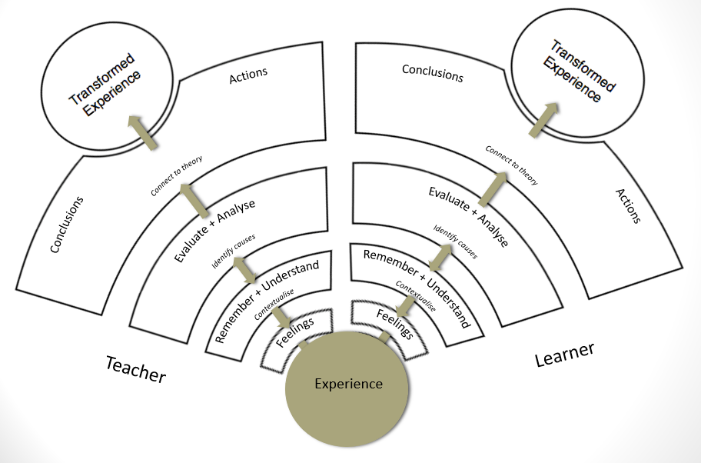
(UWTSD, 2017: 6)

I conducted my research in line legal requirements and Best Practice. British Educational Research Association (BERA) defines ‘voluntary informed consent’ as ‘the condition in which participants understand and agree to their participation without any duress, prior to the research getting underway’ (BERA, 2011: 5). I explained to the children in my class that we would be carrying out a research project, the results of which would be used to help their learning. The children were asked to confirm their assent via a blind thumbs-up or thumbs-down. Myself and the observer noted that each child had their thumbs up to confirm their assent. It was explained that if they wished to stop taking part in the research at any point, that they should make this known to either myself or the observer.
According to Mason and Danby (2011 cited in MacDonald, 2013: 257) ‘a major paradigm shift has occurred in child research – a shift from the child as the object of research, to the child as an actor in the research.’ At every opportunity, I endeavoured to ‘foreground the voices of children’ (MacDonald, 2013: 256) in my research, ensuring that the pupil voice was heard and listened to in line with UNICEF’s Article 12, ‘respect for the views of the child. Every child has the right to express their views, feelings and wishes in all matters affecting them’ (1990).
Prior to the lesson, I had also provided the teacher with parental consent forms to be sent home. I ensured that I had written parental consent for the three target children to be part of the research.
At no time during the research process were the names of any children recorded and the three target children were referred to as child a, child b and child c in the notes. The target children were asked before the interviews if the answers they provided could be used as part of the research.
The teacher was shown the notes on exit and confirmed that the notes were completely anonymous. At no point were the children ‘pressured by financial or other inducements to take part in the research’ (Mac Naughton et.al., 2010, 75). My Ethics form was approved by the Ethics Committee prior to the start of the research. Throughout the process, I monitored each child’s well-being to ensure that they were not upset or uncomfortable. The safeguarding policy of the school was followed at all times and the research was conducted in accordance with the Nuremberg code and the BERA Ethical Standards.
The principles underpinning the BERA guidelines state that ‘all educational research should be conducted within an ethic of respect for:
- The Person
- Knowledge
- Democratic Values
- The Quality of Educational Research
- Academic Freedom.’ (BERA, 2011: 4)
Indeed,
Giving ethics the attention it deserves results in ethically sound research. Research is ethically sound where it is conducted in accordance with rules, laws and codes of conduct which prevail in the research setting.
(Stutchbury and Fox, 2009 cited by University of Leicester).
Once the data collection tools and planning were complete, the next step was to ‘go into the field’ (Blaxter et.al., 2007: 167) and teach the lesson in the classroom.
In Lesson Study 1, the learning objective was to describe the attractions of Wales. The focus of the lesson was literacy which also incorporated numeracy and Curriculum Cymreig, giving the pupils ‘opportunities…to develop and apply knowledge and understanding of the cultural,…environmental and historical…characteristics of Wales’ (Welsh government, 2002: 4).
The key focus of the research lesson was Think, Trio, Share and the pupils were asked an open-ended question that would prompt discussion (Welsh government, 2010: 16) and given some individual thinking time to consider their responses.
Grouped into mixed ability trios (instead of their usual talk partner pairs), the pupils were then asked to discuss their ideas further. This collaborative model enabled them to develop their thinking, communication and listening skills. Furthermore, in accordance with the Welsh Government’s guidance (2010: 6) in establishing ‘effective group work’ and creating an effective learning environment, it ensured that ‘all contributions were valued’ and ‘no learners were excluded.’
The Share component of the model was then carried out and each group was invited to share their ideas with the whole class.
As part of the Lesson Study research, their engagement and behaviour were observed and recorded by my research partner, the non-participant observer. (See observation form in Appendix).
Following several input slides explaining the success criteria and providing information about Welsh attractions, the pupils were encouraged to use the “wow” words in their posters.
The pupils were then asked to select a topic and using their comprehension skills, extract key information from the printed resources to create a tourist poster. The class were already doing a project about Welsh Castles and the majority of the pupils in the class opted for castles as their topic.
Once the posters had been completed, and the children had achieved the learning objective, the children reconvened in their trios and discussed what they had learnt during the lesson. This second Think, Trio, Share was observed by the non-participant observer in the same way that the first had been at the start of the lesson.
The focus interviews with the three target pupils were conducted immediately following the lesson. (See focus group interview form in the Appendix).
In the post-lesson analysis with my research partner and using my reflection, we considered ways in which the lesson could be improved.
The data from the observation seemed to suggest the following: during the first Think, Trio, Share the children were engaged and ‘on task’; the children were communicating, listening and taking it in turns to speak. The children were accessing and developing their prior knowledge.
During the second Think, Trio, Share, it had been noted that most of the children were not displaying good listening skills and were talking over each other. However, they were still sharing ideas. One reason suggested for this was the timing of the lesson, just before lunch. The lesson the following day would be the lesson just before lunch and the timing of the lesson was beyond our control. Had it not been, we may have changed the lesson schedule to observe what might happen with the second Think, Trio, Share in a different time slot.
The data from the interviews appeared to suggest that the children valued the addition of the extra person in the Think, Pair Share model and they felt that it generated more ideas. When answering the question “do you like using Think, Trio, Share and why?” child a said “Yes, it was really helpful, one more makes it better, it is more like working as a team than just with one other person.”
When asked “Do you feel like you learnt more from Think, Trio, Share rather than individual thinking and why?”, child b said “Yes. Faster to get answers as if you don’t know and someone in your group does then it’s quicker.”
Child c responded to the question “Would you use Think, Trio, Share again and why?” with “Yes. Helps you more in groups than being in pairs.”
However, when child b was asked the question “did you think it was beneficial having the additional person during Think, Trio, Share and why?”, he said “No, because I was working with child x and he wouldn’t let me join in.”
On further analysis, this could suggest that merely placing the children in mixed ability groups during the Think, Trio, Share activity was not wholly effective as a stand-alone grouping strategy; perhaps the teacher also needs to ensure that all of ‘the talkative children are well distributed’ (Primary Professional Development Service, date unknown/no date: 7) to facilitate equal sharing of ideas.
We identified that although the children had used the printed materials effectively, in addition to the skills already identified, perhaps the research and digital competency skills of the children could also be developed in the next lesson. As the next school had good resources and each group would have access to a working i-Pad, they would be asked to research ideas for themselves and to include them in their poster.
As ‘one of three cross-curricular responsibilities’, digital competency could be integrated into this lesson in a ‘naturally occurring, meaningful way’ (Welsh government, 2016: 2) and by using technology in this lesson, it would ‘enable the confident, creative and critical use of technologies and systems.’ (Welsh government, 2016: 2). As the headteacher of one Digital Pioneer school explains ‘technology should only be included if it serves a valid purpose to enhance the learning’ (Dwyer, 2017) and after consideration, we believed that, in this lesson, it would serve a ‘valid purpose’.
The second Lesson Study took place the following day and was taught by my research partner to her Year 5 / Year 6 class of 26 pupils. As in the first lesson, the children were asked to design a tourist poster. The same skills were developed, i.e. thinking, communication, listening and comprehension with the addition of digital competency skills. The pattern of the research focus, Think, Trio, Share was repeated and observed by myself in the role of non-participant observer.
Directly after the lesson, the focus group interviews took place followed by post-analysis discussion between the researchers.
As an observer, I noticed that the format of both the observation form and the focus interview form could have been improved to allow more space for notes. In addition, the focus interview form could have been split into responses for child a, child b and child c to facilitate ease of note-taking.
The data from the lesson observation seemed to show very similar findings to the findings from the first lesson study in that during the first Think, Trio, Share activity, the children were engaged and focused, letting other children speak, sharing ideas and accessing and developing prior knowledge. In the second Think, Trio, Share activity at the end of the lesson, in the main, the children were unfocused, distracted and even if they were ‘on task’ they were not very enthusiastic about the discussion. Neither were they displaying good listening skills in the second Think, Trio, Share activity.
The data from the focus interviews appeared to show similar results to the data from the first set of interviews; the children seemed to value the input that the extra person could bring to the discussion.
In response to the question “did you think it was beneficial having the additional person during Think, Trio, Share and why?”, child c explained “Yes. With pairs, there’s only two brains and with one more person you have three brains. Three brains are better than two brains. You can get more ideas.”
In answer to the question “do you feel like you learnt more from Think, Trio, Share rather than individual thinking and why?”, child a said “Yes. We did because instead of thinking of your own ideas and getting stuck, there are more ideas working collaboratively.”
When asked the question “Would you use Think, Trio, Share again and why?” child c answered “It’s good. It’s easier. If you have to work independently there’s only yourself, but in a group there are more ideas.”
It would be worth noting that one of the target pupils told us that the Think, Trio, Share model “felt a bit weird because you have to talk to different people…” but thought it was “beneficial” because “it’s good to have more people”, then followed it up with “even if it still feels a bit weird, there are more ideas and bigger ideas.”
It was also interesting to recognise that the pupils from the Year 5/6 class were able to consider and identify which skills the model helped them to develop i.e. thinking, teamworking and collaboration skills.
Although the pupils from Year 3 had mentioned teamworking; in answer to the question “Do you like using Think, Trio, Share?” child a had responded with “Yes. It was really helpful, one more makes it better, it is more like working as a team than just with one other person”, the pupils had not pinpointed the skills they were developing to such an extent as the Year 5/6 class.
Following the post-analysis discussion and reflection, we analysed the results of the research study. It would appear from the focus group data then that the children valued the addition of the third person to the Think, Pair, Share model. The children believed that the extra person facilitated the sharing of more ideas within each group.
When comparing the data from the observational notes, it seems to suggest that the children were far more engaged in the first Think, Trio, Share activity at the start of the lesson, than they were in the second one towards the end of the lesson. Although the children in Lesson Study 1 were more enthusiastic when compared with the children in Lesson Study 2.
This could have been for a variety of reasons. Perhaps the children were hungry and ready to break for lunch. It would be interesting to teach the same lesson at a different time of day to see if their engagement would be the same. Maybe they felt they were repeating what they had already done at the start of the lesson. The findings would suggest then that Think, Trio, Share is an effective model for accessing and developing prior knowledge. However, the teacher should carefully consider the grouping of the trios and the timing of the activity because the research seems to suggest that it had the most impact on effective learning when employed at the start of the lesson.
Upon reflection, before my next research study I would ask myself the following questions.
Would it have been more beneficial to have larger focus groups, had time and resources allowed, or is three a representative number as recommended in the Lesson Study model (Dudley, 2014: 8)? Can the opinions of three pupils then be generalised to represent a whole class?
Although each Lesson Study was conducted within the same educational stage, i.e. Key Stage 2, whilst the pupils from the Year 3 focus interviews were able to talk about ‘team working’, the pupils from the Year 5/6 class were able to consider and identify (without prompting) which skills they were developing whilst working within a collaborative group. Was this due to the difference in ages and cognitive development or caused by another factor?
Would the research have been more valuable if it had been conducted within the same year group as suggested by Triwaranyu (2007: 55) ‘lesson study appears to work better when all teachers in the group teach the same subject matter at the same grade level’ or could this difference have been caused by a divergence in school cultures where the pupils in school b are taught to recognise the development of these skills and think about how they are learning (Hattie, 2012) and this ethos had not been instilled in the pupils in school a? Having taught in both schools, this could be a possible theory. School b had incorporated the teaching of ‘visible learning’ into their school ethos and school a was just at the start of this journey.
As two student teachers, although the research exercise itself was a learning experience, did we lack the necessary research skills and knowledge to carry out the research effectively? Dudley suggests (2014: 6) ‘Lesson Study works well when there is at least one member of the senior team involved and the teachers have a mix of teaching experience.’ Perhaps the addition of an experienced, knowledgeable teacher would have enhanced our learning.
Norwich and Jones (2014), when discussing teacher learning in relation to Lesson Study, summarise the key findings of large-scale studies by Cordingley et.al., 2014; Pedder, 2006; Opfer and Pedder 2010 and Pedder et.al., 2010 that examined the aspects of ‘professional learning that most impact on classroom practice and pupil learning’ as follows:
- Effective teacher learning takes place over months (not days);
- The classroom is the central location of professional learning activity;
- Experimentation or enquiry features in the teacher learning process; and
- There is a collaboration with one or more other professional(s) as part of that process (Dudley 2011)
(Norwich and Jones, 2014: 30).
Our small-scale research study was short due to the time parameters of the project. Would our learning have been enhanced if the project had been extended to include the third lesson study phase in-line with the full Lesson Study model (Dudley, 2014: 5)?
According to Blatchford and his colleagues (2003 cited in Blatchford et.al., 2017: 750), some ‘teachers show little awareness of the social pedagogic potential of various grouping arrangements’. Did we, as inexperienced student teachers not form our groups ‘on the basis of a strategic educational view of their purpose’ (Blatchford et al., 2003 cited in Blatchford et.al., 2017: 750)?
Did the children in the study have the necessary ‘relational skills that underpin successful group work’ (Blatchford et al., 2003 cited in Blatchford et.al., 2017: 751)? In Lesson Study 1, in answer to the question “Did you think it was beneficial having the additional person during Think, Trio, Share and why?” child b said “Yes and No. No because I was working with X and he wouldn’t let me join in.”
Or did the pupils show the ‘intolerance’ described by Nottingham (2013: 28) as one of the potential pitfalls of collaborative groups? Nottingham (2013: 28) explains further ‘members tend to reject any outside views that do not fit with their own.’
If, as a teacher, we should create a safe environment where the children are ‘co-learners’ (Baines et.al., 2007: 664) where ‘co-operation, collaboration and respect for fellow learners are paramount’ (Welsh Government, 2010: 6), would it be beneficial before the next collaborative learning activity to have a ‘refresher’ of the ‘ground rules’ of group work (Welsh Government, 2010: 7)?
As discussed earlier, it would appear that as a collaborative model, Think, Trio, Share is most effective for accessing and developing prior knowledge when used at the start of the lesson. Should we use Think, Trio, Share, or indeed any pedagogical technique, only when it is ‘purposeful’ and has the most impact on the children’s learning?
All of these questions may lead us to ask if this research study posed more questions than it answered.
It would seem that effective research is not a ‘one-off event’, but sustainable lesson study (Norwich and Jones, 2014: 62) involving collaboration with peers and senior practitioners leads to Continuous Professional Development. Indeed,
Teachers need to be viewed as ‘knowledge workers’: the best way to foster this approach is through school-based teacher professional development that links teacher inquiry and development with school improvement.
(Hill, 2013: 18).

See below a model showing how teachers access the ‘knowledge base’ during the Lesson Study process:
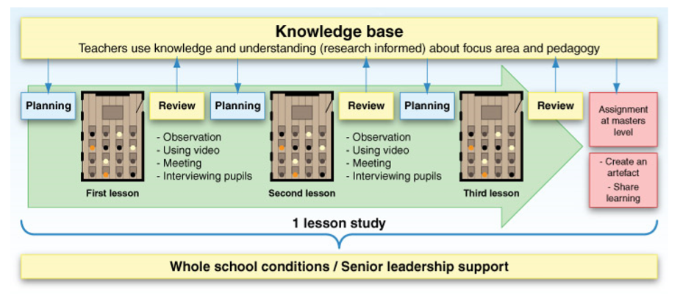
(UWTSD, 2018: 11)
According to Barber et.al (2010) ‘in the world’s most improving and highest-performing school systems teachers take responsibility for professional learning by systematically sharing successful practice and by routinely making practice public’ (cited by Norwich and Jones, 2014: 31).
Collaboration is identified as one of the five dimensions that forms the new professional teaching and leadership standards. See the model below:
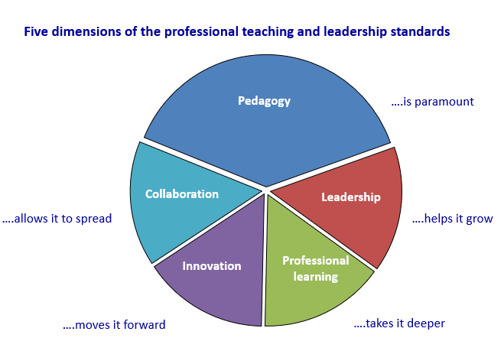
(Welsh Government, 2017: 7)

Had I been working in a school at the time of the research project, I would have shared my experience, recommendations and learning from the research with my colleagues and management in the form of formal presentations, informal chats, learning logs and learning walls creating ‘staffroom talk’ (Department for Children, Schools and Families, 2011: 13). In this way, the learning would be made ‘visible’ to other practitioners (Dudley, 2014: 16).
Steinberg and Kincheloe believe (2001: 3) that research cannot be effective if the researcher has ‘little sense of what larger purpose such research might serve’. We must therefore have a clear vision of what our research ‘could accomplish’ (Steinberg and Kincheloe, 2001: 3). Armed with this vision, it is as collaborative ‘reflective practitioners’ (Schon, 1983), that we can develop our roles as a ‘professional learners’ and facilitate ‘sustained highly effective practice’ (Welsh Government, 2017).

Reference List:
Baines, E. and Chowne, A. (2007) ‘Improving the effectiveness of collaborative group work in primary schools: effects on science attainment’, British Educational Research Journal, Vol. 33, No. 5, Autumn, pp. 663–680.
Bell, J. (2008) Doing your Research Project. (4th ed) New York: Open University Press.
BERA (2011) Ethical Guidelines for Educational Research. Available at: https://www.bera.ac.uk/researchers-resources/publications/ethical-guidelines-for-educational-research-2011 [Accessed 20th March 2018].
Blatchford, P, Baines. E., Rubie-Davies, C. and Chowne, A. (2006) ‘The effect of a new approach to group work on pupil-pupil and teacher-pupil’, Journal of Educational Psychology, 98, 4, pp.750-765. [Online] Available at: https://www.researchgate.net/publication/232474590_The_effect_of_a_new_approach_to_group_work_on_pupil-pupil_and_teacher-pupil_interactions [Accessed 5th April 2018].
Blaxter, L., Hughes, C. and Tight, M. (2007) How to Research. (3rd ed) New York: Open University Press.
Christie, D., Tolmie, A., Howe, C., Topping, K., Thurston, A., Jessiman, E., Livingston, K. and Donaldson, C. (2004) ‘The impact of collaborative group work in primary classrooms and the effects of class composition in urban and rural schools’ Teaching and Learning Research Programme Annual Conference Papers. Cardiff Marriott Hotel, Cardiff, Wales, UK, 22-24 November.
Denscombe, M. (1998) The Good Research Guide for small-scale social research projects. Buckingham: Open University Press.
Donaldson, G. (2015) Successful Futures: Independent Review of Curriculum and Assessment Arrangements in Wales Crown Copyright. [Online]. Available at: http://www.uwtsd.ac.uk/media/uwtsd-website/content-assets/documents/wcee/successful-futures.pdf [Accessed 10th April 2018].
Dudley, P. (ed) (2017) Lesson Study. Professional learning for our time. New York: Routledge.
Dudley, P. (2014) Lesson Study: A Handbook. [Online]. Available at: http://lessonstudy.co.uk/wp-content/uploads/2012/03/new-handbook-revisedMay14.pdf [Accessed 7th April 2018].
Dwyer, R. (2017) ‘We’re on a DCF journey like everyone else! Read about what we’ve learned.’ Available at: https://curriculumforwales.gov.wales/2017/03/17/were-on-a-dcf-journey-like-everyone-else-read-about-what-weve-learned/ [Accessed 14th April 2018].

Education Endowment Foundation (2017) ‘Lesson Study Project’ Available at:
https://educationendowmentfoundation.org.uk/projects-and-evaluation/projects/lesson-study/ [Accessed 10th April 2018].
Fernandez, C. (2002) ‘Learning from Japanese Approaches to Professional Development. The Case of Lesson Study, Journal of Teacher Education, Vol. 53 No. 5, Winter, pp. 393-405.
Grigg, R. (2010) Becoming an Outstanding Primary School Teacher. (2nd ed) Harlow: Pearson.
Hattie, J. (2012) Visible Learning for Teachers – Maximising impact on learning. Oxon: Routledge.
Hill, R. (2013) The future delivery of education services in Wales. Robert Hill Consulting. Available at: https://beta.gov.wales/consultations [Accessed 11th April 2018].
Ireland: Department of Education and Science, Primary Professional Development Service (no date) Promoting group work, collaborative and cooperative learning in the primary school Tip sheet for teachers. Available at: www.pdst.ie/sites/default/files/Session%203%20-%20PS%20Co%20-%20Op%20%EF%80%A2%20Group%20Work.pdf [Accessed: 10th April 2018].
MacDonald, A. (2013) ‘Researching with Young Children: Considering Issues of Ethics and Engagement’, Contemporary Issues in Early Childhood, 14, 3, January, pp.255-269. [Online]. Available at: http://journals.sagepub.com.ezproxy.uwtsd.ac.uk/doi/pdf/10.2304/ciec.2013.14.3.255
[Accessed: 9th April 2018]
Mac Naughton, G., Rolfe, S. and Siraj-Blatchford, I. (2010) Doing Early Childhood Research. (2nd ed) New York: Open University Press.
McTighe, J. and Lyman, F. (1988). ‘Cueing Thinking in The Classroom: The Promise of Theory-Embedded Tools.’ Available at: http://www.ascd.org/ASCD/pdf/journals/ed_lead/el_198804_mctighe.pdf
[Accessed: 9th April 2018]
Mukherji, P. and Albon, D. (2012) Research Methods in Early Childhood. An Introductory Guide. London: SAGE
Norwich, B. and Jones, J. (eds) (2014) Lesson Study. Making a difference to teaching pupils with learning difficulties. London: Bloomsbury.
Nottingham, J. (2013) Encouraging Learning. Oxon: Routledge.
Papatheodorou, T., Luff, P., and Gill, J. (2013) Child Observation for Learning and Research. London: Routledge.
Pollard, A. (2008) Reflective Teaching. (3rd ed) London: Conitnuum
Schon, D. (1983) The Reflective Practitioner. USA: Basic Books.
Simpson, M. and Tuson, J. (2003) Using Observations in Small-Scale Research – A Beginner’s Guide. Edinburgh: The SCRE Centre.
Steinberg, S. and Kincheloe, J. (2001) Students as Researchers: Creating Classrooms that matter. (2nd ed) London: Falmer Press.
Triwaranyu, C. (2007) ‘Models and Strategies for Initial Implementation of Lesson Study in Schools’, International Forum of Teaching and Studies, Marietta, 3, 3, Winter, pp.48-61.
UNICEF (1990) A Summary on the UN Convention on the Rights of the Child. Available at: https://www.unicef.org.uk/child-rights-partners/wp-content/uploads/sites/3/2016/08/CRC_summary_leaflet_Child_Rights_Partners_web_final.pdf [Accessed 12th April 2018].
University of Leicester (no date) ‘Doing Ethical Research’ Available at: https://www2.le.ac.uk/colleges/ssah/research/ethics/ethics [Accessed 12th April 2018].
UWTSD (2018) The Enquiring Teacher Handbook.
UWTSD (2018) The Enquiring Teacher – Session One.
UWTSD (2017) Reflecting using the ARC model.
Wales: Qualifications, Curriculum and Assessment Authority for Wales (2003) Developing the Curriculum Cymreig. Cardiff: Welsh Assembly Government, Available at: http://learning.gov.wales/docs/learningwales/publications/130424-developing-the-curriculum-cymreig-en.pdf [Accessed 13th April 2018].
Wales: Department for Education (2016) Digital Competence Framework Guidance. Cardiff: Welsh Assembly Government, Available at: http://learning.gov.wales/?lang=en [Accessed 13th April 2018].
Wales: Department for Education (2015) Effective use of data and research evidence. Cardiff: Welsh Assembly Government, Available at: http://learning.gov.wales/?lang=en [Accessed 13th April 2018].
Wales: Department for Education (2017) Professional Teaching and Leadership Standards. Cardiff: Welsh Assembly Government, Available at: http://learning.gov.wales/?lang=en [Accessed 13th April 2018].
Wales: Department for Education (2015) Reflective Practice. Cardiff: Welsh Assembly Government, Available at: http://learning.gov.wales/?lang=en [Accessed 13th April 2018].
Wales: Department for Education (2010) How to develop thinking and assessment for learning in the classroom. Cardiff: Welsh Assembly Government, Available at: http://learning.gov.wales/?lang=en [Accessed 13th April 2018].
Weston, D. (2017) ‘Does Lesson Study Work?’ Available at: http://tdtrust.org/lesson-study-work-look-new-eef-trial [Accessed 14th April 2018].

Appendix:

Observation form - Lesson Study 1:
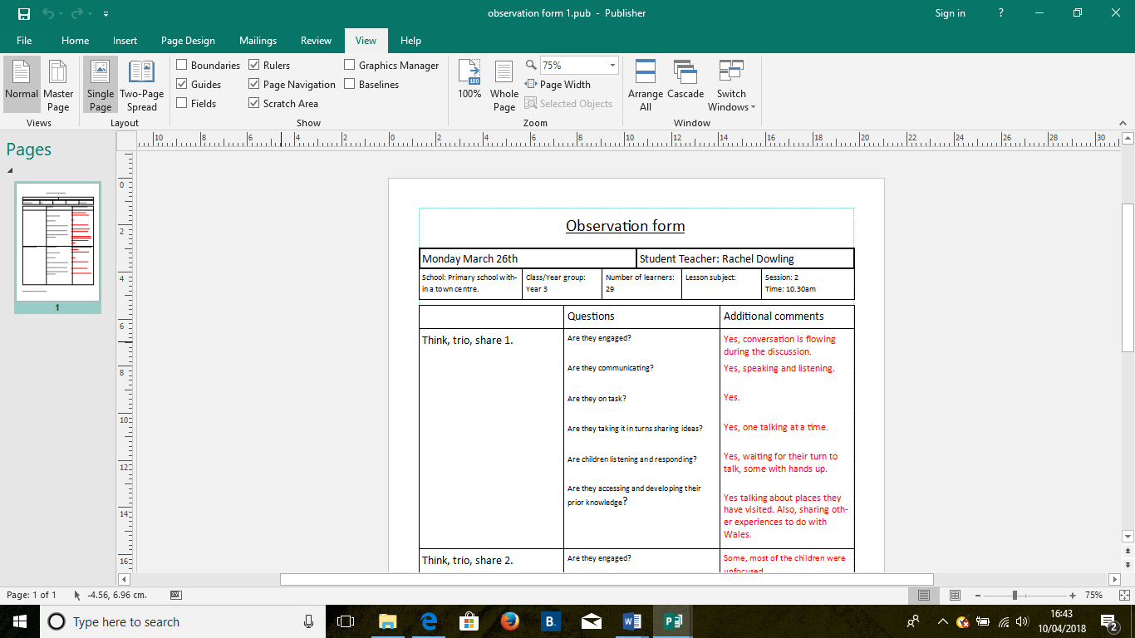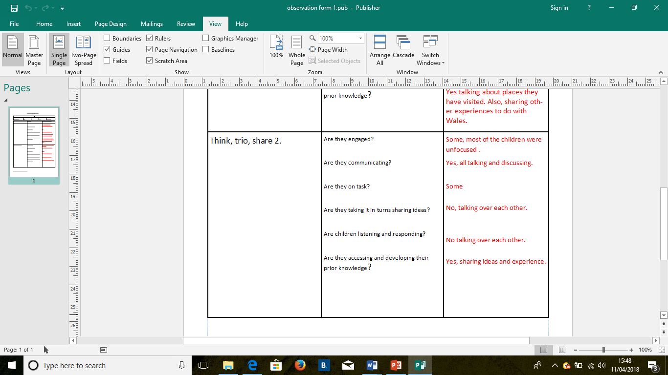

Focus Group Interviews – Lesson Study 1:
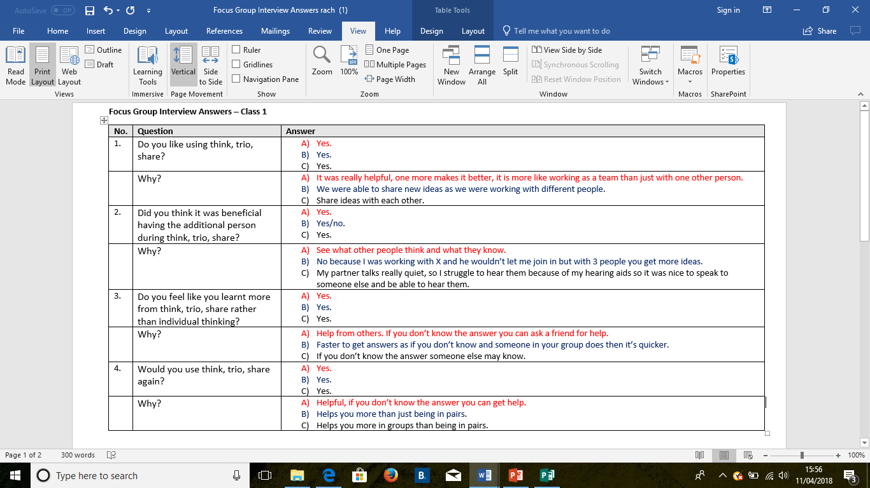

Observation Form – Lesson Study 2:
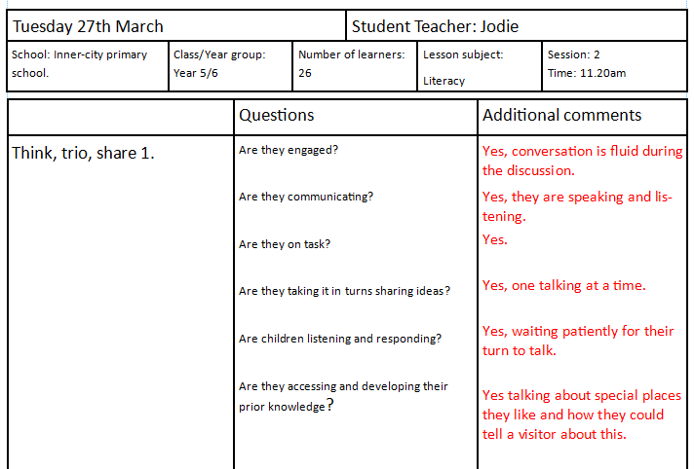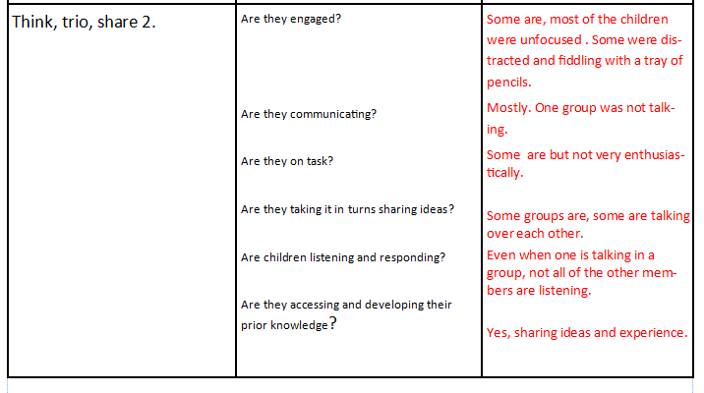

Focus Group Interviews – Lesson Study 2:
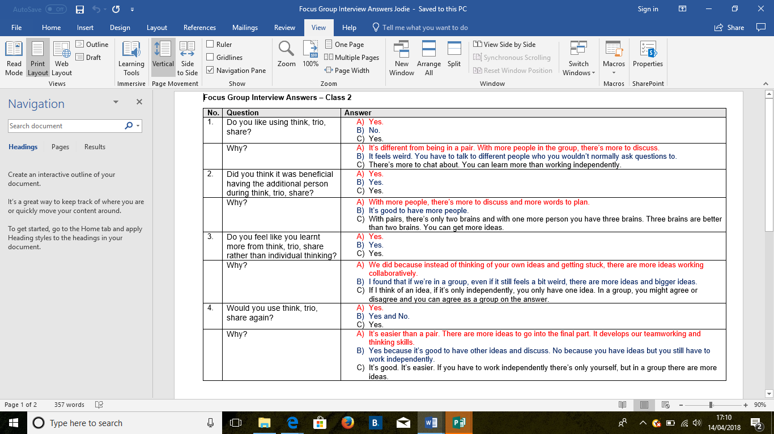

Lesson Plan – Lesson Study 1:
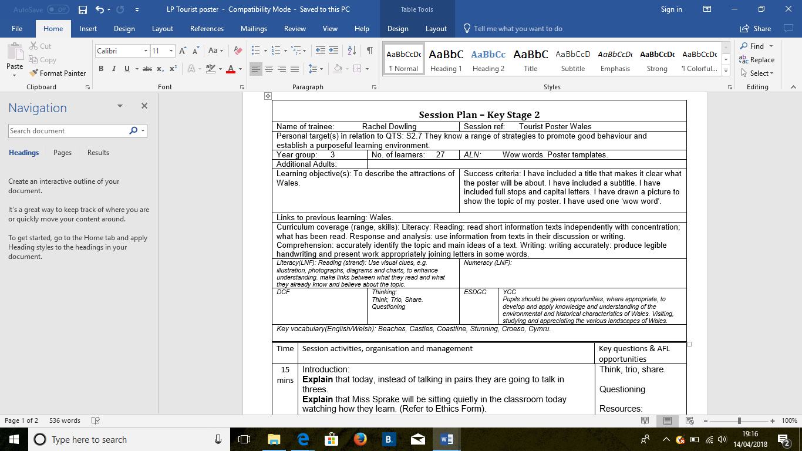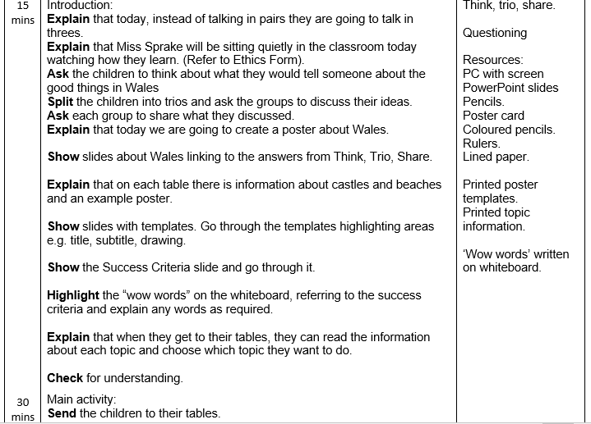
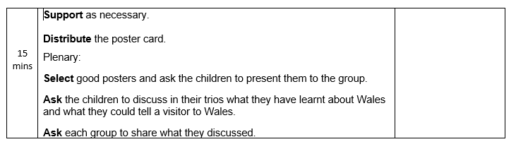

Lesson Plan – Lesson Study 2:

Session Plan – Key Stage 2
Name of trainee: |  | Jodie Sprake |  |  |  | Session ref: |  |  | 27/03/18
Personal target(s) in relation to QTS: |  |  |  | S1.3 S1.6 S2.5 S2.7 S3.1.3 S3.1.4 S3.3.7
Year group: | 5/6 |  | No. of learners:27 |  |  |  | ALN: 9
Additional Adults: |  |  | 1 teaching assistant.
Learning objective(s): To create a tourism poster to encourage people to visit Swansea. |  |  |  |  |  |  | Success criteria:  - Correct use the correct SPaG.  - Good communication skills.  - Create an eye-catching poster  - Include the things to do within Swansea.  - Include prices for things to do in Swansea and transport.
Links to previous learning: research topics using Ipads, Eisteddfod rap about Swansea.
Curriculum coverage (range, skills)
- Respond orally to a variety of stimuli and ideas.
- Speak and listen individually, in pairs, in groups and as members of a class.
- Use appropriate vocabulary suitable for the situation or purpose.
- Adapt writing style to suit the reader and purpose.
- Produce fluent and legible handwriting.
- Find information from a variety of sources for a defined purpose.
- Select suitable information and make simple judgements about sources of information.
- Make comparisons between prices and understand which is best value for money.
- Add and subtract totals less than £100 using correct notation, e.g. £28.18 + £33.45.
Literacy(LNF)  - Respond orally to a variety of stimuli and ideas.  - Speak and listen individually, in pairs, in groups and as members of a class.  - Use appropriate vocabulary suitable for the situation or purpose.  - Adapt writing style to suit the reader and purpose.  - Produce fluent and legible handwriting. |  |  |  |  |  | Numeracy (LNF)  • Make comparisons between prices and understand which is best value for money.  • Add and subtract totals less than £100 using correct notation, e.g. £28.18 + £33.45.
DCF  - Find information from a variety of sources for a defined purpose.  - Select suitable information and make simple judgements about sources of information. |  |  | Thinking  Decide in pairs how to make your poster eye-catching with all the appropriate information displayed. |  |  | ESDGC |  |  |  | YCC  Creating a poster to encourage tourist to visit Swansea.
Key vocabulary(English/Welsh):
Think, trio, share, discuss, ideas, tourism, Swansea, activities, individuals, families, fun, eye-catching, posters, communication, research, transport, cost, useful, helpful, tourists, Wales, dwylo I fyny, edrychwch arna I, da iawn, deg munud ar ol. Diolch.

Time | Session activities, organisation and management | Key questions & Assessment for Learning opportunities
5-10 mins | Introduction
5-10 mins | Using a Power point, I will place the word ‘tourism’ on the board and ask the children to discuss in their collaborative trios what they think is meant by the term, and for some examples.  We will share as a class their ideas to ensure that the children have a true understanding. I will then introduce today’s task. |  | Think, Trio, Share.
5-10 mins |  |  | Collaborative discussion.
5-10 mins |  |  | Questioning.
45-50 mins | Main activities  Introduce today’s task which is to create a tourism poster for Swansea.  Children will be working in pairs for the activity.  The children will be able to use Ipads to research information about Swansea.  The posters will be A4 size and the layout of the poster will be determined by the children. I will provide the children with an example poster that I will model on the power point. I will use this example to discuss what the poster needs to contain.  The children will need to list activities for people to do with their cost and provide some transport information and prices. The posters will need to accommodate individuals as well as families. |  | Modelling.  Questioning.
10-15 mins | Plenary
10-15 mins | I will gather all the posters and place them at the front of the class. The children will be asked to return to their seats and back into their collaborative trios. I will ask the children in their trios what information did they included within their posters. I will also be asking them to discuss whether what they put in their poster is helpful for tourists and why.  We will share discussion outcomes as a class.  I will be having an in-class competition for the most eye-catching poster and the winner will be determined by votes. |  | Think, trio, share.
10-15 mins |  |  | Class discussion.  Questioning.

ARC Observation Form:

Assisted Reflective Conclusions (ARC) Model
Date: 26/03/18
Critical incident (focus): English – Tourist Poster
Experience
Feelings  “What are your feelings regarding the experience?” | My initial feelings regarding this experience were quite positive. The children seemed excited the subject ‘attractions of Wales’.  They seemed to be engaged in what they were doing.
Remember and Understand  “Can you list the aspects of the learning experience that went well?”  “What were the elements of the learning experience that were disappointing?” | - The children were very responsive to the thought of being involved in research to help them improve their learning.  - They understood well what they needed to do and worked well in groups and independently.  - The resources and templates helped them to create their posters.  - They understood the use of “wow” words and how to use them in their posters.  - The timings were accurate and everyone finished the activities and achieved the learning objective.  - The second think, trio, share did not go as well as I was expecting.  - The children did not seem to be as engaged as they were in the first think, trio, share.
Evaluate and analyse  “What will you keep the same to ensure effective teaching and learning in the future?”  “What was the cause of the most important disappointing element?” | - The provision of resources will stay the same along with the templates to support all learners in the class.  - Clear explanations helped the children to understand what was expected of them and how they were going to get there.  - The cause is uncertain and could have been for a number of reasons i.e. the timing of the activity at the end of the lesson.  - The fact that the lesson was just before lunch could also have had an impact on the engagement.
Conclusions and actions  “What are your possible solutions to the disappointing issues identified?”  “What will you do next?” | - Think carefully about when to use group activities to ensure full participation and attention of the children.  - Only use techniques when they are of value to the learning objectives.
Transformed experience
Examples of Pupil Posters from Lesson Study 1: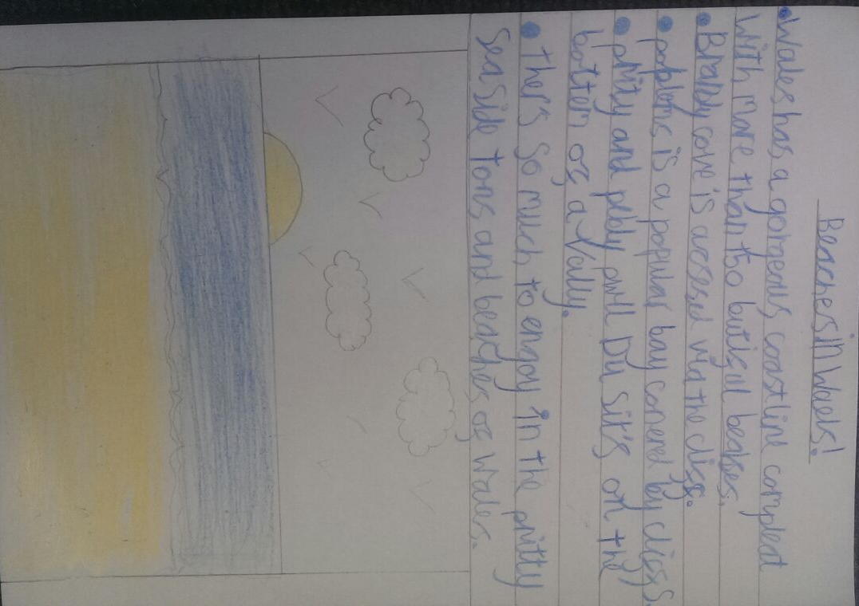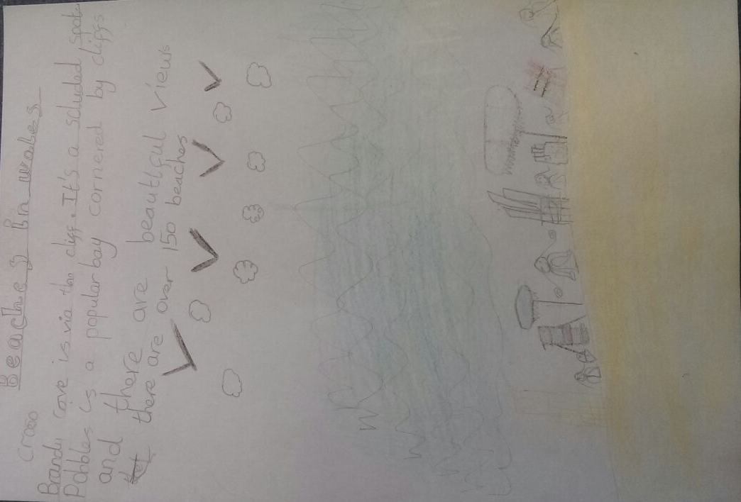
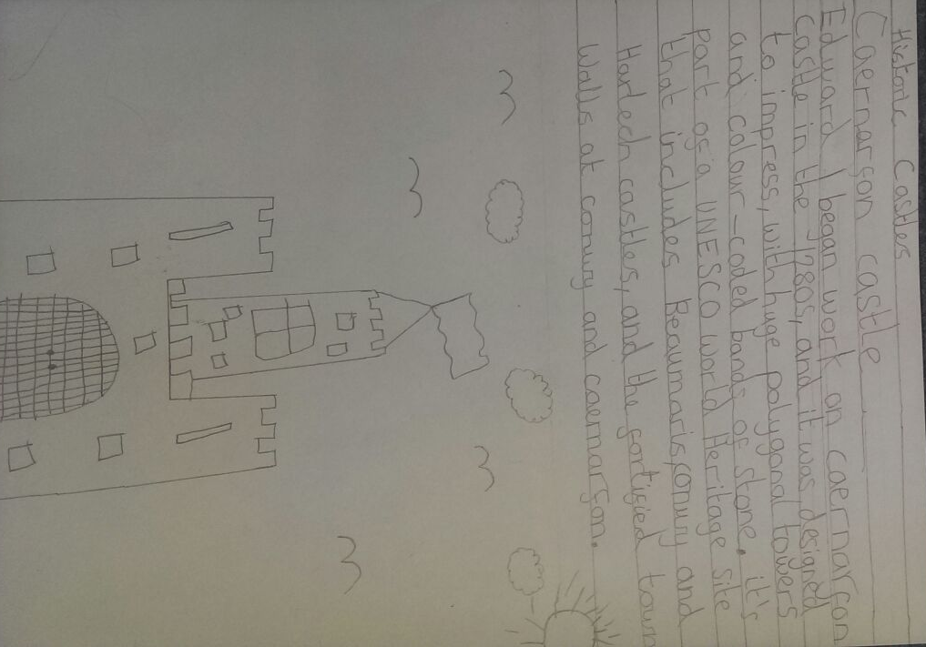

Examples of Pupil Posters from Lesson Study 2:


