Evelyn Ohiku

Student Number: 254326

Apply the Principles and Practices of Data Security, Governance, and Compliance Based on a Given Scenario

Case Study: AeroLink Logistics
Abstract

This report will analyse how AeroLink Logistics (ALL), a multinational supply chain and logistics company, handles its data security, governance and compliance. It examines the problems and risks arising from its use of cloud services [1], IoT devices [2], artificial intelligence [3], third-party outsourcing [1] and remote access from unmanaged devices [5].

The four known industry frameworks best suited to address these lapses are NIST CSF 2.0, COBIT 2019, ITIL and ISO/IEC 27001. But to provide a well-structured approach to the organisation's weak security, governance, risk and compliance challenges, the NIST CSF 2.0 framework is selected because its Govern, Identify, Protect, Detect, Respond and Recover functions offer a comprehensive approach to improving AeroLink Logistics’ security posture.

Introduction
In the past, information security was seen mainly as a technical responsibility, heavily focused on protecting physical IT environments and infrastructure such as data centres, servers and networks. However, this landscape has changed significantly with the growth of cloud computing [1], Internet of Things (IoT) devices [2] and artificial intelligence [3]. While these technologies have helped organisations scale faster, work more efficiently and become more data-driven, they have also expanded the threat and vulnerability landscape. Vast amounts of data now move across borders, third-party platforms [1], cloud services [1] and connected systems that the organisation may not directly control.
Consequently, IT security professionals are now faced with the challenge of protecting data not only as a technical task, but also as a governance, regulatory and ethical responsibility. Technical controls such as firewalls, encryption and access management are important, but organisations also need accountability, risk management, compliance monitoring and incident response processes. In this context, data security, governance and compliance must be treated as integrated parts of a unified security strategy.
This report applies the principles and practices of data security, governance and compliance to the AeroLink Logistics scenario. It examines relevant security frameworks and models, including NIST CSF, ISO/IEC 27001, COBIT and ITIL, and proposes a practical approach to improve AeroLink's security posture, compliance, risk management, vendor accountability and business continuity.

Assumptions
I am making the following assumptions to support the analysis and recommendations on the security design of AeroLink Logistics (ALL). Since the case study did not explicitly state the full profile of the organisation, I will assume some important aspects of the business to build the analysis and make it more scenario-relevant.
AeroLink Logistics is assumed to be headquartered in the United Kingdom, with wide business operations across EU countries and other international countries, regions and time zones. It is also assumed that the organisation has thousands of employees scattered across different locations around the world. These employees include truck drivers who haul goods across countries, warehouse workers, operations staff, administrative staff and internal IT department employees. Being a multinational supply chain and logistics company, the organisation is also assumed to do business with suppliers and logistics partners to help with quick deliveries and smooth processes to meet clients' demands.
As for AeroLink's internal IT department, it is assumed that it needs to be upgraded and strengthened to function effectively and manage resources at the scale required by the business. This is very important because ALL's data security, compliance obligations and general security posture are especially vulnerable due to the organisation's high reliance on third-party vendors [1].
The scenario states that approximately 88% of its IT infrastructure is outsourced to third-party vendors through IaaS and SaaS arrangements [1]. This means that a large part of AeroLink's IT infrastructure and software services is managed externally [1], and this can create risks around vendor accountability [1], data protection, access control and compliance. Employees, suppliers and logistics partners access internal applications and data using various unmanaged devices from different regions and time zones. This ultimately leaves the organisation more vulnerable and exposed to cyberattacks, data breaches and compliance failures if strong controls are not implemented.
Being an international business, AeroLink is required by law to follow the data protection laws of its home country, as well as the legal and regulatory requirements of all countries and regions where it operates or processes customer data. Every country has its own data protection laws, and companies doing business within those regions, whether local or international, must adhere to them. This means that UK GDPR, EU GDPR and other relevant international data protection laws and obligations will apply to AeroLink's operations.
Finally, in terms of budgeting, it is assumed that AeroLink Logistics has sufficient financial resources to improve its security posture and protect the organisation's data because senior management has approved a robust budget for security improvement. The main concern is not the lack of finance, but rather how the organisation should implement the right security measures effectively.

AeroLink Logistics: Security Context and Key Challenges
AeroLink Logistics (ALL) is a multinational logistics company that provides a useful case study for examining the shift from purely technical security to strategic governance. The organisation depends on cloud platforms [1], IoT tracking sensors [2] and AI-driven analytics [3] to support real-time tracking, warehousing and distribution services. As useful and effective as these technologies are for business operations, they also create significant security risks.
A major concern is that approximately 88% of AeroLink Logistics' IT infrastructure is managed by external suppliers [1] through IaaS and SaaS arrangements [1]. This means the organisation has limited direct control over a large part of its IT environment. Although outsourcing can improve efficiency and scalability, it also creates risks [1] around vendor accountability, data protection, access control and operational resilience [1].
The risk is further increased by remote access arrangements, where employees, suppliers and logistics partners access internal systems and sensitive information using unmanaged devices [5] across different time zones. This can create a major security risk, as unmanaged devices and poorly controlled access [5] can introduce malware, enable unauthorised access, and make it harder to verify who is actually behind each connection. AeroLink has already experienced several data breaches involving unauthorised access to client shipment data and customer personally identifiable information (PII). The scenario also shows that the organisation has no unified security framework, no centralised risk management process and no formal compliance audits against legal regulations such as GDPR [4] or international standards such as ISO 2700 [9]. These issues suggest that AeroLink's problem is not only technical, but also organisational, legal and strategic.
These organisational security shortcomings across key areas of information security, including access control, data classification, encryption, vendor management, incident response and business continuity planning, can cause serious damage to AeroLink's data protection, compliance position and business operations. AeroLink Logistics needs to have a well-structured security, governance, and compliance approach that combines technical controls with clear organisational responsibility.

1. Various Security Frameworks and Models.
To properly address AeroLink Logistics' security, governance, and compliance challenges, it is important to review relevant industry security frameworks to support practical recommendations for the organisation.
NIST
NIST Cybersecurity Framework (CSF) 2.0 [6] is one such framework that is most relevant to AeroLink Logistics because it is built around six core functions: govern, identify, protect, detect, respond, and recover.
Govern – It defines and assigns the rules, sets the policies and identifies the security officers responsible for managing and enforcing security. Govern is the most important part of the NIST CSF 2.0 framework because it oversees every other aspect of the framework.

Identify – This means knowing and understanding the organisation's assets, especially the most critical ones that keep business operations going. Identifying these assets will prepare the organisation's security officers to focus on securing them to reduce the impact in cases of incidents and emergencies.

Protect – This is a proactive action; it means putting proper defences in place, such as encryption, strong passwords, MFA, firewalls, patching, and system updates to prevent attacks or reduce their impact when they occur. By protecting its assets, the organisation locks things down ahead of time before emergencies happen, so the impact of any incident will be kept to a minimum.
Detect - It is the monitoring of telemetry data records to check for anomalies, combined with observability, to help with the early detection of intrusions into the network. As the saying goes, "a stitch in time saves nine."
Respond – This is the quick action taken immediately after noticing a problem, intrusion, or attack to stop the damage. With response, timing is everything; for example, Co-op was able to quickly disconnect and isolate a compromised system during a cyberattack in 2025 (Computer Weekly, 2025), and this prevented the attackers from executing their payload into the organisation's network.
Recover – This is when compromised systems are quickly fixed, restored and reintegrated back into the network pool for smooth-running business operations. Also, the lessons learned during the entire process are translated into valuable experience for future preparation ahead of another possible attack.
AeroLink Logistics will benefit greatly from the NIST framework [6] in the areas of Govern and Protect. The organisation will understand the importance of having policies to manage the business, and will protect and set controls over unmanaged remote devices [5].
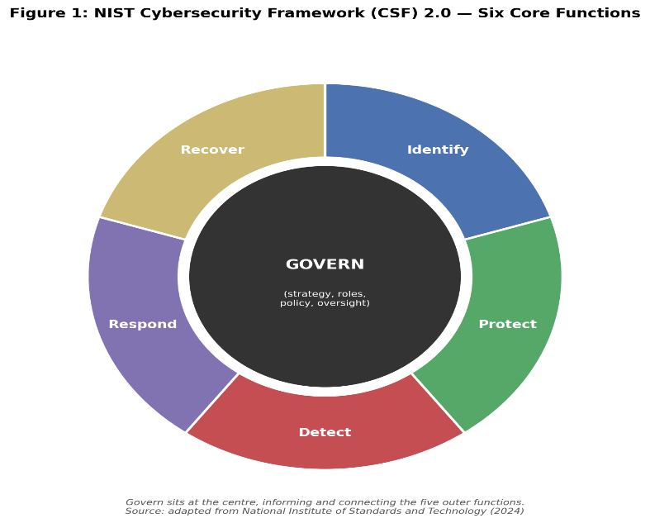

COBIT 2019
It is a framework that sets the instructions and rules that guide an organisation's information technology, ensuring that its IT and the business work in synergy to succeed, manage risk, and stay secure.
The COBIT 2019 Framework [7] addresses AeroLink Logistics IT security shortcomings in two major areas: the company's lack of a data governance structure to oversee and enforce controls on how data is accessed and used, and its heavy reliance on outsourcing 88% of its IT infrastructure [1].
COBIT 2019 Framework would help AeroLink improve data governance by dividing the work: the board will decide the direction, and the security team will implement it.

Also, it will enable the organisation to focus on taking full ownership of its own internal IT decisions and start managing vendor risk efficiently, especially given that 88% of its IT is outsourced [1].

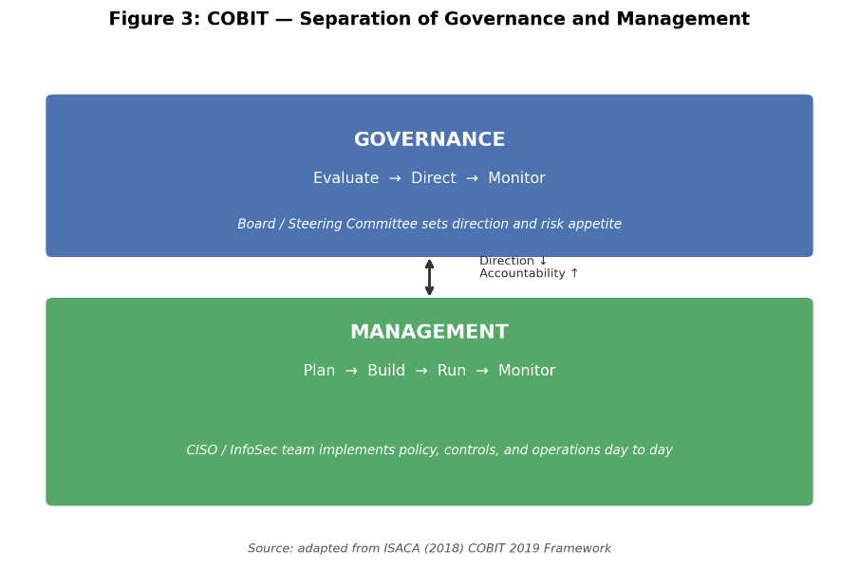

Information Technology Infrastructure Library (ITIL)

This Framework is a playbook centered on making sure IT services are well managed by keeping them reliable, ensuring quick fixes in the event of incidents, managing suppliers efficiently, and supporting smooth business operations.

ITIL [8] will help AeroLink Logistics' IT department coordinate and work together cohesively instead of working in silos. It will also help manage the cloud-based IT services the organisation depends heavily on to run its business smoothly, such as IoT-enabled tracking sensors [2] and AI-driven analytics [3].
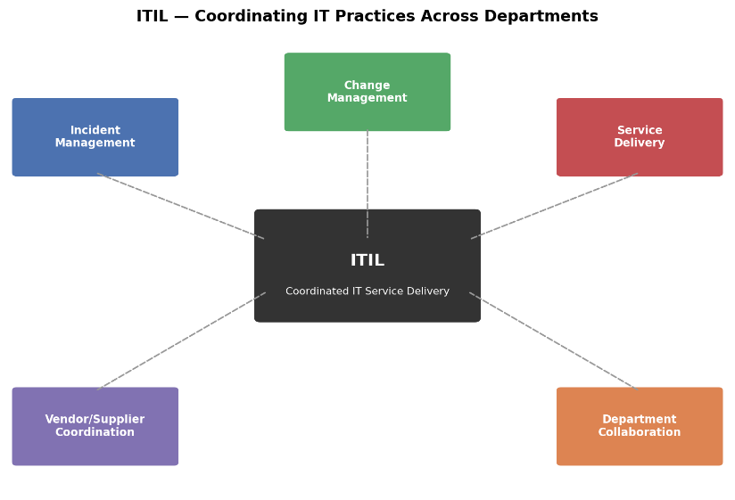

ISO/IEC 27000 Series
This framework is a family of information security standards covering how organisations should manage and protect information. Within the series, ISO/IEC 27001 [9] is the main standard that organisations can be audited against and, after meeting the requirements, become certified as compliant.
AeroLink Logistics will benefit from this framework because the company has not carried out a formal compliance audit against ISO 27001 [9]. This is confirmed in the case study, which states that there is “no formalised compliance audit against data protection standards such as GDPR [4] or ISO 27001[9].” Since the organisation handles sensitive customer PII, shipment data and cloud-based systems, this framework will help put it in a stronger security posture through an improved Information Security Management System.
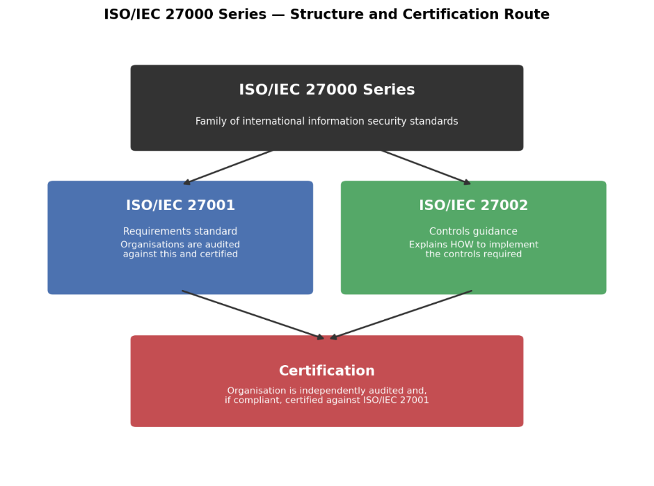

Summary of Security Frameworks and Their Relevance to AeroLink Logistics
Security framework | Main purpose | How it helps AeroLink Logistics
NIST CSF 2.0 | Cybersecurity risk management | Helps AeroLink govern, identify, protect, detect, respond and recover from cyber risks.
COBIT 2019 | IT governance and accountability | Helps AeroLink improve data governance, assign responsibility, align IT with business goals and manage vendor risks.
ITIL | IT service management | Helps AeroLink manage IT incidents, suppliers, cloud-based services and smooth business operations.
ISO/IEC 27000 series / ISO 27001 | Information security management and compliance | Helps AeroLink improve its Information Security Management System, protect sensitive data and prepare for formal compliance audits.

My Approach and Justification for Choosing the NIST Framework for AeroLink Logistics
2a. Based on the several areas of AeroLink Logistics’ organisational data security weaknesses, which require immediate intervention to prevent further cyberattacks and prevent data from falling into the wrong hands, I propose an approach to meet the company’s information system security, governance and compliance needs by choosing the NIST Cybersecurity Framework 2.0 [6].
The NIST framework is the most suitable for AeroLink Logistics because it provides a structured approach through Govern, Identify, Protect, Detect, Respond and Recover. This fits AeroLink’s weak data security situation, as the organisation has experienced data breaches, depends heavily on third-party vendors [1], uses cloud platforms [1], IoT tracking sensors [2] and AI-driven analytics, and has no unified security framework or centralised risk management process.
NIST CSF 2.0 [6] is chosen over other frameworks specifically because its Govern function directly addresses AeroLink Logistics’ major problem, which is the lack of clear security responsibilities and accountability. This places accountability at the centre of the framework rather than treating it as an afterthought.
This approach integrates Compliance (Laws and Ethics), Governance and Strategic Planning for Security, Security Policies and Procedures, Risk Management and Assessment, Security Management Models and Practices, Contingency and Business Continuity Planning, Protection Mechanisms and Access Controls, and Vendor and Service Level Agreement (SLA) Management to strengthen AeroLink’s overall security posture.

Compliance (Laws and Ethics)
To begin with, AeroLink Logistics must ensure that customer PII and shipment data are handled lawfully, securely, and fairly, in line with UK GDPR, EU GDPR [4] and other relevant data protection laws across all countries and regions where it operates.

The organisation should appoint a Data Protection Officer to monitor and oversee how its data is handled and used, given the scale of the PII processed. Ethically and legally, AeroLink Logistics must ensure that customer data is used legitimately and transparently for business purposes only.

Governance and Strategic Planning for Security
AeroLink Logistics needs to establish a three-tier governance structure: the Board, to set the direction of policies and risk appetite; the Chief Information Security Officer (CISO), to translate this into policy; and the Information Security (InfoSec) team, to implement the policy and ensure it is followed properly by internal employees and relevant external parties, including suppliers and third-party vendors [1].

Security Policies and Procedures
Having experienced several cyberattacks, AeroLink Logistics must set policies to guide how its data is accessed, especially by third-party vendors [1] and through unmanaged devices [5] from different regions and time zones.

Doing this will create stronger security controls and protect its data from unauthorised access. It is not just about writing the policy; it is about enforcing it and making sure that internal employees and relevant external parties follow it completely.

Risk Management and Assessment
To identify the assets that need protection, what could go wrong during an attack, and the degree of damage it could cause, AeroLink Logistics should introduce a risk management and assessment process. This will help the organisation to plan ahead on how to mitigate risks and reduce their impact.

Risks should be assessed based on likelihood and impact, including vendor mishandling of data [1], malware from unmanaged devices [5], unauthorised data access and data breaches. These risks can be reduced through MFA, encryption, patching, monitoring, least privilege access and regular vendor checks.

Security Management Models and Practices
For better coordination and overall good results for the benefit of the organisation, AeroLink Logistics should adopt industry-recognised and recommended frameworks to build its security management approach. These include NIST CSF 2.0 [6] as its main security framework. Other frameworks such as COBIT 2019 [7], ITIL [8] and ISO/IEC 27001 [9], can support specific areas of security management.
NIST will help AeroLink Logistics improve governance, risk management, protection, detection, response and recovery. ISO/IEC 27001 can support compliance and information security management, COBIT can support governance and accountability, while ITIL can support IT service delivery and incident management.

Contingency and Business Continuity Planning
As a matter of urgency, based on several factors, including having gone through several cyberattacks and its dependence on cloud-based services [1] for the smooth operation of its business, AeroLink Logistics should develop a contingency and business continuity plan for system failure, service interruptions and breaches.

A playbook covering incident response procedures, disaster recovery and regular backups should be developed to minimise downtime and support the quick recovery of affected systems. ALL should ensure that the plan goes through regular testing to check how quickly and effectively it can respond and return the business to full operation.

Protection Mechanisms and Access Controls
An organisation’s data is a delicate and very important asset that should not be left carelessly for just anybody to access, as it can be misused, mishandled, stolen or breached. To stop this, AeroLink Logistics needs to implement protection mechanisms and access controls to protect its data from indiscriminate and unauthorised access.

In doing this, it needs to introduce protections such as firewalls, encryption, patching, regular system updates, MFA and secure remote access [5]. Access controls like least privilege access should also be introduced, meaning that if a user is not authorised, they cannot access the organisation’s data.

Vendor and Service Level Agreement (SLA) Management.
AeroLink Logistics’ heavy reliance on third-party service providers for 88% of its IT infrastructure [1] calls for proper Vendor and Service Level Agreement (SLA) Management, as these providers may have access to customer PII and shipment data. There needs to be a clear and legal agreement to define vendors’ security duties, data protection responsibilities, service expectations and breach reporting timelines.

Under GDPR [4], AeroLink is accountable for its data even if a vendor is at fault for a breach. These agreements should be a compliance necessity, not just best practice. Vendors should be subject to ongoing monitoring and regular review due to the high level of access they have to AeroLink Logistics data. This will help minimise incidents arising from third-party security failures.

2b. Due to the fact that technology is constantly evolving, AeroLink Logistics must continuously update its regulations and standards to remain relevant and avoid becoming obsolete. This will also help protect its systems and networks, minimise cyberattacks, address newly identified vulnerabilities and ensure compliance with changing legal and regulatory requirements.

References:
[1] M. Y. M. Haq, S. Anand, L. J. M. Nieuwenhuis, and A. Abhishta,
“Cloud Outsourcing Risk Management for Cloud Consumers: A Systematic Literature Review,”
ACM Computing Surveys, vol. 58, no. 12, pp. 1–36, 2026.

[2] R. Roman, J. Zhou, and J. Lopez,
“On the features and challenges of security and privacy in distributed IoT,”
Computer Networks, vol. 57, no. 10, pp. 2266–2279, 2013.

[3] B. Brundage et al.,
“The Malicious Use of Artificial Intelligence: Forecasting, Prevention, and Mitigation,”
Oxford University, 2018.

[4] P. Voigt and A. Von dem Bussche,
The EU General Data Protection Regulation (GDPR),
Springer, 2017.

[5] S. Rose, O. Borchert, S. Mitchell, and S. Connelly,
“Zero Trust Architecture,”
NIST Special Publication 800‑207, 2020.

[6] NIST,
“NIST Cybersecurity Framework (CSF) 2.0,”
National Institute of Standards and Technology, 2024.

[7] ISACA,
COBIT 2019 Framework: Governance and Management Objectives,
ISACA, 2019.

[8] Axelos,
ITIL® Foundation: ITIL 4 Edition,
TSO (The Stationery Office), 2019.

[9] ISO,
ISO/IEC 27001:2022 Information Security Management Systems,
International Organization for Standardization, 2022.

