Student Name: Olimpia-Claudia Mihalka
Student Number: 1711809
Module No: BMSK4005
Module Title: PROFESSIONAL CAREER DEVELOPMENT
Lecturer: Mary March

Contents
Introduction 2
Lifeline 3
Self-evaluation 3
Score Interpretation 5
Learning styles 6
Importance of learning styles 6
My own learning style 6
VARK learning style 7
Honey and Mumford learning style 8
Evaluating my current position 11
SMART Objectives 14
Johari Window 16
Expectations of the world employment 17
Career ambitions and aspirations 18
Personal Development Plan 18
Development plan 19
Conclusion 22
References 23

Introduction
Professional career of an individual is the journey which he/she carries on with in order to implement their skills and abilities in real life and attain social security and dignity. The development of one’s professional career is very important because it helps in finding suitable job opportunities and in making oneself more competent in the existing job sector. This assignment has been made as a portfolio describing my own experiences throughout my professional career along with my self-evaluation on my skills and abilities. The report will demonstrate all my existing capabilities which have made a competent employee along with all the abilities which I lack. Besides, planning will be made in order to improvise my current condition based on the current situation in the world employment.
I have completed my baccalaureate from DimitrieCant emir High School of Dolj County, Romania in 1989. I have not finished my graduation and worked as a casual worker. In 2013 I moved to London for better employment and started working at Cash and Davis Ltd. as a warehouse operative in 2013. After working there for three years, I joined the company Abbeys View Produce Ltd as a pack house operative. I had to perform similar kind of works at that company as well. I have worked one year at that company and after that I got the opportunity to work as a warehouse operator at the Delta Ltd. After working there for one more year, I left the company and joined Amazon UK as a warehouse operator in which I am still working. I have always lacked academic qualification. Since joining university last year now, I am confident to have a bright future. This portfolio will justify my career development as a person and a professional.

Self-evaluation
Self-evaluation process refers to the chain of actions which are performed by any individual to assess one’s own condition regarding professional career and one’s own abilities to achieve the targeted goals and objectives of life (Cottrell, 2010). One of the core concepts to judge in the self-evaluation procedure is self motivation. Self motivation is the inherent ability of a person which keeps him going in the direction to attain the ultimate goals of life and which drives him to do even better than he already is doing (Maund, et al 2017). There are four factors which are very much crucial in maintaining the self motivation of a person which are-
- Confidence in own actions and condition
- Thinking positively
- Focusing on the targeted goals and objectives
- A motivating environment
These four factors have helped a lot to improve my own condition of self motivation. I have built confidence regarding my own actions with the passage of time. It was not built in one day and I had to work very hard to improve the condition of my self motivation. The positive attitude which I bear and the focus which I have set to fulfill my goals and objectives has helped to be strict in the context of self motivation. Besides, I always had the opportunity to work in a motivating environment which has made me more interested to improve my conditions and to better in my professional life.
Below is a motivational quiz which I have participated in to assess my condition in the self motivation sector.
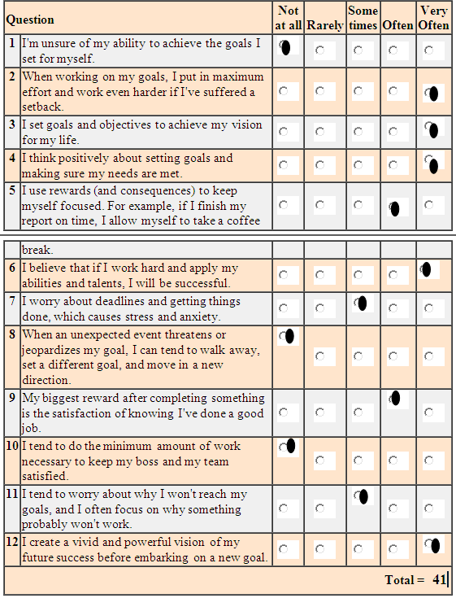

Score Interpretation
From the above quiz, it can be seen that I have scored 41. According to the score interpretation my self motivation level is okay. I am definitely motivated by myself to achieve success in my life but there is still room for improvement and I can do much better. There are some points where I do not show the competency to be a motivated and inspired person to perform the professional duties. It is imperative for me now that I put focus on those sectors and enhance my self motivational skills.

Learning styles
The term “Learning Styles” refers to the techniques and processes that are assistive to learners from several different backgrounds regardless of their educational level, learning capability and comprehension aptitudes (McMillan, et al 2006). The learning styles and the variations in this specific concept indicates and proves the fact that each person or individual has a different style of learning that is effective for himself or herself. In general, the overall learning styles of individuals designate the processes as well as techniques which are effectual and assistive for learners to process, understand and retain information on different subjects (Anderson, 2007).

Importance of learning styles
The importance of learning styles is enormous because of the fact that different learners have different techniques to learn new things and gain efficiency. It is important for each learner to find out which technique is effective for learning. Additionally, teachers and instructors must also consider the comprehension level and preferred learning technique of each different student and instruct or design the teaching process accordingly to ensure the best possible outcome. Identification of the appropriate learning style is also imperative for personal or individual learning and ensuring its efficacy (Coffield, 2004).

My own learning style
A number of different learning techniques are available for learners which are developed by researchers and academicians through study works of different types and learning sectors. Some of the effective and most commonly used learning techniques are as follows:
- VARK (Visual, Aural, Read/write, and Kinesthetic sensory modalities)
- Honey and Mumford learning style etc. (Pritchards, 2008)

VARK learning style
The VARK is a learning style whose acronyms stand for visual, aural, read/write and kinesthetic sensory modalities. According to the concept of this learning style, a learner can learn through the experiences which he/she obtains from these modalities or systems. It is about the preferences of the learners and the convenience of them in which of the systems they get comfortable for learning (McLeod, 2016). The visual preference includes maps, diagrams, charts, flowcharts, presentations etc. On the other hand, the aural or auditory reference is about hearing and speaking. The information which is collected by these learners is by listening to the speeches which are being spoken. The read/write preference is the most common one and is preferred by most of the learners and teachers. It is the learning process in which actual words are used, which may be in the forms of essays, assignment, portfolios and so on. Lastly the kinesthetic sensory preference is the learning style in which the learners use their personal experiences to learn anything.
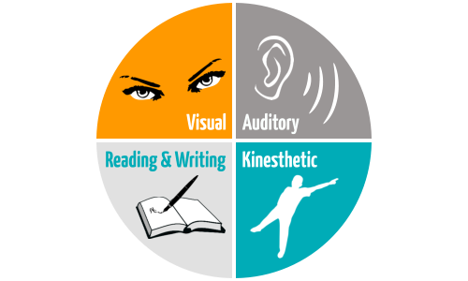
Fig: VARK Learning Style(McLeod, 2016).

I have find out through engaging myself in trying different types of learning styles in order to find out which one is the most suitable and effective for me. I have come to know that the “Honey and Mumford learning style” is quite assistive and effective for me in learning new things appropriately and efficiently.

Honey and Mumford learning style
This specific concept of learning style was developed by Peter Honey and Alan Mumford as a shorter or concise version of the “Experiential Learning Theory” of David Kolb. In total, 4 dissimilar styles of learning were proposed by Peter Honey and Alan Mumford in this concept. These 4 types of learners according to this theory are:
- Activist
- Theorist
- Reflector
- Pragmatist
This specific theory regarding learning techniques emphasizes that, each and every single learner obviously incline in the direction of a specific single learning style which is comfortable as well as effective for that individual. In the context of the aforementioned fact, it was argued by Honey and Mumford that each and every different learner must strive to recognize the innate learning style of him or her learning process. After that, the individual or learner must comprehend it. The last but not the least is the identification of the learning ways which will be beneficial as well as harmonizing and corresponding to the acknowledged specific learning style of the learner (Flemming, 2011).
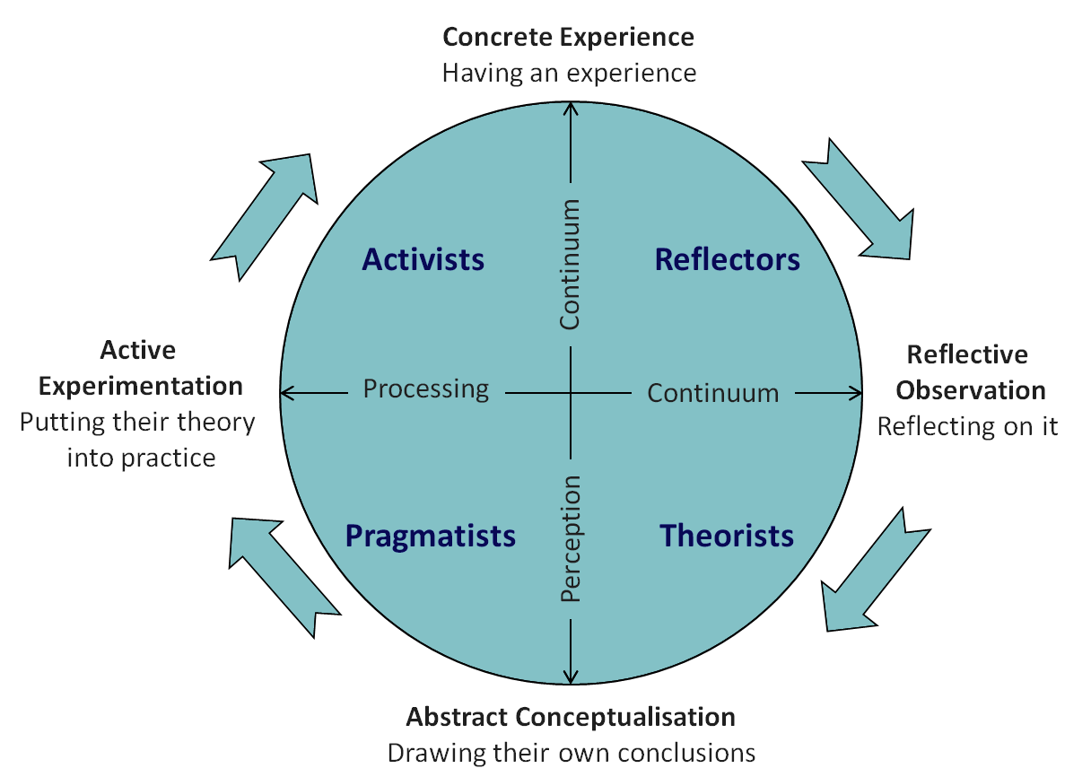
Fig: Learning styles of Honey and Mumford (McLeod, 2016)

According to this specific concept, the “Activists” are the type of students or learners who can be entitled as "do-ers" as well as "go-getters." It is imperative for this specific type of individuals to take initiative, get implicated along with entirely plunge into the learning process with proper efforts and full dedication. It is evident that these specific types of learners are usually open-minded and welcoming to new ideas and things in general. On the other hand, the learners who are the “Theorists” usually exhibit the tendency to think cautiously, vigilantly and rationally about different circumstances and conditions related to the learning process. Another type of learners is the “Reflectors” who usually prefers to take a step back from particularly complex state of affairs with a view to learn by inspection and examination so that there will be minimal chance of mistakes. This particular type of learners typically is able to learn best with the help and utilization of survey, discussion, criticism and scrutinizing actions. The last or 4th types of learners are recognized as “Pragmatists” who always have a preference to relate information and assumptions in a sensible as well as realistic way to increase the efficiency and effectiveness level of learning (Miettinen, 2000).
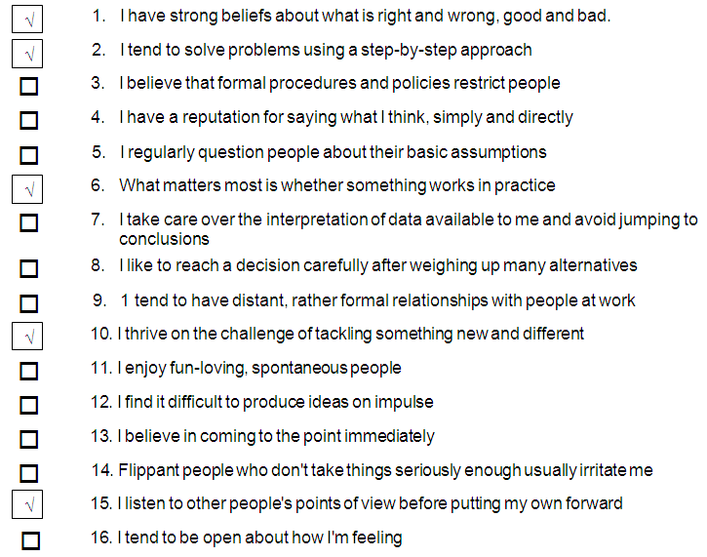
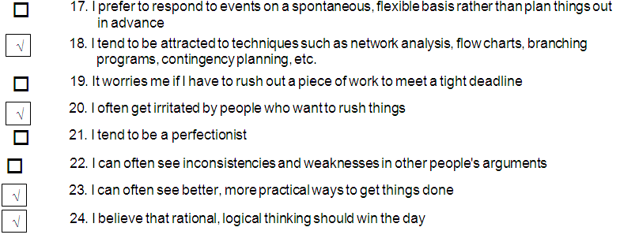

On the basis of the statements provided in the previous section, it is easily comprehendible that I am a “Pragmatists” type of learner as I possess a mixture of the characteristics of the Activist and the Theorist. I always prefer to put the things that I have learnt into practice in order to find out the effectiveness of the learning in real life.

Reflecting on my learning style using Honey and Mumford learning style:
 | Pragmatist | Theorist | Reflector | Activist | Reflections
Ethics | Learning about model and theories |  |  |  | I will learn about the models and theories related to ethics and apply those.
TeamBuilding | Forming teams in the workplace and making the team works more effective |  |  |  | I belief it is very much needed to practice effective team building in any workplace.
Numerical Skills | Excercising a numerical examples |  |  |  | I think the only way for me to get better is to practice. I will find myself some free examples, and practice twice a week for the next 6 weeks. It will help me to feel more confident in this area in future.
Time Management | Exercising time management |  |  |  | I think it is very wise to manage the time to any kind of work in the workplace
Leadership | Practicing leadership qualiites |  |  |  | I think leadership quality is a pre requisite for every workplace
Conflict Resolver | Practiciing conflict resolutions |  |  |  | Conflicts are very mucvh needed to resolved very quickly at any workplace

Evaluating my current position
In order to increase the existing skills and abilities of mine and to impact on the goals and objectives which I have set for developing my professional career, it is crucial that I monitor and evaluate my own position from time to time. There are a number of techniques which can be done in this regard and the most suitable one among those to carry out a SWOT analysis. A SWOT analysis finds out the strengths, weaknesses, opportunities and threats which I have and which I face in the professional career of mine.

Strengths | Weaknesses
I am very good at solving different problematic situations of my workplace and at the same time, I can also handle excessive pressure at work.  I also have the strong point of managing people and manage the time to do any kind of work. | I need to improve my skills of technical aspects as I do not have much knowledge about that.  Besides, I also need to improve my knowledge about the new digital era.
The years of experiences which I have in the professional sector can also be termed as one of my strengths. | I lack a huge amount of knowledge in the academic area as I have not completed my studies yet. This is big step down for me.
People think of me as a very good and effective team member. At the same time, they also think I have a very effective sense of communication.  The management of the companies I have worked with has always entrusted me as an employee and relied on me on various works. | Other people think my age as one of my weaknesses. This is because the competition in the job market is increasing rapidly and many new and young people with fresh ideas and concepts are looking for job and being a 39 years old job seeker can be a huge lacking.

SMART Objectives
The SMART objectives are the acronym for different types of criteria which are measured by an individual to get the idea about the ability of his/her targeted goals of reaching. The SMART objectives basically stand for specific, measurable, achievable, relevant and time-bound (Curriculum Wadhwani, 2013). If all these criteria are met, then a specific goal can be termed as an ideal goal.

Fig: SMART Objectives (Flemming, 2011).
Being a professional, I also have a number of goals and objectives which I have set up in order to develop my professional career and to make myself a more competent employee of any organization. Below the SMART objective model has been used to figure out if the goals I have set are ideal or not-

Skills | Specific | Measurable Criteria | Achievability | Relevance | Targeted Time | Comments
Management | I want to manage all the employees who work under me at my workplace. | I have the desire to increase the level of my management skills by 30%. | This goal is achievable because I have past experiences to work as a manager. | This goal is relevant as I have the aim to become a manager, thus I will need the skill to manage all the employees. | I want to achieve this goal by 4 months.
Supervision | I want to acquire the ability to supervise the employees while working. | About this skill, I want to increase the amount I already have to 20% | This particular goal is also achievable as I had the experience to supervise people while I was working as a manager. | This goal is relevant as supervision is one of the traits of managing the employees. | I want to achieve this goal by 2 months.
Academic Knowledge | I want to possess a vast amount of academic knowledge regarding my job matter. | I want to enrich my academic skills by 50%. | This goal is achievable too as I have admitted myself into university and already am in the process of learning. | This goal is relevant as I have a lot of room for improvement in this regard and this skill is also needed in my career. | I want to achieve this goal by 6 months.
Thus it can be said that the goals which I have selected are all specific, measurable, achievable, relevant and time-bound.

Johari Window
The Johari Window is a simple, yet beneficial technique which is used by individuals to understand the mutual understanding among a group of people and also to increase the level of self-awareness (Cottrell, 2010). It is a model which is vastly used for maintaining an effective communication practice in any kind of workplace. This model has four segments or area-
- Open self- This area contains the information about oneself which one knows and the others know as well.
- Blind self- This is the area where the information known to other people are there but this information is generally unknown to self.
- Hidden self- The hidden self is the area where those information are there which one knows about himself/herself but no other people knows about that.
- Unknown self- This area contains the information which is unknown to both the parties (Wilson, et al 2009).
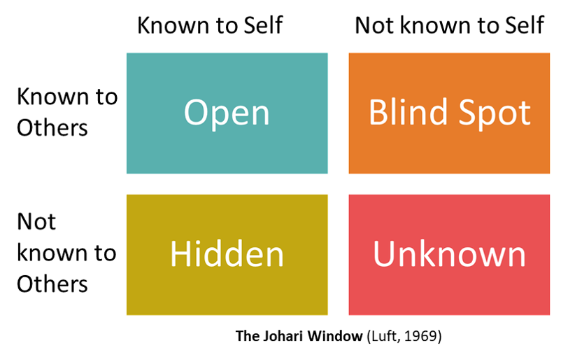
The Johari Window can be a useful model to assess my own effectiveness in communication and the assessment is very important as to be a manager in any organization will need a lot of communication with a lot of people.
As an employee, I have always been very much honest and loyal and my co-workers and my superiors are acknowledged about these qualities of mine. Moreover, I am always working hard and they can easily see that. So these qualities or information about me are known to me and also to them. However, there are definitely some things about me which other people from my workplace know about me or think about me. I do not know them but I have to try to gain that information to spread by known self spot to the blind spot. Having that knowledge can prove much beneficial for me. Again there is some information which I always kept to myself. For example, the people at my workplace do not know anything about the time and works which I did back at my other workplaces. Sharing those can make me come closer to the people I work with and they will also feel interested to share about theirs. In this way I can spread my territory to the hidden self as well. Finally, there is always some information which is known by me or the other employees. That information can be fruitful for me too. So as I have the desire to be an efficient employee of my company, I will have to explore that area besides the other ones.

Expectations of the world employment
The expectation of the employers around the world is a bit of complicated and it is always changing. Though it is somewhat hard to meet up all the standards which are set by these employers, there are some specific steps which every employer follows and the candidates having potential can act upon on those steps (Morgan, 2016).
To select the right employee for their organizations, the employers of an organization first of all publish a job description which describes the qualities and skills which they are looking for in the potential candidate (Maund, et al 2017). After that, when they obtain the CVs they screen out the ineligible candidates and call the eligible ones for interview. The interview is held for asking about the candidates’ knowledge and other information and to be sure of their abilities to perform the activities. The employers select their desired candidate depending on how they perform during the interview (Van Emden, et al 2010). However, there are some certain rules and regulations which the employers of the world must follow in order to recruit anybody. First of all, they have to be fair during the screening of CVs and taking the interviews. Moreover, the employees have some certain rights which they are ought to be provided by the employers. A number of legislations regarding employment are there which need to be known by the employer and to be followed. The Equality Act of 2010, the Health and Safety Act, the Discrimination Act, the Employment Act of 2002, the Employment Relations Act of 2004 etc. are some of the legislations which are musts to be maintained in any kind of workplace (Maund, et al 2017). The legislations have been made in order to provide the employees a better environment in their workplace and to ensure their privileges and rights.

Career ambitions and aspirations
There are some specific ambitions and aspirations which I possess regarding my professional career. After I have gone through all the skills and abilities which I have and the ones which I lack, I have made up my mind to become a manager of my organization. I am currently working at the Amazon UK and I am working as the warehouse operator of the company at this moment. The goals and objectives which I have set for the near future is that I will complete my studies which will help me in attaining the academic knowledge about the activities I have been performing at my workplace. And I will also acquire other necessary capabilities to be more competent than I am already. And for the somewhat distant future, I have the aim to be the supervisor of Amazon UK. That will take me a level up and a level closer to the ultimate goal I have for the future, which is to be the warehouse manager of the company. Years of experience of working as a warehouse operative have given me the confidence and the aspiration to become a higher level manager of a company and as I am already working in this company and thus have the necessary knowledge and idea about this company, I will be very much delighted to be the warehouse manager of this company.

Personal Development Plan
A personal development plan is basically a checklist or a scheme work which can be made by any individual to assess and to define the strengths, abilities and skills of a person along with the weaknesses and the areas which need to be developed (Flemming, 2011).This process is a very systematic and organized assessment tool and a very convenient one at the same time (McMillan, et al 2006).
There is a Personal Development Plan below which will show my goals and objectives and the plans to be executed in that regard.

NAME: |  | Student NUMBER:
COVERING THE PERIOD FROM: |  | TO:

What do I want/need to learn? | What will I do to achieve this? | What resources or support will I need? | What will my success criteria be? | Target dates for review and completion
Advanced knowledge and education about management | I will have to attend courses in my university to achieve this skill and at the same time, I will have to attend different trainings in this regard. | To have the knowledge about this skill, I will have to take help from different books, journals, articles and so on. | The skills of effective management will help me to be a competent manager which is my targeted goal for my career. | I want to achieve this skill by June, 2019.

What do I want/need to learn? | What will I do to achieve this? | What resources or support will I need? | What will my success criteria be? | Target dates for review and completion
Immense ability to lead a large group of people  Advanced knowledge about communication  Advanced Numerical Skills  Extensive ability to resolve conflicts | In order to achieve this skill, I will have to have the experience of attending various leadership enhancement workshops.  To achieve this particular skill, I will need to have academic courses in my university and also have to practice this in my current workplace.  To achieve this skill I will need to attend classes and some workshops which will help to develop this skill  To achieve this skill I will have to attend conflict resolution workshops  l | For attaining this ability, I will have to obtain the support from the employees of my current workplace and at the same time, the ability to lead some people as a practice.  To obtain this particular kind of skills, I will need the support of my fellow workers and also some academic knowledge has to be obtained from different books and articles.  To gain this skill I will need books, journals and articles and some practical exercises.  To gain this skill I will need theoretical knowledge and also practical knowledge from the workplace I work at right now. | The ability to lead people will be much needed by me when I will manage the employees of my workplace.  Communication is a much needed aspect to possess in the management of people, thus it will be a needed skill for me.  Numeral skills will help in the management of various finance related and transactional activities while I work as a manager.  This skill will come to my use when I act as the manager and have to maintain a large group of employees | I want to have this ability within May, 2019.  I want to achieve this skill within April, 2019.  I will achieve this skill by April, 2019.  I will gain this skill by May, 2019.

Conclusion
The employment world has changed a lot than it used to be in the past. Now-a-days, the competition is very much higher as there are a huge number of skilled people aspiring to get a suitable job for them. Thus, to persist in this massive competitive, everyone needs to design a complete professional career development plan as it will be very fruitful in the course of finding the perfect job or in being a more skilled and organized employee. This assignment has been prepared as a portfolio f mine which has demonstrated my own career history, my skills and abilities and the lacking which I have in possessing these skills. The report has helped me find out which areas I have to put more focus on and what should be my plan for the next years to become a desirable employee for any organization.

References
Anderson, S. (2007). Collins dictionary. Glasgow: HarperCollins.
Coffield, F. (2004). Learning styles and pedagogy in post-16 learning. London: Learning and Skills Research Centre.
Cottrell, S. (2008) The Study Skills Handbook.3rd edition. Hampshire: Palgrave MacMillan.
Curriculum Wadhwani, (2013). Explaining How to set Smart Goals, youtube.com [online] Available at: https://www.youtube.com/watch?v=d6o5PyJM3bY [Accessed 19.11.2018].
Flemming, N. (2011). Information for Publishers | VARK. Vark-learn.com. [online] Available at: http://vark-learn.com/copyright-information/information-for-publishers/ [Accessed 15.01.2019].
Maund, A. Schriek, M. and Tinkler, P. (2017). Certificate in Higher Education: Skills for the Workplace Student Yearbook. Sage Publications.
McLeod, S. (2016). Kolb's Learning Styles and Experiential Learning Cycle | Simply Psychology. [online] Simplypsychology.org. Available at: http://www.simplypsychology.org/learning-kolb.html [Accessed 11.11.2018].
McMillan, K. and Weyers, J. (2006) The smarter student: Skills and strategies for success at university, London: Prentice Hall.
Miettinen, R. (2000). The concept of experiential learning and John Dewey's theory of reflective thought and action. International Journal of Lifelong Education, 19(1), pp.54-72.
Morgan, P. (2016). The Business Student’s Guide to Study and Employability. Sage Publications.
Pritchards, A. M. (2008) Studying and Learning at University: Vital Skills for Success in your Degree. London: Sage Publications.
Van Emden, J. & Becker, L. (2010) Presentation Skills for Students (2nd edition). Palgrave Macmillan.
Wilson, E A and Bedford, D (2009) Study Skills for Part-time Students Harlow: Pearson.

