Majdah Bi
2420112
LCHS4003
Introduction to health and social care
Tsiwani Khumalo
Portofolio - two tasks
DATE 18.10.25

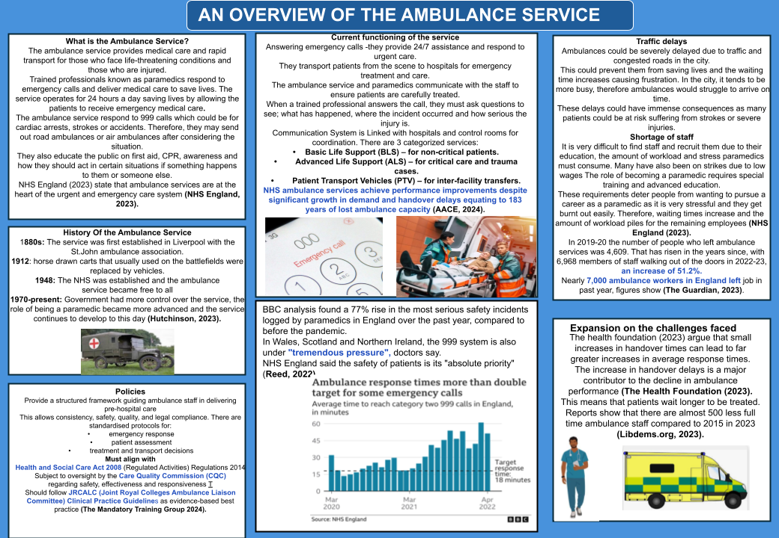

Origins of the NHS

The origins of the National Health Service (NHS) were established by the end of world war ll, around 1942-1948 and these services were free for everyone, they were funded by taxing (The Kings fund, 2023).
The Beveridge Report was produced by a civil servant named William Beveridge, this report was produced in 1942. Identifying disease as a barrier to progress. UK parliament (2025) stated that Beveridge was drawn to the idea of tackling social inequality , while working for a charitable organisation.
The five giants from the Beveridges Report are:
Idleness - when people didn't have jobs
Disease - Meaning poor health
Ignorance - Not educated
Squalor - Living in bad housing
Want - Not having enough money for basic needs
So he decided to propose for free NHS, After the world war ll,everyone was very poor and they couldn't afford to pay for basic health treatments.

Current structure and functioning

The NHS is a system within England, which is made up of different organisations which provide for hospitals, GPs, pharmacies, dentists and opticians.

NHS services are delivered in 4 different categories:
- Primary care: dentists, opticians, Gps NHS (2022)a patients first point of contact.
- Secondary care : this includes hospitals and urgent care when Gps make referrals to hospitals
- Tertiary care : tertiary care provides special care for patients with life threatening conditions e.g heart surgery or organ transplants in intensive care units.
- Community care : which includes health visitors,nursing and mental care (Majeed et al., 2022)

Challenges

NHS is currently facing lots of challenges, such as funding,staff shortages and changing policies.Since Covid 19 there is a backlog of patients waiting for treatment,lots of patients have experienced delays in receiving treatment.Waiting times have been at very high records since Covid 19 pandemic (The kings fund,2023).
The demand for healthcare service continues to rise but funding allocated to the NHS has not kept pace with the increasing funds.There is a continuous pressure on the NHs budgets and staff pay.Royal College of nursing (2025 ) A new analysis portrays that nurse starting salaries have decreased over 8,000 after a decade of pay cuts and inflation.

Conclusion

NHS remains the foundation of British society and a symbol of fairness and understanding, it was founded in 1948 to provide free health care for everyone regardless of background or income.While it faces many challenges such as funding and staff shortages, they still provide for others. The NHS believes that healthcare should be available to everyone, as it is a right for all. The department of health and social care (2023) states that the NHS has a duty to each and every individual and must respect their human rights. It continues to play a vital role for everyone. Despite the difficulties it faces, they still show dedication and commitment for the health of everyone.

References

AACE (2024). NHS ambulance services achieve performance improvements despite significant growth in demand and handover delays equating to 183 years of lost ambulance capacity - aace.org.uk. Aace.org.uk. [online] doi:https://doi.org/10/23171607/Ambulance-EOC-staff-1.

Hutchinson, S. (2023) 'History of UK ambulance services - EMSUKLEARNING,' EMSUK LEARNING, 26 March. https://www.emsuklearning.co.uk/history-of-uk-ambulance-services/

Libdems.org.uk. (2023). Revealed: Ambulance staff numbers fall as NHS crisis worsens. [online] Available at: https://www.libdems.org.uk/press/release/revealed-ambulance-staff-numbers-fall-as-nhs-crisis-worsens.

NHS England (2023). NHS England» Ambulance. [online] www.england.nhs.uk. Available at: https://www.england.nhs.uk/urgent-emergency-care/improving-ambulance-services/

NHS England (2023). NHS England » Culture review of ambulance trusts, Nhs.uk. Available at: https://www.england.nhs.uk/long-read/culture-review-of-ambulance-trusts/ (Accessed: October 16, 2025).
Reed, J. (2022). Ambulance wait times endangering patients, doctors say. BBC News. [online] 12 May. Available at: https://www.bbc.co.uk/news/health-61335711.
The Mandatory Training Group. (2024). What are ambulance service policies and procedures? [online] Available at: https://www.mandatorytraining.co.uk/blogs/complyplus/what-are-ambulance-service-policies-and-procedures.
The Health Foundation (2023). Why Have Ambulance Waiting Times Been Getting worse? [online] The Health Foundation. Available at: https://www.health.org.uk/reports-and-analysis/analysis/why-have-ambulance-waiting-times-been-getting-worse.

The Guardian. [online] 22 Aug. Available at:https://www.theguardian.com/society/2023/aug/22/nearly-7000-ambulance-workers-in-england-left-in-past-year-figures-show.

Department of Health and Social Care (2023). The NHS Constitution for England. (online) GOV.UK. Available at: https://www.gov.uk/government/publications/the-nhs-constitution-for-england/the-nhs-constitution-for-england.

The King’s Fund (2023) The NHS explained: how the health system works. Available at: https://www.kingsfund.org.uk.

Majeed, A., Maile, E. J. and Bindman, A. B. (2022) ‘The future of the NHS: challenges and opportunities after COVID-19’, The Lancet, 399(10327), pp. 1851–1860.

NHS (2022). The Healthcare Ecosystem. (online) NHS Digital. Available at: https://digital.nhs.uk/developer/guides-and-documentation/introduction-to-healthcare-technology/the-healthcare-ecosystem#primary-care.

Royal College of Nursing (2025) New analysis shows
nurse starting salaries over £8,000 lower after a
decade of pay cuts. London: Royal College of
Nursing. Available at:
https://www.rcn.org.uk/news-and-events/Press
-Releases/As-doctors-prepare-to-strike-new-analysis
-shows-nurse-starting-salaries-over-8k-lower

UK Parliament (2025). 1942 Beveridge Report. [online] UK Parliament. Available at: https://www.parliament.uk/about/living-heritage/transformingsociety/livinglearning/coll-9-health1/coll-9-health/.

`

