Zhi Yan Tan 2226088
BMBM6015 Strategic Management and Sustainability
Abstract
As the title suggests, this research analyses and evaluates Netflix, Inc. It has been found that Netflix aggressively pursues a low-cost strategy while still incorporating some sort of differentiation feature. The studies show that Netflix's meteoric ascension to the top ranks of the world's most successful organizations can be attributed in part to the firm's use of both of these Porter Generic strategies in tandem. The annual net profit for Netflix is predicted to be in the millions. The most significant issue is that it may be difficult for them to differentiate themselves from competitors while maintaining low pricing. As a result, Netflix was able to opt to retain positive relations with its investor as a recommendation for them to obtain funds.
Netflix
Strategic Management Evaluation


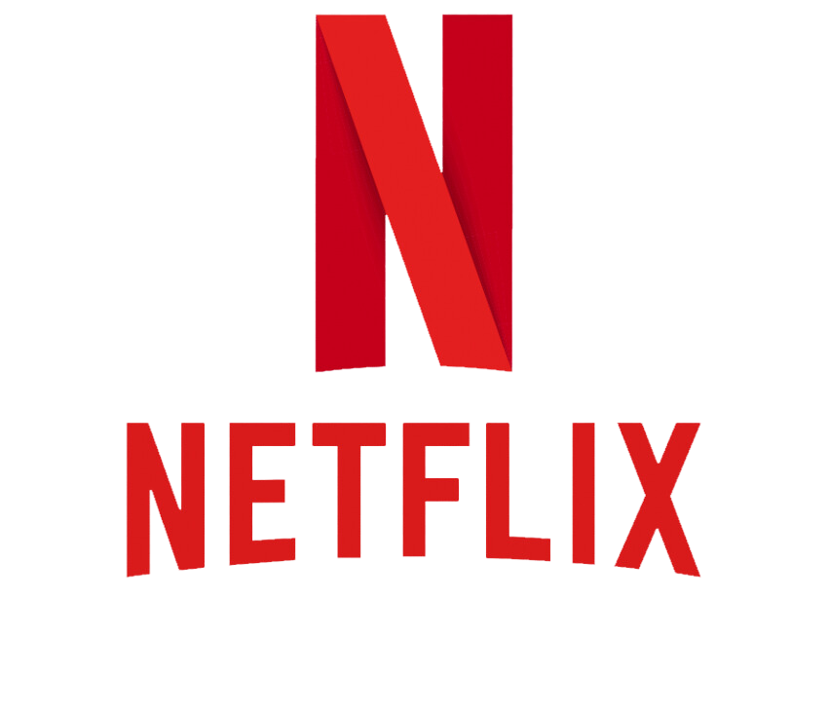
Contents
1.0 Introduction 1
1.1 History of Netflix 1
1.2 Objectives 2
2.0 Every Organizational Needs Strategic Management 3
2.1 Importance of Strategic Management 3
2.2 Porter Generic Strategies 4
3.0 Netflix Porter Generic Strategies 6
3.1 Netflix’s Combination Strategy 6
3.2 Benefits and Drawbacks of Netflix’s Strategy 8
4.0 Will Netflix continue standing strong? 11
4.1 Conclusion 11
4.2 Recommendation 11
5.0 References 13

1.0 Introduction

1.1 History of Netflix
Reed Hastings and Marc Randolph established Netflix in the year 1997 in the state of California (Netflix, 2023). Hastings and Randolph conceptualized the notion of a mail-order DVD rental service. In 1998, Netflix.com entered the market as the first online DVD-renting service. One year later, Netflix introduced its subscription service, which allowed customers to rent as many DVDs as they wanted for a set monthly fee. On the NASDAQ stock exchange under the ticker NFLX, Netflix went public in 2002, offering its shares for $1 each. By the year 2003, the monumental goal of one million accounts had been accomplished, and in the years that followed, the number of subscribers more than doubled (Gregory, 2021). Netflix first offered its streaming service to customers in the year 2007. The company's fortunes improved drastically after it debuted its streaming service. In the media and entertainment industries, they rose to prominence and became a phenomenon (Sun, 2022). Netflix initially found success with its mail business, and then it experienced explosive growth after launching its streaming service. Netflix was revolutionary because it provided a new way to stream television shows and movies. Their success led to the demise of industry pioneers like Blockbuster, which had previously dominated the DVD rental market (Fiegerman, 2018). After a few years had passed, Netflix eventually entered the worldwide market by making its service available in Canada (Chowdhury, 2020). In 2013, Netflix grew and began making its own shows, such as "House of Cards" and "Orange Is the New Black." During the same year, Netflix was recognized with 31 nominations for Primetime Emmys (Tweedie, 2014). They made history by being the very first internet television network to ever be considered for a Primetime Emmy nomination. In the years that followed, Netflix added support for 62 other languages and expanded into even more countries (Moore, 2021). Netflix is currently accessible in over 190 countries all around the world (Netflix, 2023).

1.2 Objectives
Hence, the purpose of this research is to conduct an in-depth assessment of the Strategic Management practices employed by Netflix. First, a basic explanation of why every firm needs Strategic Management will be drafted. The significance of strategic management will be emphasized, and Porter Generic Strategies will be defined, in the following section. Next, this study will conduct an in-depth examination of the Porter Generic Strategies now being put into practice by Netflix. The focus of these discussions will be on the manner in which Netflix executes both low-cost strategy and differentiation strategy within their business, as well as the benefits and downsides associated with both techniques. These points will constitute the core focus of the discussion. In the end, but certainly not least, a conclusion will be drawn from the analysis that was performed on Netflix, and some recommendations will also be provided.

2.0 Every Organizational Needs Strategic Management

2.1 Importance of Strategic Management
Strategic management is a subfield of management that focuses on creating a long-term vision for a company, defining its goals and objectives, developing and implementing a plan to achieve those targets, and identifying and addressing any obstacles along the way (Stamevska et al., 2019). It has two primary goals, the first of which is to create a competitive edge in the marketplace by outperforming its rivals and ultimately achieving market share. Second, it serves as a map for the company to follow so that it may better adapt to the shifting landscape of the commercial world. The ability of strategic management to give managers a methodical and all-encompassing approach to analysing the organization's internal and external environments is one of the primary reasons why strategic management is considered to be of such paramount significance (Farid, 2022). In addition, it analyses internal and external factors to determine where an organization is and where it may improve in order to get a competitive advantage. Furthermore, a corporation whose management places a premium on strategy will have better financial results than one whose leaders place less emphasis on it (Tapera, 2014). Successful revenue expansion, profit maximization, and return on investment are all direct results of well-thought-out and implemented strategies.

2.2 Porter Generic Strategies
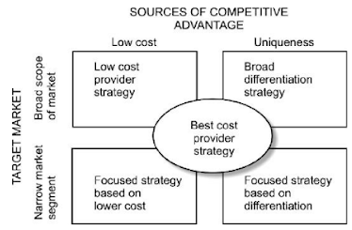
Fig.1: Generic competitive strategy, (Porter, 1985)
The generic competitive strategies are shown in figure 1 where there are three sorts of strategies that are deemed to be "generic", due to their applicability across a wide range of businesses (Ali & Anwar, 2021). The generic techniques all use slightly different approaches to gaining an edge in the market. The cost leadership strategy aims to position a company as the market's lowest-priced provider of a certain good or service while maintaining competitive margins (Roy, 2019). To continue to maintain cost leadership, it is necessary to be always on the lookout for opportunities to cut costs across all areas of the business. An organization's ability to create and market distinctive goods and services is facilitated by a differentiation strategy (Zhang et al., 2022). Differentiation is a potential technique for obtaining above-average profits in a particular industry since brand loyalty reduces clients' price sensitivity. As differentiation improves the barrier to entry, studies have shown that it is more likely to result in larger earnings than a low-cost strategy (Tanwar, 2013). But, the likelihood of generating a rise in market share with a strategy that has low costs is much higher. The focused approach allows a corporation to efficiently service a certain consumer or market group. It can be used as a targeting tactic to zero in on areas with a higher chance of a positive return on investment, such as those that are less susceptible to substitution or have less intense competition.

3.0 Netflix Porter Generic Strategies

3.1 Netflix’s Combination Strategy
Cost leadership is Netflix's overarching business approach. A low-cost strategy gives priority to an improvement in the overall performance of the firm. Everything that allows the corporation to produce or distribute its wares at a lesser cost than its rivals is a part of this process. According to Porter (1985b), a low-cost strategy is one that involves the trading of conventional products paired with aggressive pricing. With this standard approach, the online entertainment corporation may sell materials at inexpensive prices and remain competitive without having to be the lowest-cost provider in the market.
In contrast to niche-specific techniques, Netflix's generic approach aims to expand its consumer base throughout the whole online entertainment industry. For instance, the media streaming corporation capitalizes on its competitive advantages to increase the number of customers it serves in worldwide markets. Netflix's aggressive expansion goals, which place a premium on expanding its customer base, are compatible with the broad scope of this generic strategy. Netflix always monitors its competitors to determine the possibility that they can deliver a greater deal or reduced charges at the appropriate time. Netflix's ability to boost sales and profits by increasing prices and controlling conditions of offers is enhanced when rivalry in the market is low. Their current projects include concentrating more on expanding into new areas, as well as creating and disseminating more original material for their clientele. This can help with further price cuts and is something that could be suggested in the future for gaining a financial advantage and market share. In an effort to attract new consumers and keep its existing ones, Netflix has lately lowered its costs in over 30 nations, which include Thailand, Croatia, and Ecuador (Krouse, 2023). It appears that some monthly memberships have been slashed by as much as fifty percent. It has also launched a new, less expensive ad-supported plan in an effort to win over customers who might be unwilling to pay for the full version of the service (Griffin, 2023). Many of these changes seem designed to attract and retain subscribers for Netflix, which is now up against new competitors like Disney+.
While cost leadership is the cornerstone of Netflix's competitive strategy, the company also makes use of differentiation to separate itself from the competition. Differentiation is a broad marketing term that refers to the process of building an online business and the items it sells in a variety of ways that set them apart from the products offered by other companies. Hesterley and Barney (2012), claim that enterprises' ability to differentiate their products and services is a reflection of the individual and collective creativity of their employees. As a result, organizations' ability to be innovative in identifying measures to make their product distinctive is crucial in mitigating the risk of imitation of distinctiveness.
Netflix has set itself apart from its competitors by positioning itself not as a live-streaming player but rather as a source of on-demand material that does not include advertisements. Netflix has prioritized the creation of high-quality films and television shows and has steadily increased the amount of its original content. The firm's offering of unique material has been very well received. Netflix not only produces its own material but also provides a wide variety of other options to cater to a variety of preferences. The availability of movies and television programs that are not provided by other streaming services provides an edge to the company in terms of competition. Netflix's continuing global expansion can be attributed to the company's data-mining strategy, which has helped the company learn what its customers want to watch, how to best sell to them, and how to make their Netflix experience unique and enjoyable (Brennan, 2018). Netflix is committed to enhancing the viewing experiences of its subscribers all over the world by providing content in a variety of multiple languages, along with subtitles and dubbing options. As a result of these supplementary offerings, Netflix is in a position to differentiate itself from its rivals and attract a larger customer base.

3.2 Benefits and Drawbacks of Netflix’s Strategy
The pursuit of a low-cost approach should not be viewed as an offering of a service or goods that are of lower quality, but rather as the provision of a service or goods that are on par in quality with comparable offerings from competitors and is priced appropriately (Islami et al., 2020). It is essential to point out that Porter has demonstrated a correlation between a low-cost approach and the performance of a company, and his research confirmed that cutting costs and keeping them under control is the best method to maintain a competitive edge, which in turn improves an organization's overall performance (Porter, 1985a). Netflix persists in pursuing low-cost strategies because they help enterprises perform better. By focusing on reducing expenses, Netflix can undercut rivals on price without sacrificing profits. Additionally, it safeguards the business against mighty suppliers by allowing for the requisite wiggle room within the realm of profit to accommodate an increase in input prices (Islami et al., 2020). It prevents new competitors from entering the market by raising the bar for them to overcome in terms of the economic scale, controls, and cost-cutting, and also by virtue of their superior curve-fitting experience (Wright, 1936).
The downside of taking an approach based on cost leadership is that it can be hazardous. Monetary leaders need to be on the cutting edge of cost-cutting innovations. Whenever time one business finds a successful way to cut costs, its rivals are quick to follow suit. If Netflix wants to avoid suffering substantial financial setbacks, the company must be able to maintain a constant reduction in operating expenses. In addition, cost leaders are reliant on a substantial amount of daily sales since they are compelled to run their businesses with relatively low-profit margins. This indicates that in order for Netflix to be successful, they need to keep its sales at a high volume.
To differentiate itself from the competition, Netflix, for instance, creates its own original programming and does not rely on the streaming services of others to provide its viewers with entertainment. With the help of the differentiation strategy, the business model can attract and keep clients, which is crucial to the success of the company's ambitious expansion and development ambitions for its digital services. Netflix not only produces high-quality services but also strengthens ties with clients and vendors by upholding positive reputations and developing strong brands. These commercial endeavours will result in advantages over competitors that are difficult or impossible for those competitors to replicate (D. Banker et al., 2014). Existing companies that adopt a differentiation strategy will have an advantage over new entrants due to their solid reputations and product delivery expertise. These companies also have large profit margins, which might assist the companies in avoiding financial difficulties (Widuri & Sutanto, 2019). And for this tactic (Porter, 1985a), demonstrated how it correlates with company success and the benefits it brings in the form of increased profits for those that adopt it, in contrast to the competition due to the superior faith, quality, and perspective that consumers have in the company's brand.
Another one of the company’s flaws is the fact that it would have to make a higher financial investment in order to pursue a differentiation strategy. Netflix must spend a lot of money on R&D, marketing, and the actual implementation of any new services they hope will set them apart from the competition. At the same time, Netflix is required to keep its services at an inexpensive level in order to prevent its customers from looking for other, more economical alternatives. Therefore, it may be difficult for Netflix to provide a diverse selection of services while maintaining affordable prices at times.

4.0 Will Netflix continue standing strong?

4.1 Conclusion
Implementing combinations such as cost leadership and product differentiation is challenging, but not impossible because there is a possibility of a conflict arising between the goal of minimizing costs and the increased expense of value-added differentiation. Netflix’s size and dominance give them a cost advantage due to the economies of scale that result from spreading fixed costs over a larger customer base, and they can reinvest some of that money into differentiating their products and services in other ways, such as, by intensifying advertising efforts or increasing expenditures on research and development. Netflix is a fantastic illustration of a company that successfully implements both a product-differentiation strategy as well as a cost-leadership strategy at the same time since of the company’s ability to differentiate its products according to categories like movies, languages, and other factors, they were able to become the market share leader in their field while simultaneously lowering their expenses.

4.2 Recommendation
The current model that Netflix employs, which focuses on broad differentiation and affordable costs, has been very effective. Given the positive results thus far, I suggest that the company keep putting an emphasis on broad differentiation through cost advantage. Netflix must continue to gain access to finance in order to carry out these objectives and maintain the rate at which it produces original content. Due to the fact that the corporation is in debt, it is imperative that its ties with investors be preserved. Netflix is constantly looking for approaches to enhance, but in order to better manage its finances and bring down its debt, I believe it should focus on the fundamentals. The organization must ensure that its platform continues to be successful while also remaining user-friendly and free of advertisements that offer suggestions to users. In comparison to similar services, this simplifies the process of watching content online. This strategy for differentiating oneself from the competition will help Netflix maintain its allure among its users.
(Word Count: 2450)

5.0 References
Ali, B.J. and Anwar, G. (2021) “Porter’s generic competitive strategies and its influence on the competitive advantage,” International Journal of Advanced Engineering, Management and Science, 7(6), pp. 42–51. Available at: https://doi.org/10.22161/ijaems.76.5.
Aziz, H.M. et al. (2021) “Employee commitment: The relationship between employee commitment and job satisfaction,” Journal of Humanities and Education Development, 3(3), pp. 54–66. Available at: https://doi.org/10.22161/jhed.3.3.6.
Barney, J.B. and Hesterly, W.S. (2012) Strategic management and competitive advantage concepts and cases. Upper Saddle River, N.J: Prentice Hall.
Blair, T. et al. (2019) “Netflix-Company Analysis,” Business Policy & Strategic Management capstone project, pp. 1–70. Available at: https://tessacreates.com/?rara-portfolio=netflix-project Accessed: March 7, 2023).
Brennan, L. (2018) How netflix expanded to 190 countries in 7 years, Harvard Business Review. Available at: https://hbr.org/2018/10/how-netflix-expanded-to-190-countries-in-7-years. (Accessed: March 7, 2023).
Chowdhury, M.F. (2020) “An Analysis of Netflix’s Business Strategy and How the Company is Coping with the Challenges Posed by the Coronavirus Crisis. ,” AIUB Journal of Business and Economics (AJBE), 17(2), pp. 239–257. Available at: https://www.researchgate.net/publication/350041166_An_Analysis_of_Netflix's_Business_Strategy_and_How_the_Company_is_Coping_with_the_Challenges_Posed_by_the_Coronavirus_Crisis (Accessed: March 9, 2023).
D. Banker, R., Mashruwala, R. and Tripathy, A. (2014) “Does a differentiation strategy lead to more sustainable financial performance than a cost leadership strategy?,” Management Decision, 52(5), pp. 872–896. Available at: https://doi.org/10.1108/md-05-2013-0282.
Farid, O. (2022) “Strategic management identity,” American Journal of Industrial and Business Management, 12(05), pp. 995–1005. Available at: https://doi.org/10.4236/ajibm.2022.125051.
Fiegerman, S. (2018) How Netflix beat its rivals and survived the 2000s, CNNMoney. Cable News Network. Available at: https://money.cnn.com/2018/07/24/technology/netflix-2000s/index.html (Accessed: March 9, 2023).
Gregory, A. (2021) “Complete Analysis of Netflix, Inc.,” Honors Theses, pp. 1–67. Available at: https://egrove.olemiss.edu/hon_thesis/1765/ (Accessed: March 9, 2023).
Griffin, A. (2023) Netflix reduces its prices, The Independent. Independent Digital News and Media. Available at: https://www.independent.co.uk/tech/netflix-price-reduction-rise-cut-cost-b2288925.html (Accessed: March 7, 2023).
Islami, X., Mustafa, N. and Topuzovska Latkovikj, M. (2020) “Linking porter’s generic strategies to firm performance,” Future Business Journal, 6(1). Available at: https://doi.org/10.1186/s43093-020-0009-1.
Krouse, S. (2023) Netflix cuts subscription prices in over 30 countries, The Wall Street Journal. Dow Jones & Company. Available at: https://www.wsj.com/articles/netflix-cuts-subscription-prices-in-over-30-countries-ae6d047c (Accessed: March 7, 2023).
Moore, K. (2021) Does Netflix have too much foreign content?, What's on Netflix. Available at: https://www.whats-on-netflix.com/news/does-netflix-have-too-much-foreign-content/ (Accessed: March 9, 2023).
Netflix (2023) Countries where Netflix is available, Help Center. Available at: https://help.netflix.com/en/node/14164 (Accessed: March 9, 2023).
Netflix (2023) The Story of Netflix, About Netflix. Available at: https://about.netflix.com/en (Accessed: March 9, 2023).
Porter, M.E. (1985) Competitive advantage: Creating and sustaining superior performance. London: The Free Press.
Porter, M.E. (1985) Competitive strategy: Techniques for analyzing industries and competitors. New York: Free Press.
Roy, S.N. (2019) “Cost Leaderships Strategy Enhancing Competitiveness: A Critical Study On MNC Retails,” HR Marketing interface in Indian FMCG industry [Preprint]. Available at: https://doi.org/10.13140/RG.2.2.29115.34083.
Stamevska, E., Dimitrieska, S. and Stankovska, A. (2019) “Role, Importance And Benefits Of Strategic Management,” Economics and Management, XVІ(2), pp. 58–65. Available at: https://ideas.repec.org/a/neo/journl/v16y2019i2p58-65.html (Accessed: March 8, 2023).
Sun, X. (2022) “Two decades and more: Evolution of netflix’s business models and outlook of future,” SHS Web of Conferences, 148, p. 03032. Available at: https://doi.org/10.1051/shsconf/202214803032.
Tanwar, R. (2013) “Porter’s generic competitive strategies,” IOSR Journal of Business and Management, 15(1), pp. 11–17. Available at: https://doi.org/10.9790/487x-1511117.
Tapera, J. (2014) “The Importance of Strategic Management to Business Organizations,” The International Journal's Research Journal of Social Science & Management, 3, pp. 122–131. Available at: https://www.researchgate.net/publication/301801352_The_Importance_of_Strategic_Management_to_Business_Organizations (Accessed: March 9, 2023).
Tweedie, S. (2014) Netflix nominated for 31 emmys - more than twice as many as last year, Business Insider. Available at: https://www.businessinsider.in/netflix-nominated-for-31-emmys-more-than-twice-as-many-as-last-year/articleshow/38145483.cms (Accessed: March 9, 2023).
Widuri, R. and Sutanto, J.E. (2019) “Differentiation strategy and market competition as determinants of Earnings Management,” Proceedings of the International Conference on Tourism, Economics, Accounting, Management, and Social Science (TEAMS 2018) [Preprint]. Available at: https://doi.org/10.2991/teams-18.2019.30.
Wright, T.P. (1936) “Factors affecting the cost of airplanes,” Journal of the Aeronautical Sciences, 3(4), pp. 122–128. Available at: https://doi.org/10.2514/8.155.
Zhang, B. et al. (2022) “Brand recognition, interdepartmental conflict, and performance: An investigation of porter’s differentiated competitive strategy implementation in a large Chinese automobile company,” Sustainability, 14(20), p. 13546. Available at: https://doi.org/10.3390/su142013546.

