Module name: Management Economics

Assignment 1

Module Code: LCBB5008

Name: Valentina Pituscanu
Student ID: 2124861

Lecturer: Taye Osadiya
Table of Contents
Introduction 2
Economic Problems 3
Strategies 4
Difference between elasticity and inelasticity 8
The laws of supply and demand 9
References 10

Introduction

It is true that the Covid-19 epidemic has significantly impacted international supply chains. and the way businesses operate. The shortage of labour supply, disruptions in transportation, and increased demand for goods have all contributed to the challenges faced in the supply chain.
The epidemic has resulted in a greater dependence on importing intermediate goods and raw materials from elsewhere. This has led to a greater dependence on international supply chains, which have experienced immense pressure and strain during this time. The Fed Global Supply Chain Barometer has observed that recent pressures on supply chains have been more severe than ever before.
The shift in consumer behaviour from services to goods has further exacerbated the pressure on supply chains. The high demand for goods, combined with shortages of drivers, has caused fuel supply problems. The UK has experienced a shortage of drivers, with many leaving the country, possibly due to factors like Brexit and the pandemic. As a result, deliveries to some petrol stations have been disrupted, and consumers have rushed to fill their tanks, leading to a rapid increase in demand when supply was already constrained.
During the peak of the crisis, fuel shortages at forecourts in the worst-hit areas of the country reached an average of around 20%, compared to the normal level of 43%.
Overall, the Covid-19 pandemic has significantly impacted the demand and supply chain, causing disruptions and shortages across various industries. The challenges faced in the supply chain continue to be a concern for businesses globally.

Economic Problems
The case study demonstrates several basic economic issues that have emerged because of the Covid-19 outbreak and its effects on international supply chains. These problems include:
1. Shortages of Demand and Supply: The pandemic has disrupted the demand and supply chain, leading to shortages in various sectors. This has been caused by factors such as labour shortages, transportation disruptions, and increased consumer demand for goods. These shortages have resulted in imbalances in the market, with demand outpacing supply in certain areas.
2. Price Changes: The shortage of labour supply and disruptions in the supply chain have led to price changes, particularly in the fuel industry. The high demand for fuel, coupled with the shortage of drivers, has caused prices to increase. This has impacted both businesses and consumers who rely on affordable fuel for transportation and other needs.
3. Reliance on Imports: The case study highlights the continued reliance of UK firms on importing raw materials and intermediate products from abroad. This reliance on international supply chains has been put under immense pressure during the pandemic, leading to disruptions in the flow of goods and services. This highlights the vulnerability of economies that heavily depend on imports for their production processes.
4. Shift in Consumer Behaviour: Consumer behaviour has significantly changed because of the epidemic, with a focus being more on buying products than services. This change in consumer appetite has put additional pressure on supply chains, as businesses have had to adapt to meet the increased demand for goods. This shift has also resulted in challenges for businesses that primarily offer services.
5. Driver Shortages: The case study points out the exodus of EU drivers from the UK, which has created a shortage of drivers and disrupted deliveries to petrol stations. This shortage is likely a result of both Brexit and the pandemic. The lack of available drivers has further strained the supply chain, leading to fuel supply problems and consumer panic buying.
Overall, these fundamental economic problems highlight the fragility and interconnectedness of global supply chains. The pandemic has exposed vulnerabilities and emphasized the need for businesses and governments to address these challenges and build more resilient supply chain systems in the future.
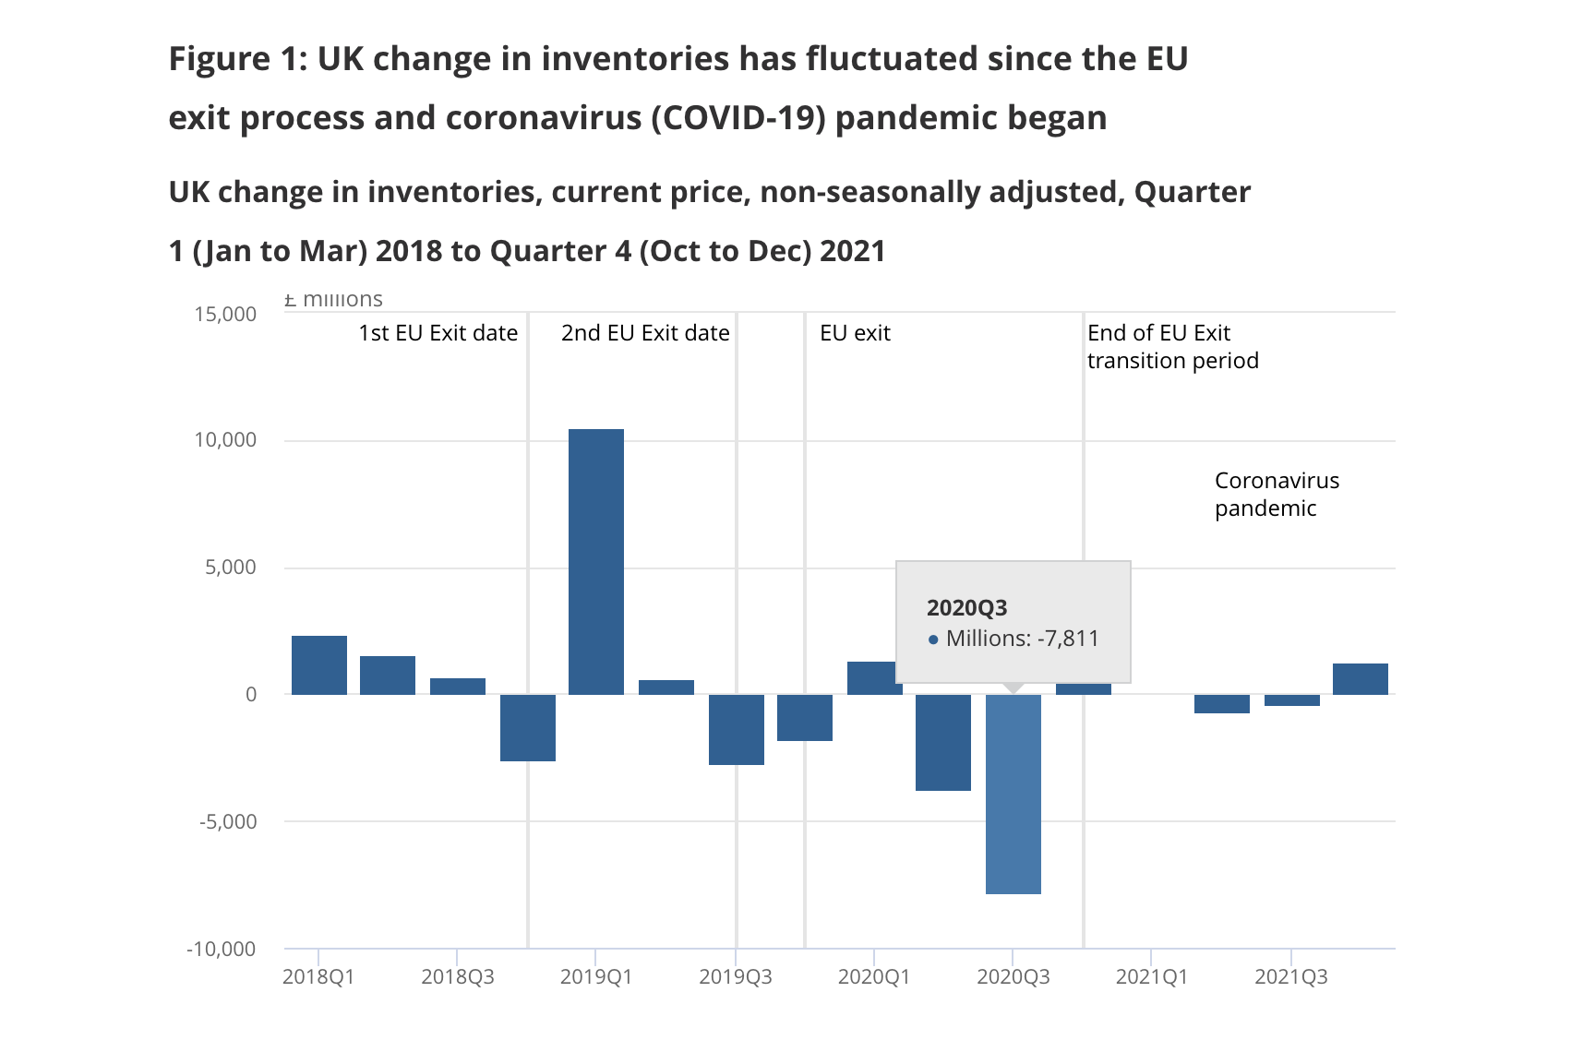

Source: Office for National Statistics – GDP data tables

Strategies

To address the economic problems identified in the case study, several strategies can be considered:
1. Diversification of Supply Chains: Businesses can seek to diversify their supply chains by exploring alternative sourcing options and reducing their reliance on a single supplier or region. This can mitigate the risk of disruptions in the future and provide more flexibility in times of crisis.
2. Investments in Local manufacturing: To lessen reliance on imports, firms and governments can make investments in local manufacturing capacities. This can involve supporting domestic industries, encouraging innovation, and providing incentives for companies to manufacture locally. Increasing local production can help mitigate supply chain disruptions and create more resilient economies.
3. Enhancing Infrastructure: Governments can invest in infrastructure development, such as roads, ports, and logistics networks, to improve the efficiency and resilience of supply chains. Infrastructure upgrades can help streamline transportation and distribution processes, reducing bottlenecks and increasing the overall capacity of the supply chain.
4. Workforce Development: Addressing labour shortages requires investing in workforce development programs. This can include training initiatives, apprenticeships, and incentives for individuals to enter industries facing shortages. By nurturing a skilled workforce, businesses can ensure smoother operations and reduce the impact of labour shortages.
5. Collaboration and Communication: Businesses and governments need to foster collaboration and communication within supply chains. This can involve sharing information, forecasting demand, and working together to address challenges collectively. Enhanced collaboration can aid in the early detection of any disturbances and enable the taking of preventative action.
6. Technology Adoption: Embracing technology can help optimize supply chain operations. Digital platforms, data analytics, and automation are examples of solutions that can increase productivity and streamline procedures and enable better demand forecasting. Technology can also facilitate better communication and coordination within supply chains.
7. Diversification of Customer Base: Businesses can reduce their vulnerability by diversifying their customer base, both geographically and across industries. This can help mitigate the impact of sudden changes in demand and reduce reliance on a single market or sector.
8. Contingency Planning: Businesses should develop comprehensive contingency plans to manage disruptions effectively. This includes identifying alternative suppliers, establishing backup inventory, and creating response strategies for potential scenarios. Contingency planning can help minimize the impact of disruptions and enable a faster recovery.
By implementing these strategies, businesses and governments can work towards resolving the economic problems highlighted in the case study and build more resilient supply chains capable of withstanding future challenges.

Demand and supply are relevant in this case study because they play a crucial role in understanding and addressing the economic problems faced by the businesses and governments discussed.
1. Supply Chain Disruptions: The case study highlights how disruptions in the supply chain, such as factory closures and transportation disruptions, have led to a shortage of critical products. Understanding the supply side of the equation helps identify the root causes of these disruptions and find solutions to mitigate them.
2. Labour Shortages: The case study mentions labour shortages as a significant challenge. Analysing the supply of labour helps identify the reasons behind the shortage and explore strategies to address it. By understanding the supply of available workers and the factors affecting their availability, businesses and governments can develop appropriate measures to attract, train, and retain workers.

In the figure 2 below you can see the employment (Pay As You Earn) graphic.
Starting around early 2019, employee growth began a slight downward trend. However, employee growth slowed more substantially past March 2020, coinciding with the coronavirus (COVID-19) pandemic, becoming negative in April 2020.
At the start of 2021, growth rates began to recover, and remained high as the labour market continued to recover from the effects of the pandemic. From April 2022 the annual growth rate has been falling. Through 2022 this fall would have been partially caused by the comparison against the increase in employee numbers from March 2021, which levelled off as we no longer compared against this higher baseline. However, since then, growth rates have continued to fall.
Source: https://www.ons.gov.uk/employmentandlabourmarket/peopleinwork/earningsandworkinghours/bulletins/earningsandemploymentfrompayasyouearnrealtimeinformationuk/june2023
Figure 2

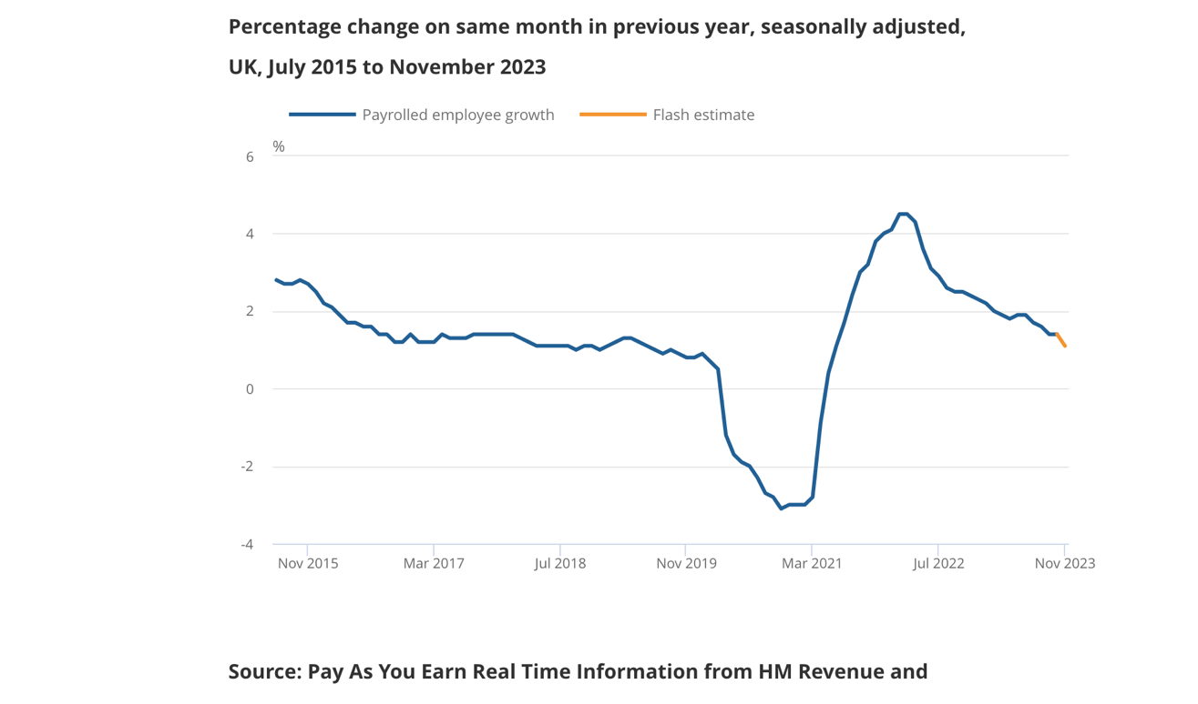

3. Market Demand: The case study also mentions fluctuations in market demand and changing consumer preferences. Understanding customer demand is crucial for businesses to effectively allocate resources, plan production, and tailor their products and services to meet customer needs. Analysing demand trends and patterns can help businesses respond to changing market conditions and make informed decisions.
4. Economic Recovery: The case study discusses the need for financial recuperation after the disruptions. Demand plays a crucial role in driving economic growth. By understanding the factors that influence consumer and business spending, governments can implement appropriate policies to stimulate demand and support the recovery process.
In summary, demand and supply are relevant in this case study because they provide insights into the causes of disruptions, labour shortages, market dynamics, and the overall economic recovery. By analysing and addressing these factors, businesses and governments can develop effective strategies to resolve the economic problems identified.
The distinction between demand's elasticity and inelasticity in relation to fluctuations in gasoline prices lies in the responsiveness of consumer demand to those price changes.
The term "elasticity of demand" describes how responsive a product's quantity desired is to price fluctuations. A little change in price causes a comparatively bigger change in the quantity required when the demand is elastic. In relation to fuel, if the cost of fuel rises and consumers respond by significantly reducing their consumption or switching to alternative modes of transportation, demand for fuel is considered elastic.
On the other hand, inelastic demand are not very responsive to price fluctuations, and even large price changes have little effect on the amount required. In the case of fuel, if consumers continue to purchase and consume fuel even when prices rise, demand for fuel is considered inelastic.

Below in the Figure 3
we can see how the Consumer Price Inflation (CPI) changed over the years.

Figure 3
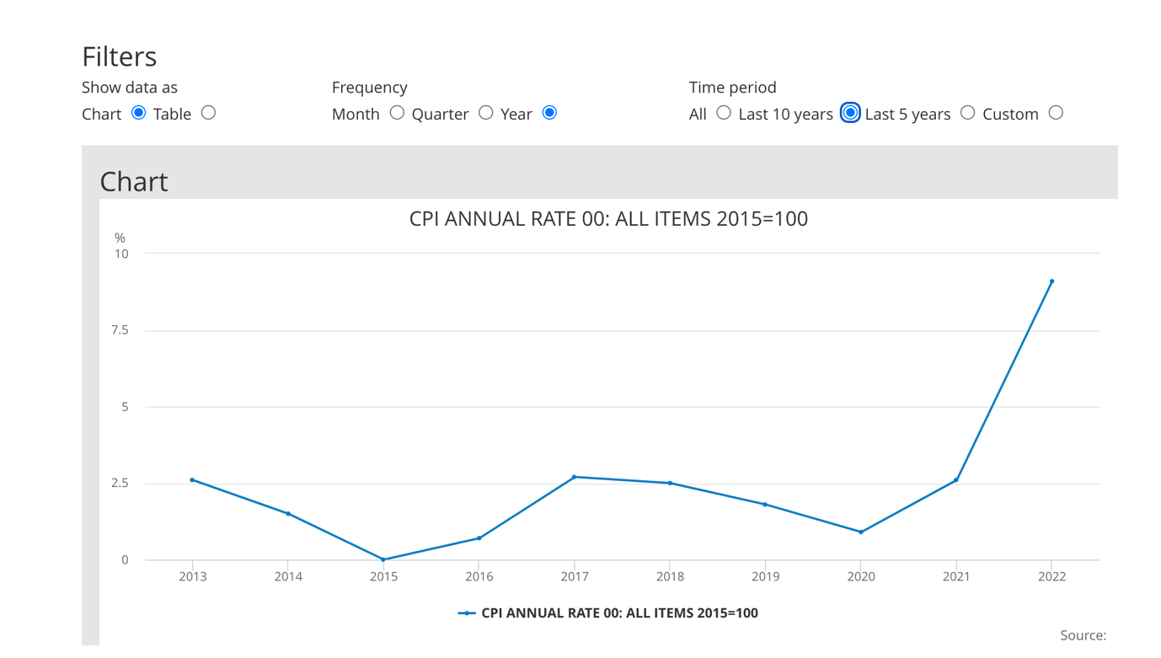

Difference between elasticity and inelasticity
The elasticity or inelasticity of fuel demand is influenced by several factors:
1. Availability of substitutes If there are easily accessible and reasonably priced fuel alternatives, such public transportation or electric cars, consumers may be more likely to have elastic demand as they can easily switch to alternatives when fuel prices increase.
2. Necessity versus luxury: If fuel is considered a necessity, such as for commuting or essential services, demand tends to be more inelastic as consumers may have limited options and must continue to purchase fuel regardless of price changes. However, if fuel is considered more of a luxury, demand may be more elastic as consumers can reduce their consumption or opt for alternative modes of transportation.
3. Time period: Demand elasticity can also vary depending on the period under consideration. In the short run, demand for fuel may be relatively inelastic as consumers may have limited immediate alternatives. However, over the long run, consumers may have more flexibility to adjust their behaviour and find substitutes, making demand more elastic.
Understanding the elasticity or inelasticity of fuel demand is crucial for policymakers, businesses, and consumers. It helps in predicting the impact of price changes on demand, assessing consumer behaviour, and making informed decisions related to pricing, transportation policies, and energy conservation.

The laws of supply and demand

The laws of supply and demand are fundamental principles in economics that describe how the costs and quantities of products and services are set in a market economy. Let's go through each law and its explanation:
1. Law of Demand:
The law of demand states that, all else being equal, as the price of a good or service increases, the quantity demanded by consumers decreases, and vice versa. This is based on the notion that consumers tend to purchase more of a product at lower prices and less at higher prices. The law of demand reflects the inverse relationship between price and quantity demanded.
2. Law of Supply:
The law of supply states that, all else being equal, as the price of a good or service increases, the quantity supplied by producers increases, and vice versa. This means that producers are willing to supply more of a product at higher prices and less at lower prices. The law of supply reflects the direct relationship between price and quantity supplied.
3. Law of Supply and Demand:
The law of supply and demand is an extension of the individual laws of supply and demand. It states that the equilibrium price and quantity in a market are determined by the intersection of the demand and supply curves. In other words, the market price and quantity will adjust until the quantity demanded equals the quantity supplied. This is where the forces of supply and demand find balance.
4. Law of Diminishing Marginal Utility:
The law of diminishing marginal utility states that as a consumer consumes more units of a good or service, the additional satisfaction (or utility) derived from each additional unit decreases. This implies that the more of a product a consumer already has, the less willing they are to pay a higher price for additional units.
5. Law of Increasing Marginal Cost:
The law of increasing marginal cost applies to producers and states that as a producer increases the production of a good or service, the additional cost of producing each additional unit also increases. This is often due to factors such as limited resources, specialized equipment, or labour constraints.
Understanding and applying these laws allows economists, businesses, and policymakers to analyse and predict market behaviour, determine optimal pricing strategies, and make informed decisions about resource allocation and production.

References
Heien, D. and Pompelli, G. (1989) The Demand for Alcoholic Beverages: Economic and Demographic Effects, Southern Economic Journal, pp. 759–769.
Shapiro, M. (1987) Measuring Market Power in U.S. Industry, NBER Working Paper, No. 2212.
Baker, J. (2003) Competitive Price Discrimination: The Exercise of Market Power Without Anticompetitive Effects (Comment on Klein and Wiley). Articles in Law Reviews & Other Academic Journals. Paper 278.
Aigner-Walder, B. (2015) Effects of the Demographic Changes on Private Consumption: An Almost Ideal Demand System Analysis for Austria. Journal of Economic and Social Stu
https://fleximize.com/articles/002211/what-is-supply-and-demand
(https://www.instituteforgovernment.org.uk/publication/supply-chains/government-response)

https://www.ons.gov.uk/economy/grossdomesticproductgdp/articles/stockandsupplychainissuesintheuk/quarter1jantomar2018toquarter4octtodec2021

OECD (2015), OECD Employment Outlook 2015, OECD Publishing, Paris. Available at: http://ifuturo.org/documentacion/Employment%20outlook%202015.pdf
Andreyeva, T., Long, M. and Brownell, K. (2010) The Impact of Food Prices on Consumption: A Systematic Review of Research on the Price Elasticity of Demand for Food. American Journal of Public Health, 100, 2, 216-222.
Osadiya T. (2023), Introduction to Economics. Amazon
Rauch, D. and Schleicher, D. (2015) Like Uber, But for Local Governmental Policy: The Future of Local Regulation of the 'Sharing Economy'. George Mason Law & Economics Research Paper No. 15-01. Available at: http://ssrn.com/abstract=2549919
https://www.instituteforgovernment.org.uk/publication/supply-chains/causes

