

UWTSD Swansea

Gaynor Thomas
Smart and Connected Devices
Daniel Algie 1706977

Contents
Table of Figures 2
Introduction 3
Creating the database and transferring data 3
Login page 4
MySQL 5
Website (HTML) 6
Testing 7
Conclusion 7
References 8

Table of Figures
Figure 1-image of user’s database 3
Figure 2-text file read to database 3
Figure 3-login page 4
Figure 4-shows the user search fields 5
Figure 5-php graph of rainfall 6

Introduction
For this report it will be shown and explained how using Personal Home Page tools (php), Hypertext Markup Language (html) and Relational Database Management System (MySQL) to make an easy to use website for the user to view data on rainfall from the Amazon rainforest.

Creating the database and transferring data
The database was created using phpMyAdmin, phpMyAdmin is an application used for creating the database and managing tables and sort the data into the correct fields.

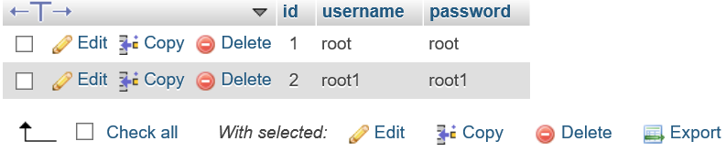
Figure 1-image of user’s database

The image above shows how the database will look for when a new user is added to the database.
When transferring the data, it was transferred using php. The first step was to create a link in PHP that connects the php my admin which creates a server that we can utilise.
$link=mysqli_connect($strServer,$strUser,$strPwd,$strDatabase)or die("Could not open database");
The php code above is used to connect to php my admin or show that the database could not connect.
Once connected to the database, the next step was to read in 3 separate text files with the amount of rainfall which had fallen, the date/time and which sensor the rainfall was recorded from [1]. This was achieved by using php to create an array and setting each text file to an element of the array and a FOR LOOP statement to keeping looping through the php code and read in each file to the database.
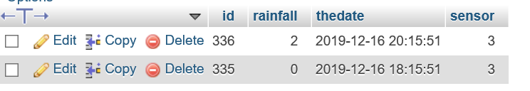
Figure 2-text file read to database

Login page
The login page was created so it would restrict who could see the data when first visiting the website the user must enter their username and password to gain access to the main website page.
The login and password used for the user were made in phpMyAdmin the first user username was set to root and the password to root and user 2 username was set to root1 and the password root1 for the purpose of this assignment. The use of php was used it was created to link the database and the html log in page to check if the user has access to the main page [2]. The use of MySQL quarries was used to search for the user.

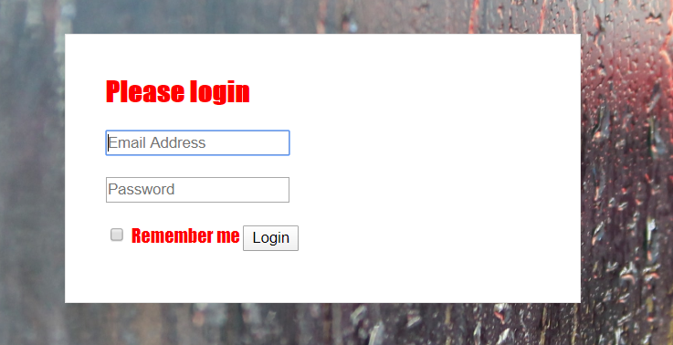
Figure 3-login page

If the user does not have access or entered the wrong password or username then it will stay on this page, if correct it will give access to the user and automatically take them to the main page of the website.
It was also implemented that the user could not type in the main page in the URL and be directed to the main page this was to stop users receiving the data it would automatically take the user to the login in page this was achieved by using session function to check if a user had entered in there login details already if the user has it would allow them to view the page and would direct them back to the login page if the user has not entered there details.

MySQL
MySQL was used to create the queries for the user to search for different types of data [3]. The user can search for data from a specific sensor as they might only want to see the date received from sensor one, two or three or the user might want to search for a certain date. This feature was created so that the user could search from a certain date to another date for example the user can search from the 14-12-2019 to the 16-12-2019 and it will display all data between those dates. This is where MySQL come into use so that the user can search these queries and using MySQL commands it will retrieve certain data from the database the user will never see the MySQL commands using html it was designed so that the user would have drop down and search bars to make these queries.

$query = "SELECT * FROM rainfalldatabase WHERE thedate BETWEEN '$dates' AND '$datef' AND sensor = '$sensor' ORDER BY thedate";

What this command does is select from the database which is called rainfall database and then take the dates the user has submitted from and to and displays all data on a separate page.


Figure 4-shows the user search fields

It was also implemented that the user could search for a specific sensor and it would generate a bar graph for the user to see how much rainfall there was from the sensor chosen. This feature was created and designed using php and then it was displayed on the website as an image adding a more pleasing interface, a bar graph was chosen over a line graph as the line graph has limited option in customising the display.
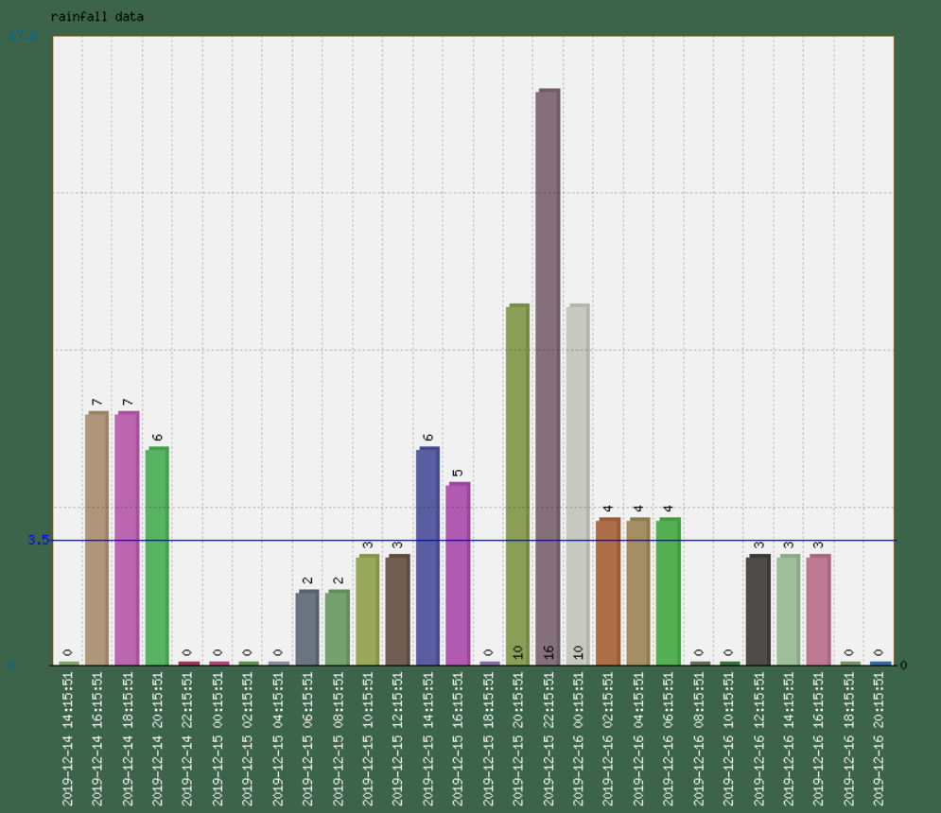
Figure 5-php graph of rainfall

Website (HTML)
When designing the website, it was created using the mobile first rule where it was designed for mobile phones devices and worked up to larger devices, this design process meant that it was compatible and available to all devices without restricting the users experience. It was also made as simple as possible for the user to access and use all the search features. An idea was to allow the user to view both the data and graph on the same page, this was attempted but with limited time it was quickly removed due to complexity of the feature.

line shows request to login from login page
line show request failed sent page to login page
database
line shows login details excepted forwarded to main page
Main page
Login page

Testing
Testing No | Testing Description | Expected Outcome | Actual Outcome | Pass / fail
1 | Entering wrong details in login | Keep the user on login page | Kept the user on login page | pass
2 | Entering correct login details | Take the user to index page | Took the user to index page | Pass
3 | Enter index page in URL | Should take the user to login page | Took the user to login page | Pass
4 | Checking all back button | Should take to previous page | Took user to previous page | Pass
5 | Search to make graph from sensor | Should show user a graph from correct sensor | Showed user correct sensor | Pass
6 | Search for rainfall greater than certain amount | Entered rainfall greater than 5 | Showed all correct data greater than 5 | Pass
7 | Check logout button | Take you to login in page | Took you to login in page | Pass
8 | Reading in all files and deleting files after implanting into database | Should store all data in database and delete files | Deleted all files and read into to database | Pass

Conclusion
In conclusion everything that was set out to achieve to make mother nature website was a success but looking to the future there are some fields which could be improved on with more knowledge and understanding in the field and a longer time frame.
When deleting the text files used to read in the data to the database the way used was incorrect it wasn’t taken in to account that there could be more data added in at a further date this is easily rectified by changing the way the file was deleted to set it to write so it would read the files and wipe but keep the empty files still there so could add to the database at a later date this was due to an error or tunnel vision to get the working demo finished within the dead line date though it was a downfall and incorrect method this was a learning curve which has been learnt and won’t happen again.
If this assignment was to be redone then a feature that would have been nice was to have the tables of data and the graph be linked on the same page to make it easier for the user to receive both data and graph at the same time. The attempt to display both tables of data and graphs on a single page was quickly scrapped after research into the topic showed the complexity of it but if more time was given and some more practice in html and php then this could have been attempted again at a later date. Having more time would allow for more research into relevant topic that would have allowed the builder to stay up to date with new techniques and to improve the mother nature website.

References

[1] | w3schools, “w3schools,” [Online]. Available: https://www.w3schools.com/php/func_filesystem_readfile.asp. [Accessed 25 febuary 2020].
[2] | w3schools, “w3schools,” [Online]. Available: https://www.w3schools.com/howto/howto_css_login_form.asp. [Accessed 25 february 2020].
[3] | http://g2pc1.bu.edu/~qzpeng/manual/MySQL%20Commands.htm, “MySQL,” [Online]. Available: http://g2pc1.bu.edu/~qzpeng/manual/MySQL%20Commands.htm. [Accessed 25 february 2020].
[4] | L. Babin, “php 5 recipes,” in a problem- solution approach , New York, Apress , 2005.
[5] | f. dummies, “php & MySQL,” in for dummies , New York, Hungry MInds .
[6] | https://www.phpmyadmin.net/, “php my admin,” [Online]. Available: https://www.phpmyadmin.net/. [Accessed 25 febuary 2020].

Appendix

Here you will find the code how completing the database base, website and php code to create mother nature.

The login in for php my admin.
<?php
$strServer="localhost";
$strDatabase="dan"; // name of database
$strUser="root";
$strPwd=""; // Leave blank for WAMPServer

$link=mysqli_connect($strServer,$strUser,$strPwd,$strDatabase)or die("Could not open database");
?>

Code to check the user has access to website

<?session_start();//start or access existing session
include "coninfo.php";
$un=$_POST["username"];
$pw=$_POST["password"];

$query="SELECT * FROM login WHERE username like '$un'
AND password like '$pw'";

$result=mysqli_query($link,$query);
$num=mysqli_num_rows($result);//how many rows found?

if($num==1)//log person in
{
$_SESSION["uname"]=$un;//set session

header('location:index1.php');

}
else//don't log them in
{

header('location:login-page.php');
}

?>

Code to read the files to the database
<?include "coninfo.php";//connect to database

$myfile = array('rainfall1.txt','rainfall2.txt','rainfall3.txt');
for ($i=0;$i<3;$i++)
{
echo $myfile[$i];
$filelink=fopen($myfile[$i],"r")or die("Unable to open file!");

$data=fread($filelink,filesize($myfile[$i]));//read entire file

fclose($filelink);//close the file
$incoming=array();
$incoming=explode(chr(13),$data);
$length=sizeof($incoming);//how big is the array?
$tempdata=array();
for($x=0;$x<$length;$x++)
{
$incoming[$x]=trim($incoming[$x]);//clean off the linebreak
$tempdata=explode(" ",$incoming[$x]);//split current line of data that has been read into 3
$timeofreading=$tempdata[1]." ".$tempdata[2];//stick datestamp back together in one variable ($timeofreading)
$rainfall=trim($tempdata[0]);//rainfall reading
$query="INSERT INTO rainfalldatabase(rainfall,thedate,sensor)
VALUES($rainfall,'$timeofreading',$i+1)";

$result=mysqli_query($link,$query);
}
}
for ($j=0;$j<3;$j++)
{ unlink($myfile[$j])or die("Unable to delete file!");

}

?>

Code for making the graph
<?
include_once ('phpMyGraph5.0.php'); // Link to library file phpMyGraph 5.0
$cfg ['title'] = 'rainfall data'; //Configure, title, width and height
$cfg ['width'] = 800; //number of pixels horizontally
$cfg ['height'] = 700; //number of pixels vertically
$cfg ['background-color'] = '#3B644A';
$cfg ['average-line-visible'] =true;
$cfg ['column-color-random'] =1;
$cfg ['box-border-color'] = '#775317';
$cfg ['key-color'] = '#fcfafa';
$sensor=$_GET["sensor"];

include "coninfo.php";
$query="SELECT rainfall,thedate FROM rainfalldatabase WHERE sensor=$sensor";//
$result=mysqli_query($link,$query); //get data from database
$data=array();
$x=0;
while ($r=mysqli_fetch_array($result))
{
$data[$r["thedate"]]=$r["rainfall"];
//$data[$x]=$r["rainfall"]; //put data into array //can put dataid in place of the [$x].
$x++;
}
//print_r($data);
ob_clean();
header ("Content-type: image/png");
$graph = new phpMyGraph();
//$graph->parseVerticalLineGraph($data, $cfg);//create graph can change column to line to make a line graph
//$graph->parseVerticalPolygonGraph($data, $cfg);
//$graph-> parseVerticalLineGraph ($data,$cfg);
$graph-> parseVerticalColumnGraph ($data, $cfg);
?>

