Thomas Woodvine (BA Course Title- Computer Games Design)

Student Number: 1800835
Module: SFDM Major Project Stage 1 (M6X01898)
Assignment: Analytical Study / Research Document
Lecturer: R. Morgan, A. Kang
Word Count: 3,189

Document Title-
A Study of Research into the Possibilities
Of Immersive Environments, Through the Visual Medium

Contents

Pgs. 3 - 4
An Introduction to Immersion...

Pgs. 5 - 10
Application and Interpretation of VR Media

Pgs. 11 - 14
Cinematic Visual Composition in Relation to Environment Tactility

Pgs. 15 - 16
Conclusion on the Effectiveness of Approaches...

Pgs. 17 - 18
Bibliography

An Introduction to Immersion
Within Aesthetic Media and Design Theory

This proposal will explore the possibilities of achieving immersion through visual design, by means of research and theory. Culminating to an overall better appreciation and insight, as to what compositional techniques are best suited or available to the design of digital 3D environments.
A key component of getting audiences to engage with any form of artistic media is to develop a sense of immersion, and the way an audience feels presence in an environment is through the five basic senses (which most audiences can experience): hearing, sight, smell, taste and touch. The most self-evident of these senses used to process traditional media (in the forms of cinema, video games, artworks and music) being sight and hearing. Whereas, it is uncommon for the taste and smell senses to be utilised for traditional art media, as said by Diaconu (2006), “Modern aesthetics regards sight and hearing as the only senses which are able to produce art” and respectively the haptic sense of touch also being unable to render any similar quality of aesthetic potential. This establishes the importance of the audiovisual medium in today’s society.
However, studies have underlined the brain’s connection of sight and touch, proving that the presence of sight can immediately enable the viewer to mentally process the touch feeling they associate with the visual material (Meyer, 2011). Since touch is such a significant way in which we react to our own environment, it only makes sense that artistic media would hugely benefit from creating an experience which is capable of presenting tactility through the visual medium or artificially recreating the physical experience, and therefore deepening the viewer’s immersion.

In concern to the design of an environment, the English landscape designer, Capability Brown (Born Lancelot Brown, 1716-1783), is a great influence towards how many country parks are landscaped and the auteur style (e.g., natural, picturesque framing by manipulating valleys, bodies of water and woods) Brown brought to these environments. Through studies on Brown’s design theory, it is evident that his focus was towards the visual presentation of land and more specifically how using a painter’s composition he could create sweeping “majestic panoramas [which] unfolded one view at a time as the visitor passed through” (Rutherford, 2016). An unavoidable factor which accentuates Brown’s designs is the matter that the audience is physically present within the aesthetic work itself and is therefore subject to all senses that encompass being within an outdoor environment (which, constitutes as outright immersion, within the designer’s crafted vision).

Above-Stowe's Grecian Garden (Photo- Rutherford, 2016). Exemplifying Brown’s compelling means to guide the audience’s view and interest (via sightline of Lord Cobham’s Pillar).

Despite the sensory effectiveness of Capability Brown’s parks, it is difficult to compare the experience of his landscape design work to the experience of traditional aesthetic media. As traditional art forms are completely capable of transcending reality, whereas landscape design is only sufficient to providing the extent of sensory immersion in the real world, and this supports the potential benefit of artificially recreating or developing sensory stimuli in wider aspects of art media. It is also important to recognise the effectiveness of Brown’s design theory, in respect to how his principles of design elicit picturesque form and by what means visual presentation can alter the viewer’s response (guiding the eye).
Application and Interpretation of
Virtual Reality Media

Progression of Stereoscopics and VR

The application of the stereoscopic image format has been an interesting concept to many throughout history. Starting most notably in 1838 with Sir Charles Wheatstone’s stereoscopes and his establishing of the term ‘stereopsis’ concerning the illusion of depth. Wheatstone’s discovery in this field has gone on to inspire the continuous development into possibilities of 3D visual representation through stereoscopics (Zone, 2014).
There have been intermittent periods in recent history, during which VR has repeatedly surfaced and has shown clear improvement each time. VR has often spawned from the gaming format, most likely due to the level of interactivity possible in games and the chance to capitalise on new emerging technology. Due to the limitations of technology, earlier headsets like Nintendo’s Virtual Boy fell short with its lack of motion tracking and 2D style (monochromatic) gameplay, and with Sega’s 3D Glasses also unable to satisfy the gaming market. It would mean, better technology for both hardware and software, to fully realise the potential of stereoscopic VR.
The theory of stereopsis later experienced commercial value in the form of cinema (around the early 2010s), due to the progression of 3D glasses, films could now either use 3D (dual mounted) cameras or digitally add the illusion. Resulting in a unique selling point for Hollywood, mainstream blockbusters, although this was short lived and has all but disappeared in contemporary cinema. From the perspective of most film critics at the time, “3D exists not to enhance the cinematic experience, but as a pitiful attempt to head off piracy and force audiences to watch films in overpriced, undermanned multiplexes” (Kermode, 2010).
The introduction of 3D computer models rapidly enhanced the capability of this visual immersion, now viewers could experience the stereoscopic illusion within a digital space and so the Virtual Reality headset (as it’s now known) was founded. Albeit a currently restrictive and slightly cumbersome format, companies continue to persist with development of VR, as technology becomes more efficient and smaller.

Practicality of VR

In 1997 the Georgia Institute of Technology developed a VR experience for veterans suffering with PTSD. The experience, Virtual Vietnam, allowed researchers to study the effect of VR environments in relation to Exposure therapy and their conclusion was that the VR experience is just a part of the patient’s recovery, but still effective in assisting the sufferer’s visualisation towards the depiction of their trauma. Although the detail of the environments was primitive, due to the technology of that time, patients were still able to respond to the visual stimuli and express emotion. Patients physically responded to the environment by ducking under aircraft blades and vocalising their gratitude when helicopters departed (Rothbaum, 2001).

The positive results from engagement shown in the Virtual Vietnam study encapsulates the type of immersion from an experience which focuses more on a visual narrative focused illusion, rather than the visual design of that space, however, this is to do with exposure to traumatic memories and therefore emotion would be triggered more sensitively than it would to someone without that traumatic experience. For someone without PTSD to have a similar experience in VR, the immersive composition of the virtual environment would need to be more ‘real’ and the possibility of this is only hindered by contemporary technology.
To improve an experience like this, traditional design methods could be implemented to enhance the composition and engage the patient more. Referring to the design theory of Capability Brown, the patient could be present within an environment which would better display an open landscape (rather than a linear format) and allow patients to proceed at their own pace (seeing an event at a distance and slowly approaching, giving time to process their thoughts), although something of this scale would only be applicable to current day VR technology.

Gaming with VR

The current state of VR hardware for recreational use is more accessible and functional than it ever has been. Creating widely successful game titles, which have profited off VR’s possibility for new gameplay styles. VR games allow for energetic movement styled input, only previously seen from motion-based arcade games and the Nintendo Wii. This combination of motion-based gameplay with stereoscopic 3D environments, creates a form of immersion which grants the player a possibility of presence which is much more intimate than that of a traditional first-person gameplay view.
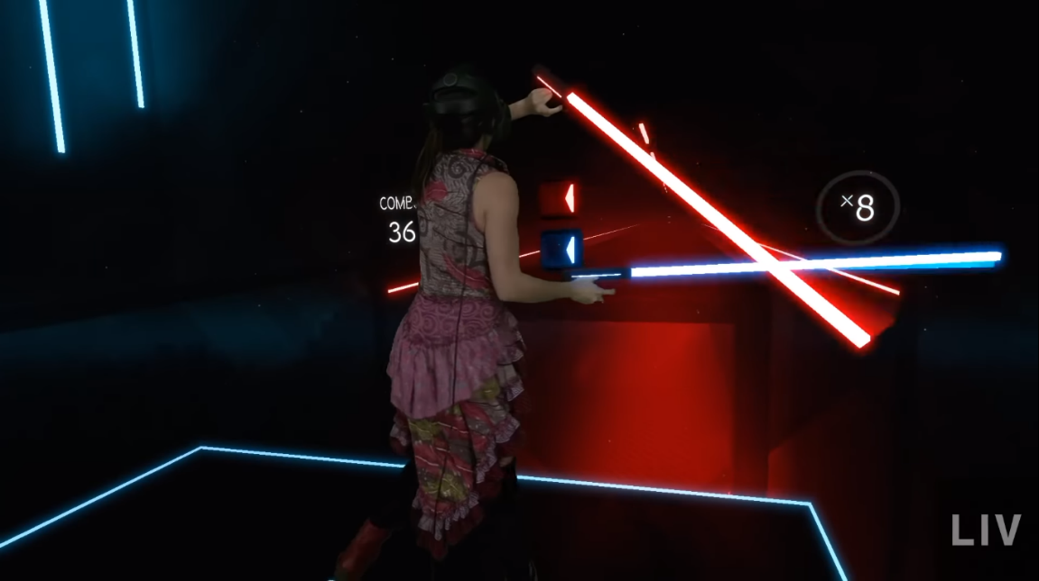
Above-A demonstration, mixed reality capture of Beat Sabre’s gameplay (LIV, 2018)
This close presence with the virtual world, should allow audiences to have deeply invested experiences, however, currently one of the most popular VR games is Beat Saber (Beat Games, 2018), a game which does not provide a compelling explorable environment, but instead focuses on rhythmic and intense motion gameplay. This may go to show that VR games primarily exist to offer something new and unique, although, explorative games are available. It is also relevant that these games are hindered by reliance that the player has adequate physical space (as traversal of the digital world becomes relatively arduous) and the subconscious knowing disparity of being present in the ‘real-world' is a constant factor to disengagement from the media (highlighting a certain fragility to this type of virtual sensory immersion).
Subjectively, VR environments benefit greatly if set in a single room layout, as there is less chance of the player feeling detached from an environment which has similar boundaries to their real space. Restricting the player to one room would not allow for such an open environment composition seen from Capability Brown, but aspects of his design theory could be implemented, and this would involve using ‘areas of interest’, to gain the player’s attention. Otherwise, if not taking advantage from visual design techniques, there is evidence that engagement with VR will take another approach to player immersion and further expand the sensory experience through the utilisation of haptic feedback.

Haptic Developments

Since this uprisal of modern VR, independent companies have sprung forward to provide services/hardware which set out to enhance the player’s stimuli driven connection to the motion tracked world and to possibly overcome the previously stated ‘distancing effect’ from the digital environment.
More recently, research teams at the technology giant, Microsoft, have developed the ‘PIVOT’, experimental VR hardware. Designed to enable the haptic response of grasping items, the ‘PIVOT’ controllers work by actuating the control handle to swing toward the user’s hand, in synchronicity with the motions detected in-game and the user then inputs physical grasp, informing the game to hold the virtual object (Hamilton, 2020). In essence, this form of controller is an effective attempt at breaking down the barrier between the player and digital interaction. Allowing for the player’s action to be confirmed both visually and physically (theoretically, the player can respond to the environment through kinetic feedback and would not have to visually confirm their input by looking at their digital hand).
Though due to the player’s expectation of haptic feedback (based on what they see, Meyer 2011), the PIVOT’s action may not match up to this, and create an unfulfilling experience. However, due to the newness of the technology, no third-party reviews currently exist and therefore the experience is to be determined.
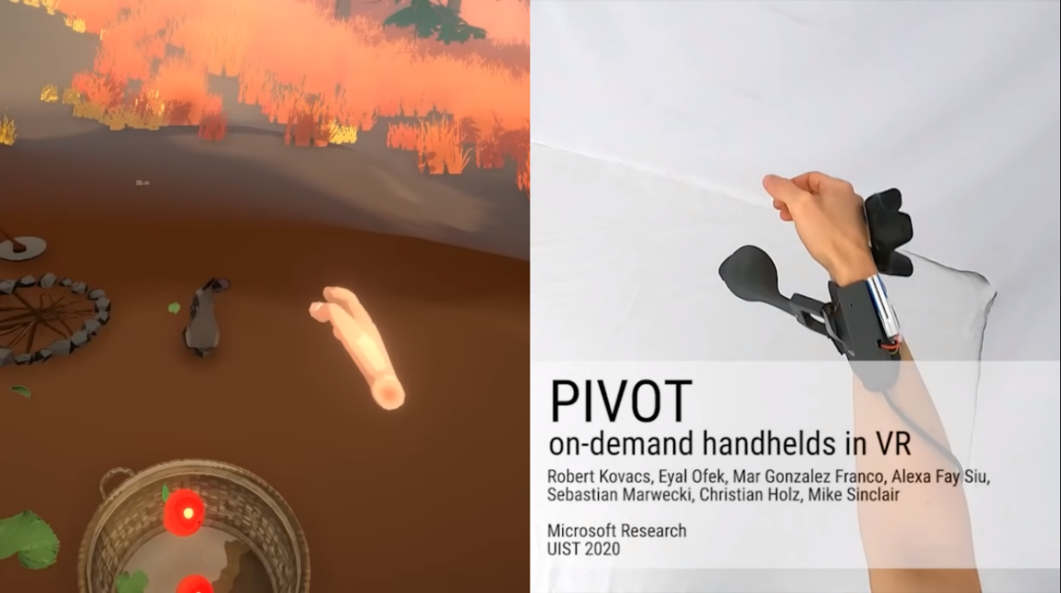
Above-A demonstration of the PIVOT in use (Hamilton, 2020). Shows how proximity and resistance work to enhance the experience.

The PIVOT applies to only a niche aspect of engagement within a game world environment (feel of grasp), the rig is also limited to providing the user with only a single form of ergonomic interaction (grabbing a plastic, controller handle) and touch detail (material feel or skin pressure) is negligible to the digital environment.

Hardware is needed which is more versatile to how the player will interact, this element of adaptivity may be found through HaptX’s VR Gloves. The gloves allow for a more accurate portrayal of touch against the user’s hands, small pneumatic air pressure pads and tensile finger bands represent resistance felt by pushing against an object. The company has stated that they see the product “as something that has some real promise in the prototyping phase for manufacturing or in making workplace training highly realistic” (Matney, 2018), without acknowledgement to commercial/gaming experiences, it may be that HaptX doesn’t yet see any application to video games and the effect to the player’s experience (or that commercial sales would not be currently viable).
The fact that the gloves are less of a controller and more simulation hardware, leads to the conclusion that for most (successful) gameplay experiences, touch stimuli gloves would not be appropriate input controls, as they do not offer the same amount of input interactivity as seen on most current VR controllers (including thumb sticks, triggers, etc.). Although, HaptX’s level of haptic feedback should not be negated from controller advancements, as previously stated, sight and touch go hand in hand with immersive environment design. Future VR (gaming) controller design should encapsulate more effective stimuli and balance sensory ergonomics with a practical control layout (like the PIVOT).

Cinematic Visual Composition in
Relation to Environment Tactility

Design Importance of Mise en Scene

Having initially established that there exists a strong cohesion between sight and touch, as the brain comprehends visual surfaces. It is therefore essential that filmmakers can develop shots which are clear and easy on the eye (whilst evoking theme, story, emotion, etc, using semiotic theory), this is achieved through careful consideration to mise en scene. Be it the film’s director, cinematographer or production designer, the application of mise en scene is also necessary to game developers, this is due to the lack of disparity between filmic narrative language and narrative formula in video games.
With current day displays capable of presenting cinema in high resolution, the audience is subject to visualising cinematic composition in the clearest of detail. Capturing the director’s auteur style, without limitations to their personal aesthetic vision of mise en scene and environment, whereas technological restrictions and gameplay factors can hinder the design flow of a game’s environment artist.
Girina (2013) has argued that “the development of new graphical and physics engines and the increased level of literacy of video game players allow today for the implementation of a more sophisticated audiovisual code in video games.”, though feasibly dated, this statement still rings true to contemporary game design and technological standards (now concerning the power of real-time rendering). It is still, however, pertinent to remember that the ‘form and function’ dynamic exists within video games; in terms of visual design (form) and gameplay (function), a factor which cinema does not contend with (arguably leading to a higher mode of artistic/auteur expression and this suggests better composition).

Stylisation in Cinema and Video Games

Even though this priority, to clearly establish composition, exists, debates and attitudes toward visual style endure. More cheap and versatile, digital cameras have gained popularity in recent years for all kinds of filmmaking, due to its supposed visual similarity with the traditional film camera (which is more expensive and restricts shooting, due to the use of film reels). Contrary to this, many current director auteurs employ cinematographers who intentionally choose shooting on film.
Though this may relate to the cinematographer’s preference of analogue and authentic filming methods. Definably the most notable difference between the two mediums is digital noise and film grain. Digital noise is created from a digital sensor adjusting to light changes and can create a distortion to the image which is visually predictable (as digital will replicate this technique consistently). Whereas, film grain occurs during the chemical development of the film stock, producing a more unique and particular effect (Hull, 2019).

Similar stylistic judgement and debate is present within game design. With imminent developments of how real time rendering is achieved, games have the capability to become more and more ‘lifelike’. But is this necessary? As many existing games embrace stylised design choices, and to decide upon realism for a form of media with so many abstract possibilities, has the chance of creating a blurred (genre mix up) and even non-conforming aesthetic style.

Cinematic Composition in a Game Environment

A game which is able to carefully balance its ‘realism’ focused design choices is Red Dead Redemption 2 (Rockstar Games, 2018). The game tackles a fictious, narratively engaging ensemble outlaw gang and throughout the game, the story casts a wide net over the subject matter of the ‘Wild West’.
The design core of the game overtly takes inspiration from the Spaghetti Western subgenre. Implementing specific visual tropes, details and cinematic mise en scene, the environment design is effectively replicated (through this translation of traditional mise en scene into a 3D, digital world) and due to its passive free roam game style, it creates what essentially feels like an interactive simulation of an entire subgenre. Cultivating an entire preestablished audience, who want to interact with an environment they’re familiar with, and in a way which cinema can obviously not achieve.

Above-A ‘RDR2’ (Rockstar Games, 2018) environment (Top), in comparison to an establishing shot motif from Leone’s (1965) ‘For a Few Dollars More’ (Bottom).

The RDR2 environment design walks a fine line of form and function. From prior knowledge of almost any Spaghetti Western, a clear visual motif is the wide, expository shot of the western landscape, these backdrops are synonymous with the subgenre and are explicably present in the landscapes of RDR2. However, due to this aesthetic choice, it’s important to note, designers do run the risk of affecting gameplay and the player’s engagement, by putting form before function (e.g., risking lack of gameplay opportunity because of big, empty environments).

Conclusion on the Effectiveness of Approaches
Towards Tactile Immersion

Proposal for Continuation of Study

Through analysis of existing research (to established and emerging immersive experiences) and with consideration to design theory, this document establishes an informed foundation of knowledge, on which to expand by a continuation of study towards:

How design outlines of traditional cinematic media can reinforce not only immersion, but also enhance the audience’s investment to specific subject material, and the applicability of this towards the design of game environment compositions.
The study should also highlight, the implications of gameplay colliding with visual design, and theory in respect to environment composition and what it accomplishes. By developing case studies through analysis of existing materials (both game and film compositions), this will further knowledge towards the effectiveness of visual design techniques, with consideration to theory (such as visual semiotics) and sensory stimuli (in reference to this research document).

Summary of Analytical Study

In summary, this study proposal has covered research which effectively communicates consideration to the usefulness of techniques (relating to visual and haptic experiences) regarding immersion within contemporary media. By way of using Capability Brown’s design theory and technological/scientific studies, the research underlines the effect which visual compositions can influence immersion, and the extent at which tactile design can be represented.

By analysing cinematic composition and exemplifying its inspiration on game environment design, it’s been highlighted that gameplay also influences design, and this requires further study, to the effects and extent of environment composition principles alongside applying gameplay functionality.
After acknowledging the promising advancements of VR, it would be unfair to completely disregard its environmental design possibilities, but due to the recentness of this technology (PIVOT released in 2020), it’s current state can easily be viewed as a gimmick and that it offers little more than commonplace gaming formats (in terms of environment presentation). However, regarding the precedent that the technology has been used practically to treat mental disorders, and the efficiency of VR is only becoming more commercial and commonplace. It is likely (to assume) that VR and Haptic technology will reach a stage of reliability and accuracy to represent 3D digital environments with almost indistinguishable sensory properties to that of the real world (offering virtual experiences akin to the real sensory immersion found in Capability Brown’s landscape parks).
Bibliography

Diaconu, M., 2006. Reflections on an Aesthetics of Touch, Smell and Taste. Contemporary Aesthetics, [ONLINE]. Available at:
https://www.contempaesthetics.org/newvolume/pages/article.php?articleID=385#:~:text=It%20has%20often%20been%20argued,stimuli%20and%20consume%20their%20objects.&text=One%20sees%20tactile%20qualities%2C%20and,the%20so%2Dcalled%20oral%20sense. [Accessed 26 October 2020].

Meyer, K., Kaplan, J., Essex, R., Damasio, A. and Damasio, H., 2011. Seeing Touch Is Correlated with Content-Specific Activity in Primary Somatosensory Cortex. Cerebral Cortex, [ONLINE]. 21. Available at: https://academic.oup.com/cercor/article/21/9/2113/383157 [Accessed 12 October 2020].

Rutherford, S., 2016. Capability Brown: And His Landscape Gardens. Pavilion Books.

Zone, R., 2014. Stereoscopic cinema and the origins of 3-D film, 1838-1952. University Press of Kentucky.

Kermode, M., 2010. No, Your Eyes Aren’t Deceiving You – 3D Really is a Con. [ONLINE] The Guardian. Available at: https://www.theguardian.com/commentisfree/2010/apr/11/3d-avatar-hollywood [Accessed 16 Nov. 2020]

Rothbaum, B.O., Hodges, L.F., Ready, D., Graap, K. and Alarcon, R.D., 2001. Virtual reality exposure therapy for Vietnam veterans with posttraumatic stress disorder. The Journal of clinical psychiatry.

LIV, 2018. If You Want to ESCAPE with Me... Beat Saber ft SwanVR - YouTube. [ONLINE] Available at: https://www.youtube.com/watch?v=gV1sw4lfwFw&ab_channel=LIV [Accessed 16 Nov. 2020].

Beat Saber, 2018. [ONLINE GAME] Vladmir Hrincar, Jan Ilavsky: Beat Games.

Hamilton, I., 2020. Microsoft’s PIVOT haptics research might improve how we throw balls in VR. [ONLINE] VentureBeat. Available at: https://venturebeat.com/2020/10/25/microsofts-pivot-haptics-research-might-improve-how-we-throw-balls-in-vr/ [Accessed 9 Nov. 2020].

Matney, L., 2018. HaptX is Bringing Touch to VR With a Pair of Scary-Looking Gloves and a Pneumatic Suitcase. [ONLINE] TechCrunch. Available at: https://techcrunch.com/2018/10/03/haptx-is-bringing-touch-to-vr-with-a-pair-of-scary-looking-gloves-and-a-pneumatic-suitcase/ [Accessed 9 Nov. 2020]

Girina, I., 2013. Video game Mise-En-Scene remediation of cinematic codes in video games. International Conference on Interactive Digital Storytelling (pp. 45-54). Springer, Cham.

Hull, C., 2019. Digital Photography vs. Film Photography. [ONLINE] Expert Photography. Available at: https://expertphotography.com/film-vs-digital-photography/
[Accessed 9 Nov. 2020]

Read Dead Redemption 2, 2018. [ONLINE GAME] Dan Houser, Michael Unsworth, Rupert Humphries: Rockstar Games.

For a Few Dollars More, 1965. [FILM] Sergio Leone, Italy: Constantin Film.

