Certificate in Higher Education Skills for the Workplace

Module: Managing Enterprise in the 21st Century
Module Code: BMSW 4006

Student names
Angel Stoyanov 2106796
Adriana Grigore 2024754
Rasheda Khanam 2109776
Sergiu Ungureanu 2108198

Lecturer Name: Olu Adegbite

Business Plan Healthy Meals- Nutty Buddy

Contents
Business Plan Healthy Meals- Nutty Buddy 1
Introduction: 3
3
1.Executive Summary 3
Business Overview 3
2.Product and Services 4
3.Market Audit 5
SWOT Analysis: 6
PESTLE Analysis 7
4. Target Market 8
Marketing Plan 8
PRODUCT/SERVICE 8
PRICE 9
PLACE 9
PROMOTION 9
Team Management 9
Financial Plan 10
CASHFLOW FORECAST 10
Profit and Loss 11
Conclusion 13
9. References 14

Introduction:

The healthy meals business report contains a clear idea of how people can use nuts as natural protein. Eating well-balanced food helps the body get the necessary proteins and minerals for a healthy life. Three people are involved in creating and developing that business idea to generate the best enterprise: Angel, Adriana and Rasheda.
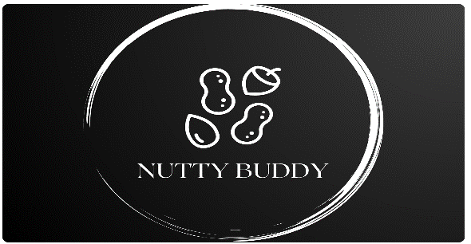

1.Executive Summary

Nutty Buddy was produced to bring joy to everyone. This product is made with great care, attention and love to meet customers’ expectations of all ages. Nutty Buddy journey started in the United Kingdom, Birmingham, with a future to expand all over the world.

Our mission is to reduce the use of chemicals and to help the human body take the necessary energy only from 100% natural products.

Business Overview

Our product and vision are based on healthy fats. To create it, we thought of combining four ingredients: macadamia, almond, cashew, and Himalayan salt.
Natural products with higher content of unsaturated fatty acids are more vulnerable of oxidative breakdown (Nadeem et al, 2013)
The product itself is mainly to boost individual energy before having a hard workout but not limited to it as it can be introduced into our everyday meals.

History of the products
Macadamia is a nut contained in a hard seed enclosed in a green husk that makes up to 65-75% macadamia oil and up to 70% oleic acid(omega9). Omega 9 is rich hydrating oil that is used for restoring dry and dehydrated skin, protecting it and leave feeling for smooth and softness.
Almond is a deciduous tree grown in Iran and surrounding countries. It is useful for some type of treatments like acne, sun damages as contains antibacterial properties and vitamin A
Cashew is a tropical evergreen tree that produce cashew seed and 100g of it provides the body with 553 calories. Important vitamins and minerals- calcium, iron, magnesium and etc.
Himalayan salt is a rich mineral rock salt that protects and helps body from detoxification. Using it in our daily meals also lower the blood pressure thanks to the less sodium than the normal salt, 80 minerals, iron and calcium that contains.

2.Product and Services

‘’The best business plans are straightforward documents that spell out the who, what, where why and how much’’
(Grow Think, 2022)

Nutty Buddy is made of 4 natural ingredients Macadamia, Almond, Cashew and Himalayan Salt. This product was designed for performance before having a hard workout to boost energy levels. As this product is a source of healthy fats and vitamins necessary for the human body, when consumed can provide magnesium, potassium, minerals and fibre. Nutty Buddy comes under a butter made of macadamia, almond, cashew and Himalayan salt and is suitable for a healthy diet, being categorized as Vegan friendly, Keto-friendly, PALEO friendly and Gluten-free. Every time one of the body muscles contracts or one of your neuron's fires, the human body uses its store of sodium and potassium (also known as salt). As humans, we need healthy fats in our body to produce hormones to make our body function better and absorb vitamin A, vitamin D, vitamin E, and vitamin K, which can only be contained in our body with the help of fats.
Fat tends to be considered harmful because it is associated with weight gain and high cholesterol. However, certain types of fat give protecting benefits to the heart if appropriate portions are consumed, that’s why our product will be ready to use as it will be stored in pouches, giving our customers the correct portion quantity. There are many ways of eating the product. You can eat it straight from the pouch, spread it on a slice of bread, put it in your smoothie, or use it as per your creativity, combining it with your preferred ingredients to create your desired meal. The pouch is something you can eat on the go. Its shape and size make the life of anyone much easier because if it cannot be consumed in time, it can still be carried in the bag and be eaten in the office, gym or anywhere else, and it is much easier to manage portions.

Many athletes avoid consuming nuts, fearing they are full of calories when they can provide enough energy to complete the training session. Nuts also have anti-inflammatory properties, helping prevent issues with joints. Therefore, nutty buddy contains proteins, which help muscles recover after physical exercises, and carbohydrates, which provide the muscular system with energy.

Plan for what is difficult while it is easy, do what is great while it is small’’
(B Plan, 2022)

3.Market Audit

Competitors: Competition and competitors in business is very real and an unavoidable part of every modern enterprise. The threat for a business to become non-existence is very real too. Competition in business field forces companies to become technologically innovative, productive, and efficient in managing resources. In modern days, competition also encourages enterprises and business to become more socially responsible which in turn gives them good publicity and helps the organization build a good reputation among their clients (Kuratko, 2009).
Entrepreneurs drive economic to growth in two different ways: first way, by entering and expanding exist market to increase competitive and ineffective economic. Second way, creating entirely new market by offering innovation products which presents profit opportunity to others (Minniti and Bygrave ,2004; Autio,2007).
Every organisation has problems that they want to see vanished and challenges that they want to overcome. Some problems are bigger, some are smaller. Some problems are complex in nature, some are relatively easy to resolve. Some problems are internal, some are external. Companies and organizations invest and allocate handsome amount of resource to solve these issues. To assist the organizations with this not so easy process, over times researchers and scholars have suggested several different methods to identify root causes of the problem including PESTEL analyses and SWOT analysis. After gathering all these information, organizations become well equipped in deciding what to do, what next steps to take. Further, Nutty Buddy has been using market audit tools such as SWOT and PESTEL to analyse market and business opportunity.

SWOT Analysis:
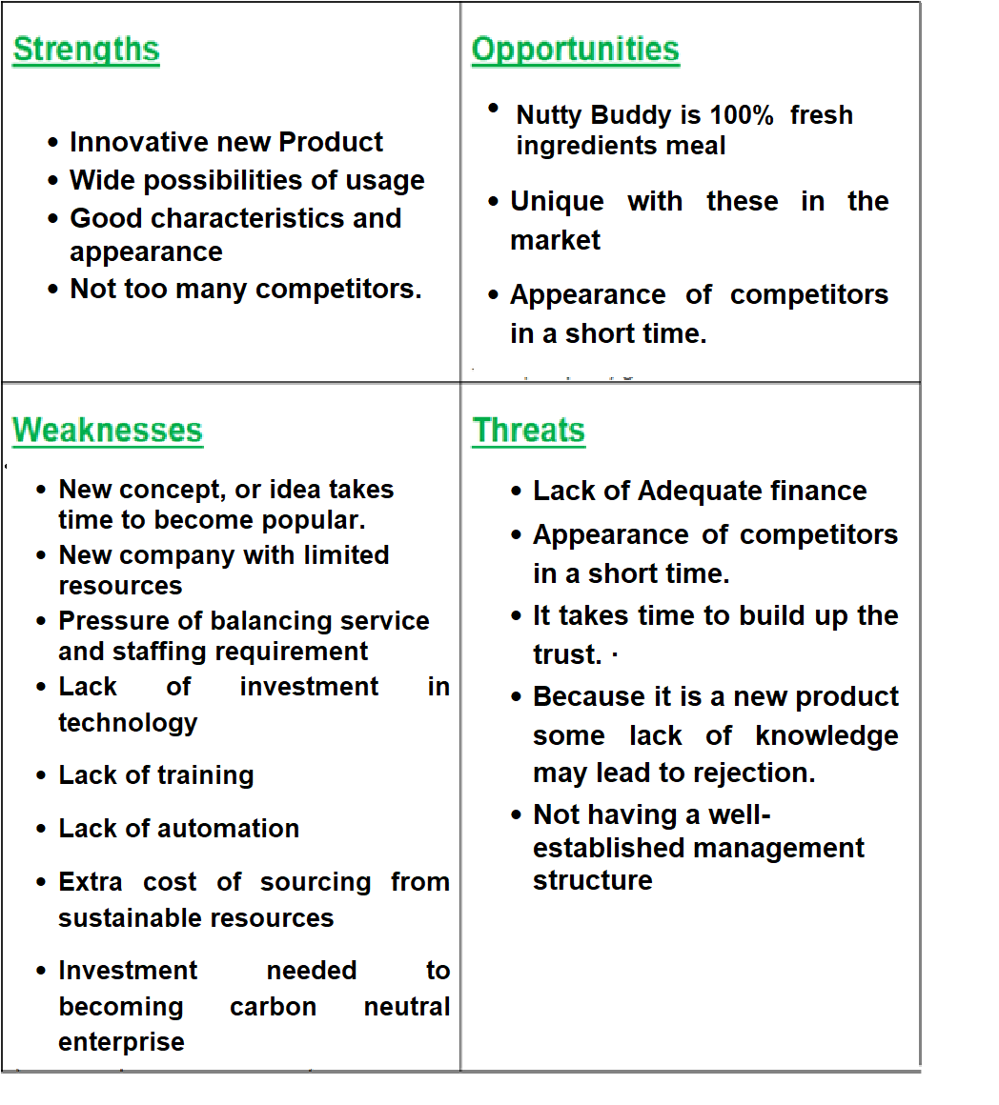

PESTLE Analysis
The acronym PESTLE stands for 6 factors which affect the business. The
factors are:
- Political
- Economic
- Social
- Technological
- Environmental
- Legal
The Nutty Buddy business context is impacted in turn by wider environmental
considerations, which include the economic, political, legal, social, cultural, social, and
natural settings. According to (Zalengera al et, 2014), SWOT focuses on analysing general
the factors surround business while PESTLE analyses widely and in more detail about
factors which affect business:
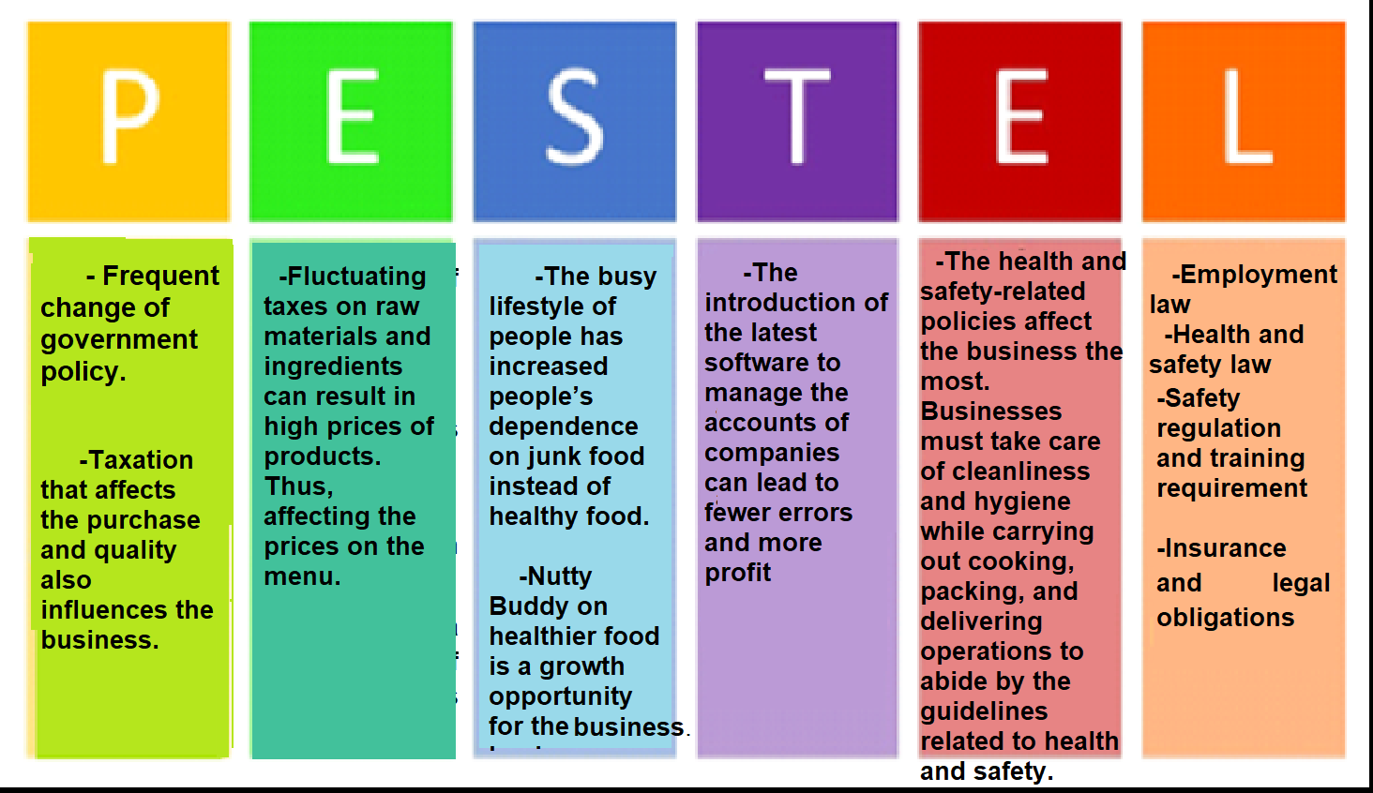

4. Target Market

Target market can be defined as the group of people that a company wants to sell their products or services.
Nutty Buddy target audience might be athletes, fitness enthusiasts, dieters, and people who simply want a quick and wholesome snack. Some people seek out protein bars that are high in protein and low in calories, while others may be searching for something that tastes sweet. Why we chose this category of people and individuals:

- Athletes: this people are the one is choosing to eat balanced; this means the nutty buddy will be prefect because contains almost all kind of food category like vitamins, good fat, minerals, and fibre.
- Dieters: people want always to take of what they are eating, wants to lose weight and eat small portion.
- Fitness enthusiastic: because was designed to boost performance and would be a great to increase energy level
- Teenagers: because is easy to eat, easy to carry one and you can serve whenever you want.
- People on the go everyday: small amount of the pouch size is easy to carry on with you in your pocket, in your bag and being served whenever you want to like in gym, office or in public transport.
- Vegans and gluten free people: this are because of the ingredients that the Nutty Buddy is made of like macadamia, almond cashew and Himalayan salt.
- Or just everybody who wants to have a delicious meal full of nutrients.

Marketing Plan

PRODUCT/SERVICE
The product and services of our company are designed to help people increase their energy levels before a workout by consuming a product 100% made of natural ingredients with no added sugar and no preservatives. The reason for using this product is straightforward, it stimulates your body energy, it gives support to cell function, it helps the body absorb different nutrients and produce essential hormones, and it all comes in balanced portions. Our goal is to help our customer achieve their athletic goals.
Alongside our journey, new opportunities will be implemented. One of those will offer a one free month gym for our customer of the month. The gym must be a well-known gym in his local area. This reward is based on how many purchases the customer has made with us within a specific period.

PRICE
As one of our goals is to educate people to become healthier, we do understand that sometimes this is not an affordable option for everyone. This is why here, at Nutty Buddy, we have implemented a strategy that will help everyone meet their needs.
The pricing strategy that will be incorporated is the variable pricing strategy.
The product will be sold in one pack of 10 pouches, and the price of one single pack is £19,99.
Therefore, in exchange of a monthly fee, customers will have the chance to choose between to special promotions created to make our product affordable to everyone.
The first promotion includes two boxes of 10 pouches each a month for a monthly price of £34,99.
The second option has been put in place for those who want to consume Nutty Buddy on a daily basis and are on a strict diet. This will include three boxes of 10 pouches each for a monthly price of £49,99.

PLACE
Nutty Buddy is based in Birmingham, United Kingdom. The Head Office location permits the company to grow as it is located in City Centre, where enough people pass by and allows the company to expose the brand to the audience.
Our business operates online, assisting the customer through website chat, emails and via telephone.

PROMOTION
As promoting is one of the keys towards success, it is crucial for us to invest time and money in it. Reaching a consistent number of people, helps our firm to place itself in a dominant position on the market, which is the reason why the promotion of Nutty Buddy will take place through a collaboration of influencers, placing our product in a valued presence on social media. Furthermore, the promotion will take place through posters, email, radio and website.

Team Management
The members of our management team are Angel Stoyanov Business Analyst/HR Legal Policies/Customer Service, Sergiu Ungureanu, Marketing Auditor/Project Manager, Rasheda Khanam, IT/Marketing Management, Adriana Grigore, Finance and Accounting/Product Development Manager. Nutty Buddy, without the contributions of each of these individuals, would not be able to operate. This slide will discuss each of the positions held by the members of our management team. All of them are professionals and can use a wide range of practical skills at work. The presented report is below.
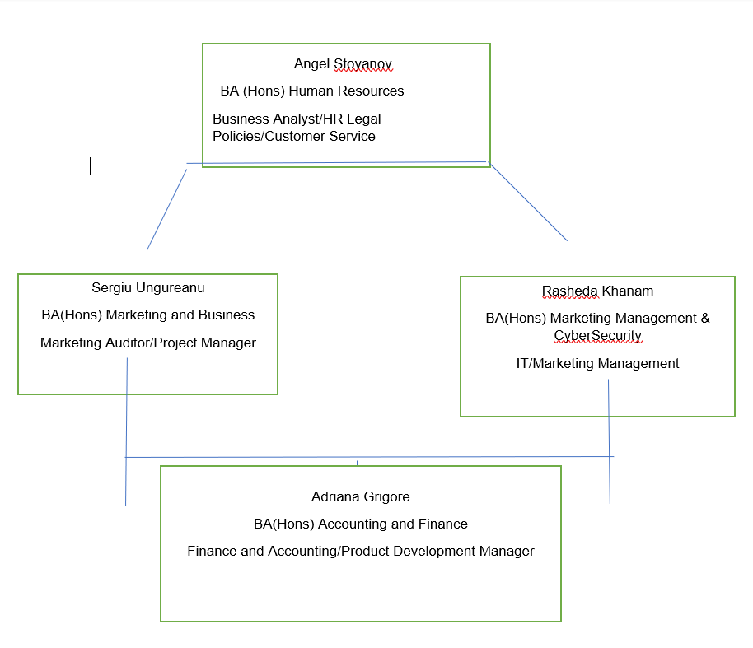

Financial Plan

The final part of our business project will provide us with information (“The big picture”) of the financial stability measuring income/cashflow statements. According to our financial advisor and between our business partners, we have decided to generate yearly report of our profits/losses, as according to (Helen,2002) cannot be identified just for few months and it is changeable over time.

CASHFLOW FORECAST
Start-up budget that we have is $50000 government grant for start-up business plus personal investment of $10000 each person which makes $80000 in total. Thanks to the financial cashflow report we will be able to see our revenue and expenses and whether the business is profitable. Logically when revenue is better and expenses it means our business will generate success. Figure below will give you better understanding of what we mean.

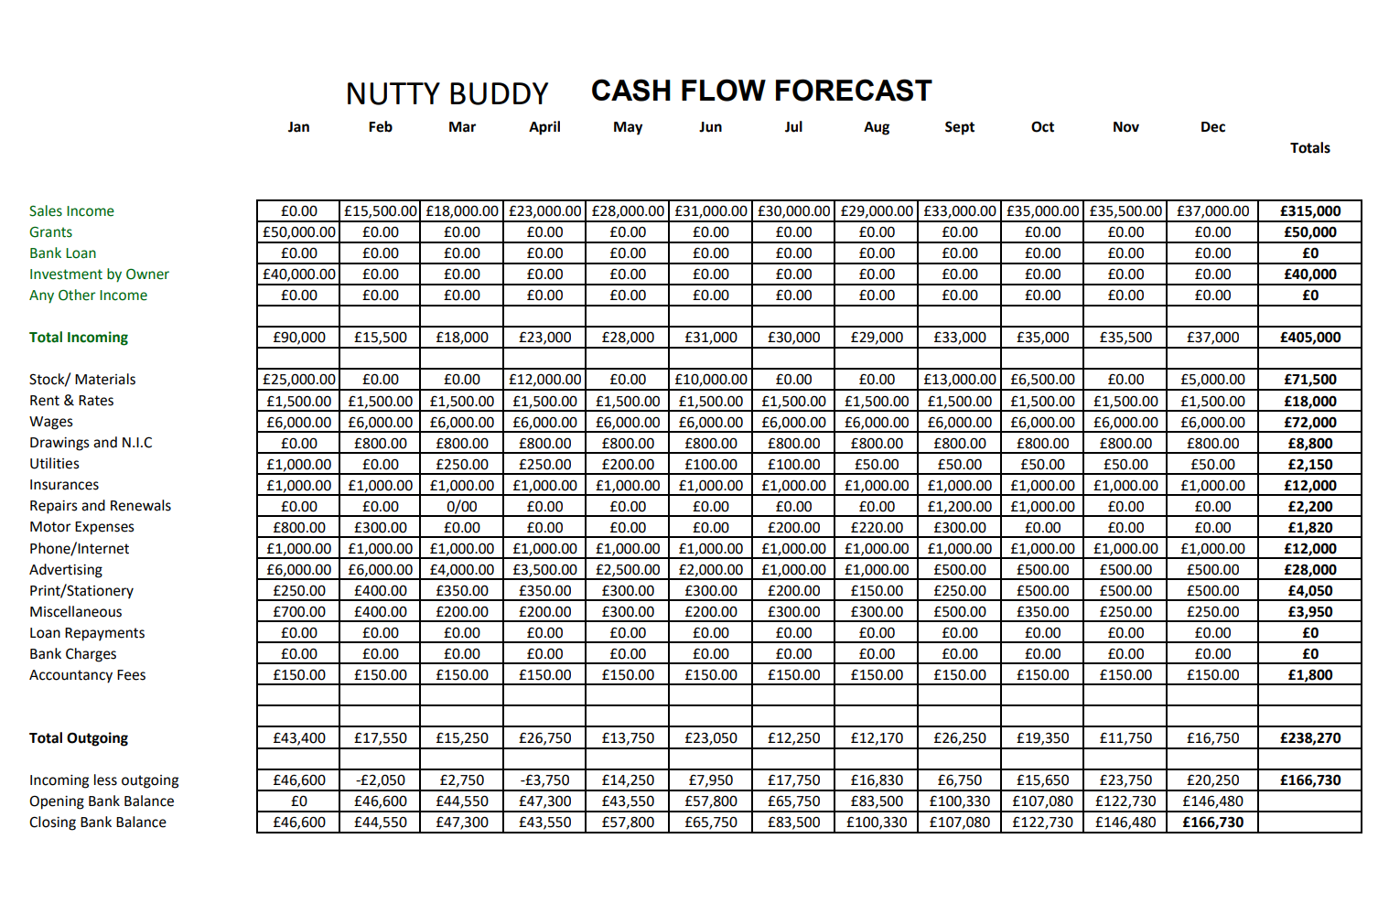

Profit and Loss
The current status of growing/expenses in organizations must be constantly monitored, and that information should be used as planning ahead (Rockart, 1979).
Nutty Buddy Meals report figure above shows the difference between profit and loss which in our case the business is profitable. Our method of accounting allows us to manage revenue and cost before cashflow run out to avoid unnecessary bank loans or even bankrupt.

Profit and loss report also contains a balance sheet which includes revenue, tax charges, and interest expenses. The calculating differences is generally known as net income (profit/earnings after all expenses).

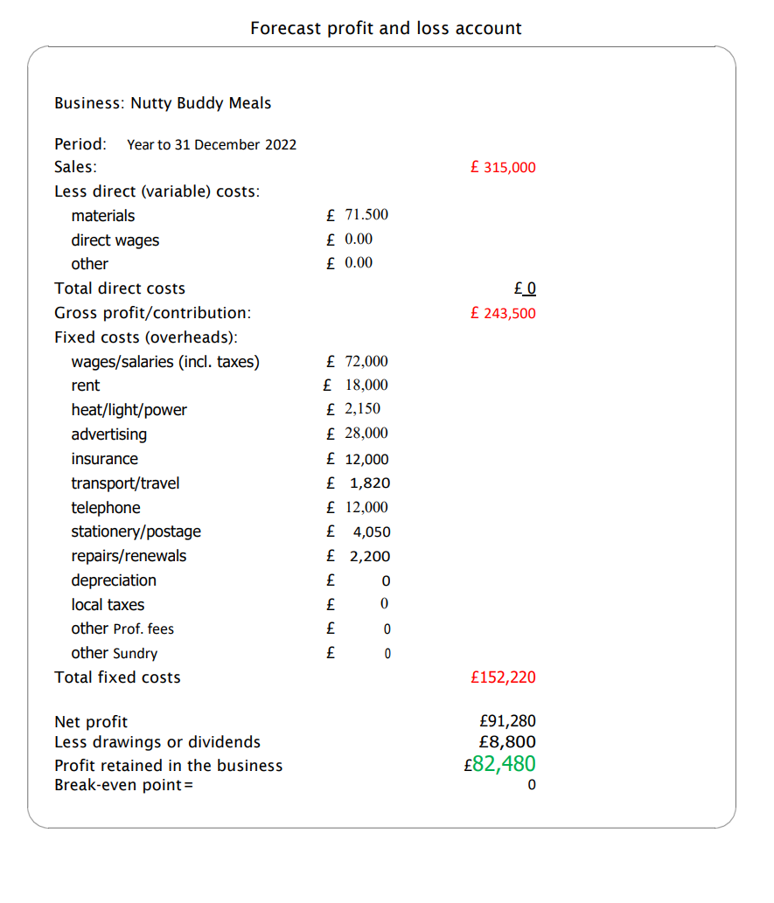

Conclusion

Thanks to the lessons learnt during this and previous modules we have managed to develop plenty of new skills and knowledges, that helped us to create this business plan and believe that it will be successful thanks to the Lottery Company UK as well, who provide us with initial capital of £50000 to support us with company start-up business.

9. References

Autio, E. (2007) Global Report on High Growth Entrepreneurship, Babson College and London, London Business School, Wellesley MA, UK
B plan (2022) 8 Quotes to Motivate You to Make a Plan and Stick to it
Available at: https://articles.bplans.com/8-quotes-to-motivate-you-to-make-a-plan-and- stick-to-it/ (Accessed on 14th July 2022)
Cambridge University Press (2022) Meaning of Target Market
Available at: https://dictionary.cambridge.org/dictionary/english/target-market
(Accessed 06 July 2022)
Commonwealth of Australia (2021) Identify Your Target Market
Available at: https://business.gov.au/marketing/identify-your-target-market
(Accessed 06 July 2022)
Grow Think (2022) The Perfect Business Plan Layout & Outline for a Great Plan
Available at: https://www.growthink.com/businessplan/help-center/business-plan-layout-how-design-your-plan
(Accessed on 14th July 2022)
Kuratko, D.F. (2009) Entrepreneurship: Theory, Process, Practice, Cengage/South- Western. Publishers, Mason, OH
Madison (1990) Small business forum: the journal of the Association of Small Business Development Centres., WI: University of Wisconsin-Extension Small Business Development Center
Minniti, M. and Bygrave, W.D. (2004) Global Entrepreneurship Monitor, Kauffman Center for Entrepreneurial Leadership.
Nadeem, M. et al. (2015) ‘Enhancement of the Oxidative Stability of Whey Butter through Almond (Prunus dulcis) Peel Extract’, Journal of food processing and preservation, 39(6), pp. 591–598
Nugus, S. (2009) Financial planning using Excel forecasting planning and budgeting techniques. 2nd ed. Amsterdam :CIMA.
Zalengera, C., Blanchard, R.E., Eames, P.C., Juma, A.M., Chitawo, M.L. and Gondwe, K.T., (2014). Overview of the Malawi energy situation and A PESTLE analysis for sustainable development of renewable energy. Renewable and Sustainable Energy Reviews, 38, pp.335-347.

