4/27/2020
Mbemba Jammeh
M4X02197
Electronic Ignition & Fuel Injection Systems
A Gibson

Abstract

The purpose of this report is to have an understanding on fuel and injection and look into a more in depth way by doing research and reading books on how the systems works and operate to get basic knowledge and also doing research into how to use a schematic diagram.

Contents
Abstract 1
Introduction 3
Literature Review/Background/Research 4
Methodology Motronic Engine 5
Methodology 2nd LE3 Engine 6
Results-LE3 10
Results Motronic 11
Analysis LE3 12
Analysis Motronic 13
Discussion 15
Conclusions 16
References 17

Introduction
The aims and objectives for this report is to carry out a test on two different engines using the oscilloscope and multimeter looking into live data and readings, Also taking different temperatures of the engine running and analyse different types of Electronic Ignition, Electronic creating a excel spreadsheet of your findings

Literature Review/Background/Research

Vauxhall 2.0 Litre Motronic Injection/Ignition
The Vauxhall 2.0 litre was first manufactured in the 1987 but in the early 1990 developed to be better calling it the 1.5 version and 1.4 version for the one in built in 1987 but the only difference was the change of the throttle position sensor But both versions operate of a supply of 5 volts both equipped with a bosh Motronic 4.1 engine management system. Which has an advanced system by having different sensors like Air flow meter, Air temperature sensor, Water Temperature Sensor, Throttle switch, Crankshaft sensor. The common thing about all these sensors are that they are all Alternative current using a digital signal which helps giving a more detailed reading for the reader.
Air Flow Meter=Measures the Air flow into the engine and intake air Temperature. This sensor helps give the correct indication of load and allowing the mixture and corrections to be made.
Water Temperature Sensor=Helps to indicate engine temperature for fuelling and helps adjusting the idle speed control when running on cold.
Throttle Switch=It shows high load positions of the throttle and tells the engine about fuelling meaning it wont overfull the engine with fuel.
Throttle Position Sensor=Implies all the throttle positions and movements helping to give a better and more accurate readings for fuelling and ignition purposes.
Crankshaft sensor=Helps to measure the engine speed giving it an accurate reading and using it as a reference for ignition timing and timing purposes.
CO Adjuster=This works by having a Motronic system which uses variable resistors or potentiometer which the ECU uses for the signal to be able to enrichen or weaken the mixture this type of sensor is not fitted on vehicles with catalytic converters but always found and fitted on the air flow meter
Motronic 1.5 operation
Motronic 1.5 is an enhancement of the Motronic 4.1 EMS fitted to earlier Vauxhall and Opel vehicles.
It was first fitted in the 1990 model year (late 1989) and is a fully integrated system that controls primary ignition, fuelling and idle control from within the same ECU.
Both 4- and 6-cylinder engines use M1.5, with little difference between applications.
Also, the six-cylinder 24 valve engine utilises a knock control facility.
A permanent voltage supply is made from the vehicle battery to pin 18 of the ECU. This allows the self-diagnostic function to retain data of an intermittent nature. Once the ignition is switched on, a voltage supply to the ignition coil and to ECU pin 27 is made from the ignition switch. This causes the ECU to connect pin 36 to earth, so actuating the main fuel injection relay.
A relay switched voltage supply is thus made to ECU pin 37, from terminal 87 of the main fuel injection relay.

The majority of sensors (other than those that generate a voltage such the CAS, KS and OS), are now provided with a 5.0 volt reference supply from a relevant pin on the ECU.
When the engine is cranked or run, a speed signal from the CAS causes the ECU to earth pin 3 so that the fuel pump will run.
Ignition and injection functions are also activated.
All actuators (Injectors, ISCV, FTVV etc), are supplied with nbv from the main relay and the ECU completes the circuit by pulsing the relevant actuator wire to earth
Vauxhall Carlton LE3 ENGINE
The Vauxhall Carlton was first introduced in the uk 1986 second generation offering different engine models like the 1.8litre which was a four cylinder or 2.0,2.3 litre engines but were rated good for towing and a people carriers meaning it had a strong and reliable engine that people could trust and also being able to run sweet with having a high millage,good rear drive handling and comfort Introduced in 1986 replacing the Mk.1 Carlton in the UK, While Opel decided to change its model name from the Record to the Omega. On its launch at the end of 1986 the Vauxhall Carlton / Opel Omega saloon and estate range earned itself the accolade of European Car of the Year. The Vauxhall Carlton Estate 1.8i GL is a 5-door estate/station wagon style road car with a front located engine powering the rear wheels. It's powered courtesy of a naturally aspirated engine of 1.8 litre capacity. This unit features single overhead camshaft valve gear, 4-cylinder layout, and 2 valves per cylinder. It has an output of 113.5 bhp (115 PS/85 kW) of power at 5600 rpm, and maximum torque of 150 NM (111 lb ft/15.3 kgm) at 4600 rpm. A 4-speed automatic gearbox delivers the power to the wheels. Its quoted weight at the kerb is 1290 kg. Top stated speed is 180 km/h (112 mph), stated fuel consumption figures are 6.1/7.8/11.0 l/100km 90 km/h / 120 km/h / city. The Motronic ECU contains a fuel map with an injector opening time for basic conditions of speed and load. Information is then gathered from engine sensors such as the AFS, CAS, CTS, and TS. As a result of this information, the ECU will look up the correct injector pulse duration right across the engine rpm, load and temperature range.
The Motronic 1.5 system is a multi-point injection system and pulses all injectors at the same time - is simultaneously and once per engine revolution. This means that half of the fuel for the next power stroke is injected at each opening of the injector and fuel lies briefly on the back of an inlet valve until that valve opens. The injector thus opens twice for every engine cycle.
During engine start from cold, the pulse duration is increased to provide a richer air/fuel mixture. During engine cranking (hot or cold), the number of pulses (frequency) is increased from once per revolution to twice per revolution. After 20 seconds of cranking, the pulse reverts to one pulse per revolution.
Although all 4 injectors are pulsed simultaneously, the injectors are arranged in two banks with injectors 1 and 2 comprising one bank and injectors 3 and 4 making up the other bank. Each bank is connected to the ECU via a separate ECU pin).
The fuel injector is a magnetically operated solenoid valve that is actuated by the ECU. Voltage to the injectors is applied from the main relay and the earth path is completed by the ECU for a period (called pulse duration) of between 1.5 and 10 milliseconds.
The pulse duration is very much dependent upon engine temperature, load, speed and operating conditions.
When the magnetic solenoid closes, a back EMF voltage of up to 60 volts is induced.
The fuel injectors are mounted in the inlet stubs to the engine inlet valves so that a finely atomized fuel spray is directed onto the back of each valve. Since the injectors are all pulsed simultaneously, fuel will briefly rest upon the back of a valve before being drawn into a cylinder.
(Robsey, 2008)
What body style? | 5 door estate/station wagon with 4/5 seats
How long? | 4729 mm
How heavy? | 1247 kg
What size engine? | 1.8 litre, 1796 cm³
How many cylinders? | 4, Straight
How much power? | 115 PS / 113.5 bhp / 85 kW @ 5600 rpm
How much torque? | 150 Nm / 111 ft.lb / 15.3 kgm @ 4600 rpm
How quick? | 0-60 mph: 13 s
How fast? | 187 km/h, 116 mph
How economical? | 5.8/7.7/10.5 l/100km 9

Methodology Motronic Engine

1)First step take readings with ignition off and engine off.
2)With everything off test the ecu for resistance and voltage with the multimeter also testing adaptor voltage and the fuel ecu for voltage.
: Ignition on and engine off
3)engine off ignition on test the ECU and test the adaptor voltages, Test fuel ECU for voltages.
4)Test resistance values of the following below with the ignition off and engine off.
(Static test)
-Throttle switch
-Coolant Temperature sensor
-Injector Valve
-Primary and secondary resistance values for ignition coil
-Test each of the spark lead for resistance starting in order (1,2,3,4)
(ENGINE RUNNING)
-Attach the Oscilloscope to the engine battery.
-Remove the dipstick and place the temperature probe into the dipstick tube.
-Using the small probe put into pin 8 which is fuel ecu.
-Take a Reading of the coolant temperature sensor.
-Open Oscilloscope on the computer to start testing.
-view injection time by only cranking the engine for few seconds to catch the measurement time.
-Run engine to testing temp which 19.6 temperature then switch the engine off.
- next probe pin 8 with the ignition on and pausing the test and viewing voltage.
-Run engine to 30 degrees then switch engine off.
-Measure the coolant temperature sensor for resistance.
-Run the engine and view the injection duration by probing pin 3.
-Run the engine to 40 degrees then measure coolant temperature.
- Probe pin 8 ignition on and take injector average.
-start engine and measure injector duration.
- Warm engine to 50 degrees then turns the engine off and Take coolant temperature for resistance.
- Place the prope into pin 8 and take the average.
-Turn the engine on enter pin 3 and check injector timing.
-Run the engine to 60 degrees then switch it off and Take a measurement coolant temperature for resistance.
- Place the prope into Pin 8 and check average voltage.
-Turn on engine and place pin 3 to check injector timing.
(ENGINE AT TEMPREATURE WITH FAN ON)
-Turn on the engine fan then start the engine and investigate pin 3 to view injector duration, give the engine slight rev and capture the injection duration and frequency change. Drag cursors and measure new injection duration.
-Place the prob into Crank Speed Sensor (pin 12) on injector ECU, crank the engine on and view analogue signal, rev the engine. And view the change of signal and not it down.
- With both of their probes yellow and red one place the yellow probe into pin 1 and red into pin 4 turn engine on and view and compare the two signals from adapter
-Use pin 3 and pin to 2 for the adaptor and to view the signals.
- Place the probe into pin 5 and view digital signal rev the engine and see frequency increase.
- Then Go to secondary scope and view secondary injector output.
- stop engine at 66 degrees and go back to Universal scope and measure the coolant temperature resistance.
-Also measure the voltage average. (pin8)
-Start the engine and measure the duration. (pin 3)

Methodology 2nd LE3 Engine
-Place extractor onto the exhaust and remove the dipstick and replace it with the temperature probe.
-Connect the battery leads to the engine battery for measurements (yellow positive) (Black negative)
-Take reading of the battery voltage.
- With the ignition on and engine off take a test of the ECU Voltage and take the fuel ECU Readings.
-with both the ignition off and have the engine off will be testing resistance for the following coolant temperature sensor, Air temperature. Idle Speed Control Valves, Injector valves, Throttle Potentiometer, Air Flow sensor.
-Using the oscilloscope lead probe into pin 3(Fuel ECU) note the voltage reading down.
-Run Engine Freeze the data to capture the shown on the screen. Measuring cold cranking =19.2 degrees =13.7 millisecond of fuel injection.
-Idle at 20 degrees =11millsec of fuel injection.
-Run engine to 30 Degrees, Next crank-4millisecond of fuel injection.
-At 40 Degrees probe pin 8=0.9volts/injection=3.1millisecound.
- coolant temperature sensor Readings
At 20degress (initial)=2.77k OHMS
At 30degress=1,230 OHMS
At 40degress=810 OHMS
At 50degress=580 OHMS
AT 60degress=420OHMS
-At 20degress Go to pin 3, turn the engine on=2.77k ohms initial
-Back emf of 6 volts on Average of 3 millisecond if fuel injection
Ignition module -Pin12/Crank sensor -speed and TDC Reference
-Ignition scope secondary voltage (kilo voltage) at idle 9900/spark1.7m
-Static test-DC voltage =
-Fuel ECU
-All 15 pins=0volts
-6/7/9/11/13=(Empty)
-Ignition ECU (Total pins 15)
-All pins 0 volts
-Pin 4(Empty)
-Pin 9(Empty)
-Engine off Auxiliary air valve (range of 200 ohms)
-Resistance-45.8
Fuel injector valve (range of 200 ohms)
Plug 1-16.1
Plug 2-16.1
Plug 3-16.1
Plug 4-16.1
Catering coil (range of 200 ohms)
Primary- 1ohms (Minus wires =0.8ohms)
Range of (20k ohms)
Resistance-7.45
HTC leads (range of 20k Ohms)
1=8.63ohms
2=8.58ohms
3=7.41ohms
4=5.63ohms
-Check the scope setting on auxiliary air, temperature check starting on 19.1 degrees.
-Turn ignition on
Ignition on static test
Pin 1=010
Pin 2=0.8
Pin 3=0
Pin 4=003
Pin 5=005
Pin 6=Empty
Pin 7=Empty
Pin 8=145
Pin 9=Empty
Pin 10=025
Pin 11=Empty
Pin 12=0.8
Pin 13=Empty
Pin 14=844
Pin 15=004
Ignition static test with Engine on
Pin 1=005
Pin 2=005
Pin 3=0.8
Pin 4=Empty
Pin 5=010
Pin6=007
Pin7=227
Pin8=165
Pin9=Empty
Pin 10=005
Pin 11=005
Pin 12=010
Pin 13=023
Pin 14=853
Pin 15=026

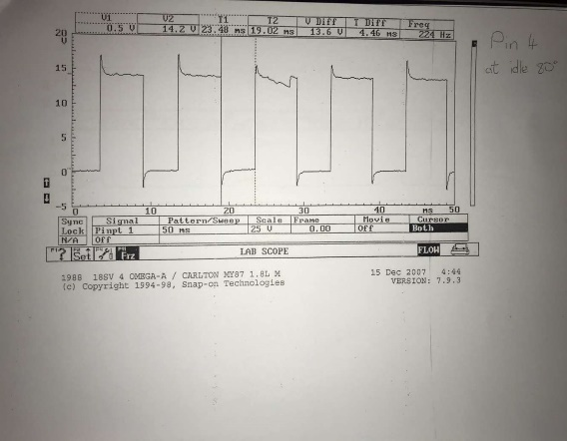
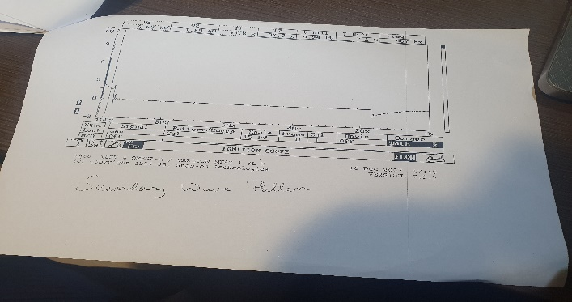
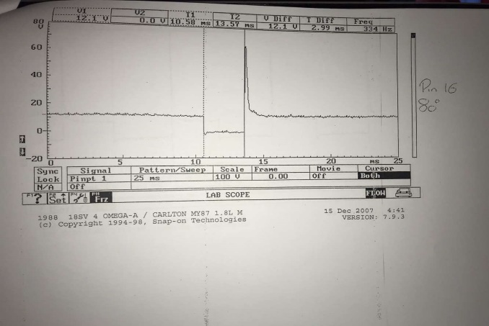
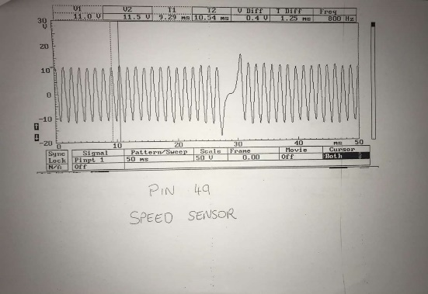
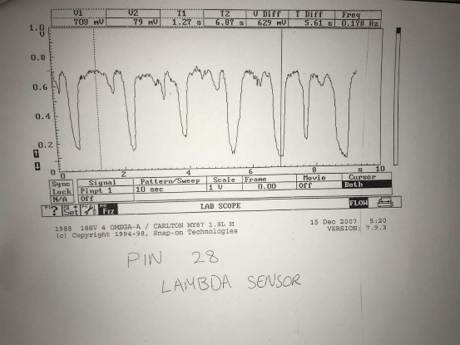
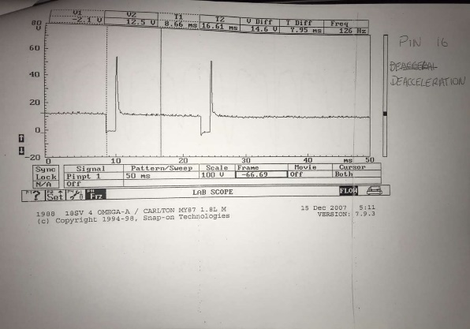
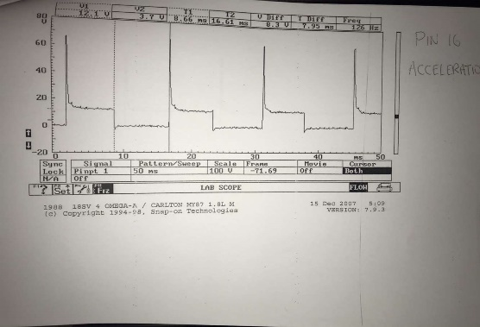
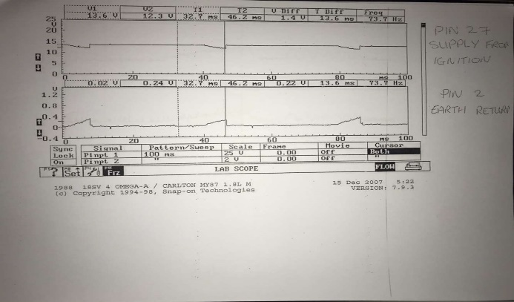
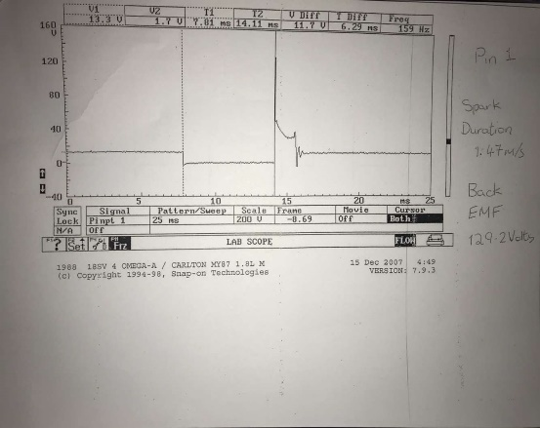
Results-LE3
FIGURE 8
FIGURE 5
FIGURE 8
FIGURE 7
FIGURE 4
FIGURE 6
FIGURE 3
FIGURE 2
FIGURE 1

Analysis LE3

Figure 1= Pin 1 shows spark duration off 1.47m/s and a back emf of 129.2voltsThe primary showing zero resistance for ohms
Figure 2= The length of the wire gives different reading of the htc leads meaning the closest one has a high resistance value compared to the furthest one away.
Figure 3=The resistance valve of the fuel injector has an set open time to spray fuel into the injector not causing it to overfull.
Figure 4==Sensor not fully working showing poor readings which means the sensor must have a fault, Negative coefficient the less voltage is being produced when the temperature starts to rise looking at the manufacturer’s specification
Figure 5= Pin 18,36 are constant live check for static test which views electrical parts with the ignition on or off check for battery voltage.
Figure 6=Faulty Air flow sensor can cause bad mpg and not letting the engine run smoothly showing low resistance.
Figure 7=During warm up phase using the oscilloscope looking into the engine ecu shows an open loop which waits for the lambda sensor to warm up to optimum temperature.

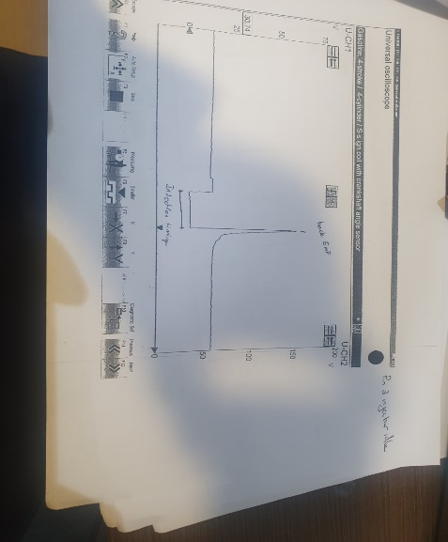
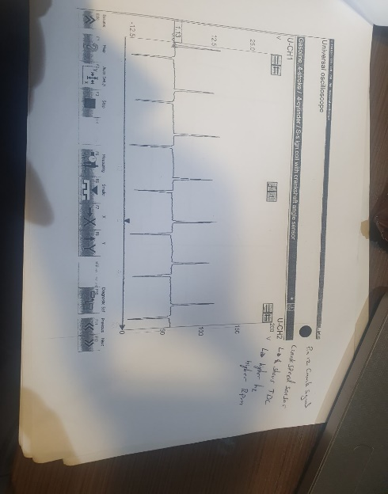
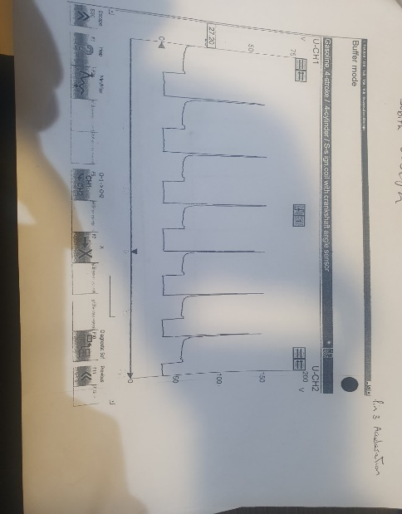
Results Motronic

FIGURE 3
FIGURE 1
FIGURE 2
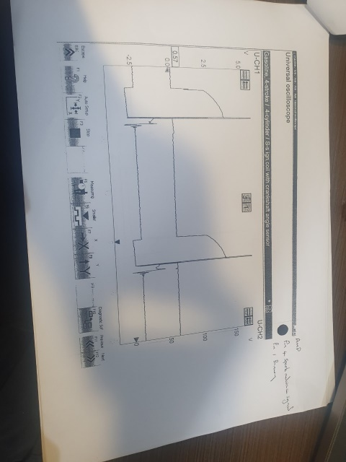
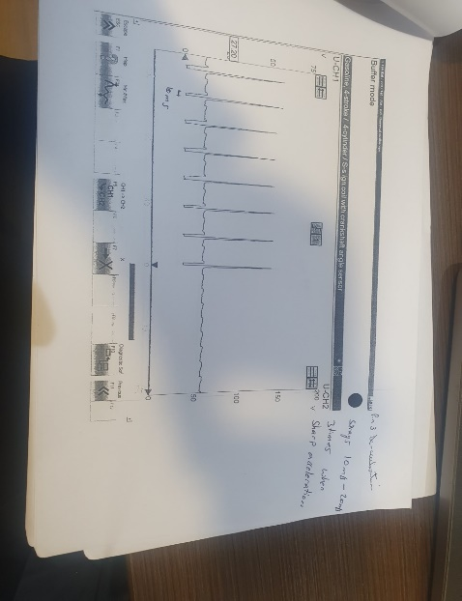
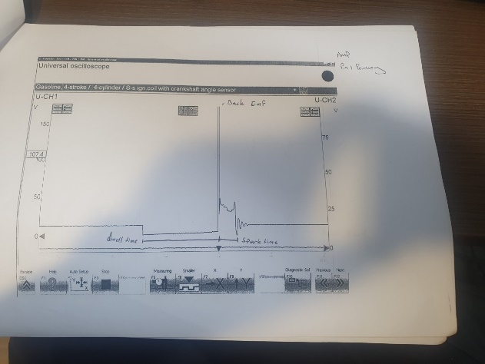

FIGURE 4
FIGURE 6
FIGURE 5
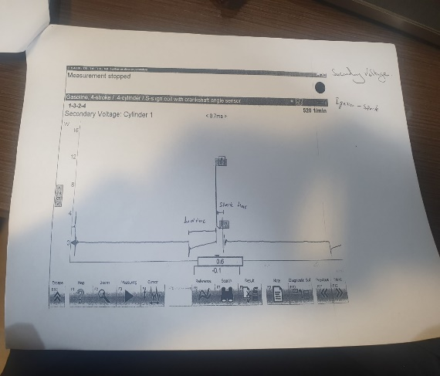
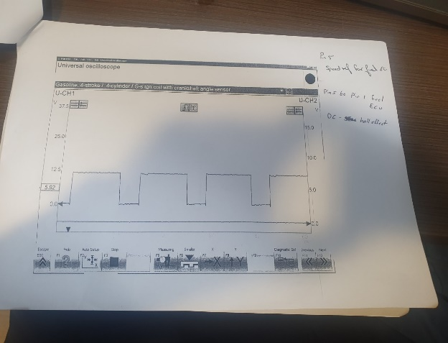
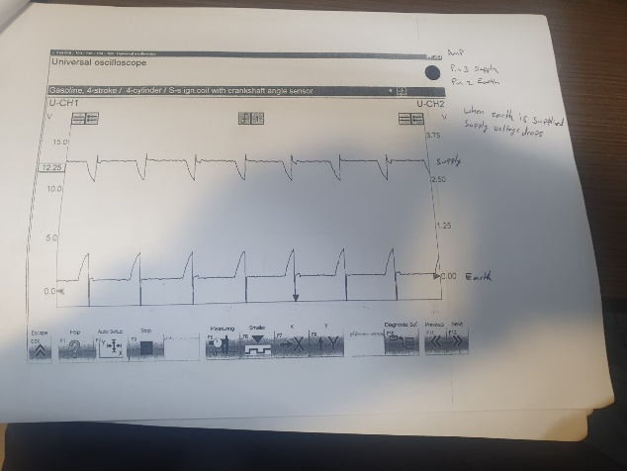

FIGURE 9
FIGURE 8
FIGURE 7

Analysis Motronic
Figure 1= At pin 3 sprays between 10m/s-20m/s three times more under acceleration
Figure 2= When engine is increased the injection timing changes also the injector increases.
Figure 3= Engine on idle it creates and shows the injection timing and very similar to the above.
Figure 4=Pin 12 crankshaft sensor Shows sine wave that in line with engine to know the speed of the road wheel at higher rpm.
Figure 5=Pin 4 shows how pin 1 the primary coil is recharging, and the secondary is sent to the spark plugs.
Figure 6=Pin 1 primary 0 volts for the dwell time, back emf is 150 volts next the spark time.
Figure 7=Pin 3 supply and Pin 2 the earth when the earth is supplied their supply voltage massively.
Figure 8=Pin 5 to 1 =Speed ref for fuel ecu crankshaft sensor turn digital for the amplifier into dc voltage
Figure 9=Secondary voltage shows spark time of 0.7m/s

Conclusions
In this task the test went well and enjoyed learning about engine electrical and electronic circuits which helped a lot to understand and interpret the diagrams and have an better understand how the vehicle electronics work and see how sensors work and what could cause them to be faulty or not be running up to manufacturer specifications and also carrying out test using the multimeter and the oscilloscope to analyse the data found and look into a in more depth way by freezing the screen and measuring different things like back emf,spark duration.

References
(n.d.). Retrieved from https://www.carfolio.com/specifications/models/car/?car=564377
(n.d.). Retrieved from https://www.carfolio.com/specifications/models/car/?car=564366
(2005, 11 08). Retrieved from https://www.rac.co.uk/drive/car-reviews/vauxhall/carlton/carlton-1986-1994/
(2013, 11 7). Retrieved from Https://classics.honestjohn.co.uk/reviews/vauxhall/carlton-mk2/
(2018, 08 29). Retrieved from https://www.flickr.com/photos/45676495@N05/30478389298
(2018, 05 08). Retrieved from http://www.vauxhallcavalier.com/forum/viewtopic.php?t=16420#p165883
Robsey. (2008, December 12). Motronic M1.5 Fuel Injection used with 20NE and C20NE. Retrieved from Vauxhall Cavalier: http://www.vauxhallcavalier.com/forum/viewtopic.php?f=70&t=16420&p=165883&hilit=motronic#p165883

Appendance
 | Igniton off | Ignition on
Pin Number | [V] | [V]
1 | 0 | 12.27
2 | 0 | 0.03 | Earth
3 | 0 | 12.1
4 | 0 | 9.8 | Rotary Idle Valve
5 | 0 | 12.04 | Rotary Idle Valve
6 | 0 | 11.35
7 | 0 | 0.31 | Airflow
10 | 0 | 0 | Earth
12 | 0 | 5.06 | NTC 1 (Coolant temperature)
13 | 0 | 10.13
14 | 0 | 0.02
16 | 0 | 12.03 | Fuel injectors
17 | 0 | 12.03 | fuel injectors
18 | 12.4 | 12.05
19 | 0 | 0.02 | earth
22 | 0 | 0.91
24 | 0 | 0.03 | Earth
26 | 0 | 0.06 | Airflow Earth
27 | 0 | 12.17
28 | 0 | 0.45 | Lambda
32 | 0 | 11.34
36 | 12.1 | 0.3
37 | 0 | 12.06
40 | 0 | 0.06
41 | 0 | 0.06
42 | 0 | 0.03
44 | 0 | 3.78 | Airflow Throttle position
45 | 0 | 3.81 | NTC 2 (coolant temperature)
46 | 0 | 5.06
49 | 0 | 0.1
53 | 0 | 0.63 | Throttle position
55 | 0 | 11.02

 | NTC 2 | NTC 2 | Fuel Injectors | Rotary Idle valve | Lambda
temperature | 45 | 45 | 16 | 5 | 28
[ºC] | [Ω] | [V] | [ms] | [%]
20 | 1520 | 3 | 3.6 | 43
30 | 1028 | 2.5 | 3.8 | 43
40 | 647 | 2 | 2.7 | 40
50 | 460 | 1.6 | 2.7 | 42
60 | 334 | 1.2 | 3 | 41
70 | 242 | 1 | 2.8 | 41
80 | 240 | 1 | 2.9 | 44
Pin 12
NTC 1 | [V] | Temperature [ºC] | Ω | Ω
Temperature [ºC] |  |  | Manufacture | Readings
20 | 3.7 | Ambiant | 4800-6600
80 | 3.3 | 30 | 2200-2800 | 1528
voltage changes | 0.4 | 40 | 1000-1400 | 647
 |  | 80 | 270-380 | 240

Pin 34
Throttle position sensor | Ω | Ω
Pin | Manufacture | Readings
1 + 2 | 1900-2000 | 1.99 | Closed
1 + 3 | 1000-2000 | 2.55 | Open
2 + Earth | 0.12-1.22 | Infinate | Closed
2 + Earth | 3.90-4.95 | Infinate | Open
HTC leads | Ω | Ω
 | Manufacture | Readings
1 | N/A | 19.65
2 | N/A | 18.55
3 | N/A | 15.26
4 | N/A | Infinate
Pin 11
Air flow sensor | Ω | Ω
Pins | manufacture | Reading
4 + 2 | 8-2500 | Infinate
4 + 3 | 300-550 | 0.03
4 + 1 | 270-520 | 0.56
Amplifier | Ω | Ω
 | Manufacture | Readings
Primary | N/A | 0
Secondary | N/A | 7
Injector Valves | Ω | Ω
 | Manufacture | Readings
1 | 15-17 | 16.1
2 | 15-18 | 16.1
3 | 15-19 | 16.1
4 | 15-20 | 16.1

