
Business Report -Comparison of Two Hospitality Organisations
Financial Management for the Hotel Industry BMIH5007

mEGAN PALLANT
2225226
tristan Hawkins
univfersity Of wales trinkity saint david
WORD COUNT: 1809

Executive Summary

Financial management is an important aspect in personal and professional settings, adapting individuals to recognise the positives and negatives of financial management becomes an advantage for a business. Understanding financial management and evolving alongside the growth of the sector are vital constructs an organisation must consider when hiring employees. Adaptable workers need to maintain awareness with the fast-growing corporate world and its strategic resources.
Travelodge and Shangri-la International are both popular brands in the hospitality industry, even though they both appear in the same marketplace important factors creating their brand message make them incomparable. The difference between customer demographics and standards of services provided leaves them in separate segments of the overall hospitality industry market, however, each hotel brand has equipped the business departments with effective strategy plans to remain competitive against suitable rivals.
Several factors determine the positive growth of an organisation in the hospitality industry, this business report looks at the influences and performance linker with: total revenue, the market and market positioning, growth potential and sustainable processes in finance. Each segment has its positives for the company if financial management resources are selected and performed according to the brand operations. Constantly assessing and altering the processes analysing the company can generate a competitive advantage and discover barriers early or new hospitality trends to incorporate.
Recommendations focus on the leading influencing factors in both t5he corporate world and human world, tackling and assisting with the rise of sustainable issues and helping embrace artificial intelligence only generates positives for the hospitality organisations. Being partially involved with prominent factors subsequently causes negative effects for the employees and operations of the hospitality industry brands.

Contents Table
Executive Summary 1
Introduction 3
Travelodge Hotels 3
Shangri-la Hotels and Resorts 3
Financial Statements 4
Main Body 4
Total Revenue 4
Market Positioning 5
Growth Potential 6
Financial Commitment to Sustainability 7
Theory: Bowmans Strategy Clock 7
Conclusion 8
Recommendations 8
Reference List: 10
Appendix 15

Introduction
Financial management is defined as the necessary process of organisations identifying and evaluating economic factors affecting the business so that informed decisions can be generated regarding the company's future progressions (Drury, 2013, p.3). Additionally, Petty (2012) et al, discusses similar importances as above on understanding and completing financial processes in both professional and personal settings. Development and growth are reliant on many internal and external factors within a company, financial management resources can uncover unknown hurdles and factors to assist in the evaluation and analysis of a company. The hospitality industry channels resources provided through the financial management department to complete market advantage and maximize profits, utilising imperative financial management tools effectively can determine the financial turnover and success of a business (Guilding, 2002). Fundamental structures, processes, and ideology continuously adapt and change in all aspects of the business world, and this simultaneously affects the progression of financial management resources (Guthrie et al, 2009).

Travelodge Hotels
Alike Premier Inn, Travelodge presents affordable rooms and services amongst the 600 hotels in popular locations around the United Kingdom, Ireland, and Spain (Travelodge, 2024). The hospitality industry alone has several market segmentations within the overall trade market, limited-service hotels (Travelodge, Premier Inn, Ibis) focus on the effects of customer satisfaction rather than customer loyalty to fuel income and financial progressions. Wilkins et al (2007), extends their vision by clarifying how consumers are selective with service quality matching brand standards when deciding on the hotel to stay in.

Shangri-la Hotels and Resorts
Luxury entwined with service excellence and transformative experiences is what the Shangri-la Hotels and Resorts brand is all about, offering over 100 hotels in more than 22 countries and currently 76 destinations (Shangri-la, 2024). The Shangri-la Hotel brand has proven to continuously adapt and progress throughout recent years, even alongside the 2020 covid-19 pandemic, Shi et al (2015), investigates and suggests how evolving financial management resources and non-stop community involvement has assisted in the increasing growth of the business.

Financial Statements
In connection with the development and economic growth of a business, financial management performs quarterly reviews and analysis to generate financial statements overviewing all profit and loss factors of the company (Osadchy et al, 2018). To define and analysis both Travelodge and Shangri-la respected approaches to financial management and influence on the organisations financial performance and sustainability, evaluations of 2023 financial statements and pre-pandemic statements need to be examined and fairly compared.

Main Body

Total Revenue
Total revenue is defined as the total calculation of money generated through all operations of an organisation, the finance department must manage new and old revenue avenues for the progression of the business. Helmold (2020), elaborates on the importance of effectively analysing the total revenue and then accurately utilising the information for new sales and profit margins. Mathematically performing price times (x) quantity achieves the total revenue sum of the businesses core operations, departments managing revenue channels to maximise profit have to strategically promote and price goods to entice the specific target market (Balcan et al, 2008).

The hospitality industry is automatically open to multiple categories of revenue due to the requirements and facilities of a hotel (room bookings, function room hire, food and beverage sales). Comparing Travelodge to its marketplace competitors, every organisation offers identical services: room bookings and food and beverage sales (Premier Inn hotels | Book direct, 2024). Even though rivals in the hospitality industry require the same services, and follow parallel revenue trends, to be a part of the market price and quantity will still affect the income and total revenue of the business which they control personally and through the financial management team.

Forming a profitable international luxury brand requires multiple avenues of revenue beyond the normal hospitality industry margin, Shangri-la provides luxurious rooms and an extensive food and beverage service in addition to function room hire, meeting rooms, and wedding ceremony hire (Shangri-la Bookings, 2024). Referring to figure five, Shangri-la Hotels and Resorts total revenue from hotel properties is roughly 1,926.3 (USD million) only around 1,000 of that total prices coming from bookings and the other part from room hire and restaurant and bar services. Additionally, this particular segment of the marketplace within the industry automatically gain a lot of attraction through the luxury brand due to the offering of indulgent experiences (Hung, Lin and Yang, 2013).

Market Positioning
Every business is incorporated within a specific market linking to the service of the organisation, market positioning between competitors in the market is dependent on many factors which generate an overview of the success of the company (Tasya and Meta, 2022). The marketplace is originally discussed economic factors surrounding the business and its competitors, in the modern-day Richard and Cleveland (2016), confirm the importance of multiple profitable avenues however this is largely impacted by personal interactions with the product and service. Market share and position influence company management decisions and can change a customer’s mind, nevertheless, Travelodge and Shangri-la may be within the same industry market but attend to different customer demographics therefore are incomparable regarding market position (Enz et al, 2009).

The luxury hospitality market is dominated by three five-star competitors: Hyatt Hotels and Resorts, Hilton and Shangri-la Hotels and Resorts meaning the financial management maintains efficient SWOT (strengths, weakness, opportunity, threat) analysis to tackle situations impacting revenue, sales, and price and gross margin (Inter Press Service News Agency – Business, 2020). Travelodge and its competitors unluckily remain balanced within the market position; cost-leadership strategy. Establishing their strategy in the market assists in being able to perform competitively alongside improved performance generating in having a leading market position against opponents (Gorondutsea and Gawuna, 2017).

Growth Potential
Operations should run simultaneously in a business, more importantly in a customer driven service. SWOT analysis (strengths, weaknesses, opportunities, threats) is a strategic planning resource which allows for an effective and thorough breakdown of the company to generate growth and overcome barriers (Phadermrod et al, 2019). Operating with strategic resources Travelodge have acquired the advantage of developing product quality with their new generation hotels to meet the new demand of the market, consumers expectations have adapted to a higher standard within this segment of the hospitality industry (New Look Travelodge, 2024). Similarly, Shangri-la International have attained a new growth opportunity through the attention to detail to surrounding countries and communities. The Turkish earthquake in July 2023 affected thousands of families, Shangri-la proposed three hundred temporary homes to struggling individuals during the recovery of the country (Shangri-la Group, 2023). Financially, the company is negatively affected every way possible, however, worldwide customer loyalty has promptly been gained due to the positive community and personal interaction.

Artificial intelligence and sustainability are the leading two threats to humans and businesses, even with organisations embracing and channelling the fast evolution of artificial intelligence can still be negatively impacted. Creese (2020), elaborates further on the personal impact of technology, current professions in the hospitality industry will be taken over by a form of artificial intelligence in the near future, but it is not certain. For current economical progression artificial intelligence is a critical factor to generate advanced strategic planning; improved customer service and lowered operational spendings are a few channels artificial intelligence is already helping (Pongsakorn , 2023).

Financial Commitment to Sustainability
The rise of environmental challenges also produces several economical barriers, companies are inclined to therefore modify their operations to counter climate change issues. Hörisch et al (2015), describes how sustainable management control is to some extent linked with financial management and the control of waste and profit. Shangri-la International Hotel and Resorts previously made steps to bettering sustainable issues in the surrounding communities, following ESG (environmental, social and governance) statements the company have entwined sustainable practices to the hotels brand. Taking personal accountability for the surrounding communities and the health of the planet has encouraged locals, employees and customers to welcome habits which can heal the earth (Shangri-la Group, 2023)

Theory: Bowmans Strategy Clock
Micheal Porters “stuck in the middle” theory represented the in-between situation of two financial strategies (Cost-leadership and Differentiation strategy) suggesting strategy is a all or nothing managerial decision, Cliff Bowman enhanced this theory due to the level of simplicity overweighing complex business issues (Wright, 1987). Bowman created a clock to calculate competitive strategies in businesses, furthermore Bowmans strategy clock can used to gain an advantage and develop options for new strategies (Eyvrigh, 2016).

Conclusion
Deeply analysing the financial management resources of both Travelodge Hotels and Shangri-la International Hotels has proven how following and committing to company operations help elevate performance and income no matter the segment of the hospitality market. Each hotel is independently dominating against its logical rivals in the industry; however, they are incomparable to each other: customer demographics, establishment location, and number of buildings are all different. Examining the hospitality market as a whole and specifically Travelodge and Shangri-la International since the 2020 COVID-19 pandemic, financial and business reports have been drastically changing, to discuss if this is the new hospitality industry normal or an anomaly caused by the closures in 2020 would need a few more years of analysis and collecting financial data. Various critical areas persuade each hotel's financial management performance and sustainability and it has been discovered both strategic planning departments tackle influencing factors through the same resources but at different levels.

Recommendations
Positively developing aspects of the financial department within a company requires affective individuals able to stay up to date with the evolving corporate world, however relying on employees comes with a lot of risk and possible disadvantages. To produce a competitive advantage within the hospitality and market place embracing future advancements of artificial intelligence and adjusting its resources and strategies to suit the company’s operations can profit and save the hotel from a later corruption when technology evolves properly. This in turn results in a marketplace advantage but additionally pre-prepared employees and business strategies which can counter attack negative factors of the evolution of artificial intelligence in the future.

Following the recommendation to embrace artificial intelligence as it’s a leading dilemma for the future so is sustainability and global warming. For the purpose and future of the human race which will simultaneously affect the business world, taking this into a large consideration to offer a lot of assistance and time towards the planet. Shangri-la International Hotel brand currently spends a lot of time and resources on surrounding communities to assist with the effects of global warming already presenting themselves. Recommending, that the hospitality industry as a whole collectively combine their resources and efforts to slowly reverse the current effects of global warming and put in place precautionary procedures for future elements of failing sustainability. An additional reason for the market as a collective to be involved in being sustainable is to influence employees and customers to also assist in the change for man kind this generates a togetherness in communities and th3e business.

Reference List:
Balcan, M.F. Blum, A. and Mansour, Y. 2008. Item pricing for revenue maximization. In Proceedings of the 9th ACM conference on Electronic commerce (2008). Association for Computing Machinery, New York, USA, 50–59. https://doi.org/10.1145/1386790.1386802. (Accessed: 8th May 2024).
Creese, S. (2020) ‘The Threat Of AI’, in Artificial Intelligence and the Law. Routledge. Available at: https://www.taylorfrancis.com/chapters/edit/10.4324/9780429344015-9/threat-ai-sadie-creese (Accessed: 9 May 2024).
Drury, C. (2013) MANAGEMENT AND COST ACCOUNTING. Third. ELBS, p. 3. Available at: https://books.google.co.uk/books?hl=en&lr=&id=l2gFCAAAQBAJ&oi=fnd&pg=PA2&dq=Management+and+Cost+Accounting+drury&ots=EvxeAxmxsZ&sig=Pb0fAOgmPmKzJeErXrnnW1a7t1k#v=onepage&q&f=false (Accessed: 1 May 2024).
Enz, C.A., Canina, L. and Lomanno, M. (2009) Competitive Hotel Pricing in Uncertain Times, The Centre for Hospitality Research, p. 6. Available at: https://ecommons.cornell.edu/server/api/core/bitstreams/8870ad6b-0e73-4e9c-a4f9-9026fdb1e09a/content (Accessed: 9 May 2024).
Eyvrigh, G.M. (2016) ‘A Review Of Marketing Strategies’, Kuwait Chapter of Arabian Journal of Business and Management Review, 6(1), p. 80. Available at: https://platform.almanhal.com/Files/Articles/89366 (Accessed: 9 May 2024).
Gorondutsea, A.H. and Gawuna, M.S. (2017) ‘COST LEADERSHIP STRATEGY AND PERFORMANCE OF HOTELS IN NIGERIAN CONTEXT’, Journal of Applied Structural Equation Modeling, 1(1), p. 2. Available at: https://www.researchgate.net/profile/Muhammad-Gawuna/publication/368634998_COST_LEADERSHIP_STRATEGY_AND_PERFORMANCE_OF_HOTELS_IN_NIGERIAN_CONTEXT/links/63f0e5842958d64a5cde741c/COST-LEADERSHIP-STRATEGY-AND-PERFORMANCE-OF-HOTELS-IN-NIGERIAN-CONTEXT.pdf (Accessed: 9 May 2024).
Guilding, C. (2002) Financial Management for Hospitality Decision Makers. 1st edition. London: Routledge. Available at: https://doi.org/10.4324/9780080506456 (Accessed: 2 May 2024).
Guthrie, J., Parker, L. and English, L.M. (2009) ‘A Review of New Public Financial Management Change in Australia’, Wileys . Available at: https://doi.org/10.1111/j.1835-2561.2003.tb00393.x (Accessed: 6 May 2024).
Helmold, M. (2020) ‘Total Revenue Management’, in Management For Professionals. Springer, pp. 1–12. Available at: https://link.springer.com/chapter/10.1007/978-3-030-46985-6_1 (Accessed: 8 May 2024).
Hörisch, J. Ortas, E. Schaltegger, S. Alvarez, I. (2015) ‘Environmental effects of sustainability management tools: An empirical analysis of large companies’, Ecological Economics, 120, pp. 241–249. Available at: https://www.sciencedirect.com/science/article/abs/pii/S0921800915004334 (Accessed: 9 May 2024).
Hung, J.-Y., Lin, F.-L. and Yang, W.-G. (2013) ‘Developing Experience-Based Luxury Brand Equity in the Luxury Resorts Hotel Industry’, Global Journal of Business Research, 6(4), pp. 45–47. Available at: https://papers.ssrn.com/sol3/papers.cfm?abstract_id=2145645 (Accessed: 9 May 2024).
INTER PRESS SERVICE NEWS AGENCY - BUSINESS (2020) FIVE STAR HOTEL – A MARKET WORTH OBSERVING GROWTH : MARRIOTT INTERNATIONAL, HILTON, HYATT HOTELS. Available at: https://ipsnews.net/business/2020/07/03/five-star-hotel-a-market-worth-observing-growth-marriott-international-hilton-hyatt-hotels/ (Accessed: 9 May 2024).
Ivanov, S. (2014) Hotel Revenue Management: From Theory to Practice. Zangador, pp. 7–8. Available at: https://books.google.co.uk/books?hl=en&lr=&id=ZSrJAwAAQBAJ&oi=fnd&pg=PA7&dq=possible+revenue+incomes+in+a+hotel&ots=4O5vWdzfaD&sig=T22cfjF92GXn5mYAwyqf02Zpw-I#v=onepage&q=possible%20revenue%20incomes%20in%20a%20hotel&f=false (Accessed: 8 May 2024).
Karmarkar, U.S. and Pitbladdo, R. (1995) ‘Service markets and competition’, Journal of Operations Management, 12(3). Available at: https://www.sciencedirect.com/science/article/abs/pii/0272696394000146 (Accessed: 9 May 2024).
New Look Travelodge (2024) Introducing the new look Travelodge, Travelodge . Available at: https://www.travelodge.co.uk/about/refitted-hotels/?r=123 (Accessed: 9 May 2024).
Osadchy, E. A., Akhmetshin, E. M., Amirova, E. F., Bochkareva, T. N., Gazizyanova, Yu. Yu., & Yumashev, A. V. (2018). Financial statements of a company as an information base for decision-making in a transforming economy. European Research Studies Journal, 21(2), 339-350. (Accessed: 7TH May 2024).
Petty, W. Titman, S. Keown, AJ. Martin, P. Martin, JD. Burrow, M. (2012) Financial Management: Principles and Applications. 6th edn. Australia: Pearson, pp. 3–4. Available at: https://books.google.co.uk/books?hl=en&lr=&id=WyviBAAAQBAJ&oi=fnd&pg=PP1&dq=what+is+financial+management&ots=qsQf4NAqMC&sig=cdTz1KhrNxsxSyu2ltN21GNdxcY#v=onepage&q&f=false (Accessed: 1 May 2024).
Phadermrod, B., Crowder, R.M. and Wills, G.B. (2019) ‘Importance-Performance Analysis based SWOT analysis’, International Journal of Information Management, 44, p. 195. Available at: https://www.sciencedirect.com/science/article/abs/pii/S0268401216301694 (Accessed: 9 May 2024).
Pongsakorn , L. (2023) ‘Artificial Intelligence (AI) in the Hospitality Industry: A Review Article’, International Journal of Computing Sciences Research, 7(7). Available at: https://stepacademic.net/ijcsr/article/view/337 (Accessed: 9 May 2024).
Premier Inn hotels | Book direct (2024) Premierinn.com. Available at: https://www.premierinn.com/gb/en/home.html?ef_id=aaf272c0be2c15e7289314fc732a9274:G:s&s_kwcid=AL (Accessed: 9 May 2024).
Richard, B. and Cleveland, S. (2016) ‘The future of hotel chains: Branded marketplaces driven by the sharing economy’, Journal of Vacation Marketing, 22(3). Available at: https://doi.org/10.1177/1356766715623827. (Accessed: 9TH May 2024).
Shangri-la (2024) Shangri-la Circle, s. Shangri-la Hotels and Resorts . Available at: https://www.shangri-la.com/?WT.mc_id=SLIM_20200224_GLOBAL_SEM_BING_ALWAYSON_BRAND-EXACT-TEXTLINK_AON2019_EN-RSA-SL-shangri-la%20hotel&&&&&ds_rl=1247775&ds_rl=1272902&msclkid=4d1dc9b564361266d31daf8f2272e8da&ds_rl=1272902&gclid=CI6murHt-4UDFX1QFQgdmqwIVQ&gclsrc=ds (Accessed: 7 May 2024).
Shangri-la Bookings (2024) Wedding & Celebrations, Shangri-la Hotels and Resorts. Available at: https://www.shangri-la.com/corporate/weddings-celebrations/ (Accessed: 9 May 2024).
Shangri-la Group (2023) Sustainability Report, Shangri-la Hotels and Resorts. Available at: https://sitecore-cd.shangri-la.com/-/media/Project/Shangri-La-Group/Sustainability/Images/Sustainability-Report/2023_SustainabilityReport.pdf (Accessed: 9 May 2024).
Shangri-La Group (2023) www.shangri-la.com. Available at: https://www.shangri-la.com/group/media/media_post?post=Friendship_City_Hatay. (Accessed: 9th May 2024).
Shi, L., Zhao, H., Li, Y., Ma, H., Yang, S., & Wang, H. (2015). Evaluation of Shangri-La County’s tourism resources and ecotourism carrying capacity. International Journal of Sustainable Development & World Ecology, 22(2), 103–109. https://doi.org/10.1080/13504509.2014.927018 (Accessed:7th May 2024).
Tasya, A. and Meta, A. (2022) ‘Effect of Brand Positioning and Brand Awareness on Repurchase Intention and Consumer Satisfaction (Study on Online Marketplace)’, Advances in Business Research International Journal, 8(3). Available at: https://myjms.mohe.gov.my/index.php/ABRIJ/article/view/19134 (Accessed: 9 May 2024).
Travelodge (2024) Travelodge | Great value hotels throughout the UK & Ireland, Travelodge. Available at: https://www.travelodge.co.uk/. (Accessed: 6th May 2024).
Wilkins, H., Merrilees, B. and Herington, C. (2007) ‘Towards an understanding of total service quality in hotels’, International Journal of Hospitality Management, 26(4), pp. 840--850. Available at: https://www.sciencedirect.com/science/article/abs/pii/S0278431906000831 (Accessed: 7 May 2024).
Wright, P. (1987) ‘A refinement of Porter’s strategies’, Strategic Management. Available at: https://onlinelibrary.wiley.com/doi/abs/10.1002/smj.4250080108 (Accessed: 9 May 2024).

Appendix
Figure One – Travelodge (2019) Financial Statement. Available at: https://www.travelodge.co.uk/sites/default/files/Thame_and_London_Quarterly_Report_to_Note_Holders_2019_Q1_FINAL.pdf (Accessed: 7 May 2024).
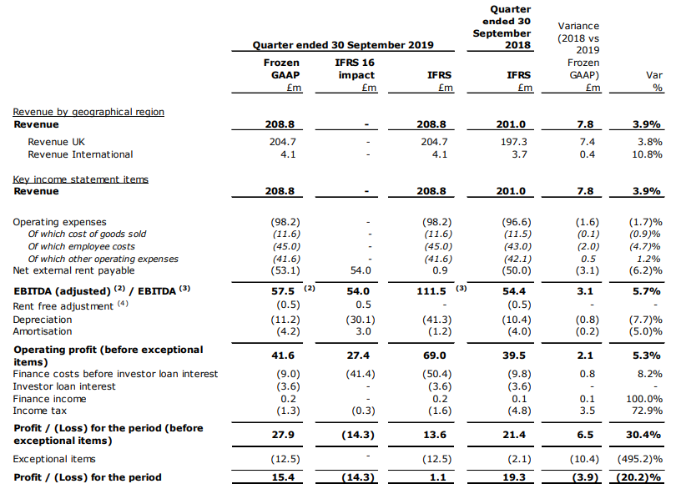
Figure Two – Travelodge (2023) Financial Statement. Available at: https://www.travelodge.co.uk/nw/sites/default/files/Thame_and_London_Quarterly_Report_to_Note_Holders_2023_Q3_FINAL.pdf (Accessed: 8 May 2024).
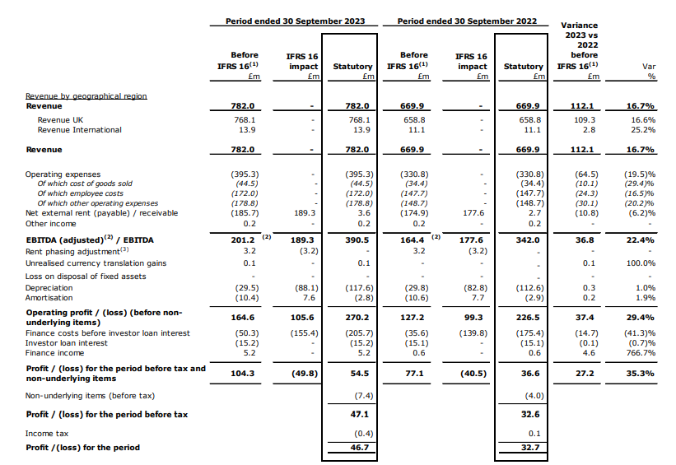
Figure Three - Shangri-La Finance (2019) Financial Statement. Available at: https://sitecore-cd.shangri-la.com/-/media/Project/Shangri-La-Group/Investor/Files/Public-Disclosures/Financial-Information/Results-Announcements/2020-03-27-Financial-results---Final-results-2019.pdf (Accessed: 9 May 2024).
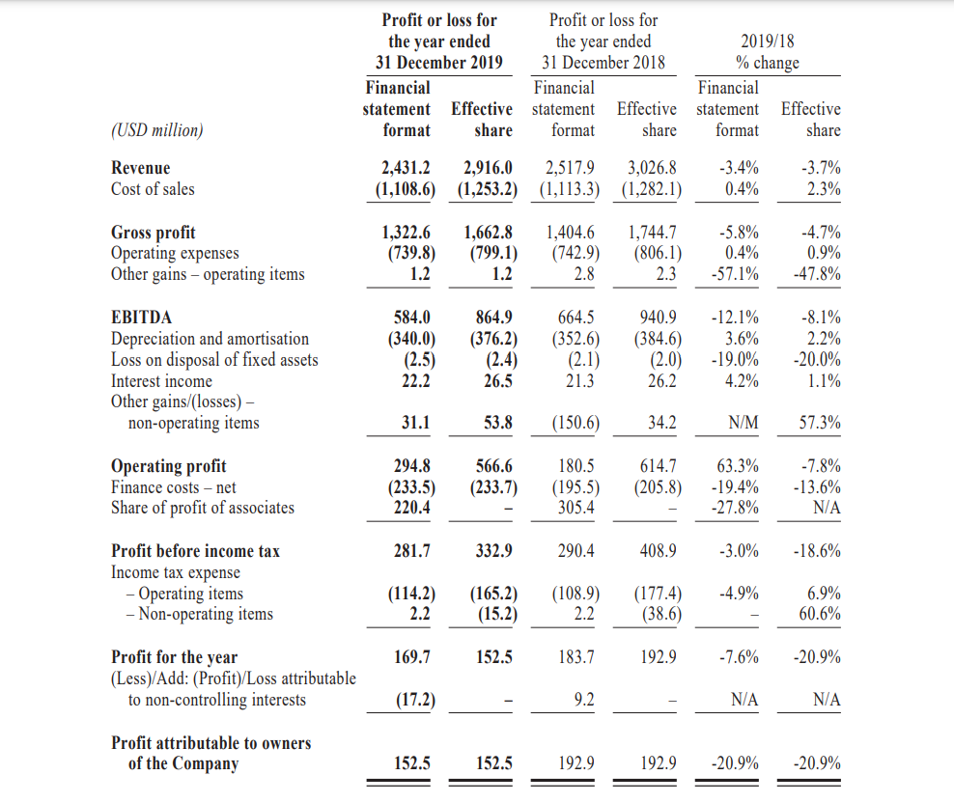
Figure Four - Shangri-la Financial Statement (2023) Financial Statement. Available at: https://sitecore-cd.shangri-la.com/-/media/Project/Shangri-La-Group/Investor/Files/Public-Disclosures/Financial-Information/Results-Announcements/Results-Announcements-Chinese/2024-03-22-Final-Results-Announcement_E.pdf (Accessed: 9 May 2024).
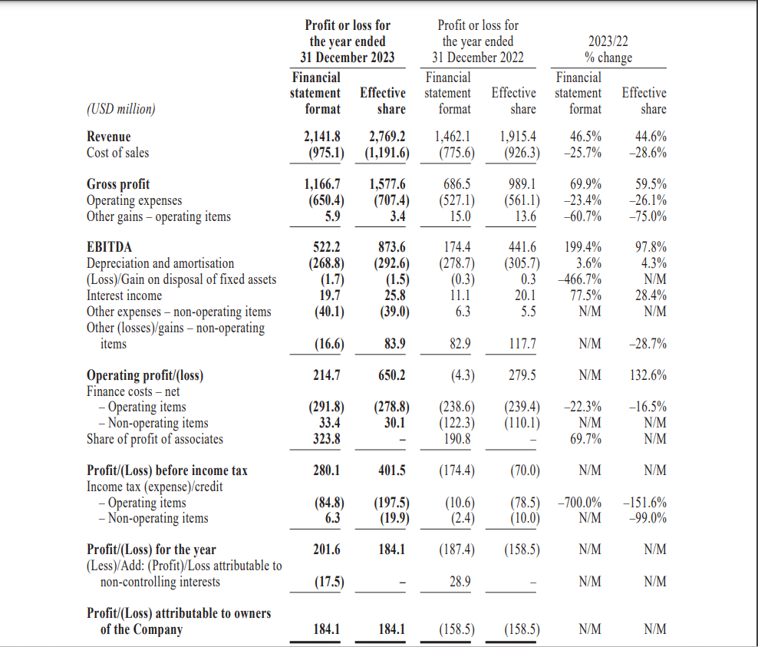
Figure Five - Shangri-la (2023) Total Revenue. Available at: https://sitecore-cd.shangri-la.com/-/media/Project/Shangri-La-Group/Investor/Files/Public-Disclosures/Financial-Information/Results-Announcements/Results-Announcements-Chinese/2024-03-22-Final-Results-Announcement_E.pdf (Accessed: 9 May 2024).


