

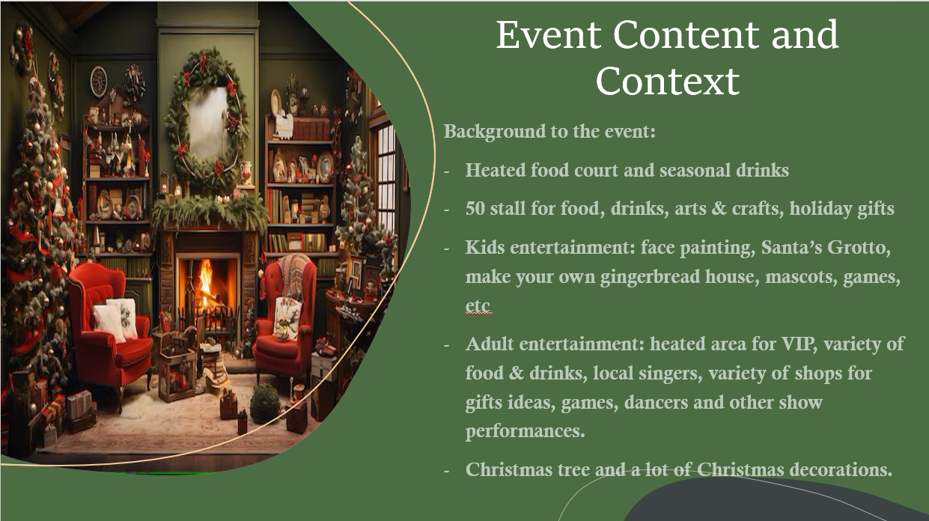

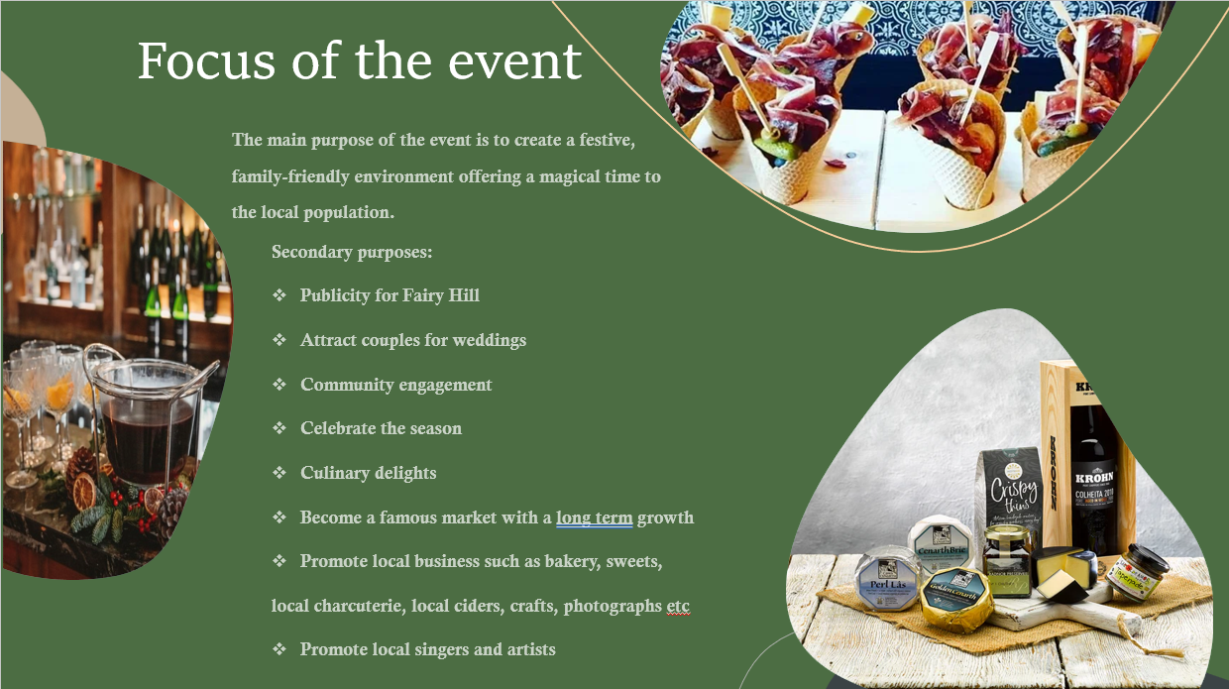

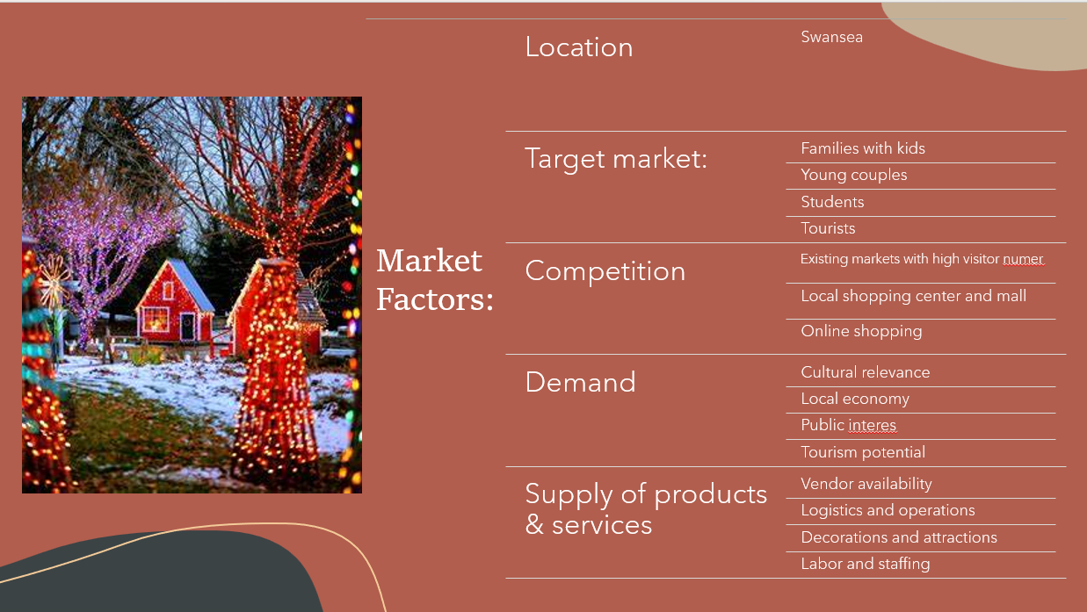

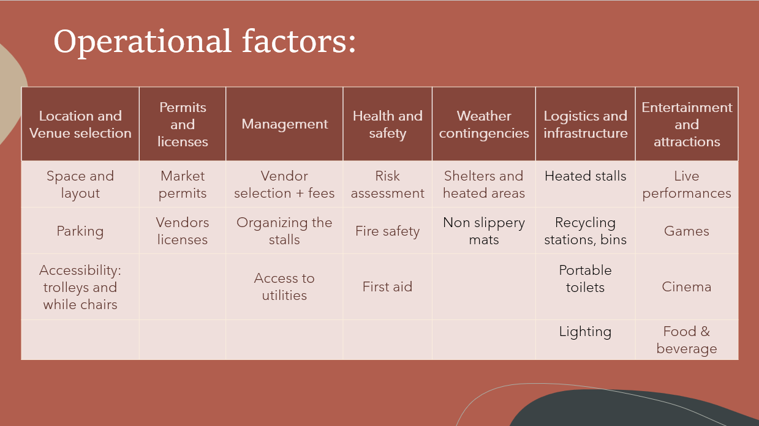

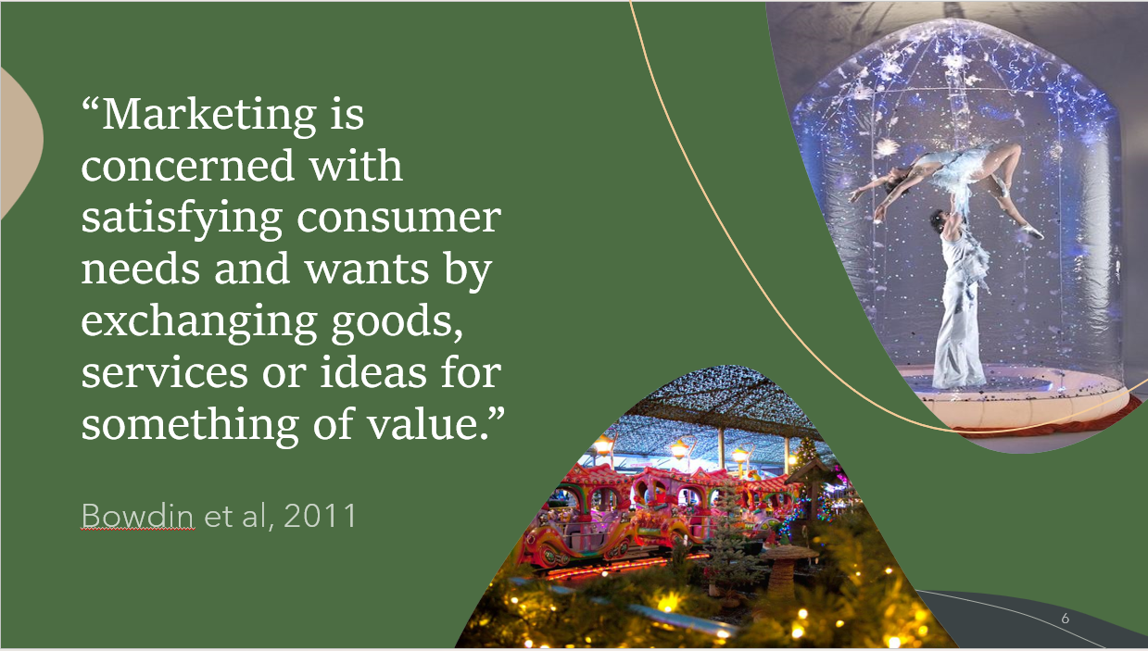

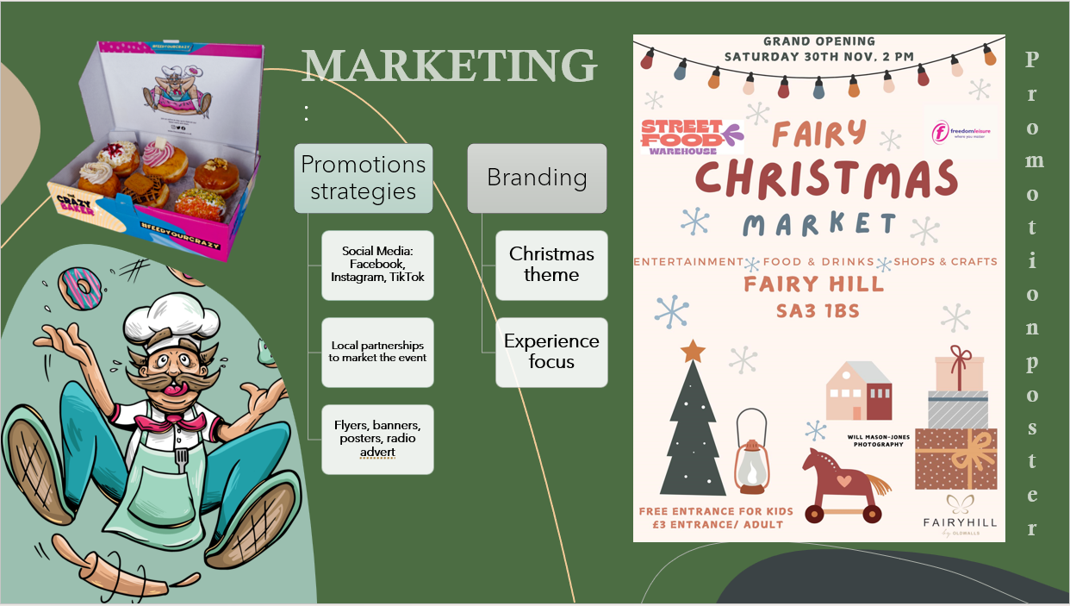

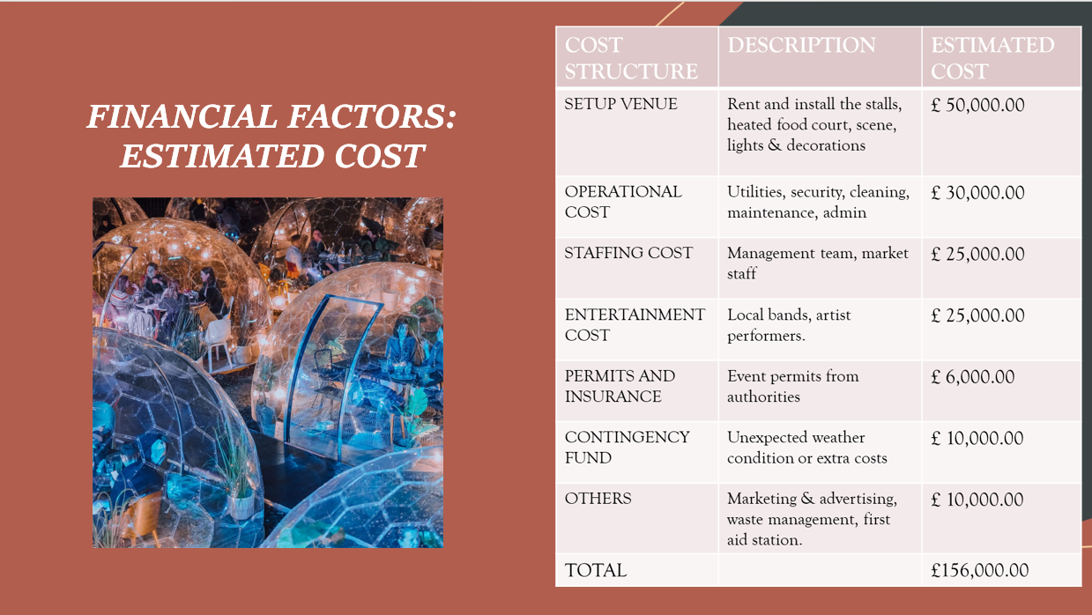

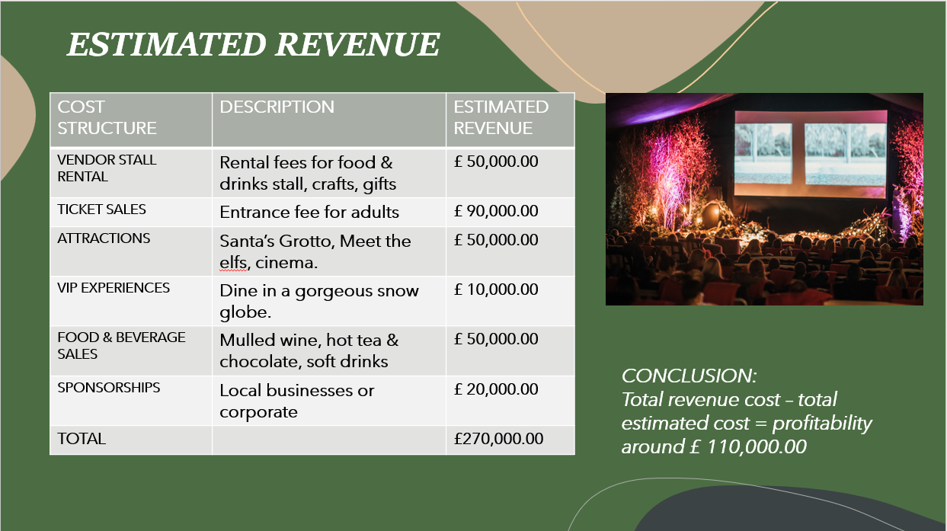

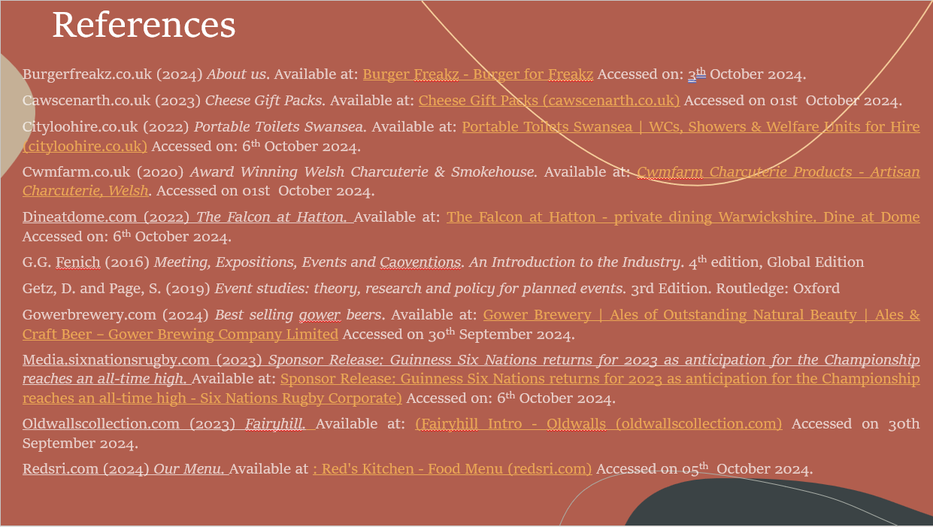

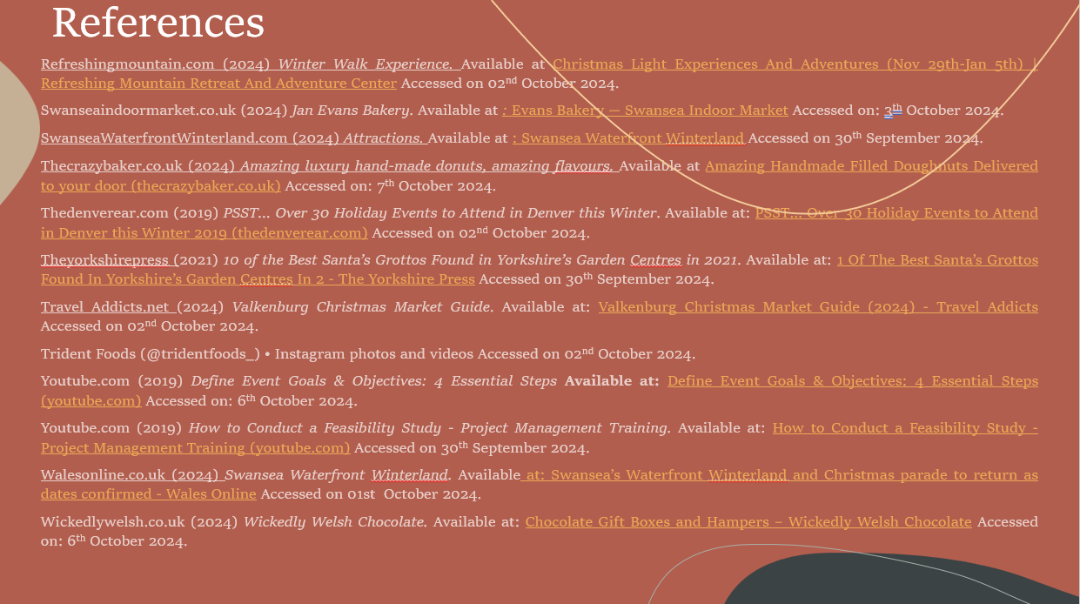

References:
Burgerfreakz.co.uk (2024) About us. Available at: Burger Freakz - Burger for Freakz Accessed on: 3th October 2024.
Cawscenarth.co.uk (2023) Cheese Gift Packs. Available at: Cheese Gift Packs (cawscenarth.co.uk) Accessed on 01st October 2024.
Cityloohire.co.uk (2022) Portable Toilets Swansea. Available at: Portable Toilets Swansea | WCs, Showers & Welfare Units for Hire (cityloohire.co.uk) Accessed on: 6th October 2024.
Cwmfarm.co.uk (2020) Award Winning Welsh Charcuterie & Smokehouse. Available at: Cwmfarm Charcuterie Products - Artisan Charcuterie, Welsh. Accessed on 01st October 2024.
Dineatdome.com (2022) The Falcon at Hatton. Available at: The Falcon at Hatton - private dining Warwickshire. Dine at Dome Accessed on: 6th October 2024.
G.G. Fenich (2016) Meeting, Expositions, Events and Conventions. An Introduction to the Industry. 4th edition, Global Edition
Getz, D. and Page, S. (2019) Event studies: theory, research and policy for planned events. 3rd Edition. Routledge: Oxford
Gowerbrewery.com (2024) Best selling gower beers. Available at: Gower Brewery | Ales of Outstanding Natural Beauty | Ales & Craft Beer – Gower Brewing Company Limited Accessed on 30th September 2024.
Media.sixnationsrugby.com (2023) Sponsor Release: Guinness Six Nations returns for 2023 as anticipation for the Championship reaches an all-time high. Available at: Sponsor Release: Guinness Six Nations returns for 2023 as anticipation for the Championship reaches an all-time high - Six Nations Rugby Corporate) Accessed on: 6th October 2024.
Oldwallscollection.com (2023) Fairyhill. Available at: (Fairyhill Intro - Oldwalls (oldwallscollection.com) Accessed on 30th September 2024.
Redsri.com (2024) Our Menu. Available at: Red's Kitchen - Food Menu (redsri.com) Accessed on 05th October 2024.
Refreshingmountain.com (2024) Winter Walk Experience. Available at: Christmas Light Experiences And Adventures (Nov 29th-Jan 5th) | Refreshing Mountain Retreat And Adventure Center Accessed on 02nd October 2024.
Swanseaindoormarket.co.uk (2024) Jan Evans Bakery . Available at: Evans Bakery — Swansea Indoor Market Accessed on: 3th October 2024.
SwanseaWaterfrontWinterland.com (2024) Attractions. Available at: Swansea Waterfront Winterland Accessed on 30th September 2024.
Thecrazybaker.co.uk (2024) Amazing luxury hand-made donuts, amazing flavours. Available at: Amazing Handmade Filled Doughnuts Delivered to your door (thecrazybaker.co.uk) Accessed on: 7th October 2024.
Thedenverear.com (2019) PSST… Over 30 Holiday Events to Attend in Denver this Winter. Available at: PSST... Over 30 Holiday Events to Attend in Denver this Winter 2019 (thedenverear.com) Accessed on 02nd October 2024.
Theyorkshirepress (2021) 10 of the Best Santa’s Grottos Found in Yorkshire’s Garden Centres in 2021. Available at: 1 Of The Best Santa’s Grottos Found In Yorkshire’s Garden Centres In 2 - The Yorkshire Press Accessed on 30th September 2024.
Travel Addicts.net (2024) Valkenburg Christmas Market Guide. Available at: Valkenburg Christmas Market Guide (2024) - Travel Addicts Accessed on 02nd October 2024.
Trident Foods (@tridentfoods_) • Instagram photos and videos Accessed on 02nd October 2024.
Youtube.com (2019) Define Event Goals & Objectives: 4 Essential Steps. Available at: Define Event Goals & Objectives: 4 Essential Steps (youtube.com) Accessed on: 6th October 2024.
Youtube.com (2019) How to Conduct a Feasibility Study - Project Management Training. Available at: How to Conduct a Feasibility Study - Project Management Training (youtube.com) Accessed on 30th September 2024.
Walesonline.co.uk (2024) Swansea Waterfront Winterland. Available at: Swansea’s Waterfront Winterland and Christmas parade to return as dates confirmed - Wales Online Accessed on 01st October 2024.
Wickedlywelsh.co.uk (2024) Wickedly Welsh Chocolate. Available at: Chocolate Gift Boxes and Hampers – Wickedly Welsh Chocolate Accessed on: 6th October 2024.

