

The future of hospitality and is it profitable to be green?

Sarah Ali (2119052)

BMIH5006, RUTH TAYLOR-DAVIES
November 10, 2023
Report

Context
Contents
1 Context 1
4 Executive Summary 2
5 Introduction 2
6 Destination Management 3
6.1 Types of tourism 4
6.2 Sustainable Tourism 4
6.3 Influences on Organisation 5
6.4 Butlers Life Cycle model applied to the circular economy, ‘Accor Hotel’ 6
7 To be profitable in 2023 7
8 Green washing/ Green hushing 7
9 Green emissions 8
10 Goals 9
10.1 Growth 10
11 Summary/ Recommendations 10
12 references 12

Executive Summary

According to Forbes (Forbes.com, 2023), “working with organisations focusing on environmental conservation and sustainability, supporting local initiatives promoting sustainable tourism”, Forbes agrees with innovation and sustainability. Tourism is travelling from one location to another, paying for services and stay. Future of tourism is to find new ways to travel in a sustainable practice, adapting to customer needs, as people’s life have changed and travel and tourism change. Research into the types of travellers and varies of tourism such as dark tourism, Ancestry, sports tourism, and urban, rural tourism. ‘Eco Tourism’ the benefits as time spent in nature is good for health a purpose for meeting interesting people. Policies, and models of sustainability, in ‘Consumer Activision standing up making a point through action for environmental issues, regulations and clear guidance, for reasonable tourism. The world population grows rapidly, and changes are for future generations to see, if everyone acts more consciously a step can be preserved for future generations, with greater profit (Info/world-population, 2023).

Introduction

This report reviews some of the hospitality industry sustainable tourism and destination managements models, policy, and directions from past present and future. The early fifties were, “The social responsibility of an organisation is to increase profits” seventy years old and the current statement is still relevant, (Friedman M, 1986). As demands, consumer growth grows and maximising profits while obeying the laws and ethical customs, from the olden days research to current research issues, shows that sustainability is about increasing profit, (Mulligan, T). According to current findings of some hospitality industries are making better change to be green for sustainable developments, whilst others are in denial of ‘Greenwashing’ more lavish hotels might be doing this. There is a demand for cheap stays, where environment is not a priority hotel can capitalise on this demand as ‘Marriott Bonvoy’ (2023), achieving a circular economy whilst it might not be possible to be totally green in sustainability in the hospitality industry it is “clear in travel and tourism market it cannot flourish without political stability” (Edgell and Swanson 2019).

DESTINATION MANAGEMENT

- Businesses responsible for being environmentally sound the triple bottom line, and the three pillars apply to some hotels in asia. Eco- Tourism hotels as ‘The Hiltons new, Asia Hotels’ expanding plan to achieve profits investments and maintain sustainability is consumer driven, and in all cases the focus on circular economy and linear economy are identified - (Davies R.T 8/11/2023).

Hilton Hotel Group, Asia (2023)
- Growth and development by ‘2030’,
- ventures the ‘New Era Asia Markets’ of its hospitality planning for long term sustainability goals, the management process is to be environmentally green in its new mission.
- “Funding will support organizations building hospitality careers, strengthening resilience of local communities and preserving travel destinations for future generations”, consumer driven demands, (Lugar K, Hilton 2023).

Eco-Tourism ‘Costa Rica’
- ‘2022’, 30% of Cost Rica’s ocean protected.
- 25% of the country is protected from future development.
- First country in the world to reverser deforestation and since 1990 has doubled the size of its forest.

The Power of Nature’ Costa Rica, management of conservation are conscious decision making of the environment making it “one of the happiest countries in the world” (Costa Rica, unk.edu, 2022). Co-operate objectives steps of a functional change in profit making with a high percentage contributing to pollution and negative gas emissions such as the ‘Linear economy’ are found in ‘package holidays, also, ‘All-inclusive hotel packages’ from the data on infrastructure, social ideological context, resorts, and companies are progressively interesting to sustainable development into their growth strategies (Surveys, WBCSD).

Urban- Resorts,
- Positive- Development, policies, legislations, planning

- Negative- Resort issues, urban infrastructure, jobs


Rural Resorts– To travel in a healthy manner, agriculture fisheries, culture.
- Positive- Economic benefits, Agriculture, Jobs
- Negative- Energy waste, development, planning
‘To create a balance “destination management, rules, and regulations” need to be clear,’ (UNWTO, 2021), (p132, Edgell).

Types of tourism (DAVIES R.T, 1/11/2023)

Domestic | Medical | Business | Educational | Dark tourism | Medieval
Booze Tourism | Stag/ Hen | Sports | Ancestry | Family | Fitness
Holiday | Leisure | Festive | Religious | Events | Birthdays

Sustainable Tourism
- To fulfil the requirements of the current population without affecting the future generations. A positive impact on sustainability to reduce a negative responsible tourism can be sustainable if everyone takes action to preserve more to tackle unethical issues. However, Doxeys Irredex model increases numbers of tourist, and results in irritation in the host of the community. “Secretary- General of the UNWTO,” is vested by the United Nations with a role in promoting peace, universally accessible tourism, economy development and human rights, (UNWTO, 2021).
- Positive Sustainability-
- Run on Solar Power
- Community involvement
- High Valu Low Impact
- Maintain the country’s infrastructure.
- Free Healthcare for locals
- Worm based tanks.
- Unique ownership models

Influences on Organisation (Rollinson, 2008)

Butlers Life Cycle model applied to the circular economy, ‘Accor Hotel’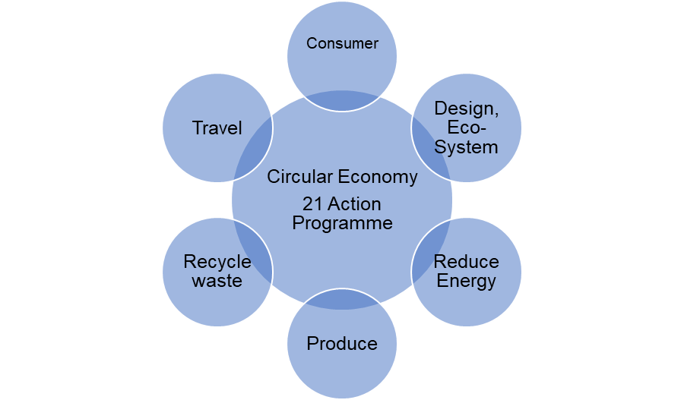 (2023)

- Waste Management
- Green Practises
- Raw Materials
- Food waste

The Circular Economy Impact on tourism with approximately “5% of global C02 emission’s”, Doxey’s Irridex model is applied to the importance in environmental issues of the impact of the circular economy affects that are on the rise in the industry as tourism grows. Transportation, the effects on the route overtime destruction, these changes behaviours of locals as it impacts their environment and life. Over tourism produces a negative impact on biodiversity, ‘cultural and historical heritage, noise pollution negative feelings in local inhabitants’ (Anton J. Almeida M, 2019). The driving forces would be that returning guests receive better recycled green products, the quality of tourism changing wearing of local sites roads, the resisting forces could be the education, policy, training, and staff attitude. (Lewin, K. 1947 p.37, Cartwright, D. Ed.)

Hospitality REACTION ‘Circular Economy’(wbcsd.org) Opportunities
High level of interest | Produce, goods procurement
Awareness in area of concern | Recycle Schemes within hotels
Circular economy deployment enablers | Utilising assets
External advice on economy training deployment pathways | Transport
 | Utilities, waste, management infrastructure

To be profitable is it still relevant in 2023

Not profitable organisations working with communities have responsible duties and gain profitable tourism, ‘volunteer tourism’ is currently trending (Tourism 20230, saving natural resources including cultures, and wildlife, such as -
- “South Africa back packer tourism” ‘has its own high-end legacy of eco-tourism. It is very profitable,
- there three key elements in its organisation, is locality, Employees, local community association,
Not for profit (Trans cape) understands each other needs the organisation commits to be a sustainable place to move towards a meaningful tourism experience’ (Mddumbi, 2017). All Inclusive Hotels could be a setback as there is so much wastage and restrictions, (Davies R.T, 8/11/2023).
Hotels that make cost reductions, value creation, waste reduction, and management of infrastructure and clean water are leading to a new trend of a ‘good choice of hotel’ to choose from all the others. The impact of the organisational culture satisfaction is of expectations of the government way. Reidhead C- Journal, 2020)

Green washing/ Green hushing

Greenwashing is a term used to describe a false, misleading, or untrue action or set of claims made by an organization about the positive impact that a company, product, or service has on the environment. Green hushing, A new research shows to getting harder for companies to claim they are green as the risk associated with co-operate decisions such as hotel electric cars. The plus and minus of how green wind turbine are as they cannot be re-cycled after the use by date, manufactures have not taken a circular approach on it. (Green hushing, Green washing
youtu.be, 2023). Managing cruise tourism impacts, Economic and social areas on the fishing industry, and coastal. Cruise ships can have a significant environmental impact. Issues include air and water pollution, waste disposal, and damage to marine ecosystems. The burning of heavy fuel oil by some cruise ships can contribute to air quality problems. Cruise tourism can also exacerbate issues related to climate change and over-tourism in sensitive areas. (Foe.org/blog/cruise-industry, 2022).
United Kingdom, ESA, contains modified copernias sentinel data, (BBC, Countryfile, 2023), ‘Lough Neagh’ one of the largest lakes in the Northern Islands, British Isle is dying due to’-
- “Toxic blue, green Algy”
- Thick layers of Algy, known as algal blooms, may form when mainly phosphorus, nitrogen build up in water in excess amounts”.
Hospitality poor results as consumer driven results of sustainability, organisations to ensure proper waste disposal is in use, business to ensure its easy for consumers to dispose waste, (BBC Countryfile, 2023).

Green emissions

Greening the tourism industry contributes to solving global problems of environmental factors of degradation and climate change, “IHG made a reduction in greenhouse gas emission using climate science, aimed at the reduction of plastic waste, mini toiletries in hotel rooms, in 2018 it promised to eliminate single-use plastic straws” (IHG, 2019).
“Worldwide Opportunities on Organic Farms (WWOOF),” ‘A global movement that connects visitors (WWOOFers) with organic farm they expertise to create cultural and educational exchange. They raise global community knowledge of ecological farming and sustainability practises. WWOOF grew from a small group of people in the 1970s to a global community of hundreds of thousands today’ (Woof.net 2023).

- “Emissions from factories and vehicles are released into the earth. They can travel long distances before the emissions turn into acid rain and fall to the ground. (Greenfacts.org 2023)

Goals

- Financial resiliency key to sustainability, financial crisis the behaviour of unethical result, “The fundamental reason behind planning and implementing strategies to make money and to increase ‘GPD’ of a country area,” Elkington’s Triple Bottom Line provides industry example of global sustainability (Tourism Teacher, 2022).

- To protect the environment hospitality are not doing enough internationally, ideas are made conscious decisions are being made on sustainability but at a cost of increasing prices, industry need to be more transparent on their websites and publicity awareness.

- To be in line with the Paris agreement by 2050 hotels need to reduce carbon footprint by 90% (Lissner, 2017)

- Managing cruise tourism impacts, Economic and social impact (foe.org/blog/Economic and social impact 2022)

UK B Corporation 2023 Growth

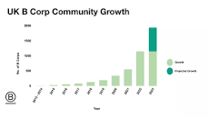(Google 2023)
UK B Corp (2014), The Benefits of B Corporation in the UK,

- “Certified B Corps in UK (2023) 1,500
- The average B Corps Score is 50.9
- B Corps in year 2023 6,400”
“The median score for ordinary business who complete the assessment,” The positive outcome is the company is growing rapidly across the world with, “Greater levels of employee relations, engagement and diversity.” ‘More robust governance processes and greater focus on community engagement.’ (B Corp 2023).

Summary/ Recommendations

Research by ‘Marriott Bonvoy,’ the loyalty programmes 2023 travel trends survey, released January 9th, 2023, “found that 63% of those quizzed say environmental consistent have at least some impacts on their travel planning” high end hotels may be environmentally sound where they can afford to attract group of customers into its core. Compared to a lower end cheaper hotel where customers are looking for a quick stay and do not give much core to the environment (Davies R.T, Moodle week 5, 2023). Green Solutions a profitable goal, based on beliefs of current financial market values ‘BBC, Asia financial markets, sees a rise in profits and trends (2023). According to a report issued in “2020, by the Italian Foundation for Sustainable Development and the COREPLA (National Consortium for the collection, recycling and recovery of plastic packaging), Italy is the leading country in of achieving a circular economy” (Travel foundation, 2022). Budget profitable market in sustainability the initiative the hospitality should make a priority to their daily operations such as reducing energy, waste, water, is a step to save the earth. Local Culture and Sustainability: Promote local culture, heritage, and sustainability practices to create unique and responsible tourism experiences (oecd.org, 2023). Initiatives recognised by ‘UNWTO (2021)’, “Those villages committed to making tourism a strong driver of their development and wellbeing”. True sustainability is a slow progress as ‘United Nations’ point problems of poverty alleviation and policy policing, “United Nations goals: it remains to see in the long run if it sustains and remains profitable”, Company’s signing up to the ‘UK B Corporation’ a key that shows business can thrive this was introduced to help achieve a system for a company to sign upto the cause of the triple bottom line (B Corporation 2014).

Recommendation
Climate change, Green energy “A prime time for investments in Sustainability is in ‘Green Energy’ to bring significant revenue to the industry” (Tamasek’s aim, BBC Asia News 2023). Future forward ideas for the tourism industry are the continuous responsible growing awareness of ‘The Carbon Footprint’ that tourists leave behind in a destination. Staff Training: Invest in comprehensive training programs for your hospitality staff, focusing on customer service, communication, and problem-solving skills.
- ‘The Future of Air Travel,’ “changing a shape of a plane could slash 50% carbon emissions” the possibilities are endless says Jet Zero (Asia Business News, 2023).
- A.I Future investments recommended in A.I Sustainability content by the hospitality industry.

references

- 1,500 UK B Corps show that business can thrive and benefit all, https://bcorporation.uk/ (Accessed 8th November 2023)
- Hilton Foundation, https://hiltonglobalfoundation.hilton.com/?_gl=1*16iud3a*_gcl_au*NTExMDY4NzgyLjE2OTk1MjgzMDc. Lugar K, 2023.
- Information World Meters, https://www.worldometers.info/world-population/ (28th October 2023).
- IHG, https://ihgplc.com Inter-Continental Hotels Group PLC, (Accessed 4th November 2023).
- Marriott Bonvoy 2023, https://www.marriott.com/en-gb/default. Mi, (9th November 2023)
- Mdumbi, Eco- Tourism, https://www.mdumbi.Co.Za (8th November 2023)
- The Rise of Eco-Tourism in Costa Rica and its Effects (unk.edu)
- The Travel Foundation, www.thetravel\foundation.org.uk (31st October 2023)
- Tourism teacher 2022, https://tourismteacher.com/why-tourism-development-planning-is-important/?utm_content=cmp-true (4th November 2023)
- UNWTO, https://www.unwto, (Accessed 1st November 2023)
- UNWTO Best Tourism, https://www.unwto.org/news/unwto-announces-list-of-best-tourism-villages-2021 (3rd November 2023)
- World Business Council for Sustainable Development (WBCSD): https://www.wbcsd.org, 2022.
- WWOOF, https://wwoof.net/ (Accessed 5th November 2023).

Google Scholar/UWTSD Library/ News
- Anton J. Almeida M, (2019) https://www.mdpi.com/2071-1050/11/20/5665, Article, Google Scholar
- A.I Future, News Corp: Close to striking deals with A.I companies who use content. (Asia Business Report, Sky 101 8th November 2023).
- BBC News, Asia business report Jet Zero, California (Friday 9th November 2023).
- BBC, Country File, ESA. 31st October 2023

- Clarke D. Lecture week 5 (Teams 2023) Accessed 3rd November 2023
- Climate change, “Singapore fund Temasek eyes green investments in emerging, markets,” Green Energy, (BBC News 8th November 2023).
- Cruise Tourism, https://foe.org/blog/cruise-industry-restart-demands/ Managing cruise tourism impacts, Economic and social impact 2022.
- Davies R.T. Lecture Sustainability 1st and 8th November 2023
- Edgell Sr, D.L. (2019) <i>Managing Sustainable Tourism</i>.3rd ed. Taylor and Francis.
- Greenfacts.org, 2023 (Accessed 31st/10/2023
- Lewin, K. (1947 p.37). Frontiers in group dynamics. In Cartwright, D. (Ed.), Field Theory in Social Science. London: Social Science Paperbacks.
- Lissner, (2017) Paris Agreement, (Davies. R.T, Lecture 1st November 2023, Moodle).
- Mulligan, T., 1986. A critique of Milton Friedman’s essay ‘the social responsibility of business is to increase its profits’.” Journal of Business Ethics, 5, pp. 265-269.
- OECD, The OECD (oecd.org) Defines Rural areas ‘Rural Tour.’
- Reidhead C- Journal of Economics and Business, 2020-papers.ssrn.com (culture 26th October 2023), (Google Scholar)
- Rollinson, D et al (2008) Organisational Behaviour and Analysis (4th edition) Harlow: Addison- Wesley Longman.

Appendix

6.1 TYPES OF TOURISM (DAVIES R.T, 1/11/2023)

Domestic, Medical, Business, Educational, Dark tourism, Medieval
Booze Tourism, Stag/ Hen, Sports, Ancestry, Family, Fitness, Holiday, Leisure, Festive, Religious, Events, Birthdays

6.2 Sustainable Tourism

6.3 Influences on organisation

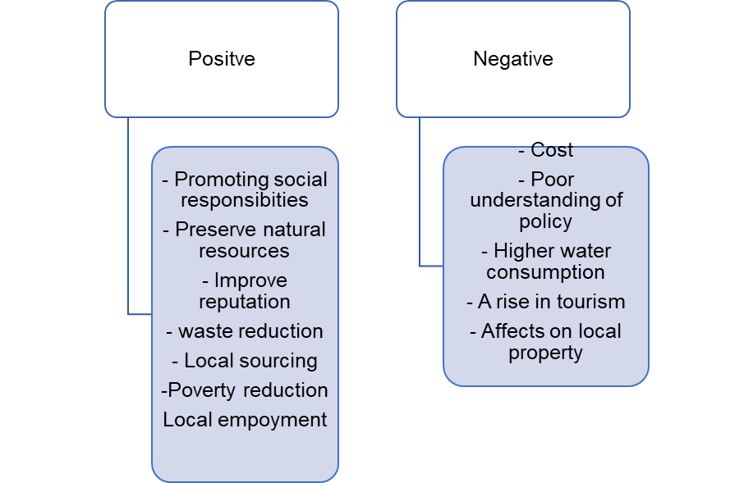

6.4 Circular Economy, Accor Hotel (2023).

6.5
High level of interest
Awareness in area of concern
Circular economy deployment enablers
External advice on economy training deployment pathways
Produce, goods procurement.
Recycle Schemes within hotels.
Utilising assets
Transport
Utilities, waste, management infrastructure

10.1 (Google 2023)

