REFLECTIVE PORTFOLIO

Student Name: Frah Islam
Student Number: 2026014
Module Code and Name: BMSW4005 Professional Career Development
Module Lecturer: Olubukola Adegbite

Table of Contents
1. Introduction 2
2. Evaluate your skills and competencies 3
2.1 SWOT Analysis for my skills 4
2.2 Personality test 5
3. Learning and Development 6
3.1 Kolb’s learning style 7
3.2 Honey and Mumford’s learning style 8
4. Reflective model 9
4.1 Open book assessment 9
4.2 Mock interview 9
4.3 UK employment laws 10
5. Conclusion 11
6. References 12
7. Appendix 13
7.1 Personality Test 13
7.2 Open book assessment feedback 14
7.3 Mock Interview feedback 15

Introduction
In this reflective portfolio, I will identify my career choice and the skills needed to support me in this career. I will evaluate my skills and competencies using SWOT analysis and Personality Tests and explain why it is essential to develop these skills and how they will help me achieve my career goal. I will be reflecting on different learning styles and why the chosen ones are beneficial for employees' learning and development training. Finally, I will be reflecting on my experiences before this course and how the skills that I have acquired will be helpful to me in my future career.

Evaluate your skills and competencies
In five years, I see myself as a qualified social worker supporting individuals going through difficult times and ensuring that children and adults are protected from harm. The skills that are required for my career choice are:
- Communication skills
- Management skills
- Team working skills
- Empathy
- Critical thinking
- Professional Commitment
- Organisational skills
- Leadership skills
- Multi-tasking
I already have most of the skills required for this career choice, as I acquired them through my previous employment. However, there are still a few skills that I still must develop, and hopefully, by completing my Health and Social Care course, I will acquire them.
Critical thinking is one of the skills that all social workers need regardless of their area of specialisation, according to Davies (2015). Furthermore, critical thinking is the skill that I must work on as I cannot process information from different sources from which I must make vital decisions. Therefore, this skill is a must for me to acquire as it will help me be effective in my work and help me to achieve my career goal target.

SWOT Analysis for my skills
STRENGTHS  - Currently doing qualifications that are needed  - Have the most transferable skills  - GCSE in psychology  - Can adapt to different situations | WEAKNESSES  - Don’t have any experience working in the social work field  - Critical thinking skill needs to be acquired  - Observation and analytical skills need to be worked on
OPPORTUNITIES  - Training provided in the workplace  - More salary  - Career advancement | THREATS  - Changes in laws and legislation  - Competition of applicants for a job  - Long hours to commit

SWOT analysis is a framework that helps to identify the strengths, weaknesses that I possess. It also helped me identify what opportunities or threats can affect me. Consultant Albert Humphrey first invented SWOT analysis in the 1960s.
Above is an outline of a SWOT analysis of my skills, it states the strengths that I possess, and it will help me achieve my goal. One of the points that I currently have is that I can adapt to different situations; being a social worker, you must adjust to various conditions, as all concerns that I'll have to deal with are unique and different.
It also states my weaknesses that could restrict me from achieving my goal. One of them is that I do not have any experience in the social work field; however, this can be turned into a strength by gaining some experience.
It also states the opportunities I can get off this career, such as career advancement, which is very good for my career. But finally, it also has threats that could potentially be in the way of achieving my goals. For example, the long hours that I might have to commit. Being a social worker could demand more hours of you to complete your tasks; however, this could be turned into an opportunity factor such as the satisfaction that I will get.

Personality test
According to Kendra Cherry (2022), "a personality test is used to assess human personality." It measures the characteristic patterns of traits that people exhibit across various situations.
Appendix 7.1 is a result of my personality test, which was taken, and I am a defender. Being a defender personality can help me achieve my career choice because of its traits. For example, being a defender, I would take my responsibilities personally and always make sure that I would go above and beyond doing everything to exceed expectations. I would also make sure that I get the tasks done on time. Being a defender, I have the excellent analytical skills required to be a social worker. I am also supportive, reliable, patient, observant, hard-working and have good practical skills, which are my strength, and would help me to achieve my career choice. However, some weaknesses could stop me from achieving my goal with these strengths. For example, I am shy and being a social worker, I must mix with other people and be confident. This weakness could turn into a strength by taking a few confidence sessions.

Learning and Development
Learning and development for every individual are different. But, according to CIPD (2022), learning and development are all about creating the right culture and environment for the employees to learn and grow.
I have been appointed as a manager in the career field, and I will be using Kolb’s learning style and Honey and Mumford’s learning styles to assess my staff's learning and development training.

Kolb’s learning style
Kolb’s learning style was first published in 1984. Its concept was to understand and explain human learning behaviours and how they could help other people when learning and developing. Below is a model of four learning styles, which defines each type.
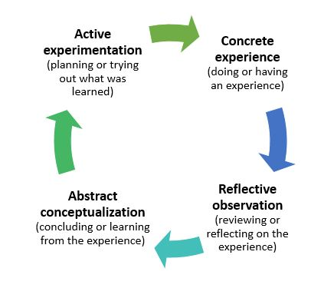

Source: www.businessballs.com
Kolb defined experiential learning as the process whereby knowledge is created through experience transformation (Coffey, 2012). The four central stages of Kolb's theory are concrete experience, reflective observation, abstract conceptualisation, and active experimentation. All four stages must be there for employees to learn from their experiences.
I chose this learning style for learning and development for my employees because this theory provides an immense opportunity to recognise the employee's style of learning. Because of this, it helps employees become more flexible and adapt to different demands of learning situations. This theory would also allow employees to transfer the knowledge into concrete and practical concept or idea. Although there are good points to why my employees should use this theory for their learning and development, there are some downs to it, such as I would not be able to apply all the four-learning styles to employees because every employee has their learning style preference.

Honey and Mumford’s learning style
Peter honey and Alan Mumford (1986) identified four different approaches learners could take to their learning development. The four learning approaches are:
- Reflector- prefers to learn from activities that allow them to observe
- Theorist- likes to think about problems step-by-step and uses graphs and charts to analyse data
- Pragmatist- prefers applying new learnings and ideas to work
- Activist- prefers the challenges of new experiences
I have chosen this learning style for my employee's learning and development because it probes the attitudes and behaviours, which could determine the preferences concerning learning. One of the other reasons is it is not a psychometric test as it's instead a checklist about how staff can learn. This is an excellent point as it means it is not time-consuming. However, there is a point in which I must make sure that my employees do not feel labelled as using Honey and Mumford’s learning style; employees can feel they're labelled when in fact, employees could exhibit more than one approach.
By understanding the employees' learning styles, I, as a manager, could make the most out of their potential, which could be an advantage to me.

Reflective model
For reflecting on my learning, I would use Driscoll's model of reflection.

Open book assessment
In week 4, we had an open book assessment we answered the question given by our lecturer in class. There were two options to answer, and I chose the second option. We had two hours to complete the assessment. We had to make sure that our cameras were on all the time, so the lecturer confirmed that students were doing their work by themselves. It was a bad experience for me because I could have researched it beforehand if given the question ahead.
There was no time to react to the situation because there was limited time to submit our work. However, I did feel nervous at that time, and I think it was because the time allocated to us made me nervous.
I have learned from this assessment that I should not be nervous; I should make sure that I have all the resources given to me to make use of them to answer my question confidently. If this situation arises again, I will make sure that I have some soothing music to soothe my nerves. I would also ensure that I have all the resources, such as relevant books or case studies relevant to the question, as in my feedback in appendix 7.2. I would also make sure that I would improve my critical thinking by making a correct judgement.

Mock interview
In week 8, we had a mock interview with our lecturer online. We had to be realistic and give an interview for our chosen job. I had to answer all the questions that my employer asked me confidently so I could pass my interview. Overall, I think it was a bad experience because I got blank on a few questions, and I didn’t research the company that I applied for, as given in the feedback in appendix 7.3.
During my mock interview, I was very nervous and did not answer the questions correctly.
What I have learnt from this experience is I should do extensive research into the company that I am applying for. In addition, I should also improve on my knowledge of how to use the STAR approach to answer the questions as referenced in appendix 7.3. This suggestion would help me to pass my interview.

UK employment laws
This model has helped me with understanding many employment laws. However, one of the employment laws I have learned about is the importance of the health and safety law. I have learnt that the employer has the full responsibility of providing a safe place for work provide safe equipment, and the supervisor must carry out the risk assessments. if there are any identified problems, and if supervisor does not take it seriously, I can then report to my health and safety manager or directly to my manager.
One of the other laws that this module has taught me is the importance of contract law; for example, it is a legal document written or oral by one party to fulfil an obligation to another party in return for consideration. Also, I have learned that there are a few clauses in the contract that need to be checked and then signed. Such as how much my pay is, the hours of work, the holiday pay, sick pay, and much more. Its primary purpose is to protect the employer and employee rights If there are any issues after. I have also learnt that I must take my time as it is my legal right to read through the employment contract, check through and then sign it as this will mean that I have signed a legal contract.

Conclusion
To conclude, I would say is every individual must evaluate their skills to achieve their career goal so that individuals can set improvement plans. As a manager, it is my responsibility to make sure that I assess their learning and development for their improvement or advancement in the job. Finally, reflecting on your learning is equally important as evaluating your skills for stepping up your opportunities on the ladder.

References
- 16 Personalities (2022) Free personality test, type descriptions, relationship, and career advice [website] Available at: https://www.16personalities.com/ (Accessed: 12th March 2022)
- Angy (2020) 13 essential social work skills list you want to master, Social Work Haven | Become A Social Worker. Become A Better You. [website] Available at: https://socialworkhaven.com/essential-social-work-skills/ (Accessed: 1st March 2022)
- CIPD People Profession (2022) Learning and development [website] Available at: https://peopleprofession.cipd.org/profession-map/specialist-knowledge/learning-development (Accessed: 15th March 2022)
- Health and Safety Executive (2019). Health and Safety at Work etc. Act 1974. [website] Available at: https://www.hse.gov.uk/legislation/hswa.htm. (Accessed: 19th March 2022)
- Lea, S (2022) Honey and Mumford’s learning styles [website] Available at: https://www.businessballs.com/self-awareness/honey-and-mumfords-learning-styles/ (Accessed: 22nd March 2022)
- Lucidchart (2022) What is a SWOT analysis [website] Available at: https://www.lucidchart.com/pages/what-is-swot-analysis (Accessed: 19th March 2022)
- Mcleod, Saul (2013) “Kolb’s learning styles and experiential learning cycle.” [website] Available at: https://www.simplypsychology.org/learning-kolb.html (Accessed: 16th March 2022)
- NursingAnswers.net (2022) Driscoll’s model of reflection [website] Available at: https://nursinganswers.net/reflective-guides/driscoll-model-of-reflection.php (Accessed: 29th March 2022)
- Prospects (2022) Job profile Social Worker [website] Available at: https://www.prospects.ac.uk/job-profiles/social-worker (Accessed: 03rd March 2022)

Appendix

Personality Test

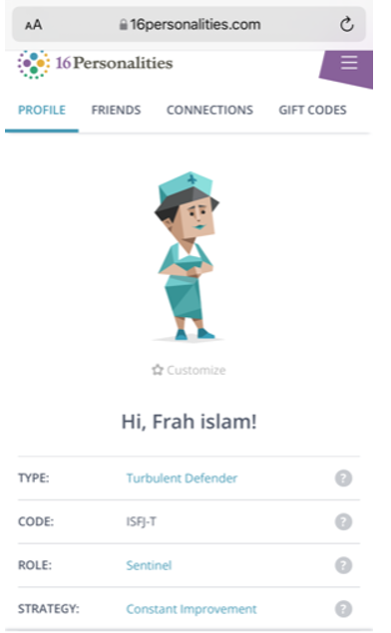

Open book assessment feedback
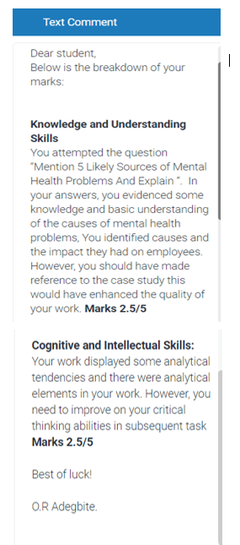

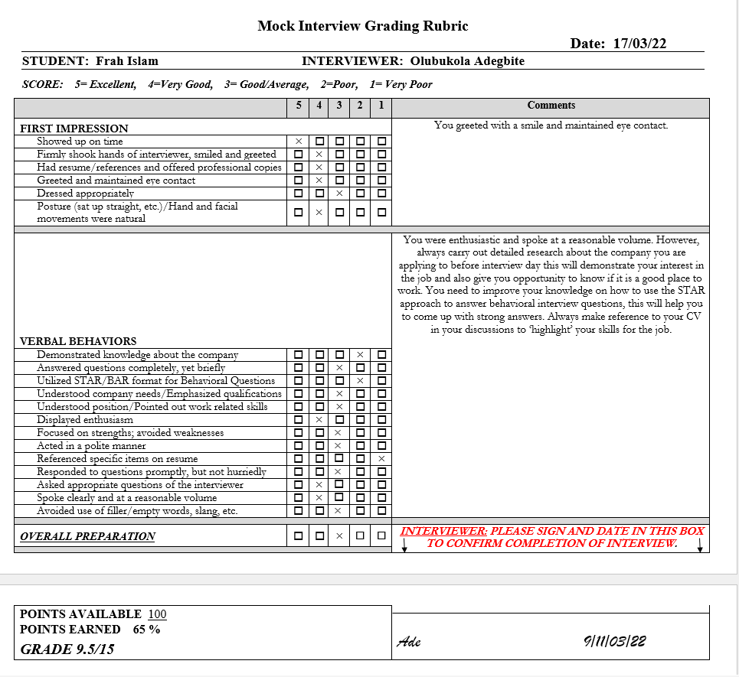
Mock Interview feedback

