
Programme: | Certificate of Higher Education Skills for the Workplace (Health and Social Care)
Module: | Introduction to Public Health
Module code: | LCHS4008 | Contribution to Overall Module Assessment (%): | 50%
Lecturer(s): | Vivian Osuchukwu | Internal Verifier: | Dr Besty Jose
Assignment Title: | Assessment 2 -  Report on a Health Issue | Word count (or equivalent): | Report – 1500 words
Student Name: | Kwasi Asiedu | Student Number: | 2419872

Table of Contents
Introduction 2
Main Body Consequences for the Community and the NHS 2
Disease Control and Management and Factors Influencing Health and Well-being 3
Emotional and Social Challenges in Heart Disease 4
Conclusion 5
Reference List 6

Report on a Health Issue

Introduction
A variety of disorders affecting the heart and its blood arteries are together referred to as heart diseases. This includes congenital heart anomalies that exist from birth, coronary artery disease, and cardiac rhythm issues, or arrhythmias. A accumulation of fatty deposits (plaque) in the arteries causes coronary artery disease, the most prevalent kind, which restricts blood flow and may result in heart attacks or strokes. Fatigue, shortness of breath, pain radiating to the arms or jaw, and chest pain or discomfort are common signs of heart disease. Symptoms might occasionally be mild or non-existent until a catastrophic incident happens.
Heart disease is the world's biggest cause of mortality, making it a serious global health problem. In 2021, cardiovascular diseases claimed the lives of 20.5 million people worldwide, or over one-third of all fatalities, according to the World Heart Federation. About one in four premature deaths in the UK are caused by coronary heart disease, which affects about 2.3 million individuals. “These statistics highlight the severity of heart disease as a critical public health challenge both globally and nationally (Mayo Clinic, 2024; British Heart Foundation, 2023).”

Main Body
Consequences for the Community and the NHS
The effects of heart disease on people and society are significant. It lowers life expectancy and quality of life and is a major source of morbidity and mortality. Chronic symptoms like weariness and chest discomfort are common in people with heart disease, and they can impair their independence and everyday activities. Patients and their family may have significant emotional and psychological effects as well, leading to stress and worry.
Heart disease is a major operational and financial burden on the National Health Service (NHS). Every year, the expenses of treating cardiovascular diseases, including emergency room visits, hospital stays, prescription drugs, and procedures, total billions of pounds. In particular, heart failure, a typical consequence of heart disease, costs the NHS over £2 billion annually and accounts for almost 2% of all inpatient bed days. In the UK, almost 200,000 people receive a heart failure diagnosis each year, which results in a high frequency of emergency hospital visits and lengthy average hospital stays of 11 days. This strain on NHS resources underlines the pressing need for effective prevention, early detection, and management strategies to reduce hospital admissions and improve patient outcomes (Downing et al., 2019; All Party Parliamentary Group on Heart Disease, 2016).”

Disease Control and Management and Factors Influencing Health and Well-being
Heart disease is controlled and managed with a mix of medication, lifestyle changes, and continuous observation. Risk evaluations, physical examinations, blood testing, and cardiac imaging, such as electrocardiograms, are frequently part of early diagnosis. Following a diagnosis, therapy regimens are customised for each patient and may involve antihypertensives to regulate blood pressure, antiplatelet medicines to lessen the risk of clots, and statins to lower cholesterol. Modifications in lifestyle are essential for illness prevention. Patients are urged to give up smoking, eat a heart-healthy, balanced diet that is low in sugar, salt, and saturated fats, and exercise often. It's also critical to manage other medical issues like diabetes and obesity. Surgery to restore blood flow may be required in more severe situations, such as bypass surgery or angioplasty. Cardiovascular illness is given priority in the NHS Long Term Plan, which aims to enhance identification and treatment of the condition in order to avoid over 150,000 heart attacks, strokes, and dementia cases by 2029. “Additional support includes community programs and enhanced patient education to encourage adherence to medication regimens and lifestyle changes (NHS England, 2023).”
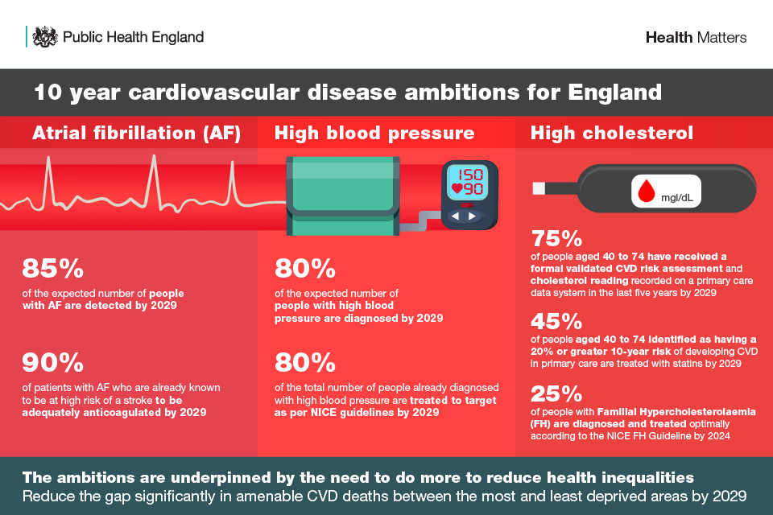
Figure 1
The health and well-being of people with heart disease and those around them are influenced by a number of variables. One important factor is socioeconomic level; people in underprivileged regions are almost twice as likely to die young and have cardiovascular diseases as people in more affluent places. Health outcomes and habits are influenced by access to healthcare services, financial level, and education.
Heart disease risk factors include smoking, eating poorly, not exercising, and drinking too much alcohol. Other factors include age, sex, race, and genetic predisposition; individuals from Black, Asian, and minority ethnic origins are at increased risk, while men are typically at higher risk. Life expectancy is shortened, and cardiovascular risk is increased by long-term stress and mental health issues such severe mental illness.
Family members and caretakers are particularly affected since they frequently offer financial, emotional, and physical assistance. Heart disease's chronic nature necessitates lifestyle modifications and may restrict social engagement, which impacts the general well-being of the community. “Support networks and access to healthcare resources are critical to mitigating these adverse effects (British Heart Foundation, 2023).”

Emotional and Social Challenges in Heart Disease
The effects of cardiac disease on one's emotional, psychological, and social well-being go well beyond its physical manifestations. Many people with heart disease experience stress, worry, and sadness, especially following a cardiac catastrophe like a heart attack or significant heart surgery. In the weeks following a heart attack, 40% of survivors report moderate to severe mental distress, and depression frequently raises the risk of further cardiac issues. Distress can affect adherence to treatment, motivation for recovery, and adoption of healthy lifestyle choices. Being forced to adapt to new duties and uncertainties presents emotional difficulties for family members and caretakers as well. They may experience elevated stress levels or even signs of post-traumatic stress disorder (PTSD).
Heart illness can produce disruptions that can lead to changed family dynamics, decreased financial stability, and changes in social roles. Strong support systems, both personal and professional, may assist patients and their families deal with these challenges, improving their quality of life and results. “Family-centred rehabilitation programmes and psychological support have shown to improve both patients’ and caregivers’ lifestyles, anxiety levels, and understanding of illness, highlighting the need for holistic approaches in cardiac care (Steptoe, 2022).”
The treatment of cardiac disease is also being increasingly impacted by recent developments in telemedicine and digital health. Patients can improve continuing treatment and early intervention by using online education, smartphone applications, and remote monitoring technologies to help them check their blood pressure, cholesterol, and medication adherence from the comfort of their own homes. In order to lessen healthcare disparities, these technologies can be especially helpful for those living in remote or underdeveloped locations. Digital solutions help patients and their families manage cardiac disease, which improves health outcomes and quality of life, even if they cannot completely replace traditional medical treatment.

Conclusion
Heart disease continues to be a major cause of mortality and disability in the UK and across the world, with substantial financial and human implications. It shows up as a variety of symptoms that frequently lower quality of life and put a significant burden on healthcare systems such as the NHS. A multimodal strategy including lifestyle modifications, medical therapy, and preventative measures is necessary for the effective management of heart disease. The frequency and consequences of this disease, which affects both patients and their families, are greatly influenced by lifestyle decisions, hereditary factors, and socioeconomic disparities. To lessen the burden of heart disease, ongoing initiatives to enhance patient education, early identification, and community assistance are crucial. Long-term success in controlling cardiovascular health at the individual and public health levels will depend on addressing health inequities and encouraging better living circumstances.

Reference List
British Heart Foundation (2023) UK cardiovascular disease factsheet. British Heart Foundation.
Downing, J. et al. (2019) Impact of a community-based cardiovascular disease program. Journal of Cardiac Care, 14(3), pp. 112-120.
Mayo Clinic (2024) Heart disease - Symptoms and causes. Mayo Clinic Publishing.
NHS England (2023) Cardiovascular disease (CVD) Long Term Plan. NHS England.
Steptoe, A. (2022) Psychosocial Influences on Cardiovascular Disease. Oxford University Press.
Cunningham, P. (2023) Managing emotional health in heart disease patients. Routledge.
World Heart Federation (2023) World Heart Report 2023. WHF Publications.
Harvard Medical School (2018) Prevention and treatment of heart disease. Harvard Health Publishing.
National Institute for Health and Care Excellence (NICE) (2022) Cardiovascular disease risk assessment and management. NICE Guidelines.
Public Health England (2019) Health matters: preventing cardiovascular disease. GOV.UK. https://www.gov.uk/government/publications/health-matters-preventing-cardiovascular-disease/health-matters-preventing-cardiovascular-disease

