Appendix

Contents Page

Appendix 1 - Ethics form Page 2

Appendix 2 - Questionnaire for staff Page 14

Appendix 3 - Semi-structured interview questions for pupils Page 16

Appendix 4 - Consent form for the headteacher Page 17

Appendix 5 - Consent form for staff completing the questionnaires Page 19

Appendix 6 - Happy/sad face cards so pupils can withdraw Page 21

Appendix 1 – Ethics form

APPLICATION FOR ETHICAL APPROVAL

RESEARCH STUDENTS
This form is to be completed by the student within SIX months for full-time students and TWELVE months for part time students, after the commencement of the research degree or following progression to Part Two of your course.

Once complete, submit this form via the MyTSD Doctoral College Portal at (https://mytsd.uwtsd.ac.uk).

This document is also available in Welsh.

RESEARCH STAFF ONLY
All communications relating to this application during its processing must be in writing and emailed to pgresearch@uwtsd.ac.uk , with the title ‘Ethical Approval’ followed by your name.

STUDENTS ON UNDERGRADUATE OR TAUGHT MASTERS PROGRAMMES should submit this form (and receive the outcome) via systems explained to you by the supervisor/module leader.

In order for research to result in benefit and minimise risk of harm, it must be conducted ethically. A researcher may not be covered by the University’s insurance if ethical approval has not been obtained prior to commencement.

The University follows the OECD Frascati manual definition of research activity: “creative work undertaken on a systematic basis in order to increase the stock of knowledge, including knowledge of man, culture and society, and the use of this stock of knowledge to devise new applications”. As such this covers activities undertaken by members of staff, postgraduate research students, and both taught postgraduate and undergraduate students working on dissertations/projects.

The individual undertaking the research activity is known as the “principal researcher”.

Ethical approval is not required for routine audits, performance reviews, quality assurance studies, testing within normal educational requirements, and literary or artistic criticism.

Please read the notes for guidance before completing ALL sections of the form.

This form must be completed and approved prior to undertaking any research activity. Please see Checklist for details of process for different categories of application.

SECTION A: About You (Principal Researcher)
1 | Full Name: |  | Hazel Smith
2 | Tick all boxes that apply: |  | Member of staff: | ☐ | Honorary research fellow: | ☐
 | Undergraduate Student | ☒ | Taught Postgraduate Student | ☐ | Postgraduate Research Student | ☐

3 | Institute/Academic Discipline/Centre: | Initial Teacher Education, Yr Athrofa
4 | Campus: | Carmarthen
5 | E-mail address: | 2314788@student.uwtsd.ac.uk
6 | Contact Telephone Number:
 | For students:
7 | Student Number: | 2314788
8 | Programme of Study: | BA Primary Education with QTS
9 | Director of Studies/Supervisor: | Dr Sioned V Hughes

SECTION B: Approval for Research Activity
1 | Has the research activity received approval in principle?  (please check the Guidance Notes as to the appropriate approval process for different levels of research by different categories of individual) |  | YES | ☒ | NO | ☐
 |  |  |  |  | Date
2 | If Yes, please indicate source of approval (and date where known): Approval in principle must be obtained from the relevant source prior to seeking ethical approval | Research Degrees Committee |  | ☐
2 |  | Institute Research Committee |  | ☐
2 |  | Other (write in) ECAD5014  Dr Sioned V Hughes |  | ☒ | 14.03.25

SECTION C: Internal and External Ethical Guidance Materials
 | Please list the core ethical guidance documents that have been referred to during the completion of this form (including any discipline-specific codes of research ethics, location-specific codes of research ethics, and also any specific ethical guidance relating to the proposed methodology). Please tick to confirm that your research proposal adheres to these codes and guidelines. You may add rows to this table if needed.
1 | UWTSD Research Ethics & Integrity Code of Practice | ☒
2 | UWTSD Research Data Management Policy | ☒
3 | BERA Ethical Guidelines for Educational Research, fifth edition (2024).  EWC Education Workforce Council’s Code of Professional Conduct and Practice (2024). | ☒

SECTION D: External Collaborative Research Activity
If there are external collaborators then you should gain consent from the contact persons to share their personal data with the university. If there are no external collaborators then leave this section blank and continue to section E.
1 | Institution
2 | Contact person name
3 | Contact person e-mail address
4 | Is your research externally funded? |  | YES | ☐ | NO |  | ☐
5 | Are you in receipt of a KESS scholarship? |  | YES | ☐ | NO |  | ☐
6 | Are you specifically employed to undertake this research in either a paid or voluntary capacity? | Voluntary | YES | ☐ | NO | ☐
7 |  | Employed | YES | ☐ | NO | ☐
8 | Is the research being undertaken within an existing UWTSD Athrofa Professional Learning Partnership (APLP)? | If YES then the permission question below does not need to be answered. | YES | ☒ | NO |  | ☐
9 | Has permission to undertake the research has been provided by the partner organisation? | (If YES attach copy)  If NO the application cannot continue | YES | ☐ | NO |  | ☐

Where research activity is carried out in collaboration with an external organisation
10 | Does this organisation have its own ethics approval system? | YES | ☐ | NO | ☐
 | If Yes, please attach a copy of any final approval (or interim approval) from the organisation (this may be a copy of an email if appropriate).

SECTION E: Details of Research Activity
1 | Indicative title: | What are staff and year 6 learners’ perceptions of success criteria?
2 | Proposed start date: | 19.03.25 | Proposed end date: | 04.04.25
Introduction to the Research (maximum 300 words per section)
Ensure that you write for a Non-Specialist Audience when outlining your response to the points below:
- Purpose of Research Activity
- Proposed Research Question
- Aims of Research Activity
- Objectives of Research Activity
Demonstrate, briefly, how Existing Research has informed the proposed activity and explain
- What the research activity will add to the body of knowledge
- How it addresses an area of importance.
3 | Purpose of Research Activity  - To explore success criteria as an AfL strategy.  - To trial interviews and questionnaires as research tools in practice  - To investigate the challenges and advantages of collecting research in a school environment.  - To analyse the data and draw conclusions.
4 | Research Question  What are staff and year 6 learners’ perceptions of success criteria?
5 | Aims of Research Activity  - To explore staff and leaners’ perceptions of success criteria as an AfL strategy.  - To critically evaluate the use of questionnaires and interviews as research tools.  - To increase knowledge and understanding of AfL to deepen my professional development.
6 | Objectives of Research Activity  - To explore the AfL success criteria strategies which are used by school staff to progress pupils’ learning using questionnaires and interviews.  - To interview pupils in focus groups and record their views about success criteria.  - To use questionnaires to obtain the views of KS2 staff on sharing success criteria.  - To reflect critically on the different research methods used to collect data.
Proposed methods (maximum 600 words)
Provide a brief summary of all the methods that may be used in the research activity, making it clear what specific techniques may be used. If methods other than those listed in this section are deemed appropriate later, additional ethical approval for those methods will be needed. You do not need to justify the methods here, but should instead describe how you intend to collect the data necessary for you to complete your project.
7 | Questionnaires  Five staff at the school in KS2 will be asked to complete a questionnaire anonymously. The questionnaire will contain key questions relating to success criteria as an AfL strategy. I will e-mail my questionnaire to the teachers and hope that as many as possible will complete it. Staff will also complete a consent form prior to participating.  Interviews  The children will be invited to answer key questions in a semi-structured focus group interview. Some question examples are: What are the advantages of success criteria? What are the challenges of success criteria? Are some methods of sharing success criteria better than others?  The interviews will be informal and I will take notes and also record their responses by audio. The children will be advised that they do not have to participate or answer any questions. They can also leave at any time. The children can use the happy/sad face cards provided to visually express their continued consent and if they would like to withdraw from the research. I will check in on the children regularly to monitor their feelings. No names will be recorded to maintain anonymity.
Location of research activity
Identify all locations where research activity will take place.
8 | The research school is in an urban area. There is one class per year group, with approximately 200 pupils in total.
Research activity outside of the UK
If research activity will take place overseas, you are responsible for ensuring that local ethical considerations are complied with and that the relevant permissions are sought. Specify any local guidelines (e.g. from local professional associations/learned societies/universities) that exist and whether these involve any ethical stipulations beyond those usual in the UK (provide details of any licenses or permissions required). Also specify whether there are any specific ethical issues raised by the local context in which the research activity is taking place, for example, particular cultural and/or legal sensitivities or vulnerabilities of participants. If you live in the country where you will do the research then please state this.
9 | N/A  (this box should expand as you type)

10 | Use of documentation not in the public domain: Are any documents NOT publicly available? | NO | ☒
10 |  | YES | ☐
11 | If Yes, please provide details here of how you will gain access to specific documentation that is not in the public domain and that this is in accordance with the current data protection law of the country in question and that of England and Wales.  (this box should expand as you type)

 | Does your research relate to one or more of the seven aims of the Well-being of Future Generations (Wales) Act 2015? | YES | NO
12 | A prosperous Wales | ☐ | ☒
13 | A resilient Wales | ☐ | ☒
14 | A healthier Wales | ☐ | ☒
15 | A more equal Wales | ☐ | ☒
16 | A Wales of cohesive communities | ☐ | ☒
17 | A Wales of vibrant culture and thriving Welsh language | ☐ | ☒
18 | A globally responsible Wales | ☐ | ☒
19 | If YES to any of the above, please give details:
 | (this box should expand as you type)

SECTION F: Scope of Research Activity
 | Will the research activity include: | YES | NO
1 | Use of a questionnaire or similar research instrument? | ☒ | ☐
2 | Use of interviews? | ☒ | ☐
3 | Use of focus groups? | ☐ | ☒
4 | Use of participant diaries? | ☐ | ☒
5 | Use of video or audio recording? | ☒ | ☐
6 | Use of computer-generated log files? | ☐ | ☒
7 | Participant observation with their knowledge? | ☐ | ☒
8 | Participant observation without their knowledge? | ☐ | ☒
9 | Access to personal or confidential information without the participants’ specific consent? | ☐ | ☒
10 | Administration of any questions, test stimuli, presentation that may be experienced as physically, mentally or emotionally harmful / offensive? | ☐ | ☒
11 | Performance of any acts which may cause embarrassment or affect self-esteem? | ☐ | ☒
12 | Investigation of participants involved in illegal activities? | ☐ | ☒
13 | Use of procedures that involve deception? | ☐ | ☒
14 | Administration of any substance, agent or placebo? | ☐ | ☒
15 | Working with live vertebrate animals? | ☐ | ☒
16 | Procedures that may have a negative impact on the environment? | ☐ | ☒
17 | Other primary data collection methods. Please indicate the type of data collection method(s) below. | ☐ | ☒
 | Details of any other primary data collection method:  (this box should expand as you type) | ☐ | ☒
If NO to every question, then the research activity is (ethically) low risk and may be exempt from some of the following sections (please refer to Guidance Notes).

If YES to any question, then no research activity should be undertaken until full ethical approval has been obtained.

SECTION G: Intended Participants TICK ALL RELEVANT BOXES HERE
If there are no participants then do not complete this section, but go directly to section H.

 | Who are the intended participants: | YES | NO
1 | Students or staff at the University? | ☐ | ☒
2 | Adults (over the age of 18 and competent to give consent)? | ☒ | ☐
3 | Vulnerable adults? | ☐ | ☒
4 | Children and Young People under the age of 18? (Consent from Parent, Carer or Guardian will be required) | ☒ | ☐
5 | Prisoners? | ☐ | ☒
6 | Young offenders? | ☐ | ☒
7 | Those who could be considered to have a particularly dependent relationship with the investigator or a gatekeeper? | ☐ | ☒
8 | People engaged in illegal activities? | ☐ | ☒
9 | Others. Please indicate the participants below, and specifically any group who may be unable to give consent. | ☐ | ☒
 | Details of any other participant groups:  (this box should expand as you type) | ☐ | ☒

Participant numbers and source
Provide an estimate of the expected number of participants. How will you identify participants and how will they be recruited?
10 | How many participants are expected? | 25
11 | Who will the participants be? | 20 children  4 KS2 teachers  1 deputy head
12 | How will you identify the participants? | Information from class teacher

 | Information for participants: | YES | NO | N/A
13 | Will you describe the main research procedures to participants in advance, so that they are informed about what to expect? | ☒ | ☐ | ☐
14 | Will you tell participants that their participation is voluntary? | ☒ | ☐ | ☐
15 | Will you obtain written consent for participation? | ☐ | ☐ | ☒
16 | Will you explain to participants that refusal to participate in the research will not affect their treatment or education (if relevant)? | ☒ | ☐ | ☐
17 | If the research is observational, will you ask participants for their consent to being observed? | ☐ | ☐ | ☒
18 | Will you tell participants that they may withdraw from the research at any time and for any reason? | ☒ | ☐ | ☐
19 | With questionnaires, will you give participants the option of omitting questions they do not want to answer? | ☒ | ☐ | ☐
20 | Will you tell participants that their data will be treated with full confidentiality and that, if published, it will not be identifiable as theirs? | ☒ | ☐ | ☐
21 | Will you debrief participants at the end of their participation, in a way appropriate to the type of research undertaken? | ☒ | ☐ | ☐
22 | If NO to any of above questions, please give an explanation
 | (this box should expand as you type)

 | Information for participants: | YES | NO | N/A
24 | Will participants be paid? | ☐ | ☒ | ☐
25 | Is specialist electrical or other equipment to be used with participants? | ☐ | ☒ | ☐
26 | Are there any financial or other interests to the investigator or University arising from this study? | ☐ | ☒ | ☐
27 | Will the research activity involve deliberately misleading participants in any way, or the partial or full concealment of the specific study aims? | ☐ | ☒ | ☐
28 | If YES to any question, please provide full details
 | (this box should expand as you type)

SECTION H: Anticipated Risks

Outline any anticipated risks that may adversely affect any of the participants, the researchers and/or the University, and the steps that will be taken to address them.

If you have completed a full risk assessment (for example as required by a laboratory, or external research collaborator) you may append that to this form.
1 | Full risk assessment completed and appended? |  | Yes | ☐
1 |  |  | No | ☒
2 | Risks to participants  For example: sector-specific health & safety, emotional distress, financial disclosure, physical harm, transfer of personal data, sensitive organisational information
 | Risk to participants:  Children might feel pressured to answer the questions in a certain way.  Participants may be concerned that their names might be identified.  Safeguarding | How you will mitigate the risk to participants:  I will ask for answers to be honest and make it clear that there will be no repercussions from any of the answers that they give in response to the questions.  I will make it clear that all responses are anonymous.  I will comply with all legal requirements in relation to working with children, including the school’s safeguarding policy.
3 | If research activity may include sensitive, embarrassing or upsetting topics (e.g. sexual activity, drug use) or issues likely to disclose information requiring further action (e.g. criminal activity), give details of the procedures to deal with these issues, including any support/advice (e.g. helpline numbers) to be offered to participants. Note that where applicable, consent procedures should make it clear that if something potentially or actually illegal is discovered in the course of a project, it may need to be disclosed to the proper authorities
N/A

(this box should expand as you type)
4 | Risks to the investigator  For example: personal health & safety, physical harm, emotional distress, risk of accusation of harm/impropriety, conflict of interest
 | Risk to the investigator:  There is a risk of being accused of fabricating or falsifying data. | How you will mitigate the risk to the investigator:  I will follow the BERA and UWTSD guidelines whilst conducting my research.
5 | University/institutional risks  For example: adverse publicity, financial loss, data protection
 | Risk to the University:  Behaviour which might result in jeopardising the relationship between the school and the university. | How you will mitigate the risk to the University:  I will maintain professionalism at all times.  All my data will be collected anonymously and stored on a password protected file.
6 | Environmental risks  For example: accidental spillage of pollutants, damage to local ecosystems
 | Risk to the environment:  N/A  (this box should expand as you type) | How you will mitigate the risk to environment:  N/A  (this box should expand as you type)

 | Disclosure and Barring Service
 | If the research activity involves children or vulnerable adults, a Disclosure and Barring Service (DBS) certificate must be obtained before any contact with such participants. | YES | NO | N/A
7 | Does your research require you to hold a current DBS Certificate? | ☒ | ☐ | ☐
8 | If YES, please give the certificate number. If the certificate number is not available please write “Pending”; in this case any ethical approval will be subject to providing the appropriate certificate number.

SECTION I: Feedback, Consent and Confidentiality

1 | Feedback  What de-briefing and feedback will be provided to participants, how will this be done and when?
N/A

(this box should expand as you type)
2 | Informed consent  Describe the arrangements to inform potential participants, before providing consent, of what is involved in participating. Describe the arrangements for participants to provide full consent before data collection begins. If gaining consent in this way is inappropriate, explain how consent will be obtained and recorded in accordance with prevailing data protection legislation.
I will liaise with my lecturer, informing them of my research proposal, which will include the rationale behind the research.
I will also verbally ask the headteacher and teachers whether they would like to participate and also ask them to fill in consent forms, as well as maintain consent throughout the research.
3 | Confidentiality / Anonymity  Set out how anonymity of participants and confidentiality will be ensured in any outputs. If anonymity is not being offered, explain why this is the case.
 | I will make sure that no individual data is made available to schools or parents. Also, I will not disclose any names keeping anonymity.

SECTION J: Data Protection and Storage

 | Does the research activity involve personal data (as defined by the General Data Protection Regulation 2016 “GDPR” and the Data Protection Act 2018 “DPA”)? | YES | NO
1 | “Personal data” means any information relating to an identified or identifiable natural person (‘data subject’). An identifiable natural person is one who can be identified, directly or indirectly, in particular by reference to an identifier such as a name, an identification number, location data, an online identifier or to one or more factors specific to the physical, physiological, genetic, mental, economic, cultural or social identity of that natural person. Any video or audio recordings of participants is considered to be personal data. | ☐ | ☐
 | If YES, provide a description of the data and explain why this data needs to be collected:
2 | (this box should expand as you type)
 | Does it involve special category data (as defined by the GDPR)? | YES | NO
3 | “Special category data” means sensitive personal data consisting of information as to the data subjects’ –  (a) racial or ethnic origin,  (b) political opinions,  (c ) religious beliefs or other beliefs of a similar nature,  (d) membership of a trade union (within the meaning of the Trade Union and Labour Relations (Consolidation) Act 1992),  (e) physical or mental health or condition,  (f) sexual life,  (g) genetics,  (h) biometric data (as used for ID purposes), | ☐ | ☐
 | If YES, provide a description of the special category data and explain why this data needs to be collected:
4 | (this box should expand as you type)

 | Will data from the research activity (collected data, drafts of the thesis, or materials for publication) be stored in any of the following ways? | YES | NO
5 | Manual files (i.e. in paper form)? | ☐ | ☐
6 | University computers? | ☐ | ☐
7 | Private company computers? | ☐ | ☐
8 | Home or other personal computers? | ☐ | ☐
9 | Laptop computers/ CDs/ Portable disk-drives/ memory sticks? | ☐ | ☐
10 | “Cloud” storage or websites? | ☐ | ☐
11 | Other – specify: | ☐ | ☐
12 | For all stored data, explain the measures in place to ensure the security of the data collected, data confidentiality, including details of backup procedures, password protection, encryption, anonymisation and pseudonymisation:
 | (this box should expand as you type)

 | Data Protection
 | Will the research activity involve any of the following activities: | YES | NO
13 | Electronic transfer of data in any form? | ☐ | ☐
14 | Sharing of data with others at the University outside of the immediate research team? | ☐ | ☐
15 | Sharing of data with other organisations? | ☐ | ☐
16 | Export of data outside the UK or importing of data from outside the UK? | ☐ | ☐
17 | Use of personal addresses, postcodes, faxes, emails or telephone numbers? | ☐ | ☐
18 | Publication of data that might allow identification of individuals? | ☐ | ☐
19 | Use of data management system? | ☐ | ☒
20 | Data archiving? | ☐ | ☐
21 | If YES to any question, please provide full details, explaining how this will be conducted in accordance with the GDPR and Data Protection Act (2018) (and any international equivalents, where appropriate):
N/A

(this box should expand as you type)
22 | List all who will have access to the data generated by the research activity:
 | (this box should expand as you type)
23 | List who will have control of, and act as custodian(s) for, data generated by the research activity:
 | (this box should expand as you type)
24 | Give details of data storage arrangements, including security measures in place to protect the data, where data will be stored, how long for, and in what form. Will data be archived – if so how and if not why not.
 | (this box should expand as you type)
25 | Please indicate if your data will be stored in the UWTSD Research Data Repository (see https://researchdata.uwtsd.ac.uk/ ). If so please explain. (Most relevant to academic staff)
N/A

(this box should expand as you type)
26 | Confirm that you have read the UWTSD guidance on data management (see https://www.uwtsd.ac.uk/library/research-data-management/) | YES | ☐
27 | Confirm that you are aware that you need to keep all data until after your research has completed or the end of your funding | YES | ☐

SECTION K: Declaration
The information which I have provided is correct and complete to the best of my knowledge. I have attempted to identify any risks and issues related to the research activity and acknowledge my obligations and the rights of the participants.

In submitting this application I hereby confirm that I undertake to ensure that the above named research activity will meet the University’s Research Ethics and Integrity Code of Practice which is published on the website: https://www.uwtsd.ac.uk/research/research-ethics/
1 | Signature of applicant: | Hazel Smith | Date:  14.03.25

For STUDENT Submissions:
2 | Director of Studies/Supervisor: | Dr Sioned V Hughes | Date:  15.03.25
3 | Signature: | S.V.Hughes | Date:  15.03.25

For STAFF Submissions:
4 | Academic Director/ Assistant Dean: |  | Date:
5 | Signature: |  | Date:

Checklist: Please complete the checklist below to ensure that you have completed the form according to the guidelines and attached any required documentation:
☒ | I have read the guidance notes supplied before completing the form.
☒ | I have completed ALL RELEVANT sections of the form in full.
☒ | I confirm that the research activity has received approval in principle
☐ | I have attached a copy of final/interim approval from external organisation (where appropriate)
☐ | I have attached a full risk assessment (where appropriate) ONLY TICK IF YOU HAVE ATTACHED A FULL RISK ASSESSMENT
☒ | I understand that it is my responsibility to ensure that the above named research activity will meet the University’s Research Ethics and Integrity Code of Practice.
☒ | I understand that before commencing data collection all documents aimed at respondents (including information sheets, consent forms, questionnaires, interview schedules etc.) must be confirmed by the DoS/Supervisor, module tutor or Academic Director.

RESEARCH STUDENTS ONLY
Once complete, submit this form via the MyTSD Doctoral College Portal at (https://mytsd.uwtsd.ac.uk).

RESEARCH STAFF ONLY
All communications relating to this application during its processing must be in writing and emailed to pgresearch@uwtsd.ac.uk , with the title ‘Ethical Approval’ followed by your name.

STUDENTS ON UNDERGRADUATE OR TAUGHT MASTERS PROGRAMMES should submit this form (and receive the outcome) via systems explained to you by the supervisor/module leader.

Appendix 2 – Questionnaire for staff

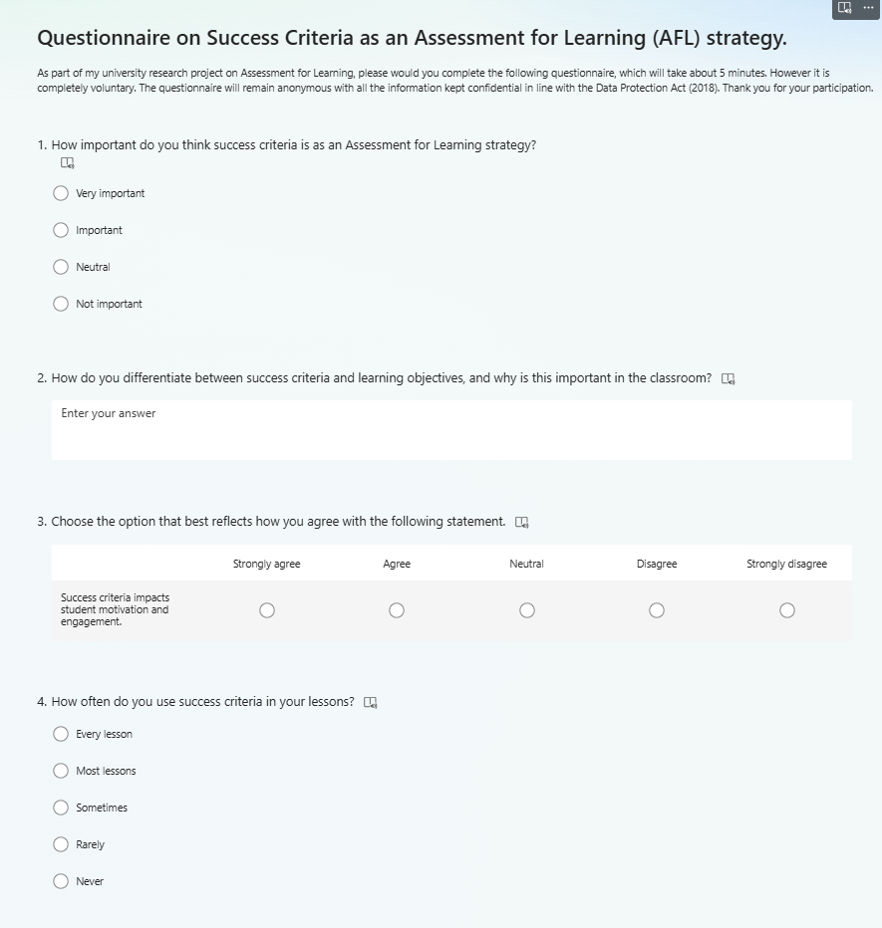

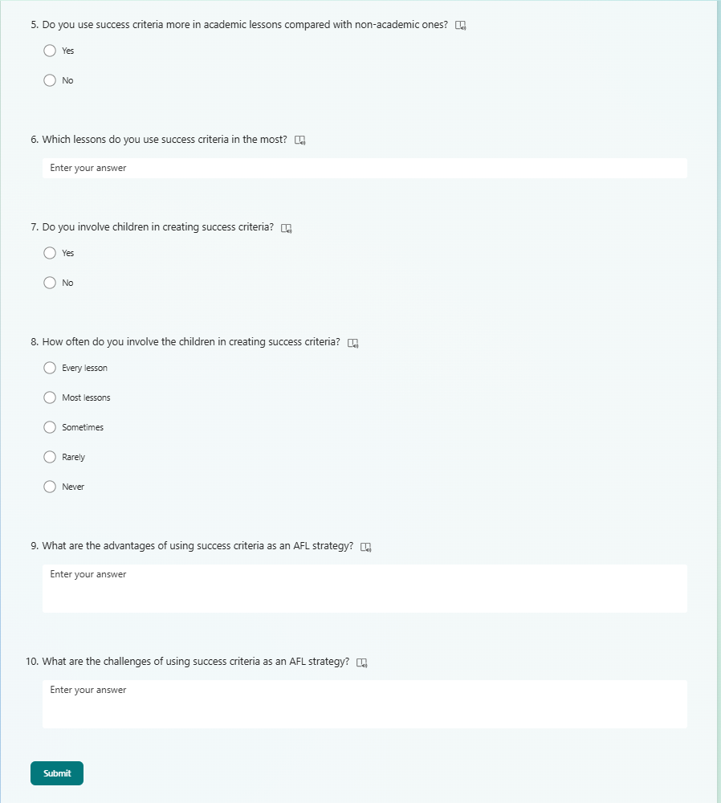

Appendix 3 – Semi-structured interview questions for pupils

What are staff and year 6 learners’ perceptions of success criteria?

Interview

- Explain to the children what the purpose of the interview is.
- Let the children know that they can stop participating at any time.
- Check throughout that the children are happy with continuing.
- Make sure all the children get the opportunity to answer each question.

- Can you explain what success criteria are?
Prompt: Can you elaborate on that?

- Do you have success criteria in every lesson?
Prompt: Which classes use it, and which classes don’t use it?

- Why do you think success criteria are important?
Prompt: Why do you feel that?

- How do you think success criteria help you with your learning?
Prompt: In what ways does success criteria help?

- Do you think there are any problems with using success criteria?
Prompt: Does using success criteria get in the way of your learning?

- Do you find success criteria more helpful when you are given it, or when you help create it as a class?
Prompt: What are your reasons?

Appendix 4 – Consent form for the headteacher



Research School Day
BA2
19/03/25

Rationale
Research Day in School is an important element of the ECAD5014 Module – Researching the Learning – what, how and why am I teaching? The aim of the module is to develop student teachers’ research skills by providing opportunities for them to create a questionnaire and interview questions and to trial these research methods in a school (i.e., PTE2 school).

The overarching research question is ‘What are learners and staff perceptions of AfL?” For the assignment, the student teachers will have to choose a particular aspect of AfL (e.g., feedback, questioning) and then design, trial and critically evaluate their research tools.

Before the Research Day in School the student teachers will have already designed their research tools (questionnaire and interview questions) and submitted an ethics form.

During the Research Day in School the student teacher should be able to carry out the following tasks:
- Distribute and collect questionnaires (school staff and/or pupils)
- Interview a group of children (from PTE2 class) and possibly some of the staff.

Following the ‘Research Day in School’, the student teachers will critically evaluate these research tools. Their focus will not be on the data they collected but on the research design, i.e. the effectiveness of their research tools.

EWC Code of Conduct:
An expectation of professionalism as outlined in the EWC’s code of conduct is expected from all stakeholder participants throughout the Research Day.
https://www.ewc.wales/site/index.php/en/fitness-to-practise/code-of-professional-conduct-and-practice-pdf.html

They are also expected to adhere to the BERA Ethical Guidelines for Educational Research (2024) https://www.bera.ac.uk/publication/ethical-guidelines-for-educational-research-fifth-edition-2024-onlineand the UWTSD UWTSD Research Ethics & Integrity Code of Practice

(Continued next page)

ECAD5014 Consent Form

Student teachers must gain the following written consent of the head teacher/ senior-mentor/mentor before trialling their research tools.

To be completed by the school:

I agree to ____________________________________ as a representative of Yr Athrofa to:

-Take photographs (Tick accordingly)

-Interview

-Record an interview

-Quote school policy documents

-Questionnaires

Name of Head teacher ________________________ Signed _____________________

Name of school _______________________________

To be completed by the student teacher:

If I am granted such permission, I agree to abide by the ethics embodied within the EWC Code of Conduct and BERA Ethical Guidelines (2024) and will not distribute any such material to audiences beyond the University authorities without their permission.

Name of student teacher: Signed:

Student teacher UWTSD e-mail address:

Programme (BA Education QTS/ Primary):

Date:

Appendix 5 – Consent form for staff completing the questionnaires



CONSENT FORM (staff)

PROJECT TITLE:

Name of Researcher: Hazel Smith

Please initial box

1. I confirm that I have read and understand the information sheet dated 19/03/2025 for the above study.

2. I understand that my participation is voluntary and that I am free to withdraw from the study at any time, without giving any reason.

3. I understand that I can choose to withdraw at any time, without giving a reason.

4. I understand that the information given will be used in a university assignment.

5. I understand that my name will not appear at any time.

6. I agree to take part in the above study.

_____________________ _____________________________ __________
Name Signature Date

INFORMATION sheet

PROJECT TITLE: What are staff and year 6 learners’ perceptions of success criteria?

Dear Participant,

My name is Hazel Smith and I am studying for a BAED qualification at Yr Athrofa, University of Wales Trinity Saint David.
I would like to invite you to participate in my research project. The title of the project is “What are staff and year 6 learners’ perceptions of success criteria?” Through your participation, I hope to develop my research skills and professional practice.
The questionnaire will take no longer than 10 minutes and all names will be kept strictly confidential and will only be known by myself. Your participation in this study is completely voluntary so you can withdraw from the study at any stage.
After careful and precise analysis of the data obtained from the questionnaire, I would be happy to provide you with a copy of the findings at your request. The results of the research will be discussed in a university assignment that will contribute to my BAED course. The results of this study will be stored on a Microsoft 360 cloud and all raw data will be destroyed once the assessment has been marked.
I thank you in advance for your time. If any questions do arise, feel free to contact me at your convenience.

Yours sincerely,

Hazel Smith

Appendix 6 – Happy/sad face cards so pupils can withdraw.



