Name-Hema Sharma
1812759

Tiny-Toes Daycare Nursery

“Do you need help with the children? ​
Tiny Toes Daycare Nursery is a magical place to share, learn, and grow. ​
We take care of your children as if they are our own” ​

A day care nursery is a place where children play and learn through playing with their peers, adults and by themselves. The key to nursery education is to provide a warm and safe environment where children feel comfortable to explore.



Types of Products/Services:

We are offering a childcare service for children aged between 8 months to 3 years old.
Timing – 7am-5pm (Monday-Friday)

Enrolment Fees:
- Part-time (25 hours) 2 to 3 Years = £125 per week (£25 a day)
- Full-time (50 hours) 2 to 3years = £240 per week (£48 a day)
- Part - time (25 hours) 8 months to 2 years = £126 per week (£25.20 a day)
- Full-time (50 hours) 8 months to 2 years = £250 per week (£50 a day)

In Wales, day-care nurseries usually charge £127 per week for part-time and £260+ per week for full-time however, Tiny Toes Day-care nursery offers a low-priced childcare Service (the Money Advice service, 2019). https://www.moneyadviceservice.org.uk/en/articles/childcare-costs#part-time-childcare-costs

We will provide:



A wide range of nutritious food such as:
- A range of food and drink to meet the dietary recommendations for children.
- Fruits and vegetables at least five portion a day.
- Bread and its products, which are labelled low green means less salt.
- Rice cakes, Crackers, Milk, Soya drinks, yoghurt choosing lower fat and lower sugar options.
- Baby food and formula milk for toddlers i.e. Heinze, Cow & Gate brand.


By all these things we will encourage children to eat a variety of nutritious foods, which will be helpful in their physical as well as mental growth and development. “The early years and childhood are a crucial period for development and provide an important foundation for a child’s future health and well-being”. (Best Practice Guidance, n.d.) https://gov.wales/sites/default/files/publications/2019-03/190313-nutrition-guidance-complete.pdf
Children will be offered around 300-400ml of milk per day. We will provide Cow & Gate Follow-on milk for the babies. Children under the age of 5 years may receive powdered infant formula, which is 189ml a day. “As an eligible childcare provider you can claim your milk reimbursement direct from the Nursery Milk Reimbursement direct from the Nursery Milk Reimbursement Unit (NMRU)”(Nursery Milk Scheme, 2019) https://www.nurserymilk.co.uk/about-nursery-milk-scheme

Activities such as: 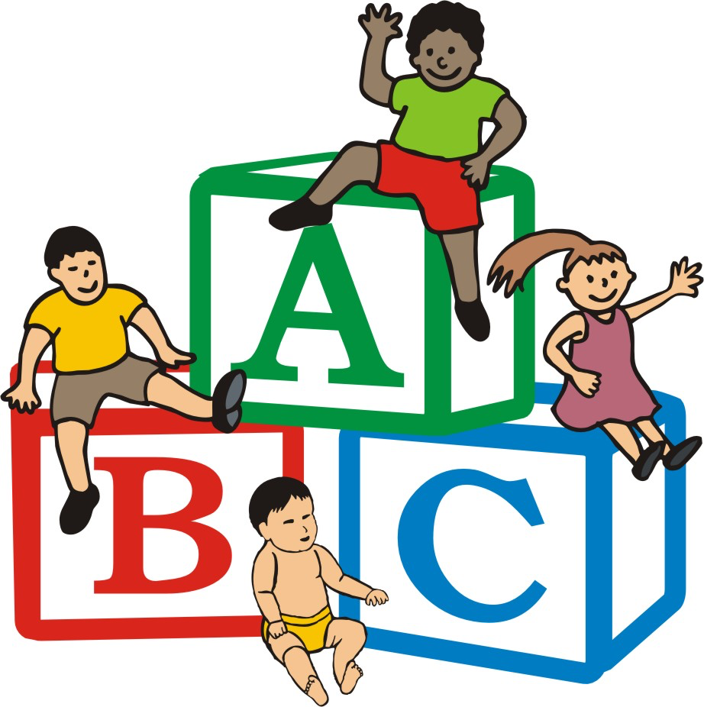
- Painting, Drawing, Sticking and Gluing
- Doing jigsaws and puzzle
- Reading and listening to stories
- Playing with the sandpit, water-table or playhouse
- Creating with construction blocks and playdough
- Singing rhymes, songs and dancing.

“Playing with blocks, jigsaws and shape sorters all lay the foundations of special thinking, logical reasoning, ordering and recognising various shapes, sizes and colours” (Sitters.co.uk, n.d.) https://www.sitters.co.uk/blog/the-15-best-activities-for-children-to-help-them-learn-through-play.aspx
These are designed to encourage your child’s social, creative, communication and listening skills and physical development.



We will be using ‘Lupilu’ brand nappies from Lidl. “They are dermatologically tested, latex free, skin-friendly and independently tested. Protecting the environment is also important, therefore the padding used is from sustainably managed forests”. (Mother&Baby, 2019).
https://www.motherandbaby.co.uk/reviews-and-shop/toiletries/disposable-nappies/lupilu-maxi-nappies-box-size-4
These nappies are cheaper than most of the famous brands, i.e. Pampers. Lupilu nappies comes at more affordable prices (pack of 24, size-1= £0.89 at Lidl), compared to famous brands like Pampers (pack of 24, size-1= 2.99 at Superdrug) which is a big price difference. By using these we will save our money and it will help us in the terms of making profit.

About food:



We will provide Cow & Gate Brand food and Heinz products. For example,
Cow & Gate Chicken Sunday Lunch 4-6+ which is 125g comes at £0.65 but when we will order 12 the price will be £6.
Cow & Gate – baby Rice Cereal 100g - £2
Cow & Gate - Growing Up Milk 3- 800g- £750
Nestle Cerelac Infant Cereal with Milk – Mixed Fruits Plus Wheat-8 months plus- £3.77
Rice Cakes – 12months plus-£2.50 (groceries.morrisons.com)
Aptamil creamed Banana Porridge – £1.87 (Boots.com)
When we will order online from Boots.com, they will take £3.50 or can give free home delivery by spending £45 or more, so if we order baby food in bulk then we can save our money to get a good profit in business.

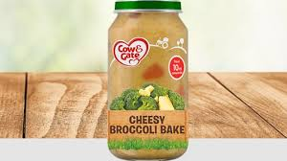



We will encourage the children to develop the habits of basic hygiene such as:
- Washing the hands after going to toilet or handling animals.
- Washing their hands with water and soap before and after eating meals or snacks.
- Not eating food that has fallen on the floor.
- Cleaning the mess made by them, immediately.



“Good hygiene is important in childcare centres to minimise the spread of infections amongst children and adults and reduce the risk of cross-contamination” (Chalak Abdulhadi, 2017).
https://www.cleanmiddleeast.ae/articles/803/safe-hygiene-in-nurseries-an-essential-requirement-of-early-child-development.html
We will be ensuring that our care provides are also implementing proper personal hygienic practices as well, for example disinfecting shared items in nursery, sanitize environment from clean toys to clean bedding, diaper changing stations and restrooms should be disinfected every time. All these will help to reduce the cross contaminations and infections in children.

Strengths:


- “Single parents are usually workers who need childcare, and there are many marriages in which both people work and are in need of day care for their children” (Mooney Lisa, 2019) https://smallbusiness.chron.com/swot-analysis-day-care-center-40710.htm
- Daycare centres offers a formal and structural environment and our care-givers are supervised every-time.
- We offers a formal and structural environment. Also we have a lot of enthusiasm and passion for children.
- We are registered with CIW (Care Inspectorate Wales) which inspects the wellbeing of children and all our staff is DBS checked, which is very important in the field of care about children and eldery people.
- Day- care centre better option for the working parents, it is affordable than hiring a nanny because a nanny can be stressful sometimes. In UK, the average cost of sending a child under two is £127 per week for time and £242 per week for full time. we are offering a very reasonable fees or price for it because it includes with baby food and nappies etc. (the Money Advice Service, 2019). https://www.moneyadviceservice.org.uk/en/articles/childcare-costs#part-time-childcare-costs
- Our day-care nursery is in Humphrey street, Swansea SA1, which is densely populated, close to city-center and Ffynony House School. This will be a plus point for our business.
- In our nursery, toddlers can benefit from the chance to be socialize with other children and parents can also have the opportunity to meet other parents and support each other when needed.
- We will have every other week check on the fire safety assessment.
- All visitors require ID before entering the nursery and need to sign the visitors book.
- We provide wide range of activities. These are designed to encourage your child’s social, creative, communication and listening skills and physical development. “An active toddler is likely to remain active later, so it is important to encourage activities both indoors and outdoors” (Olivia Foley, 2019). https://hungrycaterpillars.co.uk/six-reasons-why-you-should-send-your-child-to-nursery/
- We will help your child to develop the ability to cope with failures and learn from mistakes, all these by learning with playway manner.
- We are having an account to keep our customers updated. We will be posting different activities done by children by taking parents permission.
- “A human resourse planning aims to ensure that organisational objectives are achieved by getting the right quantity, quality and skills mix of employees at the right time” (Compton Robert, 2009). In accordance to achieve our goals and targets we would be hiring staff through different ways such as social media advertisement- Facebook, twitter, Print media advertisement, Through Job center, Through online- Indeed, Monster, Linkdin etc.
- Our staff members are usually trained. (Level-2 certificate in childcare and Education, Level-3 Diploma in Early years Education, Level-3 Diploma in Montessori Pedagogy-Birth to seven).
- “The basic demand of people springs from the organisations need to supply goods or services to its cutomers”(Cole G.A., 2004). For this we are hiring a dedicated, experienced and qualified staff, so that we satisfy our target customers means parents.
- We will know the development of your child and are able to nurture their growing skills accordingly.
- We will encourage children to eat a variety of foods including Fruits, vegetable, crackers, rice-cakes, milk, soya drinks, breads etc. because habits adopted at the toddler stage will be taken into later childhood and adult life. “Fruit and vegies give your child energy, vitamins, anti-oxidants, fibre and water. They help protect your baby against diseases later in life, including diseases like heart disease, stroke and some cancers” (Raisingchildren.net.au, 2006). https://raisingchildren.net.au/toddlers/nutrition-fitness/daily-food-guides/babies-toddlers-food-groups

- Some parents can be entitled to 30 hours a week-free childcare, depends on the income of the parents, if your child get up to 3-4 years old and parents can get child tax-credit,this will help them, we will give the leaflet to parents so that they can aware with it. (GOV.UK, 2019) https://www.gov.uk/30-hours-free-childcare

- Children under 5 years attending childcare may receive powdered infant formula, made up to 189ml a day and this will give a little contribution in the business.
- We will have an open-day for the local community to have a visit and see the facilities we offer, it will help to grow our business.
- In future we will provide staff-trainings in our nursery, Welsh Government is paying contribution of £500 for Level-1 and £1000 for level-2 in child-care.
- After achieving success we will give discount for the siblings.
- We will have every other week check on the fire safety assessment.
- All visitors require ID before entering the nursery and need to sign the visitors book.
- “Marketing consists of individual and organisational activities that facilitate and expedite satisfying exchange relationships in a dynamic environment through the creation, distribution, promotion and pricing of goods, services and ideas” (Chaffey Dave. et al., 2000).

In accordance to this we will be advertising on Facebook, twitter, Radio, posting flyers and through our own website. We will be doing online survey to get the opinion from parents about our services so that we know our strenghs and work on our weaknesses, we will be doing all these through online questionnaires, its less time consuming rather than the face to face surveys and parents will be more happy to spend few minutes to fill them as they are buisy in their life and jobs. Through all these promotion activities we can easily reach our customers.

“Marketing in its puriest sense offers a mechanism that facilitites uderstanding, communication and the development of product as solutions to actual customer needs” (Drummond Grueme, 2005). Running a business means we always needs to think about the 7ps, which are presenting down below with the picture.

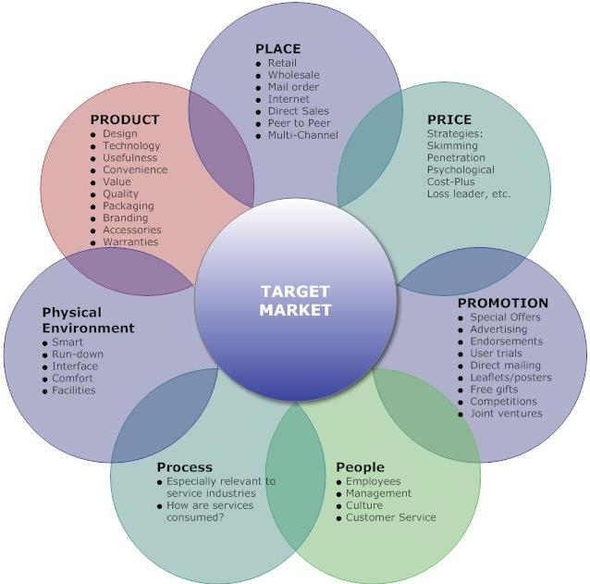

Weaknesses:



- One of the main weaknesses is parents’ fear of catching diseases such as a cold because their child will be in other children’s contact.
- Parents fear about not getting ‘one to one care’, they get from, at-home nanny or mom.
- The quality of care dips when a person has to watch over too many children but we offers the teacher-children ratio, as low as possible.
- Sometimes, the fear of another day-care nursery which may open near offering the services at very low cost.
- The threat could be from the companies that offers in-house child care and parents belongs to high society may be more happier to pay extra money for their service.
- There is also the risk of high employee turnover and difficulties in finding qualified staff members in the future, when the business will grow.
- Start-up costs can be high, as they include a building insurance, furniture, supplies and marketting budget and if we will not get enough children, it will be hard to survive. (Mooney Lisa, 2019) https://smallbusiness.chron.com/swot-analysis-day-care-center-40710.html

- Chance of decreasing in the amount of profit, resulting in the downgrading of this business.
- Sometimes, difficulties in finding the premises can be a problem.
- Chaotic environment of running the business can be stressful. It means if the staff is not efficient, have no idea about the childcare, and can’t perform the duties properly, in that case it will be harmful for the business as well.
- Starting a day-care business can be challenging and may require big amount of money.
- The maintenance of the nusery can be expensive with repairs, painting, replacement of furniture and other supplies.

References:

Nursery Milk Scheme (2019) About The Nursery Milk Scheme [Online] Available at:
https://www.nurserymilk.co.uk/about-nursery-milk-scheme (Accessed: 24 October 2019)

Best Practice Guidance (n.d.) Food & Nutrition for Childcare Settings [Online] Available at: https://gov.wales/sites/default/files/publications/2019-03/190313-nutrition-guidance-complete.pdf (Accessed: 22 October 2019)

Chaffey Dave. et al. (2000) Internet Marketing Strategy, Implementation and Practice. 3rd edition. England: Pearson Education Limited. Pg-9.
Chalak, Abdulhadi (2017) Safe Hygiene in Nurseries: an essential requirement of early child development [Online] available at: https://www.cleanmiddleeast.ae/articles/803/safe-hygiene-in-nurseries-an-essential-requirement-of-early-child-development.html
(Accessed: 13 November 2019)

Cole G.A. (2004) Management Theory and Practice. 6th edition. London: Thomson. Pg.- 169.

Compton Robert, Morrissey William and Nankervis Alan (2009) Effective Recruitment and selection Practices. 5th Edition. Australia: CCH Australia Limited. Pg.-1.
Foley, Olivia (2014) Six reasons why you should send your child to nursery [Online] available at: https://hungrycaterpillars.co.uk/six-reasons-why-you-should-send-your-child-to-nursery/ (Accessed: 25 October 2019)

GOV.UK (2019) 30 hours free childcare [Online] Available at: https://www.gov.uk/30-hours-free-childcare (Accessed: 24 October 2019)

Drummond Grueme, Ensor John (2005) Introduction to Marketing Concepts. Chennai, India:Newgen Imaging Systems (P) Ltd. Pg.-1.

Mooney, Lisa (2019) SWOT Analysis for a Day Care Center [Online] Available at:
https://smallbusiness.chron.com/swot-analysis-day-care-center-40710.html (Accessed: 24 October 2019)

Mother&Baby (2019) Lupilu Maxi Nappies Box, size 4 Review [Online] available at:

https://www.motherandbaby.co.uk/reviews-and-shop/toiletries/disposable-nappies/lupilu-maxi-nappies-box-size-4 (Accessed: 14 November 2019)

Raisingchildren.net.au (2006) Healthy food for babies and toddlers: the five food groups [Online] available at: https://raisingchildren.net.au/toddlers/nutrition-fitness/daily-food-guides/babies-toddlers-food-groups (Accessed: 14 November 2019)

Sitters.co.uk (n.d.) The 15 Best Activities for Children to Help Them Learn Through Play [online] available at: https://www.sitters.co.uk/blog/the-15-best-activities-for-children-to-help-them-learn-through-play.aspx (Accessed: 13 November 2019)

the Money Advice service (2019) Average childcare cost [Online] available at:
https://www.moneyadviceservice.org.uk/en/articles/childcare-costs#part-time-childcare-costs (Accessed: 3 November 2019)

: the five food groups

