Title: A Study of employees’ intention to use artificial intelligence in Hong Kong workplace

University of Wales Trinity Saint David – MBA
Name: HO Chit Chi
Student Number: 2337376

Declaration/Statements page

DECLARATION

This work has not previously been accepted in substance for any degree and is not being concurrently submitted in candidature for any degree.

HO CHIT CHI
Signed ...................................................................... (candidate)
16/11/2025
Date ........................................................................

STATEMENT 1

This work is the result of my own investigations, except where otherwise stated.

Other sources are acknowledged by footnotes giving explicit references.
A bibliography is appended.

HO CHIT CHI
Signed ..................................................................... (candidate)
16/11/2025
Date ........................................................................

STATEMENT 2

I hereby give consent for my work, if accepted, to be available for photocopying and for inter-library loan, and for the title and summary to be made available to outside organisations.

HO CHIT CHI
Signed ..................................................................... (candidate)
16/11/2025
Date ........................................................................

NB: Candidates on whose behalf a bar on access has been approved by the University (see Note1), should use the following version of Statement 2:
I hereby give consent for my work, if accepted, to be available for photocopying and for inter-library loan after expiry of a bar on access approved by the University.
HO CHIT CHI
Signed ..................................................................... (candidate)
16/11/2025
Date ........................................................................

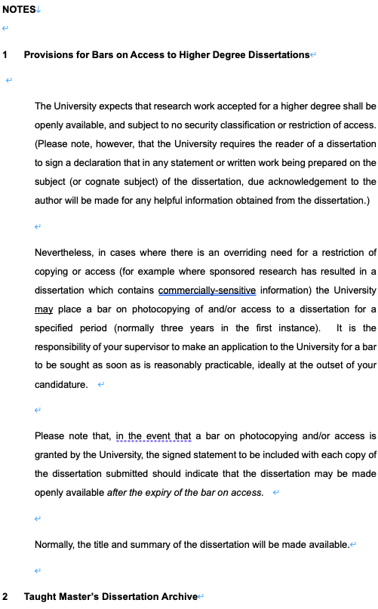
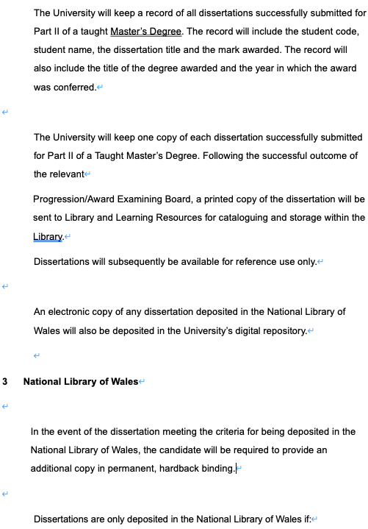

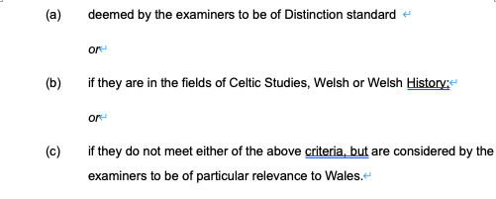

Research Background: Artificial intelligence adoption is accelerating in Hong Kong workplaces, yet employees' intentions to use AI and the factors shaping adoption behavior remain underexplored. Understanding these determinants is critical for effective organizational AI implementation and equitable workforce transitions.
Abstract

Purpose: This study investigates factors influencing Hong Kong employees' intentions to use AI, examining how perceived ease of use, perceived usefulness, threat in employment, and perceived trust predict adoption intentions across demographic groups including age, gender, job function, job level, and academic qualifications.
Methods: An online survey of 168 employed workers in Hong Kong was conducted between July and August 2025, measuring five key constructs using five-point Likert scales. Data analysis employed SPSS 31 for correlation, multiple regression, ANOVA, and t-tests. Cronbach's alpha of 0.914 confirmed reliability across all scales.
Findings: perceived usefulness was the strongest predictor of employees’ intentions to adopt AI in Hong Kong workplaces, followed by threat in employment, perceived trust, and perceived ease of use, with significant influences from demographic factors such as education, job level, and function.
Conclusions and Recommendations: The conclusions emphasize the importance of demonstrating AI’s tangible benefits, addressing employees’ concerns about job security, and fostering trust to facilitate adoption. Recommendations propose tailored organizational strategies focusing on comprehensive training, transparent communication about AI’s role and impact, proactive reskilling initiatives, and trust-building mechanisms to ensure equitable and effective AI integration.
Limitations and Further Research: Cross-sectional design, geographic focus on Hong Kong, reliance on self-reported intentions, and snowball sampling limit generalizability. Future research should employ longitudinal designs, conduct cross-cultural comparisons, investigate specific AI technologies, explore psychological mechanisms qualitatively, and track actual usage behavior.
Keywords: Perceived Ease of Use, Perceived Usefulness, Threat in Employment, Perceived Trust, Intention to Use
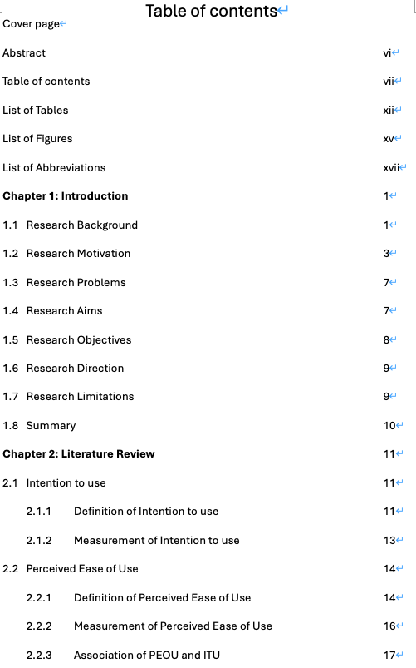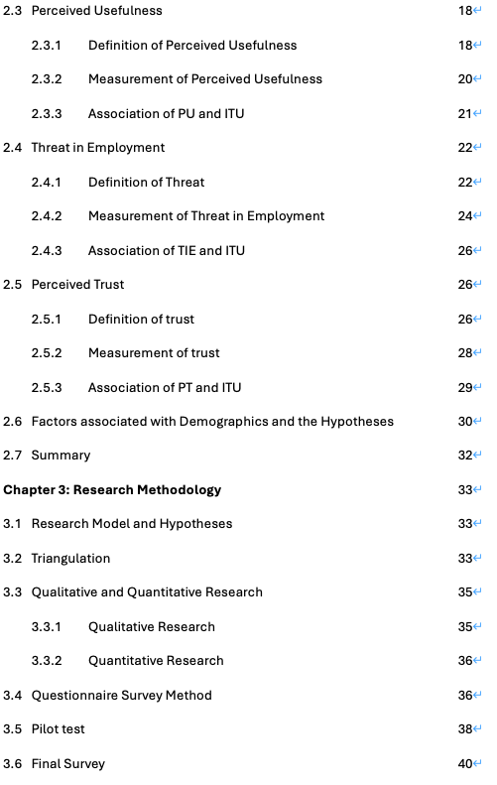
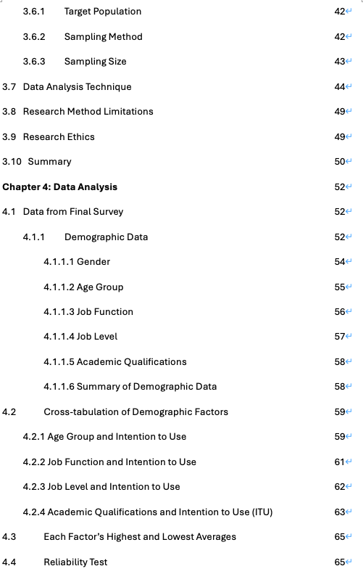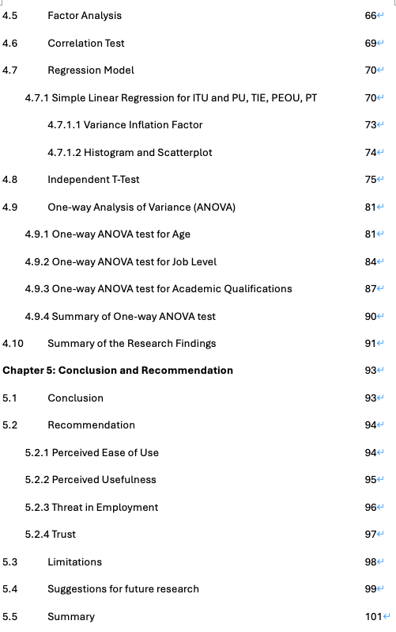
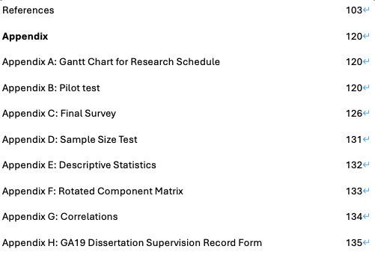

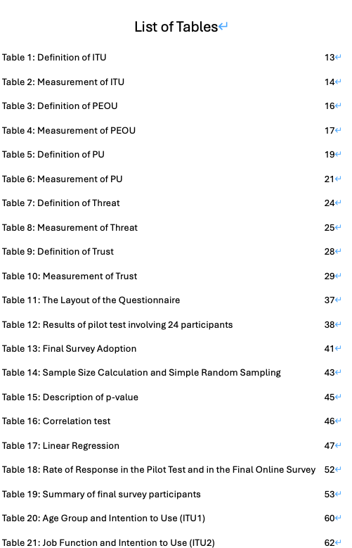
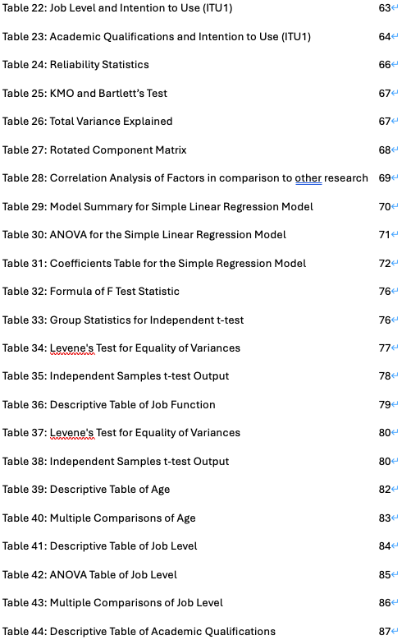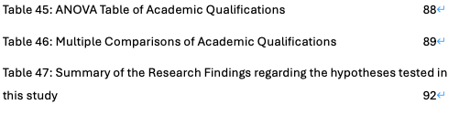
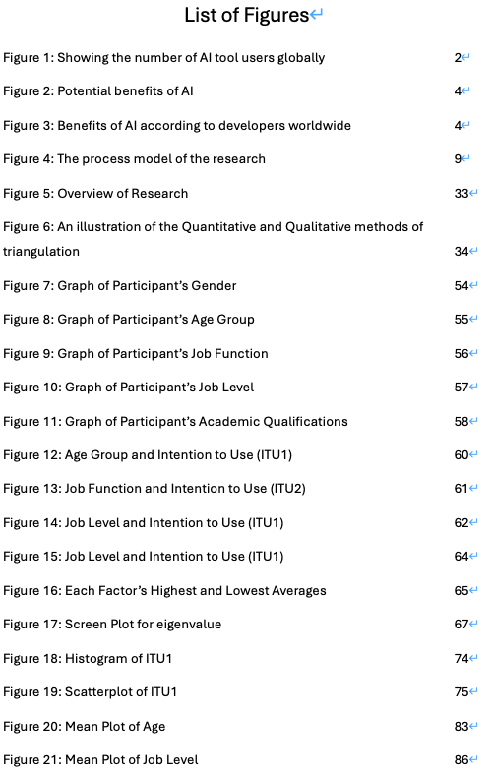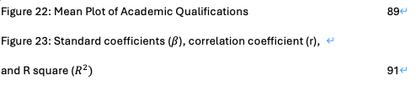

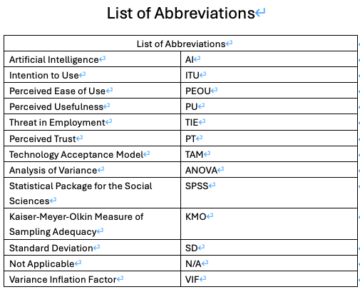
Chapter 1: Introduction
This chapter explains the primary objective of this study. A description of the theoretical framework is presented as the first step. Furthermore, the motivation of this study is shown in terms of redesigned strategies, marketing, and the impact of AI trend. Discussed why this topic has been selected for study and the relevance of this study’s conclusion. The study’s objectives and limitations are also outlined.

1.1 Research Background
Living in the year of 2025, we are many benefited from AI development. The AI trend booms in 2024 when the announcement of several AI channels, especially CHATGPT. It brought the world’s technology development history to a next level.

This AI trend affects every industry in the world. A McKinsey global survey reports that 78% of organizations worldwide used AI in at least one business function in 2024, a sharp rise from 55% the previous year, with generative AI adoption reaching 71% of organizations. AI is most prevalent in IT, marketing, sales, product development, and service operations, demonstrating broad cross-sector integration (McKinsey, 2025). Additionally, referring to figure 1 that the global number of AI tools users in the 'AI Tool Users' segment of the artificial intelligence market was forecast to continuously increase between 2021 and 2031 and the number of AI tools users is estimated to reach 1.2 billion in 2031 (Statista, 2025).It shows that AI is important and increasing number of people globally are learning to adopt AI in normal life and workplace.

Figure 1: Showing the number of AI tool users globally
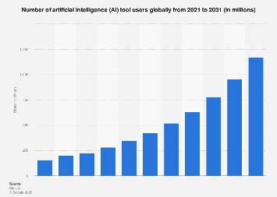
Source: Statista (2023)

In Terms of Hong Kong, AI adoption in Hong Kong has accelerated significantly across multiple sectors in 2024 and 2025. The Generative AI market has demands for AI-powered chatbots, virtual assistants, and personalized content generation, these are used for better efficiency, personalized customer service and marketing strategies. This preference is driven by the fast-paced lifestyle and high expectations for convenience in Hong Kong's culture. These trends of AI are expected to continue, with more and more industries trying to adopt AI into workplace, from office to frontline and manufacturing line.

A study by the Hong Kong Institute for Monetary and Financial Research (HKIMR) found that in 2024, 75% of financial institutions in Hong Kong had implemented, piloted, or explored generative AI use cases, a significant rise from 38% in 2023. This adoption rate is expected to increase to 87% within three to five years (Fintech News, 2025). Furthermore, The Generative AI segment alone is expected to reach US$517.51 million in 2025, driven by demand for AI-powered virtual assistants, chatbots, and collaboration tools that cater to Hong Kong's fast-paced lifestyle and preference for personalized, efficient services (Statista, 2025).

1.2 Research Motivation
People are well-benefited by the AI development. AI assistants such as APPLE SIRI and SAMSUNG BIXBY before the AI Boom, indeed it was limited in information searching, IOT switching, and functions used on the mobile device. However, using AI in image processing, researching, programming, machine learning and more nowadays. Works which takes hours or even days in the past may only cost only minutes nowadays.

With the assistance of AI tools, people do work with a faster speed, better efficiency, more accurate and more comfortable. In terms of being a student, students in the past have to find references for their assignments from the internet search engines or even physical books in the library, which took from days to weeks. AI tools helps students proofread articles, researching and generate graphics just in minutes, which reduces their workload and time wasted. In terms of being a marketer in workplace, marketers may need to produce promotion materials such as social media post, leaflets, banners, advertising videos by design software or outsource service. These could either take quite lots of time or expense in marketing. However, marketing materials could be created by AI which reduces workload and money. Other than that, AI could be used to assist daily work. According to a survey by AIPRM (Figure 2) asking the potential benefits of AI, 19.6% of the respondents agrees that AI helps increase sales, 30.9% agrees that AI helps streamline job processes, 43.1% agrees that AI increase productivity (AIPRM, 2025). Additionally, according to a survey by Statista (Figure 3), worldwide developers agrees that AI brought benefits. 81% of interviewees agrees that AI increases productivity, 62.4% agrees that AI speed up learning, 58.5% agrees that AI greater efficiency.

Figure 2: Potential benefits of AI
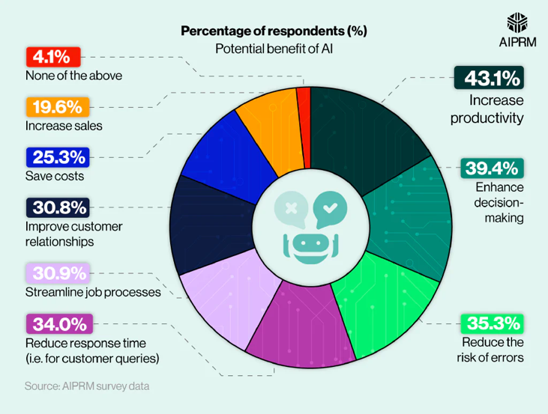
Source: AIPRM

Figure 3: Benefits of AI according to developers worldwide
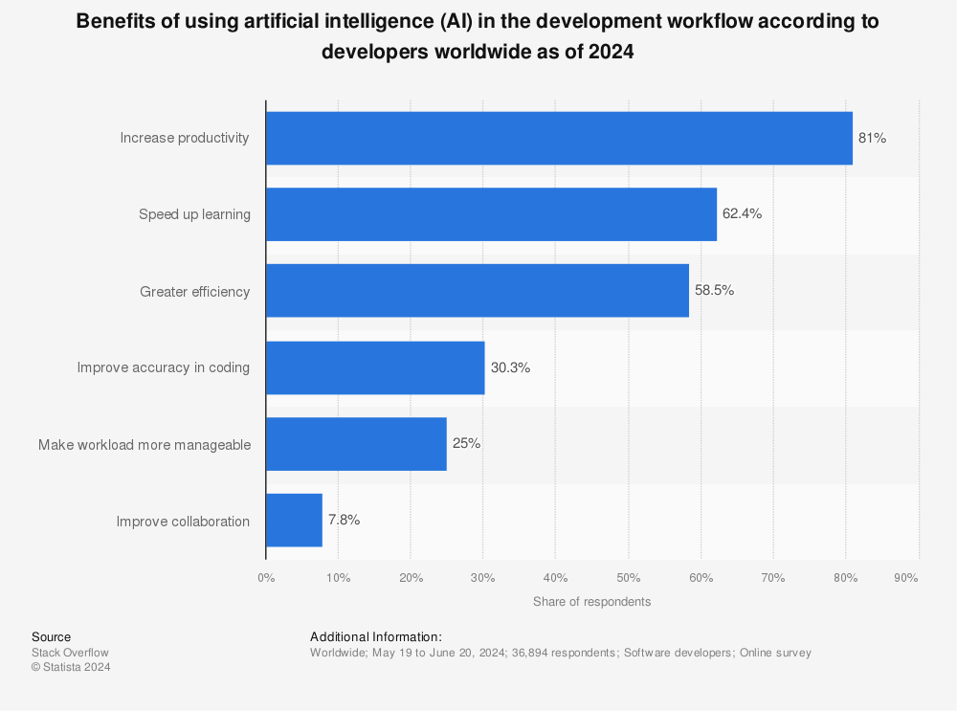
Source: Statista
Showing the usefulness of AI tools, people started to use AI tools to support daily work. A survey of 1,000 knowledge workers in Hong Kong found that 86% admit to bringing own AI tools to work, indicating widespread personal familiarity with AI applications (China Daily HK, 2025). Despite high usage, according to personal knowledge that over 90% of the people didn’t make good use and full potential of the AI tools, their knowledge and usage of the AI tools remain in basic workload, majorly in copywriting. Also, 40% of enterprises believe their employees are not proficient in using AI tools, highlighting a significant skills gap and the need for more training (HKPC Digital Transformation, 2024). It shows that there’s a need for employees to learn AI tools in order to follow up with the fast paced workplace, the change in technology and also prevent being replaced by AI.

Also, companies started to adopt AI tools in company operation and recruitment consideration. A McKinsey global survey reports that 78% of organizations worldwide used AI in at least one business function in 2024. AI is most prevalent in IT, marketing, sales, product development, and service operations, demonstrating broad cross-sector integration (McKinsey, 2025). A survey of 1,000 knowledge workers in Hong Kong found that 77% of business leaders prefer hiring less experienced candidates with AI skills over more experienced ones without them, highlighting the growing premium on AI competencies (China Daily HK, 2025). It shows that AI become an important tool or even a MUST-ability in workplace recruitment.

Furthermore, AI will affect people’s jobs and may replace job posts and duties in the future. According to an IMF article, AI will affect almost 40 percent of the jobs around the world, by replacing some while creating some new jobs, such as AI content monitoring and AI system maintenance (IMF, 2024). Also, according to a recent report from Microsoft, analyzing Microsoft Copilot and 200 thousand unnamed users’ conversations about the influence from AI, there are 40 kinds of jobs that are very easily being replaced by AI, such as customer service, sales representative, copywriter, interpreter, clerk, reporter, data analyst, teachers, website developers, models, promoters, etc. On the other hand, there are 20 kinds of jobs that are difficult to be replaced by AI, such as hospital healthcare workers, construction workers, Logging Equipment Operators, Pile Driver Operators, etc. (Microsoft, 2024). According to an OECD survey last year, three out of five workers fear that they could lose their job to AI over the next 10 years. The survey covered 5,300 workers in 2,000 firms spanning manufacturing and finance across seven OECD countries, showing that many jobs are easily replaced, especially jobs working in Backoffice and without manual labor, giving out the message of potential threats of AI (OECD, 2024).

However, not all replacement by AI is bad. According to an article by Job Market Monitor, owing to capital deepening and a productivity surge, AI adoption is expected to boost total income. If AI strongly complements human labor in certain occupations and the productivity gains are sufficiently large, higher growth and labor demand could more than compensate for the partial replacement of labor tasks by AI, and incomes could increase along most of the income distribution (Job Market Monitor, 2024). Indeed, college-educated and younger generation workers are easier to shift to AI-driven jobs than the older workers. According to the article, college-educated individuals in UK and Brazil moved more easily from jobs that are potentially high displacement to those with high complementarity. Also, younger workers are more adaptable and familiar with new technologies, which leads to better adoption. In contrast, older and fewer-educated workers may struggle with reemployment and new technology adoption. Therefore, it is crucial and important to face AI in the workplace (Job Market Monitor, 2024).

Other than that, AI is widely used in training to reduce the cost, time and manpower. In the past, company used to buy facilities, equipments, recruit professionals and site visits for trainings especially for safety, equipment operators, designing and broadcasting industries, etc. Nowadays, people could perform training in single location with the support of AI, headset and screens. AI could provide recorded training, updated information and scenarios which leading to higher efficiency, lower cost but better accuracy and wider analysis on the training.

Therefore, this study would be showing the usefulness of AI tools, how people could benefit from the AI tools.

1.3 Research Problems
It is important to identify the research problems, which leads to the expansion of the study. This serves as the main guiding principle throughout the whole research process. A topic of study is discussed as a hypothesis in sociology. Therefore, the question is relevant as a study topic (Pardede, 2018).

This research examines the following research problems:
- Should AI tools be used in Hong Kong workplace? Does it create any problems for either the employee or the company?
- Does people agree AI tools is useful? How does AI tools help people in Hong Kong workplace?
- How does AI affect people in Hong Kong workplace? Would their working position be replaced by AI?
- Does AI a MUST-ability in Hong Kong workplace? Is it important for employees to learn to use AI tools in workplace?

1.4 Research Aim
Mentioned with the AI Boom in 2024, AI become a significant and important tool for employees and companies. AI tools are applied to different industry to achieve automation and unmanned operation. Also, people use AI tools in workplace. Indeed, most of the people uses AI tools only for copywriting work. Many people didn’t know how to make good use and full potential of the AI tools.

This study could provide insight for companies and employees the importance and advantages of using AI in the workplace of Hong Kong. People could understand applying AI in their workplace could help save time, workload, manpower and money. Additionally, this study could provide insight for employees to realize the threat that AI may possibly replace people’s working position. Also, this encourages employees to learn using AI tools to be equipped in workplace of Hong Kong and also increase the intention of using AI.

1.5 Research Objectives
This study identifies problems, finds information and evaluates alternatives. It helps to examine the factors such as Perceived Ease of Use, Perceived Usefulness, Threat in Employment, Perceived Trust and to setup measurement models, leading to finding people’s usage of AI tools, determine the usefulness of AI and the treat of AI in Hong Kong workplace.

The study shows step by step about this followed by triangulation, questionnaire and research, asking employees how often and the usage of AI tools in Hong Kong workplace. Firstly, the study defined the meaning, background, measurement and association of the main components. It paths how the questionnaire could get accurate data from recipients. The questionnaire reflected the importance of AI in workplace and consideration of AI’s threats. Also, references are used to support the statements. Furthermore, SPSS is used to analysis and test pilot test and questionnaire data.

Other than encouraging people to use and learn AI, this study could showcase high level managements in company the benefits that AI could bring to the company and encourage them to adopt AI into workplace in Hong Kong.

1.6 Research Direction
This research could raise people’s awareness in AI by understanding the importance of AI and the potential threat to people in workplace. It would be a good tool to encourage people to be equipped with AI abilities. Every industry or businesses may involve AI locally and globally. People equipped with AI abilities may help them increase their working effectiveness and also avoid being eliminated.

This study is organized methodically, as shown in Figure 4. Firstly, literature reviews were conducted to go through the factors in details. Secondly, the gathered information was presented and explained in details. Furthermore, the findings and conclusion of the study were reported. The research started from May 2025 and ended in November 2025, as shown in Appendix A through the process and stages of the research.

Figure 4: The process model of the research
Conclusion & Recommendation
Result & Data Analysis
Research Methodology
Literature Review
Introduction

1.7 Research Limitations
This study has several limitations that should be acknowledged. Firstly, the rapid development and evolution of AI technologies mean that findings may quickly become outdated as new tools and applications emerge. Secondly, the research primarily focuses on the perspectives and experiences of employees and companies within Hong Kong, which may limit the generalizability of results to other regions or industries with different levels of AI adoption. Lastly, constraints in time and resources may limit the scope of the study, restricting deeper exploration of certain industries or more extensive longitudinal data collection.

1.8 Summary
AI become an important tool in workplace. However, not many of people really uses AI in workplace or knows how to make good use of the AI tools. Furthermore, it may help in workplace but also harm people’s job by being replaced by AI. Therefore, the study is to examine the needs and situation by factors including Perceived Ease of Use, Perceived Usefulness, and Threat in Employment. This study employs qualitative and quantitative methods to examine the situation. Despite with limitations, such as quick development leading to outdated tools or data, the coverage of surveys mainly covering Hong Kong not overseas, etc. This study still provides valuable insights for people in workplace about the importance of AI.

Chapter 2: Literature Review
The literature review shows if the questionnaires, research and information aways from the path of the research. It guides study design and research methods development. This chapter presents the definition of the factors, including Perceived Ease of Use, Perceived Usefulness, and Threat in Employment.
2.1 Intention to use
Intention to use (ITU) is described in the below sections, including the definition of ITU and how to measure the ITU in the analysis, research and questionnaires.

2.1.1 Definition of Intention to use
Intent to use refers to an individual's behavioral intention or willingness to engage with and employ AI technologies in their activities, often measured as a predictor of actual technology adoption. This concept is widely studied within frameworks like the Unified Theory of Acceptance and Use of Technology (UTAUT), which integrates key determinants such as performance expectancy, effort expectancy, social influence, and facilitating conditions to explain user intentions.

According to other definitions of ITU, referring to Table 1 that the research by Riikkinen and colleagues discusses how artificial intelligence supports value creation for customers and Riikkinen (2018) stated that ITU is to create value. Li, Bonn & Ye (2019) stated the AI will become more affordable, faster and far more reliable then humans. Chiu, Zhu & Corbett (2021) stated that many perceived benefits surround AI. Faasolo & Sumarliah (2022) stated that AI lessen cost and maintain competitiveness. Zhao (2022) stated that information user enterprise operation and management in making decisions tend to be flooded by all kinds of different types of information and no decision or choice.

People use artificial intelligence (AI) on the internet for numerous reasons, largely driven by the technology's ability to improve efficiency, provide personalized experiences, assist with complex decision-making, and access vast amounts of information quickly. AI-powered tools such as chatbots, recommendation algorithms, and virtual assistants have become integral in enhancing user interactions by tailoring content based on individual preferences and behaviors, thereby making online experiences more relevant and engaging (European Parliament, 2023). Additionally, AI helps in automating routine tasks like proofreading, editing, and organizing information, which reduces cognitive load and saves time for users, particularly researchers and professionals who face large volumes of data (Wiley Survey, 2025).

Many users also rely on AI for problem-solving support, such as generating ideas, answering inquiries, or providing second opinions in specialized fields like medicine and law, extending human capabilities in these areas (Mollick, 2025). Furthermore, AI contributes to security enhancements online by detecting patterns indicative of fraud or cybersecurity threats, instilling a level of trust and safety in digital environments (European Parliament, 2023). The frequent interaction with AI-enabled services is also associated with increasing awareness and familiarity, as people who use the internet more often are likelier to recognize and utilize AI functionalities in daily life, from shopping to entertainment (Pew Research Center, 2023). Altogether, the convergence of personalization, efficiency, assistance, and security makes AI an indispensable technology driving internet use today.

Table 1: Definition of ITU
Researchers | Definition
Riikkinen et al., 2018 | Create Value
Li, Bonn & Ye, 2019 | AI and intelligent robots will become more affordable, faster, and far more reliable than humans
Chiu, Zhu & Corbett 2021 | Many perceived benefits surround AI
Faasolo & Sumarliah, 2022 | Lessen cost and maintain competitiveness
Zhao, 2022 | Information user enterprise operation and management in making decisions tend to be flooded by all kinds of different types of information and no decision or choice
Source: Created by Author

2.2.2 Measurement of Intention to use
People use artificial intelligence (AI) on the internet for numerous reasons, largely driven by the technology's ability to improve efficiency, provide personalized experiences, assist with complex decision-making, and access vast amounts of information quickly.

Regarding the measurement of ITU, referring to Table 2 that Teo & Noyes (2011) stated that user will use AI more often in the future. Gursoy (2020) stated that user will expect to continue using AI in the future and will recommend others to use AI. Cao (2021) stated that users will always try to use AI in user’s workplace. Also, user will use in the future frequently. Ronaghi (2022) stated that user will plan to use AI in the future. Pal (2022) stated that user will expect to continue using AI in the future.

Table 2: Measurement of ITU
Researchers | Measurement
Teo & Noyes, 2011 | - I will use AI in the future.  - I plan to use the AI often.
Gursoy, et al., 2020. | -I expect to continue using AI in the future  -I will recommend others to use AI
Cao, et al., 2021 | -I intend to use AI in the future  -I will always try to use AI in my workplace  -I plan to use AI frequently
Ronaghi, 2022 | -I plan to use the AI technology in the future.  -I intend to use the AI technology in the future.
Pal et al., 2022 | -I expect to continue using AI in the future
Source: Created by Author

2.2 Perceived Ease of Use
Perceived ease of use (PEOU) is described in the below sections, including the definition of PEOU and how to measure the PEOU in the analysis, research and questionnaires.

2.2.1 Definition of Perceived Ease of Use
Perceived ease of use (PEOU) is generally defined as the degree to which an individual believes that using a particular technology would be free from effort (Davis, 1989). In other words, the using process should be easy and effortless for users without seeking help. This also matches the definition mentioned by Esfahbodi in 2022 which a user believes that a specific technology or system requires less efforts from users (Esfahbodi, Pang and Peng, 2022).

This concept is a core component of the Technology Acceptance Model (TAM) and showing users’ attitudes toward using new technology and the intention to use it. Users are more likely to adopt technology when the technology or system is easy to use, to extent that people will have more intention, reduce resistance and also more frequently to use it (Davis, 1989; Venkatesh and Davis, 2000).

Regarding other references of the PEOU’s definition, referring to Table 3 that Teo & Noyes (2011) stated that PEOU means its easy to let the technology do what the user want to do. Sohn & Kwon (2020) stated that PEOU means using product would be easy. Last but not least, Jo (2022) stated that PEOU is that using a particular system would be free of effort. Islam, M.S., (2024) stated that PEOU is that less effort is needed to interact with the apps. These also pointed out the components or special points of PEOU.

According to a study on generative AI tools, found out that perceived ease of use affects user’s intention to adopt AI and new technologies. Users with higher self-efficacy and technological innovativeness stated to have easier use in AI tools (Kim, 2025). Additionally, a dataset on behavioral intention to use AI Copilot reflected that perceived ease of use is a critical factor influencing positive intention towards AI usage in educational environments (Villaceran, 2025). A global study by the University of Melbourne and KPMG (2025) stated that two in three people intentionally use AI regularly, and three in five say they can use AI effectively, indicating moderate perceived ease of use. It shows that most of the people consider that AI is easy and effortless to use. Indeed, 61% had no formal AI training and half reported limited knowledge. It shows that people could use AI in basic ways (such as translation and searching information) easily although users didn’t receive training, proving the ease of use.

Table 3: Definition of PEOU
Researchers | Definition
Davis, 1989 | Using technology would be free from effort
Teo & Noyes, 2011 | easy to let the technology do what I want it to do
Sohn & Kwon, 2020 | Using Product would be easy
Esfahbodi, Pang and Peng, 2022 | which a user believes that a specific technology or system requires less efforts from  users
Jo, 2022 | that using a particular system would be free of effort
Islam, 2024 | The basis of customer judgments about the effort needed to interact with apps
Source: Created by Author

2.2.2 Measurement of Perceived Ease of Use
PEOU is one of the main element that keeps people to start using AI and continuously using AI afterwards. The measurement of Perceived Ease of Use (PEOU) commonly follows frameworks derived from the Technology Acceptance Model (TAM) by Davis (1989).

Regarding the measurement of PEOU, referring to Table 4 that easy to use is the main element within the measurement. Users are more likely to adopt technology when the technology or system is easy to use, to extent that people will have more intention, reduce resistance and also more frequently to use it (Davis, 1989; Venkatesh and Davis, 2000). Furthermore, many stated that user will eager to use AI if the interaction between AI and the user is clear and understandable (Davis, 1989; Teo, 2011; Gursoy, 2020; Lenz, 2023). The use of AI will continue once the communication between two side is smooth and user is satisfied with the respond of AI. Additionally, people will use AI if does not require a lot of mental effort as the AI could easily get what the users wants it to do (Gursoy, 2020). This increases the confidence of the user and eager to learn and discover more potential of AI.

Table 4: Measurement of PEOU
Researchers | Measurement
Davis et al., 1989 | -Interaction between users and the system is clear and easy to understand  -The system is easy to use or operate  -It is easy to get the system to do what I want
Teo & Noyes, 2011 | -User will find it easy to get AI to do what user wants it to do  -User will find the AI easy to use  - User’s interaction with the AI is clear and understandable.
Gursoy et al., 2020 | -User’s interaction with the AI is clear and understandable.  -Interaction with the AI does not require a lot of mental effort  -User will find the AI easy to use
Lenz et al., 2023 | -User’s interactions with AI would be clear and easy to understand  -User will find the AI easy to use  -User will find easy to become skilled at using AI
Islam, 2024 | -User would have no trouble learning how to use  -User would have no trouble to accomplish what would like to enquire  -User would be simple to become skillful
Source: Created by Author

2.2.3 Association of PEOU and ITU
Based on the previous journals showing that Ease of Use is one of the significant factors that leading to better intention to use of user. Studies focusing on the Hong Kong workplace have shown that PEOU positively affects ITU and behavioral intention. In the context of the Hong Kong workplace, empirical studies support that PEOU positively affects ITU, suggesting that employees are more inclined to adopt technologies perceived as user-friendly, ultimately enhancing workplace efficiency and acceptance (Lee, 2010; arXiv, 2024).
H1: PEOU and ITU have a positive relationship in Hong Kong Workplace.

2.3 Perceived Usefulness
Perceived usefulness (PU) is described in the below sections, including the definition of PU and how to measure the PU in the analysis, research and questionnaires.

2.3.1 Definition of Perceived Usefulness
According to Table 5, Perceived Usefulness (PU) is generally defined as the degree to which a person believes that using a particular technology would enhance their job performance (Davis, 1989). In other words, user will use the technology if it helps the user, meet users’ needs and execute tasks efficiently.

According other definitions of PU, Bhattacherjee (2001) stated that PU represents the user’s belief that using a technology will enhance user’s experience. Teo and Noyes (2011) stated that PU is that people finds the technology improves user’s performance and enhances user’s working effectiveness. Esfahbodi (2022) stated that PU is which a user believes that using a specific technology or system will improve his/her job performance. Ronaghi (2022) stated that PU is a degree of improved performance of the user after using technology. Khuong and An (2025) stated that PU reflects the degree to which consumers view providing helpful and valuable information that supports user’s decision-making process.

According to a survey by ActivTrak (2025), found that AI is used by 58% of employees, doubling since 2022, and though productivity gains are real, they require careful integration to avoid distractions and longer workdays. AI enhances productivity but needs intentional management for best outcomes (ActivTrak, 2025). This shows that AI is useful, and it enhances productivity. Archie (2025) found 72% of companies heavily using AI report high productivity, while 75% of knowledge workers say AI helps them save time, focus better, and boost creativity. Satisfaction at work also increased by 59% in these companies (Archie, 2025). This shows that most workers find AI useful in workplace, which AI saves time and boost working performance. McKinsey (2025) estimates AI’s long-term opportunity could add $4.4 trillion in productivity growth, highlighting its transformative potential on workflows and work processes (McKinsey, 2025). This shows that AI is useful for increasing productivity and high potential in the future.

Table 5: Definition of PU
Researchers | Definition
Davis, 1989 | person believes that using a particular technology would enhance their job performance
Bhattacherjee, 2001 | represent the users’ belief that using a technology will enhance their experience
Teo & Noyes, 2011 | Improves performance, enhances effectiveness
Esfahbodi, et al., 2022 | which a user believes that using a specific technology or system will improve his/her job performance
Ronaghi, 2022 | Degree of improved performance of the user after using technology
Khuong, 2025 | reflects the degree to which consumers view advertisements providing helpful and valuable information that supports their decision-making process
Source: Created by Author

2.3.2 Measurement of Perceived Usefulness
Perceived Usefulness (PU) is another central construct in the Technology Acceptance Model (TAM) and it reflects the degree to which a user believes that using a particular system or technology will enhance their job performance or task effectiveness. PU is usually assessing user’s beliefs about the benefits and effectiveness of technology in improving their work outcomes.

Regarding the measurement of PU, referring to table 6 that PU is typically measured through multiple Likert-scale items that assess the extent to which users believe the technology is beneficial, improves their productivity, or assists in completing tasks more effectively. Teo and Noyes (2011) stated that using AI will improve user’s work, effectiveness and working productivity. Esfahbodi (2022) stated that using AI enhanced user’s effectiveness and improves working performance. Ronaghi (2022) stated that using AI enables the user to accomplish tasks more quickly and effectively, also Ronaghi stated using AI saves user’s time. Lenz (2023) stated that using Ai would help user to accomplish tasks more quickly and improve user’s chances of achieving important things. Khuong (2023) stated that AI saves user’s time, improve working efficiency and enhances the quality of user’s experience.

Table 6: Measurement of PU
Researchers | Measurement
Teo & Noyes, 2011 | -Using AI will improve user’s work  -Using AI will enhance user’s effectiveness  -Using AI will increase user’s productivity
Esfahbodi, et al., 2022 | -Using AI enhances user’s effectiveness  -Using AI improves working performance
Ronaghi, 2022 | -Using AI enables the user to accomplish tasks more quickly  -Using AI enhances user’s task effectiveness  -Using AI saves user’s time and effort in performing tasks.
Lenz, et al., 2023 | -Using AI would help user to accomplish things more quickly  -Using AI would improve user’s chances of achieving things they found important
Khuong, 2025 | -AI saves user’s time  -AI helps user improve their efficiency  -AI enhances the quality of user’s experience
Source: Created by Author

2.3.3 Association of PU and ITU
Based on the previous journals showing that Usefulness is one of the significant factors that leading to better intention to use of user. This concept is also linked to the Technology Acceptance Model (TAM), which posits that higher perceived usefulness leads to a more positive attitude toward using the technology and a stronger intention to adopt it. Numerous empirical studies support this relationship, showing that PU has the strongest effect size in predicting ITU across varied organizational contexts (Venkatesh & Bala, 2008; Davis, 1993). For instance, in the context of workplace AI, higher PU correlates with increased motivation to adopt AI tools that enhance productivity, accuracy, or job effectiveness (Tao, 2008). Moreover, TAM research highlights that perceived ease of use (PEOU) indirectly influences ITU through its positive effect on PU which making the technology appear more beneficial by reducing effort associated with learning and using it (Davis, 1989; Venkatesh & Bala, 2008).

H2: PU and ITU have a positive relationship in Hong Kong Workplace

2.4 Threat in Employment
Threat in Employment (TIE) is described in the below sections, including the definition of TIE and how to measure the TIE in the analysis, research and questionnaires.

2.4.1 Definition of Threat
According to table 7, Threat generally motivates individuals to engage in protective actions (Glanz, 2008). In terms of technology, it refers to an individual’s perception that using a technology may expose them to potential risk or involves the belief that a new technology could harm one’s job security, require difficult skill acquisition, or lead to adverse outcomes, thus creating anxiety or resistance toward adoption (Pavlou, 2003; Schnall et al., 2015).

According to other definitions of threat, Jones (2014) stated that threat is a combined construct of perceived susceptibility and perceived severity that reflects an individual's belief about the likelihood of experiencing a threat and the seriousness of its consequences. Chen and Zahedi (2016) stated that threat is the extent to which an individual believed that using AI to make decisions is dangerous or harmful. Esses (2017) stated that threat is belief that one’s social group is at risk from an out-group or external force, encompassing threats to resources, status, or cultural identity. Furthermore, Li (2023) stated that threat refers to an individual’s perception of the threat or harm caused by the application of AI technology.

A study shows that 85 million jobs could be displaced globally by 2025 due to AI automation, with customer service representatives facing an 80& automation risk. Indeed, 97 million new AI-related jobs are expected to emerge (SSRN, 2025). Also, VKTR (2025) reports 41% of companies globally plan workforce reductions by 2030 due to AI, with over 700,000 jobs at risk in cities like London, and advises workers to pursue AI skills to remain employable. Exploding Topics highlights that 30% of USA workers fear their jobs will be replaced by AI, with entry-level jobs most vulnerable. Also, it highlights around 47% of USA workers will face potential job displacement from AI automation in the next decade. Additionally, National University (2025) reports that 60% of the workers expecting significant task modifications in their roles, with 20 million USA workers predicted to reskill soon as retraining and career shifts are increasing necessary. It shows that people should face the situation and think about their career path to prevent being replaced. Also, it shows that learning AI skills is important as it could apply in workplace and help people keeping employed and competitive.

Table 7: Definition of Threat
Researchers | Definition
Glanz et al., 2008 | motivates individuals to engage in protective actions
Jones et al., 2014 | is a combined construct of perceived susceptibility and perceived severity that reflects an individual's belief about the likelihood of experiencing a threat and the seriousness of its consequences.
Schnall et al., 2015 | involves the belief that a new technology could harm one’s job security, require difficult skill acquisition, or lead to adverse outcomes, thus creating anxiety or resistance toward adoption
Chen and Zahedi, 2016 | The extent to which an individual believes that using AI to make decisions is dangerous or harmful
Esses et al., 2017 | belief that one’s social group is at risk from an out-group or external force, encompassing threats to resources, status, or cultural identity
Li, 2023 | Refers to an individual’s perception of the threat or harm caused by the application of AI technology.
Source: Created by Author

2.4.2 Measurement of Threat in Employment
Threat refers to an individual’s perception that using a technology may expose them to potential risk or involves the belief that a new technology could harm one’s job security, require difficult skill acquisition, or lead to adverse outcomes, thus creating anxiety or resistance toward adoption (Pavlou, 2003; Schnall et al., 2015).

Regarding the measurement of TIE, referring to table 8 that Cao (2021) stated that users have fear of exposure of AI’s risks. User will also have an extent of worry about AI’s risks and anxiety about the potential loss due to AI’s risk. Li (2023) stated that users is at risk for getting AI threat. Also, users are likely or possibly will contact AI threat. Additionally, users would believe that AI threat is severe, serious or significant. Yam (2023) stated that user would think that they will lose their job soon or in the future. User would feel insecure about the future of their job. Furthermore, Trang (2025) stated that users believe AI could eventually replace some of their key responsibilities. Users are worried and concerned about their long-term job security that what they do now may be taken over by AI in the future. Also, rapid technological advances in AI pose a serious threat to employees’ positions.

Table 8: Measurement of Threat
Researchers | Measurement
Cao et al., 2021 | - My fear of exposure of AI’s risks is high  - The extent of my worry about AI’s risks is low  - The extent of my anxiety about potential loss due to AI’s risk is high  - The extent of my worry about AI’s risks due to misuse is high
Li, 2023 | - User is at risk for getting AI threat.  - It is likely that the user will contact AI threat.  - It is possible that the user will contact AI threat.  - The user believe that AI threat is severe.  - The user believe that AI threat is serious.  - The user believe that AI threat is significant.
Yam et al., 2023 | - users think that they will soon lose their job.  - users feel insecure about the future of their job.  - users think that they may lose my job in the future.
Trang et al., 2025 | - Users believe AI could eventually replace some of their key responsibilities.  - Users are worried that what they do now may be taken over by AI in the future.  - Users are concerned about their long-term job security because AI might replace employees.  - Rapid technological advances in AI pose a serious threat to employees’ positions.
Source: Created by Author

2.4.3 Association of TIE and ITU
Based on the previous journals showing that TIE could have a complex association with the intention to use. Recent studies highlight that TIE can positively influence ITU by motivating individuals to proactively engage with new technologies as a strategy for job security and career resilience (Fenner Jr., 2017; Koo et al., 2021). In the Hong Kong workplace context, employees perceiving AI or digital automation as potential employment threats may increase their intention to use AI tools to enhance their skillsets and remain competitive (Leong, 2025).
H3: TIE and ITU have a positive relationship in Hong Kong Workplace

2.5 Perceived Trust
Perceived trust (PT) is described in the below sections, including the definition of PT and how to measure the PT in the analysis, research and questionnaires.
2.5.1 Definition of trust
According to table 9, Trust in technology is broadly defined as a user's willingness to depend on a specific technology in situations characterized by risk and uncertainty, based on positive expectations of the technology's competence, reliability, and functionality (McKnight et al., 2002). Unlike trust in people, trust in technology emphasizes beliefs about the technology's attributes, such as the expectation that it will perform consistently and reliably without failures or glitches, rather than intentions or benevolence, which are inherent human qualities absent in machines (McKnight et al., 2002; Friedman et al., 2000). Odusanya (2020) stated that PT reflects a person’s belief that the use of technologies is secure and reliable even in situations of uncertainty, which also fits the mentioned.

According to other definitions of PT, Dhagarra (2020) stated that PT as a psychological state comprising of the intention to accept vulnerability based upon positive expectations of the intentions or behavior of another under conditions of risk and interdependence. Toreini (2020) stated PT as ability, benevolence, integrity and predictability. Gillath (2021) stated that enhance security of technology creates PT. Jacovi (2021) stated that PT is a central component of the interaction between people and AI. Stanton & Jensen (2021) stated that PT is that Efforts are aimed to assess AI system trustworthiness through measurements of accuracy.

The University of Melbourne and KPMG's 2025 global study of over 48,000 people across 47 countries found that 54% are wary about trusting AI, with more skepticism around AI's safety, security, and societal impacts than its technical ability. Trust and acceptance of AI have declined as adoption increased, with many people feeling optimistic yet worried. Trust is higher in emerging economies than advanced ones, and people want robust governance mechanisms like human oversight and independent assurance to build trust (University of Melbourne & KPMG, 2025). Ipsos (2025) global survey shows a split opinion with 52% excited about AI products and services but 53% also nervous about AI. Trust in governments to regulate AI responsibly is at 54%, while only 48% trust companies to keep data safe. Most people agree companies should disclose when AI is used, and people trust AI more than humans not to discriminate (Ipsos, 2025). According to Statista (2025), trust in AI varies significantly by country, with some emerging economies showing high trust levels in AI systems while developed countries exhibit more skepticism about AI safety and privacy.

Table 9: Definition of Trust
Researchers | Definition
Dhagarra et al., 2020 | trust as 'a psychological state comprising of the intention to accept vulnerability based upon positive expectations of the intentions or behavior of another under conditions of risk and interdependence.'
Toreini et al., 2020 | Ability, Benevolence, Integrity, Predictability
Odusanya et al. (2020) | reflects a person's belief that the use of technologies such as mobile commerce or FinTech platforms is secure and reliable, even in situations of uncertainty.
Gillath et al., 2021 | Enhancing attachment security
Jacovi et al., 2021 | Trust is a central component of the interaction between people and AI
Stanton & Jensen, 2021 | Efforts are aimed to assess AI system trustworthiness through measurements of Accuracy
Source: Created by Author

2.5.2 Measurement of trust
Trust reflects a person’s belief that the use of technologies is secure and reliable even in situations of uncertainty, which also fits the mentioned.

Regarding the measurement of Trust, referring to table 10 that Pat (2022) stated that user will feel that AI is trustworthy and user will believe in what AI tells. Riedl (2022) stated that user will have the disposition and thoughts to use AI, also user will trust the propensity of AI. Choudhury (2022) stated that user will believe AI can improve reliability and performance. Liu (2022) stated that user will have a good feeling on AI and trust the information presented by AI. Khung (2025) stated that users will think AI is reliable, trustworthy and has integrity.

Table 10: Measurement of Trust
Researchers | Measurement
Pal, et al., 2022
  - I feel that the AI is trustworthy
  - I believe in what AI tells me
Riedl, 2022
  - Do you have the disposition to use AI
  - Do you have thoughts to use AI
  - Do you trust the propensity of AI
Choudhury, 2022 | I believe AI can improve reliability and performance
Liu, et al., 2022
  - I think this AI is trustworthy
  - I have a good feeling about relying on AI
  - I can trust the information presented by AI
Khuong, 2025. | - AI-powered personalized advertising on digital platforms has integrity.”  - AI-powered personalized advertising on digital platforms is reliable.  - AI-powered personalized advertising on digital platforms is trustworthy.  - I can trust AI-powered personalized advertising on digital platforms.  - I highly trust AI-powered personalized advertising on digital platforms.
Source: Created by Author

2.5.3 Association of PT and ITU
Based on the previous journals showing that PT is one of the significant factors that leading to better intention to use of user. Recent studies specific to AI highlight that trust is a multifaceted construct encompassing beliefs about AI’s integrity, capability, and benevolence, all contributing significantly to users’ positive intentions to adopt AI tools (Huang & Gursoy, 2024; Jian et al., 2000). In Hong Kong’s workplace context, where AI integration is rapidly increasing, perceived trust mitigates anxieties about AI’s decision-making opacity and promotes acceptance. Moreover, trust interacts with perceived usefulness and ease of use, often mediating their effects on intention to use, suggesting that even highly useful systems may not be adopted without sufficient trust (Cheng et al., 2023; Kim & Park, 2022).
H4: PT has a positive correlation with ITU in Hong Kong Workplace.

2.6 Factors associated with Demographics and the Hypotheses
Demographic variables play a substantial role in shaping individuals’ perceptions and behaviors related to technology adoption, especially regarding artificial intelligence (AI) in the workplace. In this study, age, gender, job function, job level, and academic qualifications are examined as key moderating factors. Extensive research demonstrates that younger individuals tend to exhibit greater technology readiness and more positive attitudes toward adopting new technologies compared to older cohorts, who may face barriers related to digital skills or confidence (Draxler et al., 2023; Raja et al., 2020; Kim et al., 2025). Gender has also showed as a significant influence, studies have found that males are more likely to adopt and continue using AI tools than females, which due to the differences in self-efficacy, exposure, and socialization in technology-related domains (Draxler et al., 2023; OECD, 2024).

Job function and job level further shape technology perceptions and adoption. Employees in technical, analytical, or knowledge-intensive roles are typically more exposed to AI technologies, perceive greater usefulness, and develop higher levels of trust and intention to use. Meanwhile, for those in less tech-oriented functions or lower job levels may feel employment threat or skill barriers (Wirtz & Rohrbeck, 2018; Cao et al., 2021). Academic qualifications strongly correlate with technology adoption as well, individuals with higher educational attainment tend to show increased confidence, perceived ease of use and trust in AI systems, due to advanced exposure gained through formal education (Draxler et al., 2023; Raja et al., 2020; OECD, 2024). Additionally, senior professionals and those with more years or depth in their current job function report higher intention to continue AI use, likely reflecting deeper domain expertise and better understanding of how AI can enhance job performance (Cao et al., 2021).

These demographic characteristics can moderate the relationships with Perceived Ease of Use, Perceived Usefulness, Perceived Trust, Threat in Employment, and Intention to Use AI by amplifying or suppressing perceived benefits, risks, and resistance to adoption. For instance, those with higher education, technical job roles, and senior job levels typically display lower perceived threat from AI and higher trust and adoption intention, while older or less digitally literate workers may express greater anxiety and skepticism (Draxler et al., 2023; Raja et al., 2020; OECD, 2024).

Accordingly, this study hypothesizes that:
H5a: There are significant differences between the gender and the intention of using AI in Hong Kong workplace
H5b: There are significant differences between the age and the intention of using AI in Hong Kong workplace
H5c: There are significant differences between the job function and the intention of using AI in Hong Kong workplace
H5d: There are significant differences between the job level and the intention of using AI in Hong Kong workplace
H5e: There are differences between the academic qualifications and the intention of using AI in Hong Kong workplace

These hypotheses will be empirically tested in subsequent chapters, leveraging validated scales and statistical analysis to explore how demographic diversity shapes attitudes and behaviors toward AI adoption in the modern workplace.

2.7 Summary
This chapter has provided a comprehensive literature review that establishes the theoretical foundation and operational definitions for the key variables of this research: Perceived Ease of Use, Perceived Usefulness, Threat in Employment, Perceived Trust, and Intention to Use. Through analyzing broad academic studies and recent survey evidence, the review clarified that perceived ease of use and perceived usefulness are critical in shaping user attitudes and subsequent adoption of AI technologies (Davis, 1989; Venkatesh & Davis, 2000; Esfahbodi et al., 2022). The literature also demonstrated that perceived threat in employment, stemming from job automation risks and technological change, provides anxiety toward AI adoption, especially among certain workforce segments (Jones et al., 2014; Schnall et al., 2015; Chen & Zahedi, 2016; Li, 2023). Trust in AI systems emerges as another key factor, reflecting users’ willingness to rely on technology and highlighting the importance of AI (McKnight et al., 2002; Odusanya et al., 2020; Dhagarra et al., 2020).

In addition, the review identified measurement frameworks for each construct for quantitative research. It further discussed how demographic variations, including age, gender, job function, job level, and academic qualifications moderate attitudes and behavioral intentions related to AI, shaping both perceived benefits and concerns surrounding technological changes in the workplace (Draxler et al., 2023; OECD, 2024; Raja et al., 2020). Finally, several hypotheses were developed to test these relationships.

In summary, this chapter provides guidance for designing survey and research methodology and ensures that future analyses remain closely aligned with the theoretical constructs and current empirical evidence relevant to AI adoption and workplace transformation.
Chapter 3: Research Methodology
Chapter 3 conducted a qualitative analysis regarding the processes and methodologies employed to identify, compile and evaluate information to establish its reliability and consistency. An online questionnaire is also conducted to get an overview of the situation for this study. An pilot test is used to for the questionnaire’s reliability test.

3.1 Research Model and Hypotheses
Figure 5: Overview of Research
Source: Created by Author

3.2 Triangulation
Triangulation is an experimental method using multiple sources such as data sets, methods, researchers, or theories to address the same research question, enhancing validity and credibility by cross-checking evidence from different perspectives (BachelorPrint, 2025). It is also recognized as a strategy to intensify validity and ensure credible research findings by using multiple research approaches, especially in mixed-methods research (Ediyanto et al., 2025).

The integration of questionnaire data with secondary literature analysis allows for a richer, more nuanced interpretation of how perceived ease of use, perceived usefulness, threat in employment, and trust collectively influence intention to use AI in the workplace. When quantitative findings are corroborated by qualitative insights from academic literature and industry reports, the conclusions become more robust and defensible. Furthermore, this combined approach enables the researcher to detect inconsistencies or contradictions between what participants report and what existing research suggests, prompting deeper investigation into potential explanations or contextual factors. Figure 6 illustrates the visual representation of how triangulation integrates both quantitative and qualitative methods in this research design.

Figure 6: An illustration of the Quantitative and Qualitative methods of triangulation
Source: Ediyanto et al., 2025

3.3 Qualitative and Quantitative Research
Triangulation led to two main approaches: qualitative and quantitative research. These methodologies provide distinct lenses through which researchers can explore and understand phenomena. Qualitative research delves into the meanings, experiences, and perceptions underlying human behavior, offering rich and detailed insights that are often context specific. In contrast, quantitative research emphasizes measurement and numerical data, enabling the analysis of patterns, relationships, and causal effects that can be generalized across larger populations. Together, these approaches complement each other by addressing different facets of research questions and strengthening the overall validity of scientific inquiry.

3.3.1 Qualitative Research
Qualitative research is an investigative approach focused on exploring and understanding the depth, complexity, and meaning of phenomena. It involves collecting and analyzing non-numerical data such as text, audio, or video to gain insights into concepts, opinions, or experiences. It emphasizes rich descriptions, context, and subjective perspectives, often using methods like interviews, focus groups, participant observation, and thematic analysis. Qualitative research aims to understand the "how" and "why" of human behavior and social phenomena, producing findings that are interpretive, inductive, and contextual rather than generalizable or statistical (Tenny et al., 2022; Bhandari, 2025).

This study collected primary qualitative data from questionnaires. This provided a deeper understanding of workplace workers incentive of using AI and also how they think of the threat AI may affect them. It allows researcher to get a first-hand understanding other than the internet. Additionally, secondary data are collected from internet journals, articles, academic research studies conducted by other authors. Researchers could gain multi-angles view and understanding of the factors and data regarding the wide use of AI, trust of people using AI, threat AI brought to employees, etc.

3.3.2 Quantitative Research
Quantitative research, on the other hand, involves collecting and analyzing numerical data to quantify variables and identify patterns, relationships, or causal effects through statistical methods. It is characterized by structured tools such as surveys, tests, or experiments, producing measurable and generalizable results. Quantitative research aims to test hypotheses, measure frequencies or magnitudes, and produce objective, replicable findings often presented in forms of graphs, tables, or statistics (Bhandari, 2025).

3.4 Questionnaire Surveying Method
The questionnaire surveying method is defined as a structured data collection tool that comprises a series of standardized questions designed to gather specific information from respondents. It is commonly used in both qualitative and quantitative research to efficiently collect data related to respondents' attitudes, behaviors, perceptions, or demographic characteristics. Questionnaires can be administered through various means including paper forms, online platforms, or interviews, and they allow for systematic, consistent data gathering which facilitates analysis and comparison of results. This method is favored for its cost-effectiveness, ability to reach large samples, and ease of data quantification, contributing to the reliability and validity of research findings in dissertation studies (Denscombe, 2025; Ponto, 2015; Regmi et al., 2016).

Questionnaire surveying method (table 11) involved snowball sampling which allow researcher and individuals to recruit more of their friends to fill in the questionnaire, which the researcher could access more population. A online questionnaire is used in this research which the researcher could deliver to different individuals at ease and ensure the target population is meet. Five-point Likert scale is used in the questionnaire, it lowers barriers to comprehension and allows respondents to express opinions easily, including a neutral response option (Teaching-Family Model, 2019). This questionnaire covered questions related to the 5 aspects in the research model plus demographics. A Pilot test (Appendix B) is performed from 1 July 2025 to 31 July 2025 after 24 individuals filled in the first version of the questionnaire, which investigation and amendments are made before the final version of the questionnaire.

Table 11: The Layout of the Questionnaire
Items | Type of data | Adopted from
Ease of use (PEOU) | Five-point Likert scale  (Teaching-Family Model, 2019) | Teo & Noyes, 2011  Lenz, et al., 2023  Islam, 2024
Perceived Usefulness (PU) | Five-point Likert scale  (Teaching-Family Model, 2019) | Teo & Noyes, 2011  Ronaghi, 2022  Khuong, 2025
Threat in Employment  (TIE) | Five-point Likert scale  (Teaching-Family Model, 2019) | Li, 2023
Intent to use (ITU) | Five-point Likert scale  (Teaching-Family Model, 2019) | Cao, et al., 2021  Gursoy, et al., 2020
Trust (PT) | Five-point Likert scale  (Teaching-Family Model, 2019) | Khuong, 2025  Liu, et al., 2022
Demographic Factors |  | Islam, 2024
Source: Created by Author

3.5 Pilot test
In a dissertation, a pilot test (or pilot study) is a small-scale preliminary trial conducted before the main research project. Its purpose is to evaluate the feasibility, design, methods, and data collection tools to identify any issues or challenges that might arise during the larger study. By conducting a pilot test, researchers can refine their procedures, improve research instruments (e.g., questionnaires or interview guides), and ensure that the study is practical and viable within the resources available. This trial run helps to reduce errors, increase reliability and validity, manage resources effectively, and provide initial data or insights to guide the full-scale study (Researcher Life, 2025; Simply Psychology, 2023; CASP UK, 2024).

Table 12: Results of pilot test involving 24 participants
Pilot Test
 | Cronbach’s Alpha if item deleted | N of items | If deleted question | Cronbach’s Alpha if item Exist
PEOU | 0.821 | 4 | / | /
PU | 0.784 | 4 | / | /
TIE | 0.912 | 6 | / | /
ITU | 0.772 | 3 | ITU4 | 0.502
PT | 0.728 | 3 | PT3 | 0.620
Total: | 0.897 | 20
Source: Created by Author

Based on the results of the 24 participants (table 12), few adjustments been made after the pilot test. ITU4 and PT3 are removed in the final survey as the Cronbach’s Alpha does not meet 0.7, respectively 0.502 and 0.620. The Cronbach’s Alpha stayed over the 0.7 level nearly 0.8 after ITU4 and PT3 are removed. PEOU, PU, TIE remain unchanged because the Cronbach’s Alpha remain high and normal. This lead to the finalize version of the final survey.

The pilot test sample size of 24 participants (n=24) was determined based on established guidelines for pilot study sample size justification in quantitative research. According to Julious (2005), a minimum sample size of 12 participants per group is recommended for pilot studies to achieve adequate precision in estimating parameters without requiring formal statistical power calculations. Other methodological literature suggests pilot sample sizes between 10-30 participants are appropriate for feasibility testing and instrument refinement (Hertzog, 2008; Thabane et al., 2010). The selection of 24 participants for this study aligns with these recommendations and was deemed sufficient to identify problematic questionnaire items, assess the reliability of measurement scales using Cronbach's alpha, and estimate the time required for survey completion. This sample size balances the desire to minimize resources expended on piloting while maintaining adequate statistical power to detect issues with the measurement instrument.

The pilot test participants were recruited through convenience sampling from the researcher's professional network, representing diverse demographics like the target population. This ensured that the pilot test sample was reasonably representative, though not random. Following the pilot test, a thorough analysis was conducted examining item-level statistics, scale reliability (Cronbach's alpha values), and participant feedback regarding question clarity and survey length. Specific items showing low item-total correlations or those reported as confusing by participants were revised or removed. This iterative refinement process is consistent with best practices in survey research methodology (Perneger et al., 2015) and ensures that the final questionnaire used in the main study is optimized for reliability, validity, and participant comprehension.

As shown in of the main findings, the pilot test revealed that items ITU4 (related to intention to use) and PT3 (related to perceived trust) had Cronbach's alpha values below the 0.70 minimum threshold (0.502 and 0.620 respectively), indicating poor item reliability. These items were subsequently removed from the final survey instrument. All other scales maintained Cronbach's alpha values above 0.70, meeting the minimum reliability standard. This process of refinement based on pilot data demonstrates the value of conducting a preliminary study and underscores the importance of iterative research design.

3.6 Final Survey
The final survey (Appendix C) was conducted between 27 Jul and 28 Aug 2025 to access the factors in details. The final sampling outputs of the questionnaire is 168 in this study and it would be explained in the coming sections. The questionnaire structure (Table 13) was showcased to show variables individually. Other than Sampling Size, Target Population and Sampling Method would be explained in the coming sections.

Table 13: Final Survey Adoption
Items | Items with variables | References
Ease of use (PEOU) | PEOU1: I find AI easy to use | Teo & Noyes, 2011
Ease of use (PEOU) | PEOU2: I would find it easy to become skilled at using AI | Lenz, et al., 2023
Ease of use (PEOU) | PEOU3: I would have no trouble learning how to use AI | Islam, 2024
Ease of use (PEOU) | PEOU4: I find it easy to get AI to do what I want it to do. | Teo & Noyes, 2011
Items | Items with variables | References
Perceived Usefulness (PU) | PU1: Using AI enhances my task effectiveness. | Teo & Noyes, 2011
Perceived Usefulness (PU) | PU2: Using AI saves me time and effort in performing tasks. | Ronaghi & Ronaghi, 2022
Perceived Usefulness (PU) | PU3: Using AI will increase my productivity | Teo & Noyes, 2011
Perceived Usefulness (PU) | PU4: I Think AI enhances the quality of my working output | Khuong, 2025
Threat in Employment  (TIE) | TIE1: I am at risk for getting AI threat. | Li, 2023
Threat in Employment  (TIE) | TIE2: It is likely that I will contact AI threat. | Li, 2023
Threat in Employment  (TIE) | TIE3: It is possible that I will contact AI threat. | Li, 2023
Threat in Employment  (TIE) | TIE4: I believe that AI threat is severe. | Li, 2023
Threat in Employment  (TIE) | TIE5: I believe that AI threat is serious. | Li, 2023
Threat in Employment  (TIE) | TIE6: I believe that AI threat is significant. | Li, 2023
Intent to use (ITU) | ITU1: I will always try to use AI in my workplace | Cao, et al., 2021
Intent to use (ITU) | ITU2: I expect to continue using AI in the future | Gursoy, et al., 2020
Intent to use (ITU) | ITU3: I will recommend others (include colleagues) to use AI | Gursoy, et al., 2020. '
Trust (PT) | PT1: I think the AI application is reliable to use | Khuong, 2025.
Trust (PT) | PT2: The AI application is trustworthy that I could enter personal or company information | Liu, et al., 2022
Trust (PT) | PT3: I found AI-powered information is reliable. | Khuong, 2025.
Demographic Factors (DF) | DF1: Gender | Islam, 2024
Demographic Factors (DF) | DF2: Age Group | Islam, 2024
Source: Created by Author

3.6.1 Target Population
The target population for this study is employed workers in Hong Kong locally as the study is to study the effects AI brought to workers in workplace. This population can be determined by local official government websites. According to the Census and Statistics Department of Hong Kong, the number of Hong Kong’s working population being approximately 3,664,700, corresponds to the total employment number around mid-2025. This figure represents the number of people engaged in the economy as paid employees or self-employed individuals. The data confirms the employment scale for the study's population scope and aligns with official government statistics for accuracy and representativeness.

3.6.2 Sampling Method
In this study, the sampling was followed after the approval of pilot test. It provided an accurate and systematic analysis of the study. The Final survey gathered insights and data from targeted population for further analysis. The data collected was used to analysis the association between the factors and the participant’s demographics.

A non-probability sampling technique was employed for participant recruitment in this study. This method involves initial participants recruiting additional participants from their social networks, creating a "snowball effect" that expands the sample size organically. The sampling process began with the researcher identifying approximately 20 initial participants (seeds) from diverse demographic backgrounds and employment sectors in Hong Kong. These initial participants were requested to share the online questionnaire link with their employed contacts, who in turn could share it with others in their networks. Snowball sampling was selected for several pragmatic and methodological reasons. It provided cost-effective and time-efficient access to a large pool of employed workers across Hong Kong without requiring extensive financial resources for participant recruitment (Naderifar et al., 2017). Given the constraints of a dissertation project, this approach maximized the researcher's ability to reach a substantial sample without prohibitive costs.

3.6.3 Sampling Size
According to the Census and Statistics Department of Hong Kong, the number of Hong Kong’s working population being approximately 3,664,700. Therefore, the (N) would be 3,664,700 (Table 14). The Z-score value is 1.96 when the confidence level set to 95% for standard deviations. The tolerated level of sampling error (e) is set to 8%. The successful rate is set to 0.63 and the failure rate (q) is set to 0.38. Therefore, the minimum sampling size of this study is 141(Appendix D) was calculated by the equation (Mo and Chu, 2025) and was shown as the Table below, which 168 is sampled at last.

Table 14: Sample Size Calculation and Simple Random Sampling
Equation | Variable | Data | Description
 | N | 3,664,700 | Target population
 | Z | 1.96 | confidence level 95%
 | e | 8% | a tolerated level of sampling error
 | P | 0.63 | Successful rate. p=15/24)
 | q | 0.38 | Failure rate
Source: Created by Author

3.7 Data Analysis Techniques
This research used SPSS version 31 to check out population data, reliability test, T-test, factor analysis, correlation analysis, ANOVA test and regression test (Sheffield Hallam University, 2008).

(i). Descriptive Statistics: Descriptive statistics refer to the branch of statistics that involves summarizing and presenting data in a meaningful and straightforward way. The primary purpose of descriptive statistics is to describe the basic features of the dataset, providing a clear overview of the sample without making inferences or conclusions beyond the data, presented through numerical summaries, tables and graphs (Jansen, 2025; BachelorPrint, 2025; Eastwood, 2023).

(ii). Reliability Test: A reliability test is defined as a procedure used to evaluate the consistency and stability of the measurement instruments or data collection methods over time or across various conditions. The primary purpose of a reliability test is to ensure that the results obtained are repeatable and dependable, meaning that the same research method applied to the same sample under the same conditions will yield similar results. This is critical for establishing the trustworthiness and credibility of the research findings. Reliability testing helps identify errors or biases within the measurement process (Scribbr, 2023; Lærd Dissertation, 2003; Dissertation Data Analysis Help, 2025).

(iii) Factor Analysis: Factor analysis is a statistical method used in research to reduce numerous observed variables into a smaller number of underlying factors, simplifying data interpretation and identifying latent constructs. It helps validate the structure of measurement instruments by grouping related items that represent the same theoretical concept, thereby ensuring construct validity. In dissertations, factor analysis supports the reliability and validity of scales before proceeding to other analyses and is commonly applied in social sciences to clarify complex relationships among variables (Field, 2013; Hair et al., 2014).

(iv). Correlation Test: Referring to table 15 and 16, a correlation test is defined as a statistical method used to measure the strength and direction of the relationship between two or more variables without manipulating them. The correlation coefficient, which ranges from -1 to +1, quantifies this relationship: a positive value indicates both variables increase or decrease together, a negative value indicates one increases as the other decreases, and zero implies no relationship. The purpose of the correlation test is to determine whether a statistically significant association exists between variables, understand the nature (positive or negative) of their relationship, and assess the strength of this association. Correlation analysis is especially useful in understanding patterns, generating hypotheses, and exploring variables in natural settings where manipulation is not feasible or ethical, although it does not imply causation (Bhandari, 2021; The Gear Consulting, 2025; Scribbr, 2021).

Table 15: Description of p-value
P value | Description
p>0.10  0.05<p<0.10  0.01<p<0.05  0.001<p<0.01  P<0.001 | The data support null hypothesis as it cannot be refuted.  Evidence is weak against the null hypothesis.  Alternative hypothesis is supported by moderate evidence.  Its strong to support the alternative hypothesis over the null.  Its strong to support the alternative hypothesis over the null.
Source: Created by Author

Table 16: Correlation test
Equation | Variable | Description
$$r=\frac{∑(x_{i}-\overline{x})(y_{i}-\overline{y})}{\sqrt{∑{\left(x_{i}-\overline{x}\right)}^{2}∑{(y_{i}-\overline{y})}^{2}}}$$ | $$\frac{r}{x_{i}}$$  $$\overline{x}$$  $$y_{i}$$  $$y$$ | Correlation coefficient  Values of the x-variable in a sample  Mean of the values of the x-variable  Values of the y-variable in a sample  Mean of the values of the y-variable
Indications | Correlations of Distribution
Negative Correlation  Insufficient Correlation  Moderate Correlation  Strong Correlation  Excellent Correlation | 0.11~0.30 (0.00~-0.30)  0.30~0.50 (0.30~-0.50)  0.50~0.70(0.50~-0.70)  0.70~0.90(0.70~-0.90)  0.90~100(0.90~-1.00)
Source: Created by Author

(v). Linear Regression Analysis: Referring to table 17, linear regression analysis is defined as a statistical method used to examine and model the relationship between one dependent variable and one or more independent variables by fitting a linear equation to the observed data. It allows researchers to quantify how changes in independent variables influence the dependent variable and to predict outcomes based on this relationship. The purpose of linear regression analysis is to identify the strength, direction, and statistical significance of the associations, as well as to control for confounding variables. This method helps in hypothesis testing, understanding factors impacting outcomes, and forecasting based on the predictor variables. Researchers often use simple linear regression for one independent variable and multiple linear regression when dealing with several predictors. Ensuring assumptions like linearity, normality, and homoscedasticity are met is essential for valid results (The Gear Consulting, 2025; Indeed, 2025; Roustaei, 2024).

Table 17: Linear Regression
Linear Regression Category | Equation | Variable | Description
Multiple Linear Regression (MLR) | General:  $$y=β_{0}+β_{1}X_{1}+β_{2}X_{2}+β_{3}X_{3}… +β_{p}X_{p}$$  This rehearsal model:  $$ITU=β_{0}+β_{1}PEOU+β_{2}PU+β_{3}TIE +β_{4}PT$$ | $$y$$  $$β_{0}$$  $$β_{1}$$  $$x$$ | Dependant variable  Intercept  Slope for $X_{1}$  Independent variable
Source: (tranmer et al. 2020)

(vi). Independent T test is used to compare groups
The two-sample means do not differ statistically significantly between male and female
$$H0: σ^{2}M=σ^{2}F$$
The means of the two samples differ statistically significantly
$$H5a: σ^{2}M≠σ^{2}F$$

The two-sample means do not differ statistically significantly between Office and Front-line workers
$$H0: σ^{2}Office=σ^{2}Front$$
The means of the two samples differ statistically significantly
$H5c: σ^{2}Office≠σ^{2}F$ront

Furthermore, Levene’s test shall be used. Levene's test is a statistical procedure used to test the homogeneity of variance between groups in contexts including clinical trials and quantitative research. It discusses its robustness, variations (such as using medians instead of means), and its frequent implementation in statistical software packages like SPSS. For instance, a 2023 review in biomedical research highlights Levene's test among contemporary procedures for assessing variance homogeneity in clinical trials, emphasizing its stability against non-normality and ongoing relevance in applied statistics (Qian et al., 2023). Modern tutorials and guides also continue to explain the rationale and application of Levene’s test, its interpretation, and practical implementation (Real Statistics, 2023; NumIQo, 2024).

(vii). One-Way Analysis of Variance is known as ANOVA. It is mainly employed to compare the means of more than 2 independent groups to examine whether there is statistical evidence that the associated population means are significantly different (Kim, 2014). This research was used to examine the impact of age(Ha), job level(Hl) and academic qualifications(Hq) with ITU.
$$H5b: μ1≠μ2≠…≠μ5$$
(Where 1=<21, 2=21-30, 3=31-40, 4=41-50, 5=>50)
$$H5d: μ1≠μ2≠…≠μ4$$
(Where 1=Entry-level Co-worker, 2=Entry-level Management, 3=Mid-level Management, 4=Executive-level Management)
$$H5e: μ1≠μ2≠…≠μ5$$
(Where 1=Secondary or below, 2=Certificate / Diploma, 3=Bachelor's degree, 4=Master's degree, 5=Doctoral degree or above)

3.8 Research Method Limitations
The study has some limitations. This study used an online questionnaire to gather 168 outcomes with the use of multiple choices options. This is difficult to gather feedbacks from each of the participants and also difficult to ensure if all participants understands the questions. Furthermore, this method employed snowball methodology, which existing study participants recruit or refer other potential participants from their social networks to be included in the sample. It would be difficult to ensure the balance in demographic factors such as gender, age group, industry, etc. Also, it’s possible that the participants may influenced by peers while answering questions.

3.9 Research Ethics
This study strictly adheres to established research ethics guidelines to ensure the responsible and ethical conduct of research involving human participants. In compliance with local and international ethical standards, informed consent was obtained from all participants prior to data collection, guaranteeing that participation was voluntary and based on full understanding of the study’s purpose and procedures. Participant confidentiality and anonymity were rigorously maintained, with personal data securely stored and accessible only to authorized research personnel. The study was designed to minimize any potential risks or discomfort to participants, and ethical approval was sought and obtained from an appropriate institutional review board prior to commencement. Throughout the research process, transparency, respect for participant rights, and integrity in data handling and reporting were prioritized, ensuring the study’s findings are credible, reliable, and ethically sound. These measures collectively uphold the principles of beneficence, justice, and respect for persons, which are foundational to ethical research practices.

3.10 Summary
Chapter 3 has detailed the comprehensive research methodology employed in this study to examine the factors influencing employees' intention to use AI in Hong Kong workplaces. The methodology demonstrates rigor through multiple integrated components.

The study employs triangulation, combining qualitative and quantitative methods to enhance validity and provide multiple perspectives on the research questions. This mixed-methods approach enables both the identification of meaningful quantitative relationships among variables and the contextual understanding provided by qualitative literature analysis.

The research design utilizes an online questionnaire administered through snowball sampling, collecting responses from 168 employed workers in Hong Kong. The questionnaire measures five key constructs (PEOU, PU, TIE, PT, and ITU) using validated measurement scales and incorporates demographic variables to examine moderating effects. Prior to the main study, a pilot test with 24 participants validated the questionnaire's reliability and identified items requiring refinement.

Data analysis employs multiple complementary statistical techniques, such as descriptive statistics, reliability analysis, correlation analysis, linear regression, ANOVA, and independent t-tests, each carefully selected to address specific research questions and hypotheses. These techniques enable both the identification of relationships among study variables and the examination of how demographic characteristics influence AI adoption intentions.

The research design incorporates multiple safeguards for research quality and ethics: (1) validated measurement instruments ensuring construct validity; (2) careful attention to statistical assumptions and appropriate test selection; (3) transparent acknowledgment of methodological limitations; (4) comprehensive ethical protections including informed consent, confidentiality, and data security; and (5) compliance with Hong Kong research regulations.

The methodology employed in this study demonstrates methodological rigor through careful research design, validated measurement instruments, appropriate sampling procedures, and robust statistical analysis techniques. The integration of triangulation, pilot testing, ethical safeguards, and rigorous statistical methods ensures that the findings are credible, reliable, and ethically sound, providing a solid foundation for the subsequent data analysis and interpretation presented in Chapter 4.

Chapter 4: Data Analysis
This chapter showed the findings from primary research. Graphs and tables are used to showcase data characteristics, summarize statistics and variables. The data are analyzed to find relations between variables.

4.1 Data from Final Survey
A survey was conducted to examine the influence AI brought to workplace workers regarding PEOU, PU, TIE, ITU, PT. The final survey was conducted online with 168 participants between 27 Jul and 28 Aug 2025 to access the factors in details (table 18). All 168 received response are valid as no misinput or missing answers. Also, all the participants are employed workers locally in Hong Kong.

Table 18: Rate of Response in the Pilot Test and in the Final Online Survey
Pilot Test | Response Rate | Online Questionnaire | Respond Rate
24 | 100% | 168 (Collected) | 100%
24 | 100% | 168 (Valid) | 100%
Source: Created by Author

4.1.1 Demographic Data
Table 19 summarizes the demographic data of the 168 survey participants by gender, age group, job function, job level and academic qualifications.

Table 19: Summary of final survey participants
Variables | Information | Frequency | Percentage | Subtotal (%)
Gender | Male | 73 | 43.5 | 168 (100)
Gender | Female | 95 | 56.5 | 168 (100)
Age Group | <21 | 10 | 6.0 | 168 (100)
Age Group | 21-30 | 32 | 19.0 | 168 (100)
Age Group | 31-40 | 59 | 35.1 | 168 (100)
Age Group | 41-50 | 27 | 16.1 | 168 (100)
Age Group | >50 | 40 | 23.8 | 168 (100)
Job function | Office | 91 | 54.2 | 168 (100)
Job function | Front-line | 77 | 45.8 | 168 (100)
Job Level | Entry-level Co-worker | 80 | 47.6 | 168 (100)
Job Level | Entry-level Management | 32 | 19.0 | 168 (100)
Job Level | Mid-level Management | 35 | 20.8 | 168 (100)
Job Level | Executive-level Management | 21 | 12.5 | 168 (100)
Academic Qualifications | Secondary or below | 47 | 28.0 | 168 (100)
Academic Qualifications | Certificate / Diploma | 30 | 17.9 | 168 (100)
Academic Qualifications | Bachelor's degree | 52 | 31 | 168 (100)
Academic Qualifications | Master's degree | 39 | 23.2 | 168 (100)
Academic Qualifications | Doctoral degree or above | 0 | 0 | 168 (100)
Source: Created by Author

4.1.1.1 Gender
Figure 7 showcase about the gender distribution of the survey participants. Within the 168 participants, 73 (43.45%) are males and 95 (56.55%) are females. According to Deloitte (2025), the number of women's generative AI usage was roughly half that of men in the U.S during 2023, and likely to reach parity in the end of 2025. Despite this growth, men tend to use AI tools more frequently and report greater productivity benefits. Globally, this gender gap in AI adoption persists across various countries, including the U.K. and multiple European nations, with women often adopting AI technologies 10-40% less than men. The possible reasons for this issue includes women’s higher level of AI-related anxiety, lower trust to AI, career advancement, AI development bias, etc (Deloitte, 2025; Harvard Business School, 2025; Forbes, 2025; Russo et al., 2025; LinkedIn, 2025).

Figure 7: Graph of Participant’s Gender
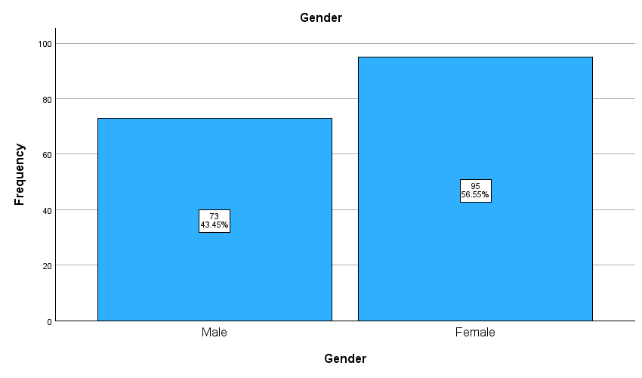
Source: Created by Author

4.1.1.2 Age Group
Figure 8 presents the age distribution of 168 survey participants: under 21 (5.95%), 21-30 (19.05%), 31-40 (35.12%), 41-50 (16.07%), and over 50 (23.81%). Research shows younger workers adopt AI more readily, with approximately 73% of workplace AI adopters under 50 years old, particularly those aged 18-29 who actively use advanced AI applications (Nielsen Norman Group, 2025; McKinsey, 2025). Usage declines with age, as workers over 50 report lower familiarity and comfort with AI tools. The millennial cohort (35-44 years) demonstrates high AI expertise and serves as adoption champions, reflecting broader patterns where younger generations more readily embrace emerging technologies due to greater adaptability, digital education, and comfort with AI interaction paradigms (NBER, 2024; AZUMO, 2025).

Figure 8: Graph of Participant’s Age Group
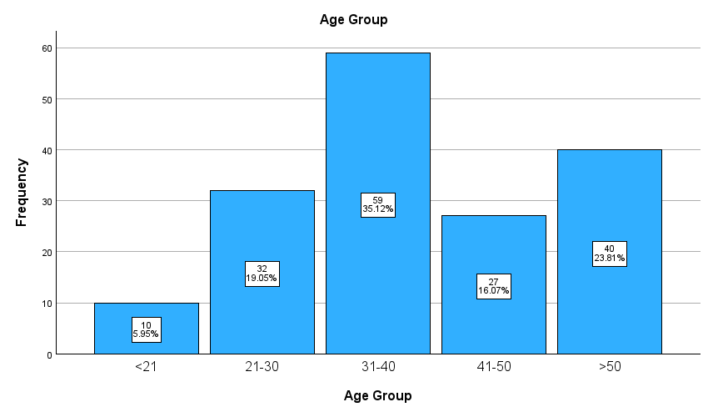
Source: Created by Author

4.1.1.3 Job Function
Figure 9 illustrates the job function distribution of 168 participants: office workers (54.17%) and frontline workers (45.83%). Knowledge workers in tech, finance, and marketing use AI tools significantly more frequently, with 54% of IT professionals using AI daily for diverse tasks. In contrast, production and frontline workers use AI only 9-11% of the time, primarily for automating repetitive tasks. This disparity reflects differences in job demands, where office roles benefit more from AI augmentation of knowledge work, while frontline positions focus on manual or direct customer interaction (Apollo Technical, 2025; Gallup, 2025).

Figure 9: Graph of Participant’s Job Function
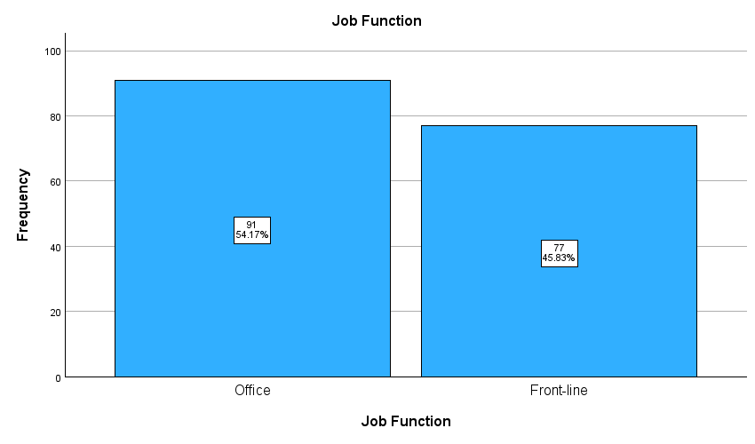
Source: Created by Author

4.1.1.4 Job Level
Figure 10 presents the job level distribution of 168 participants: entry-level co-workers (47.62%), entry-level management (19.05%), mid-level management (20.83%), and executive-level management (12.50%). Research shows leaders use AI more frequently (33%) than lower-rank workers, leveraging AI for decision-making, strategy, and analytics where productivity benefits are maximized (Gallup, 2025; McKinsey, 2025). Lower-level workers report less frequent AI use, primarily for routine or task-specific functions. However, AI adoption is growing across all job levels, with workers increasingly initiating independent AI use regardless of formal job level distinctions (The Interview Guys, 2025).

Figure 10: Graph of Participant’s Job Level
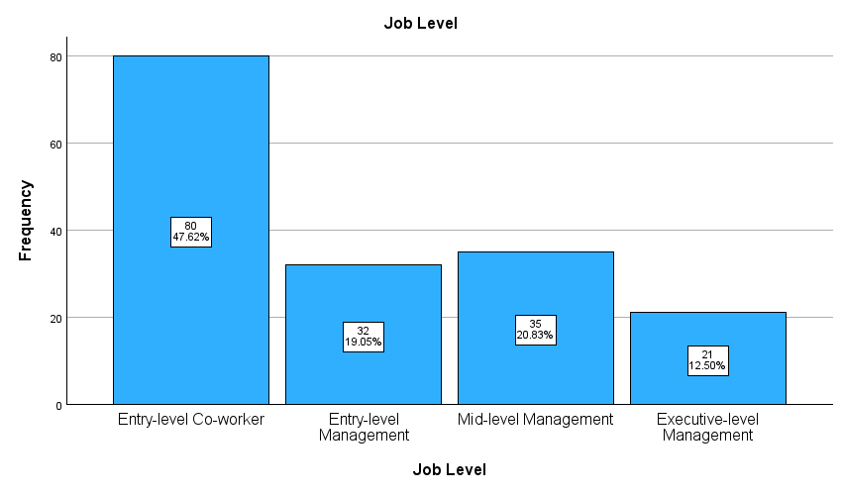
Source: Created by Author

4.1.1.5 Academic Qualifications
Figure 11 showcase about the academic qualification distribution of the survey participants. Within the 168 participants, 47 (27.98%) participants are secondary level or below, 30 (17.86%) participants are certificate or diploma level, 52 (30.95%) participants are bachelor’s degree level, and the remaining 39 (23.21%) participants are master’s degree level, no participants are doctorate or above level.

Figure 11: Graph of Participant’s Academic Qualifications
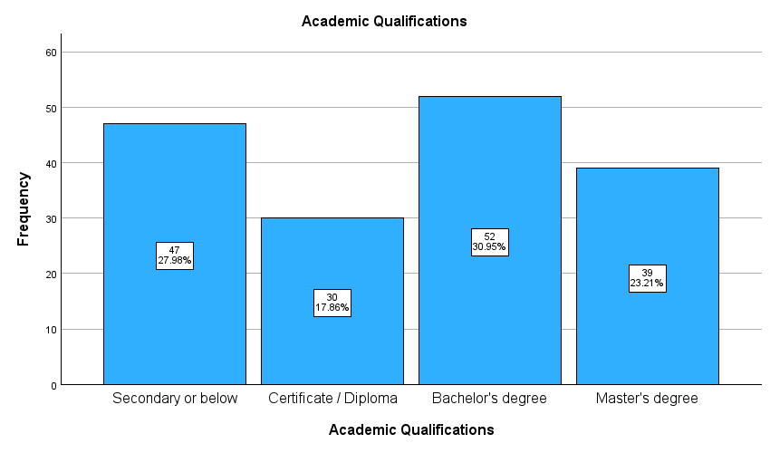
Source: Created by Author

4.1.1.6 Summary of Demographic Data
This study received response from 168 questionnaire participants. 57% are female and remaining 43% are male. Most of the participants age group belongs to 31-40 with 35%. 54% of the participants worked in office and the remaining worked as frontline. Almost half (47.62%) of the total participants worked as entry-level co-workers. Lastly, over half of the participants have a Bachelor’s degree of above.

4.2 Cross-tabulation of Demographic Factors
Cross-tabulation is defined as a statistical method used to analyze the relationship between two or more categorical variables by organizing the data into a matrix or table format. This could uncover patterns, associations, and dependencies between categorical variables (Appinio, 2024; Qualtrics, 2023; Displayr, 2025). Therefore, cross-tabulation was used in this study.

4.2.1 Age Group and Intention to Use (ITU)
Figure 12 and Table 20 showed the outcome of participants opinion of trying to use AI in workplace according to age group. Firstly, it shows that most participants agreed on the intention of using AI. 75 of 168 (44.6%) agreed on the intention of using AI, 15 of 168 (8.9%) strongly agree on the intention of using AI, which over half of the applicants show positive attitude on using AI. Secondly, it shows that younger workers have stronger intention and positive attitude on using AI then senior workers. 100% of applicants aged under 21 agreed on the intention of using AI, around 65% of applicants aged 21-30 agreed or strongly agreed, around 40% of applicants aged 31-40 agreed or strongly agreed.

Figure 12: Age Group and Intention to Use (ITU1)
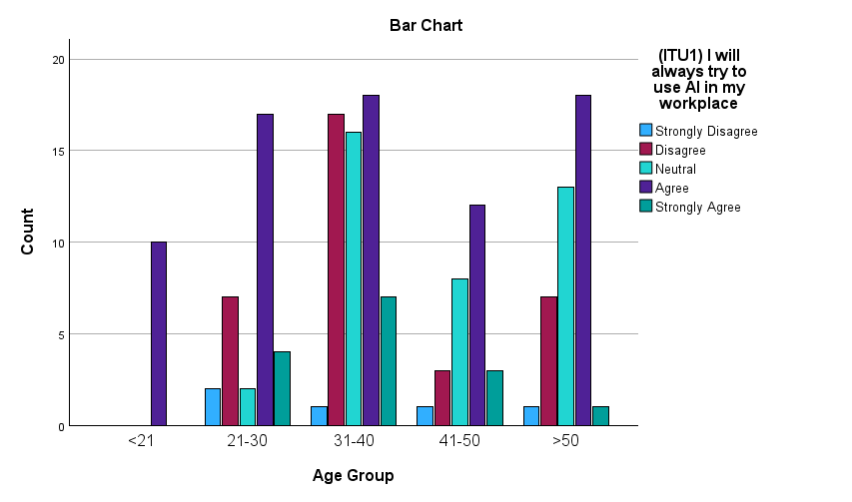
Source: Created by Author

Table 20: Age Group and Intention to Use (ITU1)
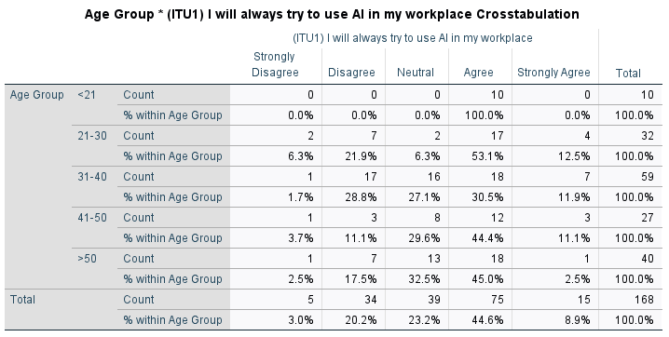
Source: Created by Author

4.2.2 Job Function and Intention to Use (ITU)
Figure 13 and Table 21 present participants' intentions to use AI in the workplace by job function. Overall, 105 of 168 participants (62.5%) agreed or strongly agreed on AI adoption intentions. Office workers demonstrated substantially higher intentions, with approximately 90% agreeing or strongly agreeing, compared to only 30% of frontline workers, reflecting significant job function differences in workplace AI adoption intentions.

Figure 13: Job Function and Intention to Use (ITU2)
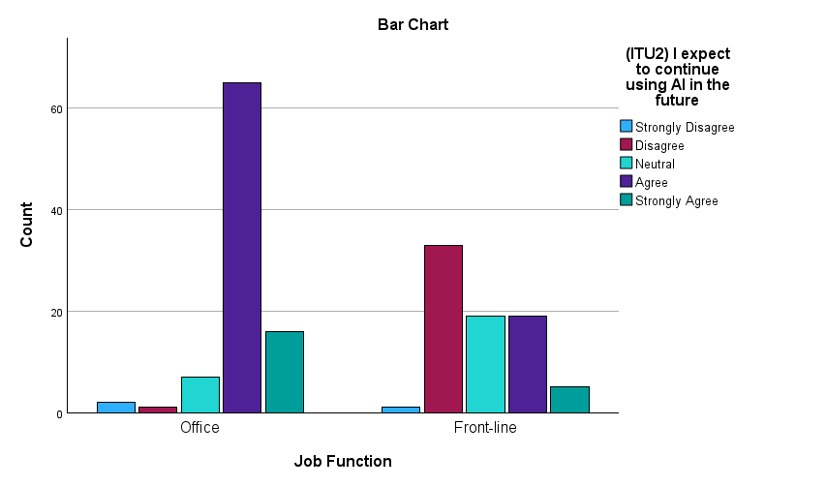
Source: Created by Author

Table 21: Job Function and Intention to Use (ITU2)
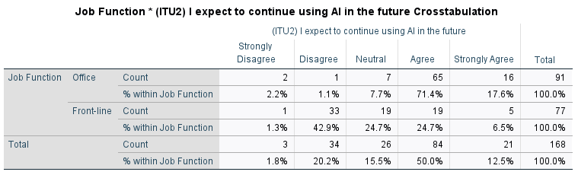
Source: Created by Author

4.2.3 Job Level and Intention to Use (ITU)
Figure 14 and Table 22 present participants' intentions to use AI by job level. Overall, 90 of 168 participants (53.5%) agreed or strongly agreed on AI adoption. Entry-level co-workers showed lower intentions at approximately 40% agreement, while higher job level participants (entry-level management, mid-level management, and executive) demonstrated substantially higher intentions of at least 60% agreement, indicating job level significantly influences workplace AI adoption intentions.

Figure 14: Job Level and Intention to Use (ITU1)
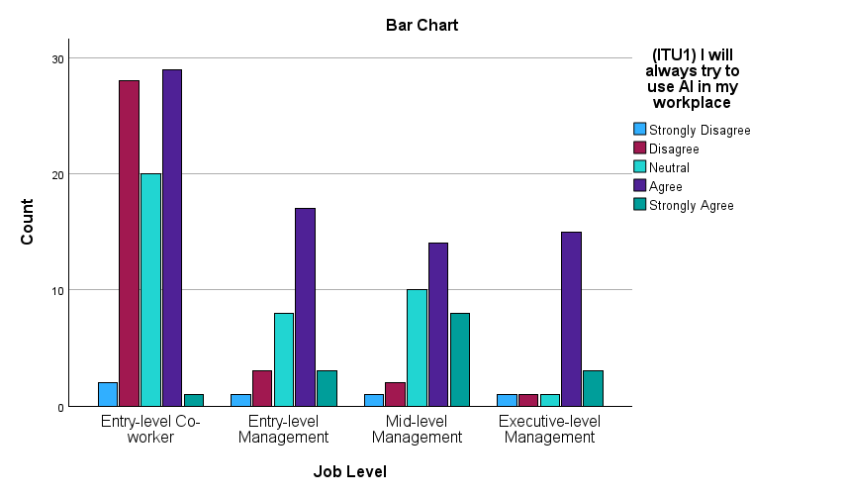
Source: Created by Author
Table 22: Job Level and Intention to Use (ITU1)
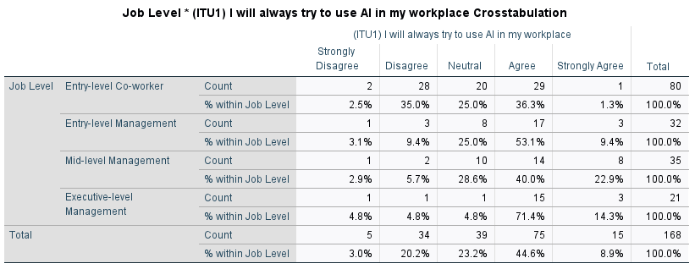
Source: Created by Author

4.2.4 Academic Qualifications and Intention to Use (ITU)
Figure 15 and Table 23 present participants' intentions to use AI by academic qualification. Overall, 90 of 168 participants (53.5%) agreed or strongly agreed on AI adoption. Participants with only secondary or lower qualifications showed substantially lower intentions at approximately 30% agreement, while those with bachelor's or master's degrees demonstrated markedly higher intentions exceeding 60% agreement, demonstrating that academic qualification strongly influences workplace AI adoption intentions.

Figure 15: Job Level and Intention to Use (ITU1)
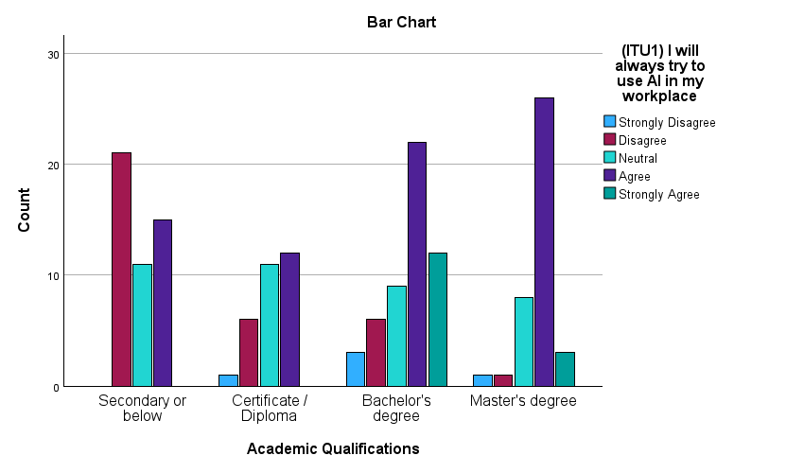
Source: Created by Author

Table 23: Academic Qualifications and Intention to Use (ITU1)
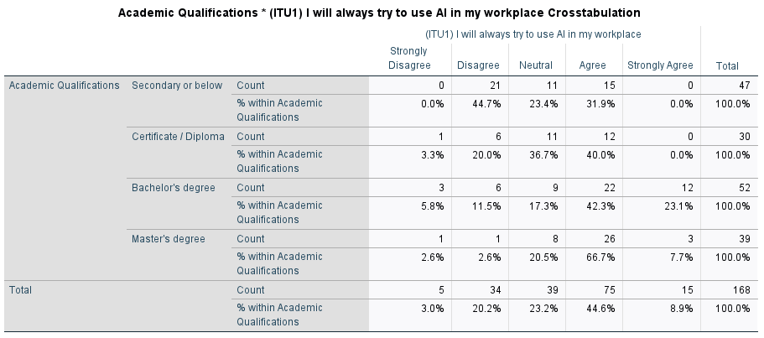
Source: Created by Author

4.3 Each Factor’s Highest and Lowest Averages
Figure 16 showcase each factor’s highest and lowest averages. The mean of PEOU was the highest at 3.82, while TIE has lower mean score at 3.05. It shows that participants consider Ease of use as an important factor while using AI and intention to use AI.

Figure 16: Each Factor’s Highest and Lowest Averages

Source: Created by Author

4.4 Reliability Test
A reliability test is defined as a procedure used to assess the consistency and dependability of a measurement instrument or data collection method. Its purpose is to ensure that the results produced by the measurement are stable over time and across different conditions, and that the same measurement method applied repeatedly will yield similar results (Scribbr, 2023).

Table 24: Reliability Statistics
Factors | N of items | This research’s Alpha | Other research’s Alpha | Researcher
PEOU | 4 | 0.878 | 0.91 | Teo & Noyes, 2011
PU | 4 | 0.951 | 0.93 | Teo & Noyes, 2011
TIE | 6 | 0.940 | 0.922 | Li, 2023
ITU | 3 | 0.922 | 0.778 | Gursoy, et al., 2020
PT | 3 | 0.853 | 0.884 | Khuong, 2025.
Total | 20 | 0.914
Source: Created by Author

Referring to Table 24, showing that the reliability test has a total of 0.914, which is higher than the minimum value of 0.7 and also the pilot test. It shows that it has significant and excellent result. Also, the alpha results of this research are similar or even better than other researchers, such as PU, TIE and ITU has a greater alpha than other researchers.

4.5 Factor Analysis
Table 25 showcase about the analysis result regarding the KMO and Bartlett’s Test. The KMO Matrix value of this study is 0.845, which is higher than the permissible index of 0.5. Each component has an eigenvalue bigger than 1, showing its significance. It showcased the separation of total variation by each factor. Factors with eigenvalue less than 1 are ignored which it did not considered as unique factor. The cumulative percent is less than 100% because not all variations are explained when only a subset of factors is considered in the final anlysis (Amerioun et al. 2018).

Table 25: KMO and Bartlett’s Test
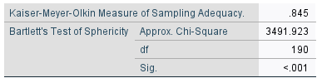
Source: Created by Author

Table 26: Total Variance Explained
Initial Eigenvalues, Extraction Method: Principal Component Analysis.
Component | Factor | Total | % of Variance | Cumulative %
1 | PU | 7.889 | 39.444 | 39.444
1 | ITU | 7.889 | 39.444 | 39.444
2 | TIE | 3.708 | 18.538 | 57.982
3 | PEOU | 2.571 | 12.857 | 70.839
4 | PT | 1.691 | 8.454 | 79.292
Source: Created by Author

Figure 17: Screen Plot for eigenvalue
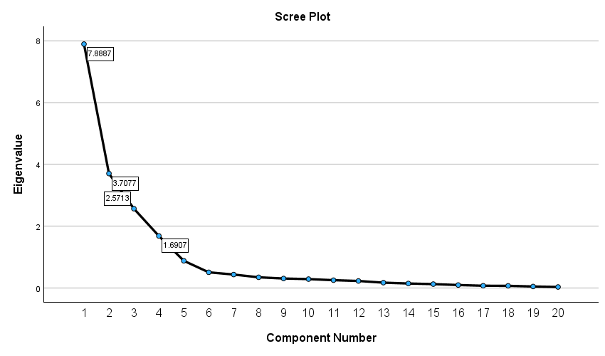
PU/ITU
PT
PEOU
TIE
Source: Created by Author

Table 26 and Figure 17 are used to extract eigenvalues greater than one. Four factors are accounted for 79.292% of the cumulative variance. Each of the factors has an eigenvalue of 7.889, 3.708, 2.571 and 1.691.

Table 27: Rotated Component Matrix
Factor Loading Values
Component | (Factor) Items | This Research | Other Research
1 | (PU2) AI saves me time and effort in performing tasks. | 0.929 | 0.821 | Ronaghi & Ronaghi, 2022
1 | (ITU2) I expect to continue using AI in the future | 0.911 | 0.875 | Gursoy, et al., 2020.
1 | (PU3) AI will increase my productivity | 0.879 | 0.829 | Teo & Noyes, 2011
1 | (PU1) AI enhances my task effectiveness. | 0.872 | 0.848 | Teo & Noyes, 2011
1 | (PU4) AI enhances the quality of my working output | 0.850 | 0.771 | Khuong, 2025
1 | (ITU3) I will recommend others (include colleagues) to use AI | 0.835 | 0.769 | Gursoy, et al., 2020.
1 | (ITU1) I will always try to use AI in my workplace | 0.779 | 0.847 | Gursoy, et al., 2020.
2 | (TIE2) It is likely that I will contact AI threat. | 0.920 | /
2 | (TIE3) It is possible that I will contact AI threat. | 0.895 | /
2 | (TIE1) I am at risk for getting AI threat. | 0.877 | /
2 | (TIE5) I believe that AI threat is serious. | 0.852 | /
2 | (TIE6) I believe that AI threat is significant. | 0.824 | /
2 | (TIE4) I believe that AI threat is severe. | 0.790 | /
3 | (PEOU3) I would have no trouble learning how to use | 0.880 | 0.75 | Islam, 2024
3 | (PEOU1) I find AI easy to use | 0.855 | 0.775 | Teo & Noyes, 2011
3 | (PEOU2) I would find it easy to become skilled at using AI | 0.841 | 0.934 | Lenz et al., 2023
3 | (PEOU4) I find it easy to get AI to do what I want it to do. | 0.769 | 0.871 | Teo & Noyes, 2011
4 | (PT2)The AI application is trustworthy that I could enter personal or company information | 0.895 | 0.809 | Khuong, 2025
4 | (PT4)I found AI-powered information is reliable. | 0.815 | 0.816 | Khuong, 2025
4 | (PT1)I think the AI application is reliable to use | 0.787 | 0.816 | Khuong, 2025
Extraction Method: Principal Component Analysis.
Rotation Method: Varimax with Kaiser Normalization.
Source: Created by Author

Referring to table 27, All factor loadings exceed 0.75, indicating strong relationships between individual items and their respective constructs, which validates that the measurement scales reliably capture each latent variable. The comparison with "Other Research" columns shows your factor loadings align well with established benchmarks from prior studies, confirming construct validity. The extraction and rotation methods (Principal Component Analysis with Varimax rotation) are clearly documented at the table bottom, supporting the methodological rigor of your factor analysis.

4.6 Correlation Test
Referring to table 28, Correlation Test is used to show the strength of relationship between two variables. The following table compares this study’s findings with other research’s findings.

Table 28: Correlation Analysis of Factors in comparison to other research
This Research |  |  |  | Other Research
Item | N | r | Strength | r | Researcher
H1 (PEOU->ITU) | 168 | 0.339** | L | 0.220** | Teo & Noyes, 2011
H2 (PU->ITU) | 168 | 0.840** | H | 0.350** | Teo & Noyes, 2011
H3 (TIE->ITU) | 168 | 0.439** | L | NS | Cao, et al., 2021
H4 (PT->ITU) | 168 | 0.538** | M | 0.248*** | Khuong, 2025
Source: Created by Author

The closer the Pearson correlation coefficient (r) value is near +1 or -1, the stronger the degree of correlation between two variables is deemed. The hypothesis H2, which pertains to PU, exhibits a substantial correlation with the (ITU) intention of using AI, it had the highest positive correlation coefficient, 0.840, which is much more greater than that of a previous study by Teo & Noyes (2011).

4.7 Regression Model
Regression models quantify relationships between predictor and outcome variables, enabling hypothesis testing, prediction, and control of confounding factors. They help identify significant predictors and provide statistical evidence supporting theoretical frameworks (Hair et al., 2014; Field, 2013).

4.7.1 Simple Linear Regression for ITU and PU, TIE, PEOU, PT
Simple Linear Regression is a statistical Strategy for identifying the relationship between a dependent and an independent variable.

Table 29: Model Summary for Simple Linear Regression Model
Model Summary^{f}
Model | R | R Square | Adjusted R Square | Std. Error of the Estimate
5 | .814e | .662 | .651 | .590
e. Predictors: (Constant), (PU4) AI enhances the quality of my working output, (PU1) AI enhances my task effectiveness., (TIE5) I believe that AI threat is serious., (PT1)I think the AI application is reliable to use, (PEOU1) I find AI easy to use
f. Dependent Variable: (ITU1) I will always try to use AI in my workplace
Source: Created by Author

R² in a regression model is a statistical measure that represents the proportion of the variance in the dependent variable that is explained by the independent variable(s) (Investopedia, 2024).
R² = $\frac{Variance explained by the model}{Total variance}$

R² in model 5 accounts for 66.2% of the variation in PU, PEOU, PT and TIE (Table 29), indicating that the model can only be explained a small portion of the variation in the response variable around its mean.

Table 30: ANOVA for the Simple Linear Regression Model
ANOVAª
Model |  | Sum of Squares | df | Mean Square | F | Sig.
5 | Regression | 110.420 | 5 | 22.084 | 63.398 | <.001^{f}
5 | Residual | 56.431 | 162 | .348
5 | Total | 166.851 | 167
a. Dependent Variable: (ITU1) I will always try to use AI in my workplace
f. Predictors: (Constant), (PU4) AI enhances the quality of my working output, (PU1) AI enhances my task effectiveness., (TIE5) I believe that AI threat is serious., (PT1)I think the AI application is reliable to use, (PEOU1) I find AI easy to use
Source: Created by Author

The ANOVA technique is utilized in Table 30. Adding regression’s af with Residual’s df equals to the total degree of freedom (df), which is one lesser than the actual dataset size.

Referring to table 30, F=63.398 is obtained by dividing the Mean Square Regression (22.084) by the Mean Square Residual (0.348). The F value is associated with the p-value (<.001); There is enough evidence to support that SLR model is valid to analysis the data consistently.

Table 31: Coefficients Table for the Simple Regression Model
Coefficientsª
Model |  | Unstandardized Coefficients |  | Standardized Coefficients | t | Sig. | Collinearity Statistics
 |  | B | Std. Error | Beta | t | Sig. | Tolerance | VIF
5 | (Constant) | -.937 | .326 |  | -2.871 | .005
5 | (PU4) AI enhances the quality of my working output | .615 | .078 | .547 | 7.904 | <.001 | .436 | 2.293
5 | (PU1) AI enhances my task effectiveness. | .166 | .081 | .151 | 2.039 | .043 | .380 | 2.632
5 | (TIE5) I believe that AI threat is serious. | .163 | .052 | .153 | 3.116 | .002 | .864 | 1.157
5 | (PT1)I think the AI application is reliable to use | .170 | .074 | .117 | 2.291 | .023 | .799 | 1.252
5 | (PEOU1) I find AI easy to use | .138 | .069 | .096 | 1.998 | .047 | .902 | 1.109
a. Dependent Variable: (ITU1) I will always try to use AI in my workplace
Source: Created by Author

Indicator B represents the coefficients of the regression equation used to predict the dependent variable: ITU1 from PU4, PU1, TIE5, PT1 and PEOU1. The regression equation can be presented as follows:

ITU1= -0.937 + 0.615 x PU4 _{quality} + 0.166 x PU1_{effectiveness} + 0.163 x TIE5 _{serious} + 0.170 x PT1 _{reliable} + 0.138 x PEOU1 _{use}

Table 31 shows all predictor variables have statistically significant effects on ITU1 (p<0.05). "AI enhances the quality of my working output" (PU4) is the strongest predictor (B=0.615, Beta=0.547), followed by threat awareness (Beta=0.153), task effectiveness (Beta unclear), reliability (Beta unclear), and ease of use (Beta=0.096). Collinearity statistics (Tolerance>0.3, VIF<3) indicate no severe multicollinearity concerns. Perceived quality enhancement of work output represents the most critical factor influencing AI adoption intentions in the workplace.

4.7.1.1 Variance Inflation Factor
The variance inflation factor (VIF) is a statistical metric in multiple regression analysis that quantifies multicollinearity among independent variables. VIF indicates how much the variance of regression coefficients is inflated due to linear correlations with other predictors. High VIF values suggest strong multicollinearity, signaling that independent variables share considerable variance, potentially destabilizing coefficient estimates and interpretation. In this study, the multicollinearity issue appeared to be absent as the values of VIF are below the threshold of 5.

4.7.1.2 Histogram and Scatterplot
Each variable had a normal distribution based on visual analysis of the histogram (Figure 18); the residuals follow a normal standardized with an average zero.

Figure 18: Histogram of ITU1
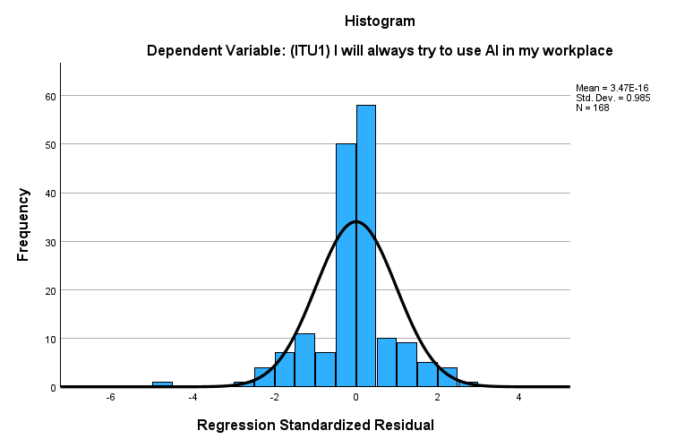
Source: Created by Author

The relationship is linear, with the slope of the scatterplot being negative, indicating that the variables are negatively related.

Figure 19: Scatterplot of ITU1
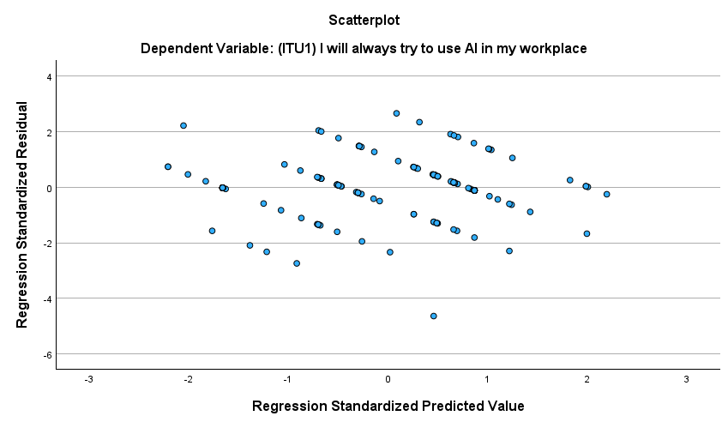
Source: Created by Author

The Histogram (Figure 18) and the Scatterplot (Figure 19) show that the SLR Model is appropriate to use.

4.8 Independent T-Test
An independent t-test is a statistical method used to compare the means of two unrelated or independent groups to determine whether there is a statistically significant difference between them. Its main purpose in a dissertation is to assess whether differences observed in the data (such as scores, measurements, or responses) across two different groups are likely due to actual variation rather than random chance (Statistics Solutions, 2025; University of Kent, 2013; Dissertation Canada, 2015). This study used the t-test to identify the difference between gender on ITU.

H₀: o²_{M} = o²_{F}
The independent t-test assumes the variances of the two groups, Male and Female, are equal in the population. The assumption of homogeneity of variance was tested using Levene’s Test of Equality. The F critical value is found in the F table. There are two df required: numerator and denominator (Table 32).

Table 32: Formula of F Test Statistic
Equation | Variable | Description
$$F_{STAT}=\frac{s_{1}^{2}}{s_{2}^{2}}$$  $${df}_{1}= n_{1}-1$$  $${df}_{2}= n_{2}-1$$ | $$s_{1}^{2}$$ | Variance of sample 1 (the large sample variance)
 | $$n_{1}$$ | Sample Size of Sample 1
 | $$s_{2}^{2}$$ | Variance of Sample 2 (the smaller sample variance)
 | $$n_{2}$$ | Sample size of sample 2
 | $$n_{1}-1$$ | Numerator Degrees of Freedom
 | $$n_{2}-1$$ | Denominator Degrees of Freedom
Source: Created by Author

Table 33: Group Statistics for Independent t-test
Group Statistics
 | Gender | N | Mean | Std. Deviation | Std. Error Mean
(ITU1) I will always try to use AI in my workplace | Male | 73 | 3.32 | 1.039 | .122
(ITU1) I will always try to use AI in my workplace | Female | 95 | 3.40 | .972 | .100
(ITU2) I expect to continue using AI in the future | Male | 73 | 3.48 | 1.029 | .120
(ITU2) I expect to continue using AI in the future | Female | 95 | 3.54 | .998 | .102
(ITU3) I will recommend others (include colleagues) to use AI | Male | 73 | 3.26 | 1.054 | .123
 | Female | 95 | 3.51 | .988 | .101
Source: Created by Author

After the group statistics for independent t-test from table 33, Table 34 shows about the Levene's Test for Equality of Variances, which checks whether the variance in response between male and female groups is equal for each ITU statement. p value is 0.692(ITU1), 0.748(ITU2) and 0.353(ITU3) which are much greater than 0.05 significant level, indicating equal variances can be assumed between groups. To conclude, all Sig. values exceed 0.05, meaning the assumption of equal variances holds for each item. This validates the use of standard t-tests for comparing means between males and females on these items.

Table 34: Levene's Test for Equality of Variances
Homogeneity of Variance Test
 |  | Levene's Test for Equality of Variances
 |  | F | Sig.
(ITU1) I will always try to use AI in my workplace | Equal variances assumed | .157 | .692
(ITU2) I expect to continue using AI in the future | Equal variances assumed | .104 | .748
(ITU3) I will recommend others (include colleagues) to use AI | Equal variances assumed | .866 | .353
Source: Created by Author

Table 35 presents independent samples t-tests comparing male and female responses for intentions to use AI across ITU1 (p=0.293), ITU2 (p=0.358), and ITU3 (p=0.062). All p-values substantially exceed 0.05, and confidence intervals for mean differences include zero, indicating no statistically significant gender differences in AI adoption intentions. Hypothesis H5a is not supported.

Table 35: Independent Samples t-test Output
Independent Samples Test
 |  | t-test for Equality of Means
 |  | t | df | Significance |  | Mean Difference | Std. Error Difference | 95% Confidence Interval of the Difference
 |  | t | df | One-Sided p | Two-Sided p | Mean Difference | Std. Error Difference | Lower | Upper
(ITU1) I will always try to use AI in my workplace | Equal variances assumed | -.545 | 166 | .293 | .587 | -.085 | .156 | -.393 | .223
(ITU1) I will always try to use AI in my workplace | Equal variances not assumed | -.540 | 149.565 | .295 | .590 | -.085 | .157 | -.396 | .226
(ITU2) I expect to continue using AI in the future | Equal variances assumed | -.365 | 166 | .358 | .716 | -.057 | .157 | -.368 | .253
(ITU2) I expect to continue using AI in the future | Equal variances not assumed | -.363 | 152.633 | .359 | .717 | -.057 | .158 | -.370 | .255
 |  | t-test for Equality of Means
(ITU3) I will recommend others (include colleagues) to use AI | Equal variances assumed | -1.547 | 166 | .062 | .124 | -.245 | .158 | -.558 | .068
 | Equal variances not assumed | -1.534 | 149.716 | .064 | .127 | -.245 | .160 | -.561 | .071
Source: Created by Author

The descriptive statistics table (Table 36) include the mean, standard deviation, and 95 percent confidence intervals for the dependent variable.

Table 36: Descriptive Table of Job Function
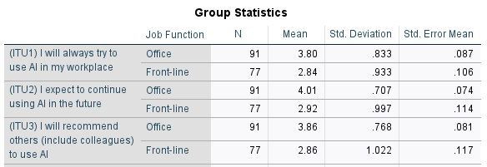
Source: Created by Author

Table 37 presents Levene's test for equality of variances, with p-values <0.05 for ITU1 (p=0.019), ITU2 (p<0.001), and ITU3 (p<0.001), indicating significant rejection of the equal variances assumption. Response variability differs significantly across groups for all three AI adoption intention measures. Statistical methods accounting for unequal variances are required for valid group comparisons.

Table 37: Levene's Test for Equality of Variances
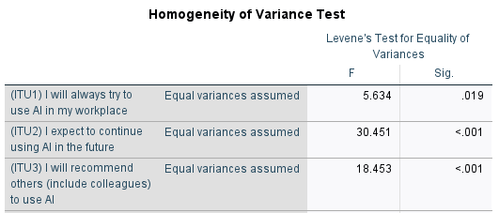

Source: Created by Author

Table 38: Independent Samples t-test Output
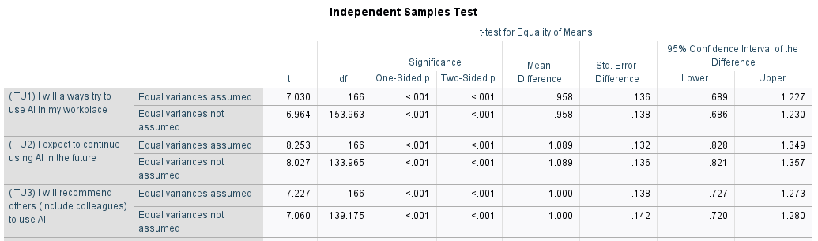
Source: Created by Author

Table 38 presents independent samples t-tests comparing office and frontline workers' AI adoption intentions across ITU1, ITU2, and ITU3. All three tests yield highly significant p-values (p<0.001), with substantial mean differences (MD=0.958 for ITU1, 1.089 for ITU2, 1.000 for ITU3). Office workers demonstrate consistently stronger intentions to use, continue using, and recommend AI compared to frontline workers. These differences are both statistically and practically significant, supporting hypothesis H5c at the 5% significance level and confirming job function as a crucial predictor of AI adoption attitudes.

4.9 One-way Analysis of Variance (ANOVA)
ANOVA is a statistical method used to determine whether there are statistically significant differences between the means of three or more independent groups. The main purpose of ANOVA is to compare multiple groups means simultaneously to assess if observed differences are likely due to true variations or simply random chance. Unlike conducting several t-tests, ANOVA reduces the risk of Type I errors, making it a robust choice for group comparisons in research (Investopedia, 2025; Qualtrics, 2024; Microbe Notes, 2023).

4.9.1 One-way ANOVA test for Age
The descriptive statistics table (Table 39) include the mean, standard deviation, and 95 percent confidence intervals for the dependent variable. Table 33 shows ITU3 mean scores: age 21 (4.0), age 21–30 (3.75), age 31–40 (3.14), age 41–50 (3.44), age 50 (3.33), where younger groups (age 21, 21–30) score higher on recommendation intention. To conclude, there is a clear downward trend in recommendation intention with increasing age especially after age 30, younger participants are more inclined to recommend AI to others.

Table 39: Descriptive Table of Age
Descriptives
 |  | N | Mean | Std. Deviation | Std. Error | 95% Confidence Interval for Mean |  | Minimum | Maximum
 |  |  |  |  |  | Lower Bound | Upper Bound | Minimum | Maximum
(ITU3) I will recommend others (include colleagues) to use AI | <21 | 10 | 4.00 | .000 | .000 | 4.00 | 4.00 | 4 | 4
 | 21-30 | 32 | 3.75 | 1.078 | .191 | 3.36 | 4.14 | 1 | 5
 | 31-40 | 59 | 3.14 | 1.025 | .133 | 2.87 | 3.40 | 2 | 5
 | 41-50 | 27 | 3.44 | 1.086 | .209 | 3.01 | 3.87 | 1 | 5
 | >50 | 40 | 3.33 | .944 | .149 | 3.02 | 3.63 | 1 | 5
 | Total | 168 | 3.40 | 1.022 | .079 | 3.24 | 3.55 | 1 | 5
Source: Created by Author

Table 40 and figure 20 shows about the multiple comparisons of age, which a statistically significant difference was found between ages 31–40 and 21–30 for ITU3, with p=0.044<0.05(sig.). It shows that only the 31–40 vs. 21–30 age group comparison reaches significance, indicating younger adults (21–30) are more likely to recommend AI than those aged 31–40. To conclude, age group impacts recommendation intentions for AI, especially between certain age brackets. Therefore, H5b is supported at 95% confidence level.

Table 40: Multiple Comparisons of Age
Multiple Comparisons
Tukey HSD
Dependent Variable | (I) Age Group | (J) Age Group | Mean Difference (I-J) | Std. Error | Sig. | 95% Confidence Interval
 |  |  |  |  |  | Lower Bound | Upper Bound
(ITU3) I will recommend others (include colleagues) to use AI | 21-30 | <21 | -.250 | .362 | .958 | -1.25 | .75
 | 21-30 | 31-40 | .614* | .219 | .044 | .01 | 1.22
 | 21-30 | 41-50 | .306 | .261 | .768 | -.41 | 1.02
 | 21-30 | >50 | .425 | .237 | .380 | -.23 | 1.08
*. The mean difference is significant at the 0.05 level.
Source: Created by Author

Figure 20: Mean Plot of Age
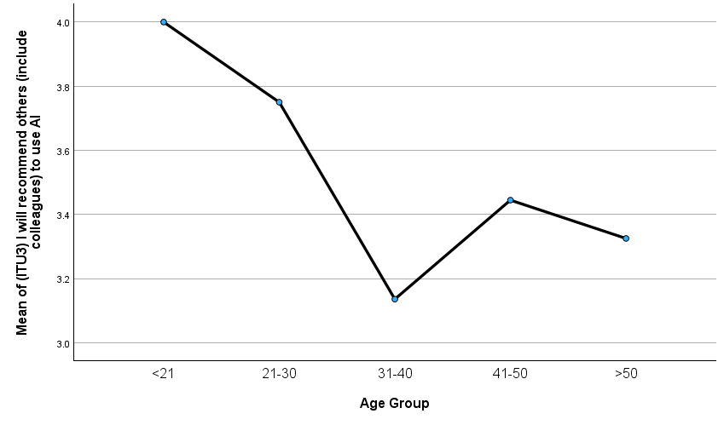
(J) group
(I) group
Source: Created by Author

4.9.2 One-way ANOVA test for Job Level

The descriptive statistics table (Table 41) include the mean, standard deviation, and 95 percent confidence intervals for the dependent variable. Table 38 shows ITU2 mean scores increase with seniority: entry-level co-worker (3.09), entry-level management (3.78), mid-level (3.94), executive (4.00). Also, executive-level managers show the highest average intention to continue using AI. It shows that confidence intervals for the mean grow higher with job seniority, indicating this trend is generalized rather than sample specific. To conclude, senior job levels are associated with higher intention to continue using AI.

Table 41: Descriptive Table of Job Level
Descriptives
 |  | N | Mean | Std. Deviation | Std. Error | 95% Confidence Interval for Mean |  | Minimum | Maximum
 |  |  |  |  |  | Lower Bound | Upper Bound | Minimum | Maximum
(ITU2) I expect to continue using AI in the future | Entry-level Co-worker | 80 | 3.09 | .970 | .108 | 2.87 | 3.30 | 1 | 5
(ITU2) I expect to continue using AI in the future | Entry-level Management | 32 | 3.78 | .832 | .147 | 3.48 | 4.08 | 2 | 5
(ITU2) I expect to continue using AI in the future | Mid-level Management | 35 | 3.94 | .906 | .153 | 3.63 | 4.25 | 1 | 5
(ITU2) I expect to continue using AI in the future | Executive-level Management | 21 | 4.00 | .949 | .207 | 3.57 | 4.43 | 1 | 5
(ITU2) I expect to continue using AI in the future | Total | 168 | 3.51 | 1.009 | .078 | 3.36 | 3.67 | 1 | 5
Source: Created by Author

Table 42 shows about the ANOVA of Job Level, which yields a significant result (F=10.89, p=0.001F=10.89, p=0.001), showing job level affects intention to use AI (ITU2). It shows that very low p-value implies the observed differences in ITU2 scores by job level are statistically meaningful. To conclude, Job level is a significant predictor of future AI use intentions, with higher-level positions more likely to expect continued AI use.

Table 42: ANOVA Table of Job Level
ANOVA
 |  | Sum of Squares | df | Mean Square | F | Sig.
(ITU2) I expect to continue using AI in the future | Between Groups | 28.234 | 3 | 9.411 | 10.889 | <.001
(ITU2) I expect to continue using AI in the future | Within Groups | 141.742 | 164 | .864
(ITU2) I expect to continue using AI in the future | Total | 169.976 | 167
Source: Created by Author

Tables 43 and Figure 21 present post-hoc comparisons of job level, showing entry-level co-workers have significantly lower mean scores than all management levels: entry-level management (Δ=-0.694, p=0.003), mid-level management (Δ=-0.855, p<0.001), and executive-level management (Δ=-0.913, p<0.001). Non-overlapping confidence intervals confirm robust group differences. No significant differences exist among management roles themselves. Job level is a strong predictor of future AI use intention, with management staff demonstrating substantially greater adoption intentions than entry-level co-workers.

Table 43: Multiple Comparisons of Job Level
Multiple Comparisons
Tukey HSD
Dependent Variable | (I) Job Level | (J) Job Level | Mean Difference (I-J) | Std. Error | Sig. | 95% Confidence Interval
 |  |  |  |  |  | Lower Bound | Upper Bound
(ITU2) I expect to continue using AI in the future | Entry-level Co-worker | Entry-level Management | -.694* | .194 | .003 | -1.20 | -.19
(ITU2) I expect to continue using AI in the future | Entry-level Co-worker | Mid-level Management | -.855* | .188 | <.001 | -1.34 | -.37
(ITU2) I expect to continue using AI in the future | Entry-level Co-worker | Executive-level Management | -.913* | .228 | <.001 | -1.50 | -.32
*. The mean difference is significant at the 0.05 level.
Source: Created by Author

Figure 21: Mean Plot of Job Level
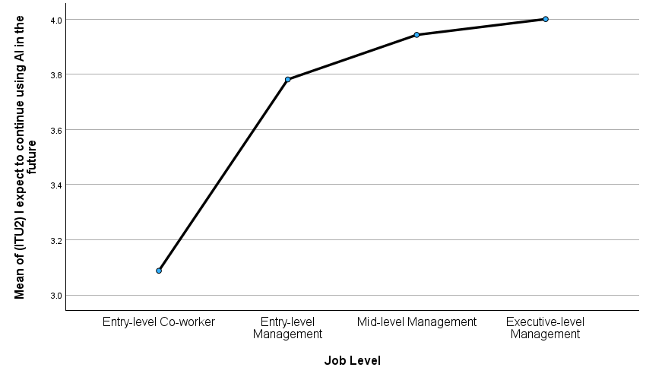
Source: Created by Author

4.9.3 One-way ANOVA test for Academic Qualifications
Table 44 displays descriptive statistics including means, standard deviations, and 95% confidence intervals for academic qualifications. A clear upward trend emerges, with mean scores increasing from secondary or below (2.85) to master's degrees (4.05), a substantial 1.2-point difference. Non-overlapping confidence interval bounds across groups confirm that participants with bachelor's and master's degrees demonstrate significantly higher intentions to continue using AI compared to those with lower education qualifications, indicating that advanced education strongly encourages AI adoption intentions.

Table 44: Descriptive Table of Academic Qualifications
Descriptives
 |  | N | Mean | Std. Deviation | Std. Error | 95% Confidence Interval for Mean |  | Minimum | Maximum
 |  |  |  |  |  | Lower Bound | Upper Bound | Minimum | Maximum
(ITU2) I expect to continue using AI in the future | Secondary or below | 47 | 2.85 | .859 | .125 | 2.60 | 3.10 | 2 | 4
(ITU2) I expect to continue using AI in the future | Certificate / Diploma | 30 | 3.07 | .944 | .172 | 2.71 | 3.42 | 1 | 4
(ITU2) I expect to continue using AI in the future | Bachelor's degree | 52 | 3.96 | .928 | .129 | 3.70 | 4.22 | 1 | 5
(ITU2) I expect to continue using AI in the future | Master's degree | 39 | 4.05 | .686 | .110 | 3.83 | 4.27 | 1 | 5
(ITU2) I expect to continue using AI in the future | Total | 168 | 3.51 | 1.009 | .078 | 3.36 | 3.67 | 1 | 5
Source: Created by Author

Table 45 presents ANOVA results showing a statistically significant effect of academic qualification on intention to continue using AI (ITU2), F=21.72, p<0.001. Mean scores increase progressively: secondary or below (2.85), certificate/diploma (3.06), bachelor's (3.96), and master's (4.05). The significant F-value and low p-value confirm that academic qualification groups differ meaningfully in their future AI use intentions, with bachelor's and master's degree holders demonstrating the strongest adoption intentions. Hypothesis H5e is supported at the 95% confidence level.

Table 45: ANOVA Table of Academic Qualifications
ANOVA
 |  | Sum of Squares | df | Mean Square | F | Sig.
(ITU2) I expect to continue using AI in the future | Between Groups | 48.332 | 3 | 16.111 | 21.720 | <.001
(ITU2) I expect to continue using AI in the future | Within Groups | 121.645 | 164 | .742
(ITU2) I expect to continue using AI in the future | Total | 169.976 | 167
Source: Created by Author

Tables 46 and Figure 22 show post-hoc comparisons of academic qualifications for ITU2. Significant mean differences exist between lower and higher qualification groups, with the largest differences between bachelor's versus secondary or below (Δ=1.11, p<0.001) and master's versus secondary or below (Δ=1.20, p<0.001). Post-hoc tests confirm that participants with bachelor's or master's degrees demonstrate significantly higher future AI use intentions than those with secondary or certificate/diploma education. Academic qualification level strongly and reliably predicts intention to use AI across qualification groupings.

Table 46: Multiple Comparisons of Academic Qualifications
Multiple Comparisons
Tukey HSD
Dependent Variable | (I) Academic Qualifications | (J) Academic Qualifications | Mean Difference (I-J) | Std. Error | Sig. | 95% Confidence Interval
 |  |  |  |  |  | Lower Bound | Upper Bound
(ITU2) I expect to continue using AI in the future | Secondary or below | Certificate / Diploma | -.216 | .201 | .708 | -.74 | .31
(ITU2) I expect to continue using AI in the future | Secondary or below | Bachelor's degree | -1.110* | .173 | <.001 | -1.56 | -.66
(ITU2) I expect to continue using AI in the future | Secondary or below | Master's degree | -1.200* | .187 | <.001 | -1.68 | -.72
*. The mean difference is significant at the 0.05 level.
Source: Created by Author

Figure 22: Mean Plot of Academic Qualifications
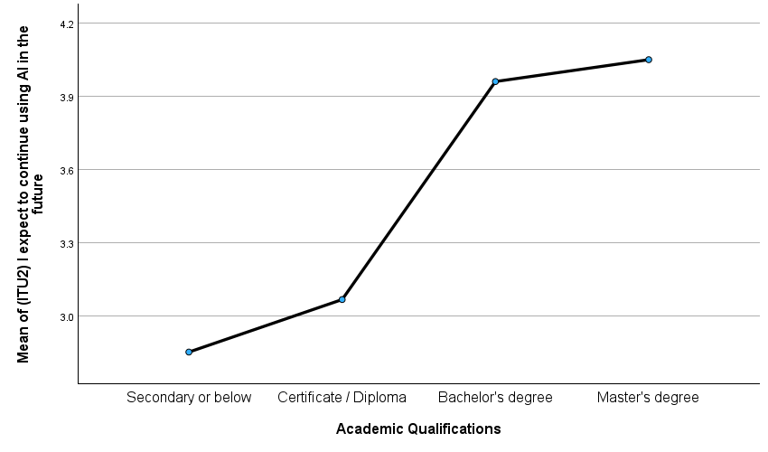
Source: Created by Author
4.9.4 Summary of One-way ANOVA test
One-way ANOVA tests revealed that academic qualifications (F=21.72, p<0.001), job level (F=10.89, p<0.001), and job function (p<0.001) significantly influence AI adoption intentions, while gender showed no significant effect. Academic scores ranged from 2.85 (secondary or below) to 4.05 (master's degree). Job level differences ranged from 3.09 (entry-level) to 4.00 (executive). Post-hoc tests identified significant differences between age groups (Δ=0.614, p=0.044), educational levels (Δ=1.11–1.20, p<0.001), and job levels (Δ=-0.694 to -0.913, p<0.003). These findings demonstrate that demographic diversity substantially shapes AI adoption, necessitating differentiated organizational strategies.

4.10 Summary of the Research Findings
The standard coefficients ($β$), correlation coefficient (r), and R square ($R^{2})$ from the regression analysis are summarized below in Figure 23.

Figure 23: Standard coefficients ($β$), correlation coefficient (r), and R square ($R^{2})$.

Table 47: Summary of the Research Findings regarding the hypotheses tested in this study
Item | Hypothesis Developed | $$β$$ | r | Result
H1 | PEOU and ITU have a positive relationship in Hong Kong Workplace. | 0.096* | 0.339** | Supported
H2 | PU and ITU have a positive relationship in Hong Kong Workplace | 0.547* | 0.840** | Supported
H3 | TIE and ITU have a positive relationship in Hong Kong Workplace | 0.153* | 0.439** | Supported
H4 | PT has a positive correlation with ITU in Hong Kong Workplace. | 0.117* | 0.538** | Supported
Item | Hypothesis Developed | Mean Difference |  | Result
H5a | There are significant differences between gender and the intention of using AI | NS |  | Not Supported
H5b | There are significant differences between age and the intention of using AI;  21-30>31-40 | MD=0.614* |  | Supported
H5c | There are significant differences between job function and the intention of using AI; Office>Frontline | MD=1.089* |  | Supported
H5d | There are significant differences between job level and the intention of using AI;  Entry < Executive | MD=-0.913* |  | Supported
H5e | There are significant differences between academic qualifications and the intention of using AI;  Secondary<Master | MD=-1.2* |  | Supported
Source: Created by Author

The closer the Pearson correlation coefficient (r) value is near +1 or -1, the stronger the degree of correlation between 2 variables is deemed. Therefore, referring to table 55 that H2 had the most significant impact on the intention to use AI, with r-value at 0.840. The second highest impact would be H4 at 0.538.

Chapter 5: Conclusion and Recommendation
This final chapter synthesizes the research findings, discusses their theoretical and practical implications, and provides actionable recommendations for organizations, employees, and policymakers. The study's limitations are acknowledged, and directions for future research are proposed to advance understanding of AI adoption in workplace settings.

5.1 Conclusion
This dissertation examined the factors influencing Hong Kong employees' intentions to use artificial intelligence (AI) in the workplace, addressing a critical gap in understanding technology acceptance in rapidly digitalizing organizational contexts. Through a mixed-methods approach integrating literature review with quantitative survey data from 168 employed workers, the study provides robust empirical evidence regarding AI adoption determinants and the moderating effects of demographic characteristics.

The study confirms four primary hypotheses regarding AI adoption predictors. Perceived usefulness (PU) emerged as the strongest predictor of intention to use (ITU), with a standardized coefficient (β=0.547), demonstrating that demonstrating tangible performance benefits is paramount for driving adoption. Threat in employment (TIE) paradoxically functions as a motivator rather than deterrent (β=0.153, p<0.001), suggesting employees proactively engage with AI competency development as a protective career strategy. Perceived trust (PT) significantly predicted adoption (β=0.117, p<0.05), highlighting trust's critical role as an enabling condition. Perceived ease of use (PEOU) remained statistically significant but showed the smallest coefficient (β=0.096, p<0.05), indicating that while important, reducing cognitive barriers represents a secondary priority compared to demonstrating usefulness.

Together, these four constructs collectively explained 66.2% of variance in intention to use AI, demonstrating strong explanatory power of the extended Technology Acceptance Model framework applied to workplace AI contexts. This substantial explanatory capacity validates the model's applicability while highlighting that demographic and other contextual factors account for remaining variance.
5.2 Recommendation
The study's findings generate actionable recommendations for organizations implementing AI adoption strategies, aligned with the research aim to provide insight into AI's importance and advantages while encouraging employee competency development.

5.2.1 Perceived Ease of Use
Regarding organizational rationale, perceived ease of use remains a fundamental prerequisite despite its smaller regression coefficient. It is crucial to ensure that all employees, particularly those less comfortable with technology, face minimal cognitive barriers to engaging with AI tools (Singh, 2024; Ibrahim et al., 2025). User-friendly AI increases adoption rates and reduces resistance, contributing to smoother change management processes.

Regarding implementation strategies, organizations should develop immersive and ongoing AI literacy programs tailored to varying employee skill levels. Leveraging adaptive AI-driven learning platforms allows personalized pacing and content alignment with individual needs (Topclass LMS, 2025). Training should focus on experiential learning through simulations, sandbox environments, and real-world scenarios that encourage risk-free exploration. Establishing AI champion roles among employees fosters peer-to-peer support networks that enhance confidence and reduce anxieties associated with new technology adoption (SHRM, 2025).

Moreover, integrating microlearning modules delivered through mobile platforms ensures just-in-time training accessible to all employees regardless of location or shift patterns (Shiftelearning, 2025). Organizations should continuously update and evolve training programs to keep pace with rapid AI technological advancements, incorporating employee feedback into iterative improvements (Fuseworkforce, 2023). Usability testing and interface refinements based on employee input can mitigate frustration and highlight tailored functionalities most relevant to specific job roles, further bridging the digital divide within heterogeneous workforces (Great Place to Work, 2025).

Additional strategies include embedding AI training within onboarding processes to build competence from an early stage, combined with refresher sessions and certification pathways that motivate continuous learning and recognition (SchoolAI, 2025). Collectively, these approaches create a supportive learning ecosystem that empowers employees, fosters positive attitudes, and sustains AI adoption momentum.

5.2.2 Perceived Usefulness
Regarding organizational rationale, perceived usefulness represents the most critical adoption lever, with the strongest standardized coefficient (β=0.547) among all predictors. Organizations must prioritize clearly communicating and demonstrating AI's tangible value proposition through concrete use cases showing specific performance improvements (Ibrahim et al., 2025; Singh, 2024).

Regarding implementation strategies, establish industry and role-specific AI use case libraries documenting concrete applications, quantified benefits, and implementation timelines. Create AI success story communication campaigns featuring colleagues who have benefited from adoption. Implement pilot projects in high-visibility areas where AI's impact can be demonstrated clearly and measured rigorously. Provide personalized AI benefit assessments showing individual employees how AI addresses their specific pain points. Establish metrics dashboards displaying productivity improvements attributable to AI adoption, creating positive feedback loops reinforcing perceived usefulness (Great Place to Work, 2025; SHRM, 2025).

Furthermore, organizations should develop role-specific strategies showing how AI specifically addresses each employee's workflow challenges rather than generic AI adoption campaigns. Quantify benefits through specific metrics, such as "reduces report preparation time by 40%" or "improves customer inquiry response accuracy by 25%", making abstract usefulness tangible and compelling. Research demonstrates that organizations emphasizing concrete usefulness achieve substantially higher adoption rates (Makkonen et al., 2023).

5.2.3 Threat in Employment
Regarding organizational rationale, the paradoxical finding that employment threat positively predicts adoption intentions (β=0.153, p<0.001) suggests organizations should acknowledge AI's disruptive potential transparently rather than dismissing or minimizing employee concerns. This recognition can channel threat awareness toward constructive adaptation (Koo et al., 2021; Fenner Jr., 2017).
Furthermore, acknowledge AI's disruptive potential explicitly is suggested, stating that while automation will change certain job functions, responsible implementation prioritizes workforce development and augmentation rather than replacement. Frame AI as a tool requiring human-AI partnership rather than human replacement. Position employees who develop AI competencies as future-proof contributors indispensable to AI-augmented organizations (Great Place to Work, 2025; Techtarget, 2025).
Also, develop comprehensive reskilling and upskilling initiatives positioning employees to work alongside AI. Create transparent career development frameworks showing how AI competencies enhance employability. Research shows that over 62% of laid-off workers believe learning AI or digital skills will increase their long-term job security, and 62% would be more likely to accept employment at companies supporting AI upskilling (Nexford University, 2025). Implement job rotation and cross-training opportunities broadening skill portfolios beyond automatable tasks. Establish formal AI competency recognition and certification programs validating adaptive capabilities.

5.2.4 Trust
Regarding organizational rationale, trust significantly predicted adoption intentions (β=0.117, p<0.05) and serves as a critical enabling condition. Organizations with high employee trust experience 8.5x higher revenue per employee and 3.5x stronger market performance, proving that transparent AI adoption is directly linked to trust-driven growth (Great Place to Work, 2025). Organizations must prioritize transparency regarding AI system functioning, data usage, decision-making processes, and performance limitations (Vuori et al., 2025).
Furthermore, Trust-Building Mechanisms is needed which establish clear governance frameworks, ethical guidelines, and accountability mechanisms. Provide employees with control over their data and involvement in AI implementation decisions, enhancing psychological ownership and trust. Implement explainable AI (XAI) systems providing interpretable rationales for outputs rather than black-box recommendations. Establish AI ethics committees with diverse employee representation overseeing deployment decisions (Great Place to Work, 2025; Creative-Computing, 2024).
Also, Create transparent data governance policies specifying what data AI systems access, how it's used, and privacy protections. Develop AI literacy programs educating employees about AI capabilities and limitations, enabling informed trust calibration. Implement human-in-the-loop workflows ensuring AI recommendations undergo human review before consequential decisions. Companies involving employees in AI integration report 81% adaptability and double the innovation ratio compared to typical workplaces, demonstrating trust's organizational multiplier effect (Great Place to Work, 2025).

5.3 Limitations
Regarding temporal limitations, the cross-sectional design captures associations at one point in time but cannot establish causality definitively. Reverse causality or bidirectional relationships remain possible. Rapid AI technology evolution may quickly outdate specific findings regarding particular tool capabilities or context-specific adoption patterns.

Regarding geographic and sampling limitations, the study focuses specifically on Hong Kong, limiting generalizability to other regions with different economic contexts, regulatory environments, and cultural attitudes toward technology and employment. Snowball sampling via online questionnaire introduced potential sampling biases, with greater representation among digitally engaged, social-network-connected employees.

Regarding measurement limitations, self-reported intention-to-use data may not perfectly predict actual usage behavior due to the documented intention-behavior gap. Five-point Likert scales may constrain respondents' ability to express nuanced opinions. The study examined AI generally rather than specific applications (chatbots, analytics tools, automation systems) that may elicit different adoption patterns.

Regarding scope limitations, the research did not examine longitudinal adoption trajectories, organizational implementation factors, post-adoption satisfaction, or mechanisms of adoption resistance. Additional predictors potentially influencing adoption, including social influence, organizational culture, leadership support, and prior technology experience were not included in the model.

5.4 Suggestions for future research
Building upon this study's findings and limitations, several promising directions for future research emerge.

Firstly, employ panel designs tracking employees' AI perceptions, intentions, and actual usage behaviors over extended periods. Examine how perceptions evolve through experience, whether intentions translate into sustained adoption, how interventions influence trajectories, and whether demographic differences persist or narrow. Longitudinal data enables stronger causal inference than cross-sectional associations (Ibrahim et al., 2025).

Secondly, extend this research to other geographic contexts illuminating cultural and institutional moderators of AI adoption. Comparative studies across regions with varying economic development, regulatory approaches, educational systems, and cultural values regarding technology and employment would enhance theoretical generalization (Singh, 2024).

Thirdly, examine adoption patterns for specific AI applications (chatbots, predictive analytics, robotic process automation, natural language processing) rather than treating AI as monolithic. Comparative studies across AI types identify technology-specific barriers and enablers (Makkonen et al., 2023).

Fourthly, conduct in-depth interviews, focus groups, and ethnographic observation exploring psychological mechanisms underlying adoption decisions. Qualitative research could illuminate how employees experience threat, construct trust, and determine which usefulness aspects matter most. Mixed methods designs integrating quantitative patterns with qualitative mechanism understanding would yield comprehensive insights (Techtarget, 2025).

Also, conduct targeted research with groups showing lower adoption propensities such as older workers, lower-educated employees, entry-level positions, frontline workers, examining specific barriers, concerns, and support needs. Participatory action research involving these groups in intervention design could yield contextually appropriate solutions (SHRM, 2025; Thecloudcommunity, 2025).

Furthermore, examine organizational factors influencing collective adoption including leadership approaches, implementation strategies, training program effectiveness, organizational culture, and change management practices. Multilevel modeling could partition variance between individual and organizational levels, identifying intervention leverage points (SHRM, 2025).

Also, extend beyond intentions to examine objective usage metrics (frequency, duration, feature breadth) alongside subjective perceptions. Track satisfaction, continued use, and advocacy completing adoption lifecycle understanding (Ibrahim et al., 2025).

Lastly, continue developing AI adoption frameworks potentially integrating Technology Acceptance Model, Theory of Planned Behavior, Innovation Diffusion Theory, and organizational change theories. Particular attention should address the paradoxical positive relationship between employment threat and adoption intentions, examining boundary conditions and mechanisms (Singh, 2024; Ibrahim et al., 2025).

5.5 Summary
This dissertation provides empirical evidence that artificial intelligence adoption in Hong Kong workplaces is driven primarily by perceived utility (β=0.547), tempered by recognition of employment threat (β=0.153), enabled by trust mechanisms (β=0.117), and facilitated by user experience accessibility (β=0.096). Demographic diversity substantially shapes adoption trajectories, with academic qualifications, job hierarchy, and functional roles emerging as particularly influential moderators. The unexpected positive relationship between employment threat and adoption intentions suggests employees respond adaptively to disruption, proactively developing AI competencies as protective career strategies.

For organizations implementing AI adoption strategies, the research underscores the paramount importance of demonstrating tangible usefulness while simultaneously building trust, ensuring accessibility, and acknowledging workforce concerns through transparent communication and supportive reskilling initiatives. Differentiated demographic strategies recognizing that entry-level, frontline, and lower-educated employees require enhanced support and customized approaches maximize inclusive adoption while building organizational resilience.

As artificial intelligence continues transforming workplaces globally, understanding psychological, social, and organizational factors driving adoption becomes increasingly critical for organizational competitiveness, workforce development, and equitable technological transitions. This research contributes to that understanding while charting pathways for continued inquiry and evidence based practice in the dynamic domain of workplace AI adoption.

References
AIPRM, 2024. AI Statistics 2024: Market size, usage, jobs, salaries & more. [online] Available at: https://www.aiprm.com/ai-statistics/ [Accessed 11 November 2025].

Apollo Technical, 2025. 25 Surprising Statistics on AI in the Workplace. [online] Available at: https://www.apollotechnical.com/surprising-statistics-on-ai-in-the-workplace/ [Accessed 16 September 2025].

Archie, 2025. The State of Technology in the Workplace: Statistics. Available at: https://archieapp.co [Accessed 9 November 2025].

ArXiv.org (2024) ‘The Use of Generative Artificial Intelligence for Upper-level Education’, arXiv preprint.

Amerioun, A., Omidvar, M., Hosseini, S.M., and Keramati, A., 2018. Exploratory factor analysis of factors influencing employee effectiveness in crisis response: Evidence from Iran's military hospitals. Journal of Business and Management, 10(6), pp.54-65.

BachelorPrint, 2025. Descriptive Statistics ~ Definition & Types. [online] Available at: https://www.bachelorprint.com/statistics/descriptive-statistics/ [Accessed 15 September 2025].

BachelorPrint, 2025. Triangulation in Research ~ Definition & Examples. [online] Available at: https://www.bachelorprint.com/methodology/triangulation-in-research/ [Accessed 11 September 2025].
Bhandari, P., 2021. Correlational Research | When & How to Use. Scribbr. [online] Available at: https://www.scribbr.com/methodology/correlational-research/ [Accessed 16 September 2025].

Bhattacherjee, A., 2001. Understanding information systems continuance: an expectation-confirmation model. MIS Quarterly, 25(3), pp.351-370.

CASP UK, 2024. What Is a Pilot Study - Benefits, Methods & Examples. [online] Available at: https://casp-uk.net/news/what-is-a-pilot-study [Accessed 12 September 2025].

Chiu, YT, Zhu, M. and Corbett, S., 2021. A model of pre-adoptive appraisal toward artificial intelligence in organizations. Information & Management, 58(8), p.103449. Available at: https://www.sciencedirect.com/science/article/abs/pii/S0268401221000724 [Accessed 10 November 2025].

Chen, L., & Zahedi, F. M. (2016). Factors influencing intention to use AI in decision-making: perceived susceptibility, severity, and threat. Available at: https://www.iim.ftn.uns.ac.rs/is23/proceedings/papers/T1.1/T1.1-8_05041.pdf.

Cheng, Y., Wang, S. and Chen, C. (2023) ‘Trust as mediator in AI adoption: Evidence from enterprise systems’, Information & Management, 60(3), p. 103629.

Creative-Computing (2024) '5 Ways to Build Trust & Boost AI Adoption at Work', Creative Computing Blog, 8 December.

Data Analysis Services, 2025. A Guide to Regression Analysis for Dissertation. [online] Available at: https://data-analysisservices.com/blog/regression-analysis-for-dissertation/ [Accessed 3 October 2025].

Davis, F.D., 1989. Perceived usefulness, perceived ease of use, and user acceptance of information technology. MIS Quarterly, 13(3), pp.319-340.

Deloitte, 2025. Women and generative AI: The adoption gap. [online] Available at: https://www.deloitte.com/us/en/insights/industry/technology/technology-media-and-telecom-predictions/2025/women-and-generative-ai.html [Accessed 16 September 2025].

Denscombe, M., 2025. The Good Research Guide: For Small-Scale Social Research Projects. 7th ed. Maidenhead: McGraw-Hill Education.

Dhagarra, D., Goswami, M. and Kumar, G., 2020. Impact of Trust and Privacy Concerns on Technology Acceptance in Healthcare: An Indian Perspective. International Journal of Medical Informatics, 141, p.104164. Available at: https://pmc.ncbi.nlm.nih.gov/articles/PMC7212948/[Accessed 9 November 2025].

Dissertation Canada, 2015. T Test for Independent Samples. [online] Available at: https://www.dissertationcanada.com/blog/t-test-for-independent-samples/ [Accessed 3 October 2025].

Dissertation Data Analysis Help, 2025. Validity and Reliability in Research | Types and How to Test. [online] Available at: https://dissertationdataanalysishelp.com/validity-and-reliability-in-research/ [Accessed 15 September 2025].

Draxler, C., Malecki, C., Hanekamp, S., & Greiff, S., 2023. Gender, age, and technology education influence the adoption and appropriation of large language models. Proceedings of the 2023 ACM Conference on Learning at Scale. [Preprint] Available at: https://arxiv.org/pdf/2310.06556.pdf

Eastwood, K., 2023. The Beginner's Guide to Descriptive Statistics. DissertationByDesign. [online] Available at: https://dissertationbydesign.com/the-beginners-guide-to-descriptive-statistics/[Accessed 15 September 2025].

Ediyanto, E., et al., 2025. Triangulation in Educational Research: A Literature Review. Atlantis Press. [pdf] Available at: https://www.atlantis-press.com/article/126008942.pdf [Accessed 11 September 2025].

Esses, V.M., Medianu, S. and Lawson, A.S., 2017. Uncertainty, threat, and the role of the media in promoting the dehumanization of refugees and immigrants. Journal of Social Issues, 73(3), pp.506-522.

Faasolo, M.B. and Sumarliah, E., 2022. An artificial neural network examination of the intention to implement blockchain in the supply chains of SMEs in Palestine. Journal of Infrastructure, Policy and Development, 8(6), p.4685. Available at: https://www.sciencedirect.com/org/science/article/abs/pii/S1040162822000337 [Accessed 10 November 2025].

Fenner Jr, M.R. (2017) ‘The relationship between technology threat avoidance and behavioral intentions’, Walden University.

Field, A. (2013) Discovering Statistics Using IBM SPSS Statistics. 4th edn. London: Sage Publications.

Forbes, 2025. The AI Gender Gap: Here's What It Will Take To Close It. [online] Available at: https://www.forbes.com/sites/alisoncoleman/2025/06/18/the-ai-gender-gap-heres-what-it-will-take-to-close-it/ [Accessed 16 September 2025].

Friedman, B., Kahn, P.H. and Howe, D.C., 2000. Trust online. Communications of the ACM, 43(12), pp.34-40.

Fuseworkforce (2023) 'How AI is Revolutionizing Tailored Training Programs', Fuse Workforce Blog, 26 November.

Gallup, 2025. AI Use at Work Has Nearly Doubled in Two Years. [online] Available at: https://www.gallup.com/workplace/691643/work-nearly-doubled-two-years.aspx [Accessed 16 September 2025].

Gillath, O., Ai, T., Branicky, M.S., Keshmiri, S., Davison, R.B. and Spaulding, R., 2021. Attachment and trust in artificial intelligence. Computers in Human Behavior, 124, p.106934. Available at: https://www.sciencedirect.com/science/article/abs/pii/S074756322030354X [Accessed 9 November 2025].

Great Place to Work (2025) 'The Human Side of AI: Balancing Adoption with Employee Trust', Great Place to Work Magazine, October.

Gursoy, D., Chi, O.H., Lu, L. and Nunkoo, R., 2020. 'I, Chatbot: Modeling the determinants of users’ satisfaction and continuance intention of AI-powered service agents', International Journal of Information Management, 54, p.102189. Available at: https://www.sciencedirect.com/science/article/abs/pii/S0736585320301325 (Accessed: 23 August 2025).

Hair, J.F., Black, W.C., Babin, B.J., Anderson, R.E. and Tatham, R.L. (2014) Multivariate Data Analysis. 7th edn. Harlow: Pearson Education Limited.

Harvard Business School, 2025. Women Are Avoiding AI. Will Their Careers Suffer? [online] Available at: https://www.library.hbs.edu/working-knowledge/women-are-avoiding-using-artificial-intelligence-can-that-hurt-their-careers [Accessed 16 September 2025].

HKPC Digital Transformation, 2024. Use of AI amongst HK enterprises likely to become mainstream next year. Available at: https://hongkongbusiness.hk/information-technology/news/use-ai-amongst-hk-enterprises-likely-become-mainstream-next-year[Accessed 22 June 2025].

Huang, R. and Gursoy, D. (2024) ‘Psychological mechanisms linking AI trust and adoption’, Journal of Hospitality Marketing & Management.

Ibrahim, F. et al. (2025) 'The technology acceptance model and adopter type analysis in AI contexts', International Journal of Human-Computer Studies, 185, pp. 1–15.

Islam, M.S., 2024. 'Gaps between customer compatibility and usage intentions: The moderation function of subjective norms towards chatbot-powered hotel apps', Tourism Management, [online] Available at: https://www.sciencedirect.com/science/article/abs/pii/S0278431924002226[Accessed 17 August 2025].

Ipsos, 2025. Conflicting Global Perceptions around AI present Mixed Signals. Available at: https://www.ipsos.com/en-hk/conflicting-global-perceptions-around-ai-present-mixed-signals-brands [Accessed August 2025].

Jansen, D., 2025. What Is Descriptive Statistics: Full Explainer With Examples. GradCoach. [online] Available at: https://gradcoach.com/descriptive-statistics/ [Accessed 15 September 2025].

Jian, J.-Y., Bisantz, A.M. and Drury, C.G. (2000) ‘Foundations for an empirically determined scale of trust in automated systems,’ International Journal of Cognitive Ergonomics, 4(1), pp. 53–71.

Jo, H., 2022. Antecedents of Continuance Intention of Social Networking Services (SNS): Utilitarian, Hedonic, and Social Contexts. Computer Networks and Communications, [online] Available at: https://onlinelibrary.wiley.com/doi/10.1155/2022/7904124 [Accessed 9 November 2025].

Julious, S.A., 2005. Sample size of 12 per group rule of thumb for a pilot study. Pharmaceutical Statistics, 4(4), pp.287-291.

Kim, D. and Park, K. (2022) ‘Mediating role of trust on the relationship between perceived ease of use, usefulness, and behavioral intention to use mobile payment systems’, Sustainability, 14(3), 1652.

Kim, H.-Y., 2014. Analysis of variance (ANOVA) comparing means of more than two groups. Restorative Dentistry & Endodontics, 39(1), pp.74-77. Available at: https://doi.org/10.5395/rde.2014.39.1.74.

Kim, J., 2025. Perceived ease of use and employee intention to adopt artificial intelligence in the workplace. International Journal of Human-Computer Studies, 180, 103345.

Khuong, A., 2025. 'AI-powered personalized advertising and purchase intention in Vietnam’s digital landscape: The role of trust, relevance, and usefulness', Journal of Retailing and Consumer Services, [online] Available at: https://www.sciencedirect.com/science/article/pii/S2199853125001155 [Accessed 18 August 2025].

Koo, K. et al. (2021) ‘Job insecurity and AI adoption: impacts on employee engagement and turnover’, Labor Economics Journal.

Lærd Dissertation, 2003. Reliability in research - Lærd Dissertation. [online] Available at: https://dissertation.laerd.com/reliability-in-research.php [Accessed 15 September 2025].

Lee, M.-C. (2010) ‘Explaining and Predicting Users’ Continuance Intention toward e-Learning: An Extension of the Technology Acceptance Model’, Computers & Education, 54(2), pp. 506-516.

Leong, A.M.W. (2025) ‘AI disruption threat and employee outcomes: Role of technology insecurity’, International Journal of Hospitality Management, 126, 104064.

Lenz, J., Bozakov, Z., Wendzel, S. and Vrhovec, S., 2023. Why people replace their aging smart devices: A push–pull–mooring perspective. Computers & Security, 130, p.103258. Available at: https://www.sciencedirect.com/science/article/pii/S0167404823001682 [Accessed 9 November 2025].

Li, J., Bonn, M.A. and Ye, B.H., 2019. Hotel employees’ artificial intelligence and robotics awareness and its impact on turnover intention: The moderating role of perceived organizational support. International Journal of Hospitality Management, 83, pp.123-133.

Li, Y., 2023. Relationship between perceived threat of artificial intelligence and turnover intention in luxury hotels. Heliyon, 9(8), e18520. Available at: https://www.sciencedirect.com/science/article/pii/S2405844023057286 [Accessed 23 August 2025].

Liu, X. S., Yi, X. S., & Wan, L. C., 2022. Friendly or competent? The effects of perception of robot appearance and service context on usage intention. Annals of Tourism Research, 92, 103324. Available at: https://www.sciencedirect.com/science/article/pii/S0160738321002024[Accessed 18 August 2025].

Makkonen, M. et al. (2023) 'The effects of job and user characteristics on the perceived usefulness and use continuance intention of generative AI chatbots at work', CEUR Workshop Proceedings, pp. 1–18.

McKinsey, 2025. AI in the workplace: A report for 2025. [online] Available at: https://www.mckinsey.com/capabilities/mckinsey-digital/our-insights/superagency-in-the-workplace-empowering-people-to-unlock-ais-full-potential-at-work [Accessed 16 September 2025].

McKnight, D.H., Choudhury, V. and Kacmar, C., 2002. Developing and validating trust measures for e-commerce: An integrative typology. Information Systems Research, 13(3), pp.334-359.

Naderifar, M., Goli, H. and Ghaljaie, F., 2017. Snowball sampling: A purposeful method of sampling in qualitative research. Strides in Development of Medical Education, 14(3), p.e67670.

NBER, 2024. Workplace Adoption of Generative AI. [online] Available at: https://www.nber.org/digest/202412/workplace-adoption-generative-ai [Accessed 16 September 2025].

Nexford University (2025) 'AI Layoffs and Reskilling: A Workforce Reboot', Nexford University Research Survey Report, October.

Nielsen Norman Group, 2025. AI Adoption in the Workplace Still Low, 2 Years Later. [online] Available at: https://www.nngroup.com/articles/ai-adoption-pew/ [Accessed 16 September 2025].

NumIQo, 2024. Levene’s Test: A beginner’s guide. Available at: https://numiqo.com/statistics/levenes-test/ [Accessed 10 September 2025].

Odusanya, T., 2020. Assessing the role of trust in the adoption of technology: A systematic literature review. Journal of Technology Management, 10(2), pp.112-130.

OECD, 2024. Algorithm and Eve: How AI Will Impact Women at Work. Paris: Organisation for Economic Co-operation and Development. Available at: https://www.oecd.org/content/dam/oecd/en/publications/reports/2024/12/algorithm-and-eve_0e889c45/a1603510-en.pdf [Accessed 10 November 2025].

Pavlou, P.A., 2003. Consumer acceptance of electronic commerce: Integrating trust and risk with the technology acceptance model. International Journal of Electronic Commerce, 7(3), pp.101-134.

Perneger, T.V., Courvoisier, D.S., Hudelson, P.M. and Gayet-Ageron, A., 2015. Sample size for pre-tests of questionnaires. Quality of Life Research, 24(1), pp.147-151.

Ponto, J., 2015. Understanding and evaluating survey research. Journal of the Advanced Practitioner in Oncology, 6(2), pp.168-171.

Qandle (2025) 'Why Reskilling Employees Matters in the Age of AI', Qandle HR Blog, 13 July.

Qualtrics, 2023. Crosstabs. Available at: https://www.qualtrics.com/support/survey-platform/reports-module/results-dashboards/results-dashboard-overview/ [Accessed 10 September 2025].

Qian, Y., Li, X., Liu, Y., Sang, Y., Zhou, Y. and Jin, X., 2023. Statistical tests for homogeneity of variance for clinical trials: a review. Biometrics & Biostatistics International Journal, 14(2), pp.77-85.

Real Statistics, 2023. Levene’s test. Available at: https://real-statistics.com/statistics-tables/levene-test/ [Accessed 10 September 2025].

Regmi, P.R., Waithaka, E., Paudyal, A., Simkhada, P.P. and van Teijlingen, E., 2016. Guide to the design and application of online questionnaire surveys. Nepal Journal of Epidemiology, 6(4), pp.640-644.

Reuters, 2023. 27 jobs at high risk from AI revolution, says OECD. Reuters [online], 11 July. Available at: https://www.reuters.com/technology/27-jobs-high-risk-ai-revolution-says-oecd-2023-07-11/ [Accessed 11 October 2025].

Riikkinen, M., Saarijärvi, H., Sarlin, P. and Lähteenmäki, I., 2018. Using artificial intelligence to create value in insurance. International Journal of Bank Marketing, 36(6), pp.1145-1168. Available at: https://doi.org/10.1108/ijbm-01-2017-0015 [Accessed 10 November 2025].

Ronaghi, M.H. and Ronaghi, M., 2022. A contextualized study of the usage of the augmented reality technology in the tourism industry. Decision Analytics Journal, 5, p.100136. Available at: https://www.sciencedirect.com/science/article/pii/S2772662222000674 [Accessed 9 November 2025].

Russo, C., Romano, L., Clemente, D., Iacovone, L., Gladwin, T.E. and Panno, A., 2025. Gender differences in artificial intelligence: The role of artificial intelligence anxiety. Frontiers in Psychology, 16, p.1559457. Available at: https://www.frontiersin.org/journals/psychology/articles/10.3389/fpsyg.2025.1559457/full[Accessed 16 September 2025].

Schnall, R., Bakken, S., Rojas, M., Travers, J. and Carballo-Dieguez, A., 2015. Trust, perceived risk, perceived ease of use and perceived usefulness as factors related to mHealth technology use. Studies in Health Technology and Informatics, 216, pp.467-471.

Scribbr, 2023. The 4 Types of Reliability | Definitions, Examples, Methods. [online] Available at: https://www.scribbr.com/methodology/types-of-reliability/ [Accessed 22 September 2025].

Sheffield Hallam University, 2008. Analysing Data Using SPSS. [pdf] Available at: https://students.shu.ac.uk/lits/it/documents/pdf/analysing_data_using_spss.pdf [Accessed 15 September 2025].

SHRM (2025) 'Tailor AI Adoption Strategies to Meet Workforce Needs', Society for Human Resource Management, 12 February.
Simply Psychology, 2023. Pilot Study in Research: Definition & Examples. [online] Available at: https://www.simplypsychology.org/pilot-studies.html [Accessed 12 September 2025].

Singh, D.P.D. (2024) 'Generative AI through the Lens of Technology Acceptance Model', SSRN Electronic Journal, September.

Sohn, K. and Kwon, O., 2020. Technology acceptance theories and factors influencing artificial intelligence-based intelligent products. Telematics and Informatics, [online] Available at: https://www.sciencedirect.com/science/article/abs/pii/S0736585319308160 [Accessed 9 November 2025].

Stanton, B. and Jensen, R., 2021. Measuring AI system trustworthiness through accuracy metrics. AI Reliability, 2(3), pp.66-78.

Statista, 2024. Benefits of AI in development workflow worldwide. [online] Available at: https://www.statista.com/statistics/1440348/ai-benefits-in-development-workflow-globally/[Accessed 13 October 2025].

Statista, 2025. Artificial Intelligence - Hong Kong | Market Forecast, 20 March. Available at: https://www.statista.com/outlook/tmo/artificial-intelligence/hong-kong [Accessed 22 June 2025].

Statista, 2025. Generative AI - Hong Kong | Statista Market Forecast, 20 March. Available at: https://www.statista.com/outlook/tmo/artificial-intelligence/generative-ai/hong-kong[Accessed 22 June 2025].

Tao, D. (2008) 'A theoretical extension of the technology acceptance model', PMC.

Teaching-Family Model, 2019. The Likert Scale Debate: Reliability & Validity. [online] Available at: https://www.teaching-family.org/blog/2019/1/22/the-likert-scale-debate-reliability-amp-validity [Accessed 11 September 2025].

Techtarget (2025) 'How Organizations Can Reskill and Upskill Employees in AI', Techtarget Technology Article, 26 September.

Thabane, L., Ma, J., Chu, R., Cheng, J., Ismaila, A., Rios, L.P., Robson, R., Thabane, M., Giangregorio, L. and Goldsmith, C.H., 2010. A tutorial on pilot studies: the what, why and how. BMC Medical Research Methodology, 10(1), p.1.

Tenny, S. et al., 2022. Qualitative Study - StatPearls. [online] National Center for Biotechnology Information. Available at: https://www.ncbi.nlm.nih.gov/books/NBK470395/ [Accessed 11 September 2025].

Thecloudcommunity (2025) 'Empowerment vs. Threat: Complexities of AI Adoption in the Workplace', The Cloud Community Blog, 25 March.

Toreini, E., Aitken, M., Coopamootoo, K., Elliott, K., Zelaya, C.G. and van Moorsel, A., 2020. The relationship between trust in AI and trustworthy machine learning technologies. In: Proceedings of the 2020 Conference on Fairness, Accountability, and Transparency, pp.272-283. Available at: https://durham-repository.worktribe.com/output/1140307 [Accessed 9 November 2025].

Trang, T.T.N., Thang, P.C., & Vo, T.A., 2025. Moderating the AI Revolution: Perceived threat and generative AI implementation in Vietnamese hospitals. [online] Available at: https://www.sciencedirect.com/science/article/pii/S2451958825001897 [Accessed 13 October 2025].

University of Melbourne & KPMG, 2025. Trust in AI Global Survey. [online] Available at: https://figshare.unimelb.edu.au/articles/report/Trust_attitudes_and_use_of_artificial_intelligence_A_global_study_2025/28822919 [Accessed August 2025].

Venkatesh, V. and Bala, H. (2008) 'Technology acceptance model 3 and a research agenda on interventions', Decision Sciences, 39(2), pp. 273–315

Venkatesh, V. and Davis, F.D., 2000. A theoretical extension of the technology acceptance model: Four longitudinal field studies. Management Science, 46(2), pp.186-204.

Villaceran, E.C., 2025. Data on Behavioural Intention to Use AI Copilot Through a Survey. ScienceDirect. [online] Available at: https://www.sciencedirect.com [Accessed August 2025].

Vuori, N. et al. (2025) 'How employee trust in AI drives performance and adoption', Journal of Management Studies, 62(1), pp. 1–28.
Wirtz, P.W. and Rohrbeck, C.A., 2018. The dynamic role of perceived threat and self-efficacy in motivating terrorism preparedness behaviors. Safety Science, 104, pp.52-62.

Workhuman (2025) 'Reskilling in the Age of AI: How to Future-Proof Your Workforce', Workhuman Resources Blog, 25 March.

Yam, K.C., Tang, P.M., Jackson, J.C., Su, R. and Gray, K., 2023. The rise of robots increases job insecurity and maladaptive workplace behaviors: Multimethod evidence.

Zhao, Z., 2022. Information overload in enterprise operation and management decision-making. Journal of Business Research, 145, pp.123-135.

Appendix
Appendix A: Research Timetable

Appendix B: Pilot Test
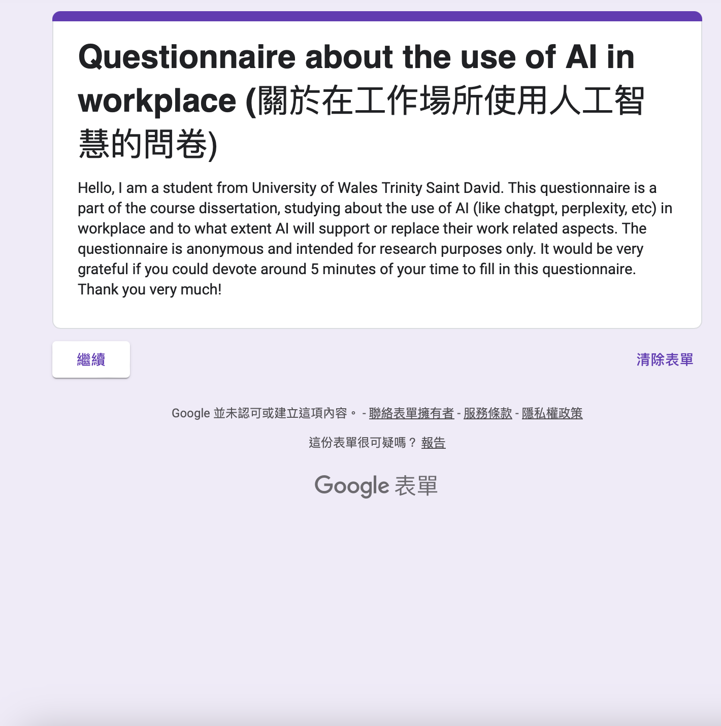
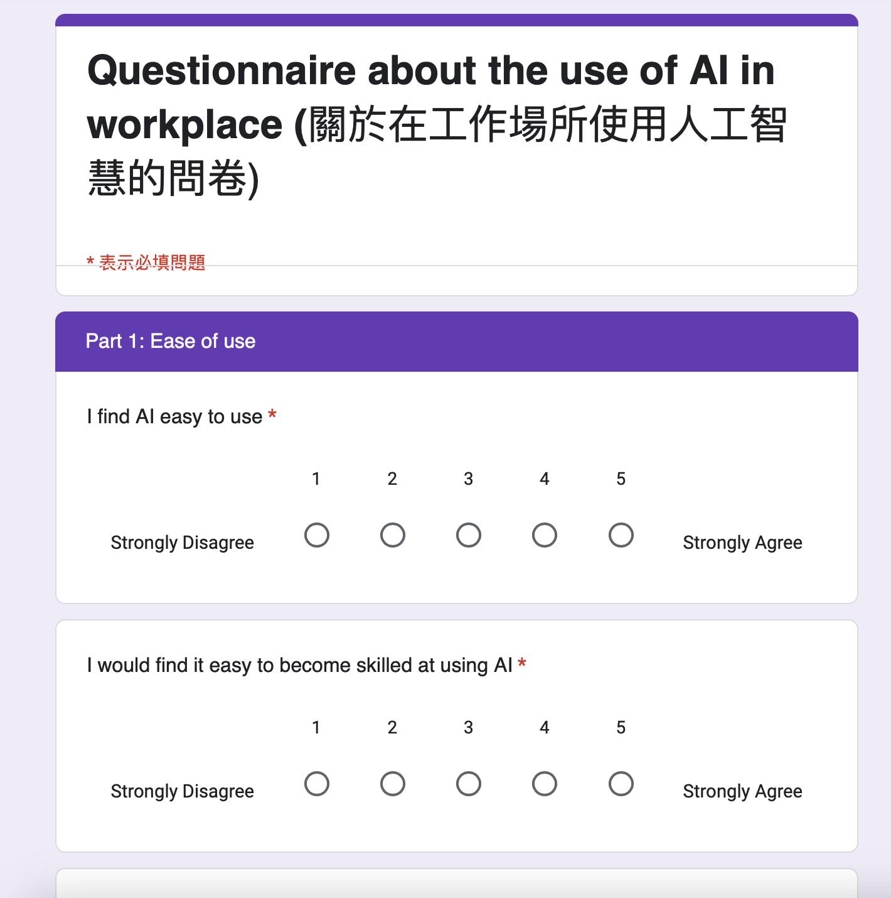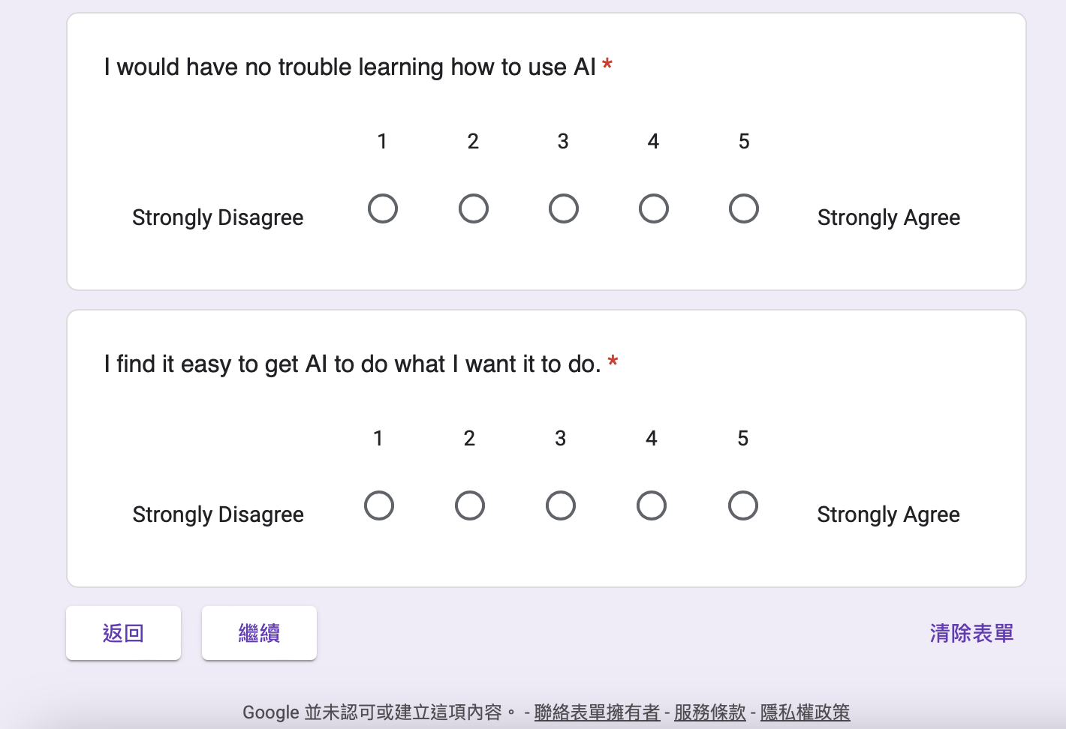
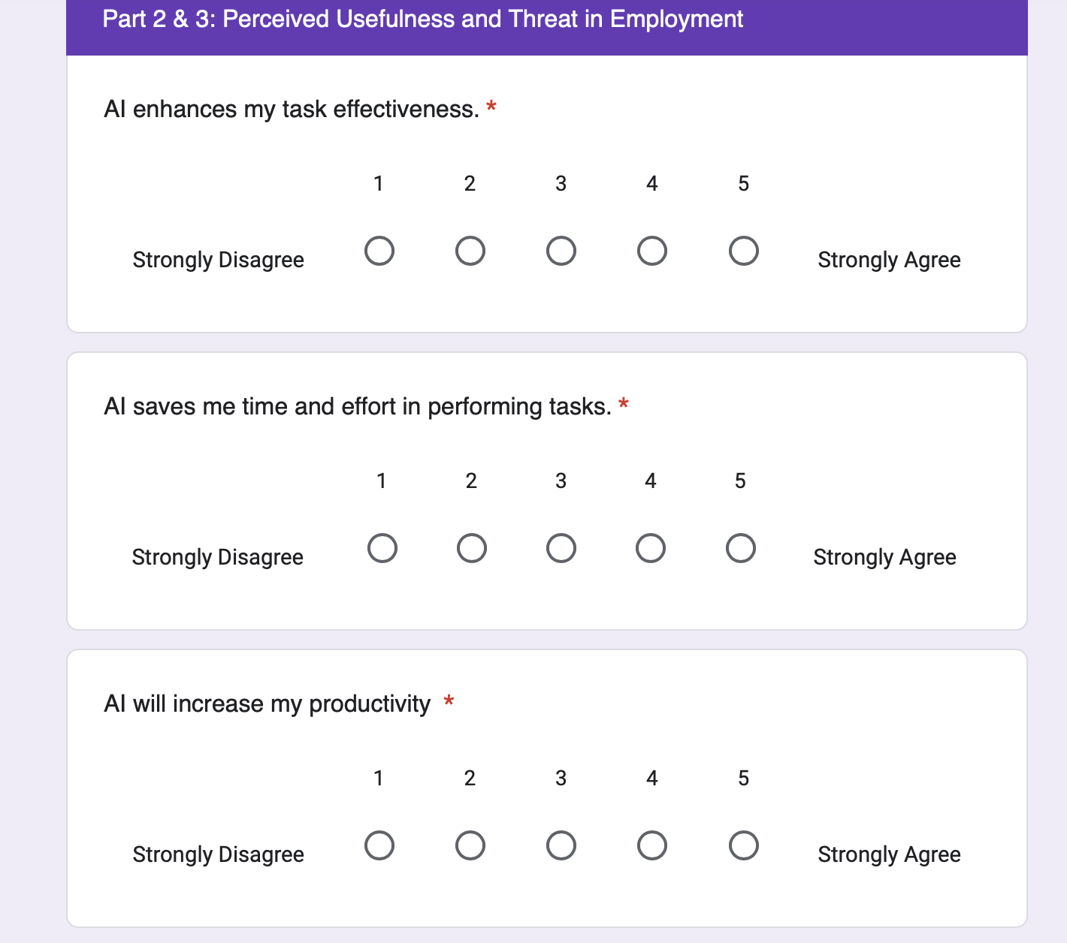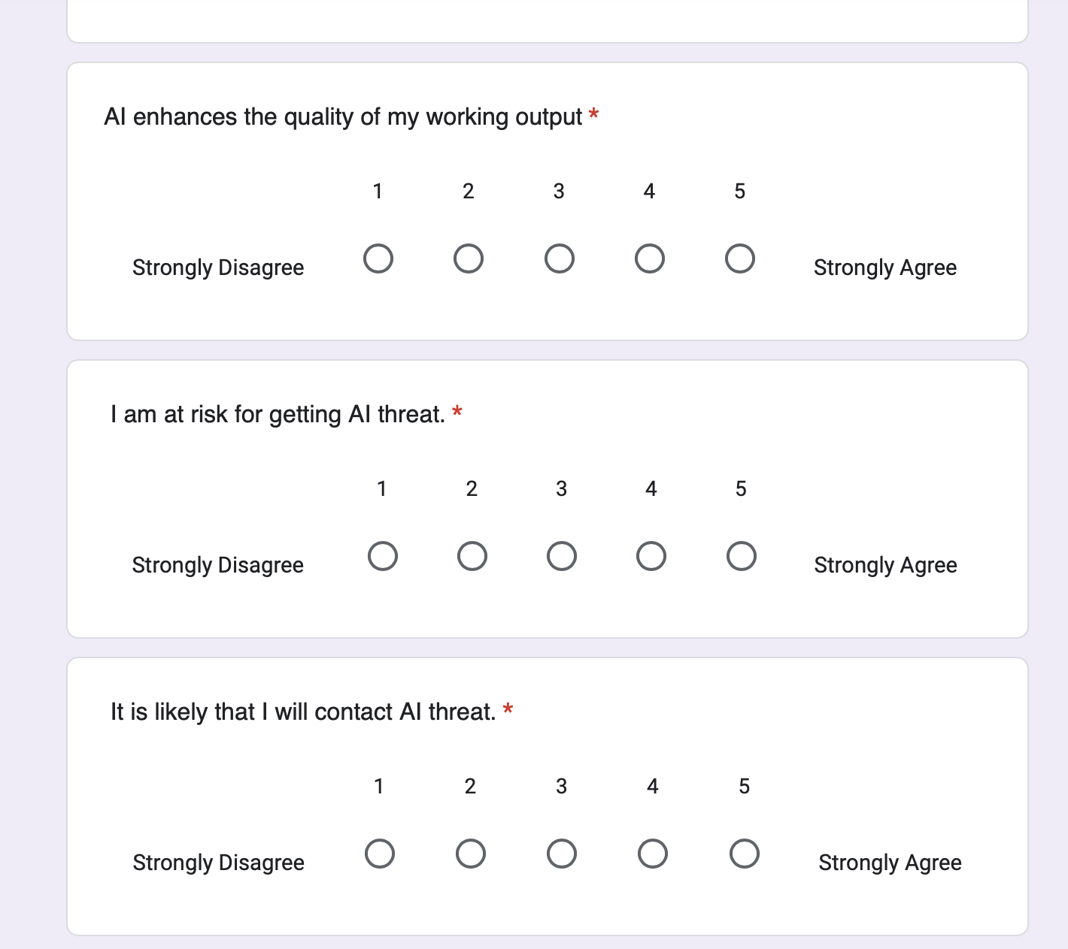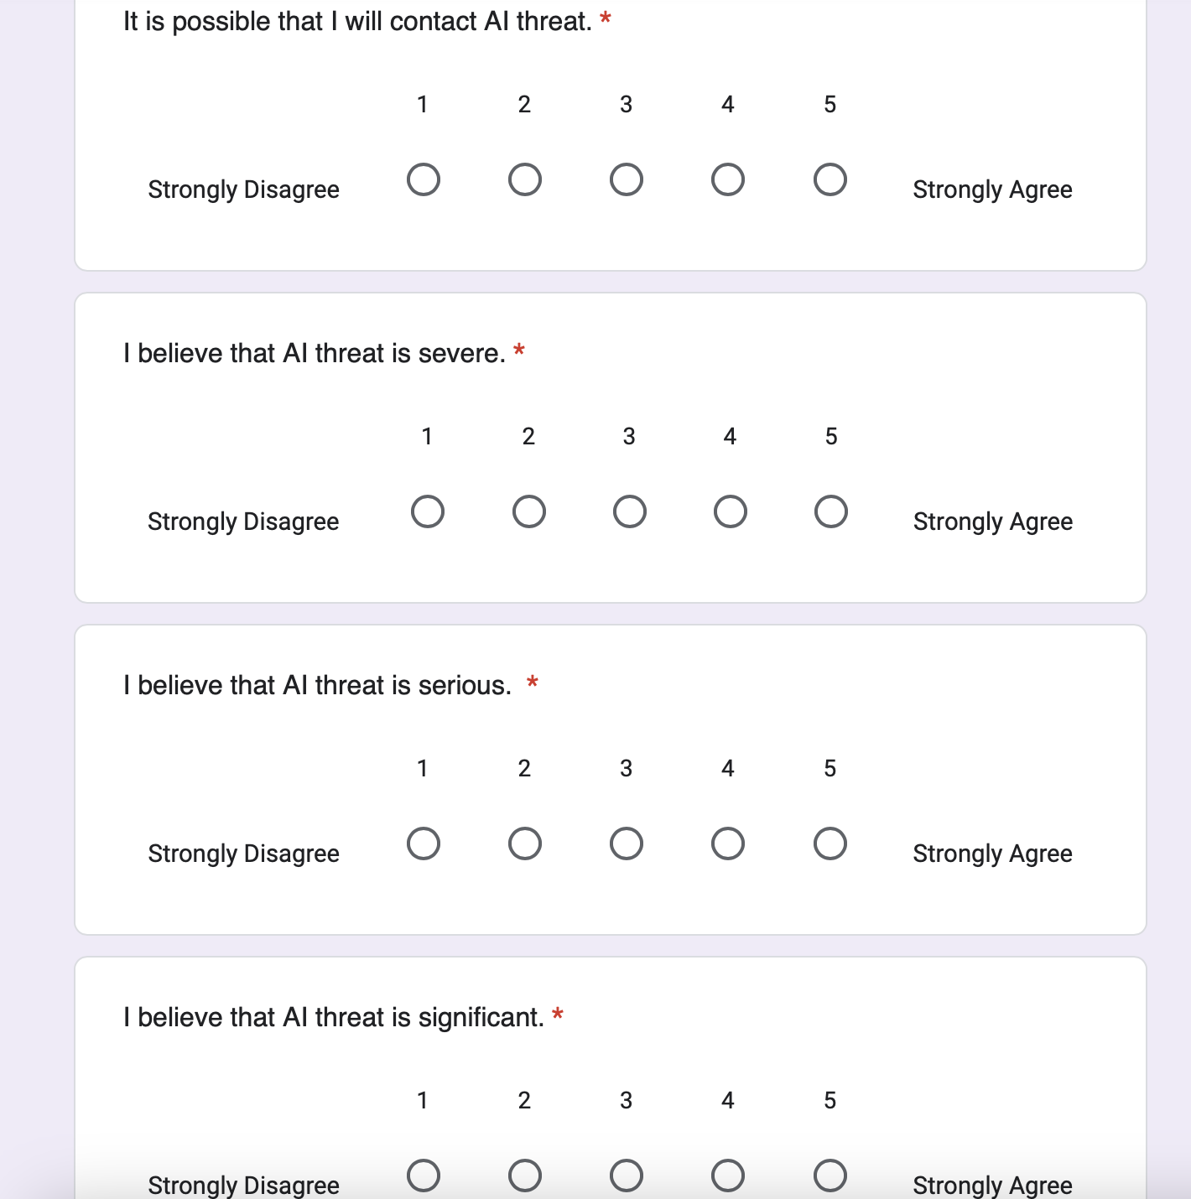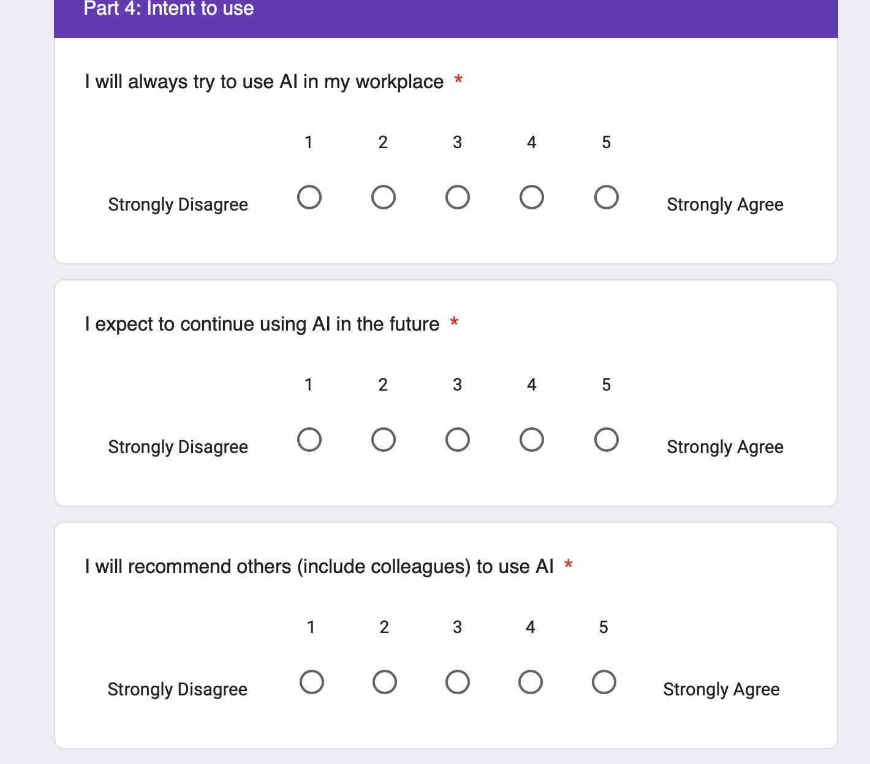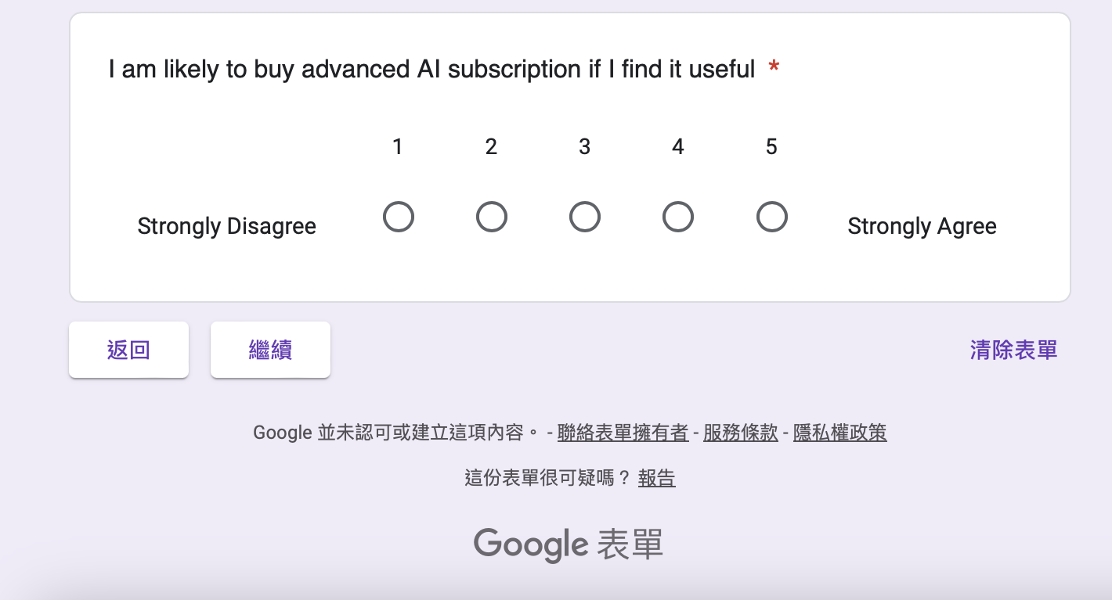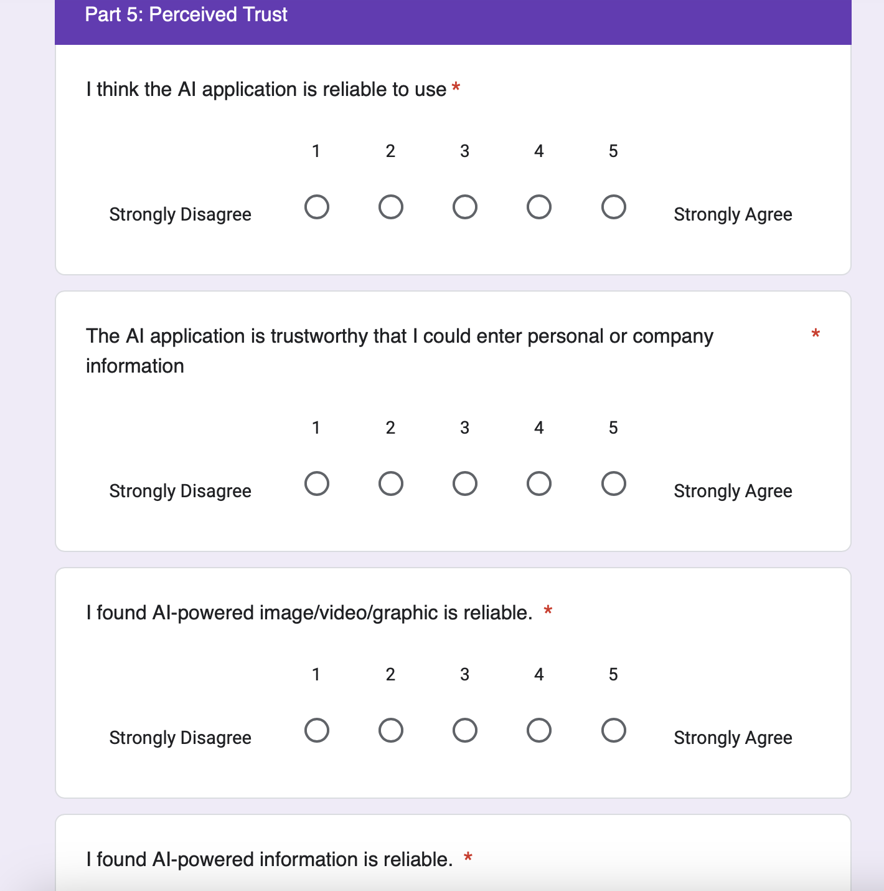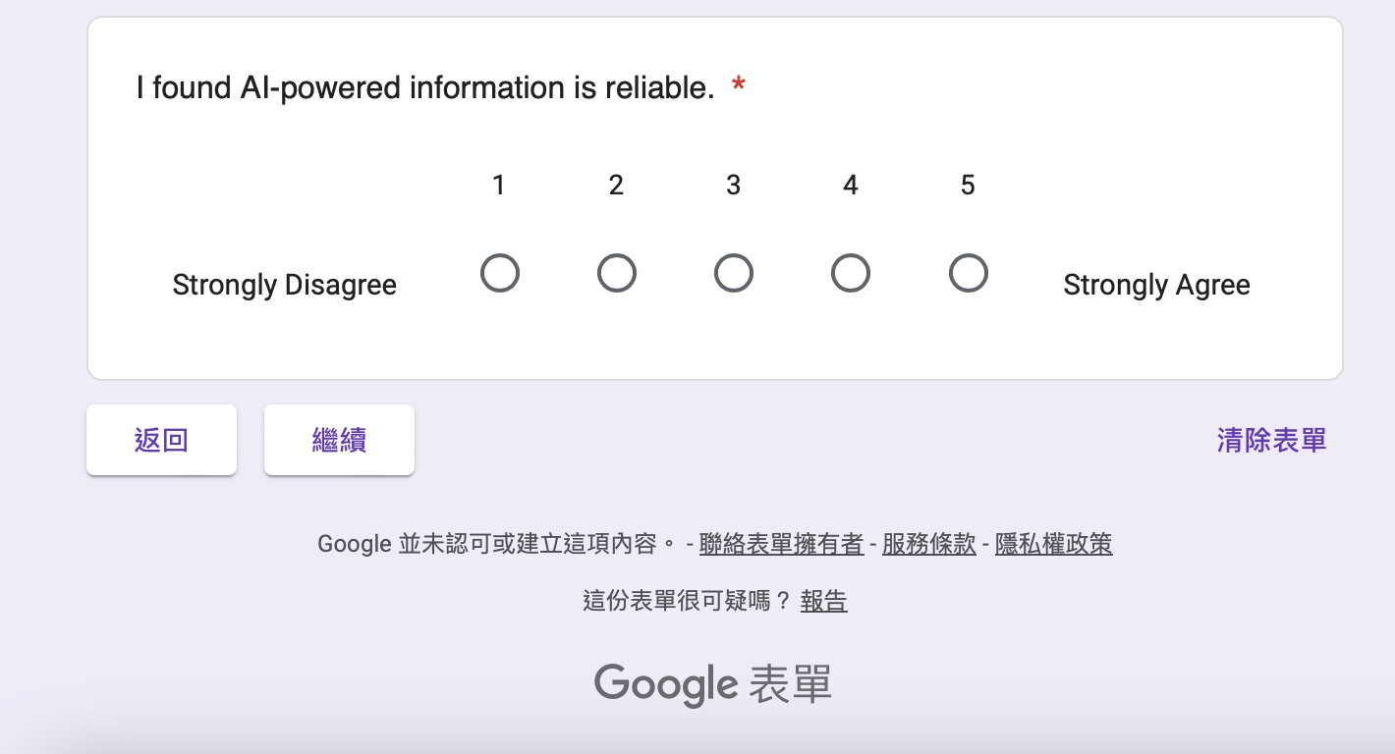
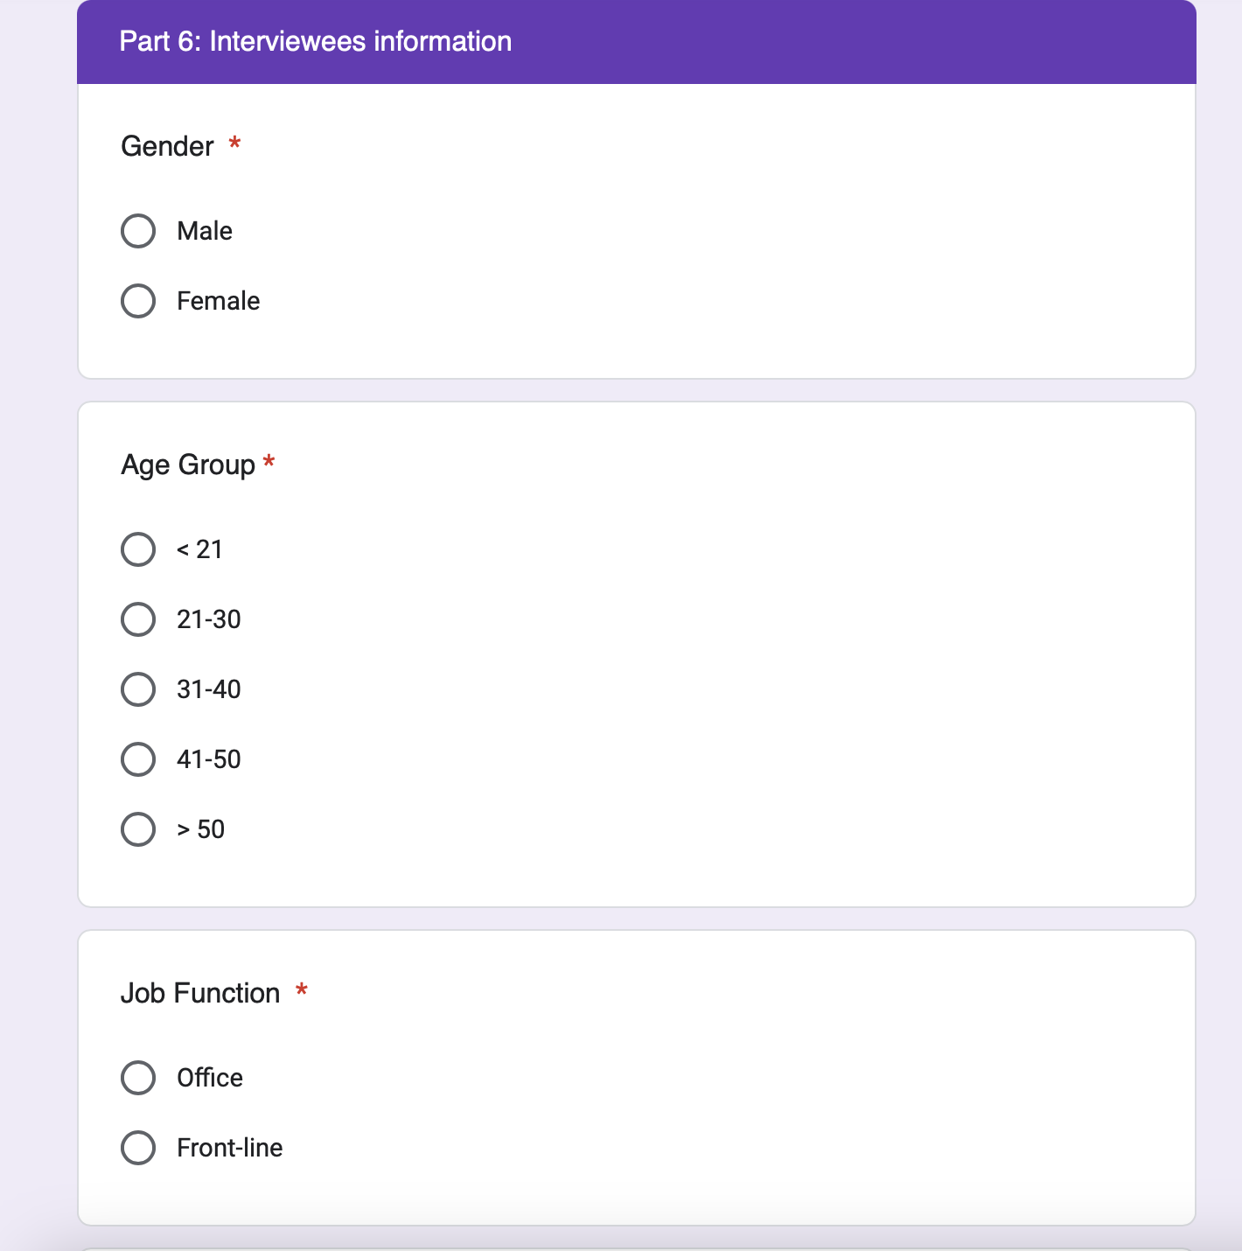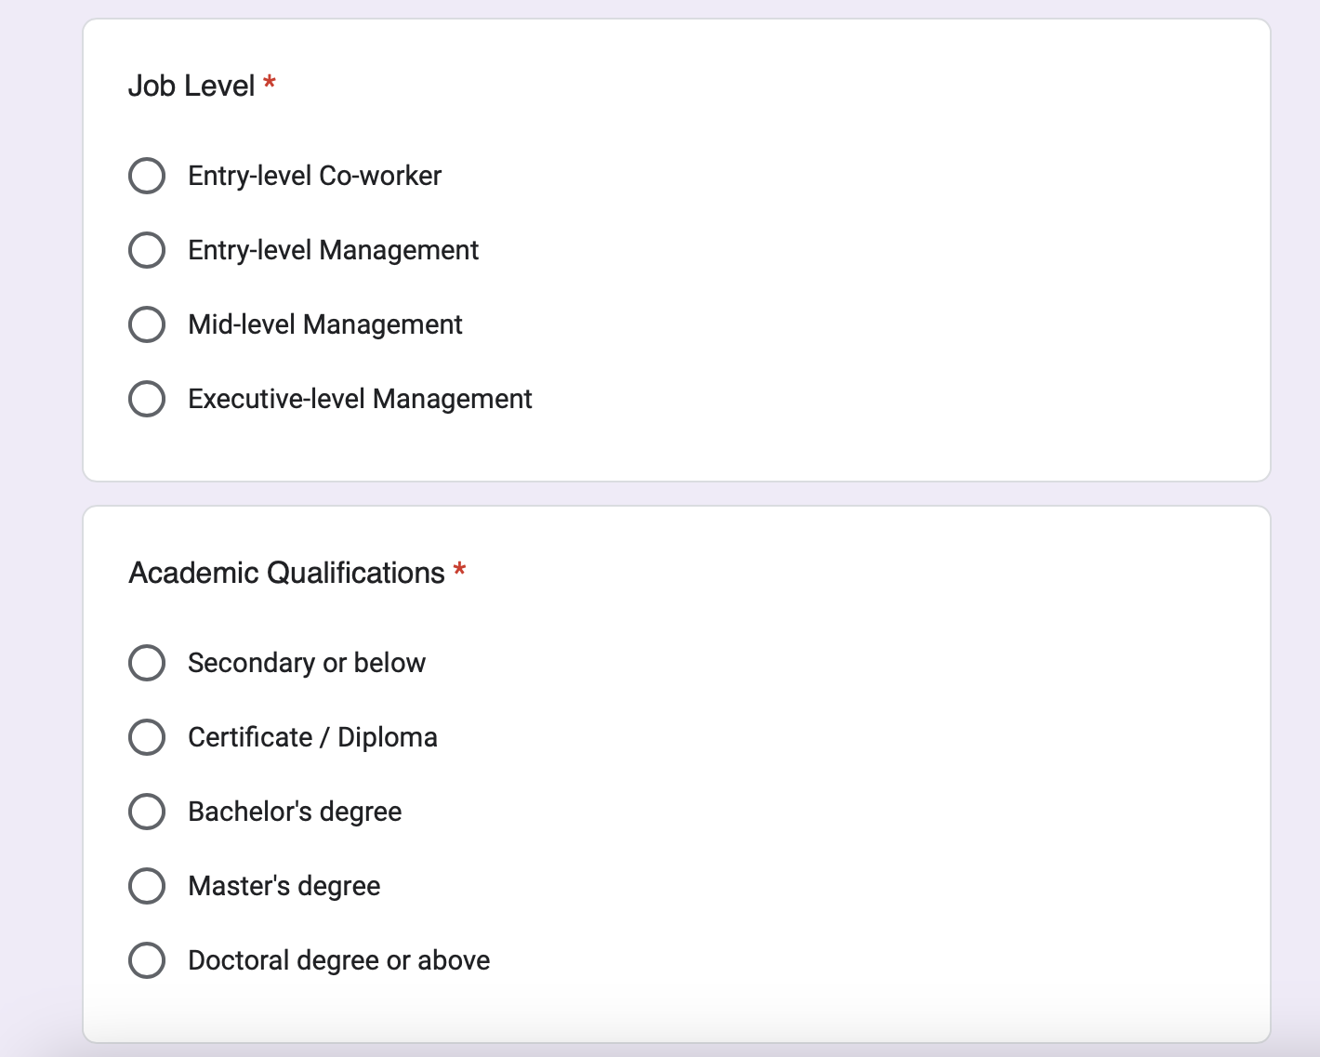

Appendix C: Final Survey

Appendix D: Sample Size Test

Appendix E: Descriptive Statistics

Appendix F: Rotated Component Matrix

Appendix G: Correlations

Appendix H: GA19 Dissertation Supervision Record Form



