

THE IMPACT OF DIGITAL MARKETING STRATEGIES TO GROW CUSTOMER BASE IN THE UK RETAIL INDUSTRY
-A CASE STUDY OF TESCO –

STUDENT NAME: VELICU BALASA
STUDENT ID: 2110947
LCBB6000
NUMBER OF WORDS: 7234

Supervisor: AFZAL SAYED MUNNA
Lecturer and Weekend Academic Coordinator
Abstract
The aim of the research study is to evaluate the influence of digital marketing practices on increasing the customer base in the UK retail sector with reference to Tesco. The present academic research is important as it has examined and defined the scope of strategies of digital marketing that Tesco has adopted. The consideration of the challenges encountered by Tesco and the prospective solutions undertaken makes the present study innovative. The research has been conducted by using quantitative methods including surveys. There has been use of interviews with the marketing executives at Tesco. Therefore, mixed methods have been used in the research. The study concluded with the data that Tesco's strategies of digital marketing have increased the base of customers. The study has been able to connect the theoretical body of knowledge about digital marketing with a company example, Tesco. Social media marketing, mobile marketing and email help Tesco reach many new customers and interact with them effectively. Complications include issues of data security and of technological change. The methods for increasing data protection and staff’s consistent training are crucial to maintaining the effectiveness of digital marketing and customers’ trust. An analysis of the study shows that 80% of the participants had a positive perception of Tesco’s digital marketing strategies. 64% acknowledged the effectiveness of the strategies and 80% also considered the virtual experience as commendable. the use of mobile applications has led to the expansion of the customer base by 1% which translates to 5. 14 million customers. The future implications of the research are consideration of advanced analytics of data, predictive analysis and comparative analysis of Tesco and other enterprises.

Table of Contents
Chapter 1 - Introduction 6
1.1: Introduction 6
1.2: Background of the study 6
1.3: Problem Statement 6
1.4: Aims, Objectives, Research Questions, Hypothesis, Propositions 7
1.5: Rationale/Importance of the Research 7
1.6: Methodology (sources, population, sample, measuring instrument, data collection, data analysis) 7
1.7: Scope of the Study/Demarcation (International, national, geographic area) 8
1.8: Structure of the Dissertation 8
1.9: Summary of Chapter 1 8
Chapter 2: Literature Review 8
2.1: Introduction 8
2.2: Base theory of the sub-discipline/different background aspects to the concept 9
2.3: Theoretical frameworks/models, and related research issues 9-10
2.4: Previous studies and lessons learnt 11
2.5: Gaps identified to situate own research 12
2.6: Summary of Chapter 2 13
Chapter 3 - Methodology 13
3.1: Introduction 13
3.2 Research Philosophy 13
3.2: Philosophical position of the research and why? 13
3.3: Paradigm position of the research and why? 13
3.4: Position of Research Approach and why? 14
3.5: Methodological stance of the Research and why? 14
3.6: Stance of the Research Strategy and Design and why? 14
3.7: Research Sample and Population 15
3.8: Data Collection and Data Analysis Tools/Techniques 15
3.9: Ethical Consideration of the Research 15
3.10: Summary of Chapter 3 16
Chapter 4: Data Analysis and Discussion 16
4.1 Introduction 16
4.2 Analysis and Discussion 17-22
4.3 Summary of Chapter 4 22
Chapter 5: Conclusions, Limitations & Recommendations 23
5.1: Introduction 23
5.2: Conclusions on each research issue/objectives/proposition 23
5.3: Conclusions on the research problem 24
5.4: Summary of the research findings and outcomes 24
5.5: Original Contribution of the Research (i.e.: management, academia, scholars) 25
5.6: Limitations of the Research 25
5.7: Recommendations/Areas for further/future research 26
5.8: Summary of Chapter 5 26
References 27-30
Appendices 31
Appendix 1 Survey Questionnaire 31
Appendix 2 Interview Questions and Transcript 32

List of Tables

Figure 1:Dissertation Structure 8

Chapter 1 - Introduction

1.1: Introduction
The study is considered with the analysis of the impact of the strategies of digital marketing for growing the consumer base through UK retail. Through this, the chapter is going to make an understanding of the research problem as well as the significance of the research.

1.2: Background of the study
Digital marketing is having a big impact on the UK retail sector because it makes a genuine link between businesses and their customers. In this context, it should be mentioned that retail businesses use a variety of strategies, including social media platforms, search engine optimization, and reaching audiences that are aware of digital trends, to make their goods and services more visible to consumers in the dynamic market (Dolega et al. 2021). Therefore, 41% of customers in the UK are in charge of controlling their active participation on digital marketing platforms. In order to increase sales, it helps retail organisations meet the expectations of digital marketing by expanding their consumer base inside their operational region (Sabanoglu, 2022).

1.3: Problem Statement
The study focuses on understanding the role and effects of digital marketing techniques in developing customer reach in the Existing UK retail sector considering the case of Tesco. As with any rapidly changing areas, new technologies are being incorporated into the vendor mix to expand both coverage, customer outreach and sales. This research also seeks to find out which of these techniques of digital marketing, like social media marketing, email marketing, content marketing, and SEO are most effective in terms of customer acquisition and customer retention. Furthermore, about how these strategies work and how data science is applied to enhance their effectiveness and the churn rate. The research will use case studies and existing data to identify the trends and offer recommendations on how UK retailers can expand their customer base in the severed competition and the changed market conditions that are tilted towards online commerce. The results should assist in revealing how digital marketing can act as a key enabler of retail development and customer acquisition in the United Kingdom. Tesco has some problematic aspects, especially in digital marketing where it faces obstacles in data security and technological implementation. Some of them include data breaches and inadequate training of the employees on emerging technologies. This background propels the research questions towards emphasizing the ways through which Tesco can improve its digital initiatives amid these major challenges.

1.4: Aims, Objectives, Research Questions, Hypothesis, Propositions
Aim - The aim of the research study is to analyse the impact of digital marketing strategies on growing customers based in the retail industry of the UK.
Objectives
- To analyse the concept of digital marketing
- To examine the impact of digital marketing strategies to improve the customer base within the UK retail.
- To identify issues that the UK retail faces in case of improving customer base through digital marketing strategies
- To recommend strategic development for avoiding digital marketing issues in the retail industry to improve the customer base.
Questions
- What is the impact of digital marketing strategies to improve the customer base in UK retail?
- What are the issues that the retail industry of the UK faces in the case of improving customer base through digital marketing strategies?

1.5: Rationale/Importance of the Research
This research project performs well enough to be considered noteworthy since it provides readers with a thorough understanding of the many obstacles that arise when using digital marketing strategies to expand a company's consumer base. Therefore, the findings of this study will also assist in developing plans or engaging in successful tactics within the operational domain of various retail firms to increase their client base through digital marketing methods. Additionally, compiling data from the present study, will provide the researcher with opportunities to do research on the same issue in the future.

1.6: Methodology (sources, population, sample, measuring instrument, data collection, data analysis)
The study is developed with the primary data analysis where the analysis of the quantitative data is developed. The sample size for the research is 25 as 25 consumers from the different UK retail are selected for the data analysis. Survey questionnaires are the main tool for analysing the raw data from the participants.

1.7: Scope of the Study/Demarcation (International, national, geographic area)
This research project performs well enough to be considered noteworthy since it provides readers with a thorough understanding of the many obstacles that arise when using digital marketing strategies to expand a company's consumer base. Therefore, the findings of this study will also assist in developing plans or engaging in successful tactics within the operational domain of various retail firms to increase their client base through digital marketing methods. Additionally, by compiling data from the present study, it will provide the researcher with opportunities to do research on the same issue in the future.

1.8: Structure of the Dissertation

Figure 1: Dissertation Structure
Source: (Self-developed)

1.9: Summary of Chapter 1
This is the chapter that developed general concepts of digital marketing strategies. Through this, there is the consideration of the general problems of the research area. On this note, the chapter is also focused on the research problems that can make a critical demonstration of the research study.

Chapter 2: Literature Review

2.1: Introduction
The chapter is going to make an analysis of the general idea of the research area. Through this, there is the consideration of the theoretical presentation of the research area. The chapter is focused on the analysis of the previous studies regarding the research study. Through this, the analysis of the literature gap also makes a proper understanding of the analysis of the research study.

2.2: Base theory of the sub-discipline/different background aspects of the concept
A brief understanding of the theoretical framework on which many digital marketing initiatives in the retail industry are based is presented below: There is the AIDA model among widely known theories, which describes the process a consumer experiences when deciding to make a purchase (Song et al., 2021). Digital marketing initiatives therefore seek to gain attention through content that is interesting, appeal through messages that are informative and interesting, and get people to take action by designing persuasive offers that are customised and linked to Excellent follow-up calls to action. Another crucial one is known as customer journey mapping which refers to the definition and continuous improvement of the possession a customer acquires from the point when he or she gets to know about a certain brand up to the moment he or she gets support after buying a product. Segmentation and targeting are very important since retailers have to split the market into certain groups according to their data of demographic, behavioural or psychographic nature and then act to favour every segment with the proper measures.
Content creation with specific reference to blog and article writing is very crucial alongside search engine optimization (SEO) in that the content posted online has to be credible and appealing to the potential market. Omni-channel retailing integrates several digital as well as the physical shopping touch-points to offer a better shopping experience while also increasing customer satisfaction and loyalty (Mosquera et al., 2017). It is the use of social media platforms such as Facebook, Instagram and Twitter to create awareness, interact with the clients and create a place for the customers. The approach of using emails for selling and communicating with customers still proves to be effective. Finally, data analytics and machine learning allow retailers to analyse the consumers' activity, and their behaviour and predict their patterns as well as to target them in a more effective manner. All these theories and concepts put together help retailers to be well-equipped and enable the expansion of their customer base while operating within a constantly shifting interface of digital commerce and client demands.

2.3: Theoretical frameworks/models, and related research issues
Theoretical concepts and paradigms also help in offering a logical way of analysing the various aspects of digital marketing strategies in the retail sector. The most common model, at present, is the 5S model, which consists of Sell, Serve, Speak, Save, and Sizzle. It outlines that selling products, serving customers, conversing, offering savings, and stirring up interest are critical factors to achieve monetization and consumer devotion. Despite this, critics have pointed out that the 5S framework presents a very good overall view of digital marketing strategies but brings out just a simple perspective of the same.
Another widely used model is the STP model which stands for Segmentation, Targeting, and Positioning, which focuses on marketing communication that deals with the appealing and convincing of a distinct customer segment. However, some scholars opine that the STP model may lack efficacy as it fails to accommodate the fact that consumer behaviour may change over time and thus may require a constant overhaul of the firms' marketing strategies due to changes in the digital arena.
Furthermore, customer engagement concepts like the Customer engagement model (CEM), illustrate how bonding with the customers on an emotional level helps in creating loyal and advocating customers (Fernandes and Castro, 2018). Although this framework gives helpful suggestions it could be insufficient in addressing the given practical realities that question how such objectives can be met in practice using digital marketing tools.
In regard to the other research-related issues, it is evident that the accurate assessment of the impact of digital market communications in the expansion of the consumer base is still a bit of a puzzle. Although tools like click-through rate, conversion rate and return on investment are widely used, there is still scope for more comprehensive measures that can truly reflect the impact of digital marketing on consumer behaviour and brand perception.
As per Wuisan and Handra, (2023) another question that can be crucial to digital marketing communication is the role of the convergence of online and offline communication. Although the omnichannel marketing strategy is used prolifically, the successful coordination of all the channels continues to be an issue of much concern for most firms in the retail industry.
Third, some of the trends that are unique to digital marketing that must be considered include privacy and data management which have become an important consideration in the wake of the GDPR. While customer data is a valuable tool in targeted promotional campaigns that can get more customers to shop in the retailers’ outlets, the retailers have to be careful that they do not infringe on the customers’ privacy rights or the regulatory rules governing the use of such data.
In summary, this research contributes to the extant literature by discussing the theoretical frameworks and models of DM strategies in the retail sector, but there is a deemed importance for more empirical research to address the practical concerns and issues of this rapidly evolving field.

2.4: Previous studies and lessons learnt
E-Commerce has brought a revolution to the retail business and has had significant effects on the consumption patterns of consumers (Wang et al., 2020)
Consumer Behaviours and Expectations
Informed Consumers
According to Schweidel et al., (2022), the use of digital tools in consumerism makes consumers more informed. According to this source, customers naturally search for reviews and compare different products before purchasing online. Retailers have to do their best to fulfil these expectations by being more transparent and guaranteeing product quality.
Personalization
It also makes it possible for retailers to gather data and even give individualised attention to their shoppers. Service customers expect to receive offers and promotions relevant to them; Thus applying this data can enhance customer relations.
Reviews and Trust
It was also noted that recommendations through online reviews and ratings are highly influential to the consumer. In the opinion of Kerschbamer et al., (2023) consumers give credence to the opinions of other consumers and allow such opinions to guide their purchase decisions. By using positive reviews and user generated content as seen above, credibility and trust are built up.
Shift in Shopping Patterns
Online Shopping
The most significant factor explaining its use is that it has proven to be very convenient. E-commerce platforms provide numerous products, comparison to product features, and convenient delivery services, as is expected by modern consumers (Dong, 2021).
Mobile Shopping
According to Siyal et al., (2024), mobile devices are an integral part of shopping. Customers use them to search for products, read some of their reviews, and buy, thus making the combination of online and offline shopping less distinct.
Omnichannel Experience
Retail is moving to these new strategies and these are successfully summarised by the term “omnichannel.” This is in accordance with Brands' approach that seeks, as far as possible, to offer a uniform shopping experience in physical stores, over the Internet, or using handheld devices. The consumer journey is a continuous one in the minds of the consumers and as such, it should not be fragmented.
E-channels have become embedded in the consumer buying process and value as has been characterised by increased e-shopping and mobile buying (Wagner et al., 2020). Consumers are expecting a more individualised and seamless shopping process across all touchpoints, leaving retailers no choice but to apply this change as a means of survival.

2.5: Gaps identified to situate own research
There are several gaps within the current literature and research relating to employing digital marketing techniques for the expansion of consumer bases in the UK retail sector. These include a lack of systematic reviews that evaluate how particular advertising strategies, for example, social networks or targeted email marketing, foster customer acquisition and loyalty. Therefore, it is essential to review the literature that addresses the application, coordination, and impact of multiple digital media platforms and technologies like AI and machine learning in the promotion of products and businesses. Earlier research was found to have shortcomings mainly in the sense that there was no exhaustive study of the relationship between electronic marketing communication and customer interactions in the retail industry. This research is therefore useful in filling the gap of a case-to-case account of Tesco, looking at the specifics of their use of digital marketing, the consequent changes in their customer base and the problems they experienced. Although previous research offers an overview of potential digital marketing initiatives, existing scholarly works tend to overlook the precise application of these measures concerning the enhancement of customer bases in the UK retail industry. Therefore, this research seeks to fill that gap by establishing the impact of Tesco’s digital marketing on its customer base. The problems that affect the UK retail business and strategies used to address them are also discussed in the research. The use of this strategy is to offer solutions for dealing with difficulties in digital marketing and for enhancing client base development within the field of retail. In addition, there is a lack of published literature related to the UK retail market, which underscores the importance of more papers that offer relevant information addressing the context of the market.

2.6: Summary of Chapter 2
The chapter that focuses on a review of the literature offers a synthesis of previous studies on digital marketing practices in the retail sector. Through it, you learn about models like AIDA or customer journey maps as well as fundamental concepts such as segmentation and targeting. It emphasises content marketing, search engine optimization, and channel selling strategies Use of calls to action on the website social media marketing Use of email marketing use of analytics study. The chapter provides a synthesis of the findings pertaining to the ability of these strategies in seeking and maintain customers, improving customers' experiences, as well as increasing sales. It also defines areas that have not been explored earlier, making the current study to build on new findings and give recommendations to the retailers for expansion of the base of consumers.

Chapter 3 - Methodology

3.1: Introduction
This is the chapter where the researchers are going to present different methods of the data collection. Through this there is the consideration of the development of the entire strategy of the research. Here ethical consideration of the research study also developed that can create proper value through the development of the research data.

3.2 Research Philosophy
In order to determine the effect of digital marketing tactics on growing the client base in the UK retail sector, the researcher in this proposal adopted a positivist research philosophy. According to Mbanaso et al. (2023), the positivist philosophy aims to assist researchers in gaining information about their subject matter through the analysis of activity, action, or reaction.

3.2: Philosophical position of the research and why?
In order to determine the effect of digital marketing tactics on growing the client base in the UK retail sector, the researcher has chosen to employ a positivist research philosophy in this study proposal. The positivist philosophy analysis activity, action, or reaction to assist the researcher learn more about the subject (Mbanaso et al., 2023).

3.3: Paradigm position of the research and why?
Descriptive study design was chosen by the researcher in accordance with the research paradigm. It helped the researcher determine how digital marketing techniques may increase the size of the retail industry's consumer base. Determining traits associated with consumer interaction and digital marketing is also beneficial for achieving outcomes (Siedlecki, 2020).

3.4: Position of Research Approach and why?
For the research study on "The Impact of Digital Marketing Strategies to Grow Customer Base in the UK Retail Industry: In "Strategic Management: A Case Study of Tesco," a mixed-method approach was highly appropriate. Therefore, by using both qualitative and quantitative data collection methods, the subject could be understood or captured in its entirety. The numerical data from the consumers' interaction, sales velocity, or website hits offered a strong benchmark for validating the outcomes of virtual marketing campaigns. However, surveying customers and conducting interviews with Tesco's marketing department provided a significant understanding of the factors that influenced the buying behaviour and attitude towards digital advertisements.
Thus, the use of both approaches guaranteed that the study included quantitative results of digital marketing alongside the qualitative nature behind such figures. This made the study access other related data to confirm the findings hence improved internal and external validity. Therefore, adopting both methods allowed for comprehensive evaluation and provided recommendations for enhancing Tesco’s modern approaches to digital marketing for the purpose of attracting more clients.

3.5: Methodological stance of the Research and why?
The researcher employed strategies, sample techniques, and data gathering procedures to carry out the total task in this present study project (Pandey and Pandey, 2021). In order to fulfil the study's objectives, it helped the researcher learn more about the effects of digital marketing techniques on the retail industry's consumer base.

3.6: Stance of the Research Strategy and Design and why?
The research method and plan on exploring the effectiveness of the digital marketing techniques that would be used in increasing the number of customers of the UK retail sector with a focus on Tesco also involves the use of mixed research design. This design incorporates quantitative data culled from customer questionnaires as well as marketing data derived from marketing confirming the quantitative data derived from specific questions posed to Tesco’s marketing team. The logic behind such an approach is to obtain detailed information about the customers’ behaviour, choices, and their reaction to various digital marketing campaigns. More importantly, qualitative information gives more meaning and further explanation to certain strategic management interventions and their performance. Hence, the expansion of the customer base by digital marketing strategies will be examined through both qualitative and quantitative data in the study. It confirms strong research results providing vital recommendations for improving the digital marketing strategy in the retail business. Tesco is a timely company as it is among the leading retailers from the United Kingdom and has adopted vivid digital marketing strategies for its business.

3.7: Research Sample and Population
A straightforward random sampling strategy used by the study to determine the appropriate sample size for data collection. The researcher must be assisted in choosing a certain sample size from a variety of demographics by using this particular strategy (Obilor, 2023). In order to get feedback on the effect of digital marketing tactics on growing the company's client base, the researcher used a sample size of twenty-five customers from various Tesco stores in the UK. On this note, the researcher collected the primary qualitative data through interviews from four people of Tesco marketing department. The justification for choosing the sample size of 25 is that the research focuses on Tesco’s digital marketing possibilities within the framework of a finite sample. Nonetheless, the study might have used a small sample hence reducing external validity. The limitation of the survey is solved through the use of data with the help of qualitative interviews that make the data abundant and accurate.

3.8: Data Collection and Data Analysis Tools/Techniques
The researcher collected primary data about the topic area by applying the primary data collection process (Mazhar et al., 2021). The primary data was collected using a quantitative method, which must aid the research in obtaining accurate results regarding the role that digital marketing is playing in strengthening the customer base within the UK retail industry. On this note, primary qualitative data was also collected through this research study from the marketing department of the organisation.

3.9: Ethical Consideration of the Research
The participants through the research study are provided with the consent form and this makes sure that the participants are giving the information from their own wish. This can make proper ethical value through the development of the research study. It is also made sure that the researchers did not manipulate the participants for giving any type of the information. On this note, all of the data related to the research study are protected under the Data Protection Act. After the completion of the research study all of the data will be removed from the storage. Even, it is made sure that there will be no access of the third party to use the dataset. The study safeguarded the anonymity of the participants as a way of guarding their identity. This study specifically sought informed consent as the participants were aware of the data to be used in the study. Data was collected and kept secure and undisclosed to anyone and this study respects GDPR and all other regulations to do with data protection of the participants.

3.10: Summary of Chapter 3
This research study's methodology chapter uses Tesco as a case study to examine how digital marketing techniques affect the expansion of a company's client base in the UK retail sector. Using a combination of quantitative data from online surveys of Tesco consumers and qualitative data from in-depth interviews with Tesco marketing executives, it uses a mixed-methods approach. Measures of sales growth, consumer involvement, and satisfaction are the main topics of data collecting. The chapter explains the data analysis methodologies, sampling tactics, and ethical issues in order to provide readers a thorough grasp of how Tesco's digital marketing initiatives affect both customer acquisition and retention.

Chapter 4: Data Analysis and Discussion

4.1 Introduction
The present chapter will present and examine the data findings. In the present chapter, data findings collected from surveys will be presented in the form of graphs. The chapter will analyse these findings and support the analysis of the interview transcripts. The complete chapter will assess the data findings as per the research objectives.

4.2 Analysis and Discussion
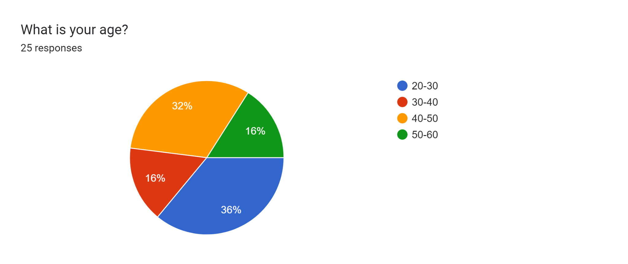
It can be seen from the above chart, that the age group of 50-60 comprises 36% of the survey participants, followed by the age group of 30-40.
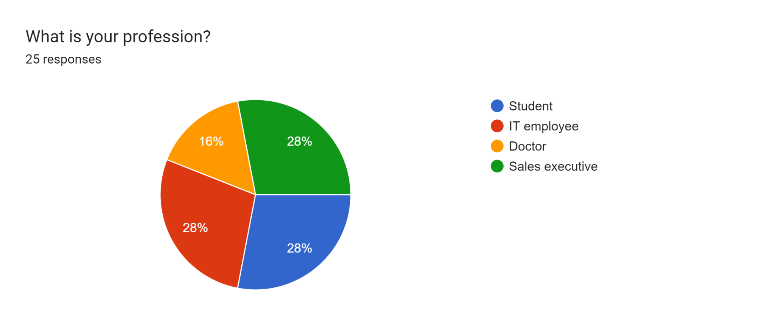
As per the above figure, 28% of the participants belong to the occupational group of both IT employee and student.
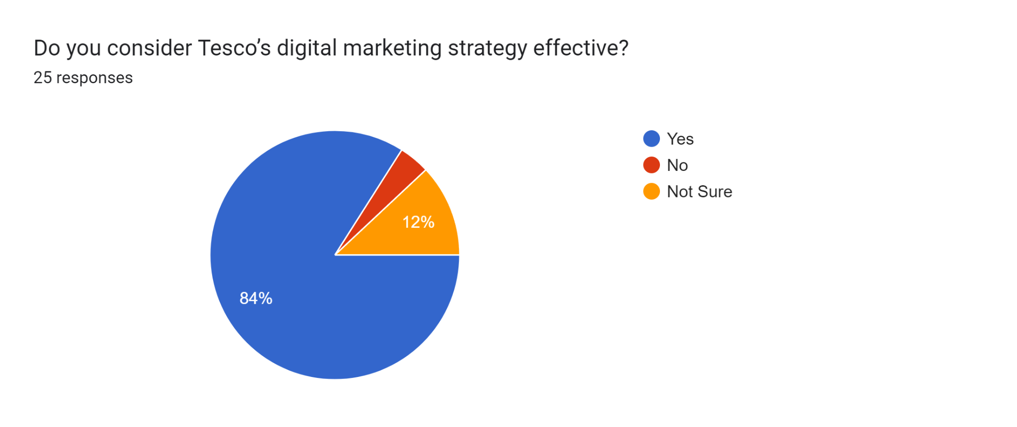
It can be observed from the above figure that the majority of 64% of the participants consider that Tesco has adopted a strategy of digital marketing.
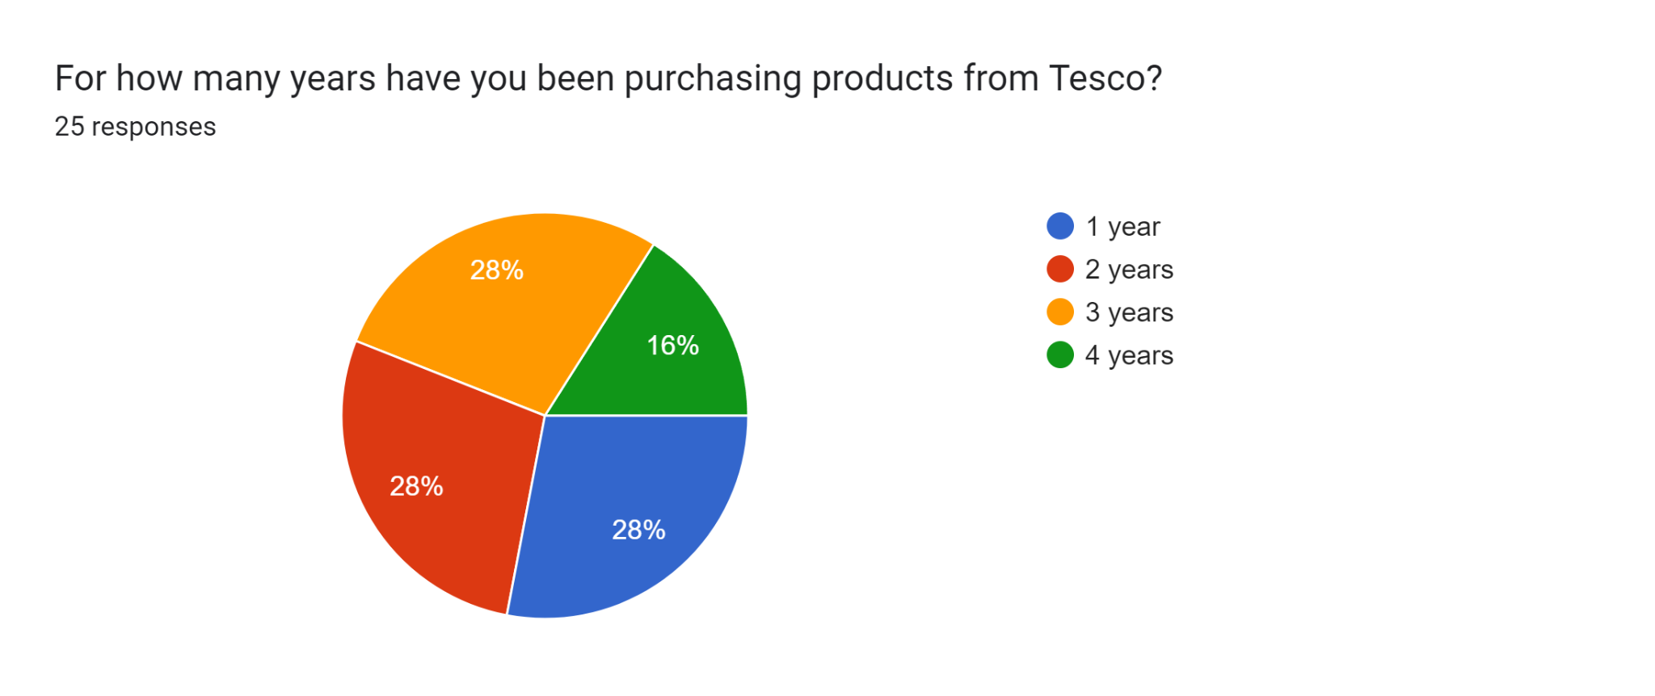
It can be seen from the above figure that 28% of the participants have purchased products for 1, 2 and 3 years from Tesco.

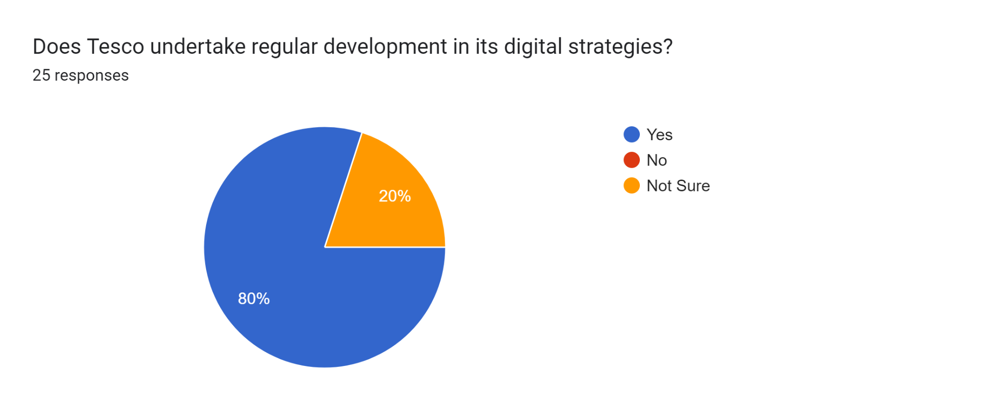
As per the above graph, it can be seen that 80% of the participants consider that Tesco undertakes developments in strategies of digital marketing.
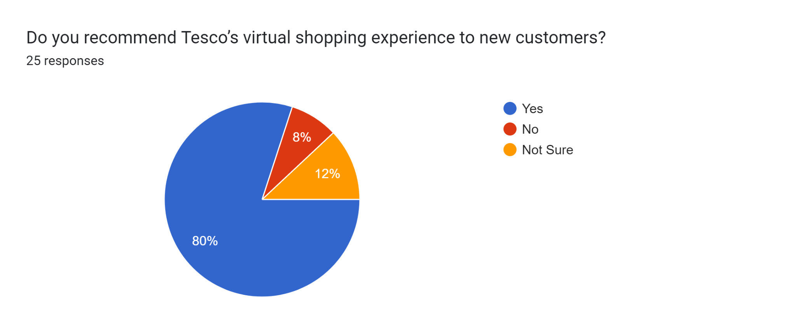
As per the above chart, 80% of the respondents consider the virtual experience provided by Tesco recommendable.
Based on the above charts, it can be stated that practices of digital marketing are an important aspect of Tesco's enhancement of its customer base. Digital marketing is defined as the inclusion of different channels for connecting with stakeholders, including consumers (Peter and Dalla Vecchia, 2021). Digital marketing simultaneously refers to the use of Web 2.0 tools and the Internet. The major digital channels that are leveraged are marketing through social media, content marketing, SEO and email marketing. The adoption of these channels helps an organisation to reach an extensive base of customers with minimum effort, time and financial resources. The use of digital channels has gained prominence with developments in technology, competition edge and meeting the changing demands of the customers. This aligns with all the components of the 5S model.
Tesco, a prominent retail supermarket in the UK, has also adopted the practice of digital marketing for the perpetuation of its customer base. 80% of the consumers in the survey have affirmed that Tesco has effectively included its strategies of digital marketing. A similar insight is gained from the interview conducted with managers in the marketing department. The company has leveraged different digital platforms such as Twitter, Facebook and Instagram to connect with the consumers. For example, Tesco with its digital strategy of marketing has been to reach 42 million users on TikTok (MarketingWeek, 2023). The use of digital channels has helped the company in sharing information about specialised deals and products. The coordination with the consumers through this method has helped in improving customer engagement and keeping them informed. The active presence on social media platforms has helped the purchasers in solving any queries and concerns (Dong, 2021), and it has improved the service to the customers. A prominent digital medium that has been harnessed by Tesco is the organisation’s official application. This digital tool has supported the customers in easily navigating through the products of the company and also collecting points of Clubcard. Tesco has simultaneously focussed on mobile marketing. Mobile marketing has grown in importance for providing customers with options of convenience, accessibility and ease of use (Siyal et al., 2024). Mobile marketing has been included for the customers by integration of the official and dedicated mobile application, Tesco Mobile App (Tesco, 2024). Through the application, the customers are given easier options to navigate the range of products offered by the organisation. The easier navigation is also supported by options for filtering the location of the store and checking coverage. The convenient options in the Tesco Mobile App have increased the customer base by more than 1% which translates to nearly 5.14 million customers (Agnew, 2022). Even easier options for payment are integrated in this application making the process of digital innovation strengthened. Being a popular business, it uses the internet to access a large population in the shortest time possible with the objective of improving the customers’ experience, increasing its brand appeal, and, therefore, increasing sales. It is evident that the utilization of digital marketing approaches has expanded the customer base for Tesco. Mobile applications, emails and social media as the primary advertisement channels are suitable for targeting customers directly and providing the best shopping experience. These strategies have benefited by enhancing customer loyalty, increasing sales and expanding the market base.
The offering of convenience through the digital tool has encouraged the audience to regularly shop and increased customer loyalty. On the other hand, email marketing has been used for directly connecting with customers. The use of this marketing has enabled in sending of personalised newsletters and offers. The efficacy of email marketing and its exclusive offers have resulted in open rates of 87% (Faull, 2020). Tesco has taken the help of data analytics in gaining information about the consumer’s search history and sending recommendations based on this. The said strategy has been useful as the customers in advance get recommendations based on their choices. The proactive and targeted outlook of the company has assisted in boosting sales. Simultaneously, when the customers get to choose products from the company, they feel the urge to recommend the company to new customers. During the last quarter of 2020, the sales of the company have increased by more than 15% (Bedford, 2024). Therefore, both the instances of attraction of new customers, increasing customer base and repeated purchases are strengthened.
Tesco however also faced certain challenges in the implementation of the practice of digital marketing. The primary challenge has been encountered due to the rise in concerns about data security. Tesco's digital tactics of digital marketing have increased the intensity of customer recommendations. Customers when purchasing products through online platforms prefer easier navigation and convenience (Kerschbamer et al., 2023). It has been seen from the survey findings that 80% of the respondents consider the virtual experience provided by Tesco recommendable. The application of digital channels has made it easier to compare the products in terms of specifications, product usage and price (Schweidel et al., 2022). In a similar vein, the integration of comments and reviews on all the digital platforms such as social media sites and the mobile application makes the comparisons more consolidated. New customers can know the products in more detail and are able to make more prospective decisions about whether they will buy products from Tesco.
Manager 2 in the interview has talked about this issue in particular. The foundation of digital marketing lies in dependence on the collection of information from the customers and storing them. The said information in the absence of effective data protection protocols lies completely vulnerable to external attacks and manipulation by third parties. Similarly, the information is stored on the cloud storage making such instances of data breach more prevalent. The other loophole in the exhaustion of the practice of digital marketing lies in the lack of acceptance among human resources. The organisation in some instances feels that the development and training provided to the staff are not as par with the change in technological developments (Stanikzai and Ali, 2024). It is the absence of skill upgradation that leads to resistance among the staff in the marketing team. At the same time, there has been continuous change in technological innovations and advancements. It becomes difficult for an organisation, massive in its scale of operations, to integrate new technology regularly. The update in technology requires continuous investment in financial resources. At times, this becomes constrained and it leads to making the tactics of digital marketing hampered. The allied limitation in the practice of digital marketing is making the personalisation more uniform, accountable and justified. It implies that Tesco at times makes its advertising and marketing practices more intrusive. This creates a negative repercussion among the customers. The purchasers feel dissuaded from making any purchases from the brand, decreasing the customer base.
Tesco, nevertheless, has included prospective practices for addressing the challenges faced. The prominent way the company has addressed the issue of data privacy and data breaches is through the integration of robust mechanisms of security. The cloud storage is protected through strong encryptions (Seth et al., 2022). Similarly, the customers have included transparent practices in the use of data. For example, the company has communicated with the audience regarding which data will be collected and how it will be applied in the business. Concurrently, the organisation also gives options of convenient opting-out from the promotional offers. It has increased the trust among the consumers and also assisted in increasing the customer base. The company has included adequate financial investment deciphered from the interview with Managers 1 and 4. There has been the adoption of effective tools of social listening for the resolution of customer concerns. Any form of negative experiences among the customers are transformed into positive experiences increasing the customer base. Appropriate initiatives for the development of digital skills have been included for upskilling and reskilling of the workforce. If these strategies are to be adopted, the risks are likely to be brought under control, customers’ confidence is likely to be upheld, and the successes in the usage of digital marketing tools are likely to be achieved.

4.3 Summary of Chapter 4
The above chapter presented the data findings gained from the survey responses and the interview. The research findings have been properly analysed and supported by the graphical representation. It can be seen from the data analysis that all the strategies of data marketing have a prospective influence on the increasing customer base at Tesco.

Chapter 5: Conclusions, Limitations & Recommendations

5.1: Introduction
Digital marketing has promising capability for enhancing the customer base of Tesco. The present chapter will discuss the concluding remarks based on the research objectives. Final thoughts about the research problems will be examined. There will be consideration of the areas in which the said research to academia, management and scholars. Recommendations for future research and also limitations of the academic study will be considered in this chapter.

5.2: Conclusions on each research issue/objectives/proposition
Objective 1: Digital marketing has become a prominent strategy for establishing connections with stakeholders, including customers. The business houses have included diverse digital channels such as content marketing, social media, SEO and email marketing. Each of these digital channels has been helpful for the enterprises to access an extensive base of audience within minimum pursuits, financial resources and time. It is the fluctuations in the technological landscape, choices and necessities of the customers that have made digital marketing a crucial element in the business environment. Tesco, a popular supermarket in the UK retail market has similarly gained advantages from the incorporation of digital marketing.
Objective 2: The diverse strategies of digital marketing have supported Tesco in the perpetuation of its customer base. It has been observed from the interview responses that executives in Tesco have given prime importance to the inclusion of tactics of digital marketing. The application of social media as well as the use of the official website of Tesco has benefitted the organisation. The use of digital strategies comprises offering detailed specifications about the products. These specifications include knowledge about price, product deals and exclusive offers. The execution of personalised marketing through emails has also helped the company to prioritise customisation, supporting customer needs.
Objective 3: The organisation nevertheless encountered diverse complications in the endorsement of digital strategies. The prominent impediment has been due to a rise in security concerns and issues of data breaches. The entire digital strategy is based on storing the information about the customers. Therefore, any form of setbacks in this storing process creates an adverse impact on the customers. The customers feel a lack of motivation or desire to share any form of information with the company, hampering the process of customisation considerably. On the other hand, there are complications from the aspect of internal resistance. It implies the workforce is not empowered and equipped enough to accommodate the technology in business.
Objective 4: Tesco has also included different practices for supporting its digital strategy in marketing. Each of these strategies has become important for the promotion of the customer base. There has been the inclusion of mechanisms of robust security such as cloud storage, encryptions and effective collection of data and taking rights decisions and actions based on it. Digital marketing has included adequate financial investment for the consolidation of the tactics of digital marketing. In addition, there has been considerable involvement in practices of upskilling the workforce to integrate virtual marketing considerably.

5.3: Conclusions on the research problem
The research has underscored the pertinent function of techniques of digital marketing in the expansion of the customer base with reference to Tesco. The analysis in the present research has highlighted the prominence of strategies of marketing such as email marketing, SEO and content marketing by use of social media sites. The research problem has focussed on understanding whether Tesco has been able to improve its customer base by integrating of digital strategy. From the research findings, it has been evident that Tesco has really been able to improve its customer base. In addition, the present research has highlighted that digital marketing has been important in gift retention and acquisition of customers improving dynamic growth in the landscape of the UK retail market.

5.4: Summary of the research findings and outcomes
The study has been able to define the chief strategies of digital marketing showing their efficacy in retention and acquisition of customers. The research has been conducted regarding Tesco and shown that the company has successfully integrated the strategies of digital marketing. The use of diverse tools of digital marketing such as SEO, email and social media marketing has been given attention in academic study. Therefore, the outcome of the research shows the importance of effective measures of data protection, continuous upgradation, digital learning and workforce development. Some of the key findings of the study are the changes that have been brought about by digital marketing on the retail sector especially the ability to reach out to the customer and obtain information about the customers. Retail chains & grocery should therefore exploit social media platforms as they offer a cheap method of marketing compared to traditional ones. This shift requires organisations to remain dynamic in embracing technology innovations and capital for security purposes as they seek to safeguard the customer’s data to build trust. Also emerging from the study is the need for personnel to engage the consumers directly by being more personal with them hence acquiring their loyalty and making more sales. That is why these digital initiatives can succeed in creating certain benefits to build the competitiveness and sustainability of the whole retail sector.

5.5: Original Contribution of the Research (i.e.: management, academia, scholars)
The research has offered actionable perceptions and insights to the management regarding the strategies of effective digital marketing. The use of said practices is important for managers to improve retention and acquisition of customers. The research has provided practical solutions addressing difficulties due to technological adaptation and data security.
The present research has contributed to the academic knowledge regarding the practices of digital marketing in the retail sector of the UK. There has been a detailed analysis of Tesco, offering a real and practical example of the assimilation of strategies of digital marketing.
The research has provided empirical information as well as analysis that can be closed for the conduction of further research in the domain of digital marketing. Moreover, scholarly contribution comprises a connection between theoretical foundation and organisational example.

5.6: Limitations of the Research
It is worth mentioning the fact that this research has only concentrated on Tesco as a retailer which means that it provides information only on Tesco as a UK-based retailer. This limited range implies that conclusions that may be drawn may not be useful for other retail supermarkets since each one of them may use different digital marketing techniques and involve customers differently. The research results may also not be very transferable to other retail firms in the UK, within the broad context of the research industry.
Also, the proposed research was limited by the available time and funding. They influenced the scope and the analysis of data in terms of how deep and comprehensive they were. Thus, the study can lack systematic data from more sources and or retail environments, thus limiting the validity of recommended conclusions. It is also noted that it is possible to conduct further research that is based on the multi-retailer and encompasses a greater amount of data, which can help to get a deeper insight into the use of digital marketing among UK retailers.

5.7: Recommendations/Areas for further/future research
Future research can take place regarding advanced analytics in digital marketing along with the role of big data. There can be consideration of the role of predictive analytics in the promotion of customisation and personalisation. The research concluded by pointing at the necessity of continuing to examine the case of efficient digital marketing and protecting data in retailing. As for the suggestions for future investigation, further development must include the usage of higher technologies and big data analysis. Scholars can employ these insights to fine-tune approaches to unify practical applications, strengthen safeguards for customers’ information, and develop methods for leveraging information technology in marketing customers’ value and business expansion. In addition, past research can take place regarding the comparative analysis of digital marketing practices among diverse retail supermarkets in the UK.

Based on these two recommendations can be suggested.

Tesco can increase its capacity in leveraging data analytics, regarding customer experience personalization. Tesco can now use more advanced analytics that will show the customer preference and their behaviour that will allow the company to launch more specific marketing actions and products that will increase the level of customer satisfaction and, therefore, their loyalty.

Tesco should continue to improve and add more components to its omnichannel plan in relation to the online and offline experiences of its customers. This could entail ensuring there is synchronization of using stores and online shops for shopping possibly through pick up of internet purchases at stores and touch screen terminals at stores. This will help integrate the shopping experience contributing to customers’ interactions with the brand on various contact points.

5.8: Summary of Chapter 5
It can be summarised from the above chapter, that the concerned research has emphasised the importance of practises of digital marketing with reference to Tesco. The findings of the research have contributed to the accomplishment of all the research objectives. In the present chapter, the limitations of the academic study and future implications have been considered.

References:
Agnew, R. (2022) Tesco Mobile gets momentum back, TelcoTitans.com. Available at: https://www.telcotitans.com/telefonicawatch/tesco-mobile-gets-momentum-back/5571.article (Accessed: 23 July 2024).
Bedford, E. (2024) Tesco sales growth Great Britain 2024, Statista. Available at: https://www.statista.com/statistics/386598/tesco-sales-percentage-change-great-britain-uk/ (Accessed: 18 July 2024).
Dolega, L., Rowe, F. and Branagan, E., (2021). Going digital? The impact of social media marketing on retail website traffic, orders and sales. Journal of Retailing and Consumer Services, 60, p.102501https://www.sciencedirect.com/science/article/pii/S0969698921000679
Dong, Z., (2021). [Retracted] Construction of Mobile E‐Commerce Platform and Analysis of Its Impact on E‐Commerce Logistics Customer Satisfaction. Complexity, 2021(1), p.6636415.https://onlinelibrary.wiley.com/doi/pdf/10.1155/2021/6636415
Faull, J. (2022) Tesco has a major new media offering for advertisers: Here’s what you need to know, The Drum. Available at: https://www.thedrum.com/news/2021/11/30/tesco-has-major-new-media-offering-advertisers-heres-what-you-need-know (Accessed: 18 July 2024).
Fernandes, T. and Castro, A., (2018). Customer Engagement in Social Network Brand Communities: Drivers and Impact on Brand Loyalty. In SERVSIG Conference 2018" Opportunities for Services in a Challenging World".https://repositorio-aberto.up.pt/bitstream/10216/110751/3/250962.2.pdf
Kerschbamer, R., Neururer, D. and Sutter, M., (2023). Credence goods markets, online information and repair prices: A natural field experiment. Journal of Public Economics, 222, p.104891. https://www.sciencedirect.com/science/article/pii/S0047272723000737
MarketingWeek (2023) How Tesco reached 42 million people on TikTok, Marketing Week. Available at: https://www.marketingweek.com/tesco-tiktok-social-media/ (Accessed: 18 July 2024).
Mazhar, S.A., Anjum, R., Anwar, A.I. and Khan, A.A., (2021). Methods of data collection: A fundamental tool of research. Journal of Integrated Community Health (ISSN 2319-9113), 10(1), pp.6-10.http://medicaljournalshouse.com/index.php/ADR-CommunityHealth/article/download/631/496
Mbanaso, U.M., Abrahams, L. and Okafor, K.C., (2023). Research philosophy, design and methodology. In Research Techniques for Computer Science, Information Systems and Cybersecurity (pp. 81-113). Cham: Springer Nature Switzerland.https://link.springer.com/chapter/10.1007/978-3-031-30031-8_6
Mosquera, A., Pascual, C.O. and Ayensa, E.J., (2017). Understanding the customer experience in the age of omni-channel shopping. Icono14, 15(2), p.4.https://dialnet.unirioja.es/descarga/articulo/6054345.pdf
Obilor, E.I., (2023). Convenience and purposive sampling techniques: Are they the same. International Journal of Innovative Social & Science Education Research, 11(1), pp.1-7.https://www.semanticscholar.org/paper/Convenience-and-Purposive-Sampling-Techniques%3A-Are-Obilor-Isaac/443c8b6a4b79a0319e659f6d273eb5b5fa3bb432
Pandey, P. and Pandey, M.M., (2021). Research methodology tools and techniques. Bridge Center.http://dspace.vnbrims.org:13000/jspui/bitstream/123456789/4666/1/RESEARCH%20METHODOLOGY%20TOOLS%20AND%20TECHNIQUES.pdf
Peter, M.K. and Dalla Vecchia, M., (2021). The digital marketing toolkit: a literature review for the identification of digital marketing channels and platforms. New trends in business information systems and technology: Digital innovation and digital business transformation, pp.251-265. https://www.researchgate.net/profile/Marc-Peter/publication/342784263_The_Digital_Marketing_Toolkit_A_Literature_Review_for_the_Identification_of_Digital_Marketing_Channels_and_Platforms/links/64059fbc0cf1030a56777e0c/The-Digital-Marketing-Toolkit-A-Literature-Review-for-the-Identification-of-Digital-Marketing-Channels-and-Platforms.pdf
Sabanoglu, T. (2022) Customer engagement with companies by Channel 2019, Statista. Available at: https://www.statista.com/statistics/1026930/consumer-engagement-with-companies-in-the-uk-by-channel/ (Accessed: 17 June 2024).
Schweidel, D.A., Bart, Y., Inman, J.J., Stephen, A.T., Libai, B., Andrews, M., Rosario, A.B., Chae, I., Chen, Z., Kupor, D. and Longoni, C., (2022). How consumer digital signals are reshaping the customer journey. Journal of the Academy of Marketing Science, 50(6), pp.1257-1276. https://link.springer.com/article/10.1007/s11747-022-00839-w
Seth, B., Dalal, S., Jaglan, V., Le, D.N., Mohan, S. and Srivastava, G., (2022). Integrating encryption techniques for secure data storage in the cloud. Transactions on Emerging Telecommunications Technologies, 33(4), p.e4108. https://onlinelibrary.wiley.com/doi/abs/10.1002/ett.4108
Siedlecki, S.L., (2020). Understanding descriptive research designs and methods. Clinical Nurse Specialist, 34(1), pp.8-12.https://www.academia.edu/download/114343622/nur.000000000000049320240509-1-tfem8r.pdf
Siyal, A.W., Chen, H., Shah, S.J., Shahzad, F. and Bano, S., (2024). Customization at a glance: Investigating consumer experiences in mobile commerce applications. Journal of Retailing and Consumer Services, 76, p.103602. https://www.researchgate.net/profile/Syed-Shah-196/publication/376191309_1-s20-S0969698923003533-mainpdf/data/656dbbebb1398a779dd96fce/1-s20-S0969698923003533-main.pdf
Song, H., Ruan, W.J. and Jeon, Y.J.J., (2021). An integrated approach to the purchase decision making process of food-delivery apps: Focusing on the TAM and AIDA models. International Journal of Hospitality Management, 95, p.102943.https://www.sciencedirect.com/science/article/pii/S0278431921000864
Stanikzai, I.U. and Ali, H., (2024). The Influence of Social Media Platform Marketing on the Global Reach And Performance of the UK Retail Sector Organisation.” A Case Study on Tesco Plc. https://www.researchgate.net/profile/Irfan-Ullah-Stanikzai/publication/381851567_The_Influence_of_Social_Media_Platform_Marketing_on_the_Global_Reach_And_Performance_of_the_UK_Retail_Sector_Organisation_A_Case_Study_on_Tesco_Plc/links/66822576714e0b0315386ef8/The-Influence-of-Social-Media-Platform-Marketing-on-the-Global-Reach-And-Performance-of-the-UK-Retail-Sector-Organisation-A-Case-Study-on-Tesco-Plc.pdf .
Tesco (2024) Tesco mobile app: Manage your account online: Help: Tesco Mobile, Manage Your Account Online | Help | Tesco Mobile. Available at: https://www.tescomobile.com/help/managing-your-account/manage-your-account-online/tesco-mobile-app (Accessed: 23 July 2024).
Wagner, G., Schramm-Klein, H. and Steinmann, S., (2020). Online retailing across e-channels and e-channel touchpoints: Empirical studies of consumer behaviour in the multichannel e-commerce environment. Journal of Business Research, 107, pp.256-270.https://e-tarjome.com/storage/panel/fileuploads/2019-12-18/1576657458_E14093-e-tarjome.pdf
Wang, O., Somogyi, S. and Charlebois, S., (2020). Food choice in the e-commerce era: a comparison between business-to-consumer (B2C), online-to-offline (O2O) and new retail. British Food Journal, 122(4), pp.1215-1237.https://researchcommons.waikato.ac.nz/bitstream/handle/10289/14150/Open%20access%20version_Food%20Choice%20in%20e%20commerce%20era.pdf?sequence=27&isAllowed=y
Wuisan, D.S. and Handra, T., (2023). Maximizing online marketing strategy with digital advertising. Startupreneur Business Digital (SABDA Journal), 2(1), pp.22-30. https://www.researchgate.net/profile/Volodymyr-Zhezhukha/publication/342987374_The_evaluation_of_content_effectiveness_within_online_and_offline_marketing_communications_of_an_enterprise/links/5f10615d45851512999e97bc/The-evaluation-of-content-effectiveness-within-online-and-offline-marketing-communications-of-an-enterprise.pdf

Appendices

Appendix 1 Survey Questionnaire
- What is your age?
- 20-30
- 30-40
- 40-50
- 50-60
- What is your profession?
- Student
- IT employee
- Doctor
- Sales executive
- For how many years have you been purchasing products from Tesco?
- 1 year
- 2 years
- 3 years
- 4 years
- Do you consider Tesco’s digital marketing strategy effective?
- Yes
- No
- Not Sure
- Does Tesco undertake regular development in its digital strategies?
- Yes
- No
- Not Sure
6. Do you recommend Tesco’s virtual shopping experience to new customers?
- Yes
- No
- Not Sure

Appendix 2 Interview Questions and Transcript
Question 1 What is the position of Tesco in adopting the strategy of digital marketing?
Manager 1: “Our company feels the importance of digital strategies such as the use of social media platforms for improving the customer base.”
Manager 2: “Tesco has always given importance to using advanced technology for maintenance of its competitive edge.”
Manager 3: "I have felt that our organisation has undertaken adequate financial investment in the promotion of digital strategies of marketing."
Manager 4: “Tesco has always believed in maintaining a digital approach for retaining the competitive edge in the retail market.”
Question 2: What challenges have been faced by Tesco in the adoption of the strategies of digital marketing?
Manager 1: "The primary challenge that jeopardises Tesco's approach in digital marketing is the inclusion of digital infrastructure with the prevalent system."
Manager 2: “Data privacy is a major issue while becoming fully reliant on the digital innovations in marketing.”
Manager 3: " I consider that digital marketing requires continuous updating in the business system and is not always feasible with our efforts."
Manager 4: “The digital trends have been continuously changing and to keep pace with these changes is sometimes difficult.”
Question 3: What major steps have been implemented by Tesco in addressing the problems of digital strategy for increasing its customer base?
Manager 1: "Our organisation has tried to make an adequate financial investment in digital strategies of marketing."
Manager 2: “Tesco has always favoured the integration of an effective security system and has been able to maintain data transparency for supporting customers.”
Manager 3: “The company has integrated smartphone applications and aims to enhance convenience among customers.”
Manager 4: “Our department has also updated training for its staff to adapt to the changing technological advancements.”

