University of Wales Trinity Saint David
School of Engineering



Materials Testing and Sustainability in Composites for Motorsport & Automotive Industries

Automotive Materials and Sustainability

ACHA6012

Freddie Watkins
2107574
20/03/2025

Contents

1.0 Introduction 1
2.0 Composites Literature Review 2
2.1 Composite Materials Abstract 2
2.2 Carbon Fiber Reinforced Polymer (CFRP) 2
2.3 Glass Fibre Reinforced Polymer (GFRP) 2
2.4 Kevlar (Aramid Fiber) Composites 3
2.5 Natural Fiber Composites (Flax, Hemp, and Basalt Fibers) 3
2.6 Hybrid Composites (Carbon/Kevlar, Carbon/Basalt, etc.) 3
3.0 Sustainability Literature Review 4
3.1 Sustainability Abstract 4
3.2 Carbon Fibre Composites 4
3.3 Kevlar Composites 4
3.4 Flax Composites 4
3.5 Hemp Composites 5
4.0 Methodology 6
4.1 Equipment 6
4.2 Safety Measures 6
4.3 Experimentation 6
5.0 Raw Data 8
5.1 Time vs. Applied Load 8
5.2 Time vs. Stress 11
5.3 Applied Load vs. Stress 15
5.4 Average Point of Failure 19
5.5 Tensile Mechanical Properties 20
6.0 Results Analysis 21
7.0 Summary 22
7.0 Bibliography 23

1.0 Introduction

In recent years, composite materials have become increasingly more popular and widely used in the automotive and motorsport industries and are even used to replace materials such as aluminium. This study aims to analyse and evaluate the properties of some of these materials and determine the benefits and setbacks that are associated with them. This includes a direct comparison between tensile strengths through testing, in addition to a comprehensive literature review.
This study will also discuss the environmental and sustainability concerns that come with the use of these materials, as increasing environmental regulation and demand for sustainable materials have increased the interest in natural composites such as flax and hemp. These materials have shown promise in the use of components such as interior panels, and so further development to use them in a broader range of areas would be massively beneficial. Nonetheless, questions remain regarding their mechanical properties and degradation over time when compared to their synthetic counterparts.
The purpose of this investigation is to analyse and compare different carbon fibre, Kevlar, flax and hemp composites, and discuss the practicality and use case of each material, along with their environmental impacts and sustainability factors.

2.0 Composites Literature Review

2.1 Composite Materials Abstract
The increased popularity of composite materials in the automotive and motorsport industries is mostly due to the weight to strength ratio that many different composites have to offer, in addition to their resistance to corrosion, affordability, and design flexibility. All composite materials are formed by combining a fibre fabric (such as carbon, hemp, glass fibre etc.) with a resin. This combination maintains the spatial arrangement of fibres, preventing misalignment under stress (National Research Council, 2005).
When forming these materials, the resin is soaked through each layer of fibre creating an extremely strong bond between the two materials, with the highest strength being along the direction of the fibres. For this reason, many composites are created with fibres in random directions, whereas some have the fibres aligned, to increase tensile strength across one specific axis.
There are however some downsides to using composite materials, one example of this is that the tensile strength is very unlikely to be equal in all directions. This is a major cause for concern when engineering components such as a vehicle chassis, which is likely to experience both stress and strain across a multitude of directions as it can be difficult to predict when a composite component may fail due to its structure having a weaker axis.
Composite materials are also extremely sensitive to crack propagation and sudden failure due to their brittle nature. Surface imperfections from the manufacturing process or general wear can cause a very sudden, and catastrophic failure which is often unpredictable. These areas act as stress concentrators, and when under tension or shear deformation, a dominant crack often dictates the failure process, with its propagation path determining the strength of the composite (Zhang et al., 2021).
Another disadvantage to using composite materials, is the cost and difficulty to repair them.

2.2 Carbon Fiber Reinforced Polymer (CFRP)
Carbon Fibre Reinforced Polymers, commonly known as simply ‘carbon fibre’, is used in the higher end of the automotive and motorsport industries. Due to its high production cost, it is generally reserved for high performance vehicles and race applications where the reduced weight of the material is essential.
- Most widely used in motorsports (Formula 1, Le Mans, NASCAR, etc.).
- Extremely lightweight and strong.
- Used in monocoques, body panels, aerodynamic components, wheels, and suspension parts.
- Often combined with epoxy resin for high stiffness.

2.3 Glass Fibre Reinforced Polymer (GFRP)
- More affordable than carbon fibre but heavier.
- Commonly used in body kits, bumpers, interior panels, and aftermarket parts.
- Provides good impact resistance but lower stiffness than CFRP.

2.4 Kevlar (Aramid Fiber) Composites
- Often used in bullet-proofing, safety components, and reinforcement layers in CFRP.
- Highly resistant to impact and abrasion.
- Found in fuel tanks, cockpit safety structures, and wheel arch liners.
- Commonly used in safety equipment due to high impact and abrasion resistance, most notably motorcycle clothing.

2.5 Natural Fiber Composites (Flax, Hemp, and Basalt Fibers)
- Increasingly used for sustainability in production vehicles.
- Found in door panels, dashboards, and interior trims.
- Lightweight with decent mechanical properties but lower performance than CFRP.

2.6 Hybrid Composites (Carbon/Kevlar, Carbon/Basalt, etc.)
- Used to optimize material properties, such as improving impact resistance while maintaining strength.
- Found in protective structures, crash zones, and aerodynamic parts.

3.0 Sustainability Literature Review

3.1 Sustainability Abstract
The sustainability implications of using composite materials within the motorsport and automotive industries is becoming a growing concern, particularly around the environmental impacts of production, recyclability, and the availability of resources. To be discussed are the environmental impacts and sustainability issues with each of the composite materials tested in this investigation.

3.2 Carbon Fibre Composites
The production of carbon fibre is extremely energy-intensive and will typically consume between 198 – 595 MJ/kg of material produced. This is primarily due to the to the high temperature processing that is required (up to 3000°C) in an oxygen-free environment. This can result in substantial greenhouse gas emissions which is a huge obstacle and drawback to its production. In addition to this, the primary precursor for carbon fibre, polyacrylonitrile, is derived from petroleum, which raises concerns about resource availability (NitPro Composites, 2023; Zhang et al., 2020).
Recycling carbon fibre composites can also be complicated due to the durability of the material and use of resins. Recycling methods will often degrade fibre quality, limiting reuse in high-performance applications. Pyrolysis is a method used to remove resin from the composite, however due to the thermal requirements this is also incredibly energy-intensive and can release harmful emissions (Composites Construction, 2022; NitPro Composites, 2023).
There have been many attempts at mitigating the environmental impact of producing carbon fibre composites, most notably Carbonium®, which is developed using aerospace by-products and offers a more sustainable alternative by reducing the environmental impact by 40-50% (Financial Times, 2024).

3.3 Kevlar Composites
The production of Kevlar involves the use of hazardous chemicals, most notably sulphuric acid which is used during the spinning process. This raises many environmental and safety concerns for its development in mass-production (Kevlar Web, 2023).
Unlike carbon fibre composites, Kevlar is 100% recyclable and can be repurposed in many ways. This involves chopping the material into small fibres which can then be re-spun into new products, however, if not properly disposed of then Kevlar can persist in landfills for very long periods due to its high resistance to degradation (Kevlar Web, 2023).
Whilst recyclable, Kevlar is a synthetic aramid fibre produced from petrochemical sources, making its availability dependant on fossil fuels, there is however some development in bio-based Kevlar alternatives, this research into natural fibre composites could potentially offer substitutes in the future.

3.4 Flax Composites
Flax fibres are generally considered to be much more environmentally friendly as they are biodegradable and require less energy during production. However, the cultivation of flax can contribute towards eutrophication and ecotoxicity due to the use of fertilisers and pesticides. Additionally, processing flax can be labour-intensive (Deng et al., 2015; Ma et al., 2023).
Flax fibres are often considered to be recyclable, however this can be debated. Natural fibres such as flax as susceptible to degradation during recycling which can compromise the integrity of the recycled material (Parodo et al., 2024). Flax is widely cultivated; however, the global production capacity has dropped from a peak of 1,000,000 tonnes in 2004 to approximately 300,000 tonnes in 2010. This raises concerns about its future availability (Deng et al., 2015).

3.5 Hemp Composites
Hemp cultivation is environmentally beneficial as it requires minimal pesticides and herbicides. It can also improve soil health and has a low water footprint. However, processing hemp into fibres can be an energy-intensive process. Hemp-based composites are also biodegradable and can be recycled, more so when combined with biodegradable resins. This makes them an attractive option for applications where end-of-life disposal is a consideration (Alliance for European Flax-Linen & Hemp, Unknown).
As hemp is cultivated globally, with China and France being leading producers, the crops adaptability to rapid growth makes it a very sustainable and available resource for composite materials. Overall, it is an excellent choice for an environmentally friendly composite material, especially when formed with a biodegradable resin.

4.0 Methodology

4.1 Equipment
The necessary equipment required for the investigation is as follows.
  - Material Samples
  - Tensile Testing Equipment
  - Computer
  - Vernier Callipers
  - Safety Goggles

4.2 Safety Measures
To ensure a safe working environment, safety goggles are used throughout the entire experiment. In addition to this, it is imperative that nobody is to operate the computer at the same time as somebody installing or removing material from the machine. This is to ensure the safety of the person using the machine and reduces the risk of fingers or hands becoming trapped or cut by moving components.

4.3 Experimentation
The experimentation begins by selecting the material that is to be tested from the selection of material samples provided. From here, the testing samples width and thickness are accurately measured using vernier callipers, and this data is then entered into the computer software (figure 1) so that it’s tensile properties can be calculated accordingly.
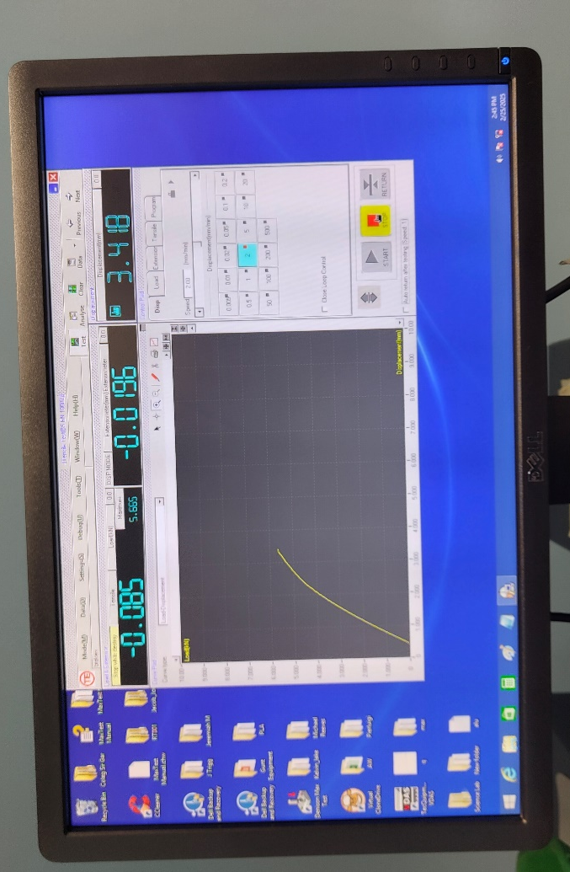
Figure 1 - Computer Software During Experimentation
Once this is done, the material sample is fitted into the testing equipment (figure 2). This is done by loosening an upper and lower clamp and tightening them around the material sample at either end. A command is then made on the computer, telling the testing equipment to apply the correct amount of preload, until the material is firmly in place, but not under any significant tensile load.
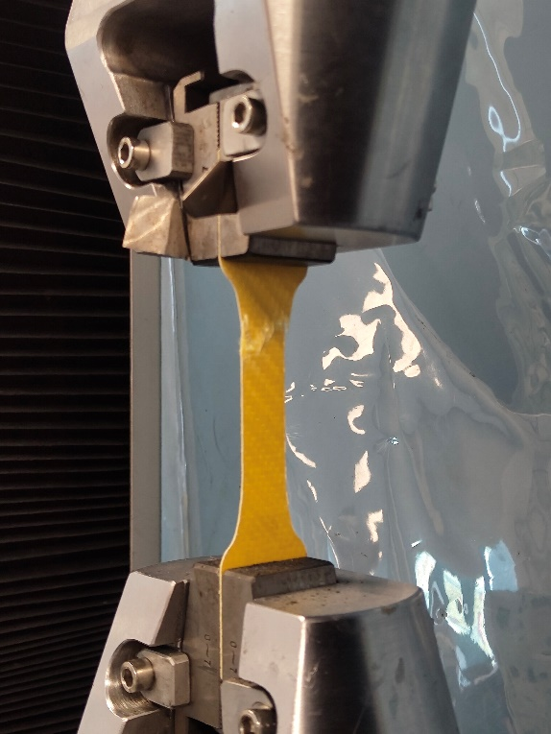
Figure 2 - Material Testing Equipment Post-Failure
The tensile testing can then begin, with the testing equipment applying an increasing load to the component, whilst logging the applied force and total distance moved (how much the material has ‘stretched’) throughout the process. Once the material has failed, the test is stopped, and results are logged into a ‘.txt.’ file on the computer. In this file, key factors are logged such as the total time elapsed, the total load applied, stress, stress, and the total displacement. The material sample is then removed from the machine and the clamps are manually returned to their original position. This process is repeated twice for each material, to ensure that any outliers in the results are noticeable.
The next material sample can then be tested, and the experiment can be repeated, once a new profile for the next material is made, including the name of the material, and its dimensions. Figure shows each material sample after testing.
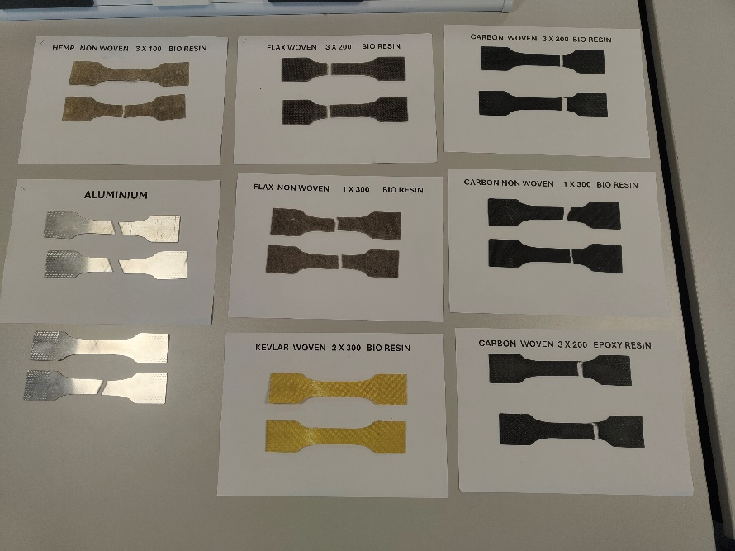
Figure 3 - Selection of Material Samples Post-Failure

5.0 Raw Data

5.1 Time vs. Applied Load

Figure 4 - Aluminium, Time vs. Load

Figure 5 - Carbon Non-Woven (Bio Resin), Time vs. Load

Figure 6 - Carbon Woven (Bio Resin), Time vs. Load

Figure 7 - Carbon Woven (Epoxy Resin), Time vs. Load

Figure 8 - Flax Non-Woven (Bio Resin), Time vs. Load

Figure 9 - Flax Woven (Bio Resin), Time vs. Load

Figure 10 - Hemp (Bio Resin), Time vs. Load

Figure 11 - Kevlar Woven (Bio Resin), Time vs. Load

5.2 Time vs. Stress

Figure 12 - Aluminium, Time vs. Stress

Figure 13 - Carbon Non-Woven (Bio Resin), Time vs. Stress

Figure 14 - Carbon Woven (Bio Resin), Time vs. Stress

Figure 15 - Carbon Woven (Epoxy Resin), Time vs. Stress

Figure 16 - Flax Non-Woven (Bio Resin), Time vs. Stress

Figure 17 - Flax Woven (Bio Resin), Time vs. Stress

Figure 18 - Hemp (Bio Resin), Time vs. Stress

Figure 19 - Kevlar Woven (Bio Resin), Time vs. Stress

5.3 Applied Load vs. Stress

Figure 20 - Aluminium, Load vs. Stress

Figure 21 - Carbon Non-Woven (Bio Resin), Load vs. Stress

Figure 22 - Carbon Non-Woven (Bio Resin), Load vs. Stress

Figure 23 - Carbon Woven (Epoxy Resin), Load vs. Stress

Figure 24 - Flax Non-Woven (Bio Resin), Load vs. Stress

Figure 25 - Flax Woven (Bio Resin), Load vs. Stress

Figure 26 - Hemp (Bio Resin), Load vs. Stress

Figure 27 - Kevlar Woven (Bio Resin), Load vs. Stress

5.4 Average Point of Failure
Material | Point of Failure (MPa)
Aluminium | 23.27
Non-Woven Carbon (Bio Resin) | 191.46
Woven Carbon (Bio Resin) | 421.91
Woven Carbon (Epoxy Resin) | 505.99
Non-Woven Flax (Bio Resin) | 56.36
Woven Flax (Bio Resin) | 76.37
Non-Woven Hemp (Bio Resin) | 16.02
Woven Kevlar (Bio Resin) | 317.87
Figure 28 - Average Point of Failure Data

5.5 Tensile Mechanical Properties
Below are the mechanical properties of each material, supplied as part of data sheets from Easy Composites Ltd, EcoTechnilin, and Pyrofil.
 | Non-Woven Carbon Fibre Comp | Twill Weave Kevlar Cloth | Epoxy Infusion Bio-Resin | Epoxy Infusion Resin | Non-Woven Flax Fibre Comp | Non-Woven Hemp Fibre  Comp | Twill 3K Carbon Fibre Mat | Twill Flax Fibre Comp
Upper Tensile Strength (MPa) | 330 | 3,000 | 68 | 72.25 | 44 | 108 | 4,120 | 61
Lower Tensile Strength (MPa) | 290 | 3,000 | 68 | 72.25 | 37 | 46 | 4,120 | 58
Upper Modulus of Elasticity (GPa) | 35 | 112.4 | 3.04 | 3.3 | 5 | 11 | 234 | 7
Lower Modulus of Elasticity (GPa) | 25 | 112.4 | 3.04 | 3.3 | 5 | 6 | 234 | 6
Figure 29 - Provided Material Properties
From here, the modulus of elasticity and tensile strength of the woven carbon fibre composites and Kevlar composite can be calculated using the rule of mixtures and composites. These calculations assume that the materials are combined at a 1:1 ratio by volume.
Shown below is each of these composites calculated material properties.
 | Woven Kevlar (Bio Resin) | Woven Carbon Fibre (Bio Resin) | Woven Carbon Fibre (Epoxy Resin)
Upper Tensile Strength (MPa) | 1,534 | 2,094 | 2,096.13
Lower Tensile Strength (MPa) | 132.99 | 133.79 | 142.01
Upper Modulus of Elasticity (GPa) | 57.72 | 118.52 | 118.65
Lower Modulus of Elasticity (GPa) | 5.92 | 6 | 6.51
Figure 30 - Calculated Composite Material Properties

6.0 Results Analysis

The data collected from the tensile testing of composite materials shows varying mechanical behaviours between them, however these correlate with the inherent properties of each fibre, and their structural arrangements within the matrix.
The three carbon fibre composites demonstrated the highest tensile strength among the tested material samples, which aligns with the calculated material properties (figure 30). Most notably, the woven carbon fibre and epoxy resin performed best with an average breaking point of nearly 506 MPa (figure 28). This is expected as the epoxy resin features the highest tensile strength, and modulus of elasticity out of the two resins, and the woven carbon fibre also has the strongest qualities amongst all the tested fibres (figure 28). This is likely due to the woven structure of interlaced fibres providing a higher tensile strength in the tested direction. The carbon fibre composites also demonstrated brittle characteristics, with little deformation prior to fracture. This can be seen when comparing figures 12 and 15, as the curved shape seen in figure 12 shows the aluminium deforming before failure, this however is not as present anywhere else.
The Kevlar composite proved to be another high-performance option but displayed slightly lower tensile strength compared to carbon fibre. It did however display marginally more deformation prior to failure. This is consistent with literature describing Kevlar’s toughness and impact resistance (Chung, 2010).
In contrast, the flax and hemp composites failed under considerably lower loads. Both materials failed in a progressive manner which suggests a more ductile failure mode. This variability in these results can be attributed towards inconsistencies in fibre alignment or natural defects inherent to biological materials (Dittenber and GangaRao, 2012). Despite their lower mechanical performance, these materials have much better potential for renewability and biodegradability which contribute positively to their overall sustainability.

7.0 Summary

Overall, the results from this experiment demonstrate a clear trade-off between mechanical performance and environmental impact. Synthetic fibres such as carbon fibre and Kevlar provide exceptional strength but pose significant challenges in terms of sustainability, particularly regarding recyclability and energy-intensive manufacturing. Natural fibres like flax and hemp offer environmentally advantageous alternatives with lower mechanical capabilities, suitable for non-structural or semi-structural applications where high strength is not as essential. These findings suggest that material selection for composites must be guided by both performance requirements and sustainability goals, especially in industries increasingly governed by environmental regulations.
This experiment was able to successfully demonstrate the material properties of each sample and calculate their theoretical properties which aligned with both the test data, and external literature. Given more time and resources, further research could be conducted into analysing the effects of fibre alignment with a composite and how this may affect tensile strength in different directions, as well as surface imperfections.

7.0 Bibliography

  - Alliance for European Flax-Linen & Hemp. (Unknown). Eco-design and composite materials. Available at: https://allianceflaxlinenhemp.eu/en/flax-lin-tex-tech/flax-tex-and-tech/eco-design-composite-materials [Accessed: 4 May 2025].

  - Chung, D.D.L. (2010). Composite Materials: Science and Applications. 2nd ed. London: Springer.

  - Composites Construction UK. (2022). Is Carbon Fibre a Sustainable Material for Strengthening Buildings and Structures? Available at: https://www.fibrwrap-ccuk.com/carbon-fibre-strengthening/is-carbon-fibre-a-sustainable-material-for-strengthening-buildings-and-structures/ [Accessed: 4 May 2025].

  - Deng, Y. & Tian, Y. (2015). Assessing the Environmental Impact of Flax Fibre Reinforced Polymer Composite from a Consequential Life Cycle Assessment Perspective. Sustainability, 7(9), pp.11462–11484.

  - Dittenber, D.B. & GangaRao, H.V.S. (2012). Critical review of recent publications on use of natural composites in infrastructure. Composites Part A: Applied Science and Manufacturing, 43(8), pp.1419–1429.

  - Financial Times. (2024). Industry warms up to sustainable carbonium alloy. Available at: https://www.ft.com/content/1d376690-2c75-454e-88bd-e291349a97e2 [Accessed: 4 May 2025].

  - Ma, H., Guna, V., Raju, T., Murthy, A. & Reddy, N. (2023). Converting flax processing waste into value added biocomposites. Industrial Crops and Products, 195, 116434.

  - National Research Council. (2005). High-Performance Structural Fibers for Advanced Polymer Matrix Composites. Washington, DC: The National Academies Press.

  - NitPro Composites. (2023). Sustainability in Carbon Fiber Production: Challenges and Green Solutions. Available at: https://www.nitprocomposites.com/blog/sustainability-in-carbon-fiber-production [Accessed: 4 May 2025].

  - Parodo, G., Sorrentino, L., Turchetta, S. & Moffa, G. (2024). Manufacturing of Sustainable Composite Materials: The Challenge of Flax Fiber and Polypropylene. Materials, 17(19), p.4768.

  - Zhang, J., Chevali, V., Wang, H. & Wang, C. (2020). Current status of carbon fibre and carbon fibre composites recycling. Composites Part B: Engineering, 193, 108053.

  - Zhang, Y., Li, J. & Wang, Q. (2021). Influence of Cracks and Voids on the Responses of Composites. Composites Part B: Engineering, 223, 109102.

