
INTERCULTURAL COMPETENCE REPORT
Student name: Cecilia Maria Cojocaru (1816288)
Module: Foreign Languages and Cultural Awareness
Module code: BMIH5003
Word count:1109

Contents
Executive Summary 2
Intercultural Competence Report 3
Main Body 3
Cultural differences 4
Cultural Intelligence and Sensitivity 4
Personnel management 4
Globe Project analysis 5
Conclusion 6
Recommendation 7
References 8

Executive Summary

The Diversity Hotel & Spa London is about to broaden its reach with the inauguration of a new location in Madrid, Spain. The general manager of the company is moving to support this new endeavour to enable the brand's values and culture to be seamlessly incorporated into the local environment. Madrid, a major hub for business and travel, has a hotel economy that is based on relationships. However, there are a number of subtle differences between the cultures of England and Spain, ranging from lifestyle choices to linguistic preferences, work ethics to hierarchical viewpoints. To successfully integrate the global brand ethos with Spain's regional distinctiveness, the manager must navigate these variations with an important level of cultural intelligence and sensitivity. The GLOBE Project analysis highlights the significance of adaptation by revealing further notable differences in leadership values between the two countries. To fully realise the hotel's potential in Madrid and guarantee its international success, the manager needs to set up a setting that values and incorporates these cultural distinctions while promoting a mutual understanding of what constitutes exceptional hospitality. To create a harmonic fusion of Spanish and English hospitality customs, it is recommended to prioritise visitor comfort, engage the community, and supply ongoing cultural training.

Intercultural Competence Report

Introduction
Relocating a general manager to a different country is often a good way of sharing the organization's culture with the locally employed staff. This can help the employees understand the company's values and cultures, which is also a great opportunity for the general manager to understand local traditions and cultures and adapt employee training accordingly to the local employees to identify potential risks or future developments to the organization's profit (Reynolds 2019). A new opening in Madrid, Spain, is needing an experienced manager for Diversity Hotel & Spa London to present help to employees to onboard into the brand culture and adapt to the potential changes from an international brand and its new view in comparison to the local hotel industry.

Main Body
The capital of Spain, Madrid, is well known for its thriving hotel industry, which reflects the city's appeal as a leading travel and business destination. Since relationship-driven service is valued in Spanish culture, the city's hotels range from historic buildings to contemporary luxury rooms (Paradores 2013). While social meetings usually follow a more relaxed format, professional settings emphasise punctuality. A fundamental aspect of the country's social structure is its deep respect for regional identities and customs, including festivals and languages (Ideal Education Group S.L. 2023; Christiansen 2020).
.

Cultural differences
Because of their different histories, locations, and influences, the cultures of Spain and England are diverse from one another. While English is spoken by the majority of hospitality employees, Spanish is the primary language. Addressing employees in Spanish helps break the ice. With direct and intense conversation, Spanish employees have late eating customs. Spain is famous for its vibrant social events, but England supports a more conventional workweek that includes a brief lunch break. In England, being on time is highly regarded, while in Spain, time feels more flexible (Gómez, 2016). England has a history of monarchy, while Spain's history is heavily affected by many cultures. England's more varied temperature encourages a more indoor-centric lifestyle, while Spain's Mediterranean environment encourages an outdoor-oriented lifestyle. Jogulu (2010) states that England places more emphasis on individualism and self-reliance, while Spain emphasises ties to the family and the community. Both cultures supply possibilities for learning depending on individual beliefs and regional variations (Ideal Education Group S. L. 2023).

Cultural Intelligence and Sensitivity
Understanding Spanish work ethics, customs, and beliefs is essential to establishing a peaceful workplace that combines international norms with regional differences. This strategy not only improves staff morale and output but also improves visitor experiences by fusing the warmth of Spain with the Diversity Hotel & Spa Brand, which aims to forge closer relationships and retain talent. A manager with this level of cultural competence is seen as an inclusive leader who fosters employee satisfaction and corporate success (Jogulu, 2010).

Personnel management
The hospitality industry in Spain is known for its friendly and approachable work culture. Spain, with its long history of tourism, values setting up a good rapport with visitors (Ideal Education Group S.L. 2023). According to The Culture Factor Group Hofstede (2023), analysis shows workers in Spain believe in hierarchies, where they might potentially access a powerful figure as a leader. Since success in England is more initiative-taking than in Spain, workers in Spain require positive incentives to boost output. Spanish workers dislike ambiguity, so it is important to communicate clearly to prevent misunderstandings and doubts. Indulgence lowers morale; therefore, a strong employee engagement programme and incentive structure can raise morale among staff members (Sharma 2019). Spanish people are known for their direct, enthusiastic communication. Staff schedules often consider the city's later dining and nightlife customs (Centro Mondo Lengua 2017); effectively managing hotels in Madrid requires managing the city's dynamic culture while adhering to international hospitality standards. These challenges can be overcome with a well-structured plan for employee engagemen

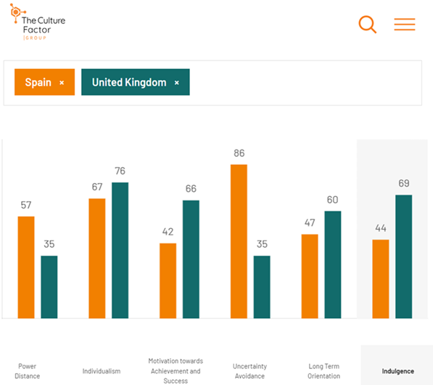

Globe Project analysis

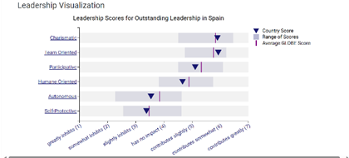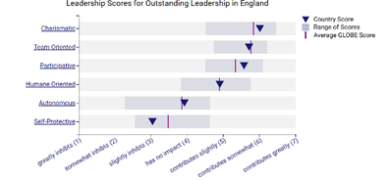

England's country score is neutral, aligning with the average GLOBE score. Its collaborative score is slightly higher than the average GLOBE score. Spain's score is slightly higher, but still falls between "has no impact" and "contributes slightly." Both countries value charisma, teamwork, and participation in leadership, but there are nuances in how much these traits are valued. Spain values charisma and humane orientation slightly more than England. Both countries place minimal emphasis on autonomy, with self-protective traits being more positively viewed in Spain than England (GLOBE PROJECT 2023) (GLOBE PROJECT 2023a).

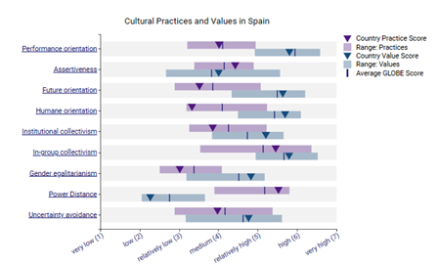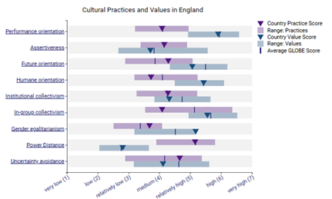
England and Spain have diverse cultural values and attitudes in all aspects; England values achievements and results, while Spain values interpersonal relationships and community. Both countries emphasise collective resource distribution and decision-making, but Spain may emphasise gender equality more. Spain may have a higher tolerance for unequal power distribution and the avoidance of uncertain situations (GLOBE PROJECT 2023a).

Conclusion

The opportunity to bridge the cultural differences between England and Spain is presented by the general manager's relocation from Diversity Hotel & Spa London to the new location in Madrid, guaranteeing a seamless integration of business procedures and service philosophy. Both parties must have a profound grasp and appreciation of the huge cultural variations, which range from social conventions to professional ethics. The Spanish concentration on community and human ties contrasts with the English emphasis on accomplishments, creating a learning curve that, with cultural intelligence, can result in a successful hotel business (Gomez 2016). The hotel's success in Madrid depends heavily on the manager's ability to create a work atmosphere that values and incorporates these differences. In addition to improving the brand's reputation, this reciprocal cultural exchange will guarantee the company's flexibility and durability in the rapidly changing global hospitality industry.

Recommendation

• Establishing a feedback and continuous learning system that asks for periodic input from both staff will aid in finding potential areas of cultural confusion or dominance resulting from the blending of cultures. The implementation of elective English language courses for personnel would ease effective correspondence with British visitors. A similar suggestion would be to provide visiting British personnel with Spanish culture lessons to promote mutual respect and understanding. Encourage personnel to make decisions that prioritise the comfort of guests, even if they occasionally need a departure from established protocols. This degree of flexibility corresponds to the degree of adaptability necessary to combine two unique cultural approaches to hospitality. Consistent review courses The hospitality sector is continuously progressing; implement biennial revision courses to ensure that the staff is still well-informed about the most recent developments in the hospitality industries of Spain and the United Kingdom. Fostering a sense of community by motivating personnel to partake in regional celebrations and activities and increasing their knowledge of Spanish culture will set up the hotel as an indispensable establishment within the community.

References

Centro Mondo Lengua (2017) 5 Biggest Cultural Differences in Spain. [online] Centro MundoLengua. Available at: https://centromundolengua.com/5-biggest-cultural-differences-spain/ [Accessed 21 Oct. 2023].
Christiansen. (2020) Global applications of multigenerational management and leadership in the transcultural era (Christiansen, Ed.). IGI Global. https://doi.org/10.4018/978-1-5225-9906-7 [Accessed 21 Oct. 2023].
GLOBE PROJECT (2023) Results - Spain GLOBE Project. [online] www.globeproject.com. Available at: https://globeproject.com/results/countries/ESP?menu=list#country [Accessed 21 Oct. 2023].
GLOBE PROJECT (2023a) Results - England GLOBE Project. [online] www.globeproject.com. Available at: https://globeproject.com/results/countries/GBR?menu=list#country [Accessed 21 Oct. 2023].
Gómez Jiménez, M. (2016) Employee Creativity and Culture. Evidence from an examination of culture's influence on perceived employee's creativity in Spanish organizations. [Accessed 21 Oct. 2023].
Ideal Education Group S.L. (2023) Spanish Customs and Traditions - Learn more about Spain | don Quijote. [online] www.donquijote.org. Available at: https://www.donquijote.org/spanish-culture/traditions/ [Accessed 21 Oct. 2023].
Jogulu, U.D. (2010) Culturally linked leadership styles. Leadership & Organization Development Journal, 31(8), pp.705–719. Doi: https://doi.org/10.1108/01437731011094766 [Accessed 21 Oct.2023].
Paradores (2013) 10 Spanish Customs that Will Surprise You | Paradores. [online] paradores.es. Available at: https://paradores.es/en/blog/10-spanish-customs-will-surprise-you [Accessed 21 Oct. 2023].
Reynolds, K. (2019) 13 benefits and challenges of cultural diversity in the workplace. [online] Hult Blog. Available at: https://www.hult.edu/blog/benefits-challenges-cultural-diversity-workplace/ [Accessed 21 Oct. 2023].
Sharma (2019) Management techniques for employee engagement in contemporary organizations (Sharma, N. Chaudhary, & V. K. Singh, Eds.). IGI Global. https://doi.org/10.4018/978-1-5225-7799-7 [Accessed 21 Oct. 2023].
The Culture Factor Group (2023) Country comparison tool Spain-England. [online] www.hofstede-insights.com. Available at: https://www.hofstede-insights.com/country-comparison-tool?countries=spain%2Cunited+kingdom [Accessed 21 Oct. 2023].

