John Hughes
1708241
Networking & Cybersecurity

Manage and maintain network resources, and its services applying suitable policies and drafting security and redundancy practices.

Dr. Nitheesh Murugan Kaliyamurthy

Semester 2

ACCA5023

Contents

- Employing network policy and security techniques to manage and preserve network resources
  - NTFS
  - Share Permissions
  - Group Policy

- Routing and packet filtering within core tcp/ip services and critical failover/redundancy practices
2.1 Utilising ARP and Routing Tables
2.2 Deploying Core Services
2.3 Installing and Configuring the Routing and Remote Access Service
2.4 Packet Filtering

- Observation
3.1 Password Principles for Modern Network Environments
3.2 Failover Clustering
3.3 Network Policy Draft
4. References

- Employing network policy and security techniques to manage and preserve network resources

1.1 NTFS

The first stage of deploying NTFS involves creating a new folder to contain a text file on a client within the nosstask.msft domain
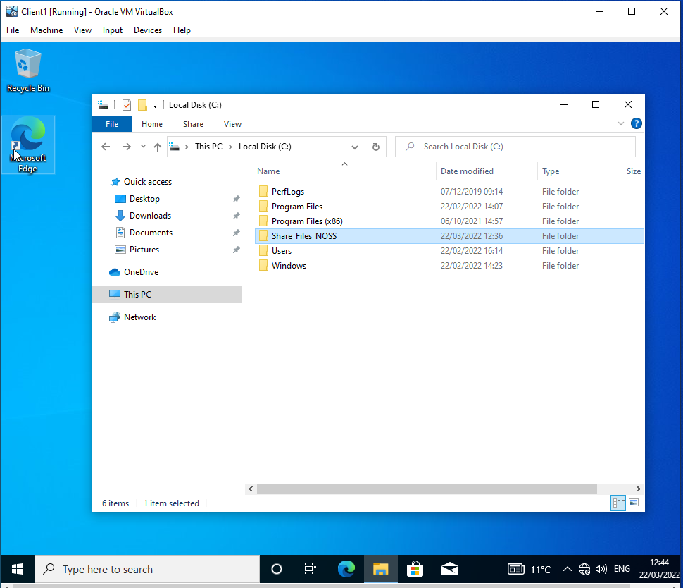
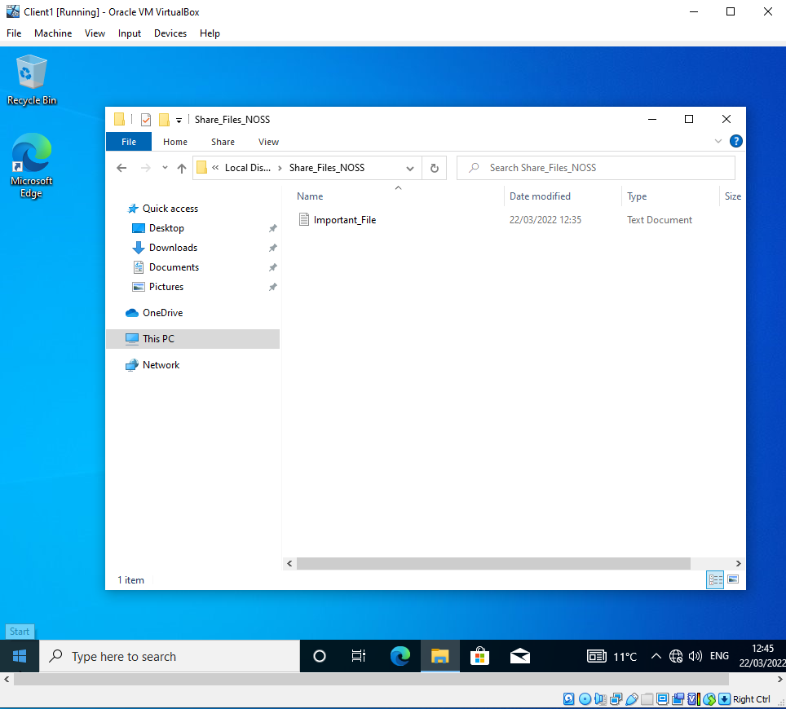

This folder and file are then used to set NTFS permissions between different users. Before deploying this feature, inheritance permissions must be disabled.
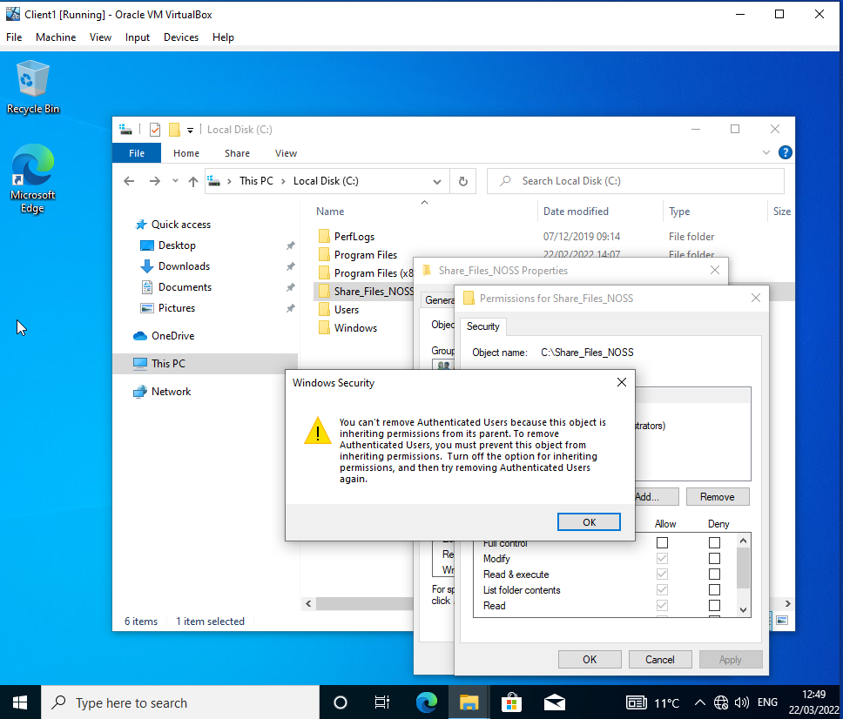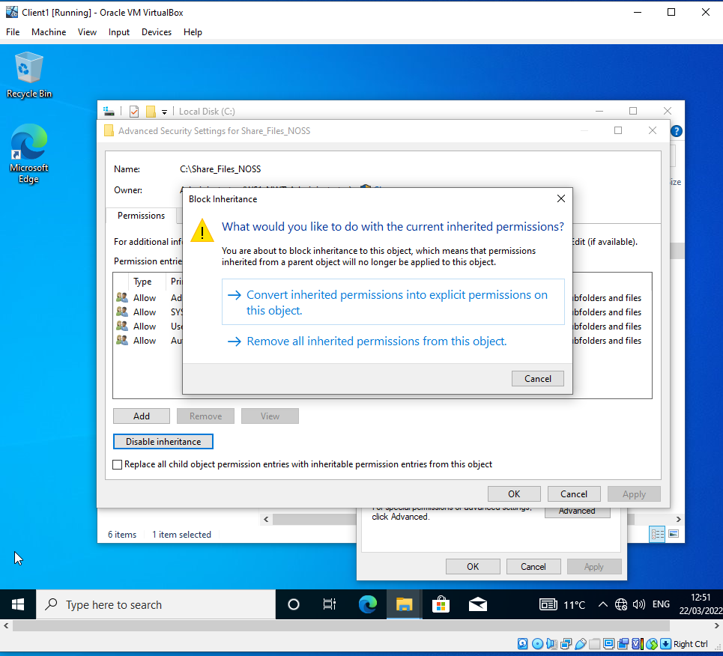

With inheritance disabled, it is now possible give one user full access permissions and the other read-only permission
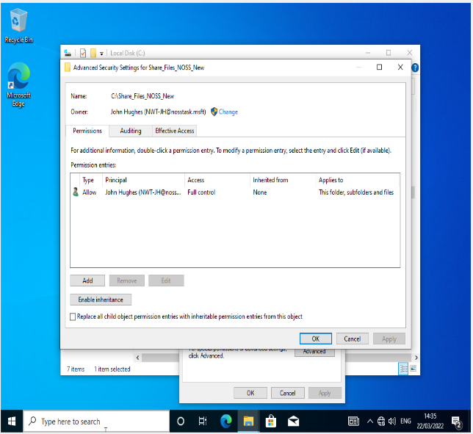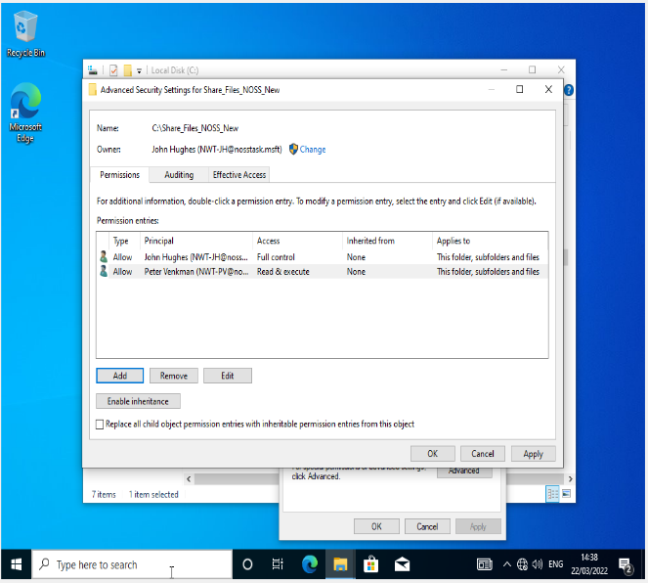

Testing the non-admin account shows the read-only permission are working and the user only has read access
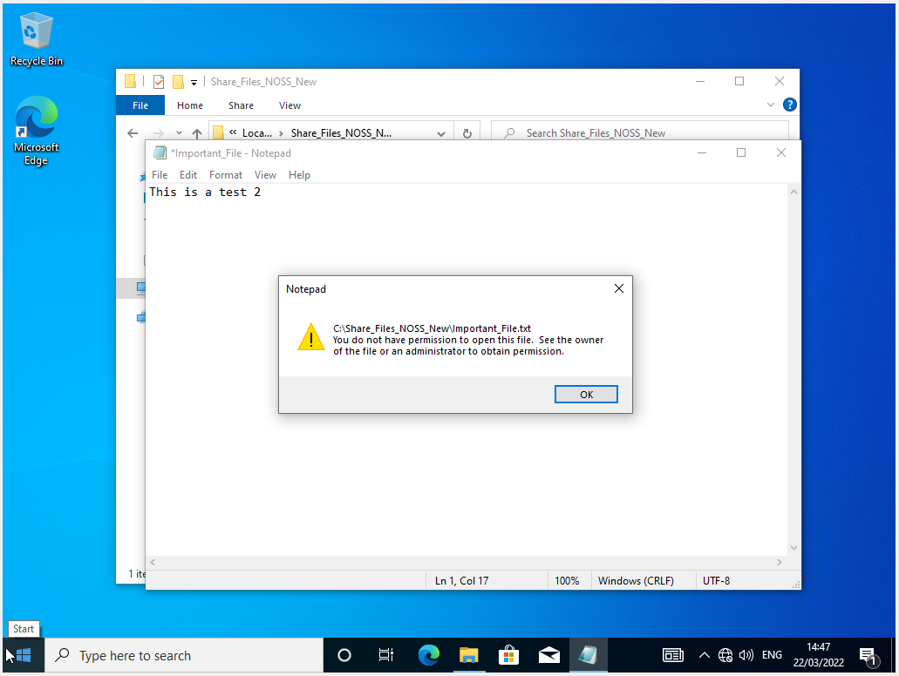

  - Share Permissions

Separate from NTFS, share permissions can also be set on shared folders and applicable to all devices over the network. Share permissions and NTFS run alongside each other with the most restrictive rule taking precedent over any other. Three permissions looked at are full access, read and execute.
The first step involves selecting a file in server manager to apply the permissions. The following screenshot shows the selected file and the local path to access it from other users on the network. A screenshot showing access based enumeration is also provided in order to specify the exact files/folders certain users can access.
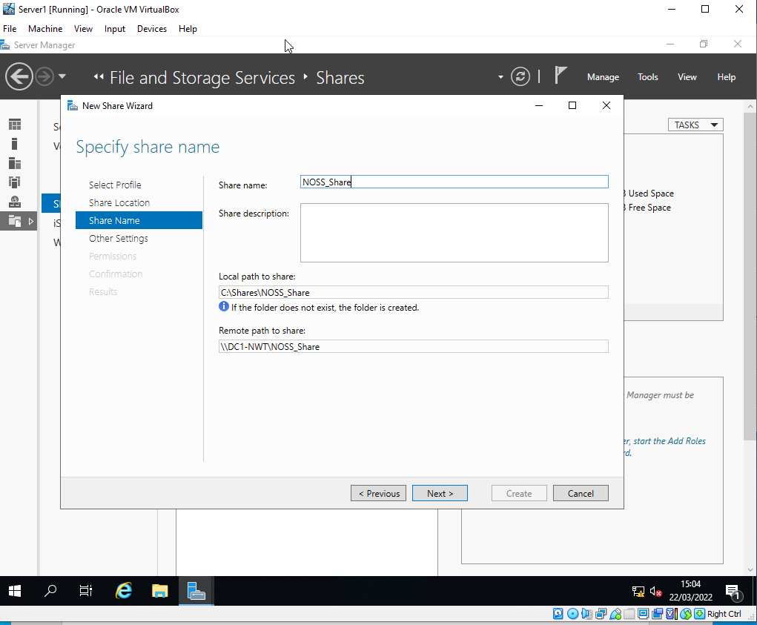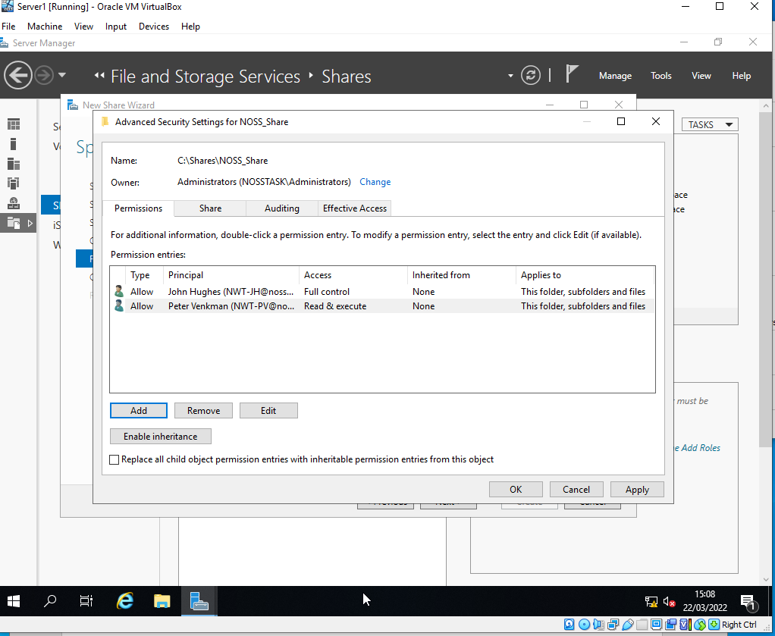

A summary is shown below
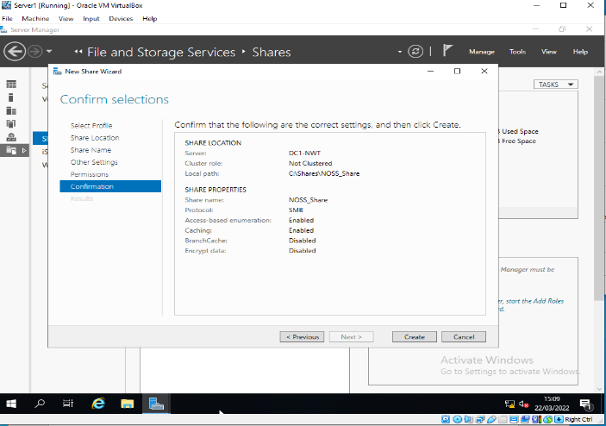

Below are examples of the network share granted to the administrator account. Also, a screenshot of access denied to non admin user attempting to change the file name. This is due to read/execute permissions only.
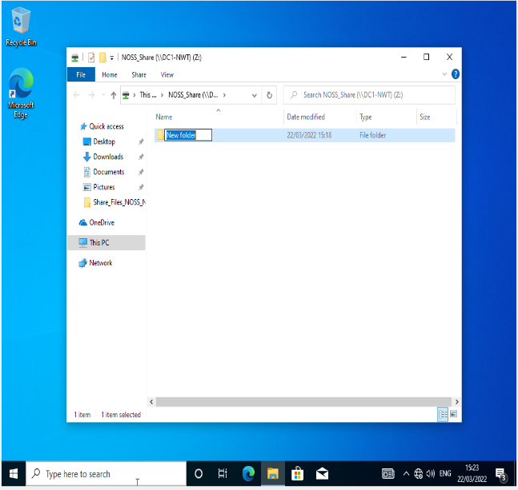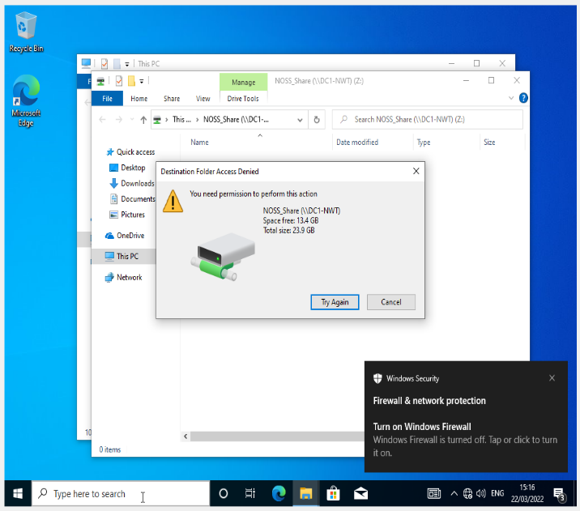

  - Group Policy

Group policy allows the server to manage both local computers and accounts joined to the domain. As opposed to local group policy which would apply to individual machines, group policy can be applied to entire organisation departments within the domain.

The first example of group policy is to create an organisational unit to apply a group policy to, in this case, to deny access to the control panel for non admin users.
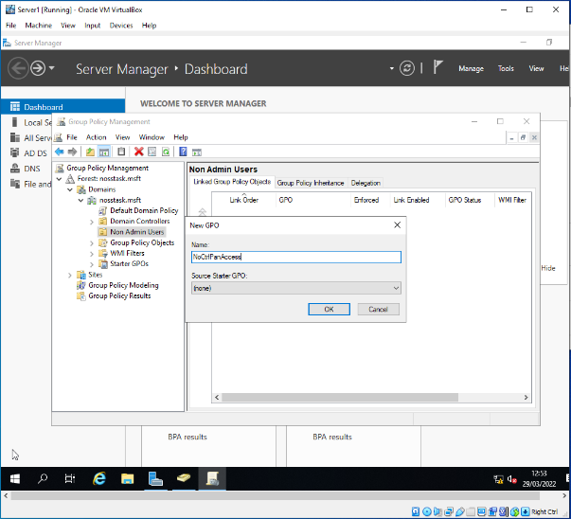

The following screenshots shows in the non-admin users, restriction to the control panel with object named NoCtrlPanAccess
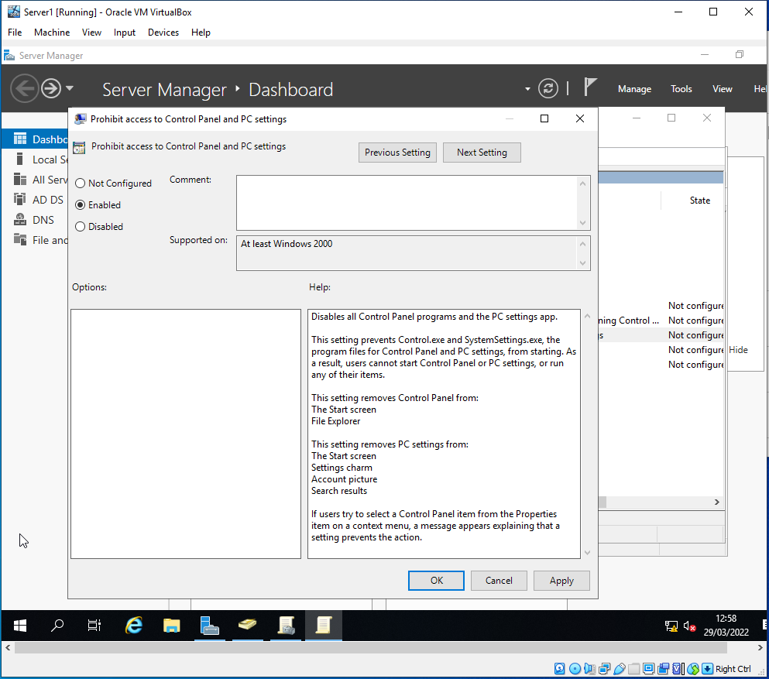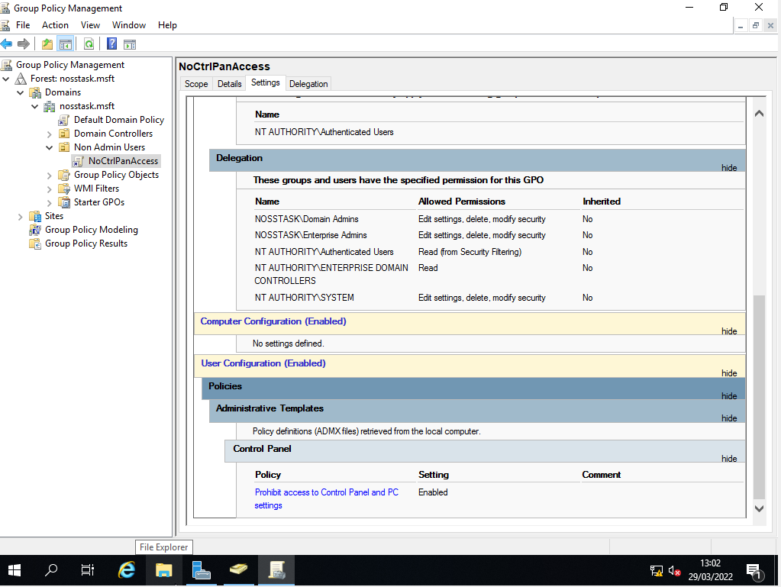

The following screenshots show the administrator using cmd to force update the active directory, ensuring that the new restrictions are applied without any delay in waiting for them to become effective. Another screenshot shows the restrictions are working correctly on a non-admin account
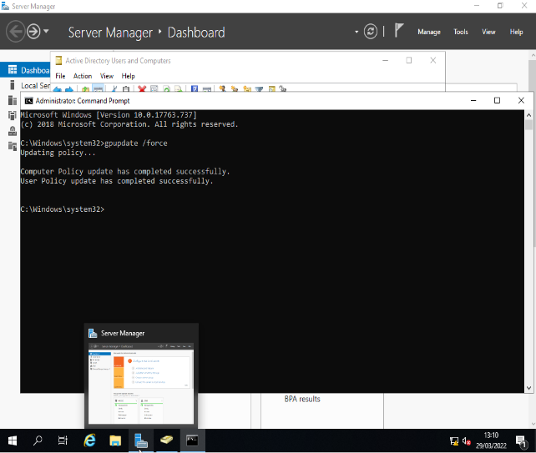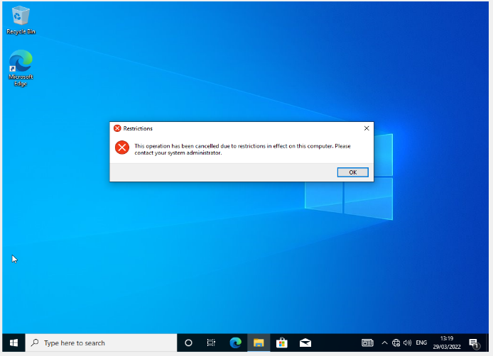

Similarly, a new group policy object is created within the existing OU to prevent non-admin users from accessing the control panel, this time called NoCmdPrmptAccess.

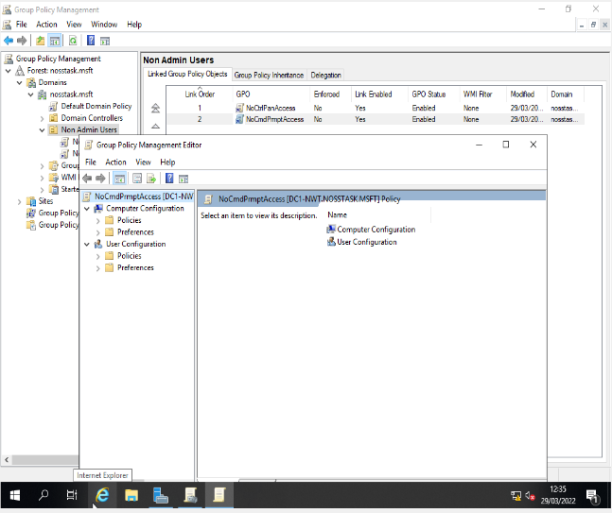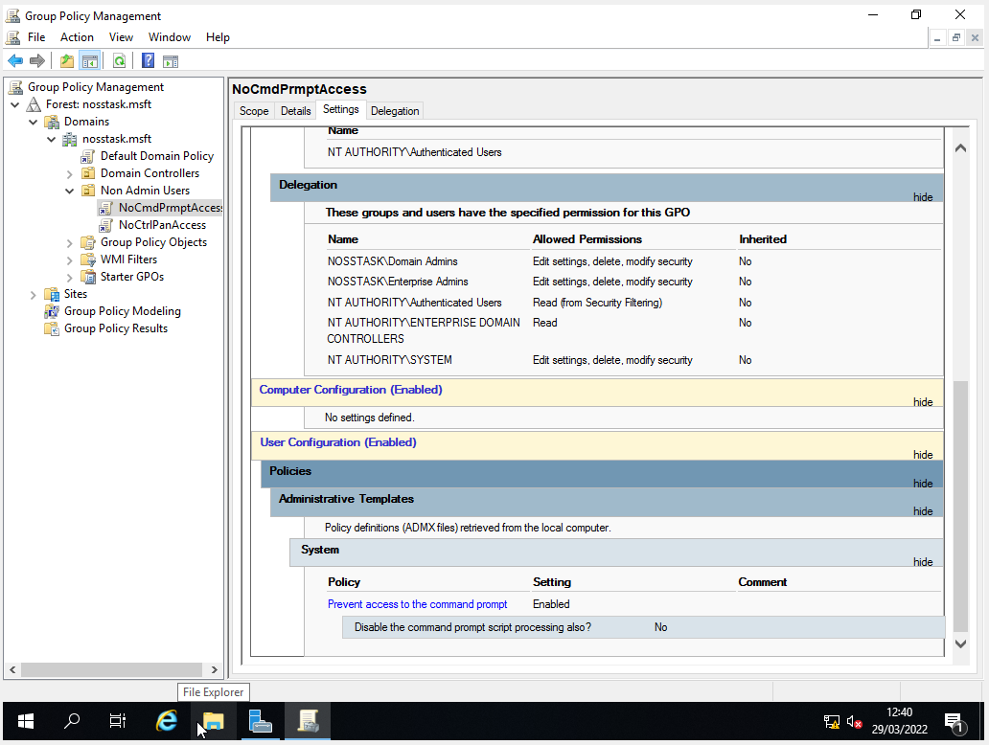

Here is the force update command from the admin account, followed by the cmd access denied from the non-admin user.
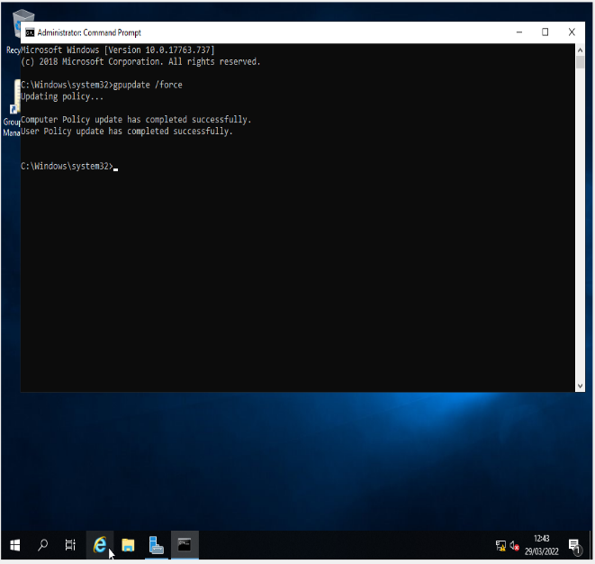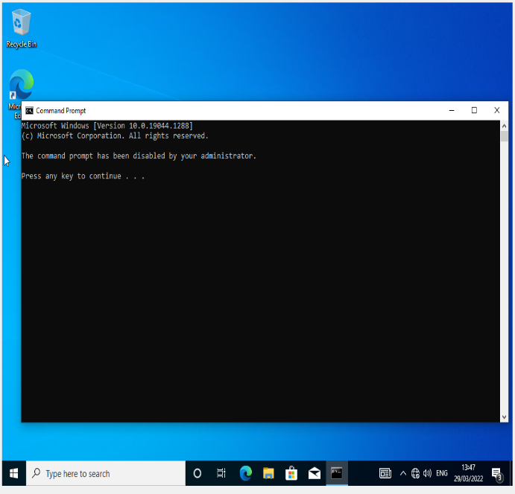

The next GPO is for access to removable media drives, denying access to all except the domain admin accounts.
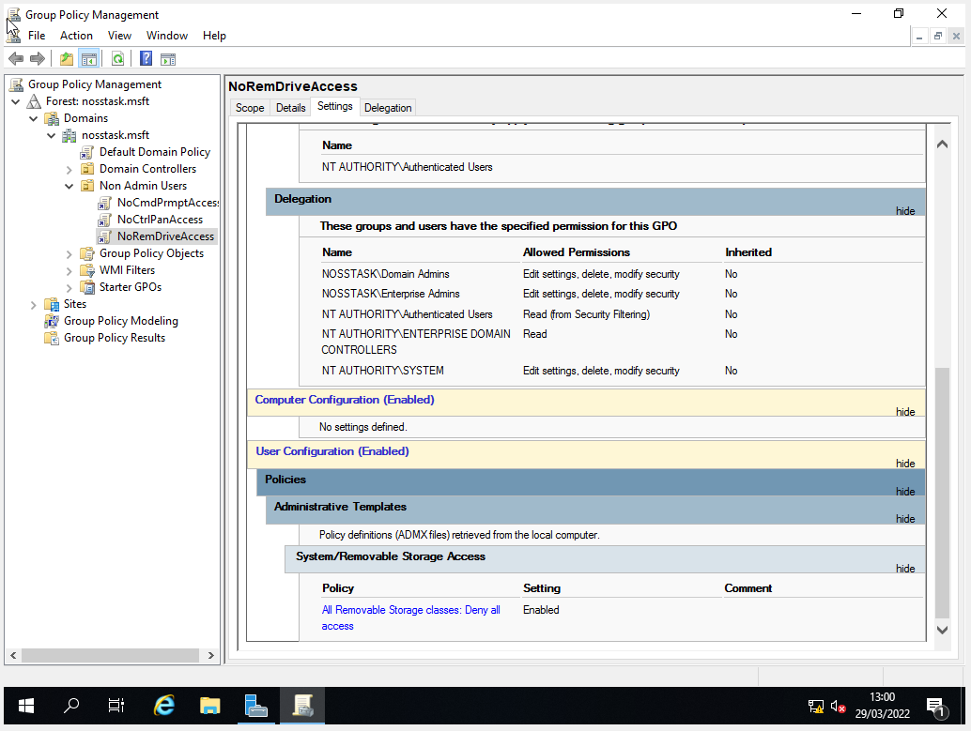
Unfortunately, this step was unable to be tested as the task was being run on VMs within type 2 hypervisor and therefore no access to removable drives were available.

The fourth GPO was for restriction of software installs. This required internet access for the client machines to test the restriction by attempting to install downloaded applications.
The first step is to ensure the client machine has internet access by creating a wireless adapter for it as shown below

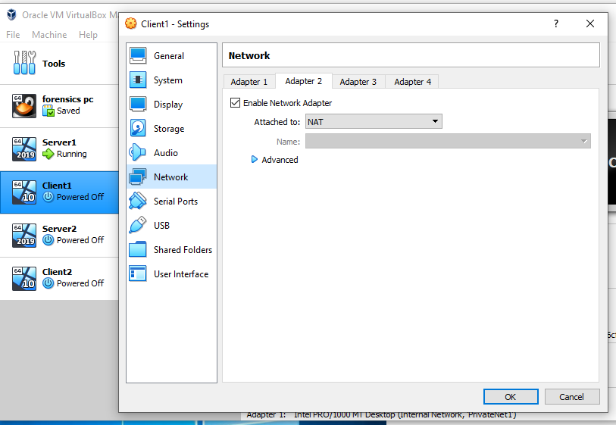

With non-admin access beyond the PrivateNet1, the next stage is to create a new Organisational Unit named NWTClient Computers and move the computer object to within the new OU.
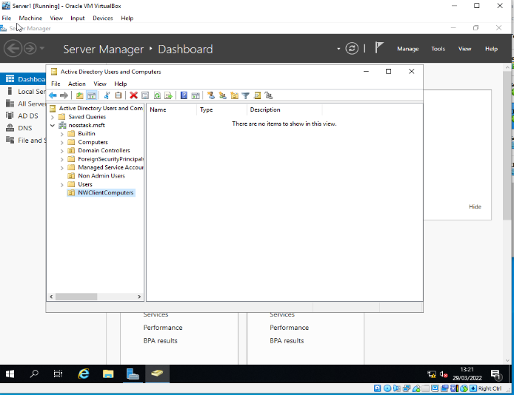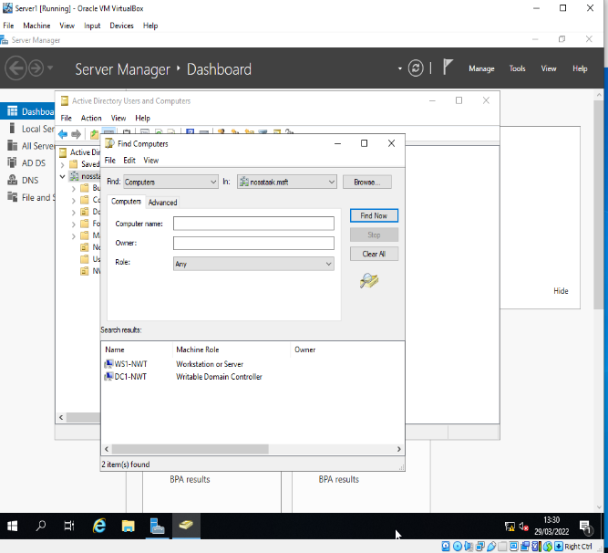

A new group policy object is then created within the OU called NoUnauthSoftInstallS. From there, in administrative templates, prohibit user install policy can be enabled as shown.
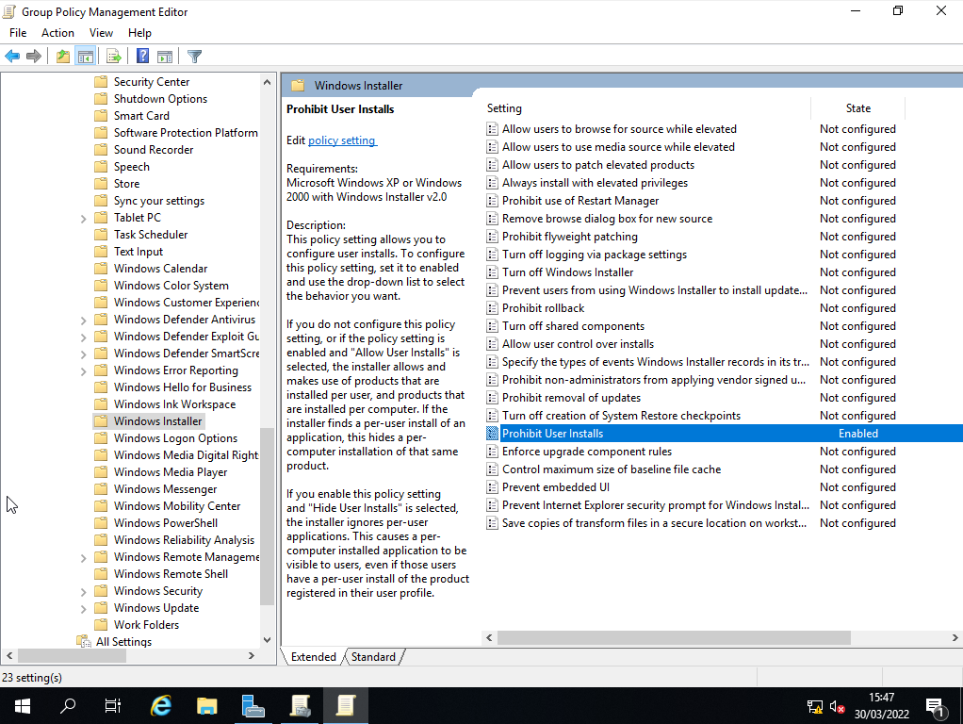

Shown below is the user install policy prompting the user to enter admin credentials before gaining access to the installer. Without required credentials, elevation is requested.
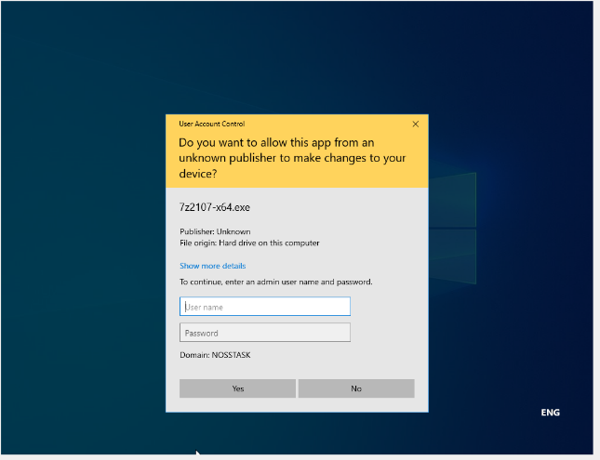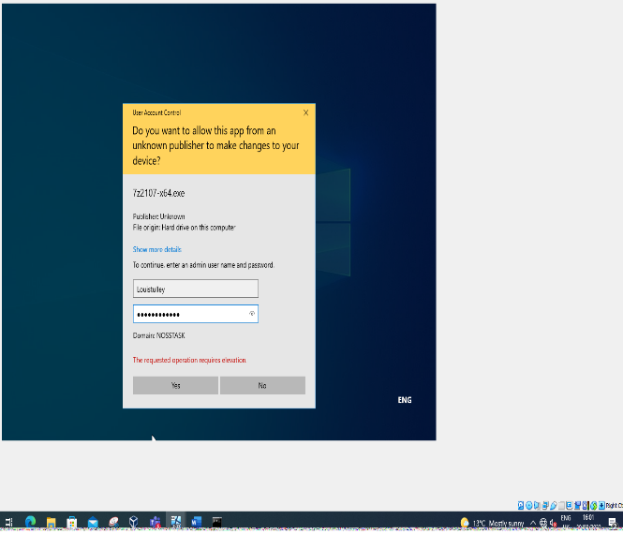

The fifth GPO will apply to password requirements. Unlike the previous policies, this will apply across the entire domain for all user accounts and computers.
The security settings are accessed within the Default Domain Policy GPO. Within password settings, the default settings are changed to the following requirements.
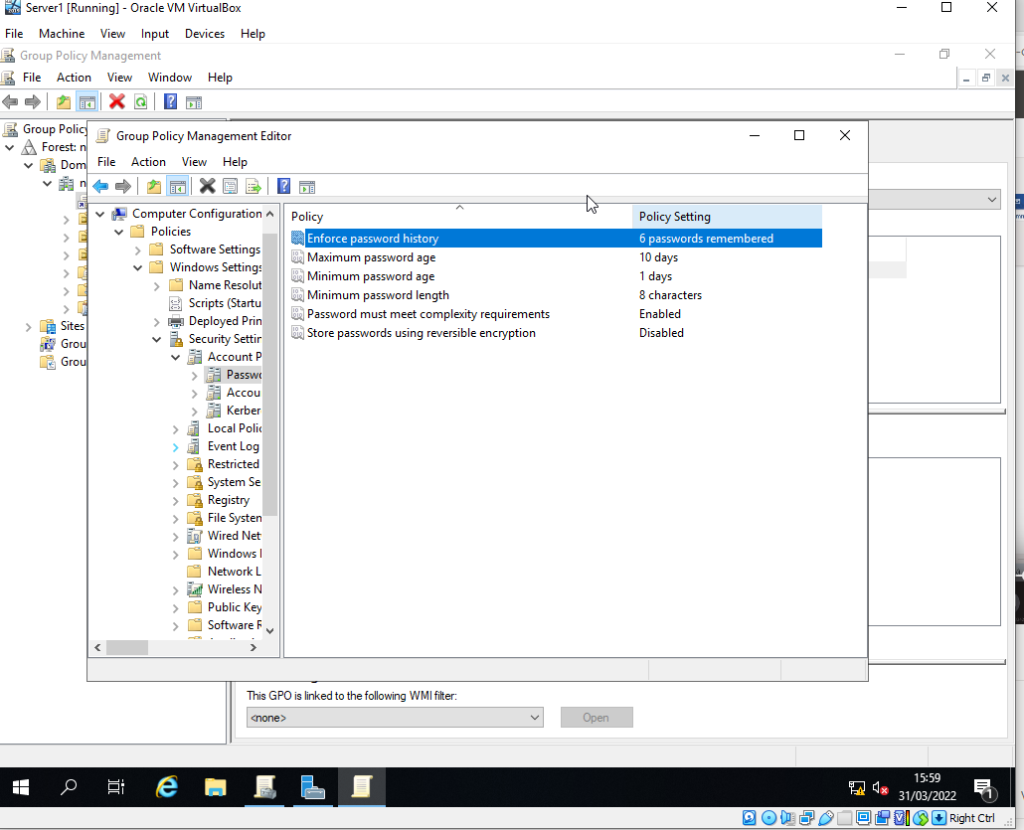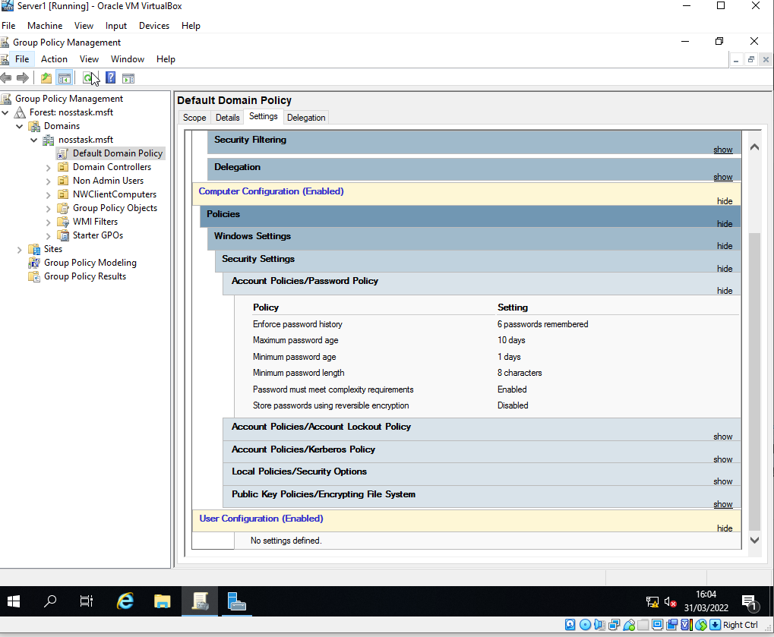

Having used the gpupdate /force command, a new account is created whilst attempting to enter a password that does not meet the minimum requirements
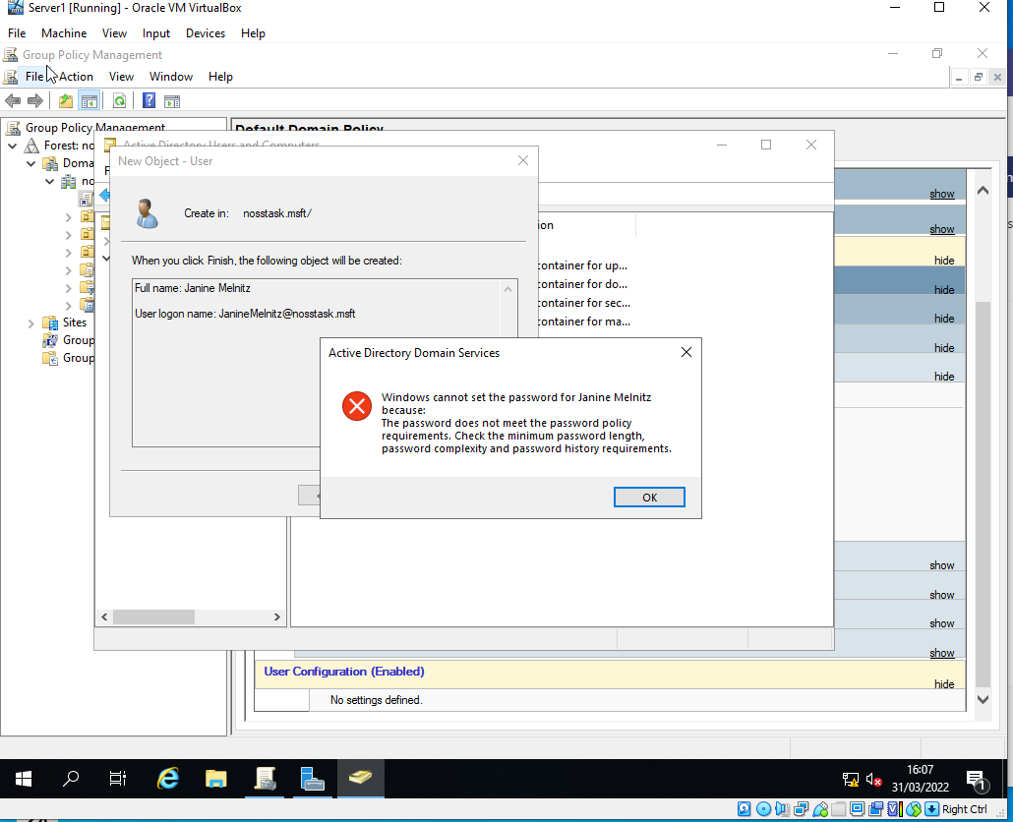

- Routing and packet filtering within core tcp/ip services and critical failover/redundancy practices

2.1 Utilising ARP and Routing Tables

Native routing capabilities must be established for each LAN. To achieve this, ARP tables are needed to map logical IP addresses to physical MAC addresses.

First the arp – a command shows the information on the interface, the mac address and ip address connected to it. With each device that pings the interface, the table updates
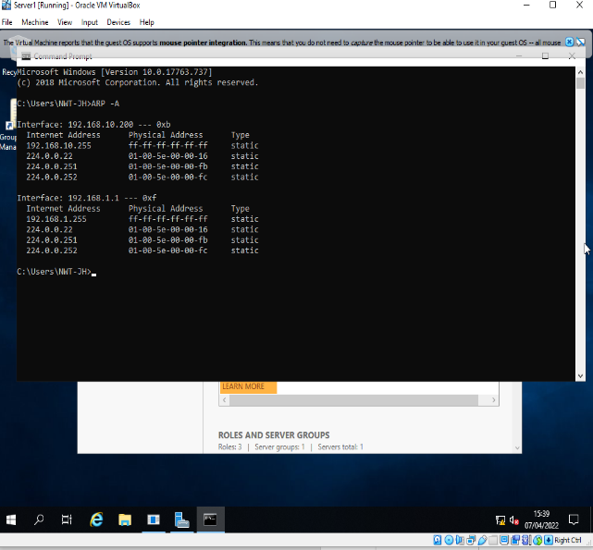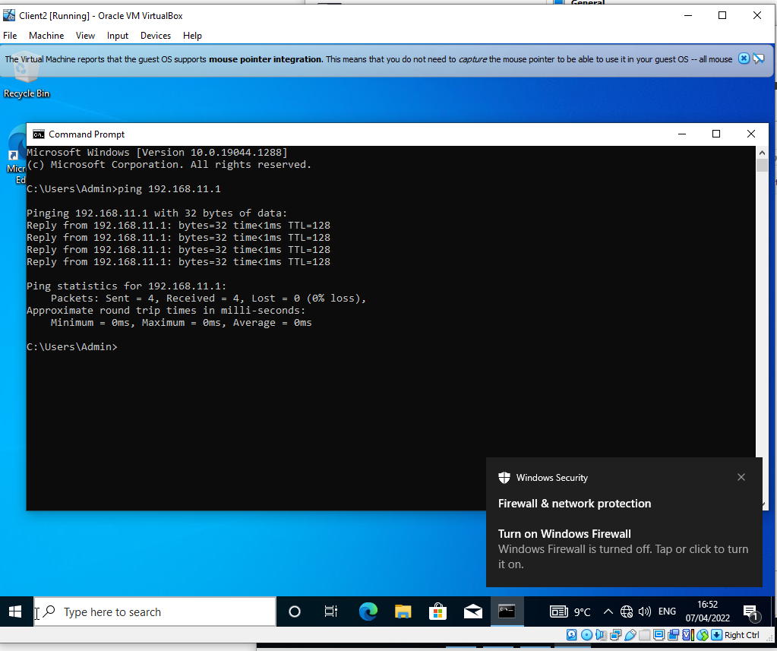

  - Deploying Core Services (FTP)
The following process involves utilising FTP services on the Server2 computer
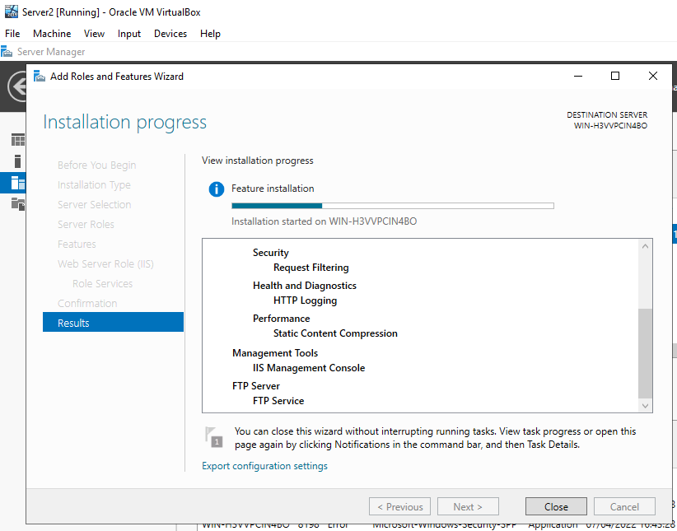

With FTP services installed via server manager, a test site is created, with no SSL selected
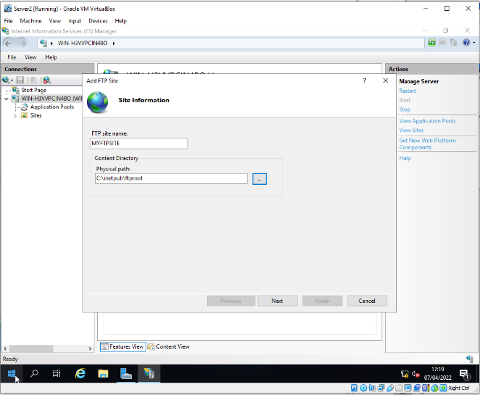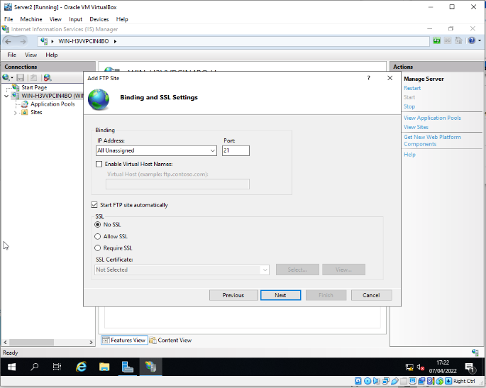

A banner is created to indicate the connection is made to the correct server
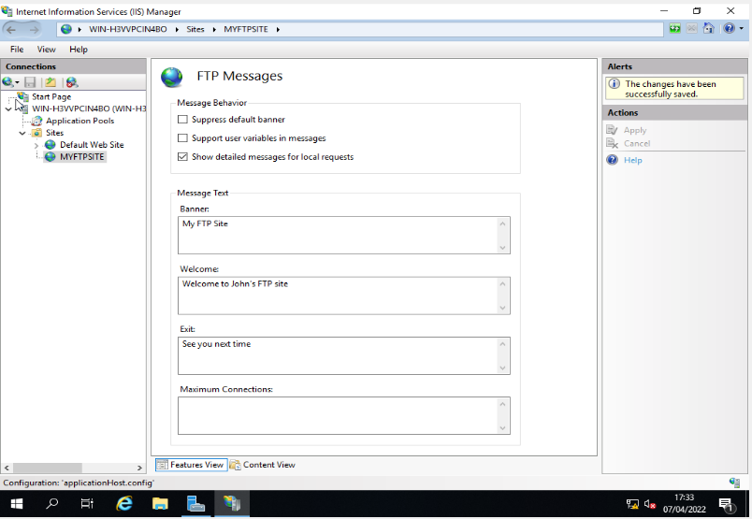
The newly created user account is then added to the user permission and the servers firewall is turned off
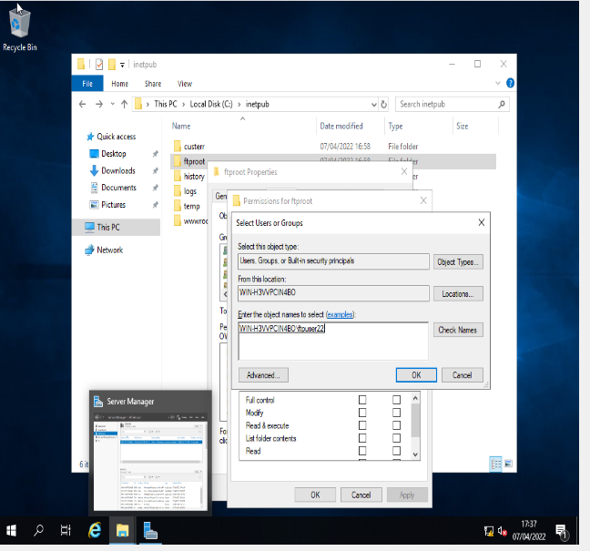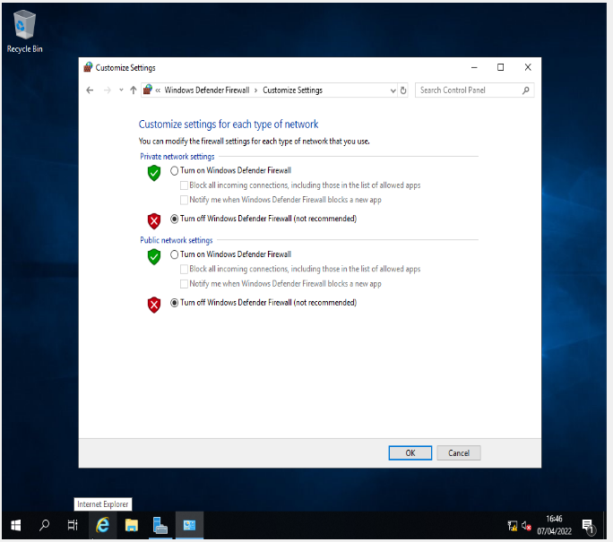

Client1 can now attempt to connect to the FTP service running on Server2 and upload a file.
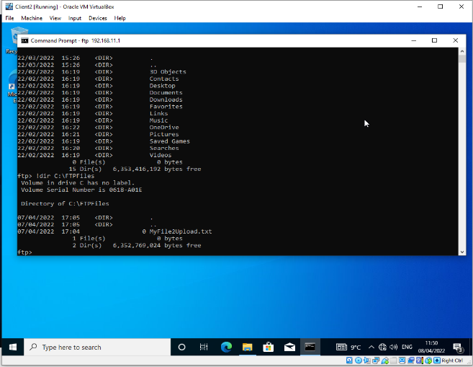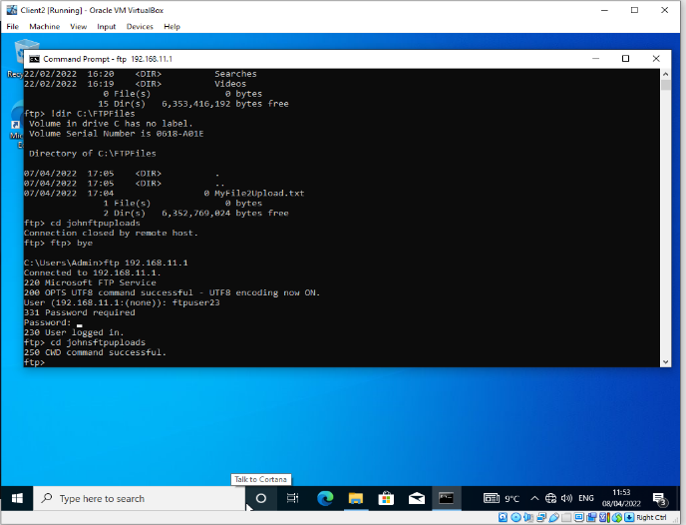

With the put command from the client completed, the file transfer is confirmed on the server
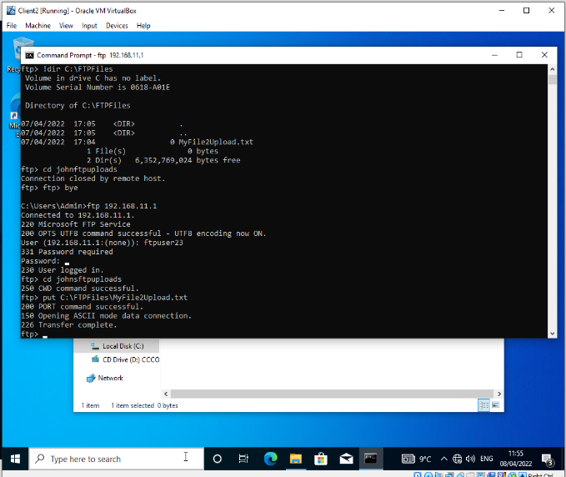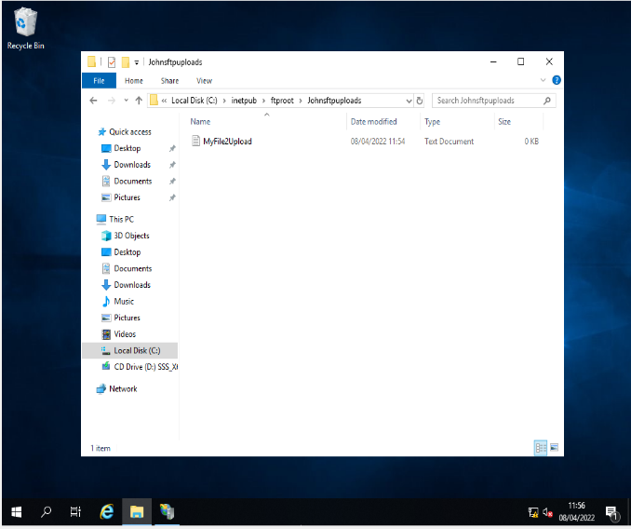
2.3 Installing and Configuring the Routing and Remote Access Service

In order for the clients on PrivateNet1 andPrivateNet2 to communicate with each other, Routing Services are needed to set up on the servers of both subnets. This will expand the two LANs into a WAN.
The Routing and Remote Access Wizard is selected in in the roles and features of server manager with VPN deployed and RIP protocol activated.
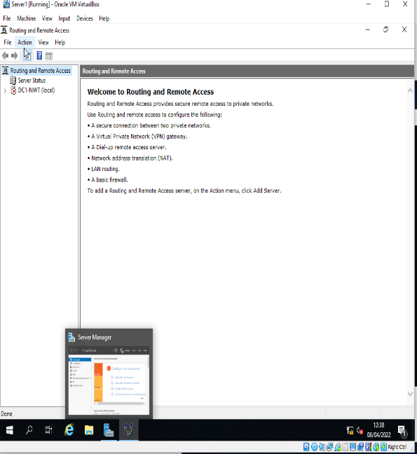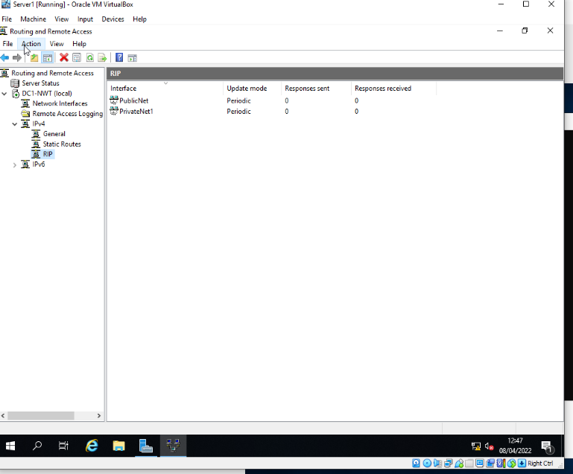

Here is an example of successful ping from Client2 to Server1, displaying the routing and remote access successful along with the route table showing that the routers have learned the paths they are connected to
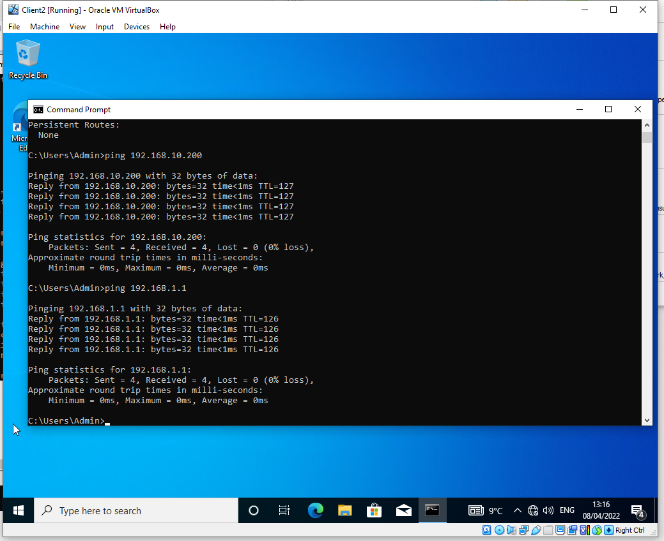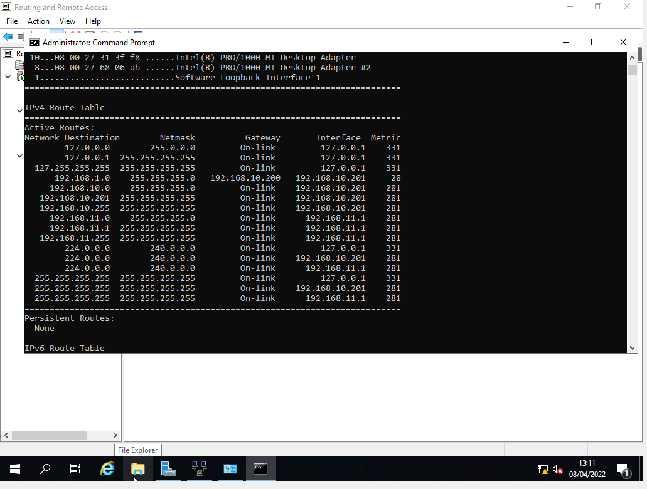
  - Packet Filtering

The packet filter feature on Windows Firewall can prevent both inbound and outbound packets from reaching certain ports. This can be done in a myriad of ways to achieve the desired results

Here is one example of preventing PrivateNet1client from pinging Server1. The inbound filter blocking any client access at the inbound side of the server’s firewall. The subnet mask tells the firewall to block packets to the specific host and ICMP refers to the ping protocol.
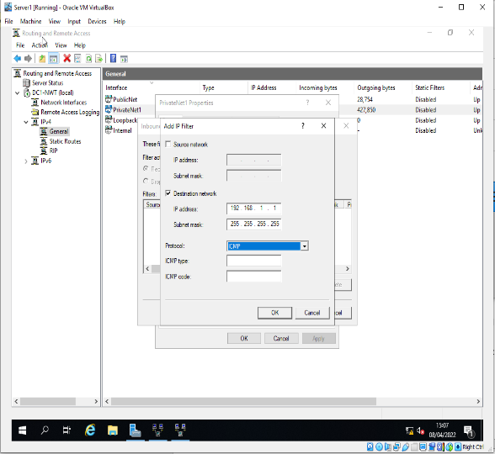
This filter does have a shortfall as the PrivateNet1 clients can still reach the server via its other NIC, for PublicNet. This can be addressed by either adding a 2nd inbound filter for the PublicNet interface, or alternatively as shown below, Create a new inbound filter that does not specify the host and therefore blocks packets sent to all host interfaces.
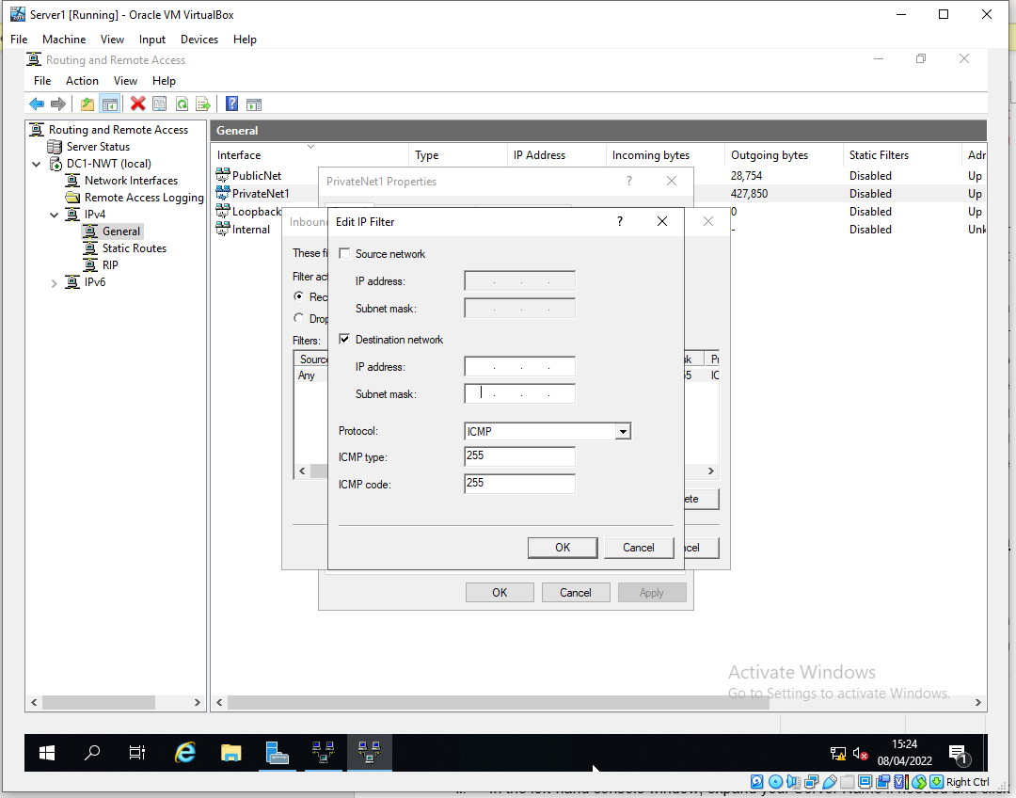

The following filter restricts access to Server2 FTP service to only allow access for the clients on PriveteNet2. This is achieved by filtering outbound packets on Server1, which will block Client1 from reaching beyond Server1 and therefore unable to reach FTP on Server2.
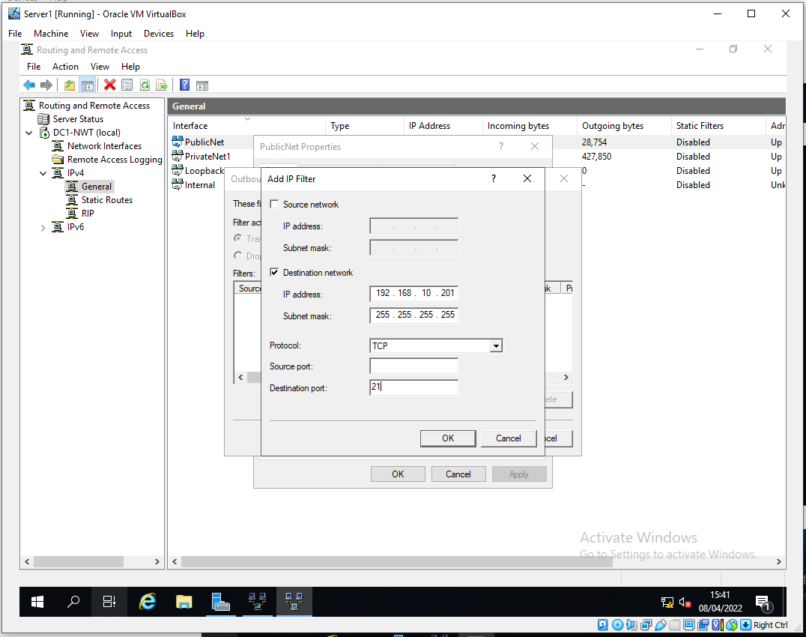

As shown, this filter alone has shortfalls, since it is only applied to port 21, since FTP can run on two binding ports, it can also access via port 20.
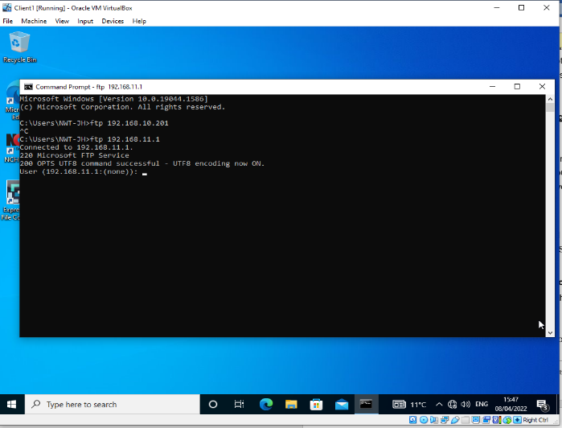

To address this issue, another outbound filter is applied to both ports. The results are shown to successfully block FTP access.
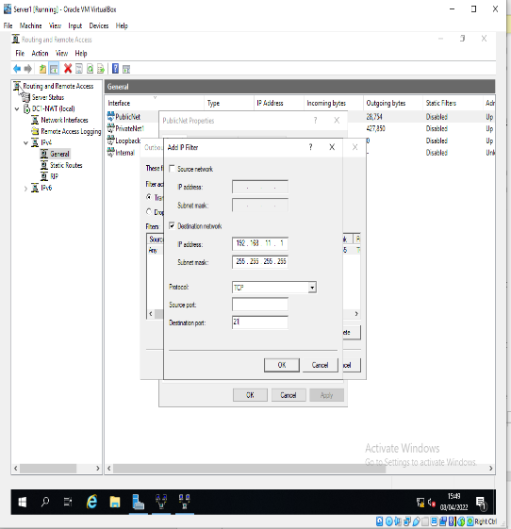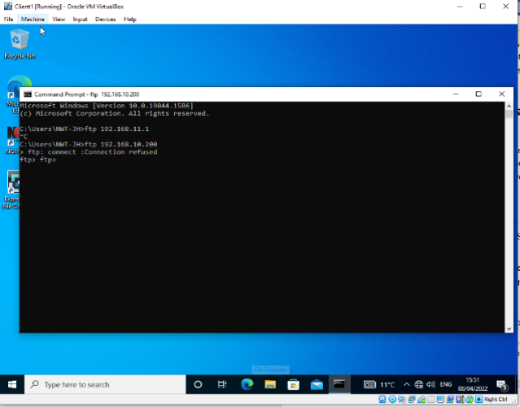

Here is a summary of both filters working to prevent FTP access to Server2, via PrivateNet1
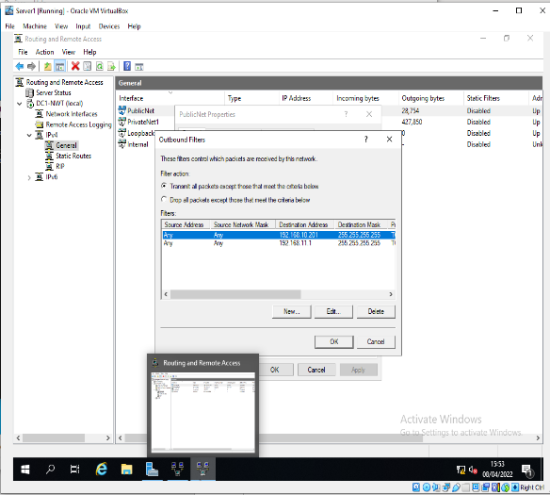

The following filter allows only specific hosts on PrivateNet1 access to FTP service running on Server2. This rule will leave only Client1 able to access Server2 whilst blocking everything else.
To achieve this, Server2 can allow all clients to access FTP via port 21 except for the specified inbound filters, one placed on interface for Publicnet and another for PrivateNet2, allowing only the packets from PrivateNet1.
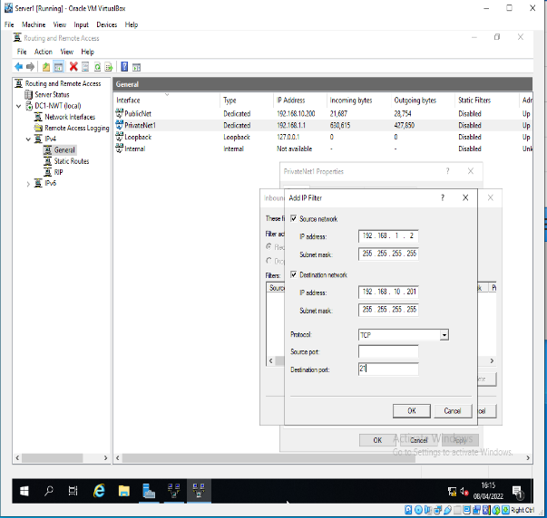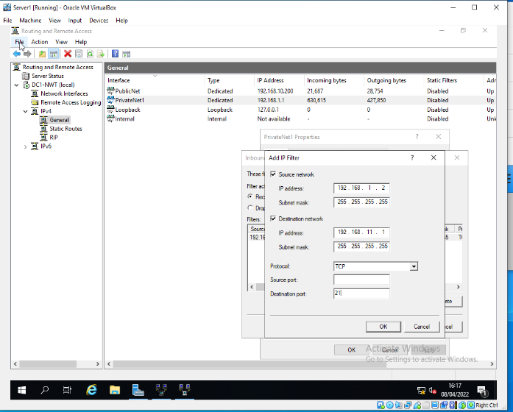

Alternatively, filters can be set up to drop all packets except from Client1 as shown below
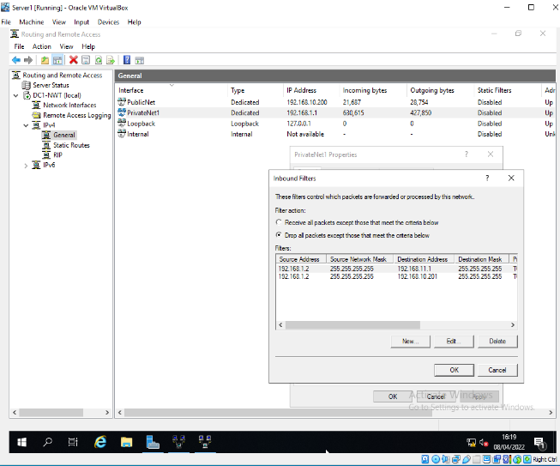

This is shown to be working for Client1 and as shown from previous tasks, would hypothetically block any other clients on PrivateNet1
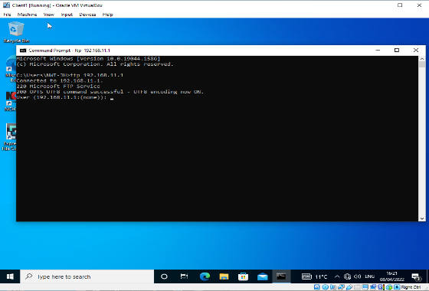
- Observations

  - Password Principles for Modern Network Environments

As shown in the practical work of this assignment, there are several security features that can be utilised within the settings of the group policy manager for increased password security. It would be a minimum requirement to enforce these settings such as minimum password length and complexity requirements, maximum age to periodically refresh passwords and store passwords using reversible encryption [1].
Beyond these minimum requirements, an article by Ian Maddox for Google Cloud Solutions suggests not to use plain text passwords under any circumstances but to use encryption that cannot be reversed. It goes on to state that all passwords should be encrypted to a high standard using Argon2id or Scrypt hashing [2].
Password hashing involves complex algorithms to encrypt a password. According to Bambang Sugiantoro Sutriman in his journal article, it is possible for hackers to reverse the hashing by identifying words that are commonly hashed and therefore identified. This can be avoided by using industry leading hashing algorithms that hash many times over. Salting can also be added to the encryption which adds unique, random character to the password before the hashing process which further increases the security strength [3]

  - Failover Clusters

Failover clusters involve a group of computers, known as nodes, that can provide high availability to a network by utilising redundant machines to quickly provide services in the event of a server failure. To achieve this, there are several requirements that need consideration.
A web article by Microsoft lists a number of basic requirements as follows [4].
Starting with hardware, multiple servers are required to act as nodes, with the minimum requirement being two servers, and commonly more for larger networks. Network adapters/cables are required to connect the nodes.
Each device should have compatible operating systems and storage capabilities. For Windows servers, Storage Spaces Direct is required as a server feature to allow separate storage devices on the network to be pooled together and managed on a shared basis.
A script is required to manage fault tolerance across the nodes. Windows servers feature Fault Domain Awareness to manage any faults across the nodes. In Storage Space Direct, the Fault awareness is used to maintain multiple copies of data so if one copy is lost, it can be recopied as required to restore resiliency [5].
Windows divides the fault domains into four levels to allow for necessary compatibility. Those four levels being node, site, rack and chassis, with the nodes being automatically discovered and the remaining levels to be configured optionally. This allows for scalability as required depending on the hardware in use. It is also useful to note that fault domains should be specified before enabling Storage Space Direct to allow for the automated features to configure the required settings [5].
These features will provide a level of resilience to the network, reducing any downtime in the event of a server/hardware failure.

  - Network Draft Policy

Policy Brief
The purpose of this policy is to outline the network infrastructure, provide guidance and provisions on its use and adequate safety measures. It’s coverage applies to all areas of the enterprise network, the devices connected to it and all users, including full/part time employees, contractors, remote users and guests.
Network Structure
The network structure involves a Wide Area Network consisting of 3 subnets. This features failover cluster and offsite backup storage as shown below
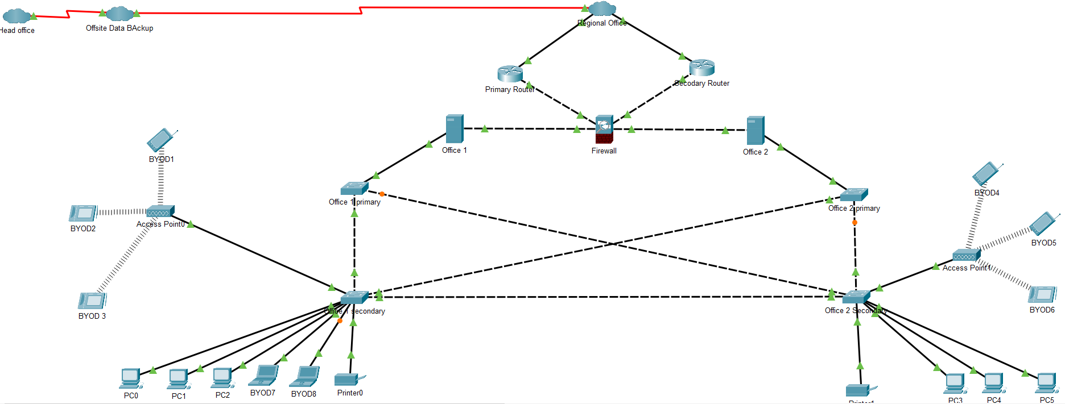

Staff Structure
This enterprise employs a top-down staff structure. The security management plan is mandatory for all users. The Information Security Team will be tasked with maintaining data security, including user account access and provisions that are set out for all network users. As such, this will be adjoined to the network administrator team that are tasked with general maintenance, with both having administrative status. A security champion will be assigned to act as a security staff link between CEO and all other staff.
All staff will adhere to the entirety of this policy. Adequate training will be provided to ensure competence and understanding of the policy requirements.

Confidential Data
All data must remain confidential. Only relevant departments will have access to specific data that will be determined through Microsoft Firewall Packet Filtering. It will be the responsibility of the Information Security Team to determine the correct inbound/outbound filters to specific offices and the end devices within them. Any issues regarding access must be sent to this team. If necessary, the information security team can escalate queries to the security champion for authorisation.

Backup Strategy
With failover cluster in place, the network should be prepared for the event of outages and downtime of certain nodes on the network. This will include RAID features and server mirroring.
For all sensitive data, backup files should be kept at a separate location to prevent data loss/hijacked from any of the offices. The network administrators are tasked with scheduling updates of sensitive data and periodical checks to ensure the updates are complete.

Network Access
A Bring Your Own Device policy is in place to ensure the safety of the network is not compropmised by access for end users with private devices via VPN. All devices will need user account accreditation set out in the domain Group Policy by security administrators. Passwords should have minimum length 10 characters, maximun age of 30 days and meet complexity requirements as set out in the security section within Group Policy Manager.
All end user devices must be up to date. Any lost/stolen devices must be reported to the administrators. Access to the network is forbidden when any user leaves the organisition and must be reported to the Information security Team by the relevant staff acording to the staff structure.
Remote access for staff is restricted to only when necessary. Staff that need to work from home or other locations should contact the Information Security team for VPN access to the network.

- References

Bibliography

[1] | L. Cobley, NOSS Worksheet Part 2, UWTSD, 2022.
[2] | I. Maddox, “13 best practices for user account, authentication, and password management, 2021 edition,” 6th May 2021. [Online]. Available: https://cloud.google.com/blog/products/identity-security/account-authentication-and-password-management-best-practices. [Accessed 5th May 2022].
[3] | B. S. Sutriman, “Analysis of Password and Salt Combination Scheme,” International Journal of Advanced Computer Science and Applications, vol. 10, no. 11, 2019.
[4] | Microsoft, “Failover clustering hardware requirements and storage options,” Microsoft, 29th March 2022. [Online]. Available: https://docs.microsoft.com/en-us/windows-server/failover-clustering/clustering-requirements. [Accessed 5th May 2022].
[5] | Microsoft, “Fault domain awareness,” Microsoft, 10th January 2022. [Online]. Available: https://docs.microsoft.com/en-us/windows-server/failover-clustering/fault-domains. [Accessed 5th May 2022].

