Site Investigation Case Study
Rhys Bolton (1902382) Word Count:2107
Historical Background of the allocated land selected
The suggested piece of land that has been selected for the proposed construction of the new restaurant, ice-cream parlor and manager’s apartment, is situated on the seafront, between the Marriot Hotel, and the City and county of Swansea’s Library and Civic Centre. The piece of allocated land is in a rectangular shape that constitutes part of the Marriot hotel’s carpark, part of Swansea Library’s carpark and a pedestrian and cycle path running straight through the middle of the site with grass banks with numerous trees running along both sides, adjacent to the footpath. The footpath that runs through the allocated site is a very popular route for people to take when going from the City Centre to the seafront promenade or vice versa. When visiting this site during November it became apparent to me that the proposed site is also located South of Swansea prison. The proposed construction is supposedly going to be one of a large construction with it being two stories high, with both nearest adjacent structures being a lot larger than it, with the multistory hotel to the East of it and the several story high, Civic Centre and Library building to the West.
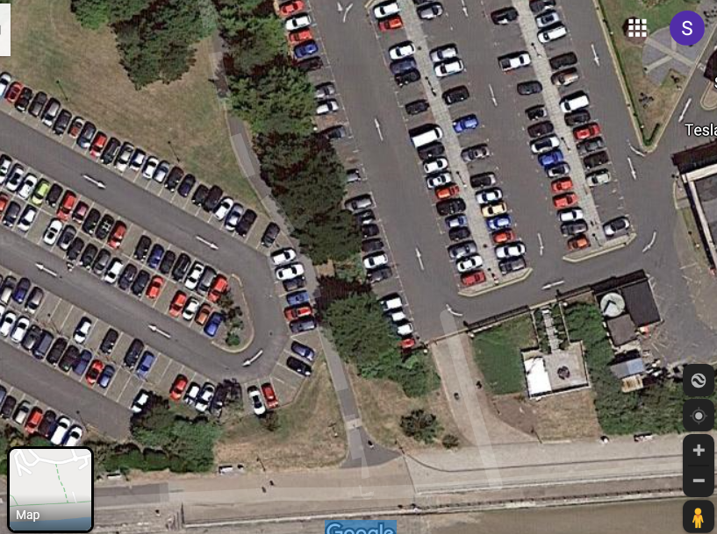
Figure 2 (below): Map of Swansea centre and Bay, with the proposed site located within the south of this image (centre). (Ordnance Survey Map of Swansea, 1948)
Figure 1 (left): Shows the allocated site for the proposed construction highlighted within the red rectangular shape, with the blue line indicating the path through the middle of the site. (Google Maps, 2019)

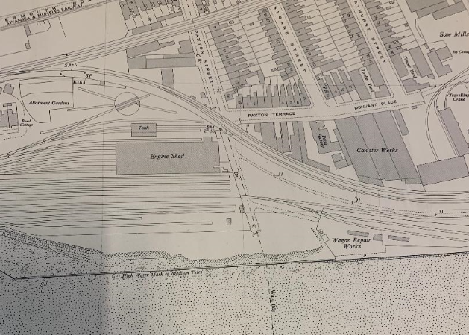
During the 1800’ and early to mid-1900’s Swansea Bay was completely covered in industrial works, railway lines and railway engine sheds. With there being several factories and railway lines previously being located within our site boundaries, it makes me believe that it may be the case that the majority of the land could perhaps be contaminated with oil, fuel and any other contaminated waste from the factories. Another factor that may affect our site is the possibility of gas or electric mains running underneath or within close proximity of our site. I believe that there may still be some of the connections under the ground as responses from local experts within the Archive Centre located within Swansea Civic Centre strongly believe that they have not been removed and therefore could quite possibly be beneath our site. Other information that can be identified and obtained from the map above is that there are high probability levels that there would have been a mine located near the site. This would have been located beneath the Mills located near Swansea Marina, Swansea Bay and Oystermouth Road. With the chance of there being an old mine shaft located within relatively close proximity to our site, this could result in unsteady ground, lacking in strength and stability. Another factor that certainly has to be taken into consideration is the chance of unexploded bombs being found in and around the site. During the Second World War between 1939 and 1945 Swansea got intensely bombed and was deemed to be the part of Wales that had experienced the largest levels of bombing. Some of Swansea’s most prominent buildings such as St. Mary’s Church located within the Centre of Swansea were ‘largely destroyed’ during the ‘Three-night blitz’ during February 1941 when thousands of bombs were dropped across Swansea.
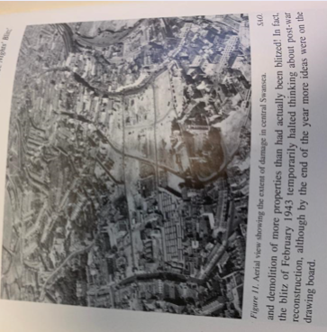

Figure 3 (left) An aerial photograph of the Centre of Swansea showing the most affected areas from the bombings. (J.R.Alban, 1994)

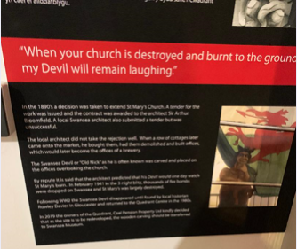
Figure 4 (right) A current Display situated in Swansea Museum concerning the ‘Bombings’ especially St. Mary’s church. (Museum, 2019)

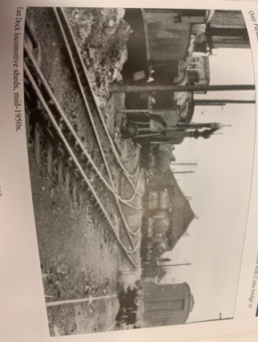
Looking back at figure 2 (the Ordnance map of Swansea Bay) it is evident that there were many railway lines running adjacent to and through a small proportion of the site. From the year of 1804 to the latter date of 1960, a railway service was run from ‘Swansea Docks to Mumbles Quarries’ and vice versa. This allowed them to transport minerals, rocks and materials etc. such as limestone. Swansea then developed this initial principle of its railway and eventually owned and ran the ‘Mumbles Railway’ which has since been deemed the first passenger railway in World history. (Rogers, 1995) The closure of this service in 1960 was disliked by many of the residents of the city. Once again it may be the case that contaminants from this service have been left behind near to and on our site affecting the surface of the ground and anything underlying it.

Figure 5 (left): The location of the site in the mid-1950’s showing the railway lines and engine sheds present there at the time. (Roberts, 2006)

Recommendations
As previously mentioned, concerning itself with (figure 2), there is still the chance that there may be electric and gas mains present underground, beneath our site. Initially, the best method to controlling or eliminating this factor would certainly be to try and find historic plans of the cabling/pipework in this area and assess whether we believe that it is the case that they are still beneath the site. If the plans are unavailable or unfound, then the other measure that should be put in place is to just proceed with the works with caution, maintaining sight on what is being unearthed and being mindful of the injuries that could be sustained if there was to be an explosion due to the removal of a pipe/cable. Adequate safety precautions should be put in place, such as wearing mandatory PPE (Personal Protective Equipment) including possible fire proof clothing due to the potential hazards of explosions, with the risk of these at a higher level than average on normal sites, and all inductions to the site setting out the potential dangers present that any worker should be aware of. (Executive, Health and Safety, 2014)
Another recommendation that is linked to this site is also previously mentioned and linked to figure 5, is the possible contamination of the soil due to fuel spills. This is due to there historically being railway lines and engine sheds located on the exact site in question. The way that we could identify if the soil is contaminated is for us to dig several bore-holes around the site at different locations, so that when removed and sent away to be tested then the different layers of soil can all be reviewed independently with ease. If the soil that has been taken away and tested comes back positive for contamination then it will all have to be removed and treated so that it is safe to use before it can be returned to site, before the construction phase can begin. If there are contaminants in the soil then there is a legal responsibility on the contractor to process and clean this soil of any contaminants as certain contaminated soil can present a hazardous risk to the health of humans and animals. This is perhaps one of the most-costly processes of the construction of a building, but if it isn’t done correctly then the repercussions will be a lot larger in legal fees and compensation for any victim in question. (Gov.UK, 2019)
As a result of the War, unexploded bombs play a huge part in the risk within new construction sites within Swansea. Unexploded bombs are still being found in and around the City Centre, with at least one being found within West Cross since the start of 2019. The control safety measures that can be implemented within a pre-construction phase to find and identify any unexploded bombs, is to carry out a bomb survey with a specialist trained team who will locate any bombs within the site boundaries. (Unexploded Ordinance (UXO) Survey, n.d.)
As the allocated site is within close proximity to the public, including both residents and visitors to the area, several safety measures will have to be implemented before any of the phases can begin and will have to be upheld for the whole duration of the construction. This would include; fencing, signs, locking of any gates at all times to restrict access onto the site of the public and a possible gates man to advise people on where to walk etc. and to help any wagons/machinery when entering and exiting the site. As the public walkway through the middle of the site is indefinitely going to be shut and cut off, another route would have to be put in place so that the public can still get to where they need to be.
As previously mentioned, concerning figure 2 (Ordnance Survey Map of Swansea) and the concern of there being historic mineshafts located within close proximity of the site, which could have possibly affected the ground to be unstable and lacking in strength. Therefore, before the works can begin on this site at all, any available documentation relating to this site should all be reviewed and any reliable evidence relating to there indefinitely being a mineshaft present at any time will show that it could have an impact on the build. As a result of this, if evidence is found, then excavations will have to take place to find out the exact depth of the mineshaft in question and if it is of a certain depth then it will have to get filled in with concrete to give a sturdy and strong enough base for the construction works to begin to ensure that the collapse of the build is not inevitable.

Building Regulations that my recommendations are derived
The building regulations that would have to be implemented and stuck to, would be the Health and Safety and the British standards for the depth of the foundations needed for this type of building, taking the area and stability and strength of the soil beneath into consideration. It would also have to provide technical standards on a wide range of products, with certificates being needed to be provided to prove this. This can be seen at the British Standards Institution (https;//www.BSIgroup.com, n.d.) The health and safety regulations, to keep the workers and the public around the site safe during the whole duration of the construction can be seen at the Health and Safety Executive for the United Kingdom. (Health and Saftey Executive, 2014)

Foundations
The type of foundation that should be selected to support the construction of this build is the use of a raft foundation. This is because after doing a site walk and researching on websites such as the British Geological Survey, I have discovered that mudstone, sandstone and siltstone were highly likely to be the makeup of the ground of the proposed site. This type of rock and soil is extremely weak and in order for it to be able to withhold the construction of any building, not even taking into the consideration that the building in question is proposed to be two stories high, then It is going to need added strength combined with it to give it more strength and rigidity. A raft foundation Is also known as a mat foundation and is a continuous slab that sits directly above the rock and soil. It doesn’t only sit under the building itself but it also extends outwards across the whole of the site. This gives the foundations added strength as it supports the whole building as it transfers all of its weight evenly across and into the ground. As the soil beneath the construction is soft and loose, this foundation type works well as it is considered to almost ‘float over the ground itself and therefore doesn’t cause that much stress and strain on the ground beneath it and therefore is more likely to withstand the weight and support itself, giving the building the strength and stability needed to stand up. With the ground having a low bearing capacity this type of foundation adds to it. For this foundation to be used well and efficiently, then the removal of the soil down to the correct depth is critical, it would then have to be compacted so that the soil becomes more closely compacted, once again adding to its strength. This compaction would take place by ramming the ground vigorously over and over until it is believed to have the suitable amount of strength. Reinforcement is highly likely to be needed in this situation, so that would get placed into the foundations first, before any concrete is to get poured in. Finally, the concrete gets poured in, which may need even more enforcement by adding bits of steel for the concrete to grip to, to give it its final bit of strength. (https://www.labc.co.uk/news/raft-foundation-basics, 2018)

Bibliography:
(n.d.). Retrieved from https;//www.BSIgroup.com.
(2018, November 21). Retrieved from https://www.labc.co.uk/news/raft-foundation-basics.
Executive, Health and Safety. (2014). Risk at Work - Personal protective equipment (PPE). Retrieved from https://www.hse.gov.uk/toolbox/ppe.htm.
Google Maps. (2019).
Gov.UK. (2019). Contaminated Land. Retrieved from https://www.gov.uk/contaminated-land.
Health and Saftey Executive. (2014). Retrieved from https://www.hse.gov.uk.
J.R.Alban. (1994). The 'Three Nights' Blitz. Swansea: City of Swansea.
Museum, S. (2019). "When your church is destroyed and burnt to the ground my Devil will remain laughing.".
Ordnance Survey Map of Swansea. (1948, November). Swansea.
Roberts, D. (2006). SWANSEA 'Snapshots & Sentiment'. Swansea: Bryngold Books Ltd.
Rogers, P. (1995). The Mumbles Train- World's first railway service. Retrieved from http://www.welshwales.co.uk/mumbles_railway_swansea.html.
Unexploded Ordinance (UXO) Survey. (n.d.). Retrieved from https://www.fugro.com/our-services/land-site-characterisation/geotechnical-ground-investigation/uxo-unexploded-ordnance-surveys.

