  LOCATION Swansea | LLEOLIAD abertawe
LEVEL 5 | LEFEL 5
EXAMINATION PERIOD | CYFNOD ARHOLIADAU
July 2019 (r) | Gorfennaf 2019 (r)

MODULE CODE: ACDA5002
Electronics 1

TIME: 2 Hours – Laboratory based exam
answer all questions

Questions are not equally weighted - make note and distribute your time accordingly

Equipment or materials required – PC running Proteus

ANSWER ALL QUESTIONS

QUESTION ONE Answer Q1 as a hard copy using the blank sheets/exam book provided.
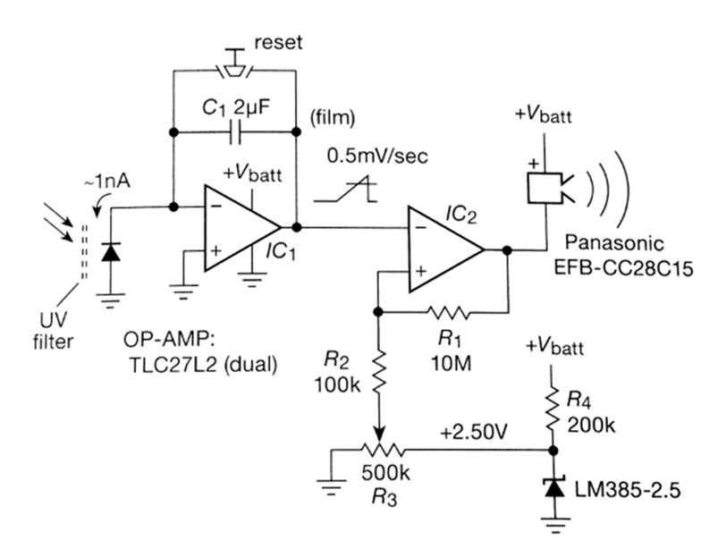

The Circuit above shows a purely analogue implementation of a simple ‘suntan timer’ where the light falling on a photodiode causes the sounder to operate after a time period that can be adjusted by the 500K potentiometer.
It is based around two op-amps configured in different ways.

- Identify and name how IC1 is configured. Explain its method of operation, specifically on the use of C1 and how the ‘reset’ button works?
- Identify and name how IC2 is configured. Explain its method of operation, including a description of all the associated resistors and their function in this particular circuit, as well as the purpose of the LM385 device.
- What is the diode type device on the far left of the circuit? How does it operate in this context, what is the UV filter for?
- Describe any potential disadvantages of using this simple analogue implementation? How might these be overcome?
(5 marks each section, 20 marks total)

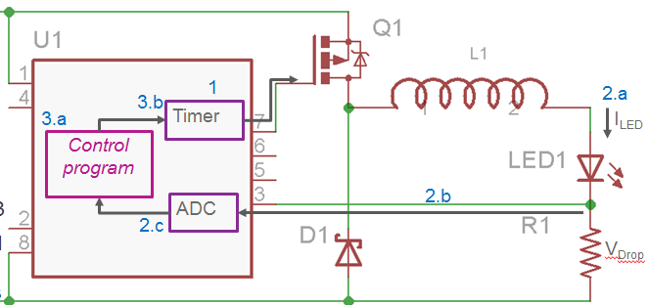

The above shows a generic circuit based around a microcontroller (U1) which could be used as an intelligent high power LED driver.
- Identify and explain the principle of operation of each 6 component – U1, Q1, D1, L1, LED1 and R1
(5 marks each – 30 marks total)

QUESTION TWO

- Using the analogue circuit given in Question one, simulate IC2 and its surrounding circuitry (R1 – R4 and the LM385) using proteus to demonstrate its principle of operation.
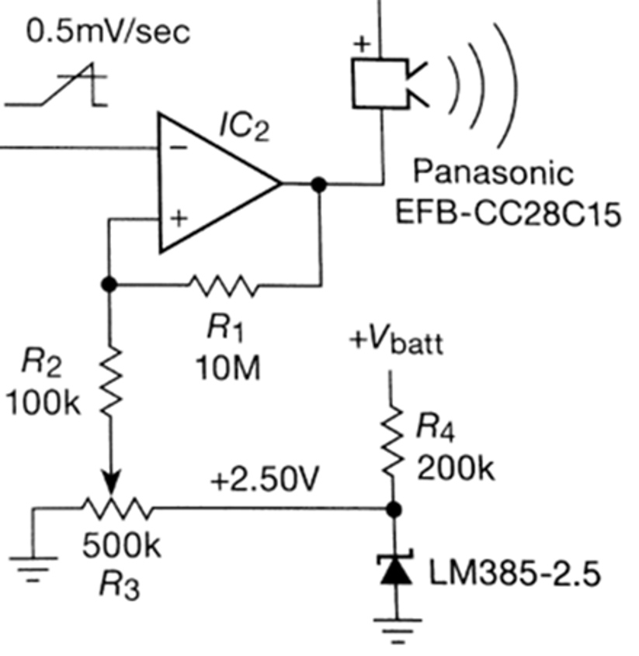
Instead of using IC1 to generate the input sawtooth ramp, directly inject a similar voltage source from a Proteus function generator which you will need to configure. Also swap the buzzer for an LED. Choose a ramp frequency of a couple of seconds so its easily visible on the LED.
When you have completed this task, call the supervisor over so they can see it in operation. ( 20 marks)
Save your simulation to disk. Name it ‘TaskA_<your name>’ and upload it to the appropriate link on Moodle (your supervisor will demonstrate where this is located)
- Now, you are required to replace the function generator with your own circuitry that generates an approximated sawtooth waveform from clocked, discrete digital logic using 74xx series ICs.
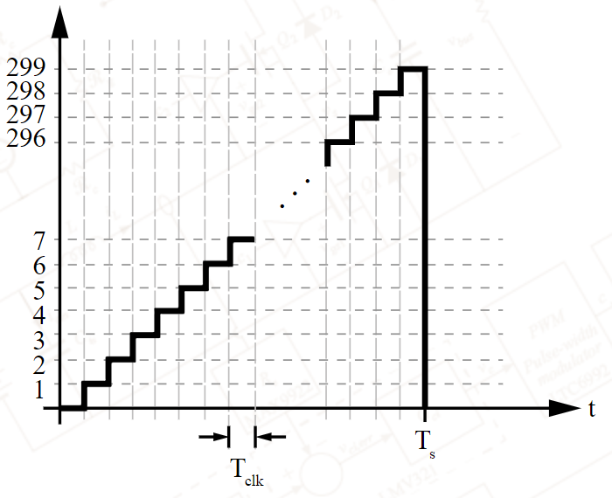
Use a minimum of 4 bits to give at least 16 analogue steps.
When you have completed this task, call the supervisor over so they can see it in operation. (20 marks)
Save your simulation to disk. Name it ‘TaskB_<your name>’ and upload it to the appropriate link on Moodle (your supervisor will demonstrate where this is located)
- Provide an explanation on how your digital sawtooth circuit operates. Answer this as a hard copy using the blank sheets/exam book provided. (10 marks)

