
Student Name: Parmar Mansi Sureshbhai
Student ID: 2432121
Marketing Management
Module Code: LCMB7024
Portfolio Assessment
AIRBNB GREENSTAY+
Sustainable Brand Extension Poster, STDP Analysis, Marketing Mix and Critical Reflection
Lecturers: Laila Maazouz
Term 1

TABLE OF CONTENT
Element 1: Sustainable Brand Extension Poster 3
Element 2: Segmentation, Targeting, Differentiation and Positioning Analysis 5
2.1 Segmentation Analysis 5
2.2 Targeting Strategy 6
2.3 Differentiation Strategy 7
2.4 Positioning Strategy 7
Element 3: Marketing Mix – 7Ps 9
3.1 Product 9
3.2 Price 9
3.3 Place 9
3.4 Promotion 10
3.5 People 10
3.6 Process 11
3.7 Physical Evidence 12
3.8 Integrated Marketing Mix Evaluation 12
Element 4: Critical Reflection 13
4.1 Developing the Sustainable Brand Extension 13
4.2 Marketing Knowledge and Critical Thinking 13
4.3 Poster Development and Presentation 13
4.4 Professional Development and Future Action 14
References 15

Element 1: Sustainable Brand Extension Poster
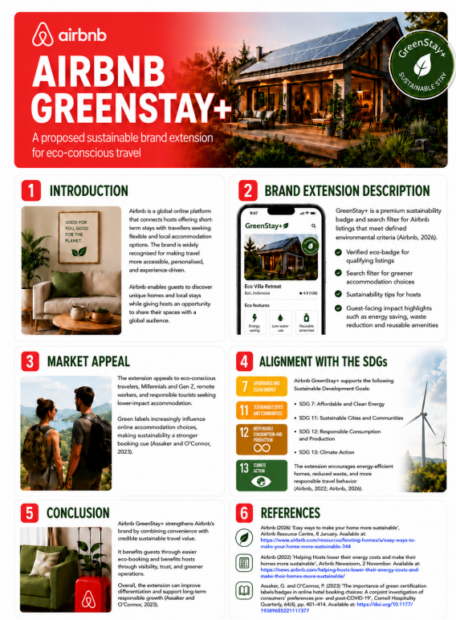
Figure 1: Poster
Airbnb GreenStay+ is a suggested brand extension, which will enable travellers to find and compare accommodation that meets clear environmental standards. Airbnb, having an established platform, brand, and host network, has a global digital marketplace of stays and travel services (Airbnb, Inc., 2026). The strategic rationale is due to an increasing pressure on tourism to minimize energy consumption, waste and other environmental effects and enable resilient tourism economies (United Nations, 2024). GreenStay+ would react by providing an approved badge, sustainability filters in search, per-property details of energy, water and waste behaviours and useful guidance on how to behave as a host. The capabilities of Airbnb to offer sustainability guidance to hosts have been already developed and thus the extension would formalise these practices and increase their visibility to customers (Airbnb, 2026). Its primary attraction is to decrease the information issue of travellers who would prefer greener accommodations yet is unable to assess competing allegations so conveniently. The idea mainly aims at the younger travellers who are environmentally conscious, digitally active but age alone should not be the defining factor of the market. Verified GreenStay+ may be much more successful in terms of differentiation and loyalty as a business strategy, though the existing weak controls might open Airbnb to greenwashing accusations and even reputation losses (Alyahia et al., 2024).

Element 2: Segmentation, Targeting, Differentiation and Positioning Analysis

2.1 Segmentation Analysis
Segmentation must distinguish between groups whose needs and responses warrant a specific value proposition and not solely characterize the market of travel as a whole (Kumar, 2023). GreenStay + has four bases that are pertinent, albeit their strategic value varies.
Table 1: Critical Market Segmentation for Airbnb GreenStay+
Basis | Proposed segment | Strategic opportunity | Critical limitation
Geographic | High-demand urban and nature destinations | Supports phased rollout where guest demand and host supply coexist | Standards and certification systems vary
Demographic | Mainly Gen Z and Millennials with digital confidence and disposable income | Familiar with platform booking and may respond to sustainability features | Age alone does not predict green purchasing
Psychographic | Environmentally conscious, ethical and responsible travellers | Strong fit with GreenStay+ value proposition | Attitudes may not become bookings
Behavioural | Users who filter, compare and seek verified green attributes | Closely linked to actual booking behaviour | Willingness to pay varies
Geographically, a world-wide launch would suit the size of Airbnb but would pose control issues since environmental regulation and established standards would vary in various countries. A slow roll-out in the markets that have adequate host density and verification capacity would thus be more justifiable. Weaker in terms of age, younger travellers are also appealing due to the possibility of impacting accommodation decisions due to environmental practices (Kim et al., 2024).
The psychographic segmentation will be more appropriate since the GreenStay+ is aimed at those travellers who engage in responsible consumption. According to Baca and Reshidi (2025), when attributed to meaningful environmental value, green branding can impact the decision to purchase the product. The behavioural segmentation is also vital since the extension is an inbuilt digital booking. Filter users and comparative travellers are more doable than those who are showing general concern. The authors of the research by Ray et al. (2024) support the necessity of information on sustainability on the Internet to be more representative in assessing the green accommodation of the criteria that are utilised by customers.

2.2 Targeting Strategy
The potential audience could mainly be digitally active, sustainable Gen Z and Millennial leisure travellers, utilizing online accommodation sites and seeking reliable sustainability data. This community can be reached via the digital ecosystem of Airbnb, and it can have a positive reaction to the environmental presentation. According to Kim et al., (2024) some younger consumers are ready to pay a higher price when it comes to sustainable attributes. Nonetheless, it would be overly broad to reach out to all the users of Airbnb and narrow to address only eco-tourists. GreenStay, therefore, should MBA demographic, psychographic and behavioural features, which is in line with effective targeting basing on accessibility, attractiveness and strategic fit.

2.3 Differentiation Strategy
GreenStay+ is advised to differentiate the Airbnb with certified sustainability, simple comparison and integration with the existing Airbnb booking site. Hosts are not allowed to self-identify properties as being eco-friendly without justifiable reasons because a transparent and authentic experience will diminish the concerns of greenwashing (Alyahia et al., 2024). Searchable sustainability data would also enhance comparisons between listings as standardised (Ray et al., 2024). A graphic GreenStay+ label may reinforce the knowledge and have an impact on guest behaviours, whereas digital eco-labels may assist with sustainable tourism decisions (Wong and Lai, 2024; Luo, Yang and Shahzaib, 2026). Another advantage of the by-product extension is the high parent-brand fit since it will build on the existing Airbnb experience of accommodation search (Wu, Y. et al., 2024). Verification however is more costly and burdensome to the host with stricter verification. Credibility must thus be the matter of choice rather than explosive growth.

2.4 Positioning Strategy
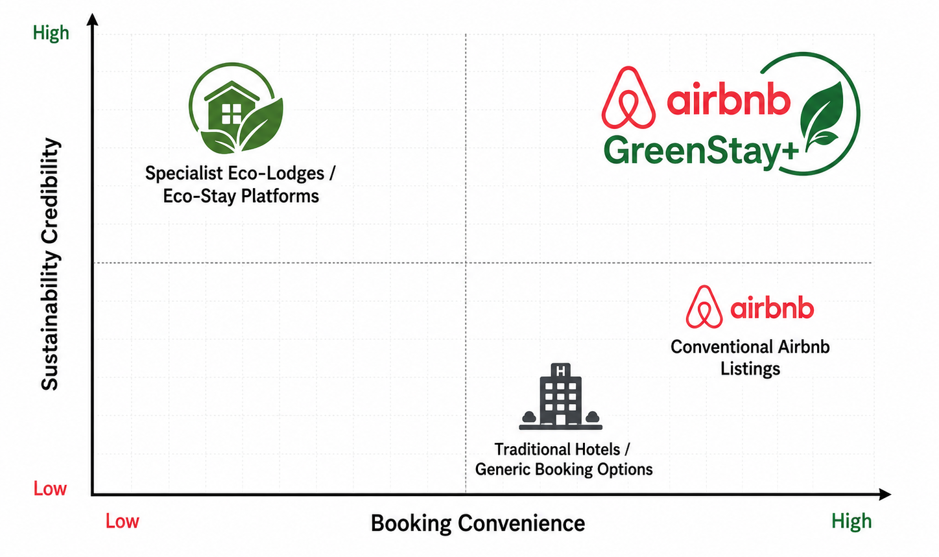
Figure 2: Positioning Map
The proposed positioning statement is:
“For environmentally conscious digital travellers seeking convenient and credible sustainable accommodation choices, Airbnb GreenStay+ provides verified sustainability information within Airbnb's familiar platform, enabling customers to identify and compare qualifying stays confidently.”
GreenStay+ must be at high-convenience, high-sustainability-credibility location. Traditional directories can be convenient but not always offer adequate information in an environmental aspect, and the specialized eco-accommodation directories can give more credible information in this aspect, but limited coverage. GreenStay+ tries to have a combination of both advantages. According to Akram et al. (2024), eco-labelling and green marketing signals are capable of supporting a purchase decision. The brand must not, however, make unconditional statements like the greenest or zero impact travel. According to Baca and Reshidi (2025), green branding is the most robust when the marketing of environmental meaning is legitimate. Thus, even a reliable and convenient solution to more sustainable stays is a more justifiable stance than a highly stated sustainability claim.

Element 3: Marketing Mix – 7Ps

3.1 Product
GreenStay+ has to be a digital service (augmented) and not a simple eco-badge. Its main advantage is that it will lead to more confidence in choosing sustainable accommodation with verified badges, sustainability filters and standardised indicators to use energy, water, waste and reusable facilities. Airbnb (2026) already gives the hosts sustainability tips, which will offer an operating base, whereas Tanveer et al. (2025) relate Airbnb-based collaborative consumption with the principles of the circular economy. Nonetheless, overindications might lead to information overload, whereas over-simplified labelling may obscure significant varyability. GreenStay+ should thus employ few transparent and comparable sustainability metrics that are clear.

3.2 Price
Access to GreenStay+ search and comparison by the guest should be free since it creates a needless barrier to its adoption, charging customers with the value of sustainability information. The more difficult to solve is host verification cost. Full host subsidies would decrease the Airbnb spending but might cut off smaller hosts and limit the number of eligible properties. An introductory model would thus be better as a subsidised model after which there will be a slight shared cost model as the extension increases. Certain environmentally friendly real-estate can fetch a higher price. Kim et al., (2024) indicate that environmental characteristics have the potential to select willingness to pay by younger consumers. However, the luxury-only idea of GreenStay+ has to be avoided, as too high prices might decrease the availability and circumscribe the market segment. Sustainability is supposed to be a plus not a reason to raise unsustainable prices unquestioningly.

3.3 Place
Location of concerns within GreenStay+ customer journey. It also needs to be incorporated into the Airbnb web and mobile platform search, filters, map search results, property detail page, booking experience and including a post stay review. This integration is offered by Airbnb, Inc. (2026) which offers a platform infrastructure. It is better to roll out it in stages over separate geographies than roll it out worldwide at once. The markets are to be put in priority based on the host density, traveller demand, the feasibility of verification and pressures under sustainability of destination. When there are not enough qualifying listings, launching it beforehand might result in low search results and lead to a loss of customer trust. Geographic expansion thus must be based on proven supply and not on Airbnb just being global.

3.4 Promotion
Enhanced advertising needs to focus on substantiated environmental value instead of the non-specific sustainability assertions. Awareness might be created through in-app promotion, email, social media, destination content, host stories and partnerships, whereas green marketing and eco-labelling might affect purchase intentions in tourism (Akram et al., 2024). Reward design could be a way of helping Airbnb promote green consumption, too, by giving travel credits or using host visibility or recognition features (Yu et al., 2025). Nevertheless, exaggerated assertions can bring about greenwashing dangers. Thus, the GreenStay+ messages must include verifiable declarations, like certified as GreenStay+, but transparency and credibility have to be prioritized over the exaggerated environmental promises (Alyahia et al., 2024).

3.5 People
GreenStay+ relies on Airbnb employees, sustainability specialists and verification partners, and hosts as well as guests. Hosts, experts, Airbnb employees handle regulations and conflict, and customers give feedback after their perusal. According to Mohammed et al. (2026), the quality of green service is linked to revisit intentions, which derive that the sustainability credentials are unable to offset a negative experience of a poor hospitality business. The GreenStay+, as such, should add to the current expectations of the quality of the accommodation as opposed to substituting them. Intense sustainability standards can enhance credibility but will dishearten host involvement. Airbnb ought to therefore integrate explicit requirements and training, real-life guidance, and easy-to-follow evidence handing over.

3.6 Process
Credible GreenStay+ process must consider host application, eligibility check, submission of evidence, assessment, approval, badge activation, booking of the guest, feedback and periodic reassessment.
Table 2: Proposed GreenStay+ Verification Process
Stage | Main activity | Control purpose
Application | Host submits evidence against defined criteria | Prevent unsupported self-declaration
Assessment | Evidence is independently or internally checked | Establish minimum credibility
Certification | Badge and sustainability information are activated | Signal qualification to customers
Stay and feedback | Guests use and review verified information | Add customer-based monitoring
Reassessment | Evidence is renewed; badge may be suspended | Prevent outdated or false claims
Ray et al. (2024) emphasize the significance of comprehensible environmental knowledge in online hospitality. GreenStay+ should thus include periodic audits, expiry dates, badge suspension and complaints procedures. The administrative costs will definitely arise through verification. It would however interfere with central positioning of GreenStay+ to save money by verifying. A valid service entails thus that Airbnb must bear some further operating complexity, as the price of making more assertive sustainability claims.

3.7 Physical Evidence
Being a digital service, GreenStay+ requires observable evidence of its promise of sustainability. This must consist of the GreenStay+ sticker, the verification day, uniform sustainability icons, photos of the property, third-party accolades where applicable and guest comments related to sustainability. The usefulness of visible cues of environmental certification is supported by Wong and Lai (2024), whereas Luo, Yang and Shahzaib (2026) demonstrate the capabilities of digital eco-labels in changing sustainable tourism behaviour. Standardisation is essential. When individual hosts refer to their own terminology and symbols to represent the environment, comparison is not as reliable and greenwashing is more difficult to tell. The control of the GreenStay+ visual language is therefore required and must make sure that all the presented sustainability claims are related to specific evidence.

3.8 Integrated Marketing Mix Evaluation
The seven elements are mutually dependent. Promotion with minimal verification poses the risk of greenwashing; high strictness of verification with no host backing limits supply; high premium prices spurred by premium perceived value low adoption; and high guest demand without adequate qualifying listing leads to disappointment. Kumar, (2023) underline aligned marketing judgments in response to the desired customer value proposal. The strategy should also be able to handle the two-sided platform logic of Airbnb: guests can only be interested in demand when there are enough hosts willing to qualify, yet the participation of hosts is never of great value yet travellers do not know or trust the badge. Wider expansion should therefore be pre-empted by coordinated supply building and education to the customer. GreenStay+ then needs to go live as long as the product designing, the participation of hosts, verification and provision of destinations is well coordinated.

Element 4: Critical Reflection

4.1 Developing the Sustainable Brand Extension
The creation of GreenStay+ altered my perception of sustainability as the highly promoted theme to an operative brand promise. Firstly, I paid attention to the palpable aspects, including the eco-badge, filters and SDG alignment. Additional investigation revealed that the credibility relies on the position to check the environmental assertions underlying these features by Airbnb. My understanding was also expanded by the United Nations (2024) associating sustainable tourism with the aspects of environmental responsibility and a robust economic activity. I thus gathered that a sustainable brand extension should be under-pinned by plausible procedures, facts and stakeholder behaviour. This made me move past merely marketing GreenStay+ and consider whether the sustainability promise it made was going to be provided in a consistent and credible way.

4.2 Marketing Knowledge and Critical Thinking
The STDP analysis helped me get a better perspective of how a large market can be whittled down to a defendable target. First, the term eco-conscious traveller appeared to be narrow enough, but the studies revealed that demographic factors, per se, are not the sure indicator of sustainable behaviour. I thus integrated the demographic, psychographic and behavioural variables to form a more significant target. I also got to know how to evaluate trade-offs and not think that all of the recommendations are good. Plausible checks enhance credibility at a sacrifice of stronger verifications, but at a cost and burdening hosts; in contrast, weak verifications can enhance participation but pose reputational risk. Likewise, high cost can enhance rates but make it less accessible. This rendered the strategy more analytical and evidenced based.

4.3 Poster Development and Presentation
The creation of the GreenStay+ poster helped me to gain skills in the visual presentation of a strategic idea. Its obvious identity, app-like mock-up, sustainability icons and SDG alignment assisted in comprehending the idea and making it appear realistic. Yet, a look through the poster demonstrated that the solution relevant to the customer was much more evident than the sustainability issue and business rationale behind it. I also realised that the investor value should be given a greater priority by the differentiation, credibility, loyalty and long term brand relevance. Making the presentation consequently opened my eyes that no matter how visually appealing the content of the presentation, a good marketing communication should be strategically convincing, evidence-based and highly prioritised when complicated information needs to be delivered within a few minutes.

4.4 Professional Development and Future Action
In an event where GreenStay+ was further developed, I would gather primary data on Airbnb customers and Airbnb hosts prior to advising on a large scale application. The trust in sustainability badges could be evaluated with the help of guest surveys, filter use and readiness to pay, and host interviews might lead to the detection of verification costs and operational obstacles. In the chosen destinations, a pilot could then gauge booking conversion, host involvement, badges and badge credibility. The qualification standards to be put in place should also be measurable, and this should be done by sustainability specialists. This would help minimize assumptions and fortify subsequent decisions. The project enhanced my skills to combine marketing theory, sustainability and service design and to understand that plausible sustainable marketing requires the brand to match brand promise with implementation and evidence.

References
Airbnb (2026) ‘Easy ways to make your home more sustainable’, Airbnb Resource Center, 8 January. Available at: https://www.airbnb.com/resources/hosting-homes/a/easy-ways-to-make-your-home-more-sustainable-344 (Accessed: 12 August 2026).
Airbnb, Inc. (2026) 2025 Annual Report (Form 10-K). San Francisco, CA: Airbnb, Inc. Available at: https://investors.airbnb.com/financials/sec-filings/sec-filings-details/default.aspx?FilingId=19141636 (Accessed: 12 August 2026).
Akram, U., Lavuri, R., Bilal, M., Hameed, I. and Byun, J., 2024. Exploring the roles of green marketing tools and green motives on green purchase intention in sustainable tourism destinations: a cross-cultural study. Journal of Travel & Tourism Marketing, 41(4), pp.453-471.https://www.tandfonline.com/doi/abs/10.1080/10548408.2023.2293022
Alyahia, M., Azazz, A.M., Fayyad, S., Elshaer, I.A. and Mohammad, A.A., 2024. Greenwashing behavior in hotels industry: The role of green transparency and green authenticity. Sustainability, 16(3), p.1050.https://www.mdpi.com/2071-1050/16/3/1050
Baca, G. and Reshidi, N., 2025. Green branding and consumer behavior, unveiling the impact of environmental marketing strategies on purchase decisions. Business Strategy and the Environment, 34(3), pp.3701-3713.https://onlinelibrary.wiley.com/doi/abs/10.1002/bse.4172
Kim, S.I., Gim, J., Kim, H. and Park, S., 2024. How can hotels Co-create value through the localized mini bar in the room: discrete choice modeling approach with CSR strategies with local products. Journal of Travel & Tourism Marketing, 41(7), pp.973-987.https://www.tandfonline.com/doi/abs/10.1080/10548408.2024.2371907
Kumar, P., 2023. Principles of marketing. Sultan Chand & Sons.https://www.sultanchandandsons.com/images/BookImages/EBook/237_Question%20Bank..pdf
Luo, F., Yang, H. and Shahzaib, F., 2026. Digital Eco-Labels as Catalysts for Sustainable Tourism: An Application of an Extended Norm Activation Model. Sustainability, 18(4), p.1846.https://www.mdpi.com/2071-1050/18/4/1846
Mohammed, M., Zhou, S., Abduljabbar Hael, M., Abdulwase, R. and Almuwaffaq, F., 2026. The impact of green service quality on consumers’ intentions to revisit green hotels based on theory of planned behavior. Journal of Quality Assurance in Hospitality & Tourism, 27(2), pp.396-432.https://www.tandfonline.com/doi/abs/10.1080/1528008X.2024.2343716
Ray, A., Sachdeva, I., Rana, N.P., Nunkoo, R. and She, L., 2024. Is the information on green hotel websites aligned with the drivers affecting customers’ intention to visit green hotels? A mixed-methods approach. Journal of Hospitality Marketing & Management, 33(1), pp.1-32.https://www.researchgate.net/profile/Robin-Nunkoo/publication/372493404_Is_the_information_on_green_hotel_websites_aligned_with_the_drivers_affecting_customers'_intention_to_visit_green_hotels_A_mixed-methods_approach/links/654366213cc79d48c5c71fda/Is-the-information-on-green-hotel-websites-aligned-with-the-drivers-affecting-customers-intention-to-visit-green-hotels-A-mixed-methods-approach.pdf
Tanveer, U., Sahara, S.N.A., Kremantzis, M. and Ishaq, S., 2025. Integrating circular economy principles into a modified theory of Planned Behaviour: Exploring customer intentions and experiences with collaborative consumption on Airbnb. Socio-Economic Planning Sciences, 98, p.102136.https://www.sciencedirect.com/science/article/pii/S0038012124003367
United Nations (2024) Promotion of sustainable and resilient tourism, including ecotourism, for poverty eradication and environmental protection. Report A/79/228. New York: United Nations. Available at: https://digitallibrary.un.org/record/4059447 (Accessed: 12 August 2026).
Wong, J.W.C. and Lai, I.K.W., 2024. Influence of the green certification logo and text on environmental awareness and hotel guests’ water-saving behaviour. Journal of Travel & Tourism Marketing, 41(4), pp.491-507.https://www.tandfonline.com/doi/abs/10.1080/10548408.2024.2310763
Wu, H., Wang, W., Tao, Y., Shao, M. and Yu, C., 2024. Understand the Chinese Z generation consumers’ green hotel visit intention: an extended theory of planned behavior model. Heliyon, 10(3).https://www.cell.com/heliyon/pdf/S2405-8440(24)01098-3.pdf
Wu, Y., Cai, Y., Zhou, X. and Huang, X., 2024. Shaping extendibility: The influence of circular versus angular shapes on consumer brand extension evaluation. Journal of Business Research, 171, p.114366.https://www.sciencedirect.com/science/article/pii/S0148296323007257
Yu, W., Liao, X., Ji, S. and Cui, F., 2025. Green rewards vs. non-green rewards? The impact of hotel marketing incentives on guests’ green consumption intentions. Journal of Sustainable Tourism, 33(8), pp.1534-1552.https://www.tandfonline.com/doi/abs/10.1080/09669582.2024.2378190

