Developing innovation abd creativity for business avantage

Development of Innovative Product or Unique Service Proposition



Kazi Shaila Sultana Sonia

University of Wales Trinity Saint David

Student ID: 2013422

Module Code: BMSW6102

Lecturer’s Name: Rexon Niting

Unit Name: Developing Innovation and Creativity for Business Advancement

Programme Name: BA (Hons) Leadership and Management Skills for the Workplace

EXECUTIVE SUMMERY

This report has proposed a dynamic and innovative idea named ‘First Step Towards Sustainable Use of Energy’ addressing household and business needs considering the volatile and ambiguous society we are living since the onset of Codiv-19 pandemic in early 2020 till today aiming to leverage the online platform rather than conventional Brick and Mortar (B&M) businesses. This project is aimed to sell a variety of sustainable energy-saving goods on the well-known e-commerce site eBay along with a unique value proposition that educate customers about sustainable energy and promotes waste reduction through succinct but powerful visual aids like short videos and messages, creative content, and image on the well-known social media platform Facebook.

PESTEL, Porter’s Five Forces and STP model have critically been analysed to get insight of business environment. Moreover, Stage gate model, Market Matrix, product life cycle and stakeholder matrix have been analysed in order to recommend the suitable marketing strategy for the dynamic and innovative project. Furthermore, GDPR rules, Data Protection Act of 2018, payment service, and Privacy and Electronic Communication Regulations (PECR) have illustrated widely in order to comply the business with all rules and regulation. It is recommended to use 7Ps of Marketing Matrix for the implementation of marketing strategy and monitoring and scanning the business environment through PESTEL and Porter’s Five Forces platform, furthermore, advised to appoint a Data Protection Officer to comply with GDPR and data protection act 2018.

It is expected that the project will be able to achieve the sustainable competitive advantages through the unique value proposition and create the awareness to the target market about sustainable use of gas and electricity and reduce the wastages of natural resource and it is committed to make a positive contribution towards sustainable future.

Table of Contents
T
1. Introduction 4
2. Value Proposition……………………………………………...……………….…………….6
2.1. Scope and Objectives……………….………………...…………………………………7
2.2. PESTEL Analysis…….….………………….…………………………………………….8
2.3. STP Model………………………………….……………………………………………10
2.4. Open Innovation Model…….……………….………………………………………….11
2.5. Porter's Five Forces Model………………….………………………………………….12
3. eCommerce 14
3.1. eBay & Facebook Market Place …………………...…...…………………………....14
3.2. Content & Photographs…………………...………...…...…………………………....15
3.3. Payment Service and PCI-DSS Compliance…………………………………...……20
4. Marketing Strategy……….……………...………………………………………………….21
4.1. 7Ps of Marketing Matrix………………….…………………………………...……….22
4.2. Stage Gate Model……………………………………………………...……………….23
4.3. Mandelow’s Stakeholder Matrix ……………………………………………...……….24
4.4. Product Life Cycle Model……...…...………………...……………………………….25
5. Privacy and Data Protection………………………………………….............................26
5.1. Data Protection Act 2018 and GDPR Rules.………...………………………………27
5.1.1. Comply with GDPR ……...……………………………………………………...............28
5.2. Privacy and Electronic Communication Regulations (PECR)…...…………………29

5.2.1. Comply with PECR……………………………………………………………………….29
6. Recommendation…………………………………………...………………………………30
7. Conclusion…………………………………………………...………………………………31
8. Reference………………………………………………………………………...………….32

1.INTRODUCTION

We currently find ourselves in a highly dynamic and complex environment. The onset of the Covid-19 pandemic in early 2020 brought about significant changes in the way we live and work, and unfortunately, more than 1.9 million people have regrettably died globally (WHO, 2021). Furthermore, since early 2021, the cost of living in the UK has been increasing substantially. The Consumer Prices Index (CPI) revealed a 10.5% increase in consumer prices in December 2022, and the annual rate of inflation actually reached 11.1% in October 2022 (Bank of England, 2023). In addition, the conflict between Russia and Ukraine, which has disrupted energy supplies and led to a 129% increase in gas prices and a 65% increase in electricity prices at the end of 2022 (Bank of England, 2023). Households and SMEs have found it challenging to afford products and services due to the high inflation rate, which could result in a society that is poorer, and less productive. Instead of investing primarily in Brick & Mortar (B&M) business, which confront unprecedented challenges, the idea is to innovate and leverage the technological advancement to create a long-term sustainable competitive advantage. Innovation is the process of developing new ideas that either incrementally, broadly, or disruptively satisfy market demands and add value. (Tidd & Bessant, 2009). The combination of innovation and technology could offer an effective solution to this ambiguous situation.

This report presents an innovative business idea named ‘First Step Towards Sustainable Use of Energy’ that addresses the excessive rising price of energy for households and business and provides a sustainable solution on virtual platform instead of traditional ‘Brick and Mortar’ solution. The idea proposes to sale the energy-saving products on virtual platform eBay, along with leveraging social media giant Facebook to create brand value and broaden the awareness among the target audience through short video, blog, and contents. The aim is to provide a platform where people find all necessary information and products in order to reduce Households’ and SMEs Energy Cost for survive in this volatile circumstances.

Business Environment is being justified before proposing the innovative idea such as PESTEL and Porter’s Five Forces analysis as well as STP model. eBay and Facebook Marketplace are being selected as virtual platform instead of Brick & Mortar and PayPal is used as an online payment service. Some Marketing Strategy are being critically analysed and underpinned with the report, for instance, Stage gate model, Market Matrix, product life cycle and stakeholder matrix. GDPR rules and PECR regulations are presented, ensuring compliance and successful business with tangible and intangible profits, thereby achieving a sustainable competitive advantage. It is recommended to apply Market Matrix for own marketing strategic approach, review business environment through PESTEL and Porter’s Five forces; furthermore, it is highly recommended to appoint a Data Protection Officer ensuring that business complies with GDPR rules, Data Protection Act of 2018, and Privacy and Electronic Communication Regulations (PECR).

2. Value Proposition:

Value Proposition refers the unique reason for what customer made their mind to buy the proposed product or service and the competitive advantages a company going to offer (Lynch, 2018).

This report is aimed to provide reliable, affordable, and sustainable energy saving solution through online instead of traditional ‘Brick and Mortar’ solution with an innovative business idea named ‘First Step Towards Sustainable Use of Energy’ that offers a variety of goods designed to lower the cost of energy for homes and businesses. The innovative idea gives not only the solution for households and businesses to reduce gas and electricity price through a range of energy-efficient products selling on eBay planform, but also use Facebook social media platform to create awareness through contents, short video, images, and blogs about natural resources (gas and electricity) and how to use it in a sustainable way and what a small effort everyone can contribute to value the natural recourses.

Therefore, the Value Proposition of this project is to provide energy-efficient products with affordable price as well as services to raise public awareness of sustainable energy use. Prior to purchasing proposed energy-efficient products, a segmented market will be educated via social media; this strategy sets the project apart from its current rivals and aids in the achievement of long-term competitive advantages.



2.1. Scope and Objective:

Scope is a term used in Project Management, refers to the combined objectives and requirements needed to complete a project pointing target customer, geographic location and products and services (Lynch, 2018). Objective refers the primary goal or purpose that will propel a firm ahead over the following several years. It also needs to be specific, measurable, and time bound. (Lynch, 2018).

The Scope of ‘First Step Towards Sustainable Use of Energy’ project is broad and inclusive with a strong focus on UK households and businesses. It aims to assist them in managing their high living costs by reducing gas and electricity waste, offering sustainable products and disseminating accurate knowledge and information about how to use natural energy sustainably, leveraging social media and e-commerce platforms rather than traditional Brick and Mortar (B&M) businesses.

The objective of this project is to provide sustainable energy solution products with affordable price for each UK households and SMEs and develop the awareness about use of electricity and gas. In order to accomplish this objective, sustainable energy items will be made available on eBay's e-commerce site and the targeted audience will be educated via Facebook's social media platform. The business environment, marketing strategy, payment service, and the 2018 Data Protection Act are all being rigorously examined to support the creative idea.

2.2. PESTEL Analysis:

PESTEL analysis refers to a framework to analyse macro-environmental elements used to conduct a strategic analysis or conduct market research and provides a summary of the many considerations for strategic management decisions (Aguilar, 1967). PESTEL analysis is being used to analyse the external factors of proposed innovative idea ‘First Step Towards Sustainable Use of Energy’.

Politic: The energy industry and online platform have been significantly impacted by politics both during and after COVID-19. Government implemented policies and guidance during Covid-19, which has promoted energy sector and online platform, on the other hand, post Covid-19, the unstable global economy, war between Russian and Ukraine, Brexit issue have a great impact on energy price interrupting supply chain. In turn, the gas price increases 129% and electricity price 65% in the late of 2022 (Bank of England, 2023).

Economic: The pandemic caused a substantial fall in some industries, which decreased demand for products and services related to energy. However, during this time, internet platform usage significantly increased. For instance, at the beginning of Covid-19, Amazon announced a profit rise of over 200%, and Facebook had 2.29 billion active daily users, making it the most well-liked social media site worldwide. According to the Bank of England, the higher cost of living during the pandemic had a significant impact on consumers and small and medium-sized businesses (SMEs), with inflation topping 11.1%, fuel prices rising by 129%, and energy costs rising by 65% by the end of 2022 (Bank of England, 2023).

Social: During Covid-19, People turned to online buying and e-commerce due to restriction of movement and reduced energy consumption. Post Covid-19, consumption behaviour has impacted with other factors and people move towards sustainable lifestyles through less wastages of energy.

Technology: Technological advancements like contactless pickups, online marketplaces like Amazon.com, Facebook marketplace, and eBay were able to make significant profits during the pandemic. To manage energy systems, digital technology has also been used. Technology developments like artificial intelligence and machine learning have had a favourable effect on the energy industry and internet platforms since the epidemic, enhancing the overall customer experience.

Environmental: The COVID-19 pandemic brought attention to the necessity of sustainable energy consumption. After COVID-19, renewable energy, lowering carbon emissions, and sustainability awareness are likely to receive more attention.

Legal: Legal factors have a minimal impact on Facebook's marketplace (Martin, 2022), but they have a large impact on the energy sector's emissions and sustainable use of energy.

To wrap the PESTEL analysis, it could be said that promoting sustainable energy-saving goods and services on eBay and Facebook Marketplace has the potential to gain competitive advantages and guarantee long-term sustainability. Environmental and legal concerns may present difficulties even though other external forces, such as political, economic, technological, and social aspects, create opportunity. Therefore, to improve the strategic management decision-making process, it is crucial to constantly monitor the external environment.

2.3. STP Model:

The Segmentation, Targeting, and Positioning (STP) model is a strategic marketing method used to identify and target particular client groups or segments (Hanlon, 2022). The three stages of STP model are as follows:

Segmentation: Refers the process of breaking the market down into smaller groups of consumers with comparable wants or traits. Numerous variables, including demographics, geography, psychographics, and behaviour, can be used to segment an audience.

Targeting: The next stage is to choose one or more segments to target after the market has been segmented. Targeting a certain market segment depends on a number of variables, including market size, development potential, competition, and corporate resources.

Positioning: Positioning entails developing a distinct picture or perception of the good or service in the target market's thoughts in comparison to rivals. (Hanlon, 2022)

The report proposes the innovative idea ‘First Step Towards Sustainable Use of Energy’
to sell on eBay sustainable energy saving products & services on Facebook platform to create awareness. In order to understand the demands and characteristics of the segmented market and target them with a value proposition and competitive advantages, the STP model is employed with proposed plan as shown below:

‘First Step Towards Sustainable Use of Energy’
Sustainable Energy saving products & service

Positioning:
Stand out from competitors offering sustainable products and create awareness on natural resource

Segmentation:
UK based household,
SMEs, & age group (8 to 16 )

Targeting:
UK household & SMEs

2.4. Open Innovation Model:

There are two types of open innovation are considered: Inbound open innovation, and Outbound open innovation (Oxford, 2021).  Finding ways to enhance and improve goods and services is the aim of open innovation, which is very advantageous and practical. Because of this, large corporations like NASA, Opel, and Netflix choose open innovation.  (Isomäki, 2018). | 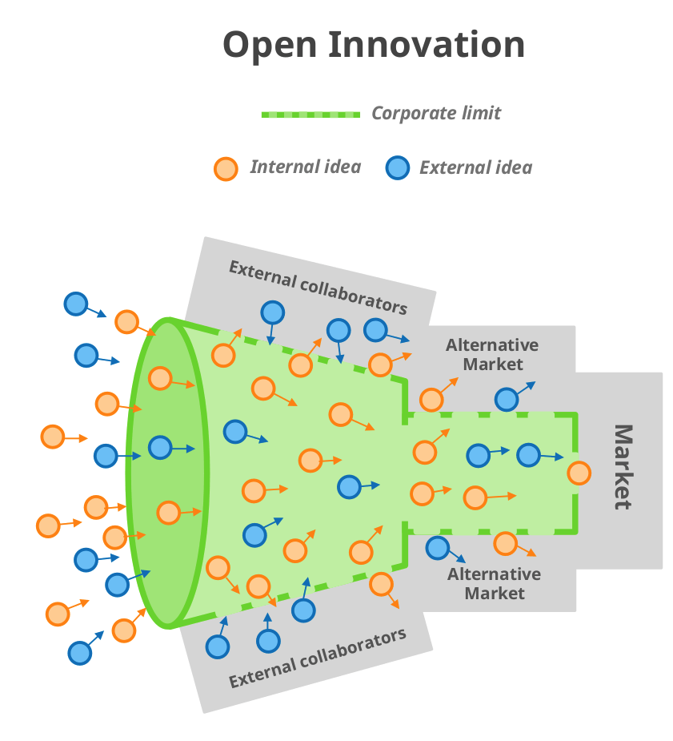
Open innovation means a situation where an organisation uses multiple external sources, such as customer feedback, published patents, competitors, external agencies, etc., in addition to their own internal knowledge, sources, and resources to innovate new goods, services, business models, and processes (Oxford, 2021).
By leveraging open innovation marketplaces, the project ‘First Step Towards Sustainable Use of Energy’ will be able to achieve the following benefits:
True Feedback: The project will receive a variety of ideas that can help it solve an issue or suggest a new good or service (Isomäki, 2018).
Newer Perspectives: In an open innovation, possible to pick from a sizable pool of concepts, recommendations, and viewpoints.
Cost-Effective: Compared to conventional approaches, open innovation may be more economical. Depending on the situation, it enables us to obtain effective solutions to issues without requiring a significant investment and fresh concepts for goods that have the potential to have an

2.5. Porter's Five Forces Model:

Porter’s Five Forces offers a framework to an organization to examine the level of competition in a particular market and its macroenvironment. An organisation must evaluate the factors that have a direct impact on performance and profit margin and mould them to achieve organisational goals and a sustainable competitive advantage (Lars, 2018).

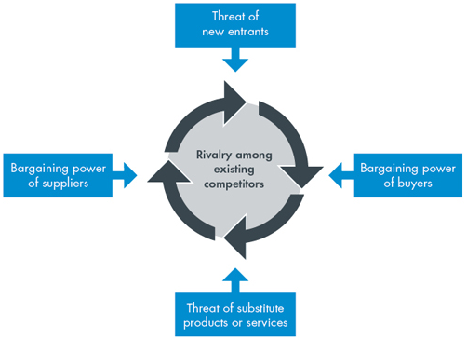

There are five factors that makeup Porter's 5 Forces:
Threat of new entrants: Refers to the competition new competitors pose to the industry.
Supplier bargaining power: This component looks at how suppliers can use their influence to raise the cost of goods and services.
Consumer bargaining power: When customers have more clout, they may be able to influence prices, bringing them down.
The threat of substitutes: Products and services can easily be substituted from the rival which is also a threat to a business.
Rivalry among existing competitors: Refers the competition among the rivalry.

Porter's Five Forces analysis of the project
‘First Step Towards Sustainable Energy’
Five forces | Innovative idea of | Power
Threat of New Entrants | No require significant investment or infrastructure for new entry | High
Bargaining Power of Suppliers | Supplier sources are diversified that reduce the power of bargaining. | Low
Bargaining Power of Buyers | Strong Value proposition and intangible benefits felicitate consumers and reducing their power of bargaining. | Low
Threat of Substitutes | There is different online service provider in the market with same principle. | Medium to high
Rivalry Among Existing Competitors | The idea offers the combination of sustainable product and training to educate people about natural resources like energy, which help them to gain  competitive advantage over rivalry | Low

Overall, the project has strong value offer, the project has a generally strong market position, which reduces the negotiating power of customers and suppliers as well as rivalry among current rivals. On the other hand, the project needs to be more innovative in its approach to the target market due to existing substitute threat and threat of new entrant.

3. eCommerce:

Online purchases and sales of goods and services by businesses and individuals are referred to as electronic commerce (e-commerce). E-commerce can be done on computers, tablets, cell phones, and other smart devices, and it operates in several market segments (Bloomenthal, 2023). To increase online sales, one can use ecommerce channels like their own website, an established selling e-commerce website like Amazon, eBay, or social media sites like Facebook and Instagram. One of the most well-known online marketplaces for buying and selling goods and services is eBay, which was established by American Pierre Omidyar in 1995. The methods eBay implemented to promote secure, open trading that was available to everyone and almost everywhere had a significant role in the company's growth. A key component of eBay's transaction environment has been PayPal, an online automated clearinghouse for payments (Augustyn, 2023). One of the most popular social media platforms in the world, Facebook has 2.29 billion daily active users (Martin, 2022); among them, 53.2% of users are between the ages of 16 and 24, and 66% of users interact with local business pages at least weekly. Therefore, using Facebook Market Place to promote a business, build brand recognition, gain more online followers, and increase sales of goods and services is a great idea (Martin, 2022). Choosing an audience, an age group, a location, a time frame, and an advertising plan for Facebook is simple.

3.1. eBay & Facebook Marketplace:

The report explains the ground-breaking idea of "First Step Towards Sustainable Use of Energy," which is successfully promoted through the use of the social media sites Facebook and eBay. This strategy's main goal is to make it easier for sustainable items to be sold, which will reduce energy waste. Additionally, Facebook is used to educate the target audience about the use of renewable energy before they make a purchase. This programme is distinguished by an open innovation structure that enables people to contribute to the project by coming up with original ideas, creating material, and submitting videos via the specific Facebook account. the project's innovative approach to energy conservation, which combines social media and e-commerce platforms in a synergistic way, is anticipated to produce significant advantages for both customers and the environment. Therefore, it justifies more research and application in the context of using sustainable energy.

3.2. Content and Photographs:

Anything shared with others on social media, including text updates, images, videos, links, and more, is referred to as Content, its ultimate purpose of content is to provide some kind of value-adding knowledge, amusement, or entertainment (Mukherjee, 2022). In order to reach every target client and create a change that is more engaging, this project has both short-term and long-term content, a website, blog, and awareness videos as well as short-course videos. This content is being used to leverage content marketing by using social media like Facebook, Instagram, WhatsApp, Snapchat, LinkedIn and so on to attract and retain customer. For instance, there are some photos of products, some short message and photographs which being inserted on Facebook business account and eBay account of the ‘First Step Towards Sustainable Use of Energy’.

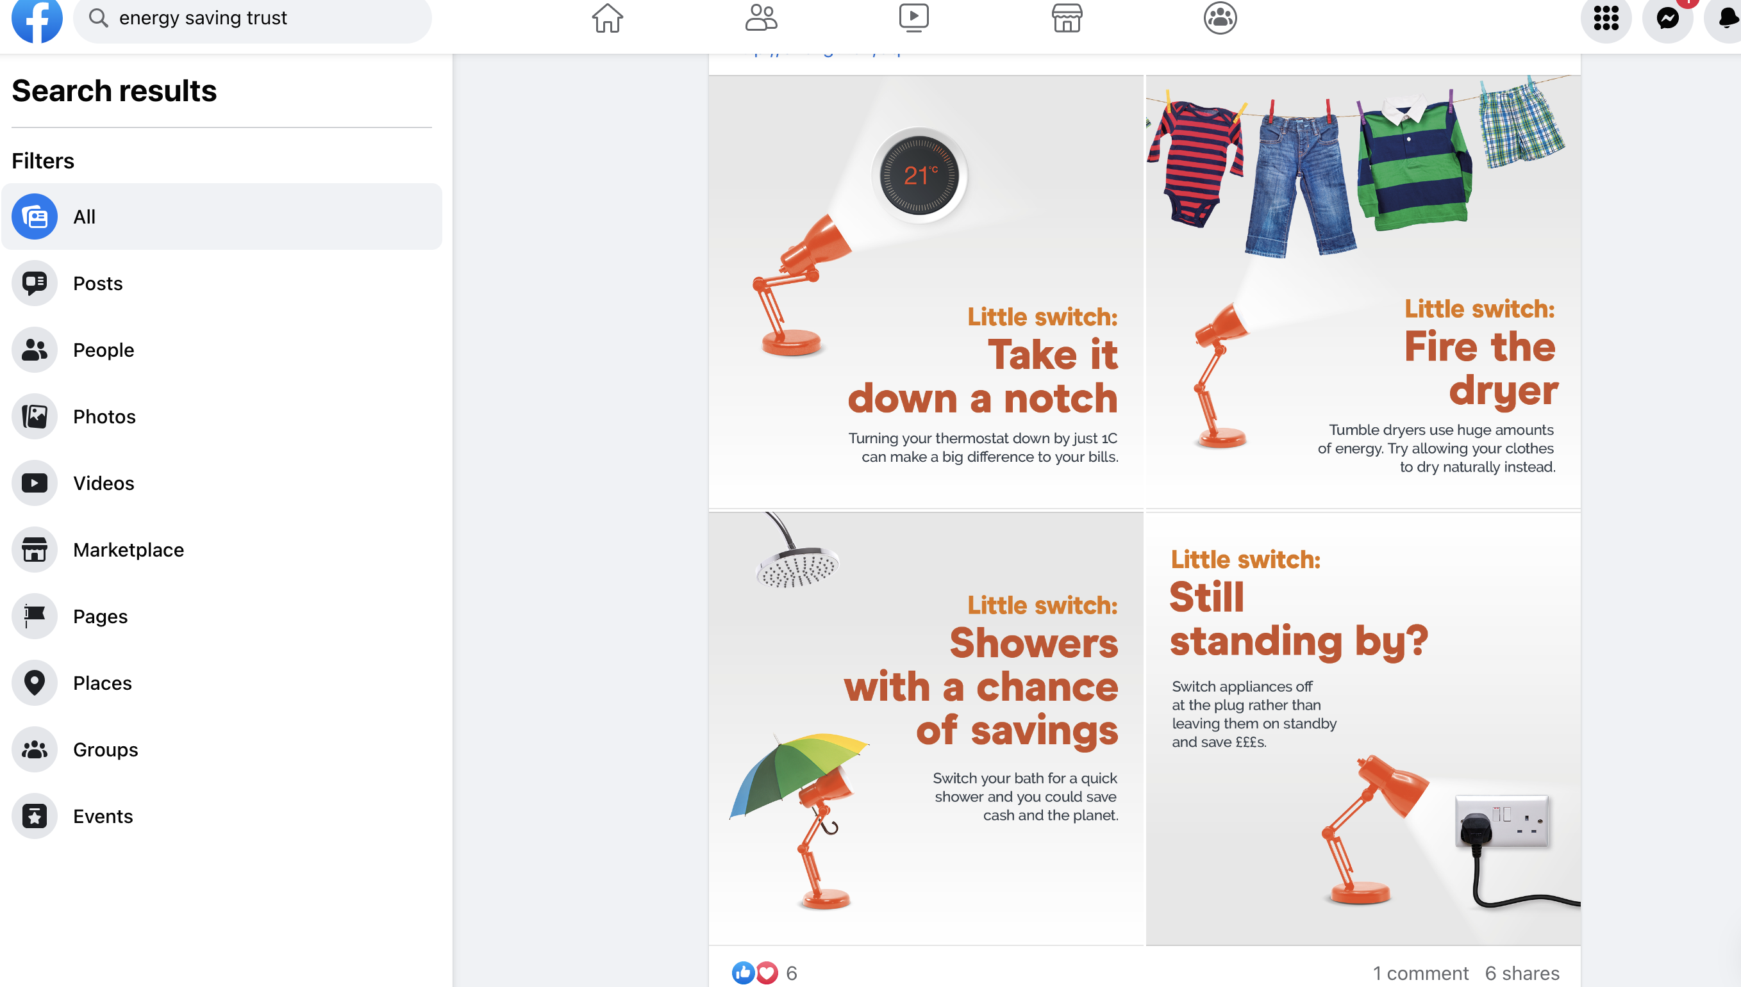
Facebook Business Account Layout

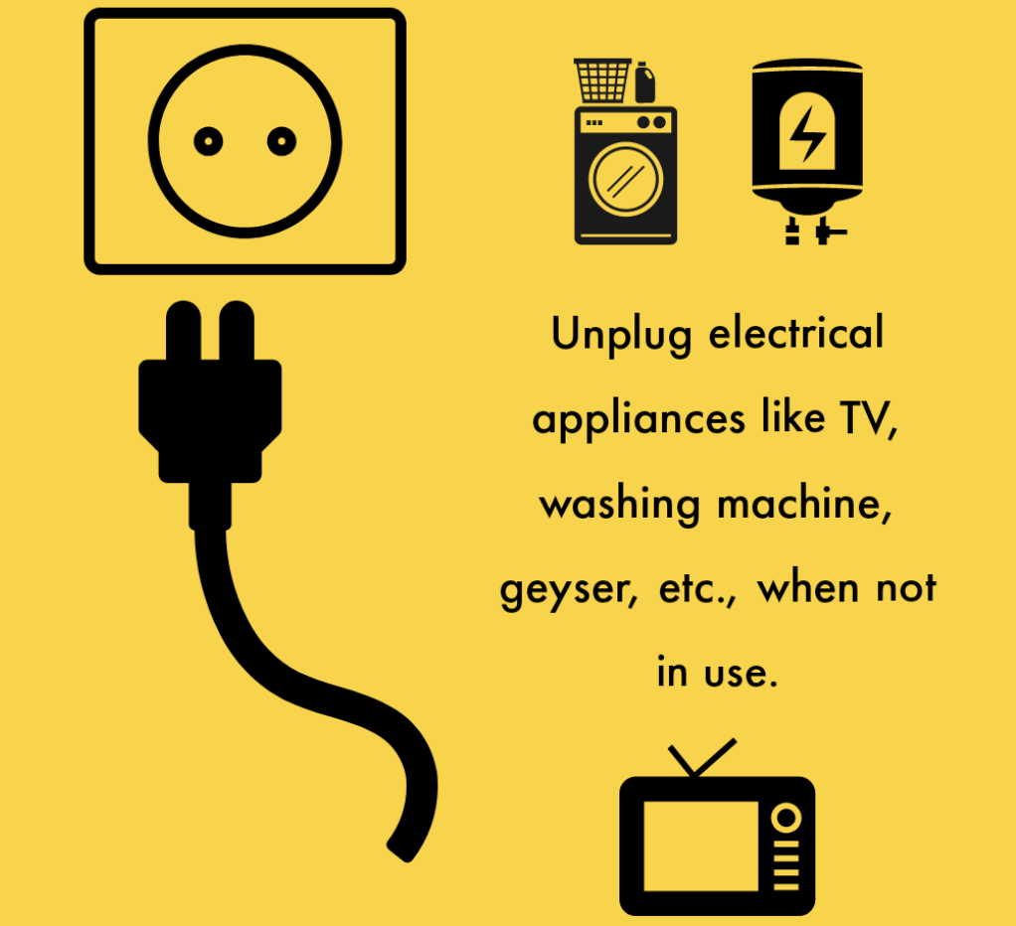

Awareness message and contents


Interface of Business page

Energy saving products and its probable utility image

 Save up to £60 a year fixing draughts! |  Lightbulbs would be upgraded by led one!
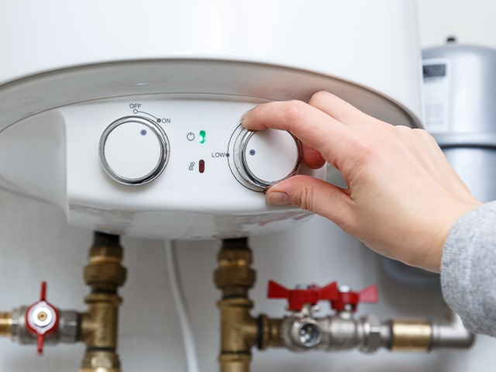Is your boiler reviewed and maintained? | 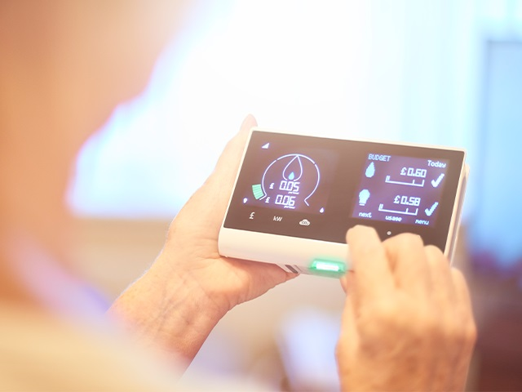  Be smart installing a smart meter!
Why not to adjust your heating! |   Be frugal by turning off lights in unoccupied areas!

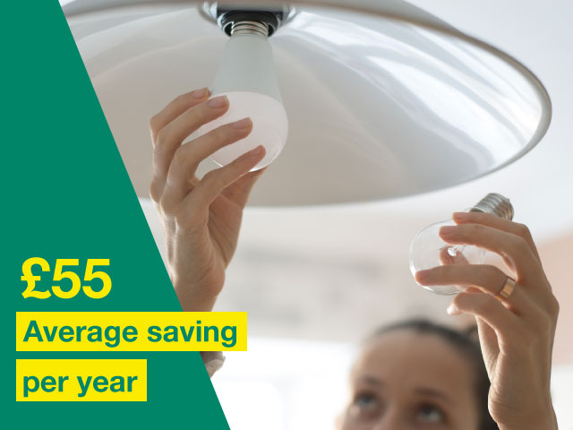 Save up to £55 a year switching to energy saving smart lightbulbs!  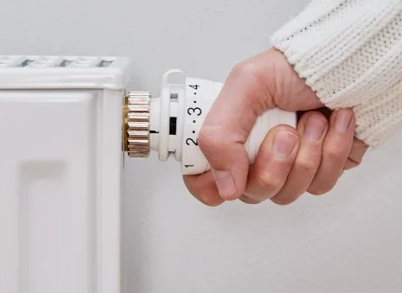  Turn down radiators in rooms!  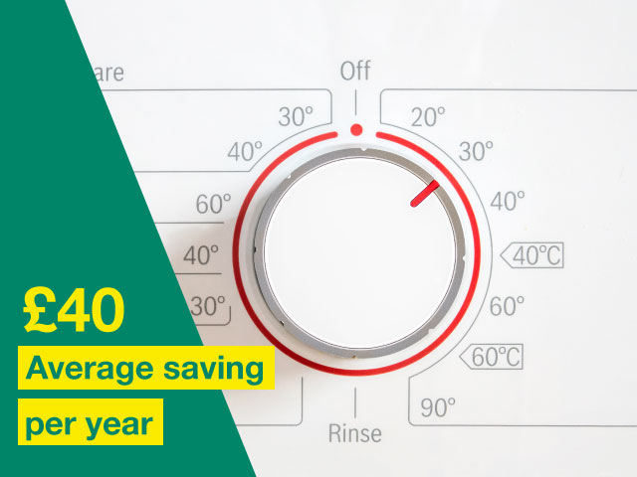  Wash your clothes at a lower temperature and save up to £3.04/month! | 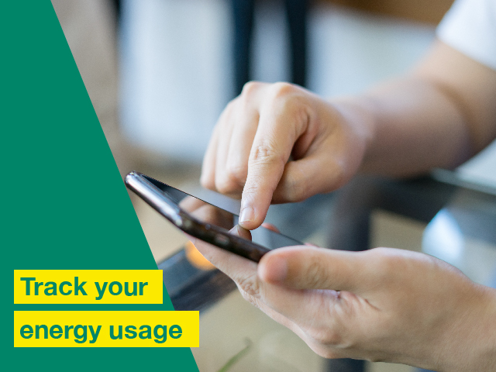Are you track your energy using an app?    What about your curtains? Closing them all at night!    Be sustainable and use tumble dryer!

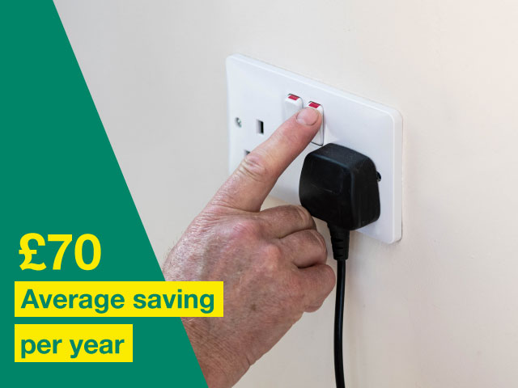  Save up to £70/year turning appliances off at the socket! |   Review your energy statement!

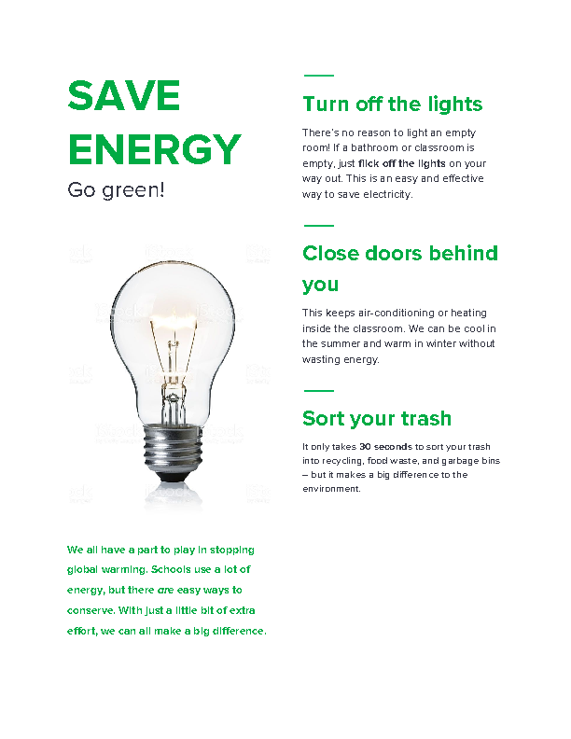

3.3. Payment service and PCI-DSS Compliance:

In order to improve customer experience and engage them with the project's value proposition, it is essential to have a convenient, secure, and regulated payment mechanism. One of the well-known payment options is PayPal, which is used to sell goods and services. PayPal, an American financial institution started by Dan Schulman in 1998, rules the electronic payments industry. In 202 countries and 21 different currencies, 173 million users use their service (PayPal, 2023). They provide a simpler, quicker, and safer payment mechanism that does not require entering bank information repeatedly and hides the bank information from retailers. To help keep information secure, PayPal uses anti-fraud technology and data encryption around-the-clock. Using the PayPal app to pay money safely and without disclosing financial details is convenient.

Any type of business must Manage Compliance issues. In order to gain user experience and protect customer data, PayPal is chosen since they have a dedicated compliance team and treat any compliance issues seriously (PayPal, 2022). To use PayPal's payment service, you must adhere to certain rules, such as the Payment Card Industry Data Security Standard (PCI DSS). In 2004, Visa, MasterCard, JCB, Discover, and American Express created a set of security guidelines known as the Payment Card Industry Data Security Standard (PCI DSS). The Security Programme, run by the Payment Card Industry Security Standards Council (PCI SSC), was created to guard against data theft and fraud for both online and offline credit and debit card transactions (Baykara, 2020). Building and maintaining secure networks, safeguarding cardholder data, developing a Vulnerability Management Programme, implementing strong access control measures, regularly monitoring and testing networks are all goals of PCI DSS (Baykara, 2020).

The 'First Step Towards Sustainable Use of Energy' project's payment system will implement the following security measures in order to handle card transactions and comply with PCI DSS regulations measures: robust password requirements, updating antivirus software, maintaining a vulnerability management programmer, implementing robust access control mechanisms, and protecting cardholder data, routinely tested and monitored, an annual self-evaluation.

4. Marketing Strategy

A marketing strategy is a long-term plan for attaining a company's objectives through comprehending client wants and forging a distinctive and durable competitive advantage (Aghazadeh, 2018). It includes everything, including figuring out who the target audience is and the best channels to utilise to reach them. Using a marketing strategy, a business can decide how it wants to position itself in the market, what kinds of products to make, who to partner with strategically, and how to advertise and promote its products. In this section, four Marketing Strategy models are being critically analyzed in order to recommend the most suitable one for the project ‘First Step Towards Sustainable Use of Energy’.

4.1. 7Ps of Marketing Matrix

The 7Ps of Marketing Matrix is a marketing framework that assists organisations in creating a thorough and successful marketing plan to meet client needs and position the company (Oxford College of Marketing, 2022). McCarthy proposed the 7Ps (Product, Price, Place, Promotion), along with an extra three aspects, in 1960. Booms and Bitner introduced the concepts of "Service, People, and Physical Evidence" in 1982.

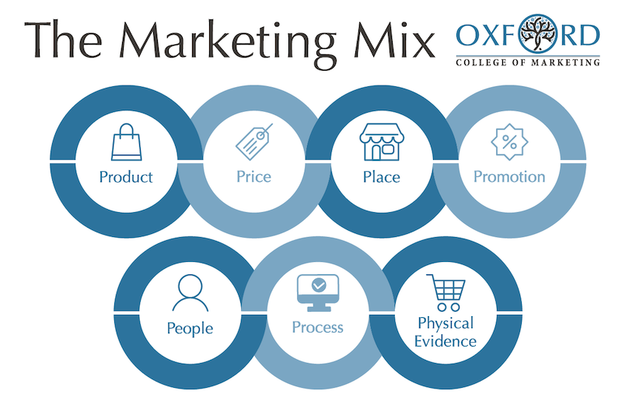

1.Product: This refers to the items or services that a business generates to satisfy client needs and set itself apart from rivals.

2.Price: This relates to how much a good or service costs. Developing a competitive edge and market positioning is essential.

3.Place: This refers to the medium—physical store or online platform—through which customers make a transaction.

4.Promotion: This refers to all methods of reaching out to customers, such as advertising, public relations, customer service, and sales promotion.

5. People: This is a reference to the staff members who deal with customers and offer service.

6.Process: This refers to the procedures and tools that a company uses to offer its goods and services; these procedures and tools include those for production, order processing, customer service, quality control, monitoring, and evaluation.

7. Physical evidence: This relates to the tangible aspects of a firm that customers interact with physically; examples include packaging, branding, user manuals, and retail layout, design, and cleanliness.

When creating a marketing strategy, the seven Ps must be considered in order to satisfy customer needs and enhance customer experience (Oxford College of Marketing, 2022). The creative concept of ‘First Step Towards Sustainable Use of Energy’ can take into account all seven principles and coordinate them effectively to positioning into the market and generate sustainable competitive advantage.

4.2. Stage Gate Model

Robert G. Cooper created the stage gate model in the 1980s (Cooper, 1990). It is a method of product development intended to control the innovation process from concept creation to product release. A product must travel through a number of stages, or gates, in the model in order to get from an idea to launch. Below are the stages:

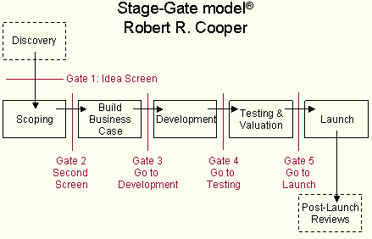

Stage 0: Idea: The first stage entails coming up with fresh product concepts.
Stage 1: Scoping: In this stage, the viability, market potential, and technical feasibility of the project are all initially evaluated.
Stage 2: Build the Business Case: In this stage, the project's economic potential is thoroughly examined, including the market size, target market, pricing strategy, and financials to support project objectives.
Stage 3: Development: During this phase, a prototype or small batch of the product is made, tested, and then improved in response to client input and technical limitations.
Stage 4: Testing and Validation: During this phase, the product is tested in actual settings to determine its technical, commercial, and financial viability.
Stage 5: Launch: During this phase, the product is fully commercially launched, which includes production, marketing, and distribution.

The Stage-Gate model is a versatile framework that can be customised to fit various product development methodologies. It helps to ensure that innovation is handled methodically, minimising the risk of failure and maximising the chances of success.

Benefits of the Stage Gates Model: Each stage has a defined task that helps to reduce ad hoc or unplanned changes to the idea, lowering risk. Its review phase is also good at managing resources and minimising waste. The stage gate technique is helpful in directing staff members to work on the appropriate assignment at the appropriate time. Stage gates allow for constant project monitoring, ensuring that important objectives are met with little change. Stage gate technique is adaptable, allowing it to be changed to fit a range of organisational circumstances.

4.3. Mandelow’s Stakeholder Matrix

Mendelow’s Stakeholder Matrix is a strategic management tool introduced by Mendelow in 1991 that helps organizations categorise stakeholders according to their level of interest and influence and learn how to engage with them successfully (Oxford, 2022). Stakeholders are divided into four quadrants in this matrix:

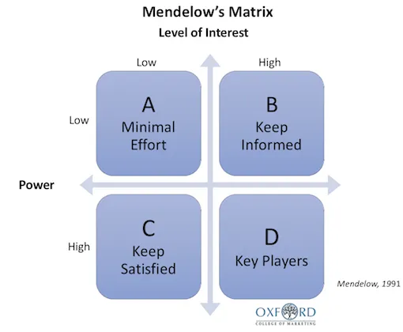

A. Low power, lower interest (Monitor): Avoid droning these stakeholder groups with constant communication.
B. Low power, high interest (Keep Informed): Inform these individuals fully and communicate with them to ensure that no significant concerns arise.
C. High power, less interested (Keep Satisfied): Work hard enough to keep these group happy.
D. High power highly interested (Manage Closely): Make every effort to fully engage these individuals and satisfy their needs.

Organisations may prioritise their engagement activities and gain a better understanding of their stakeholders by using Mendelow's Stakeholder Matrix. To ensure support and needs of important stakeholders, such as customers and employees, the innovative project dubbed ‘First Step Towards Sustainable Use of Energy’ would consider stakeholder based on interest and power and communicate with them effectively while prioritising compliance issues.

4.4. Product Life Cycle Model

Product lifecycle strategies are the many marketing strategies that businesses employ to manage a product as it moves through its life cycle (Pettinger, 2022). According to the PLC concept, a product passes through various stages from launch to decline, and each stage necessitates a unique set of marketing tactics. There are four stages:

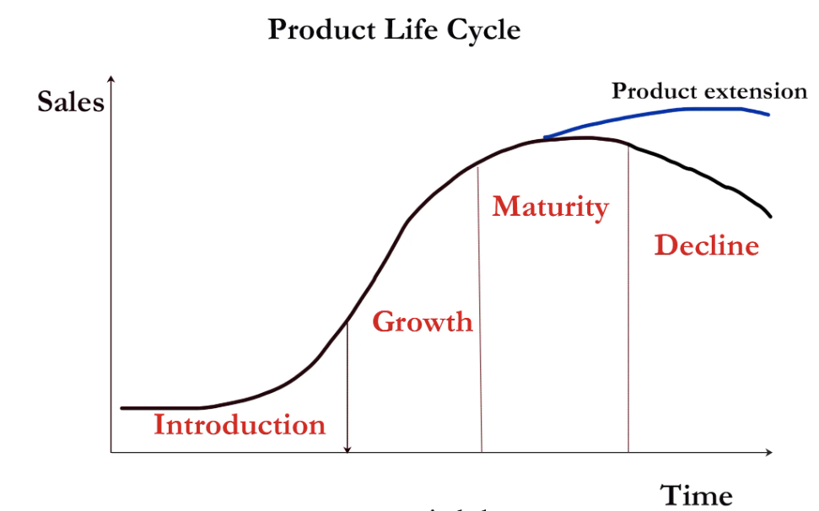

1. Introduction: The product is new to the market, introduce it through price, distribution channel development, and advertising and marketing.
2. Development: Sales of the product are increasing quickly as the market accepts it.
3. Maturity: The product reaches its peak and sales growth starts to slow down.
4. Decline: Sales begin to fall.

Companies need PLC plans to make sure they are managing their products well throughout their life cycles and maximizing their potential (Pettinger, 2022). The proposed project can maximize revenues by extending the life of their products by comprehending the many stages and putting the right strategies into place.

5. Privacy and Data Protection

5.1. Data Protection Act 2018 and GDPR Rules

The UK's Data Protection Act 2018 regulates the handling of personal data and how it is used by businesses, organisations, and the government. Incorporating the EU's General Data Protection Regulation into UK legislation, it was introduced to replace the Data Protection Act of 1998 (Legislation.gov.uk, 2018). It provides people more control over their personal data and places responsibility on businesses to handle it securely and ethically. Additionally, it gives people the right to control, access, and request the erasure or correction of their personal data (Legislation.gov.uk, 2018). The 2018 Data Protection Act's guiding concepts are:
- The information is used in a fair, legal, and transparent manner.
- used for explicit purposes.
- kept up to date.
- kept for no longer than is necessary.
- Ensures appropriate security
Sensitive Information includes details like race, ethnicity, political leanings, religious convictions, union participation, biometrics, health, and sexual orientation. There is advice available. Individuals have eight rights regarding personal data, under the UK GDPR:
- The right to information.  - The right to access  - The right to correction  - to be eliminated | - Right to restrict processing  - Data portability right  - Right to object  - Profiling right

5.1.1. Comply with GDPR Rules:

Any type of business that handles personal data must comply with the GDPR's rules in order to follow the law, protect its reputation, and gain a competitive advantage in the market. (FSB, 2021) Following steps are being taken for the project ‘First step towards sustainable energy’ to adhere with GDPR rules:

- Appoint a Data Protection Officer
- Understanding GDPR rules well
- Conduct an audit
- Implement appropriate security measure
- Obtained consent and right to withdraw.
- Train all employees who handle the data
- Produce a plan of data management

5.2. Privacy and Electronic Communication Regulations (PECR)

A UK regulation called Privacy and Electronic Communication regulates how companies might use electronic technology to promote to UK customers (Legislation.gov.uk, 2003). In this particular sector, the PECR contains comprehensive rules. A corporation must abide by both the PECR and the GDPR because they are complementary to one another. According to PECR electronic communication covers:
- Email
- Phone
- Instant messaging
- Fax
- SMS
- Electronic communications networks
- Online tracking technologies: Cookies (Legislation.gov.uk, 2003).

5.2.1. Comply with PECR:

Privacy and Electronic Communication aims to safeguard people's privacy. A successful firm must adhere to PECR in order to operate. (Legislation.gov.uk, 2003). Following steps is being applied to adhere with UK PECR Law:

- Free choice to consent and withdraw
- Consent for electronic mail marketing
- Keep record
- Must not use pre-ticked opt-in consent
- Any time opt-out opportunity
- Simple and easy communication

6. Recommendation

The primary objective of this report is to propose an innovative idea that leverages technological advancements to benefit households and small-to-medium-sized businesses in the United Kingdom. The current global environment is characterized by unprecedented levels of volatility and complexity, stemming from the Covid-19 pandemic that emerged in early 2020, an inflation rate increase of 11.1% in 2022, a 129% increase in gas prices, a 65% increase in electricity prices along with unstable global economy. Against this backdrop, the dynamic and innovative project, 'First Step Towards Sustainable Use of Energy', offers a real-time solution to the challenges faced by consumers. The project focuses on the sale of sustainable and affordable products via the eBay platform, as well as educating select customers through social platform.
It can be said that the combination of innovation and advanced technology of the project could offer an effective solution to this ambiguous situation. However, it would be challenging to gain completive advancement and create a Value Proposition in the competitive market. It is recommended to critically analysed the external and internal business environment applying PESTEL and porter’s Five Forces and consider Open Innovation model to face challenging ambiguous situation to use multiple external sources to drive innovation in a sustainable approach. To define a long-term plan and SMART objectives, it is recommended to focus on a proper marketing strategy for achieving goals by understanding the needs of customers and creating a distinct and sustainable competitive advantage. It is recommended to consider the 7Ps of Marketing Matrix that is an effective marketing strategy to satisfy customer needs and positioning the business considering all 7Ps and co-ordinate them efficiently to position into the market and achieve sustainable competitive advantages. Furthermore, it is highly recommended to appoint a Data Protection Officer (DPO) for ensuring that the business complies with the PECR, GDPR regulations and the Data Protection Act 2018 to avoid the heavy fine, and damage reputation and to create a credible and unique value proposition.

7. Conclusion

The "First Step Towards Sustainable Use of Energy" project offers a dynamic and innovative approach to sustainable energy utilisation, utilising cutting-edge technology to promote environmentally friendly solutions that address the specific challenges faced by UK households and small-to-medium-sized businesses in today's complex global environment.

In this report, Facebook was utilised as a social media platform to educate the target audience while eBay was used as an e-commerce platform to offer energy-saving products instead of Brick-and-Mortar stores. PESTEL, Porter's Five Forces, and the STP model have all been critically evaluated to get insight into business environment aspects. In order to recommend the best marketing approach for the innovative and dynamic project, the Stage Gate Model, Market Matrix, product life cycle, and stakeholder matrix have been analysed. GDPR regulations, the Data Protection Act of 2018, and the Privacy and Electronic Communication Regulations (PECR) have been illustrated in order to comply with the process. Moreover, it has recommended to apply 7Ps of Marketing Matrix to approach efficiently towards challenging market, and monitoring and scanning the business environment through PESTEL and Porter’s Five Forces platform. Furthermore, suggested to appoint a Data Protection Officer to comply with data protection rules. It is important that the recommendations are being followed to secure customer data, avoid fine and disruption of brand reputation and to reach the customer with the right solution.

To wrap up, the report proposed a need-pull open innovative idea that seeks to deliver a distinctive value proposition to its customers and consequently achieve sustained competitive advantages by providing a sustainable solution.

8. REFERENCES

Aghazadeh, H. (2018) Strategic Marketing Management: Achieving Superior Business Performance through Intelligent Marketing Strategy. Science and Direction, 207(10), pp. 125-134
- Aguilar, F.J. (1967) Scanning the Business Environment. Johannesburg: Macmillan Press.
- Ansoff, H. (1957). Strategies for Diversification. Harvard Business Review. 35 (5): 10–25
- Augustyn, A. (2023) eBay: Online auction company. [Online] Available at: https://www.britannica.com/topic/eBay (Accessed :16 April 2023).
- Bagchi, B., Chatterjee, S., Ghosh, R. & Dandapat, D. (2021) Impact of COVID-19 on Global Economy. International Journal of Environmental Research and Public Health, 18(5), pp. 247-355
- Bank of England (2023) Inflation and the 2% target [Online]. Available at: https://www.bankofengland.co.uk/monetary-policy/inflation (Accessed: 24 April 2023).
- Baykara, S. (2020) PCI- DSS Guide. [Online] Available at: https://www.pcidssguide.com/what-is-pci-dss-and-pci-compliance/ (Accessed: 25 April 2023).

Bloomenthal, A. (2023) Ecommerce Defined: Types, History, and Examples. [Online] Available athttps://www.investopedia.com/terms/e/ecommerce.asp (Accessed :15 April 2023).
- Cooper, R. G. (1990) Stage gates systems: A new tools for managing new project. Business Horizons, 33(3), pp. 44-54.
- Foss, N. & Saebi, T. (2015) Business Model Innovation: The Organizational Dimension, Oxford: OUP Oxford.

FSB (2021) A Guide to UK GDPR Compliance for Small Business [Online] https://www.fsb.org.uk/resources-page/gdpr-for-small-businesses-how-to-stay-compliant.html (Accessed 24 April 2023).

Hanlon, A. (2022) The segmentation, targeting, positioning (STP) marketing model. [Online] Available at https://www.smartinsights.com/digital-marketing-strategy/customer-segmentation-targeting/segmentation-targeting-and-positioning/ (Accessed :26 April 2023).
- Isomäki, A. (2018) Open Innovation – What It Is and How to Do It. [Online] Available at: https://www.viima.com/blog/open-innovation (Accessed :26 April 2023).
- Lars, D., B. (2018) Business-to-you [Online]. Available at: https://www.business-to-you.com/porters-five-forces/ (Accessed: 23 April 2023).

Legislation.gov.uk (2003) The Privacy and Electronic Communications (EC Directive) Regulations 2003 [Online] https://www.legislation.gov.uk/ukpga/2018/12/contents/enacted (Accessed 24 April 2023).

Legislation.gov.uk (2018) Data Protection Act 2018 [Online] https://www.legislation.gov.uk/ukpga/2018/12/contents/enacted (Accessed 24 April 2023).
- Lynch, R.L. (2018) Strategic management. 8th ed. Harlow: Pearson Education Limited.
- Martin, M. (2022) Facebook Marketing in 2023: A very complete guide [Online]. Available at: https://blog.hootsuite.com/facebook-marketing-tips/ (Accessed: 24 April 2023).
- Michael, E. R. (1998) Competitive Advantage: Creating and Sustaining Superior Performance. Cambridge: Free Press.
- Mukherjee, P. (2022) What is content: Definition, types and how it can help your brand. [Online] Available at: https://www.justwords.in/blog/what-is-content/ (Accessed :16 April 2023).

Oxford College of Marketing (2022) What Is Mendelow’s Matrix And How Is It Useful?[Online]https://blog.oxfordcollegeofmarketing.com/2018/04/23/what-is-mendelows-matrix-and-how-is-it-useful/ (Accessed: 13 April 2023).
- Oxford College of Marketing (2023) Understanding The 7Ps of Marketing Matrix [Online]. Available at: https://blog.oxfordcollegeofmarketing.com/2020/10/08/understanding-the-7ps-of-the-marketing-mix/ (Accessed: 24 April 2023).
- Oxford Review (2021) Open Innovation: definition and explanation. [Online] Available at https://oxford-review.com/oxford-review-encyclopaedia-terms/encyclopaedia-open-innovation-definition-explanation/ (Accessed :26 April 2023).
- PayPal.com (2023) What is PayPal? [Online] Available at https://www.paypal.com/uk/webapps/mpp/paypal-popup (Accessed :26 April 2023)
- Pettinger, T. (2022) Product Life-Cycle [Online] Available at https://www.economicshelp.org/blog/140934/business/product-life-cycle/ (Accessed: 26 April 2023).
- Taylor, S. (2021) Amazon now employs nearly 1.3 million people worldwide [Online]. Available at: https://www.geekwire.com/2021/amazon-now-employs-nearly-1-3-million-people-worldwide-adding-500000-workers-2020// (Accessed: 05 April 2023).
- Tidd, J. and Bessant, J. (2009) Managing Innovation: Integrating Technological, Market and Organizational Change, 2nd ed, Chichester: John Wiley
- Trott, P. (2008) Innovation Management and New Product Development, 4th ed, Harlow: FT Prentice Hall.
- World Health Organization (2021) the impact of Covid-19 on global health goal. [Online] Available at: https://www.who.int/news-room/spotlight/the-impact-of-covid-19-on-global-health-goals (Accessed: 05 April 2023).

