University of Wales Trinity Saint David
School of Engineering



Technical Report

Van Watkins
2104732
Automotive Engineering
15th March 2022
Engineering Design and Materials, ACHA4001

Table of contents
2.Introduction.........................................................................................................................................2
3.Material Properties..............................................................................................................................3
4.Material Selection................................................................................................................................4
5.Manufacturing Process........................................................................................................................7
6.Conclusion……………………………………………………………………………………………….……………………………………..9
7. References………………………………………………………………………………………….……………………………………….10

Introduction
The aim of this report is to research, analyse and discuss the materials needed to meet certain standards for a piston with justification and the manufacturing process to produce the piston from the chosen material. The report is broken into three main sections: The Material Properties, in which I’ll discuss the properties a material would need to handle due to the mechanical and thermal stress a piston goes through. Secondly is the Material Selection, where I will rank a list on materials and discuss the properties of each one and choose which would be the best. Thirdly is the manufacturing process, which will explain how I plan to manufacture the piston from the said chosen material. Lastly, I will conclude the report with a summary of the properties, the material I have chosen and how I plan to manufacture the piston.

Material Properties
The Main function of a piston is to convert chemical energy into mechanical energy to rotate the crankshaft. Other purposes of the piston involve “Dissipation of heat from combustion chamber to cooling medium” (Bosch handbook page 495).
The piston must be made of a material that can handle different stresses such as being tough enough to be able to handle the high pressure from the explosion of the mixture in the cylinder repeatedly, it must also be light weight so the piston doesn’t lose momentum and that it can have the highest conversion efficiency of converting the chemical energy from the gas pressure into mechanical motion, instead of wasting some energy each time the piston makes its way back up to top dead centre, this is important for cars that want to maintain higher engine speeds.
The material must also be resistance to certain things such as corrosion because the piston is constantly encountering fuel and lubricant, which can carry sulphur and water that enters the engine oil is generated inside. (JARDINE, F., "ENGINE CORROSION-ITS CAUSES AND AVOIDANCE," SAE Technical Paper 250030, 1925 ENGINE CORROSION-ITS CAUSES AND AVOIDANCE (sae.org) )
Its material must also have good thermal/heat conductivity for an efficient heat transfer so the piston doesn’t explode and can also so it doesn’t expand in any way, if it were to expand then it can get stuck in the cylinder. Good thermal conductivity can also allow for a higher compression ratio (CarBike Team, Piston: Design, Functions, Materials, And Qualities - CarBikeTech, March 13th 2020) . The Piston must be able to withstand temperatures up to and in excess of 300°C. (Bosch handbook page 494)
The piston can be expensive to replace and must last a long time, as its also in the centre of the engine so it would take a quite some time to replace, so the material must be durable and be able to last a long life and withstand a long effect of repeated explosions and strain without breaking.

Material Selection
I will choose which material groups to rank through a young’s modulus vs yield strength bubble chart.
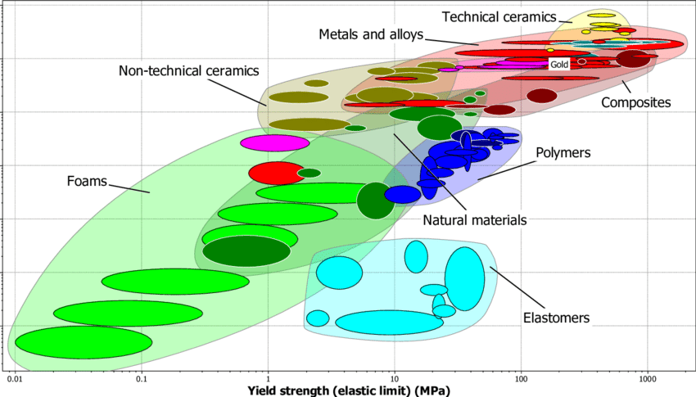
(Xenofon Katifes, March 2016, Structural Analysis, Fatigue Analysis and Optimization of Aircraft Wings, ResearchGate.net, (PDF) Structural Analysis, Fatigue Analysis and Optimization of Aircraft Wings (researchgate.net) )
this graph shows that the materials with the worst yield strength are foam and elastomers, and the materials with decent yield strength are polymers, natural metals and non-technical ceramics. The materials with the best yield strength are Metals and alloys, technical ceramics and composites, however composite materials are a broad term and after research, its difficult to find materials that can meet all standards to be used in a piston, therefore the two material groups we’ll consider we’ll begin to consider are metals and ceramics.
After some research into different metals, I will consider up to 5 metals and alloys I think are the best contenders to be used in a piston and rank each in order to come to the best conclusion for which material would be best for a piston. The material groups I will consider are steel, cast iron (and malleable cast iron), Aluminium (and alloys), Titanium (and alloys), Brass, and ceramics.
The first property I will rank the material group by is its thermal conductivity because I believe its one the most important properties a piston should have. Metals are typically good heat conductors due to being very dense compared to most other materials besides stone, however ceramic isn’t due to its bonding (Structure and properties of ceramics - The American Ceramic Society) so although they have a good yield strength, they would make a poor piston.
This leaves us with just metals; therefore, I will discuss each metal and its properties and see how they compare. The first being steel. Different types of steel have different properties, most being strong and being able to handle high temperatures, however only a few are corrosion resistance, such as stainless ferritic steel and stainless austenitic steel (Bosch handbook page 224). However, ferritic steel is magnetic, so it could affect/be affected by other components in the engine bay. Another steel would be Cold work and hot work steel (hardened and tempered), cold work having great edge retention and toughness which is important, so fuel mixture doesn’t seep through cracks on the edge of the piston crown, and hot work having high resistance wear (Bosch handbook page 223), so it lasts a long time under the stress a piston goes through. However, one issue all steel/stainless stell has is that its heavy, compared to other materials such as aluminium. As discussed, the weight of the piston is important to maintain high engine speeds, therefore steel will be one of the lower ranked materials.
The next material is cast iron. Cast iron is defined as “a hard, relatively brittle alloy of iron and carbon which can be readily cast in a mould and contains a higher proportion of carbon than steel (typically 2–4.3 per cent)” (Google) or, as stated in the bosch handbook (page 226) “Cast iron is defined as an iron-based alloy with a carbon content greater than 2%. Most cast irons have suitable properties, despite typically being known as brittle, however one cast iron, cast iron with spheroid graphite, has a larger fatigue strength (Bosch handbook page 226), however all cast irons are can be a good piston material due to them having iron, meaning they’ll expand less (Automotive Piston Types You Need to Know About - MZW Motor). Cast iron is a good material to use for a piston, I will rank it higher on the list.
Aluminium and its alloys are the most used materials to make pistons out of, this is due to aluminium’s properties being low density making it lightweight compared to other metals, high thermal conductivity, “simple net shape fabrication techniques” being casting and forging, and easy machineability (The Aluminium Automotive Manual, 2011, 1 (european-aluminium.eu) ). There are different aluminium alloys used, for example the Universal aluminium casting alloy (typical materials being EN AC-AlSi7Mg0,3 T6) has good mechanical properties, good corrosion resistance, and very good weldability and machineability. (Bosch handbook).
Titanium as a metal is known for its high strength to density ratio, being one the highest of any material, which like aluminium makes it a great contender for a piston, but it’s also corrosion resistance (What are Properties of Titanium Alloys - Definition | Material Properties (material-properties.org) ).
After reviewing these metals, the most appropriate material would be aluminium due to it having the best properties and is used most to make pistons for that reason.

Manufacturing Process
The three casting techniques we could consider are sand casting, die casting and investment casting. However, we will only discuss Die casting and investment casting due to the piston having an intricate design and so less money is spent on finishing the piece.
Die casting is most likely the preferred type of casting for products that require dimensional accuracy (RDCastings Aluminium High Pressure Die Casting (HPDC) | RD Castings Ltd | Suffolk) and can produce good threads and surface finish. Die casting is done by forcing molten metal at high pressure into a 2 or more-piece steel mould, the metals that are being casted must have a low melting temperature, which is appropriate for the piston being made from aluminium and has tight tolerances.
The final type of casting is investment casting, which is done by creating a master wax pattern which will act as a disposable replica as it’s made of a cheap dye that will solidify. Multiple wax patterns can be attached to wax sprue to make multiple at a time. Heat resistant materials are then applied to the wax, once its hardened, the mould is placed into a furnace, upside down and heated until the wax inside has melted and flowed out of the mould, the wax is then collected and reused to make more intricate designs. The last step is to heat the mould up to 800- 1000°C to vaporise any residual wax and moisture and to harden the mould even more. (What is Investment Casting? Applications, Pros and Cons - 3D Insider). This casting is good as it can recreate intricate designs, produce good dimensional accuracy and cast smooth surfaces, however, is a poor for products that aren’t hollow, therefore would require machining.
Forged pistons are made by pressing a chunk of metal using machines and hammers into the desired shape, which will eliminate Impurities and also result in a stronger and brittle piston when compared to a cast piston, however it is more labour intensive and more expensive (Automotive Piston Types You Need to Know About - MZW Motor). Cold forging would be the best due to not needing any finishing work, saves money and is less susceptible to contamination.
To cut costs, I will manufacture the piston through cold forging. Once I have the basic piston design, I would go through the outer diameter of the piston with a lathe to shave it and to cut the rings into it. I’d also file the hole where the gudgeon pin would go through so there is nothing to affect the fit.

Conclusion
We have discussed the essential properties a piston would need, such as thermal conductivity and being strong and tough. We have also discussed which materials would be suitable by ranking each material by their properties, all of which being metals due to ceramics having low thermal conductivity. The two metals that would be most suitable for the applications of a piston were aluminium and titanium, however aluminium was the preferred choice. Lastly, we discussed different manufacturing techniques to produce the piston, casting and forging. The castings involved Sand, die and investment casting, die casting being the most suitable, however after discussing forging, I decided cold forging was the best manufacturing process for piston due it being cheaper, and producing stronger pistons than casted pistons.

References
- Bosch Handbook, various authors.
- JARDINE, F., "ENGINE CORROSION-ITS CAUSES AND AVOIDANCE," SAE Technical Paper 250030, 1925 ENGINE CORROSION-ITS CAUSES AND AVOIDANCE (sae.org)
- CarBike Team, Piston: Design, Functions, Materials, And Qualities - CarBikeTech, March 13th 2020)
- (Xenofon Katifes, March 2016, Structural Analysis, Fatigue Analysis and Optimization of Aircraft Wings, ResearchGate.net, (PDF) Structural Analysis, Fatigue Analysis and Optimization of Aircraft Wings (researchgate.net)
- Structure and properties of ceramics - The American Ceramic Society
- Automotive Piston Types You Need to Know About - MZW Motor
- The Aluminium Automotive Manual, 2011, 1 (european-aluminium.eu)
- (What are Properties of Titanium Alloys - Definition | Material Properties (material-properties.org)
- (RDCastings Aluminium High Pressure Die Casting (HPDC) | RD Castings Ltd | Suffolk
- What is Investment Casting? Applications, Pros and Cons - 3D Insider
- Automotive Piston Types You Need to Know About - MZW Motor

