Distributed Intellegence System Car Lights

13/02/26

Distributed Intellegence Systems

(ACDA5018)

Rhys Jones (2419998)

Dr.Gary Jones
Contents

TITLE PAGE 1

1) INTRODUCTION 3

2) TRANSMISSION SYSTEMS 3

2A) POINT TO POINT 3

2B) POINT TO MULTIPOINT 4

2C) MULTI MASTER 4

3) RESEARCH 5

3A) CAR LIGHTS 5

3B) MICROCONTROLLER 5

4) PROTEUS DESIGN 6

5) PROGRAMMING 7

6) QUALITY MANAGMENT 9

7) CONCLUSION 9

8) REFRENCES 10

1) INTRODUCTION

This report is about designing a distributed intelligence system to control the rear passenger side car lights. The car lights being controlled are important because they show other drivers what the car is doing, such as braking, indicating or being visible in poor conditions. To complete this task, different transmission systems will be explained including point to point, point to multipoint and multi master systems. These are important because data needs to be sent between devices correctly, so the output lights turn on at the right time. The report will also explain why the PIC16F616 microcontroller was chosen, as it has enough inputs and output for simple tasks without making the circuit too complicated. Proteus is then used to design the circuit with two microcontrollers communicating using RS232, where one microcontroller reads the inputs and the other microcontroller controls the outputs. The following report will show the research, design and program needed to make the rear car light system work correctly.

2) TRANSMISSION SYSTEMS

A Transmission system is a way of sending data through a communication path and the data finishing in another device where it can be used. The main goal is to move the data from a transmitter to a receiver without losing any data or having corrupted data. Variables such as; speed of transmission, latency of transmission and bandwidth of transmission are really important as these all need to be calculated to make sure the correct setups are on both devices otherwise the data could be incoherent coming through to the other side.

2A) POINT TO POINT

Point to point transmission is when data is sent from one device straight to another device using a direct communication link. This means that there is one transmitter and one receiver, and the data is sent between these two points instead of being shared between lots of different devices. This can be used to connect two systems together, such as a local system to a remote system, and is often used in wider network connections where data needs to travel from one place to another. IBM explains that point-to-point connections can be used to send data from a local system to a remote system or from one network to another network [1]

The main advantage of point-to-point transmission is that it gives a more direct and reliable path for the data to travel through. This is because the connection is mainly being used by the two devices that are connected, which means there is less chance of other devices affecting the signal. It can be done using different types of links such as copper wires, fibre optic cables, radio links, or satellite links [2]. However, if lots of devices need to be connected, it can become more expensive because each connection may need its own separate link.

2B) POINT TO MULTIPOINT

Point to multipoint transmission is when data is sent from one main device to many different devices using the same system. This means there is usually one central transmitter or coordinator, and then multiple receivers or end devices connected to it. This is different from point-to-point transmission because the data is not just travelling between two devices, but from one point to many points. Point to multipoint communication can be wired or wireless, and it is used when one system needs to communicate with several other devices at the same time. This type of system normally uses a central coordinator with multiple remote nodes connected back to it, which is also known as a star network [3]. This means it can be cheaper and easier to expand than using lots of point-to-point connections. An example of this could be a Wi-Fi router sending data to multiple devices, or a central control unit communicating with several sensors. However, the system can become slower if too many devices are using the same connection at once, because the available bandwidth must be shared.

2C) MULTI MASTER

Multi master transmission is when more than one master device is connected to the same communication bus and any of the master devices can start sending data [4]. This is different to a single master system because the control of the bus is not just done by one device. An example of this is an I2C bus, which can have multiple controller devices and multiple target devices connected to the same two wire bus [5]. This means that different master devices can control the communication when they need to, which makes the system more flexible. However, only one master should control the bus at one time, otherwise the data could become corrupted.

The main problem with a multi master system is when two masters try to send data at the same time. To stop these causing errors, the system uses arbitration, which decides which master is allowed to carry on transmitting [4]. The other master then stops transmitting and waits until the bus is free again. This means that even if more than one master starts at the same time, the system can still work correctly, and the data should not be lost. Multi master systems are useful because they allow more than one device to control communication, but they are also more complicated because the timing, clock signals, and arbitration must be controlled correctly [6].

3) RESEARCH


3A) CAR LIGHTS

Rear lights on a car are important because they show the drivers behind what the car is doing and where the back of the car is. The rear position lights make the car easier to see in the dark, and the brake lights show when the car is slowing down or stopping, which gives the driver more time to react. Indicators are also important because they show when the car is turning or changing direction, and the rear fog light is used when visibility is very poor so the car can still be seen from behind. The Highway Code says that sidelights and rear registration plate lights must be lit between sunset and sunrise, and that fog lights should only be used when visibility is seriously reduced [7]. Rear lights are also checked in MOT, including position lamps, stop lamps, indicators, hazard warning lamps, fog lamps and reversing lamps, which shows that they are a safety important part of the car [8]. This means that rear lights are needed because without them the car would be harder to see and other drivers would not know what the driver is doing, which could lead to accidents. I chose to do the rear passenger side lights on a Renault scenic 2010 mkIII as this is the car I own and makes programming it simpler as I can check how the switches/buttons work in the car for myself.

3B) MICROCONTROLLER

The PIC16F616 is a good microcontroller for simple tasks because it has enough inputs and outputs to control basic circuits without being too complicated. It is an 8-bit PIC microcontroller with 14 pins, 128 bytes of RAM, and around 3.5KB of program memory, which is enough for small programs like switching LEDs, reading buttons, controlling relays, or using sensors [9]. It can also run up to 20MHz and has useful built-in features such as timers, PWM, a watchdog timer, comparators, and a 10-bit analogue to digital converter, which means it can read analogue signals and control outputs without needing lots of extra components [9]. Another reason it is useful is because it can work from a low supply voltage range, around 2V to 5.5V, which makes it suitable for small battery powered or low power circuits [9]. This makes the PIC16F616 a good choice for simple embedded systems because it is small, reliable, and has the main features needed without making the circuit or code too difficult. I used the microchips parametric search tool to fund a microcontroller to use.

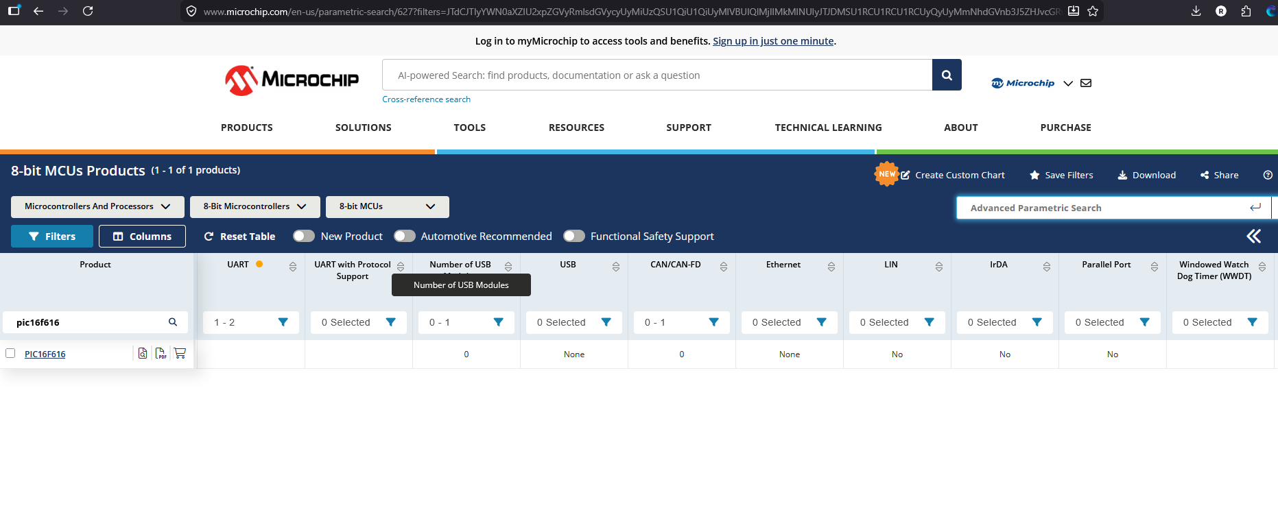

4) PROTEUS DESIGN

The proteus design uses 2 PIC16F616 using RS232 to communicate on pin C0 for transmit and receive on pin C1 on the input Microcontroller (INM) and on the outputting microcontroller (OTM) transmit is pin A0 and receive is Pin C1. The buttons are inputted on Port A on the INM and sent through to the other microcontroller using rs232 and then outputted on Port C. Using a simple token sending this was made easy by putting the input from A into a variable which can be transmitted easier. There is a 555 timer being used to generate the blinking Led for the indicator lights. The relay is being used to switch the connection from the indicator button to allow the 555 timers to give the signal to the indicator LED as the 555 timer is always working. The images below show the buttons for input and the LEDs on the back of the car in a practical demonstration instead of using labels.

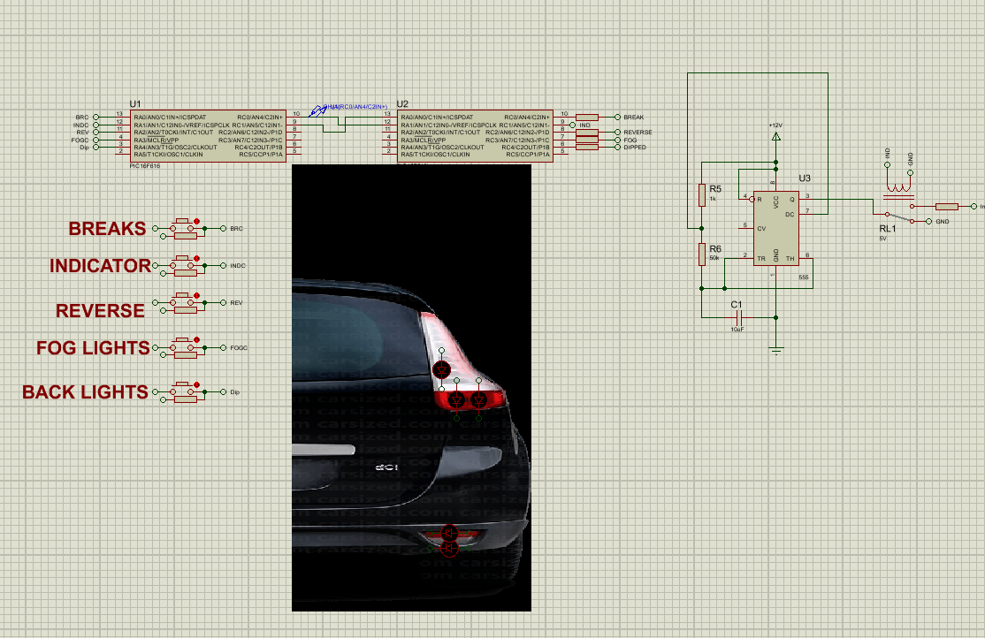

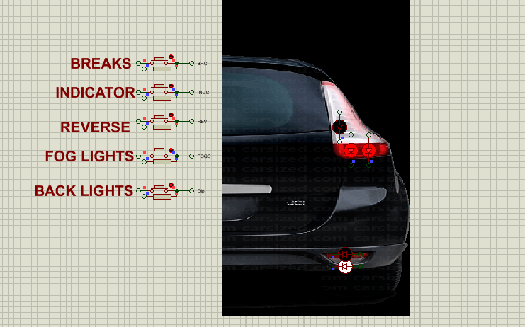

5) PROGRAMMING

Next is the section about the program and what was needed to send and receive data.
This will be displayed in the form of sudo code and a flow chart at the end.

Microcontroller 1 Input code



While true is a true loop that continues going till there is an error on the microcontroller or until the microcontroller losses power



Printf( “as character”, Port A inputs); this means that it will send a character on the transmit pin based on the inputs into port A

This is all the input microcontroller does.

Microcontroller 2 Output code

While true is a true loop that continues going till there is an error on the microcontroller or until the microcontroller losses power

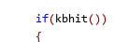

This is an if statement that waits until there is data that has been received on the receive pin.

The data is then used by get character and puts that value into variable out.

Finally the code is outputted onto port C where the LEDs light up.

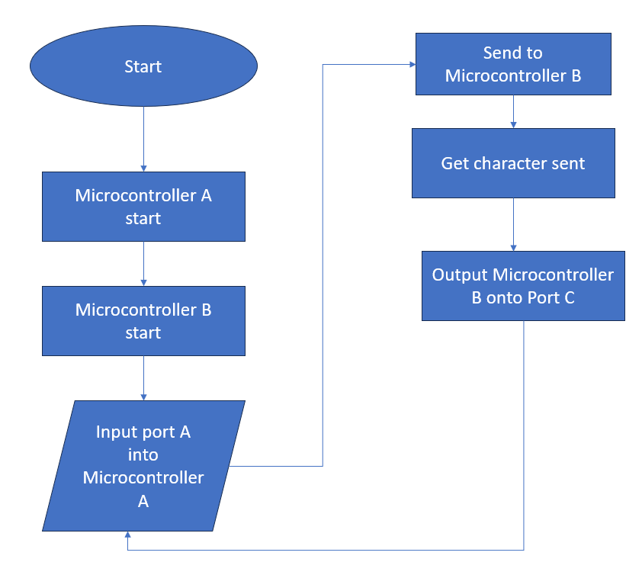

6) QUALITY MANAGMENT

Quality management is needed when designing a program to control car lights because the lights are a very important safety feature on the car. If the program has an error, then the brake lights, indicators, rear lights or hazard lights might not turn on when they are needed, which could cause confusion for other drivers behind the car. This could then lead to an accident because the other drivers would not know if the car is slowing down, turning or stopped. Quality management helps to prevent this by making sure the program is planned, tested and checked at each stage of the design. This means that the inputs from the switches or sensors can be checked to make sure they give the correct output to the lights. It also means that any errors in the code can be found before the system is used in the car. Overall, quality management is important because it makes the program safer, more reliable and easier to improve if a problem is found later. Further improvements in the design can make the car even safer in the future.

7) CONCLUSION

In conclusion, this report has shown how a distributed intelligence system can be used to control the rear passenger side lights of a car. The research showed that rear lights are very important because they let other drivers know what the car is doing and help to reduce the chance of accidents. The different transmission systems were also explained, and this showed why communication between devices needs to be reliable so the correct data is received. The PIC16F616 was a good microcontroller for this task because it is simple, small and has enough features to control the inputs and outputs needed for the lighting system. Using Proteus, the circuit was designed with two microcontrollers using RS232 communication, where one microcontroller reads the button inputs and the other outputs the correct signal to the LEDs. Quality management is also important because any error in the program could cause the wrong light to turn on or stop a light from working. Overall, this task shows how microcontrollers can be used in vehicle systems and how planning, testing and checking the program makes the final design safer and more reliable.

8) REFRENCES

References

[1] | ibm, "https://www.ibm.com," 08 04 2025. [Online]. Available: https://www.ibm.com/docs/en/i/7.6.0?topic=ssw_ibm_i_76/rzajw/rzajwptop.html. [Accessed 20 02 2026].
[2] | m247, "Point-to-Point Networks Explained," 18 02 2025. [Online]. Available: https://m247.com/blog/point-to-point-networks-explained/. [Accessed 20 02 2026].
[3] | DIGI, "Point-to-multipoint communication," 16 09 2021. [Online]. Available: https://docs.digi.com//resources/documentation/digidocs/90001456-13/default.htm#concepts/c_point_to_multipoint.htm. [Accessed 27 02 2026].
[4] | NXP, "UM10204," 01 10 2021. [Online]. Available: https://www.nxp.com/docs/en/user-guide/UM10204.pdf. [Accessed 27 02 2026].
[5] | Microchip, "I2C Bus Introduction," 24 06 2026. [Online]. Available: https://developerhelp.microchip.com/xwiki/bin/view/applications/i2c/. [Accessed 06 03 2026].
[6] | J. Wi, "A Basic Guide to I2C," 11 2022. [Online]. Available: https://www.ti.com/lit/an/sbaa565/sbaa565.pdf. [Accessed 06 03 2026].
[7] | Uk government, "The HIghway Code," Westminister Government, [Online]. Available: https://www.highwaycodeuk.co.uk/lighting-requirements.html. [Accessed 13 03 2026].
[8] | GOV UK, " 4. Lamps, reflectors and electrical equipment," GOV UK, 01 04 2026. [Online]. Available: https://www.gov.uk/guidance/mot-inspection-manual-for-private-passenger-and-light-commercial-vehicles/4-lamps-reflectors-and-electrical-equipment. [Accessed 10 04 2026].
[9] | MicroChip, "PIC16F610/16HV610," 2000. [Online]. Available: https://ww1.microchip.com/downloads/aemDocuments/documents/OTH/ProductDocuments/DataSheets/41288F.pdf. [Accessed 13 03 2026].

