Module title: Certificate of Higher Education in Skills for the Workplace
Module Lecturer’s name: Yajesh Kumar
University: University of Wales Trinity Saint David (London Campus)

Student’s name: Greta Stanelyte
Student’s number: 1919216

Benefits of Teamwork in the Workplace
This is based on the general rule that the team can achieve more than individual members because together they make better decision or have more ideas working in teamwork. Every person can be good at different kind of things or they might be seeing different problems and have mutual support. There are many benefits of teamwork. Some of these are:
1.Increase productivity- every team member can share ideas and teach each other for the best effective solution. The team can reach the best result if everyone is distributed, in which part they are strongest and weakest. Creativity inspire members grow together in a team and collaborating helps toward a common goal.
2.Provides a Support Network- Team members need to trust and support each other in good and bad times. When they know that somebody will support them it will increase their motivation. This allows them focus and achieve their goals more effectively when they are helping each other.
3.Encourages Innovation- Teams are better able to produce more creative, innovative and practical solutions to problems rather than working alone.
5.Attract Talent- teams would be able to produce results which are more creative, innovative and practical solutions to problems rather than working alone.
6.Establishes Strong Relationships- is the establishment and development of strong relationships among co-workers’. This helps them communicate more freely and openly, as well as encourage and motivate each other to work to their strengths and talents, which is key to the success of any organisation.
8. It advances your career- Also provides you with the prospect of building your professional network with alliances that can potentially lead to greater and greater and better opportunities. While working in a company you would encounter various skills, so you learn an expand your knowledge.
These benefits of teamwork are the key to success and achieve the best effective and sufficient solution.

Student Name: Celia Gomes
Student ID: 1919335

Stages Of Team Development
Every team has stages of development. There is 5 different stages and I will be explaining one at the time.
The first stage that we have is Forming. Forming is the first stage that is looks more like orientation day at your first job or school, where everyone is introduced to each other and everyone is very polite and pleasant. In the beginning some of the team members are more excited than others because is something new and they will know new people. The initial part where we will put all one team together where no one knows each other to get them to know new people.
The second stage is Storming. Storming is the stage of reality and weight of completing the task that at hand now hit everyone. The first feelings are of excitement and need to be polite. Many personalities can often shock and often teammates debate and confront themselves to decide the best way to follow each other.
The third one is Norming. Norming when people start to notice that everything is going back to normal and they start to appreciate their team members strengths. They will contribute and work as a team living all the uncomfortable situations beyond.
The fourth one is Performing. The stage where members of the team are familiar and motivated enough with the team, project and they can operate without supervision .On the same page and driving full everyone full spend ahead towards the final goal. This is essential where the team start shinning and showing good results.
The last one is Adjourning or Transforming . Once the project ends, the team detaches, sometimes this is phase is mourning because the members have developed close along with and fell a loss of their team mates or environment. The experience is over. The team will break up after all the tasks are completed. Transforming is when the does not breakup after the project is completed, but they will move to another projects.

Student Name: Gabriel Nicut
Student ID: 1919217

MANAGING CONFLICTS
According to Thomas and Kilmann model (1974), competition, collaboration, compromising, avoidance, and accommodation are “instruments” used to manage conflicts (Please see appendix 1).
Cooperativeness and assertiveness are 2 basic elements to determine whether an individual is assertive or unassertive, cooperative, or uncooperative (Thomas and Kilmann, 2018).
The decision makers must acknowledge the existing problem, than find a reasonable solution (Mound, et al., 2017, p. 185).
Mutual respect and willpower are required when managing conflicts and no method will succeed if every team member is not willing to comply the followings:
- Listening
- Acknowledge
- Resolve differences
- Respond (Thomas and Kilmann, 1974).
The negative and positive effect of conflicts
“Conflict is a lot like fire. When it sparks, it can intensify, spread, and lead to pain, loss, and irreparable damage” (COLEMAN & FERGUSON, 2014, p. 12).
“MAKING CONFLICT WORK” (2014) by Coleman and Ferguson, describes how Nelson Mandela, the worlds popular leader, promoted methods for non-cooperation, noncompliance, and nonviolence among groups by studying authorities’ laws and rules.
Questioning and challenging, is the positive side of discussing conflict. However, conflict can be controlled through our choice of mindset (Ian, 2012).
For a team to work effectively, all members must cooperate and uphold the ambiance for all to prosper. To encourage cooperation, you may use tactics like group-focused objectives, interpersonal activities, and communication.
However, if a team is too cooperative when concentrating on maintaining the atmosphere that loses control over the teams objectives (Levi, 2011, pp. 82-83).
Provide effective training.
“Very often, managers want teams, but don’t know what they want teams to do” (Holpp, 1999, p. 48).
With very limited information and understanding, managers reveal their scheme for teams, then expect the idea to be achieved.
Assuming that your organisation is employing the best candidates, diversity is very common in teams through each individual characteristic. These can be talent, personality, attitude, or values (Learning, 2008, pp. 6-7).
Having employees from different backgrounds and cultures can be very productive in terms of costumer’s variety and service deliverance. “As an employer, we remain committed to promoting equality and diversity amongst our workforce” (Authority, 2020).
Training, understanding policies and procedures, what need to be done and applied in practice, monitor and record the results, should be part of the training process (Acas, 2020).
Ways to prevent conflicts.
A face to face conversation may solve conflicts when a member of the team is either avoiding your approach or has already accommodated with noncompliance.
Lack of support, fear of confrontation, concern of consequences, lack of skills, can lead to never ending issue that can only be solved by its superiors, managers, or supervisors through reflection and direct dealing (Holpp, 1999, pp. 150-154).
- Talk to all members of your team with respect and appreciation
- Set the ground rules from beginning
- Rotate leadership roles between team members
- Support your team concerns
- When giving a task, make sure everyone is guided accordingly
- Offer additional training or support to those that lack confidence
- Share responsibilities equally
- Be honest, focused, and empathic when listening or speaking
- Make sure you give recognition for everyone’s work (e.g. a team dinner, an interactive training activity, a piece of equipment that everyone will be able to use and make their job easier etc.)

References
Acas, 2020. acas working for everyone. [Online]
Available at: https://www.acas.org.uk/improving-equality-diversity-and-inclusion/making-your-workplace-inclusive
[Accessed 29 11 2020].
Authority, C. a. M., 2020. GOV.UK. [Online]
Available at: https://www.gov.uk/government/publications/cma-diversity-and-inclusion-strategy-2020-to-2024/equality-diversity-and-inclusion-strategy-2020-to-2024
[Accessed 28 11 2020].
COLEMAN, P. T. & FERGUSON, R., 2014. MAKING CONFLICT WORK: : Harnessing the power of disagreement. First Edition ed. BOSTON NEW YORK: HOUGHTON MIFFLIN HARCOURT.
Holpp, L., 1999. Managing Teams. First Edition ed. London: McGraw-Hill Companies, Inc.
Ian, 2012. Challenging Coaching. [Online]
Available at: https://challengingcoaching.co.uk/conflict-and-challenge/
[Accessed 24 11 2020].
Learning, P. F., 2008. LEADING TEAMS: Managing Extra. Revised ed. London: Elsevier Ltd.
Levi, D., 2011. GROUP DYNAMICS for TEAMS. Third Edition ed. London: SAGE Publications, Inc.
Mound, A., Schriek, M. & Tinkler, P. K., 2017. Certificate in Higher Education: Skills for the Workplace Student Yearbook. In: M. S. P. K. T. Andrew Mound, ed. Certificate in Higher Education: Skills for the Workplace Student Yearbook. First Edition ed. London(United Kingdom): SAGE Publications, Ltd., p. 185.
Thomas, K. W. and Kilmann, R. H. (2018) ‘Thomas – Kilmann Conflict Mode Instrument COMPETING ASSERTIVENESS’, P R O F I L E a N D I N T E R P R E T I V E R E P O R T. Available at: file:///C:/Users/alexa/Downloads/Thomas-Kilmann_conflict_MODE_instrument.pdf.

Appendix 1

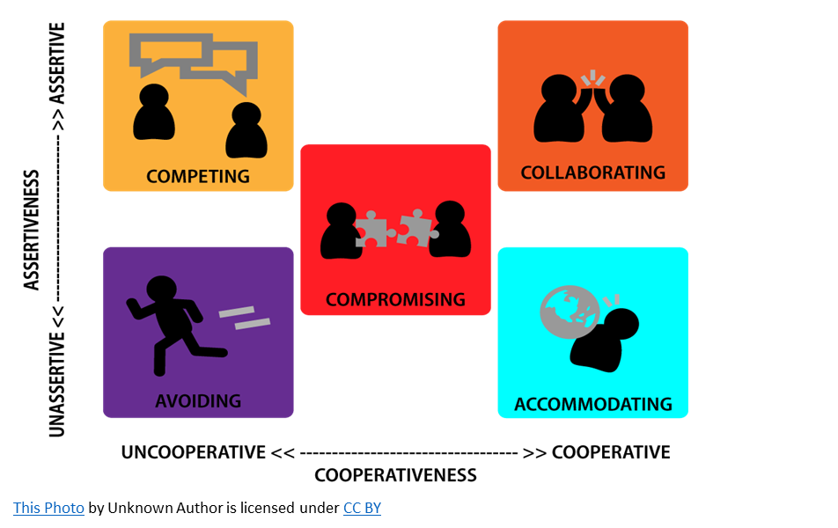

Student Name: Noemi Navas Macias
Student ID: 1921194

HELLO, MY NAME IS NOEMI I WILL TALK ABOUT THE TEAM ROLES.
WE HAVE 9 MAINS ROLES IN THE TEAMS ARE: SHAPER, IMPLEMENTER, COMPLETER/ FINISHER, CO-ORDINATIOR, TEAM WORKER, RESOURCE INVESTIGATOR, MONITOR-EVALUATOR, SPECIALIST ROLES AND PLANTS ROLE.

WHEN WE CREATE A TEAM, THE FIRST THING IS TO DECIDE WICH PART EACH ONE IS GOING TO DO, ONE CAN BE GOOD IN THE COMPUTER ANOTHER ONE CAN BE GOOD TO BRINGING IDEAS, WE ALSO MUST HAVE THE TEAMS WORKER RESOLVING CONFLICT OR ISSUES AFFTECTING, THAT’S THE BEST PART WORKING US A TEAM BECAUSE YOU WILL LEARN FOR EVERYONE OF THE MEMBERS SOMETHING NEW THEN WHEN THAT IS DECIDE WE HAVE TO CHOOSE THE TEAM LEADER, HOW IS GONNA MAKE SURE THE WORK GET ON TIME TO THE TEACHER AND WILL KEEP THE EYES TO MEMBERS, ONCE THE TWO MAING THINGS ARE DONE, WE HAVE TO SHARE EACH PART OF OUR WORK IN THE COMMON GOUP AND CHECK IF IT IS RIGHT OR NOT, WE HAVE TO CHECK EVERYONE IS DOING THEM JOB IN THE CORRECT DATE WITH NOT LATE.
WHEN THE WORK OF EACH MEMBER OF THE GROUP IS FINISHED IT MUST GO THROUGHT THE MAIN GROUP THERE IT WILL BE DECIDED IF SOMETHING SHOULD BE CHANGED OR NOT.
THE TEAM LEADER OF THE GROUP MUST ENSURE THAT EACH MEMBER OF THE GROUP DOES THEIR PART OF THE WORK, THIS IS CALLED TEAMWORK IF THERE ARE MUST WORK EQUALLY. IF ANY MEMBER OF THE GROUP HAS A PROBLEM, THEY SHOULD COMMUNICATE IT AS SOON AS POSSIBLE, THIS IS CALLED COMMUNICATION BETWEN GROUPS AND IS ESSENTIAL TO CARRY OUT TEAMWORK, WHEN EVERYTHING IS CLEAR AND DONE EVERYONE MUST TO PRACTICE THE JOB BEFORE THE PRESENTATION AS MUCH AS BE NEED.

Student Name: Arnas Kazlauskas
Student ID: 1920008

Successful Team Development
Building a successful team is more than just finding individuals with the right skills. Effective teams can make or break the organization. When the team if effective it can do an amazing thing and could improve company's productivity by a big margin. First thing to a successful team is clear sense of direction. Team needs to have shared purpose. All the team members need to know the goal of their work.
Second thing is to have talented team members. It is essential to have someone who knows what needs to be accomplished and have the right skills and talent to achieve corporate goals. Another very important thing to have a successful team is to make sure everyone knows what their role is. When everyone knows what they need to do there is less confusion and as a result there is more productivity.
Communication is most important of having a successful team. Without a communication there is no team. Communication helps teams to solve problems, achieve goals and leaves no room for confusion. It is important that team members communicate and share information. As a result of each team members contribution, it will move the entire team closer to its goal.

