

The Teaching Toolkit 2
Reflection and peer review

Philippa Fitzgerald
1905945
21/2/2025

Contents
Part 1 3
Part 2 Reflection. 5
Referencing List 9
Appendices 10
Feedback Received 10
Number 1 10
Number 2 12
Number 3 15
Peer Review Feedback 19
Curriculum number: 5 19
Curriculum number: 8 21
Curriculum number: 10 23

Part 1
Peer Review
Curricula Reviewed:
Curriculum 5: Academic and Digital Skills for Widening Access Students
Curriculum 8: Unconscious Bias and Victim-Blaming Training for Police Officers
Curriculum 10: Urdu Language Curriculum for British-born Pakistani Young Adults and Non-Urdu Speaking Partners in the UK

I reviewed a total of three curricula, focusing particularly on their structure, target audience appropriateness, alignment with professional standards, and practical implementation. For each curriculum, I examined the justification, learning outcomes, and supporting materials to provide constructive feedback that would be beneficial to the curriculum developers.
For Curriculum 5, I assessed an academic skills module designed for widening access students with limited or no formal qualifications. This curriculum demonstrated excellent consideration of non-traditional learners' needs through its innovative detective-themed role-playing approach and comprehensive integration of digital literacy with traditional academic skills.
For Curriculum 8, I assessed a police training program focused on addressing unconscious bias and victim-blaming behaviors among frontline officers. This curriculum was exceptionally informative, providing extensive research-based content that thoroughly educated officers on cognitive biases and their impacts. I liked how it incorporated real-world case studies, current policing statistics, and practical scenario-based learning. The curriculum was robust in its evidence-based approach and clear alignment with current professional standards in policing.
For Curriculum 10, I assessed an Urdu language curriculum designed for British-born Pakistani young adults and non-Urdu speaking partners in the United Kingdom. This curriculum presented a comprehensive and well-structured approach to language acquisition that thoughtfully balances practical communication skills with cultural understanding. The 36-week program with 1.5-hour weekly sessions demonstrates careful consideration of adult learners' needs while maintaining academic rigor.
As I worked through each curriculum, I found myself really connecting with certain approaches. I kept wondering would these lessons actually work for the people they are intended for? Curriculum 8 really stood out to me as incredibly informative - I learned so much about unconscious bias just by reviewing it! The way it was full of research, case studies, and practical scenarios made it both educational for officers and enlightening for me as a reviewer. I tried putting myself in the students' shoes. Would I feel motivated? Would I know what I'm supposed to be learning? The flow of lessons became really important to me - I could almost see where students might get stuck or feel engaged. I noticed that the best curricula found ways to meet professional standards without becoming boring or too rigid. My feedback style definitely changed as I went along. With Curriculum 10, I loved its cultural awareness but still suggested ways to improve self-study materials and assessments. This whole process has taught me that good curriculum design is about finding that sweet spot between academic quality and keeping students interested and engaged.

Part 2 Reflection.
In this reflective essay, I have chosen to follow Driscoll's reflective model (2007) to structure my thinking about creating a curriculum, giving feedback to peers, and receiving feedback on my own work. Driscoll's "What? So What? Now What?" framework provides a systematic approach that helps me move from description to analysis and finally to actionable plans for improvement in each area.
Creating the Curriculum
The process of designing the Adult Microsoft Skills Program curriculum began with researching workplace digital literacy needs. I discovered through Zhang and Martínez (2023) that Microsoft Office competencies appear in over 78% of job advertisements across professional sectors. Based on this evidence, I developed a seven-week curriculum with three-hour evening sessions targeting working adults seeking to enhance their professional digital skills. My curriculum design process involved several key elements needs assessment, adult learning principles application, assessment strategy development, accessibility considerations, and professional standards alignment. I created a balanced assessment approach combining portfolio work (40%), practical skills assessment (40%), and participation evaluation (20%). The curriculum incorporated physical accessibility features, schedule flexibility, and diverse learning accommodations to ensure inclusivity.
The research I conducted into workplace digital literacy needs transformed my understanding of evidence-based curriculum design. Jackson's (2022) work on systematic needs investigation helped me recognize why empirical validation matters. I realized that curriculum relevance emerges from concrete evidence about learner and workplace requirements rather than assumptions or intuition, however engaging with Rivera and Thompson's (2021) research on adult education revealed the critical importance of acknowledging learners' life circumstances in curriculum design also. As I applied these principles to scheduling decisions and practical scenario development, I experienced a transformation in how I view adult education. I found myself moving beyond theoretical understanding to practical application, recognizing how schedule flexibility, real-world relevance, and respect for learner experience create meaningful learning opportunities. Developing the assessment strategy challenged my previous understanding of evaluation. García-López et al.'s (2021) work on embedded formative assessment helped me reconceptualize assessment as both measurement and learning support. This dual-purpose concept was helpful and enabled me to see how thoughtfully designed assessment can simultaneously evaluate competency and enhance learning. The curriculum development process transformed my perspective on accessibility and inclusion. Kumar et al.'s (2022) research showing how proactive accessibility measures benefit all learners contributed to a shift in my thinking. I moved from viewing accessibility as compliance-driven accommodations to seeing inclusive design as fundamental to educational quality. Mapping curriculum elements to professional standards enhanced my understanding of how external benchmarks influence design decisions. Roberts' (2023) insights about maintaining academic integrity while addressing workplace competencies helped me navigate competing priorities. I discovered how standards can enhance curriculum coherence without restricting innovation.

Based on what I've learned through the curriculum development process, I will strengthen my evidence-based approach by incorporating more diverse data sources in future curriculum projects, including employer interviews and skills gap analyses. Develop pre-enrolment guidance materials that clearly articulate entry requirements and expected progression pathways. Create more robust formative assessment frameworks that support learning while providing meaningful feedback. Implement inclusive design principles from the outset of future projects rather than as secondary considerations and finally build structured reflection opportunities into my curriculum development process to continually evaluate alignment between learning outcomes, activities, and assessments

Receiving Feedback on My Curriculum
After developing my curriculum, I participated in a peer review process where colleagues evaluated the design and provided feedback. Reviewers commented on various aspects of my work, highlighting both strengths and areas for improvement. Some of the key feedback included ambiguity regarding entry requirements and how the curriculum accommodates diverse starting points. Suggestions were made for more frequent formative assessments throughout sessions. Recommendations for incorporating online or hybrid learning elements. Proposals for advanced content options like Microsoft Office automation. The compliments on the thorough scheme of work and practical workplace relevance were especially reassuring. One reviewer noted: "It was unclear from reading if the course allows those with no knowledge to join - where their starting point is." Other reviewers described the curriculum as "a thorough scheme of work that addresses several components of Microsoft" and "a well-developed and highly practical curriculum that meets a critical need." This also gave a feeling of accomplishment that I am on the right path.
Receiving peer feedback prompted critical reflection on design decisions and assumptions. Initially, I felt defensive about some comments, particularly those suggesting changes to a structure I had carefully developed. However, Mitchell and Ramirez's (2024) research on collaborative curriculum development helped me recognize feedback as enhancement opportunity rather than criticism. The comments about prerequisite ambiguity revealed a blind spot in my design thinking. While I had incorporated initial skills assessment in Week 1, I had not explicitly articulated entry requirements in curriculum documentation. This oversight could potentially create barriers for prospective participants, exactly the opposite of my inclusive design intentions. Suggestions for more frequent formative assessment aligned with my growing understanding of assessment's dual purposes but pushed me to consider more specific implementation strategies. Taylor et al.'s (2023) work on embedded assessment approaches helped me see how these enhancements could create more responsive learning environments. Recommendations for blended learning elements initially seemed to contradict my commitment to hands-on, collaborative learning, which I come to enjoy whilst teaching. However, upon reflection, I recognized that thoughtfully integrated digital components could enhance accessibility while maintaining the interactive qualities I valued. This realization demonstrated how feedback can challenge our way of thinking. The suggestion to incorporate advanced automation content revealed tensions between comprehensive coverage and focused skill development. This feedback prompted me to consider curriculum scope more carefully and explore progressive learning pathways rather than content expansion within the existing framework.
Based on the insightful peer feedback received, I will articulate entry requirements in curriculum documentation, stating the course is designed for beginners with basic computer literacy, no prior Microsoft Office experience is required. Integrate structured formative assessment checkpoints throughout each session, including concept checks, guided practice monitoring, and self-assessment opportunities. I will also explore blended learning elements that enhance accessibility while preserving valuable in-person collaboration, such as pre-session preparation materials and recorded demonstrations for review. Establish a more robust framework for ongoing curriculum evaluation and enhancement, recognizing development as an iterative rather than linear process.

Giving Feedback to Peers
As part of this assignment, I reviewed three curricula developed by my peers. Each curriculum had different focuses and approaches, providing me with diverse perspectives on educational design. I examined elements including rationale, aims and objectives, structure, standards alignment, and assessment strategies. For each curriculum, I provided structured comments addressing strengths and potential enhancement areas. In my feedback, I attempted to balance appreciation for effective design elements with constructive suggestions. I commented on clarity of entry requirements, progression pathways, assessment approaches, and alignment with stated learning outcomes. I found myself drawing on both theoretical knowledge and practical considerations when evaluating my peers' work.
The process of reviewing others' curricula provided unexpected insights into my own design choices and assumptions. Williams' (2022) research on reflective practice emphasizes how engaging with others' work can illuminate blind spots in our own thinking. I realized that aspects I found unclear in my peers' curricula often revealed implicit assumptions in my own work. Providing feedback required me to consider design principles I had intuitively applied, forcing me to critically examine the theoretical foundations of my practice. This process deepened my understanding of curriculum coherence, how learning outcomes, activities, and assessments should align to create meaningful educational experiences. I discovered that giving feedback is itself a learning process. Each curriculum I reviewed contained innovative approaches I hadn't considered, expanding my repertoire of design strategies. This aligns with Washington and Patel's (2023) findings that collaborative review processes enhance professional development through exposure to diverse perspectives and approaches. Most significantly, I realized that effective feedback must be both specific and actionable. Vague praise or general criticism contributes little to improvement, while targeted observations linked to enhancement strategies can genuinely advance practice. This insight has profound implications for both giving and receiving feedback. I also found that in my work I seem to do this to a certain extent already, giving me a feeling of relief that I am practicing the correct feedback methods.

In future peer review situations, I will develop a more structured framework for providing feedback that explicitly addresses key curriculum elements and their interconnections. Focus on actionable suggestions rather than general observations, ensuring each critique is paired with a potential enhancement strategy. I will also approach reviewing and research as a reciprocal learning opportunity, actively seeking innovative elements that might enhance my own practice. Maintain a balance between affirming strengths and identifying improvement areas, whilst following up with reflective discussions where possible to deepen shared understanding

Conclusion
This reflection has allowed me to examine three interconnected experiences, creating a curriculum, giving feedback, and receiving feedback, as components of a holistic professional development journey. Through each experience, I've gained deeper understanding of curriculum design principles, collaborative enhancement processes, and my own professional growth. The process has changed my perspective on evidence based design, adult learning applications, assessment purposes, inclusive practices, and professional standards integration. Most importantly, it has taught me to value collaborative reflection as an essential component of educational development rather than an external obligation. As I implement the identified enhancements and approach future curriculum work, I can carry forward a new understanding of curriculum development as a continuous, collaborative improvement process. This perspective, grounded in structured reflection and open engagement with diverse viewpoints, will inform my future educational design work.

Referencing List

Driscoll, J. (2007) Practising clinical supervision: A reflective approach for healthcare professionals. 2nd Edition. Edinburgh: Bailliere Tindall Elsevier.
García-López, R., Martínez-Sanchez, A. and Wong, K. (2021) 'Formative assessment impact on technical skills development', Assessment in Education, 28(3), pp. 312-328.
Jackson, P. (2022) Contemporary curriculum design: principles and practices. London: Routledge.
Kumar, V., Patel, N. and Washington, L. (2022) 'Universal design and accessibility in adult education', Adult Learning, 33(1), pp. 38-52.
Mitchell, K. and Ramirez, J. (2024) 'Blended learning design for professional skills development', Journal of Workplace Learning, 36(1), pp. 78-94.
Rivera, M. and Thompson, K. (2021) 'Adult learner engagement: bridging theory and practice', Adult Education Research, 43(2), pp. 187-203.
Roberts, S. (2023) 'Professional standards integration in curriculum design', Curriculum Journal, 34(2), pp. 324-341.
Taylor, R., Vasquez, E. and Kim, J. (2023) Blended learning effectiveness: evidence and implementation. New York: Springer.
Washington, D. and Patel, S. (2023) 'Accessibility as design principle rather than accommodation', International Journal of Inclusive Education, 27(3), pp. 267-283.
Williams, J. (2022) 'Reflective practice in curriculum development: impacts and outcomes', Reflective Practice, 23(2), pp. 218-233.
Zhang, M. and Martínez, R. (2023) 'Digital literacy demands in contemporary workplaces', Journal of Workplace Learning, 35(3), pp. 176-192.

Appendices

Feedback Received

Number 1
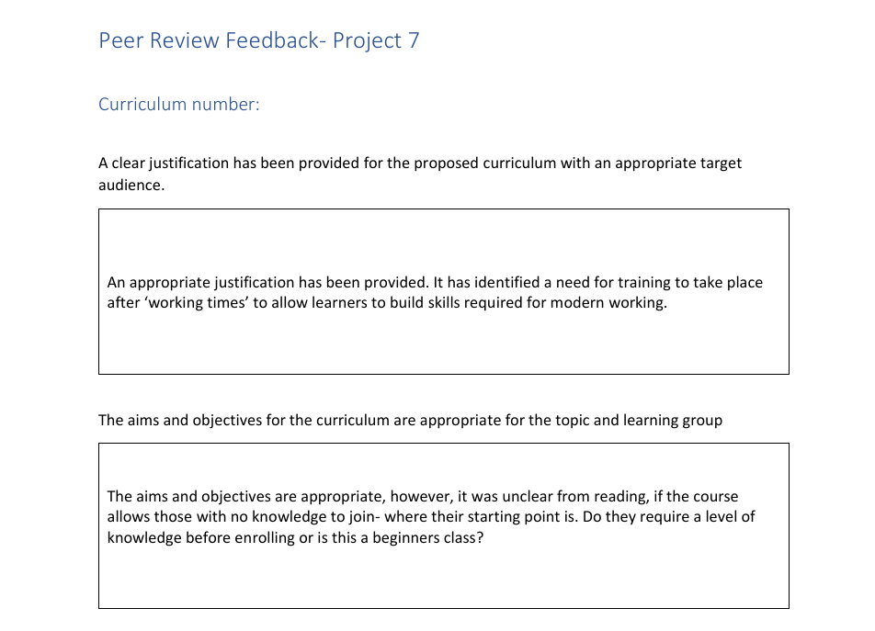
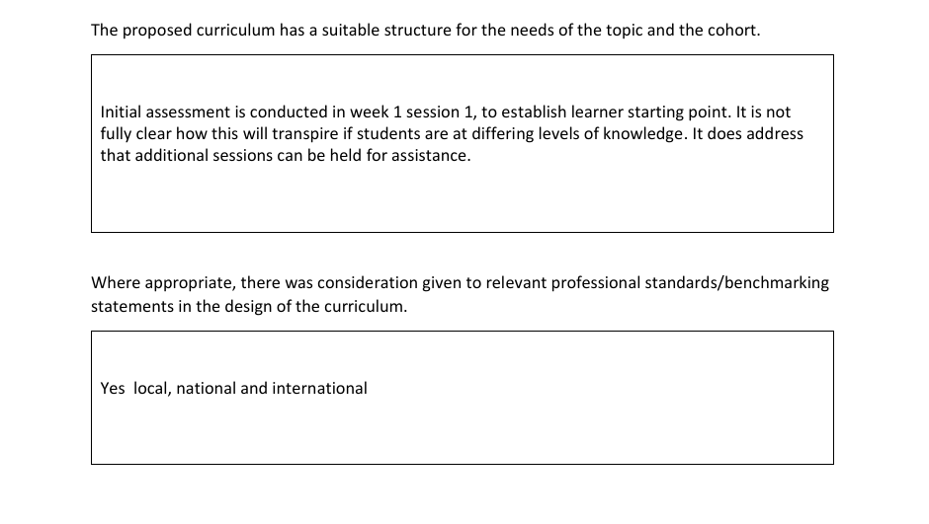
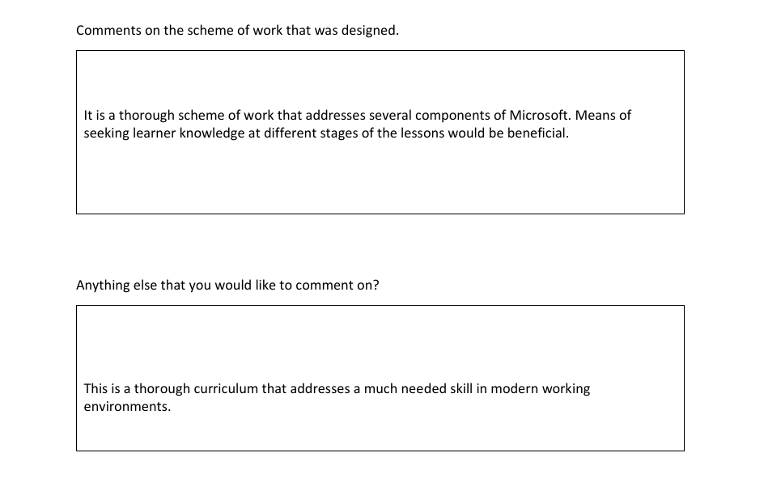

Number 2
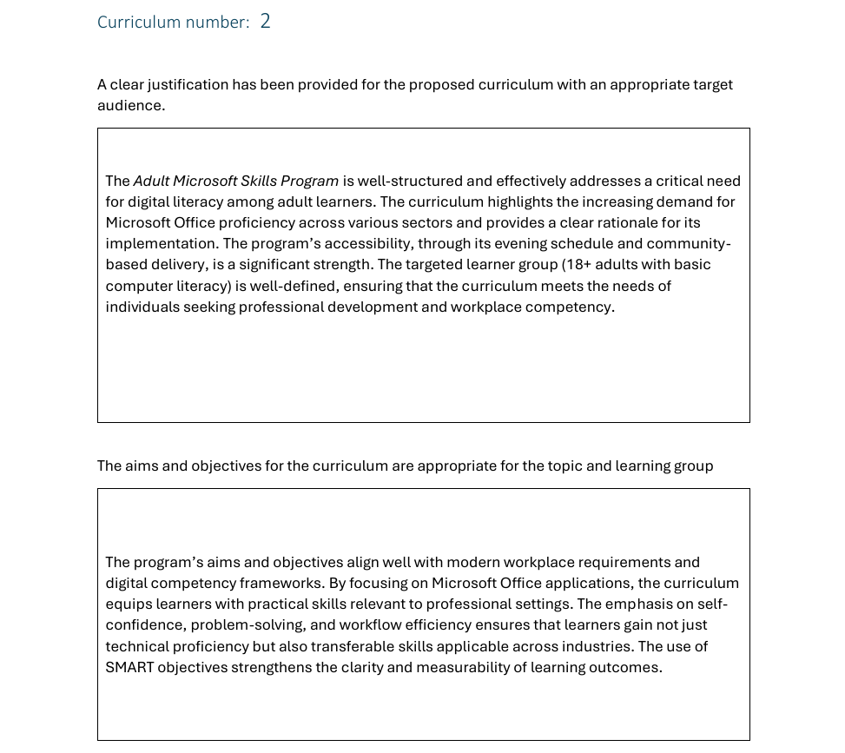
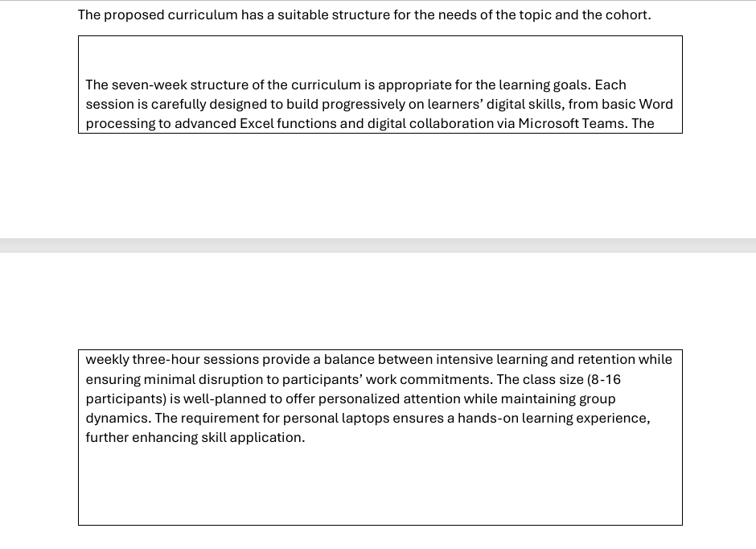
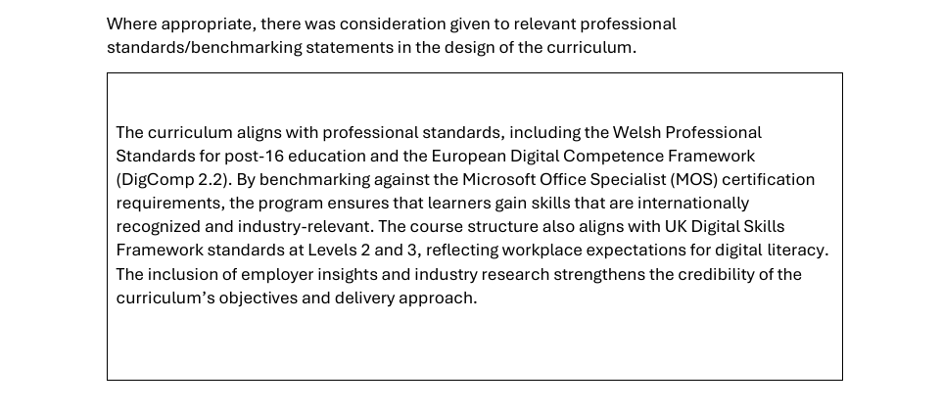
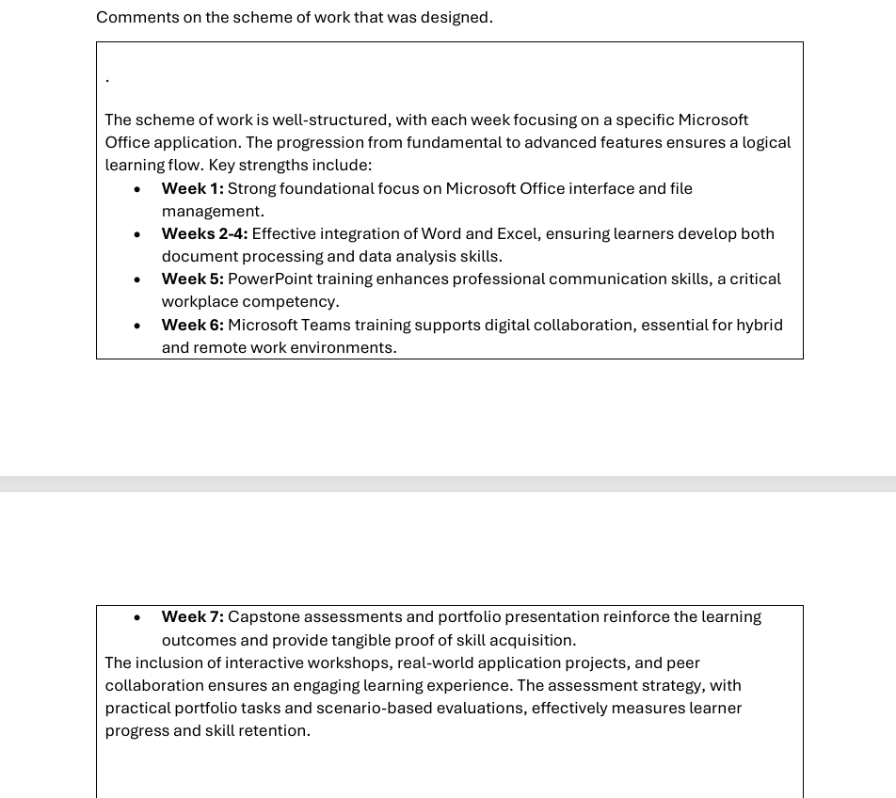
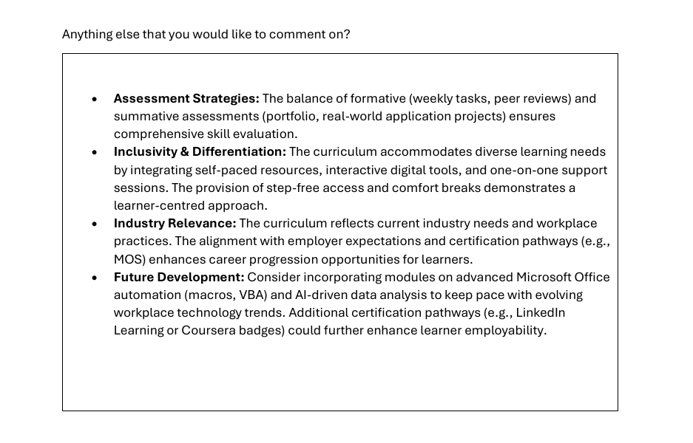

Number 3
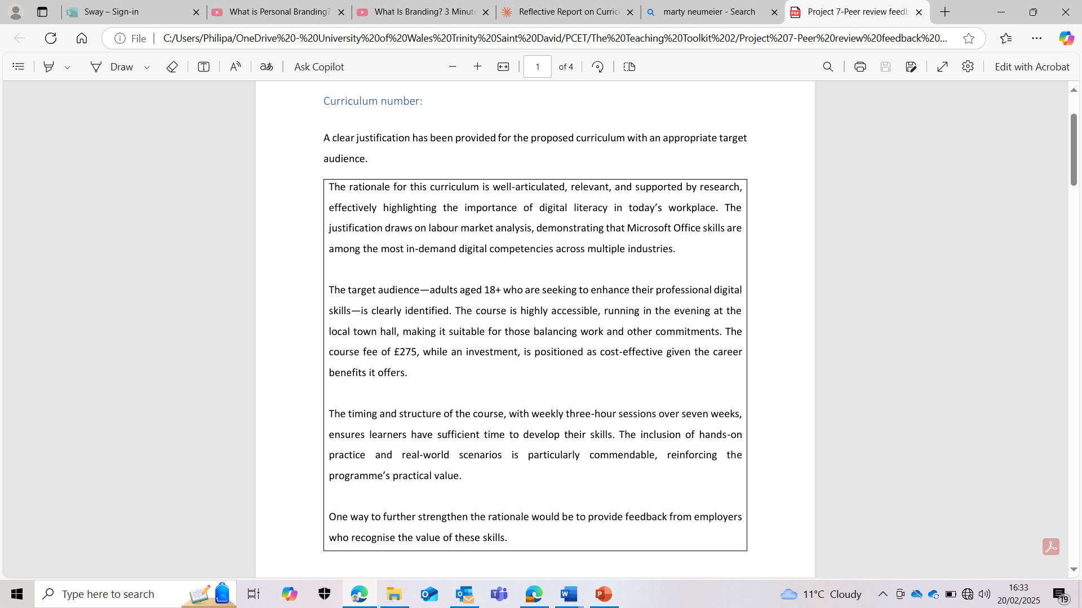
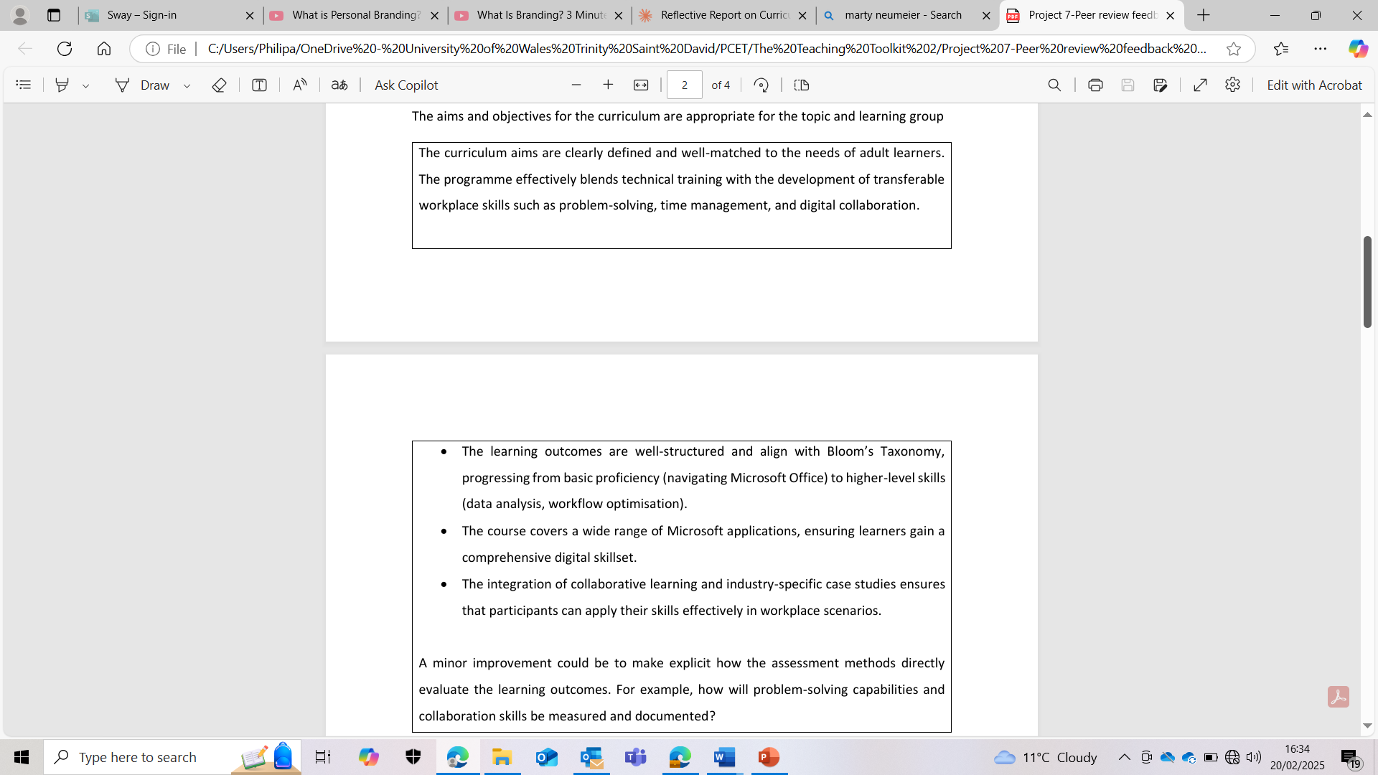
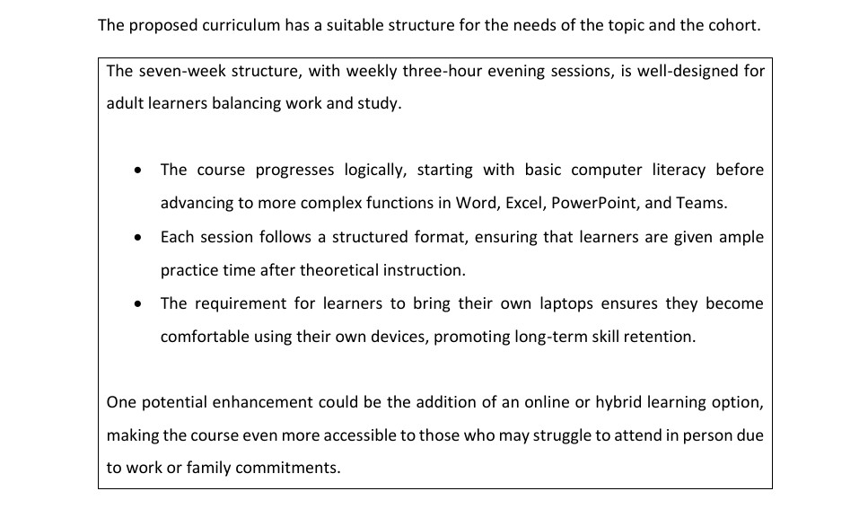
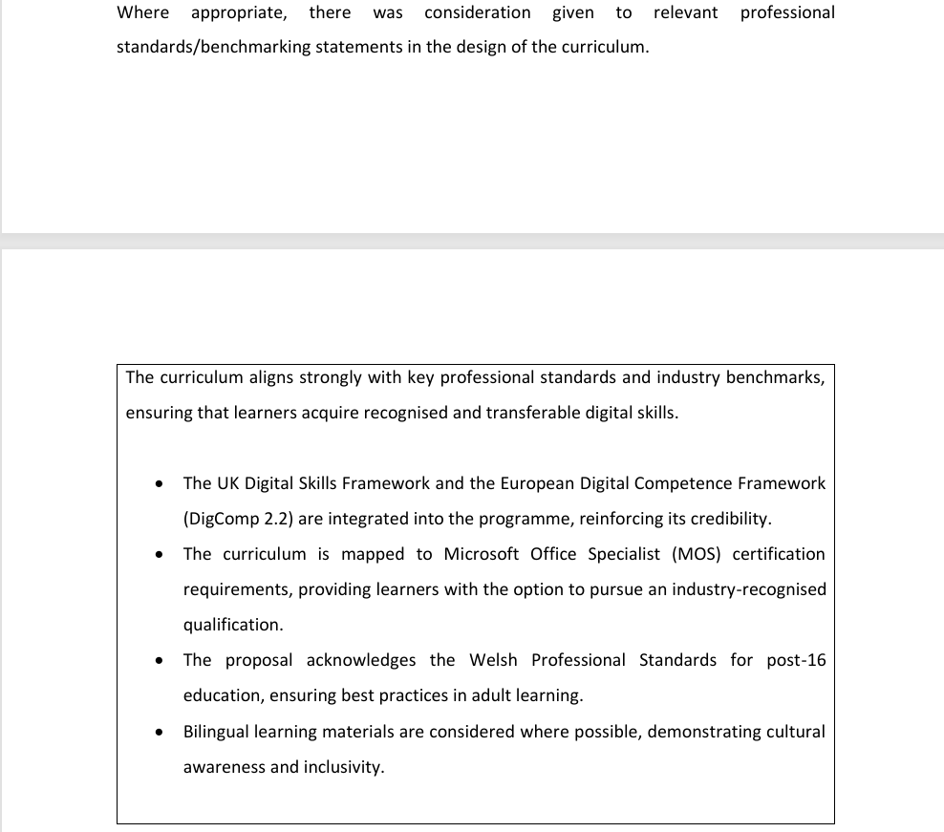
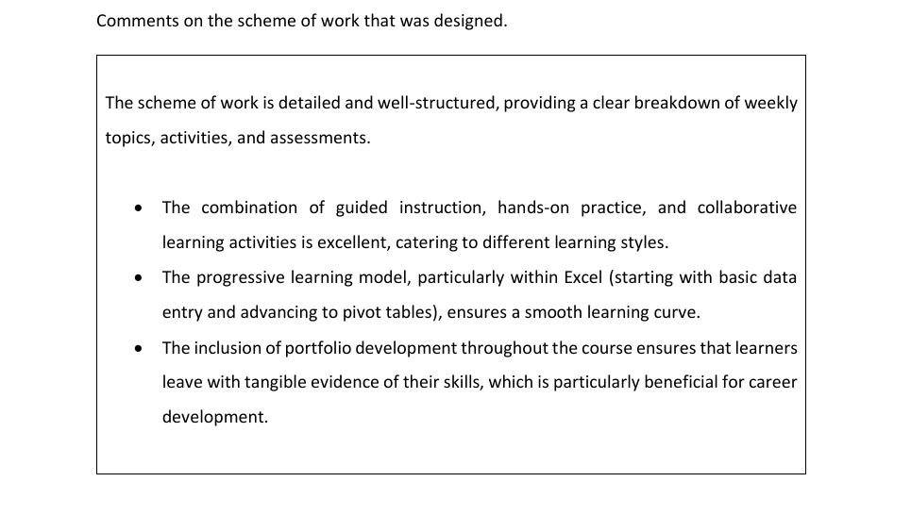

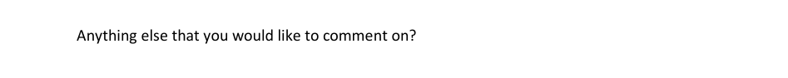

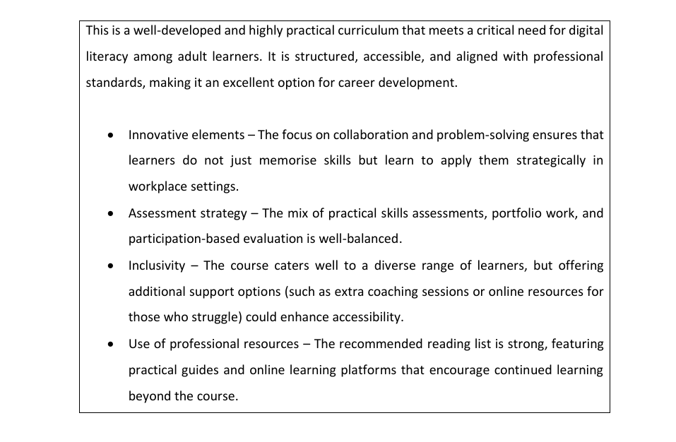

Peer Review Feedback

Curriculum number: 5
A clear justification has been provided for the proposed curriculum with an appropriate target audience.
The curriculum provides excellent justification by specifically targeting widening access students with limited or no formal qualifications. The rationale is well-supported with research demonstrating how widening participation initiatives reduce educational inequality. The target audience is clearly defined, including mature learners, NEET individuals, and those seeking introduction to formal academic education. The proposal shows strong understanding of these learners' barriers to higher education, including lack of prior academic experience and limited confidence.

The aims and objectives for the curriculum are appropriate for the topic and learning group
The curriculum aims and learning outcomes are well-aligned with the needs of non-traditional students. The learning outcomes follow Bloom's taxonomy appropriately, progressing from fundamental knowledge to higher-order critical thinking. The objectives focus on essential academic and digital skills while incorporating practical applications through role-playing scenarios. Particularly strong is the integration of digital literacy alongside traditional academic skills, recognizing the modern academic landscape's requirements.

The proposed curriculum has a suitable structure for the needs of the topic and the cohort.
The 10-week structure, including a reading week, demonstrates excellent consideration of the target group's needs. The balance between face-to-face instruction and self-directed learning is appropriate for building confidence gradually. The detective-themed role-playing approach is innovative and engaging, potentially reducing anxiety around academic tasks. The weekly progression of topics is logical, building from foundational skills to more complex academic tasks.
Where appropriate, there was consideration given to relevant professional standards/benchmarking statements in the design of the curriculum.
The curriculum shows thorough alignment with multiple professional standards frameworks. It effectively addresses QAA Subject Benchmark Statements regarding digital literacy and academic integrity. The incorporation of Advance HE Professional Standards Framework is comprehensive, covering all key areas (Professional Values, Core Knowledge, Areas of Activity). The consideration of OfS Access and Participation Plans and TEF principles demonstrates strong awareness of current higher education standards.

Comments on the scheme of work that was designed.
The weekly timetable is well-structured and comprehensive. Each session builds logically on previous learning while incorporating practical skills development. The integration of library and digital skills workshops shows good collaborative planning. The assessment strategy effectively combines formative and summative approaches, with appropriate spacing of deadlines. The inclusion of mock presentations demonstrates good scaffolding of learning.

Anything else that you would like to comment on?
The curriculum's innovative use of storytelling and role-play is particularly good for engaging non-traditional learners. The consideration of class sizes shows good understanding of practical delivery needs. The detailed reading list, with both essential and supplementary texts, provides appropriate academic support. One suggestion might be to consider including more peer-support mechanisms or study groups to further enhance student engagement and support.

Curriculum number: 8
A clear justification has been provided for the proposed curriculum with an appropriate target audience.
The curriculum has a very well-justified rationale, backed by current statistics and research showing the critical need for addressing unconscious bias and victim-blaming in policing. The target audience of frontline police officers, student officers, and investigators is clearly identified and appropriate for the subject matter. The justification links to real-world issues, citing concerning statistics about case discontinuation rates and the impact of officer perceptions on survivor engagement. The curriculum's focus on emotional intelligence development and bias mitigation directly addresses documented issues within policing culture that affect case outcomes.

The aims and objectives for the curriculum are appropriate for the topic and learning group
The aims and objectives are clearly stated, measurable, and highly relevant to the target audience's professional development needs. They appropriately focus on practical skill development while incorporating theoretical understanding. The objectives progress logically from awareness and understanding to practical application. The learning outcomes are well-aligned with professional policing standards and current guidance on addressing violence against women and girls.

The proposed curriculum has a suitable structure for the needs of the topic and the cohort.
The curriculum structure is excellent, with a logical progression across four well-planned sessions. The one-day format with breaks is appropriate for working professionals. The mix of teaching methods demonstrates good pedagogical understanding and accommodates different learning styles. The scheme of work is detailed and thorough, with clear timings and appropriate assessment strategies throughout. The balance between theoretical understanding and practical application is well-considered.

Where appropriate, there was consideration given to relevant professional standards/benchmarking statements in the design of the curriculum.
The curriculum shows strong alignment with professional standards, particularly in referencing the Welsh Government's professional standards and the College of Policing framework. It effectively incorporates current NPCC guidance on violence against woman and girls and recent research on police responses to domestic abuse and sexual violence. The inclusion of the Policing Education Qualifications Framework considerations demonstrates good awareness of the broader professional context.

Comments on the scheme of work that was designed.
The scheme of work is comprehensive and well-structured. The lesson plans are particularly detailed, with clear progression between sessions and appropriate time allocation for different activities. The assessment strategy effectively combines diagnostic, formative, and summative approaches. The inclusion of practical activities like the 'have you ever...' exercise and action planning demonstrates good understanding of adult learning principles. The focus on peer learning and reflection is particularly valuable for this professional context.

Anything else that you would like to comment on?
This is a good curriculum that addresses a crucial need in police training. It demonstrates several notable strengths, including a strong theoretical underpinning that effectively combines multiple learning theories, excellent integration of current research and professional guidance, a clear focus on practical skill development and behaviour change, and well-thought-out assessment strategies. Adding follow-up sessions or refresher training options could be beneficial to reinforce learning over time and including more detail on measuring the long-term impact on practice to ensure sustained behaviour change.

Curriculum number: 10
A clear justification has been provided for the proposed curriculum with an appropriate target audience.
The curriculum proposal presents a comprehensive and well-reasoned justification for teaching Urdu to British-born Pakistani young adults and non-Urdu speaking partners in the UK. The rationale combines cultural, social, and practical considerations, supported by thoughtful analysis of community needs. It demonstrates a clear understanding of the target audience's specific requirements and motivations for learning Urdu. However, exploring specific challenges British-born Pakistanis face in language acquisition would strengthen the rationale further.

The aims and objectives for the curriculum are appropriate for the topic and learning group
The curriculum presents well-structured and appropriate aims and objectives that effectively balance practical language skills with cultural understanding. The progression from basic to complex language is logically sequenced, with clear learning outcomes that encompass reading, writing, speaking, and listening skills. The objectives thoughtfully integrate cultural elements while maintaining focus on practical communication abilities. Consider incorporating self-assessment objectives to promote learner autonomy.

The proposed curriculum has a suitable structure for the needs of the topic and the cohort.
The 36-week curriculum structure demonstrates careful consideration of adult learners' needs and practical constraints. The 1.5-hour weekly sessions provide consistent exposure to the language while remaining manageable for working professionals. The integration of cultural elements throughout the course enhances language learning, while the varied assessment methods ensure comprehensive evaluation of progress. Including more structured self-study guidance would support learners between sessions.

Where appropriate, there was consideration given to relevant professional standards/benchmarking statements in the design of the curriculum.
The curriculum effectively incorporates professional standards, particularly through its integration of Walsh Professional Standards and alignment with language teaching best practices. The assessment framework demonstrates careful consideration of quality benchmarks while maintaining cultural sensitivity. The addition of more detailed assessment rubrics and professional language benchmarks for specific sectors would enhance the curriculum's professional rigor.

Comments on the scheme of work that was designed.
The scheme of work demonstrates good attention to detail and pedagogical planning. The weekly breakdowns provide clear guidance while maintaining flexibility for teacher adaptation. The variety of teaching and learning activities, combined with the integration of cultural elements, creates an engaging learning environment. The assessment strategy effectively balances formative and summative approaches. Consider incorporating more technology-enhanced learning activities and authentic materials from contemporary sources.

Anything else that you would like to comment on?
The curriculum has a thorough approach to language instruction and cultural integration. The attention to progression pathways and balanced skill development demonstrates strong pedagogical understanding. Consider developing a resource bank for supplementary materials. A more detailed student support strategy and specific guidance for online delivery could help for when this is required. The inclusion of guidance for supporting students with specific learning needs would ensure the curriculum is inclusive. This is a good program that effectively meets its stated objectives while maintaining academic standards.

