ASSIGMENT FOR SOFTWARE DEVELOPMENT IN C#
KOSTADIN MICHEV_1913374
UNIVERSITY OF WALES: TRINITY SAINT DAVID
Dr Paul Jenkins

Table of Contents
Section 2 3
Part A (Understanding) 3
Part B (Testing) 8
Part C (Implementation) 9
References 16

Section 2

Part A (Understanding)
1. Arrays:
The array is the data structure which is contained the group of the elements. Mainly all these elements are of same data types like string or integer or double. These arrays are generally used in the computer programs for organizing the data to search or sort a related set of the values (Alayan et al. 2019). So, this can be recognized from the above discussion that the arrays are the data structure which can store the fixed sized sequential collection of the elements which are same type. These arrays are mainly used for storing the collection of the data. By using this, user can use only one array variable instead of using multiple variables. For example, instead of using many variables like num1, num2, num3, num4, num5, user can use the array variable named num and store the value of num1 into num[0], num2 to num[1], num3 to num[2], num4 to num[3] and num5 to num[4] (Li et al. 2019). Any particular element in the array can be accessed by the index of the array which is started from 0. The arrays are contained contiguous memory location.
To declare an array, user can first indicate the type of the elements like string, int, double and after that user can give a name of the array and after that user can give the size of the array. So the syntax of the array is as follows:
datatype arrayname [ arraysize ];
This is the syntax of single dimensional array. For example, int marks [15]. In this example, the data type of the array is integer, the name of the array is marks and the size of the array is 15 (Dageförde and Kuchen 2020). User can also initialize any array with the values. For example:
int marks[5] = {45, 65, 78, 75, 98};
Here, marks[0] has the value 45, marks[1] has the value 65, marks[2] has the value 78, marks[3] has the value 75 and marks[4] has the value 98.
The importance of the array in programming are as follows:
i) This is mainly used for representing same types of the multiple data elements by using the single name.
ii) To implement other data structures like graphs, queues, linked lists and many more by using this array.
iii) To represent the matrices, the concept of two dimensional arrays.
iv) The arrays are mainly strongly typed, for this reason, performance of application will be better, and this can prevent the runtime errors.
The example of the array is as follows:
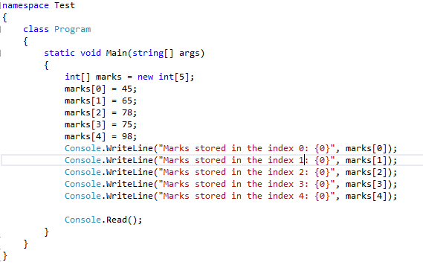
Figure 1: Example of the array
Source: Created by author
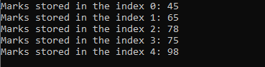
Figure 2: Example of the array
2. Inheritance in Object Oriented Programming (OOP):
Inheritance is a main concept of any object oriented programming (Wang 2019). This is the mechanism in which user can derive a class from any other class for the hierarchy of the classes which is shared a set of the attributes and also the methods (Kouraklis 2020). In the inheritance, two classes are observed one is super class and another class is sub class.
The super class is the class from which the features such as attributes and methods are inherited. This class is also known as the parent class (Browning and Sutherland 2020). The super class has all the features such as the attributes and methods in it. All these features are inherited from these class by other classes for reusability.
The class that is inherited the features from the super or parent class is known as the sub class or extended class, child class or derived class. This class is also added its own methods and attributes with the features of super class (MEHTRE and VERMA 2019). The inheritance is supported concept of the reusability.
The example of the inheritance is as follows:
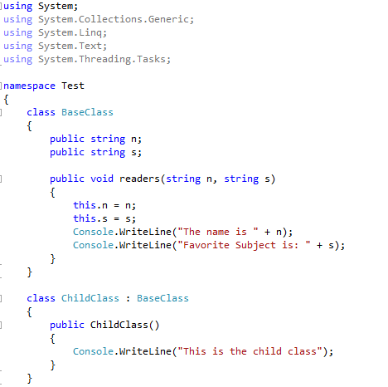
Figure 3: Example of the inheritance in Object Oriented Programming (OOP)
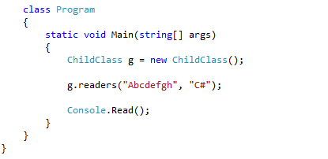
Figure 4: Example of the inheritance in Object Oriented Programming (OOP)
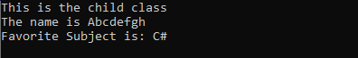
Figure 5: Example of the inheritance in Object Oriented Programming (OOP)

Part B (Testing)
The testing of software is the technique for checking if the actual product of software is matched the expected requirements also for confirming that the given product of software is free from defect. This is involved the execution of the elements of the system or software by using the automated or manual tools for evaluating one or more than one properties of the interest. The motive of this testing of software is to recognizing the missing requirements, gaps or errors with respect to the actual requirements of the given software. So, in the simplest way this can be stated that the testing of software means verification of the AUT or Application Under Test. This testing is important and the reason is if in the developing software has any errors or bugs in it, then this can be identified early and solved this problem before completing the product. If the testing is done successfully then this will remove all the errors from software.
There are many types of testing present, which are as follows:
i) Unit testing
ii) Regression Testing
iii) Integration Testing
iv) Alpha Testing
v) Beta Testing
vi) System Testing
vii) Smoke Testing
viii) Performance Testing
ix) Object-Oriented Testing
x) Stress Testing

Part C (Implementation)
The implementation of the programming exercise is as follows:
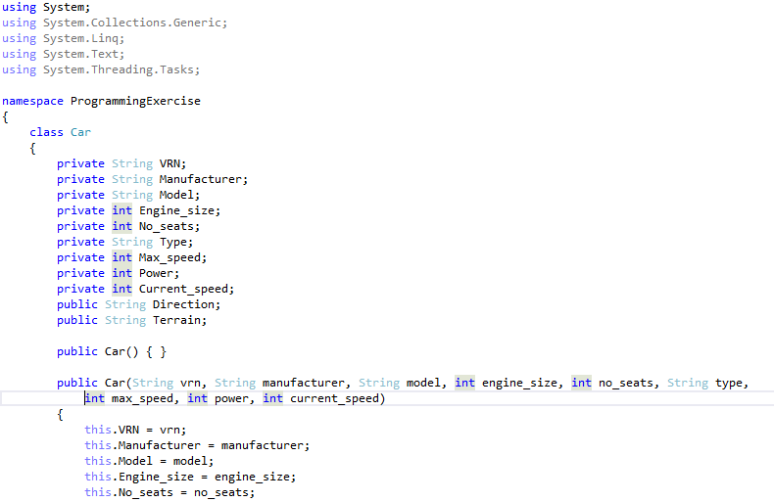
Figure 6: Implementation of the programming exercise
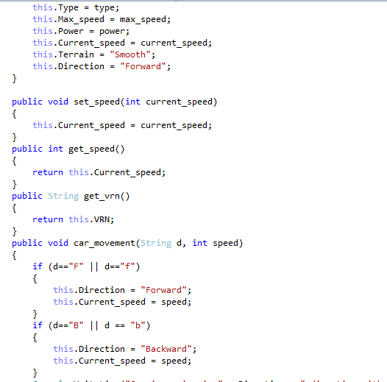
Figure 7: Implementation of the programming exercise
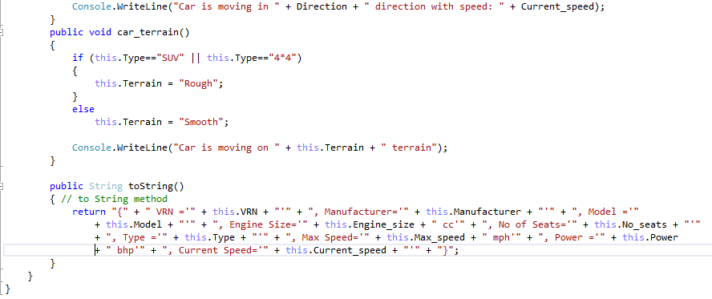
Figure 8: Implementation of the programming exercise
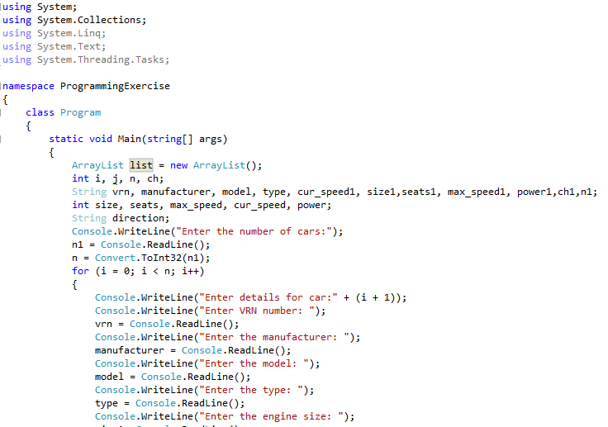
Figure 9: Implementation of the programming exercise
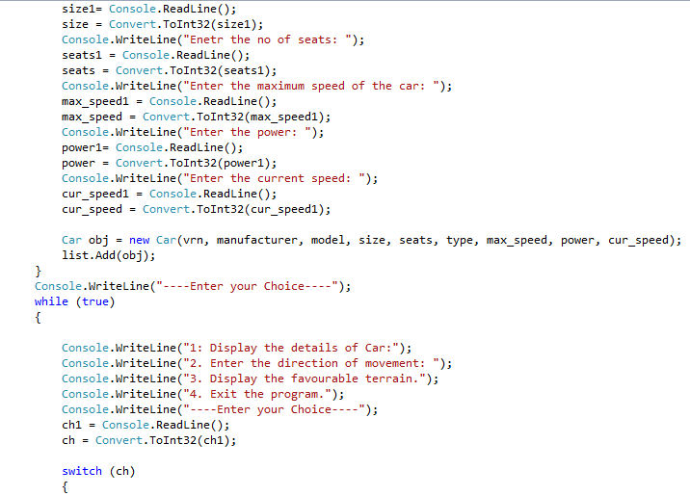
Figure 10: Implementation of the programming exercise
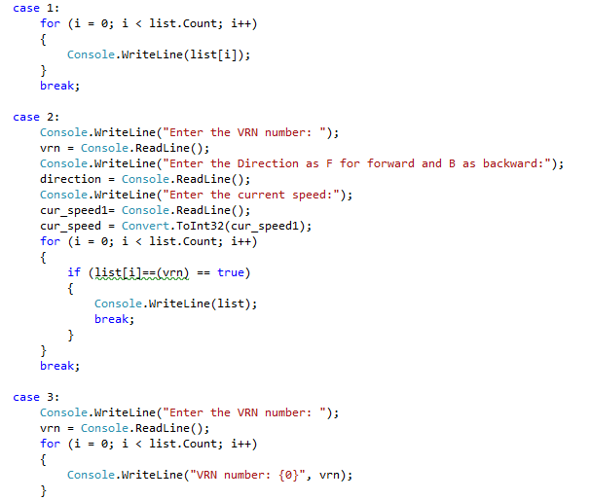
Figure 11: Implementation of the programming exercise
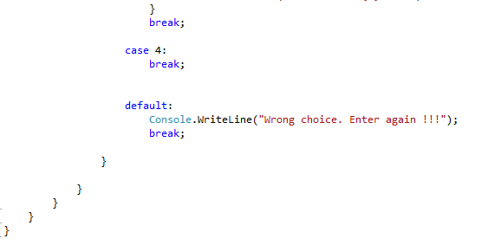
Figure 12: Implementation of the programming exercise

References
Alayan, M., Muhr, E., Levisse, A., Bocquet, M., Moreau, M., Nowak, E., Molas, G., Vianello, E. and Portal, J.M., 2019. Switching event detection and self-termination programming circuit for energy efficient reram memory arrays. IEEE Transactions on Circuits and Systems II: Express Briefs, 66(5), pp.748-752.
Browning, J.B. and Sutherland, B., 2020. Inheritance. In C++ 20 Recipes (pp. 189-213). Apress, Berkeley, CA.
Dageförde, J.C. and Kuchen, H., 2020. Constraint-Logic Object-Oriented Programming with Free Arrays. arXiv preprint arXiv:2008.13460.
Kouraklis, J., 2020. Object-Oriented Programming (OOP). In Delphi Quick Syntax Reference (pp. 73-102). Apress, Berkeley, CA.
Li, Z., Xie, Y., Shangguan, L., Zelaya, R.I., Gummeson, J., Hu, W. and Jamieson, K., 2019. Towards programming the radio environment with large arrays of inexpensive antennas. In 16th {USENIX} Symposium on Networked Systems Design and Implementation ({NSDI} 19) (pp. 285-300).
MEHTRE, V.V. and VERMA, U.R., 2019. Concepts Related to Object Oriented Program OOP‟ S: Basics.
Wang, Y., 2019. Revisiting multiple inheritance for modularity and reuse. HKU Theses Online (HKUTO).

