Materials and Manufacturing
Emyr Owen Pritchard
Component Analysis Report
Ian Williams
Word count: 1958

Materials and Manufacturing: Component Analysis Report
Guitars are a highly mass-produced product across the world, in this essay, I will be laying out just one of the many ways guitars are built in industry. The second part of this piece is where I will then outline my new choice for a new material for the guitar body, I will also be showing my reasoning for why my material choice suits the guitar and why I think it would work. Choosing a new material for the guitar is a difficult decision given how long the acoustic guitar has been around, the first can be dated to the 15th century, although originally strung with 4 strings.

How a modern acoustic guitar is built
Firstly, the raw material for the guitar is cut to size, there are many woods that can be used for a guitar and there are even multiple woods used in the making of the guitar but for the purpose of this essay, this guitar is constructed out of thin sheets of spruce as it is light and has the right density for acoustic resonance which is a huge factor on how good a guitar will sound. The sheets of spruce are cut to 2 shapes, one in long strips thick enough for the sides of the guitar, and larger rectangular pieces to use on the front and back of the guitar body.
Next the larger spruce sheets are pressed under a large hydraulic stamp to give the front and back of the guitar is shape, higher end guitars may have the back and fronts of the guitar hand cut or by band saw, depending on the wood but due to the low density spruce can easily be cut with a press.
The fronts of the guitar are then bored into by a large circular dill piece to give the hole for the sound to resonate through, the size of the hole is important because the controls how much resonance a guitar will have this is usually a set size for mass produced guitars but a client could have a specific size cut if they wanted to customise the sound made by the guitar. During this process a small decorative inlay is also placed around the hole, which is called the “rose”, this is to give the guitar a higher aesthetic quality.
To create the sides of the guitar the long spruce strips are first soaked in a bath of boiling water for around 15 seconds, this makes them more pliable for the next step of placing the strips into a shaped heated press that give the sides the shape required, the strips are held in the press for around a minute before being removed. Once removed 2 sides are glued together from the top and bottom and given 2 strengthening blocks of mahogany on each side and are left to dry in clamps.
Next a wooden strip in glued to both sides of the guitar to help them attach the front and back, the strip is serrated to make it easier for the strip to flex around the bends of the side piece, they are left in clamps to dry. The strip is then accurately hand routered to make spaces for support arms to be placed across the sides to help support the body. At the same time strategic supports are added to the front and back of the guitar which helps to control the tension in the body and its vibration, these are glued under a vacuum press to ensure the glue dries evenly.

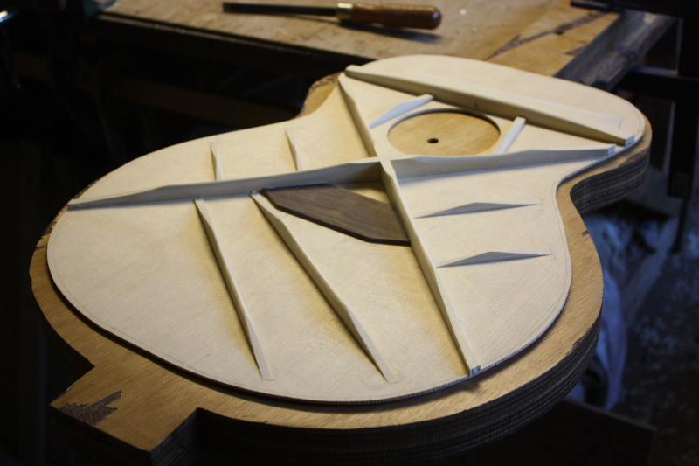
(image of the supporting arms glued onto the inside of the guitar body before the sides are joined)
Once dry, the side, front and back are glued together using PVA along the strip on the sides of the guitar, the body is then left in a press and then left to dry on a rack. When dry the body is given a supportive plastic strip along its join to ensure the guitar will stay strong across its lifetime. The completed guitar body is then finely sanded with a high grit orbital sander, to remove any small imperfections and any excess glue that may be left around the body.
A specially made, precise machine is then used to drill holes into the guitar body and the pre-cut neck. The machine has a high level of accuracy to make sure that the neck and body align correctly, if the angle if not correct then the sound of the guitar will be ruined so this step is vital to the build. Each piece is then sanded side-by-side to make sure that they will fit correctly.
Lacquer is then applied to the guitar body in multiple coats, the amount of layers involved depends on the required finish on the guitar, usually this ranges for 4-8 layers, again this can be changed for the customers specification is required and each guitar is sprayed by hand, one at a time.
The finger board is then cut from a raw block of rose wood or ebony, depending on the specification. The board is then routered to make gaps for metal frets to be placed along the board. The frets are spaced at specific lengths to create the correct musical notes along the length of the board, the frets are separated by half tones to give the right musical range required.
An adjustable metal rod is then placed into the neck of the guitar, this will be used later to attach the neck to the body, but first the finger board is glued down onto the neck of the guitar and is held in a vacuum seal to ensure even gluing across the neck. At this time the machine heads are also inserted into the top of the neck, the machine heads are specific metal attachments that would be bought in before hand as they are unique items of their own and a guitar can be fitted with most pre-made heads.
The neck and body are then assembled together using the adjustable rod to guide the pieces together into the holes cut earlier, glue is then used to adhere the part together and screws and clamps are used to hold the pieces together when they are drying. At the same time the bridge is also glued into place using screws and clamps to hold the part on during gluing.
The head stock and saddle are then glued into place at either side of where the strings will fit, they are used to separate the strings to the correct spacings required as part of its specification. The bridge pins are then held into place below the saddle. Finally, the strings are individually strung through the bridge pins and along the guitar to their respective machine head and spun to the correct tension by a bespoke drill head.
Due to the large amount of drying time involved, it can take 3 weeks to make just one guitar.

These instructions are just a simple layout of the most basic of guitars, higher end guitars would use more hands-on construction to give each piece more care and attention.
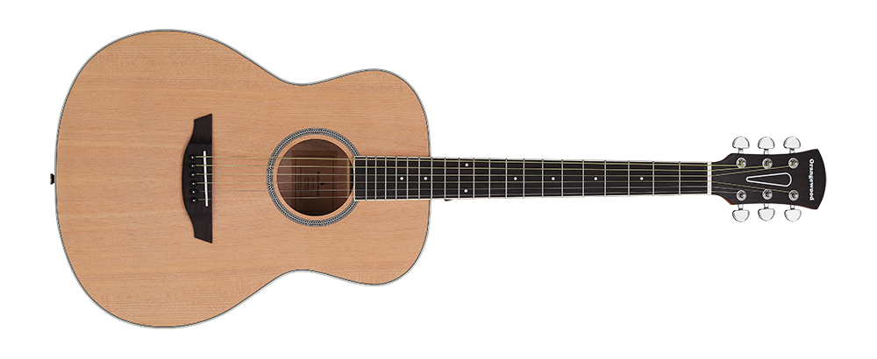
(image of completed spruce wood guitar with rosewood neck)
New Material Choice
The material I have chosen to replace the spruce for the body of the guitar is fiber glass. I have chosen fiber glass based on many factors, these factors will help create a guitar that can stand alongside the spruce guitar currently being sold:
Acoustic resonance- with the correct layering of the glass fibers, a similar resonance can be made with the fiber glass, this is the most important factor in my opinion because if the resonance is too high or too low then the sound produced by the guitar will be nothing as it should be, hence my selection.
Cost- Fibre glass would cost more than the same amount of spruce, but it is cheaper than the next fiber option that I investigated which would be carbon fiber. The carbon matting is more expensive than its glass counterpart, making glass more viable for larger scale production to keep costs down. The Fiber glass is also easier to colour than the carbon fiber making a larger range for the customer.
Usability- Very little would need to change in the manufacturing process of the guitar, the only changes that need to be made would be at the beginning of the process, instead of using spruce sheets you would use sheets to build the body, you would make 2 molds, one which would make the sides and back of the body and another to make the front, they would then be similarly joined but through using a resin instead of glue.
Aesthetics- Although of course looking very different to the natural finish of the Spruce, fiber glass can be produced in a range of colours and marbles, and is just as easy to spray with a custom paint after the body is constructed, this makes it very suitable as aesthetics go as you are able to be more creative with it. Also like the wood it is just as easy to set in any inlays that may be required.
Durability- Whilst the spruce used has a very unique property of becoming softer with age and creating a better sound as it ages, this is very difficult to replicate with any material that you may wish to use, this is why is has no baring on the choice to use fiber glass.
Fixings-The spruce guitar uses a range of joins and fixings to help attach the strings of the guitar to the body to allow them to work correctly, a believe that the fiber glass will be more than capable of holding these fixings whilst keeping the same level of tension in the strings, making it a good choice.
Strength and flexibility- The strength of the fiber glass would be far stronger than that of the spruce guitar as the strength of the spruce comes from the internal support structures to help hold it together. If the fiber glass guitar has these same structural arms, then it would be much stronger than the spruce due to the fibers combining to make an extremely solid and rigid structure.
Drawbacks
The fiber glass build wouldn’t be without its drawbacks as all materials have some bad qualities that would make them not suitable to make a guitar. The fiber glass is not immune to these. Firstly, fiber glass would require more training for the staff as the process is a skilled job to complete, increasing cost. Also, the greater rigidity of the material means that the body would be more prone to chips and cracks on impact, this may cause loss of resonance making the guitar useless.
Conclusion
Whilst the option of using fiber glass for the body of a guitar would satisfy many criteria required to make it suitable for using, I don’t think it would be the best. In my opinion there isn’t any material that you could choose that would be better than the use of wood, specifically spruce. Its robust and adaptable nature makes it easy to work with, light, inexpensive and the perfect guitar building material. Given the amount of years guitars have been made, nobody has come up with a material that improves the quality of sound produced by a wooden acoustic guitar.

Bibliography
Bailey M. image of guitar supports. For personal blog. 2014 (10th may 2019) recovered from: http://news.baileyguitars.co.uk/index.php/2011/07/bailey-custom-acoustic-guitar-ziricote-and-bearclaw-bootlegger-p5/
Unknown. Image of spruce guitar. For Orangewoodguitars . N.A (10th may 2019) recovered from: https://orangewoodguitars.com/products/victoria

References
I have used information from each of these sources along with my own prior knowledge to make this analysis of a spruce (wood) guitar body.
https://www.youtube.com/watch?v=kJogy9pANEU
https://www.guitarandlute.com/gtrhstry.html
https://www.researchgate.net/publication/52001722_Wood_for_sound

