
Amazons strategy`s case study
BMSW6011_CARD
March 31, 2025
name: tekle atobrhan (2210427)
Lecturer: Christine Joy

Contents
1. Introduction 2
2. Main Body 3
2.1. Strategy 3
2.1. Organisation Overview 3
3. Strategic analysis 9
4. Amazon Mission, Vision and Market Position 11
5. Conclusion and Recommendations 14
6. Reference 15

Introduction
This case study aims to analyse Amazon's strategies from its inception in the early 1990s to the present, categorising them by decade. The University of Wales Trinity Saint David requests a case study for Level 6 students developing leadership and management as an outcome of the module' Developing Strategy Capability', to apply their theory into practice. The paper begins with a definition of strategy, an in-depth background, and an examination of Amazon's strategies in every decade, comparing them with the Ten Strategy Schools of Mintzberg. This case study also attempts to answer the following questions: What is the current strategy? What are the advantages and disadvantages of the current strategy? What is the SWOT analysis of the strategy? What is the company's position about its competitors? What are the company's vision and mission? How do these missions and visions contribute to the company's current market position? Furthermore, it concludes with a summary and some strategic recommendations for achieving further market dominance and profitability.

2. Main Body

2.1. Strategy
Strategy is the art of a long-term plan of action or movement to achieve an organisation's goal. An organisation can be advantageous in a changing environment by organising resources and capabilities to fulfil stakeholder expectations (Johnson and Scholes, 2008; Barrington, 2024). Additionally, the strategy involves creating a unique and valuable position through activities different from your competitors (Cory, 2024). Furthermore, according to Henry Mintzberg, there are ten different strategy schools: design, planning, positioning, entrepreneurial, cognitive, learning, power, cultural, environmental, and configuration (Johnson and Scholes, 2008). Therefore, this Amazon strategy case study will compare Amazon's strategies with those of these strategic schools to analyse which and where of the company's strategy aligns with Mintzberg's strategy schools.

Organisation Overview
    - Early Years (1994-1999)
Jeff Bezos founded Amazon in 1994 in Bellevue, Washington, initially as an online bookstore, driven by the Internet's immense potential. Launched in July 1995, it quickly gained popularity for its wide book selection and low prices (Michigan Journal of Economics, 2023). Key milestones include its initial public offering in 1997, expansion into music and DVDs in 1998, and the introduction of a third-party seller marketplace in 1999, which led to the company becoming “Earth’s most customer-centric company” (Professor Freire, 2020). “Amazon established key competitive advantages that allowed it to differentiate itself from traditional bookstores and emerging online competitors” (Carreno, 2024). However, although Amazon appeared to have a bright long-term future in this era, the company faced financial challenges due to low profit margins and security concerns related to online payments (King, 2024).
According to Mintzberg's framework, Amazon has employed various strategies over the initial six years. The transformative leadership that encourages creativity and innovation while navigating uncertainties aligns with the entrepreneurial school. The entrepreneurial school of Mintzberg represents a visionary process that fosters innovation and creativity. It encompasses strategic decisions and actions necessary for creating, developing, and growing a successful business project (DePillis and Sherma, 2021; Duagi, 2023).
The strategy began with books to enhance its expanding logistics and capabilities via the Internet. This choice was practical due to the books' consistency and ease of shipping. Moreover, Amazon's reliance on formal strategic planning has driven its growth, expanded its product offerings, and enhanced user trust through features like customer reviews, which align with Mintzberg's planning school. The planning strategy school, as outlined by Mintzberg, outlines every step the organisation takes, from investigating the situation to implementing the strategy (Malik, 2017; Mishra, 2016).
Furthermore, the launch of the third-party marketplace has transformed Amazon into a dynamic online hub, facilitating operational scaling and improved data management. The company's strategy is linked to Mintzberg`s design school. The design strategy school focuses on establishing a clear and distinctive strategy, utilising the company's internal situation to align with the external environment (Waters, 2025; Hattangadi, 2022).
    - E-Commerce Expansion Leadership Years
Amazon expanded speedily during the late 1990s but faced profitability challenges. It adapted by reinvesting in growth, launching the Amazon Marketplace in 2000, introducing Amazon Web Services (AWS) in 2002, and unveiling Amazon Prime in 2005. By the end of the decade, Amazon had established itself as a leader in online retail, renowned for its customer service and innovative logistics (Marlesh, 2024). In the early years of expansion, Amazon faced financial and profitability challenges due to its investments, navigating cash flow strategies, and pressure from investors resulting from a lack of profit (King, 2024). Additionally, it faced logistics and supply chain challenges due to its shipping and delivery strategies. Additionally, it faced challenges in scaling its operations, as Amazon attempted to expand its product categories, which made the system more complex. Furthermore, during this period, Amazon faced another challenge in making a profit due to high advertising expenses in order to build its brand (Mohith, 2024).
According to Mintzberg's strategy schools, Amazon has employed several approaches over this era. Amazon's strategic development into the new marketplace is a significant milestone. Amazon Web Services was carefully designed to generate revenue for the IT infrastructure. Amazon Prime aimed to enhance customer loyalty by aligning with Mintzberg's planning strategy school. The Planning School of Strategy is considered an innovative process, and criticality arises when something happens outside the strategy's plan; however, a proper prediction is required to succeed (Mishra, 2016; Jassy, 2024; King, 2024).
Additionally, Amazon's establishment as a low-cost leader and its innovative use of logistics have continued to grow. At the same time, the launch of the Kindle has transformed digital reading, solidifying its unique position in the marketplace and aligning it with the positioning of schools. The Positioning School of Strategy entirely focuses on the strategy's content. It does not assume that the market can change, so, like the planning school, it can fail if any changes occur in the business environment (Pelling, 2004; Martin, 2024).
Furthermore, the company continuously learned from market feedback and advanced its business model. The early lessons from the marketplace facilitated Amazon's refinement of its logistics, while the rapid progression of AWS demonstrated the company's ability to adapt based on technology and developments. This learning culture employs the repetition of ideas and the testing of new products, which are closely linked to the learning school. A learning strategy enables one to be active and intentional with the organisation's resources to support and grow their business. The Learning School strategy involves constructing and sharing knowledge within the business, utilising that information to refine the organisation's strategy (Francis, 2024; Jassy, 2024).
    - Exploring Diversification and the Wonders of Technology Years
Amazon focused on technology and digital content, launching products like the Kindle and Echo. It surpassed its market value in 2015 and acquired Whole Foods in 2017. AWS emerged as a key revenue driver, while innovations in logistics strengthened its delivery capabilities (Carreno, 2024).
Amazon`s vision-driven and risk-taking approach to inventing new products and services prompted Whole Foods in 2017 to establish a physical grocery store and develop technologies such as Eco/Alexa and separate delivery options. According to Mintzberg's strategy, schools identify this approach as aligned with the entrepreneurial school, as this strategy school emphasises vision and innovation (Simon, 2017; Alonso, 2022).
Amazon is diligently planning to expand its business. This includes ongoing growth and the enhancement of AWS's global cloud computing capabilities, the strategic introduction of Amazon Prime Video, and the thoughtful integration of acquired businesses into its ecosystem. The company’s clear and formal plans for long-term progress and infrastructure investments have significantly managed its rapid diversification. This strategy aligns with Mintzberg`s planning strategy school. The Planning School of Strategy is considered an innovative process, and criticality arises when something happens outside the strategy's plan; however, a proper prediction is required to succeed (Mishra, 2016; Treasurer, 2024).
One of Amazon's strategies during this era was continuous learning. The company experiments with new ideas, assessing its products to refine its logistics, AI, and robotics network for delivery services. Furthermore, the feedback and data-driven insights enabled Amazon to enhance its products and services, which aligns with the learning school of Mintzberg. The Learning School strategy involves constructing and sharing knowledge within the business, utilising that information to refine the organisation's strategy (Francis, 2024; Alonso, 2022).
Amazon's steady offering of low prices, fast delivery, and a broad product range has strengthened its market position. Its innovations, such as Kindle and Prime Video, make Amazon unique and differentiated from its competitors. This Amazon strategy is linked to the positioning strategy school of Mintzberg, as this strategy school involves the analytical process by which an organisation differentiates itself from its competitors. As Mintzberg states, this type of strategy is referred to as the positioning school. The Positioning School of Strategy entirely focuses on the strategy's content. It does not assume that the market can change, so, like the planning school, it can fail if any changes occur in the business environment (Pelling, 2004; Chaffey, 2023).
Amazon’s deeply entrenched “Day 1” mindset and unwavering commitment to customer experience have influenced all its decisions, strengthening its strategic approach, which aligns with Mintzberg's strategy schools, particularly the cultural school. The Culture School strategy is a plan or set of tactics that the organisation uses to enhance its team or company culture, aligning with Mintzberg's cultural school. Cultural strategies typically centre around the company's core values, so it must begin there (Mishra, 2018; Heslin, 2025). In response to growing regulatory oversight and changing market conditions, Amazon has adjusted its strategies to tackle external issues, from enhancing data security and compliance to engaging in lobbying initiatives, demonstrating the responsiveness typical of the Environmental School. The Environmental School of strategy is an organisation's long-term approach to managing environmental practices and developing environmental resources and capabilities, ensuring a good alignment with its stakeholders' expectations (Aragón-Correa and Ortiz-De-Mandojana, 2016; Slater, 2025).

    - Latest Updates and Future Prospects
The COVID-19 pandemic significantly boosted Amazon's revenue. Jeff Bezos stepped down as CEO in 2021, and the company developed Metro-Goldwyn-Mayer (MGM) Studios in 2022 to enhance its streaming content. Ongoing investments in Artificial intelligence and healthcare establish Amazon's commitment to progress despite facing regulatory challenges and employment issues (Hoy, 2022; Lino, 2024).
Amazon has formalised ambitious, long-term plans, such as investing in climate change, logistics, and fulfilment technologies. The expansion of AWS remains a cornerstone, with structured plans to diversify its cloud services further and penetrate new markets, such as healthcare. This Amazon strategy aligns with the planning school of Mintzberg's strategies. The Planning School of Strategy is considered an innovative process, and criticality arises when something happens outside the strategy's plan; however, a proper prediction is required to succeed (Mishra, 2016; Amazon, 2024).
In this fast-paced world shaped by digital trends, Amazon has emphasised a culture of data-driven learning. The company leverages its analysis of digital data and customer feedback to enhance its services, adjusting the inventory strategies of Prime Video and Alexa throughout the pandemic and iterating on its digital platforms. This research culture fosters continuous learning, which aligns with Mintzberg's learning school strategy. The Learning School strategy involves constructing and sharing knowledge within the business, utilising that information to refine the organisation's strategy (Francis, 2024; Amazon, 2021).
To maintain its uniqueness, Amazon strengthens its market differentiation through innovation by enhancing its warehouse operations, logistics technology, and personalised customer service. Amazon's fast delivery and wide range of products and services, including Prime Video, help the Company stay unique and maintain a competitive market position. Among the ten different Mintzberg strategy schools, this Amazon strategy aligns with the positioning school of thought. The Positioning School of Strategy entirely focuses on the strategy's content. It does not assume that the market can change, so, like the planning school, it can fail if any changes occur in the business environment (Pelling, 2004; Slater, 2025).
Due to increasing investigations into competition laws and worker problems, Amazon has navigated complex government rules and politics. The company utilises promotional efforts, partnerships, and public relations to influence the market's operation and establish regulations. This approach is essential for Amazon, given its significant presence in the market and diverse interests. This type of strategy is linked to the Power School strategy, which focuses on understanding how each decision can affect the organisation in pursuit of its goals (Pelling, 2004; Authority, 2024).
The global economy's external circumstances, environmental changes, and social predictions have prompted strategic modifications at Amazon. Sustainability initiatives are also influenced by responses to societal demands and regulatory pressures rather than being solely internal. This reactive aspect, reflected in improved Environmental, Social, and Governance (ESG) reporting and enhanced supply chain practices, signifies an environmental strategy designed to mitigate external risks while seeking new opportunities, which align with the environmental school. The Environmental School A strategy is an organisation's long-term approach to managing environmental practices and developing environmental resources and capabilities, ensuring a good alignment with its stakeholders' expectations (Amazon, 2025; Amazon, 2024; Mishra, 2018).
Amazon has transformed from an online bookstore into a leading tech and retail empire driven by customer-centred and continuous innovation. However, as it expands, it must navigate increasing competition and regulatory scrutiny.

Strategic analysis
  - Advantages and Disadvantages of the current Amazon strategies
Advantages
Amazon's investment in artificial intelligence (AI) and robotics strategies has driven significant cost reduction and enhanced its operational productivity. For instance, its robotic system led the warehouse, enabling faster delivery, achieving a 25% cost reduction, and bolstering the company's competitiveness against its competitors (Uddin, 2025).
Additionally, Amazon's diversification beyond e-commerce, including Amazon Web Services, streaming services, and advertising services, provides an advantage in terms of revenue streams. Prime Video, Advertising, and cloud services bring a significant amount of profit to the company, which the e-commerce sector often views as added value (Onggowidjojo and Ellitan, 2023).
Furthermore, the customer-centric approach helps Amazon build a strong brand loyalty and an active customer base by prioritising its customer satisfaction through initiatives such as fast delivery, a wide range of product options, and a user-friendly interface (Jain et al., 2023).
Disadvantages
However, even with the technological advancements, Amazon has gained benefits in boosting its productivity. These advancements bring changes in the work culture and labour practices. Therefore, Amazon is facing criticism from its employees due to these changes. It concerns work conditions and displacements, while the aim of technology advancement is to enhance its productivity (Sainato, 2020). Although Amazon's third-party dependencies offer a wide range of products, the company has no control over the quality of these products and the customer service provided, which can impact the overall customer experience (Lopienski, 2024).
Additionally, Amazon is currently facing increased market share competition from Chinese retailers, such as Temu and Shein, which offer low-cost products. These competitors are offering low prices and expanding rapidly, which is prompting Amazon to continually innovate and adjust its strategies to remain competitive (McMahon, 2024).
Furthermore, Amazon is currently under heightened scrutiny as concerns mount over its substantial market dominance and controversial business practices. For instance, a United States judge has recently dismissed a significant lawsuit alleging that Amazon misled its shareholders regarding its treatment of third-party sellers and its strategic plans for expanding operational capacity. The dismissal of this lawsuit reflects the ongoing tension between regulatory bodies and one of the world's largest e-commerce giants, raising questions about transparency and fair competition in the market (Yona, 2025).
  - SWOT analysis
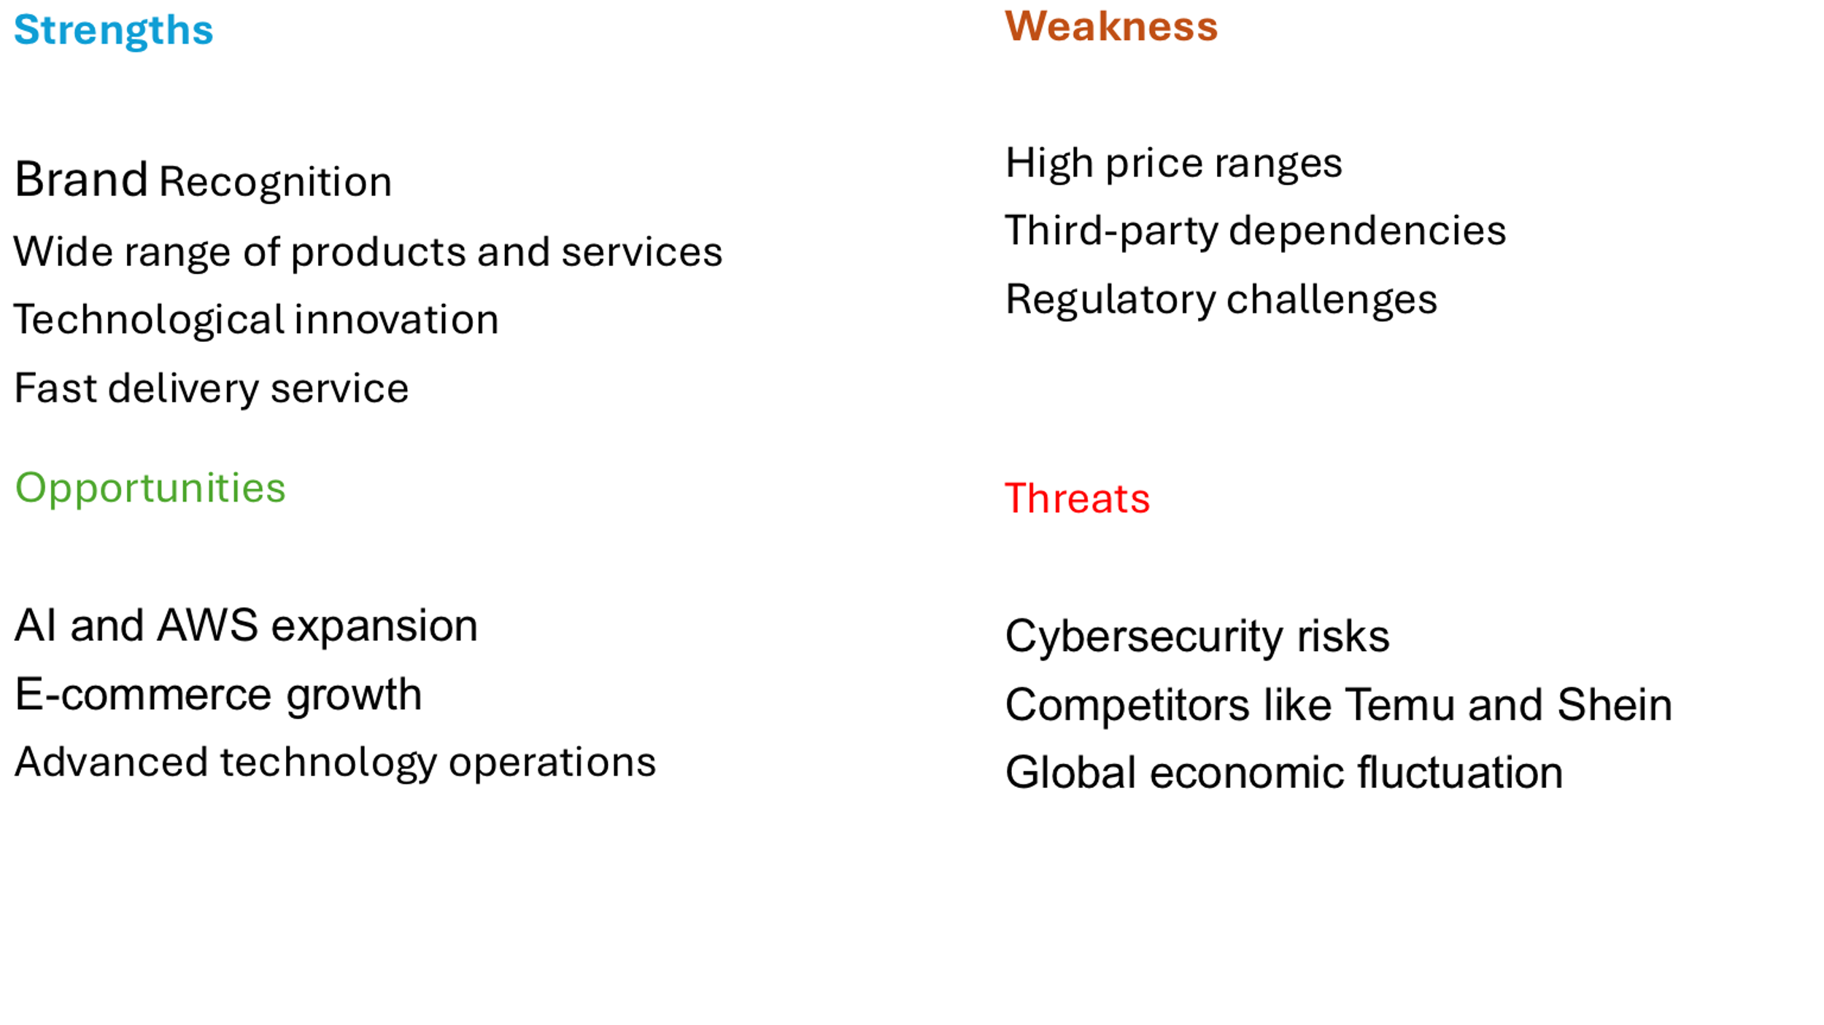
- Strength:
Amazon is a well-known global brand, renowned for its reliability and for fostering customer loyalty and trust. Its wide range of product selection, combined with Prime Video and AWS, gives Amazon strength as an organisation. Moreover, its advanced logistics and fulfilment centres enable fast delivery services, and technological advancements provide the company with operational efficiency and flexible profitability (Downie, 2025).

- Weaknesses:
Amazon`s thin profit margin strategy is one of its weaknesses, as it can affect profitability. Additionally, the regulatory challenges it faces due to global concerns about its market dominance and business practices could lead to operational constraints for Amazon. Furthermore, Amazon's dependence on third-party sellers is also a weakness, as it cannot control the quality of the products and services, which could negatively impact the customer experience (Khan, 2025).
- Opportunities:
As one of Amazon's current strategies is to invest in technology advancements, capitalising on AWS and AI can boost its marketplace. The global growth of E-commerce and investment in eco-friendly technology can enhance Amazon's environmental appeal and corporate image (Jurevicius, 2025; Uddin, 2025).
- Threats:
Amazon is a target of cyber threats due to its status as a leading tech company, and global economic fluctuations can impact its customers' spending limits. Additionally, competitors such as Temu and Shein pose a threat to Amazon, as they offer low-cost products (Pereira, 2024; Yona, 2025).

Amazon Mission, Vision and Market Position
  - Mission and Vision
Amazon's vision is “to be the Earth's most customer-centric company, where customers can easily find and discover what they might want to buy online” (Jassy, 2025). Additionally, Amazon's mission is to be the Earth's most customer-centric company, the best employer, and the safest workplace (Amazon, 2025a).
Amazon is guided by its four core principles, which enable the company to achieve its vision and mission: customer obsession, passion for innovation, operational excellence, and long-term thinking (Amazon, 2025a).
- Customer obsession
Amazon is focusing on customer satisfaction more than its competitors, as one of its key strategies is to be a customer-centric company, understanding its customers' needs and innovating quickly to meet their expectations (Slater, 2025). Although this Amazon strategy helps to satisfy its customers by centralising its customer base, it can challenge Amazon to meet its customer expectations and profitability if the Company fails to focus on its rivals, such as Temu and Shein, as they are trying to dominate the market by offering low-cost products (Pereira, 2024).
- A passion for innovation
Amazon is passionate about innovating new products and services, as well as diversifying its offerings to deliver better services to its customers and positively impact the communities (Amazon, 2025b). As explained earlier, its diversified services and technological innovations, such as Prime Video and AWS, give the company more uniqueness and differentiation from its competitors (Downie, 2025).
- Commitment to operational excellence
Amazon excels at running its operations, which gives it a significant edge over its competitors. The company effectively manages its extensive delivery network, ensuring that products arrive quickly and reliably. You can see this skill in how well Amazon's warehouses operate and how quickly they are improving their delivery times; this is one of the company's unique qualities that sets it apart (Logiwa, 2025).
- Long-term consideration
Since its inception, Amazon has long emphasised long-term thinking as a core value. The company measures its focus in terms of long-term customer-centric metrics, including leading customer satisfaction, the intensity to which consumers continue to buy from Amazon on a repeat basis, and strengthening its brand. Amazon invests for the long term and consistently refines and enhances its products based on consumer comments (Staff, 2018). This long-term thinking has helped the Amazon to remain sustainable for an extended period, as the company has been one of the dominant E-commerce companies for the last few decades (Lino, 2024).

  - Market position
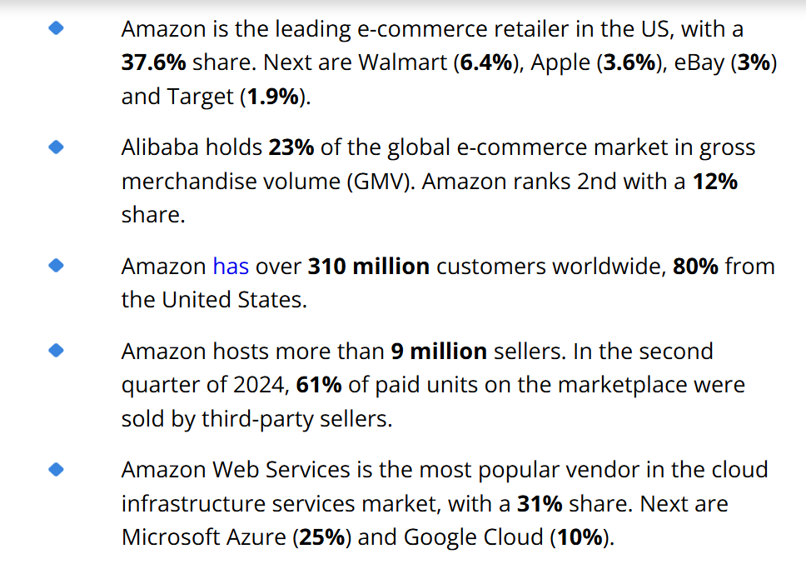(Petrunyshyn, 2025)
According to the top analysis figure, Amazon dominates the E-commerce and cloud computing markets, beating many competitors across different sectors. Additionally, according to Deffenbaugh's (2025) report, in the last quarter of 2024, Amazon earned $7 billion more than Walmart for the first time. However, in the full-year analysis, Walmart earned $680.99 billion, while Amazon earned $637.96 billion, which gives Walmart the sales crown of that year. Moreover, Amazon's new rivals, such as Temu and Shein, are attracting customers by offering low prices, which leads Amazon to cut its competitive pricing by 15 to 35 percent. The United States e-commerce market is expecting Temu to triple its market share, establishing a significant challenge to Amazon's market dominance (Herrera, 2024).

Conclusion and Recommendations
Analysing Amazon's strategies through the lens of Henry Mintzberg's ten schools of strategy reveals that the company has successfully leveraged a diverse range of strategic approaches to adapt to its growth and respond to a dynamic market environment. From its entrepreneurial roots in the early years to the expansive growth phases characterised by innovative offerings such as Amazon Web Services and Amazon Prime, Amazon has continuously adapted and refined its strategies to maintain a leadership position in e-commerce and technology. The company's ability to balance creativity, structured planning, and environmental adaptability has been crucial to its success, enabling it to navigate challenges while consistently meeting and exceeding stakeholder expectations.
Recommendations
1. Highlight Sustainable Practices: As consumers increasingly prioritise sustainability, Amazon should enhance its commitment to environmentally friendly practices. Implementing a comprehensive sustainability strategy that includes reducing its carbon footprint, optimising supply chain efficiency, and utilising renewable energy sources will not only appeal to environmentally conscious consumers. Still, it can also lead to long-term cost savings and advance its customer loyalty.
2. Expand Product and Service Diversification: Continuing to diversify its product and service offerings will further position Amazon as the best solution for consumers. The company should explore opportunities in emerging markets, personalised services, and digital goods that complement existing products. Investing in innovation and exploring collaborations or attainments in new sectors can help alleviate risks and capture new revenue streams.
3. Enhance Customer Engagement with AI and Data Analytics: To enhance customer experience and loyalty, Amazon should invest in advanced AI technologies and data analytics. By assessing customer data more effectively, Amazon can offer personalised recommendations and improve customer service through optimising operational efficiency. Enhanced engagement through designed marketing strategies and loyalty programs can extend consumer relationships and secure a competitive approach in the market.
Overall, these recommendations, when integrated into Amazon's ongoing strategic context, will support its goals for sustained growth and innovation, aligning with developing market requirements.

Reference
Alonso, T. (2022) How Amazon conquered the E-Commerce and tech industries worldwide. https://www.cascade.app/studies/amazon-strategy-study (Accessed: March 22, 2025).
Amazon (2021) Amazon Sustainability 2020 Report: Further and Faster, Together, Amazon Sustainability. https://sustainability.aboutamazon.com/amazon-sustainability-2020-report.pdf (Accessed: March 23, 2025).
Amazon. (2024) Amazon Sustainability Report, Amazon Sustainability. https://sustainability.aboutamazon.com/2023-sustainability-report.pdf (Accessed: March 22, 2025).
Amazon (2025) Driving Climate Solutions - Amazon Sustainability. https://sustainability.aboutamazon.com/climate-solutions (Accessed: March 23, 2025).
Amazon (2025a) About us | About Amazon. https://www.aboutamazon.com/about-us?utm_source=chatgpt.com (Accessed: March 28, 2025).
Amazon (2025b) Innovating Products & Services - Amazon Sustainability. https://sustainability.aboutamazon.com/products-services#innovating-services (Accessed: March 28, 2025).
Aragón-Correa, J.A. and Ortiz-De-Mandojana, N. (2016) 'Environmental strategy,' Palgrave Macmillan UK eBooks, pp. 1–6. https://doi.org/10.1057/978-1-349-94848-2_477-1.
Authority, C. & M. (2024) Investigation into Amazon’s Marketplace. https://www.gov.uk/cma-cases/investigation-into-amazons-marketplace (Accessed: March 22, 2025).
Barrington, R. (2024) Using the SAF Strategy model to evaluate strategic options. https://blog.oxfordcollegeofmarketing.com/2018/02/25/evaluating-strategic-options-using-saf-strategy-model/.
Carreno, A.M. (2024) Analysing Amazon’s evolution from an online bookstore to a global tech giant, ResearchGate. https://doi.org/10.5281/zenodo.14649218.
Cory, K., 2024. Revisiting “What is Strategy?” and Why it Matters. Strategy & Leadership, 52(1), pp.1-6.
DEFFENBAUGH, R. (2025) Amazon Takes Walmart’s Revenue Crown (For Now). https://www.investors.com/news/technology/amazon-stock-walmart-revenue-amzn-wmt/?utm_source=chatgpt.com (Accessed: March 29, 2025).
DePillis, L. and Sherma, I. (2021) Amazon’s extraordinary evolution. https://edition.cnn.com/interactive/2018/10/business/amazon-history-timeline/index.html (Accessed: March 10, 2025).
Downie, R. (2025) Don't Buy Amazon Stock Until You Understand These Risks. https://www.investopedia.com/amazon-stock-biggest-risks-8713887?utm_source=chatgpt.com (Accessed: March 27, 2025).
Duagi, B. (2023) 10 Schools of Strategy formation. https://www.linkedin.com/pulse/od102-10-schools-strategy-formation-b%C3%BClent-duagi- (Accessed: March 24, 2025).
Francis, A. (2024) 'Ten schools of strategy,' MBA Knowledge Base [Preprint]. https://www.mbaknol.com/strategic-management/ten-schools-of-strategy/.
Hattangadi, V. (2022) The Ten Schools of Thoughts by Henry Mintzberg. http://drvidyahattangadi.com/ten-schools-thoughts-henry-mintzeberg/ (Accessed: March 24, 2025).
Herrera, S. (2024) Amazon and Temu’s New Battleground: Winning Over Sellers. https://www.wsj.com/business/retail/amazon-temu-suppliers-online-sellers-e3327fa1?utm_source=chatgpt.com (Accessed: March 29, 2025).
Heslin, M. (2025) The behavioural science behind a 'Day 1' mindset. https://www.linkedin.com/pulse/behavioral-science-behind-day-1-mindset-mike-heslin-fsshe (Accessed: March 22, 2025).
Hoy, L. (2022) Amazon - Completes acquisition of MGM. https://www.hl.co.uk/shares/share-research/Amazon-completes-acquisition-of-MGM (Accessed: February 17, 2025).
Jain, V., Mogaji, E., Sheth, J. N., & Ambika, A. (2023). "Customer-Centric Support Services: An Introduction to the Next Frontier for Competitive Advantage in the Digital Era." Springer eBooks, pp. 1–10. https://doi.org/10.1007/978-3-031-37097-7_1.
Jassy, A. (2024) Amazon CEO Andy Jassy`s 2023 letter to shareholders. https://www.aboutamazon.com/news/company-news/amazon-ceo-andy-jassy-2023-letter-to-shareholders (Accessed: March 13, 2025).
Jassy, A. (2024) Amazon on AWS. https://aws.amazon.com/solutions/case-studies/innovators/amazon/ (Accessed: March 13, 2025).
Jassy, A. (2025) Amazon Mission, Vision & Values. https://www.comparably.com/companies/amazon/mission?utm_source=chatgpt.com (Accessed: March 28, 2025).
Johnson, G. & Scholes, K. (2008) Exploring corporate strategy. 8th edn, Long Range Planning. 8th edn, p. 947. https://doi.org/10.1016/s0024-6301(97)90503-3.
Jurevicius, O. (2025) SWOT analysis of Amazon 2025. https://strategicmanagementinsight.com/swot-analyses/amazon-swot-analysis/?utm_source=chatgpt.com (Accessed: March 27, 2025).
Khan, R. (2025) Amazon SWOT Analysis 2025: Deep dive into their business. https://www.allnewbusiness.com/amazon-swot-analysis/?utm_source=chatgpt.com (Accessed: March 27, 2025).
King, F. (2024) 'Amazon e-commerce: What you need to know – Azura,' Azura – Think Brighter, 16 October. https://azuramagazine.com/articles/amazon-e-commerce-what-you-need-to-know.
Lino, G. (2024) Amazon's Rise: Unveiling a Global Powerhouse. https://www.girolino.com/the-rise-of-amazon-understanding-why-amazon-is-taking-over-the-world/.
Logiwa (2025) Behind the scenes of Amazon inventory management. https://www.logiwa.com/blog/amazon-inventory-management-system#:~:text=Speed%20of%20Customer%20Demand%20and,inventory%20management%20and%20customer%20satisfaction. (Accessed: March 28, 2025).
Lopienski, K. (2024) Overcoming the cons of Amazon: Make the most of Amazon sales. https://www.shipbob.com/blog/amazon-cons/ (Accessed: March 27, 2025).
Marlesh. (2024) How a small Amazon online bookstore became king of retail? https://ciobusinessworld.com/how-a-small-amazon-online-bookstore-became-king-of-retail/.
Martin, M. (2024) 'Why Amazon’s Kindle is More Than a Device: It’s part of ecosystem,' Medium, 21 November. https://medium.com/@marias_martin/why-amazons-kindle-is-more-than-a-device-it-s-part-of-ecosystem-9a9be6fe22b7.
Malik, E. (2017) Amazon History Timeline. https://www.officetimeline.com/blog/amazon-history-timeline (Accessed: March 10, 2025).
McMahon, L. (2024) Haul: Amazon launches Temu rival with 'crazy low' prices. https://www.bbc.co.uk/news/articles/clyv0yp130go (Accessed: March 27, 2025).
Michigan Journal of Economics (2023) The History of Amazon and its Rise to Success https://sites.lsa.umich.edu/mje/2023/05/01/the-history-of-amazon-and-its-rise-to-success/.
Mishra, A. (2016) Henry Mintzberg’s 10 Schools of strategic thought. https://www.linkedin.com/pulse/10-schools-strategic-thought-abhijeet-mishra?utm_source=share&utm_medium=member_ios&utm_campaign=share_via (Accessed: March 24, 2025).
Mohith, R. (2024) These issues stopped Amazon’s growth. https://www.productmonk.io/p/product-strategy-of-amazon (Accessed: March 26, 2025).
Onggowidjojo, V. and Ellitan, L. (2023) 'Strategies for achieving competitive advantage: the case of Amazon,' Zenodo (CERN European Organization for Nuclear Research) [Preprint]. https://doi.org/10.5281/zenodo.8373836.
Pelling, N. (2004) MINTZBERG’S TEN SCHOOLS. MBA Dissertation. https://www.nickpelling.com/dissertation/chapter4.pdf.
Pereira, D. (2024) 'Amazon SWOT Analysis (2025),' Business Model Analyst, 4 December. https://businessmodelanalyst.com/amazon-swot-analysis/ (Accessed: March 27, 2025).
Petrunyshyn, A. (2025) Top 20 Amazon Competitors Overview: Retail, Prime, and AWS rivals in 2025. https://doit.software/blog/amazon-competitors?utm_source=chatgpt.com#screen4 (Accessed: March 28, 2025).
Professor Adriano Freire, Ph.D. (2020) STRATEGIC REPORT. https://www.strategosinstitute.com/uploads/77f1eff7aa4cc12ed7676a60ee4f4e1c56d865efe56a72c36f4879759fac3be7.pdf.
Sainato, M. (2020) '‘I’m not a robot’: Amazon workers condemn unsafe, grueling conditions at warehouse,' The Guardian, 27 July. https://www.theguardian.com/technology/2020/feb/05/amazon-workers-protest-unsafe-grueling-conditions-warehouse.
Simon, H. (2017) Whole Foods is becoming Amazon’s Brick-and-Mortar pricing lab. https://hbr.org/2017/09/whole-foods-is-becoming-amazons-brick-and-mortar-pricing-lab (Accessed: March 22, 2025).
Slater, D. (2025) Elements of Amazon’s Day 1 culture | AWS Executive Insights. https://aws.amazon.com/executive-insights/content/how-amazon-defines-and-operationalizes-a-day-1 culture/ (Accessed: March 22, 2025).
Slater, D. (2025) The Imperatives of Customer-Centric Innovation | AWS Executive Insights. https://aws.amazon.com/executive-insights/content/the-imperatives-of-customer-centric-innovation/ (Accessed: March 23, 2025).
Staff, A.A. (2018) How we operate. https://www.aboutamazon.co.uk/news/job-creation-and-investment/how-we-operate (Accessed: March 28, 2025).
Treasurer, G. (2024) How Amazon’s AWS is revolutionizing the tech industry - the global treasurer. https://www.theglobaltreasurer.com/2024/05/02/how-amazons-aws-is-revolutionizing-the-tech-industry/ (Accessed: March 22, 2025).
Uddin, R. (2025) 'Amazon bets savings from automation can help fuel AI spending boom,' Financial Times, 26 February. https://www.ft.com/content/50b7ecc3-08de-433a-9a5b-6d6590cf8179?utm_source=chatgpt.com.
Waters, J. (2025) Amazon.com American company. https://www.britannica.com/money/Amazoncom (Accessed: March 10, 2025).
Yona, K. (2025) Judge dismisses shareholder lawsuit against Amazon. https://www.findlaw.com/legalblogs/courtside/judge-dismisses-shareholder-lawsuit-against-amazon/ (Accessed: March 26, 2025).

