
Sports Independent Project
Applied Portfolio

Student Name  Thomas Studholme | Project Title  Service to Educate Young People how Sports Effects on Mental Health
Project Aim (1)
- To create a website that is designed to educate 16-25 year olds on the effects of mental health in relation to sport and physical activity

Objectives (3/4)
- To create a video to pitch to propose the idea of a free and easily accessible website to guide young people on the effects sport and physical activity have on mental health, in compliance with ethical processes and procedures.

- To critically examine current research on mental health in relation to sport. Evaluating how impactful sport and physical activity is on mental health problems including anxiety and depression, and analysing what measures are taken at different levels of sport and physical activity to combat mental health issues.

- To design a user-friendly, engaging, and accessible website tailored to different age groups within the 8-25 range.

Contents Page
Element 1….......………………………………………………………………………….(1.0)

Video Pitch URL…………...…………………………………………………………….(1.1)

Ethics Form………………………………………,,,…………………………………….(1.2)

Element 2……………………………………………...………………………………….(2.0)

Aim......................................................................................................................................(2.1)

Why I am doing this.......................................................................................................(2.1.1)

Literature Review (Main Body).......................................................................................(2.2)

Health and Well-Being in the UK....................................................................................(2.3)

Health and Well-Being in Wales......................................................................................(2.4)

Wellness and Well-Being...................................................................................................................................(2.5)

Fitness.................................................................................................................................(2.6)

Health..................................................................................................................................(2.7)

Website Design...................................................................................................................(2.8)

Conclusion..........................................................................................................................(2.9)

Element 3……………………...………………………………………………………….(3.0)

5000 Word Document/30 Minute Video….......………………………………………...(3.1)

Reflection/Conclusion/Recommendation…………..…………………………………..(3.2)

References..........................................................................................................................(4.0)

(1.0) Element 1 - Individual Presentation (5 minutes – Online)
(1.1) URL YouTube Link: https://youtu.be/QXtI4Pv2qH0

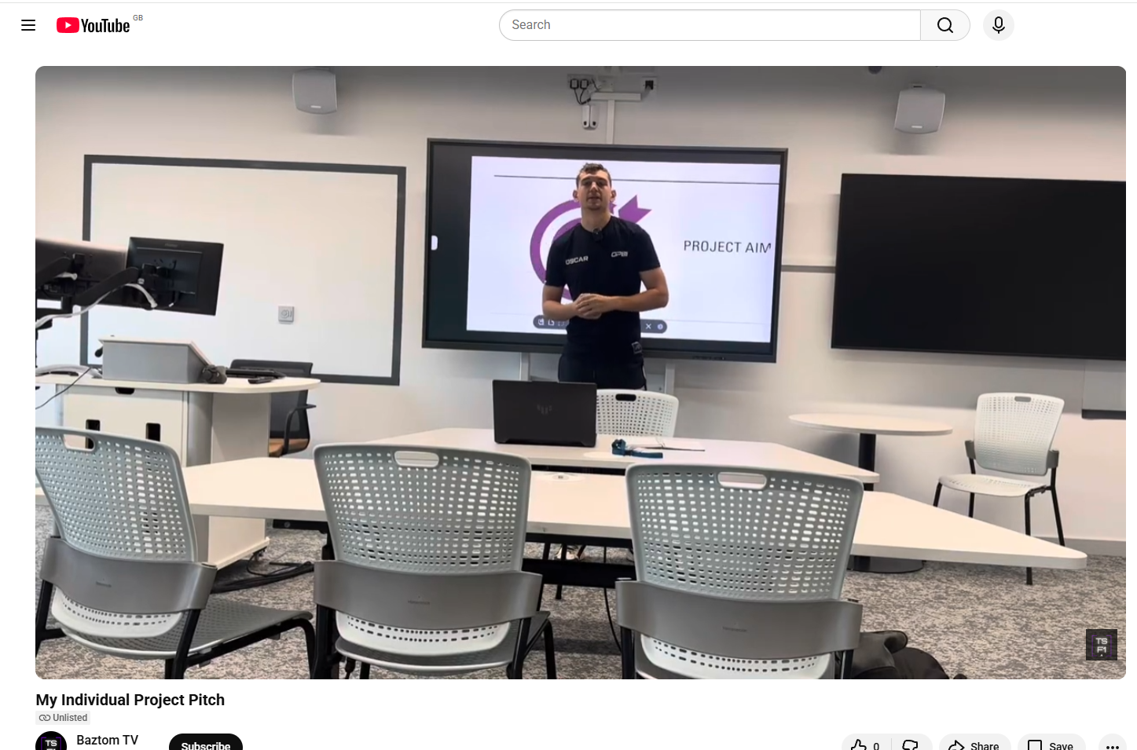

In order for research to result in benefit and minimise risk of harm, it must be conducted ethically. A researcher may not be covered by the University’s insurance if ethical approval has not been obtained prior to commencement.

The University follows the OECD Frascati manual definition of research activity: “creative work undertaken on a systematic basis in order to increase the stock of knowledge, including knowledge of man, culture and society, and the use of this stock of knowledge to devise new applications”. As such this covers activities undertaken by members of staff, postgraduate research students, and both taught postgraduate and undergraduate students working on dissertations/projects.

The individual undertaking the research activity is known as the “principal researcher”.

Ethical approval is not required for routine audits, performance reviews, quality assurance studies, testing within normal educational requirements, and literary or artistic criticism.

Please read the notes for guidance before completing ALL sections of the form.

This form must be completed and approved prior to undertaking any research activity. Please see Checklist for details of process for different categories of application.

(1.2) Element 1 – Ethics Form (All Pages)
SECTION A: About You (Principal Researcher)
1 | Full Name: |  | Thomas David Michael Studholme
2 | Tick all boxes that apply: |  | Member of staff: | ☐ | Honorary research fellow: | ☐
 | Undergraduate Student | ☒ | Taught Postgraduate Student | ☐ | Postgraduate Research Student | ☐

3 | Institute/Academic Discipline/Centre: | Institute of Management and Health
4 | Campus: | Swansea Waterfront SA1
5 | E-mail address: | 2319134@student.uwtsd.ac.uk
6 | Contact Telephone Number: | 07477092676
 | For students:
7 | Student Number: | 2319134
8 | Programme of Study: | BA Sports Management
9 | Director of Studies/Supervisor: | Andrew Thomas

Where research activity is carried out in collaboration with an external organisation
10 | Does this organisation have its own ethics approval system? | YES | ☒ | NO | ☐
 | If Yes, please attach a copy of any final approval (or interim approval) from the organisation (this may be a copy of an email if appropriate).

SECTION B: Details of Research Activity
1 | Indicative title: | Service to Educate Young People how Sports Effects on Mental Health
2 | Proposed start date: | 26/09/25 | Proposed end date: | 29/03/26
Introduction to the Research (maximum 300 words per section)
Ensure that you write for a Non-Specialist Audience when outlining your response to the points below:
- Purpose of Research Activity
- With my insights from working with young people in sport and physical activity. I want to work with the NHS to create an educational service to help young people understand how sport and physical activity can benefit mental health. I am creating this service because sport and physical activity are some of the biggest cures for mental health problems. Sport and physical activity are known as “natural mood boosters” that benefit physical and mental wellbeing.

- Aim of Research Activity
- To create a website that is designed to educate 16-25 year olds on the effects of mental health in relation to sport and physical activity

- Objectives of Research Activity
- To create a video to pitch to propose the idea of a free and easily accessible website to guide young people on the effects sport and physical activity have on mental health, in compliance with ethical processes and procedures.

- To critically examine current research on mental health in relation to sport. Evaluating how impactful sport and physical activity is on mental health problems including anxiety and depression, and analysing what measures are taken at different levels of sport and physical activity to combat mental health issues.

- To design a user-friendly, engaging, and accessible website tailored to different age groups within the 8-25 range.

- Demonstrate, briefly, how Existing Research has informed the proposed activity and explain
- What the research activity will add to the body of knowledge
- It is understood that sport and physical activity is now being medically prescribed for mental health problems related to anxiety, stress, and depression.

How it addresses an area of importance.
- It addresses the increase of understanding of the effects sports and physical activity have on mental health.
3 | Purpose of Research Activity  - With my insights from working with young people in sport and physical activity. I want to work with the NHS to create an educational service to help young people understand how sport and physical activity can benefit mental health. I am creating this service because sport and physical activity are some of the biggest cures for mental health problems. Sport and physical activity are known as “natural mood boosters” that benefit physical and mental wellbeing.  (this box should expand as you type)
4 | Research Question  Do sport and physical activity bring benefit to mental health and wellbeing?  (this box should expand as you type)
5 | Aim of Research Activity  - To create a website that is designed to educate 8-25 year olds on the effects of mental health in relation to sport and physical activity  (this box should expand as you type)
6 | Objectives of Research Activity  - To create a video to pitch to propose the idea of a free and easily accessible website to guide young people on the effects sport and physical activity have on mental health, in compliance with ethical processes and procedures.  - To critically examine current research on mental health in relation to sport. Evaluating how impactful sport and physical activity is on mental health problems including anxiety and depression, and analysing what measures are taken at different levels of sport and physical activity to combat mental health issues.  - To design a user-friendly, engaging, and accessible website tailored to different age groups within the 8-25 range.

 | Does your research relate to one or more of the seven aims of the Well-being of Future Generations (Wales) Act 2015? | YES | NO
12 | A prosperous Wales | ☒ | ☐
13 | A resilient Wales | ☐ | ☒
14 | A healthier Wales | ☒ | ☐
15 | A more equal Wales | ☒ | ☐
16 | A Wales of cohesive communities | ☒ | ☐
17 | A Wales of vibrant culture and thriving Welsh language | ☐ | ☒
18 | A globally responsible Wales | ☐ | ☒
19 | If YES to any of the above, please give details:
My project specifically targets a healthier and more equal Wales. With my service guiding and educating young people on what they can do to help their mental health and wellbeing.
(this box should expand as you type)

SECTION C: Scope of Research Activity
 | Will the research activity include: | YES | NO
1 | Use of a questionnaire or similar research instrument? | ☐ | ☒
2 | Use of interviews? | ☒ | ☐
3 | Use of focus groups? | ☒ | ☐
4 | Use of participant diaries? | ☐ | ☒
5 | Use of video or audio recording? | ☒ | ☐
6 | Use of computer-generated log files? | ☐ | ☒
7 | Participant observation with their knowledge? | ☒ | ☐
8 | Participant observation without their knowledge? | ☐ | ☒
9 | Access to personal or confidential information without the participants’ specific consent? | ☐ | ☒
10 | Administration of any questions, test stimuli, presentation that may be experienced as physically, mentally or emotionally harmful / offensive? | ☐ | ☒
11 | Performance of any acts which may cause embarrassment or affect self-esteem? | ☐ | ☒
12 | Investigation of participants involved in illegal activities? | ☐ | ☒
13 | Use of procedures that involve deception? | ☐ | ☒
14 | Administration of any substance, agent or placebo? | ☐ | ☒
15 | Working with live vertebrate animals? | ☐ | ☒
16 | Procedures that may have a negative impact on the environment? | ☐ | ☒
17 | Other primary data collection methods. Please indicate the type of data collection method(s) below. | ☐ | ☒
 | Details of any other primary data collection method:  (this box should expand as you type) | ☐ | ☒
If NO to every question, then the research activity is (ethically) low risk and may be exempt from some of the following sections (please refer to Guidance Notes).

If YES to any question, then no research activity should be undertaken until full ethical approval has been obtained.

SECTION D: Intended Participants
If there are no participants then do not complete this section, but go directly to section H.

 | Who are the intended participants: | YES | NO
1 | Students or staff at the University? | ☒ | ☐
2 | Adults (over the age of 18 and competent to give consent)? | ☒ | ☐
3 | Vulnerable adults? | ☐ | ☒
4 | Children and Young People under the age of 18? (Consent from Parent, Carer or Guardian will be required) | ☐ | ☒
5 | Prisoners? | ☐ | ☒
6 | Young offenders? | ☐ | ☒
7 | Those who could be considered to have a particularly dependent relationship with the investigator or a gatekeeper? | ☐ | ☒
8 | People engaged in illegal activities? | ☐ | ☒
9 | Others. Please indicate the participants below, and specifically any group who may be unable to give consent. | ☐ | ☒
 | Details of any other participant groups: | ☐ | ☒

Participant numbers and source
Provide an estimate of the expected number of participants. How will you identify participants and how will they be recruited?
10 | How many participants are expected? | 3
11 | Who will the participants be? | Myself, head teacher and another member of school staff
12 | How will you identify the participants? | They have been identified to be suitable for giving answers for my project

 | Information for participants: | YES | NO | N/A
13 | Will you describe the main research procedures to participants in advance, so that they are informed about what to expect? | ☒ | ☐ | ☐
14 | Will you tell participants that their participation is voluntary? | ☒ | ☐ | ☐
☒ | Will you obtain written consent for participation? |  | ☐ | ☒
16 | Will you explain to participants that refusal to participate in the research will not affect their treatment or education (if relevant)? | ☒ | ☐ | ☐
17 | If the research is observational, will you ask participants for their consent to being observed? | ☐ | ☐ | ☒
18 | Will you tell participants that they may withdraw from the research at any time and for any reason? | ☒ | ☐ | ☐
19 | With questionnaires, will you give participants the option of omitting questions they do not want to answer? | ☐ | ☐ | ☒
20 | Will you tell participants that their data will be treated with full confidentiality and that, if published, it will not be identifiable as theirs? | ☐ | ☐ | ☒
21 | Will you debrief participants at the end of their participation, in a way appropriate to the type of research undertaken? | ☒ | ☐ | ☐
22 | If NO to any of above questions, please give an explanation

 | Information for participants: | YES | NO | N/A
24 | Will participants be paid? | ☐ | ☒ | ☐
25 | Is specialist electrical or other equipment to be used with participants? | ☒ | ☐ | ☐
26 | Are there any financial or other interests to the investigator or University arising from this study? | ☐ | ☒ | ☐
27 | Will the research activity involve deliberately misleading participants in any way, or the partial or full concealment of the specific study aims? | ☐ | ☒ | ☐
28 | If YES to any question, please provide full details
 | The equipment they will be using is a camera and a tripod

SECTION E: Anticipated Risks

Outline any anticipated risks that may adversely affect any of the participants, the researchers and/or the University, and the steps that will be taken to address them.

If you have completed a full risk assessment (for example as required by a laboratory, or external research collaborator) you may append that to this form.
1 | Full risk assessment completed and appended? |  | Yes | ☐
1 |  |  | No | ☒
2 | Risks to participants  For example: sector-specific health & safety, emotional distress, financial disclosure, physical harm, transfer of personal data, sensitive organisational information
 | Risk to participants: | How you will mitigate the risk to participants:
3 | If research activity may include sensitive, embarrassing or upsetting topics (e.g. sexual activity, drug use) or issues likely to disclose information requiring further action (e.g. criminal activity), give details of the procedures to deal with these issues, including any support/advice (e.g. helpline numbers) to be offered to participants. Note that where applicable, consent procedures should make it clear that if something potentially or actually illegal is discovered in the course of a project, it may need to be disclosed to the proper authorities
4 | Risks to the investigator  For example: personal health & safety, physical harm, emotional distress, risk of accusation of harm/impropriety, conflict of interest
 | Risk to the investigator: | How you will mitigate the risk to the investigator:
5 | University/institutional risks  For example: adverse publicity, financial loss, data protection
 | Risk to the University: | How you will mitigate the risk to the University:
6 | Environmental risks  For example: accidental spillage of pollutants, damage to local ecosystems
 | Risk to the environment: | How you will mitigate the risk to environment:

 | Disclosure and Barring Service
 | If the research activity involves children or vulnerable adults, a Disclosure and Barring Service (DBS) certificate must be obtained before any contact with such participants. | YES | NO | N/A
7 | Does your research require you to hold a current DBS Certificate? | ☐ | ☒ | ☐
8 | If YES, please give the certificate number. If the certificate number is not available please write “Pending”; in this case any ethical approval will be subject to providing the appropriate certificate number.

SECTION F: Feedback, Consent and Confidentiality

1 | Feedback  What de-briefing and feedback will be provided to participants, how will this be done and when?
Participants will be explained what questions they will be answering, and what they are answering them for.

(this box should expand as you type)
2 | Informed consent  Describe the arrangements to inform potential participants, before providing consent, of what is involved in participating. Describe the arrangements for participants to provide full consent before data collection begins. If gaining consent in this way is inappropriate, explain how consent will be obtained and recorded in accordance with prevailing data protection legislation.
All participants are happy that what they are doing is completely voluntary and have the right to back out of participation should they want to at any time.

(this box should expand as you type)
3 | Confidentiality / Anonymity  Set out how anonymity of participants and confidentiality will be ensured in any outputs. If anonymity is not being offered, explain why this is the case.
Participants are happy to not be anonymous in my video pitch

(this box should expand as you type)

SECTION G: Data Protection and Storage

 | Does the research activity involve personal data (as defined by the General Data Protection Regulation 2016 “GDPR” and the Data Protection Act 2018 “DPA”)? | YES | NO
1 | “Personal data” means any information relating to an identified or identifiable natural person (‘data subject’). An identifiable natural person is one who can be identified, directly or indirectly, in particular by reference to an identifier such as a name, an identification number, location data, an online identifier or to one or more factors specific to the physical, physiological, genetic, mental, economic, cultural or social identity of that natural person. Any video or audio recordings of participants is considered to be personal data. | YES | ☐
 | If YES, provide a description of the data and explain why this data needs to be collected:
2 | The names of the teachers and their status within the school will be used as a means to provide context and clarity for my video pitch, which they are happy to comply with
 | Does it involve special category data (as defined by the GDPR)? | YES | NO
3 | “Special category data” means sensitive personal data consisting of information as to the data subjects’ –  (a) racial or ethnic origin,  (b) political opinions,  (c ) religious beliefs or other beliefs of a similar nature,  (d) membership of a trade union (within the meaning of the Trade Union and Labour Relations (Consolidation) Act 1992),  (e) physical or mental health or condition,  (f) sexual life,  (g) genetics,  (h) biometric data (as used for ID purposes), | ☐ | NO
 | If YES, provide a description of the special category data and explain why this data needs to be collected:
4

 | Will data from the research activity (collected data, drafts of the thesis, or materials for publication) be stored in any of the following ways? | YES | NO
5 | Manual files (i.e. in paper form)? | ☐ | ☒
6 | University computers? | ☒ | ☐
7 | Private company computers? | ☐ | ☒
8 | Home or other personal computers? | ☒ | ☐
9 | Laptop computers/ CDs/ Portable disk-drives/ memory sticks? | ☒ | ☐
10 | “Cloud” storage or websites? | ☒ | ☐
11 | Other – specify: | ☐ | ☒
12 | For all stored data, explain the measures in place to ensure the security of the data collected, data confidentiality, including details of backup procedures, password protection, encryption, anonymisation and pseudonymisation:
Logging into the account that the information is stored on requires a form of 2FA

(this box should expand as you type)

 | Data Protection
 | Will the research activity involve any of the following activities: | YES | NO
13 | Electronic transfer of data in any form? | ☒ | ☐
14 | Sharing of data with others at the University outside of the immediate research team? | ☐ | ☒
15 | Sharing of data with other organisations? | ☒ | ☐
16 | Export of data outside the UK or importing of data from outside the UK? | ☐ | ☒
17 | Use of personal addresses, postcodes, faxes, emails or telephone numbers? | ☒ | ☐
18 | Publication of data that might allow identification of individuals? | ☒ | ☐
19 | Use of data management system? | ☒ | ☐
20 | Data archiving? | ☒ | ☐
21 | If YES to any question, please provide full details, explaining how this will be conducted in accordance with the GDPR and Data Protection Act (2018) (and any international equivalents, where appropriate):
 | Data and files for the project will be consistently transferred between University computers and my personal laptop.
22 | List all who will have access to the data generated by the research activity:
 | Myself (Thomas Studholme), James Prosser, Andrew Thomas
23 | List who will have control of, and act as custodian(s) for, data generated by the research activity:
 | Myself (Thomas Studholme)
24 | Give details of data storage arrangements, including security measures in place to protect the data, where data will be stored, how long for, and in what form. Will data be archived – if so how and if not why not.
 | Project data will be stored on a cloud in an account with 2FA enabled. It will be kept for the duration of the academic year in the form of word documents.
25 | Please indicate if your data will be stored in the UWTSD Research Data Repository (see https://researchdata.uwtsd.ac.uk/ ). If so please explain. (Most relevant to academic staff)
 | Yes it will be. So that work can be accessed on university ground without issue.
26 | Confirm that you have read the UWTSD guidance on data management (see https://www.uwtsd.ac.uk/library/research-data-management/) | YES | ☒
27 | Confirm that you are aware that you need to keep all data until after your research has completed or the end of your funding | YES | ☒

SECTION H: Declaration
The information which I have provided is correct and complete to the best of my knowledge. I have attempted to identify any risks and issues related to the research activity and acknowledge my obligations and the rights of the participants.

In submitting this application I hereby confirm that I undertake to ensure that the above named research activity will meet the University’s Research Ethics and Integrity Code of Practice which is published on the website: https://www.uwtsd.ac.uk/research/research-ethics/
1 | Signature of applicant: | T.Studholme | Date:01/11/25

Checklist: Please complete the checklist below to ensure that you have completed the form according to the guidelines and attached any required documentation:
☐ | I have read the guidance notes supplied before completing the form.
☒ | I have completed ALL RELEVANT sections of the form in full.
☒ | I confirm that the research activity has received approval in principle
☒ | I have attached a copy of final/interim approval from external organisation (where appropriate)
☒ | I have attached a full risk assessment (where appropriate) ONLY TICK IF YOU HAVE ATTACHED A FULL RISK ASSESSMENT
☒ | I understand that it is my responsibility to ensure that the above named research activity will meet the University’s Research Ethics and Integrity Code of Practice.
☒ | I understand that before commencing data collection all documents aimed at respondents (including information sheets, consent forms, questionnaires, interview schedules etc.) must be confirmed by the DoS/Supervisor, module tutor or Academic Director.

RESEARCH STUDENTS ONLY
Once complete, submit this form via the MyTSD Doctoral College Portal at (https://mytsd.uwtsd.ac.uk).

STUDENTS ON UNDERGRADUATE OR TAUGHT MASTERS PROGRAMMES should submit this form (and receive the outcome) via systems explained to you by the supervisor/module leader.

(2.0) Element 2 - Literature Review (3000 words)
(2.1) The aim of my project
My aim is to create a website where 16-24 year olds can freely access to acquire knowledge on how sport and physical activity can impact their mental health.

(2.1.1) Why am I doing this?
I am doing this because I have a major passion for being an advocate for mental health. I want young people to understand how getting involved in sport and physical activity can help with their mental health and help them create strategies and coping mechanisms for issues including stress, anxiety, and depression to name a few. During my time at the ages between 16 and 18, I suffered from very high levels and anxiety and depression. It was also at this time where I wished that there were a lot more resources available to me in order to help my understanding of what causes these issues and what action I can take to make them easier. It wasn’t until I started to get more involved with sport and physical activity post lockdown that I realised how much it helped my mental health. I now want to use my own personal experience, as well as experience I have gained from coaching and working with younger people, to collaborate with the NHS to create a website that can educate young people about mental health issues and how getting involved in sport and physical activity can help their well-being, this service is going to be freely accessible for anyone at any time, a service I wish I had when I was young and struggling with mental health problems.

(2.2) Literature Review (Main Body)

(2.3) Health and Well-Being in the UK has seen major fluctuations over the past few years. COVID-19 has proven to have lasting effects on the wellbeing of young adults in the UK. When the UK lockdown restrictions were implemented, UK citizens from the age of 18 were gathered to partake in online surveys between 31st March to 9th April 2020. Results found that from approximately 3000 respondents, there was a similar rate of “suicidal ideation” across both men and women, 12.5% in people aged between 18-29 to be exact. (O’Connor, 2021). This indicates the mental health issues that lead up to suicide, including stress, anxiety, depression, and loneliness, are a constant issue in the UK. Physical activity has proven to be a method to improve health and well-being. Using data from approximately 1,500 respondents

to the 2018 UK Parkrun Health and Well-Being survey, researchers analysed both quantitative and qualitative responses with participants reporting mental health problems such

as depression, anxiety, panic attacks and PTSD. Researchers used people with and without mental health problems, they found those with poorer mental well-being were more likely to state improvement, as well as share more about condition management and happiness as key motivations for taking part. They also found to be more likely to report improvements in their mental well-being. Qualitative findings showed that regular, social, and outdoor nature of parkrun, along with opportunities to walk or volunteer, made it inclusive and accessible, leading to improved social connections, physical activity levels and healthier lifestyle choices. However, some participants experienced social anxiety, fear of being too slow in the run, or not fitting in. (Quirk, 2024). This study highlights how physical activity can be both a benefit and a drawback, meaning that physical activity can improve health and wellbeing, while on the other hand, health and wellbeing can be put on “hault” because people may have fears of not fitting in, or worrying about their appearance, which shows how health and wellbeing is an issue in the UK. While national evidence highlights well-being challenges and the potential benefits of physical activity across the UK, these experiences are not the exact same across all regions. Devolved health systems, population demographics and levels of deprivation mean that local contexts shape how health and wellbeing are experienced. Wales, in particular, faces distinct social, economic and geographical pressures that influence both physical and mental health and wellbeing outcomes, making it essential to explore Welsh specific patterns in more detail.

(2.4) Wales, in the current day, has seen limited progress in health and wellbeing. Healthy life expectancy has declined for both men and women since 2011, with inequality between deprived and affluent areas widening, especially for women. The rate of low birth weight single babies has risen to its highest record level. While adult healthy behaviours declined before the pandemic and have slightly improved recently, young people’s healthy behaviours have increased. Adult mental wellbeing is stable, but young people’s mental wellbeing has declined, with growing gaps linked to family affluence. Housing safety has also improved over the decade. (Perks W, 2025). On the topic of young people, a Welsh study of approximately 16,000 schoolchildren examined how physical activity relates to wellbeing and mental health. Most children reported high wellbeing, despite high deprivation levels. Regression and decision tree

analyses showed that intrinsic factors including feeling competent, confident, safe, and autonomous, were stronger predictors of wellbeing than activity levels alone. Lower sedentary time was linked to better wellbeing, while higher sedentary behaviour, low confidence, low safety and low competence predicted emotional difficulties. Girls reported more emotional problems and boys more behavioural difficulties.

The findings emphasise that fostering confidence, competence, autonomy and safe environments is more important than simply increasing physical activity time. (James M, 2025). Adolescence is a critical life stage for health and wellbeing, when many young people are first exposed to substances and experience emerging mental wellbeing problems. Drawing on a large, nationally representative Welsh school survey, a study found that positive relationships within family and school environments are central to better outcomes. Strong family support and supportive relationships with teachers were independently associated with higher subjective wellbeing, fewer mental health symptoms and lower levels of alcohol, tobacco and cannabis use. In contrast, peer relationships were more complex. Feeling connected to peers within school was linked to better wellbeing, yet high reliance on friends was associated with greater substance use, and among young people with low family support, poorer mental wellbeing. Importantly, teacher support was most protective for pupils lacking family support, indicating that schools can help buffer social disadvantages and reduce inequalities in adolescent health and wellbeing. (Moore, 2018). In Wales, declining healthy life

expectancy and widening inequalities highlights growing wellbeing challenges, particularly for young people. Evidence shows that confidence, safety, autonomy, and support family and school relationships matter more than physical activity alone. This shifts the focus from health behaviours to broader wellness and wellbeing, centered on emotional security, belonging and supportive environments.
(2.5) Wellness refers to a state of physical health supported by habits like healthy eating, exercise and sleep that helps individuals avoid chronic illness and have energy for life. Wellbeing is broader and includes five elements. These elements are career, social, financial, physical, and community. These contribute to a thriving life. Wellness is one component of overall wellbeing, but someone can be physically well yet still struggle if other dimensions of wellbeing are lacking. Employers increasingly recognise wellbeing’s importance because poor wellbeing affects engagement, productivity, and retention. Furthermore, participation in

workplace wellness programs is often low despite widespread availability. (Pendell, 2021). The World Health Organisation defines wellness and wellbeing as a tool that enables people to realise their potential, cope with everyday stress, work productively, and contribute to their community. It is seen as essential for everyone. High emotional wellness includes self-esteem, optimism, confidence, and effective coping skills. Low wellness and wellbeing can be improved by learning resilience, as reactions matter more than events. Building supportive relationships, maintaining physical health through exercise and physical activity, good nutrition and good sleep, and taking regular breaks to reduce all stress. Enjoyment,

generosity, and daily sunlight can boost mood, while mindfulness supports present focused thinking. A healthy work life balance and proactive medical care help sustain long term mental wellbeing. (Channel, 2020). A journal article found that wellness and wellbeing are complex concepts shaped by biology, psychology, culture, and environment. Life quality reflects humans’ evolutionary drive to secure resources, relationships, and purpose. Modern wellbeing includes both objective conditions such as health and income, and subjective wellbeing, or how people feel about their lives. Research shows that subjective wellbeing is influenced by genetically determined mood set-points that are protected by psychological “homeostasis”. People draw on external resources like money, close relationships, and meaningful activity, as

well as internal cognitive coping strategies, to maintain wellbeing. Although wellbeing is generally stable, cultural norms affect how individuals interpret and answer wellbeing questions, making cross cultural comparisons challenging. (Cummins, 2018). Mental wellness and wellbeing reflect our ability to realise potential, cope with stress, and maintain positive emotions through resilience, relationships, and self-care. These foundations rely not only on mindset, but also on how we treat our bodies. Fitness plays a critical role in supporting mental wellbeing by strengthening physical health, boosting mood-regulating hormones, improving sleep and increasing confidence. Regular activity provides structure, purpose and social connection, all of which reinforce resilience. By prioritising movement alongside mindfulness and balance, fitness becomes a practical bridge between caring for the mind and sustaining long-term wellbeing.

(2.6) Fitness means more than looking athletic. Fitness is the body’s ability to perform daily tasks with energy, strength, and alertness without excessive fatigue. Higher fitness is linked to lower risk of chronic disease, better mental health, improved sleep, and greater mobility across

a person's lifespan. Fitness includes several components such as cardiorespiratory endurance, muscular strength, flexibility, balance, and speed. Physical activity is the tool used to improve fitness. Fitness looks different for everyone, meaning it has no single appearance. Ultimately, being fit translates into real world functions, such as climbing stairs, carrying groceries, and staying active with family. (Everyday Health, 2022). A study found that as populations age, maintaining physical fitness becomes crucial for protecting brain health and reducing age related decline. The study shows that moderate intensity physical activity, measured objectively with accelerometers, is linked to a “younger” biological brain age in older adults. Fitness indicators such as RHR, healthy blood pressure, lower BMI, and stronger grip strength were even more strongly associated with slower brain aging than activity alone. Importantly, improvements in fitness partly explained how physical activity

benefits the brain, suggesting that exercise supports healthy aging primarily by enhancing overall physical fitness rather than activity duration alone. (Hoogen, 2025). A book that analyses healthy living habits and fitness within schools found that schools promote fitness and

healthy living through whole school initiatives that target eating habits, drinking choices and physical activity. Programmes are introduced in assemblies and PE lessons, supported by booklets that teach the benefits of healthy behaviours and encourage pupils to set short, medium and long term objectives. Pupils monitor their habits in and out of school, while positive behaviours such as choosing healthy meals or joining extracurricular activities are rewarded with stamps and prizes. Parents are informed and encouraged to reinforce these behaviours at home. Reviews show such programmes improve diet and activity levels, supporting fitness, and lifelong healthy lifestyles. (Human Kinetics, 2018). Fitness is about how effectively the body carries out everyday activities with stamina, strength, and focus rather than how a person looks. It involves elements such as endurance, muscular strength, flexibility, balance, and speed. In relation to mental and physical wellbeing, these elements contribute to better mood, improved sleep, mobility, and lower risk of illness. Evidence shows that higher fitness levels protect brain function and reduces age related decline, highlighting the close link between fitness and health. Schools strengthen this link by promoting healthy eating and physical activity through structured programmes that support lifelong wellbeing.

(2.7) Health is defined as a person’s current state of mental, physical, and emotional well-being. Based on components such as a balanced diet, getting regular physical activity, and

connecting with those around, will determine how well a person is capable of maintaining good overall “health”. (Felman, 2025). In the current state, the UK plans to transform the NHS to secure its long term future by overhauling how care is delivered and experienced. Faced with rising demand, workforce pressures and poor outcomes in areas such as cancer and access to GPs, the government will shift the system from being hospital centered to community based, from paper based to fully digital, and from focusing on sickness to prioritising prevention. Neighbourhood health centres will provide joined up local care, while the NHS app will become the main access point for appointments, advice, prescriptions and care planning. The plan aims to harness AI, genomics and wearable technology to predict and prevent illness and personalise treatment. Reducing health inequalities, tackling obesity, smoking and mental health, and strengthening the NHS workforce are key priorities. Greater transparency, patient

choice and value based funding will improve quality and productivity, ensuring the NHS remains free, universal, and financially stable for future generations.

(GOV, 2025). A journal article states that the UK faces worsening health outcomes, growing mental illness an ageing population and persistent health inequalities. While some progress exists, such as improved oral health, the NHS must prioritise prevention and health promotion, as the government’s long term plans state. The UK should have addressed a broader view of the impacts of COVID-19 and strengthened resilience against threats like climate change, antimicrobial resistance and Brexit. (Lancet, 2021). These challenges are especially relevant to young people’s wellbeing. Rising rates of anxiety, depression, obesity, and inactivity mean that early intervention is vital. Supporting mental health in schools, promoting physical activity, and improving access to healthy food can help build resilience, reduce future disease risk, and improve long term quality of life. The Uk’s changing population, increasing mental illness, and ongoing health inequalities are placing growing strain on the NHS. Health outcomes such as life expectancy are falling behind other developed nations, while preventable diseases are becoming more common. This highlights the need for a stronger focus on health promotion. This approach can particularly benefit young people, as early support reduces the risk of long term physical and mental health problems. Encouraging physical activity, balanced diets and positive wellbeing can help young people build resilience, establish healthy habits, and improve their quality of life into adulthood.

(2.8) Firstly, website design is built upon the relationship between clients and servers. A server is powerful hardware running special software that stores and delivers website files when requested. Companies maintain these systems and rent space to users through web hosting. On the other side is the client, which is any device or application that asks for displays web content, such as browsers like Chrome or Safari, mobile apps, or even smart TVs. When a user enters a web address or selects a video, the client sends a request over the internet, the server gathers the required files, and sends them back to instantly be displayed. (Kramer, 2022). Good website design begins with a strong layout and composition. Designers must be able to guide the viewer’s eye using visual hierarchy, balance, contrast, rhythm, and unity. Layout is not decoration but structure, but helping users understand information quickly. Grids are emphasized as essential tools for organising content consistently across pages. Balance can be symmetrical or asymmetrical, but it must feel stable. Contrast in size, colour, and spacing draws attention to key elements. White space is not empty; it improves readability and focus. Effective composition makes websites clear, attractive, and easy to navigate. (Beaird, 2020). Modern website design must be responsive, meaning it adapts to different screen sizes, devices, and input methods. It is built on three core principles. These are fluid layouts, flexible media, and CSS media queries. Designers are encouraged to adopt a mobile first, progressive enhancement approach, starting with small screens and enhancing for larger ones. Strong semantic HTML is essential for accessibility and structure, while CSS features such as Flexbox and Grid enable flexible layouts. The book also stresses performance, testing on real devices, accessible forms, scalable graphics like SVGs, and avoiding unnecessary frameworks to create efficient, future proof websites. (Frain, 2020). Website visual design influences business outcomes only through user experience, not directly. Attractive visual design improves users’ perceived usability, which then increases the pleasure they feel when using a site. This pleasure is the key driver of positive website evaluation, including perceived value, intention of reuse, and intention to recommend. Usability alone does not directly affect these outcomes; it must create pleasurable experiences. Two experimental studies show that the correct sequence is visual design, usability, pleasure, and evaluation, while the reverse order is unsupported. The findings highlight that designers must prioritise visual design that supports learning and ease of use to generate emotional satisfaction and better user loyalty. (Jongmans, 2020).

(2.9) Conclusion
This literature review explores the relationship between mental health, physical activity, wellbeing, fitness and website design to support the creation of an online mental health resource for young people aged between 16-24. It highlights how COVID-19 worsened mental health across the UK, with high levels of anxiety, depression, and suicidal ideation, particularly among young adults. Evidence shows that physical activity, such as parkrun, can improve mental wellbeing through social connection, routine and outdoor environments, although barriers like social anxiety remain. In Wales, declining healthy life expectancy and widening inequalities emphasise the importance of confidence, safety, autonomy and supportive family and school relationships over activity levels alone. The review distinguishes wellness, wellbeing, fitness and health, stressing that mental wellbeing depends on resilience, relationships, lifestyle habits and physical fitness rather than appearance. Fitness is shown to protect brain health and support long term wellbeing with schools playing a key role in encouraging healthy habits. UK health policy now prioritises prevention and digital care, making early intervention for young people essential. Finally, effective website design is framed around client-server relationships, strong layout principles, responsive, mobile first design and accessible, user centred experiences that enhance usability, pleasure and engagement.

(3.0) Element 3
(3.1) 5000 Word Document or 30 Minute Video
https://thomasdmsfootball.wixsite.com/how-sport-can-help-y
Word Count for Website: Approximately 4,800-5000 Words
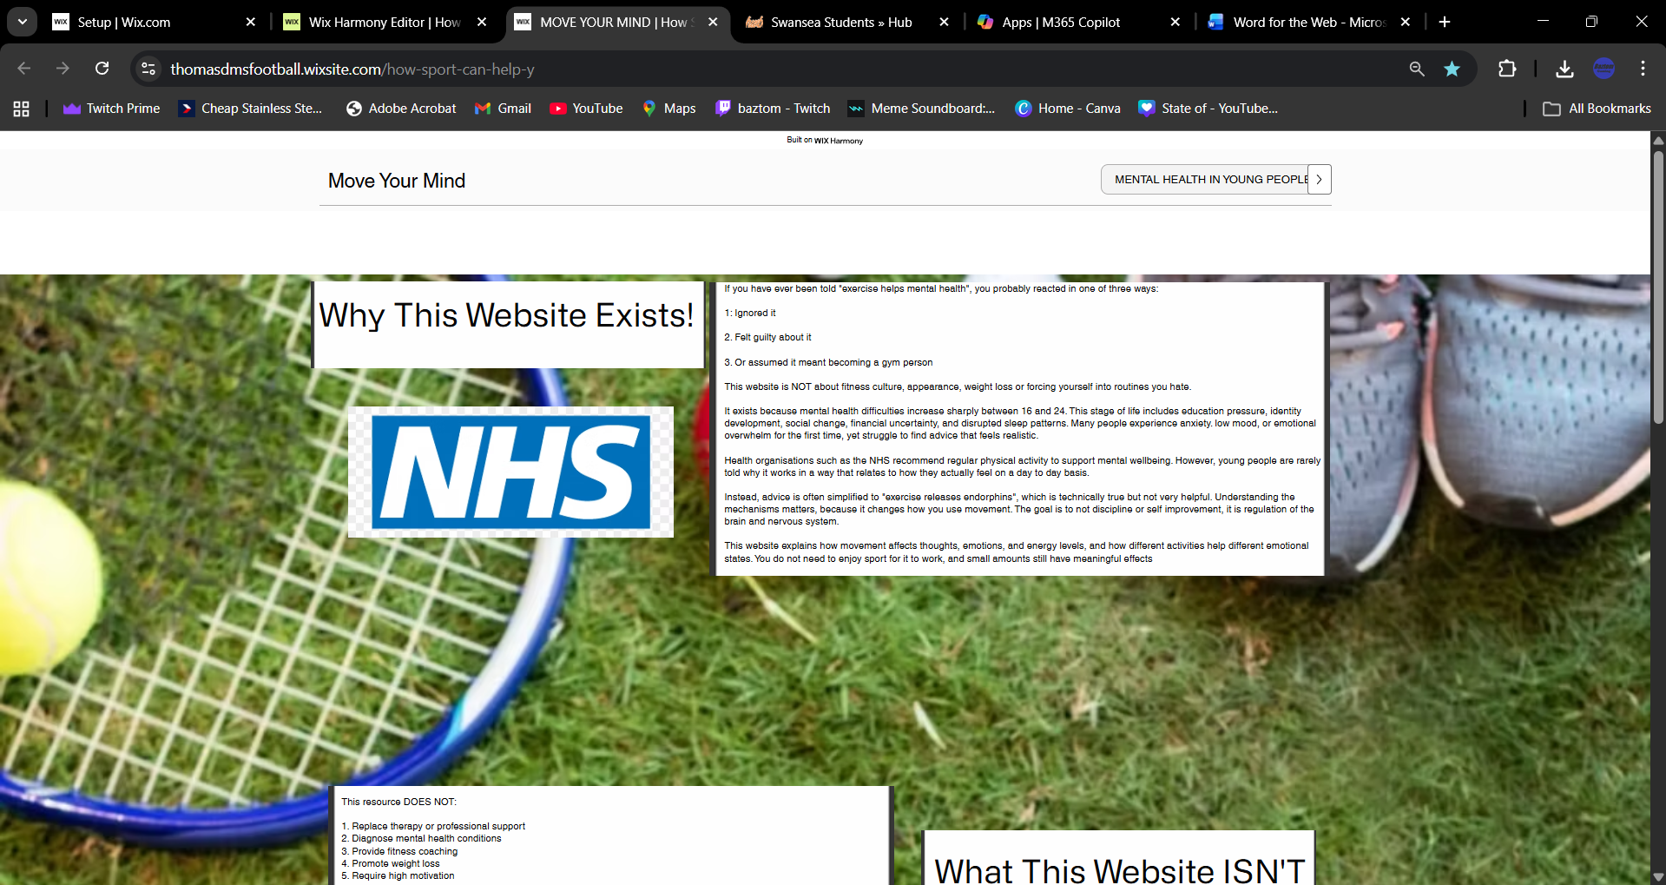
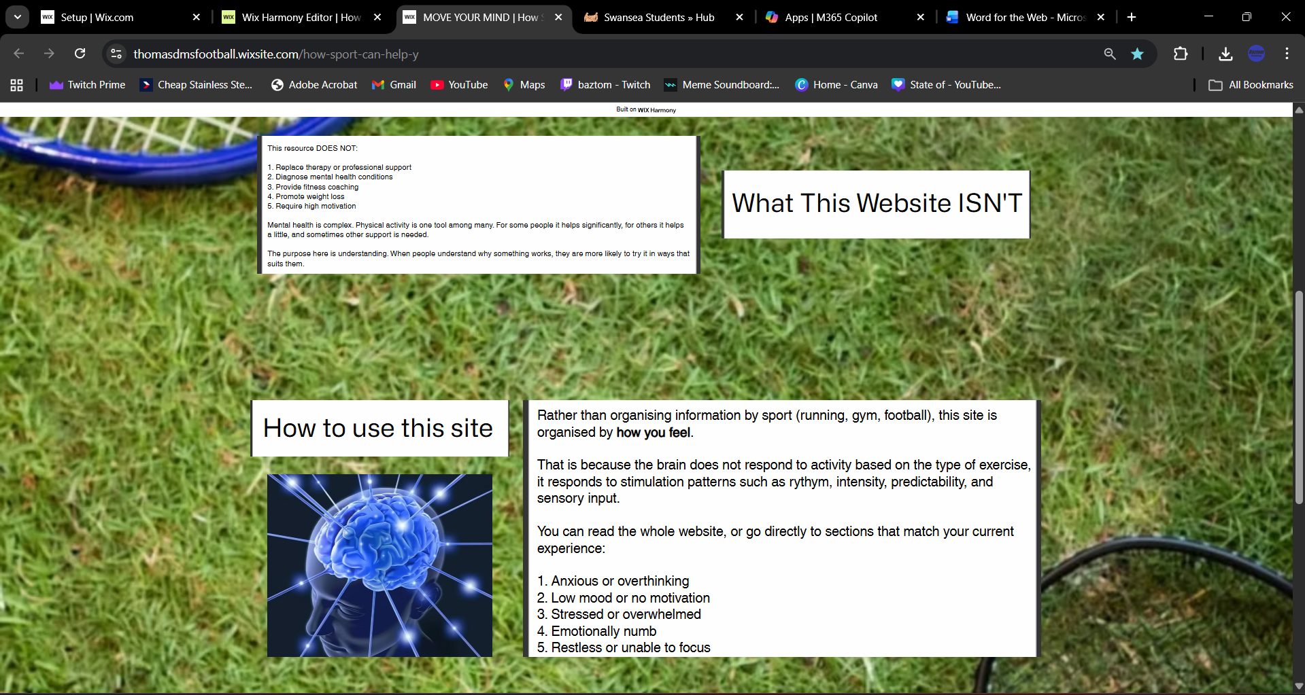

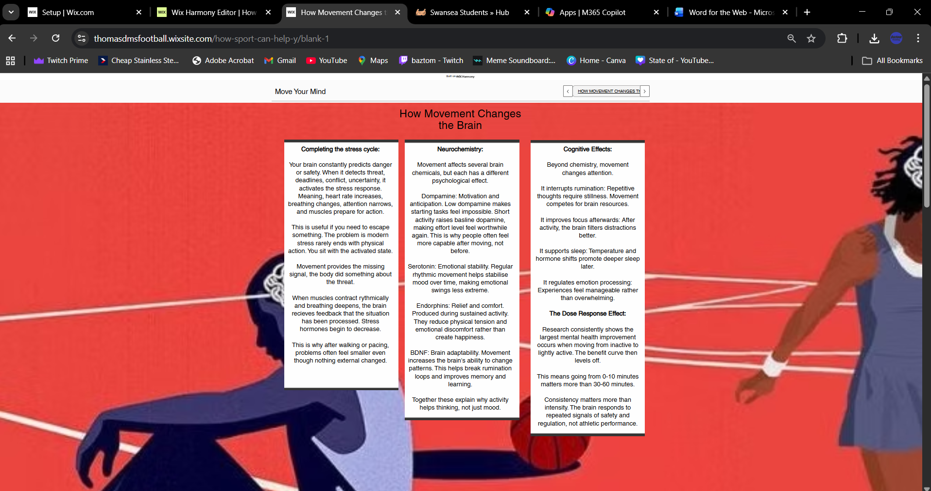
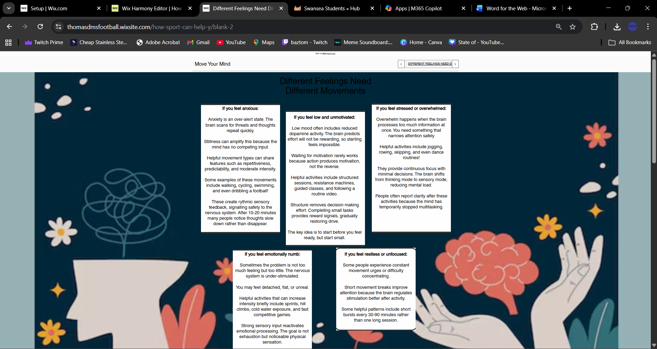

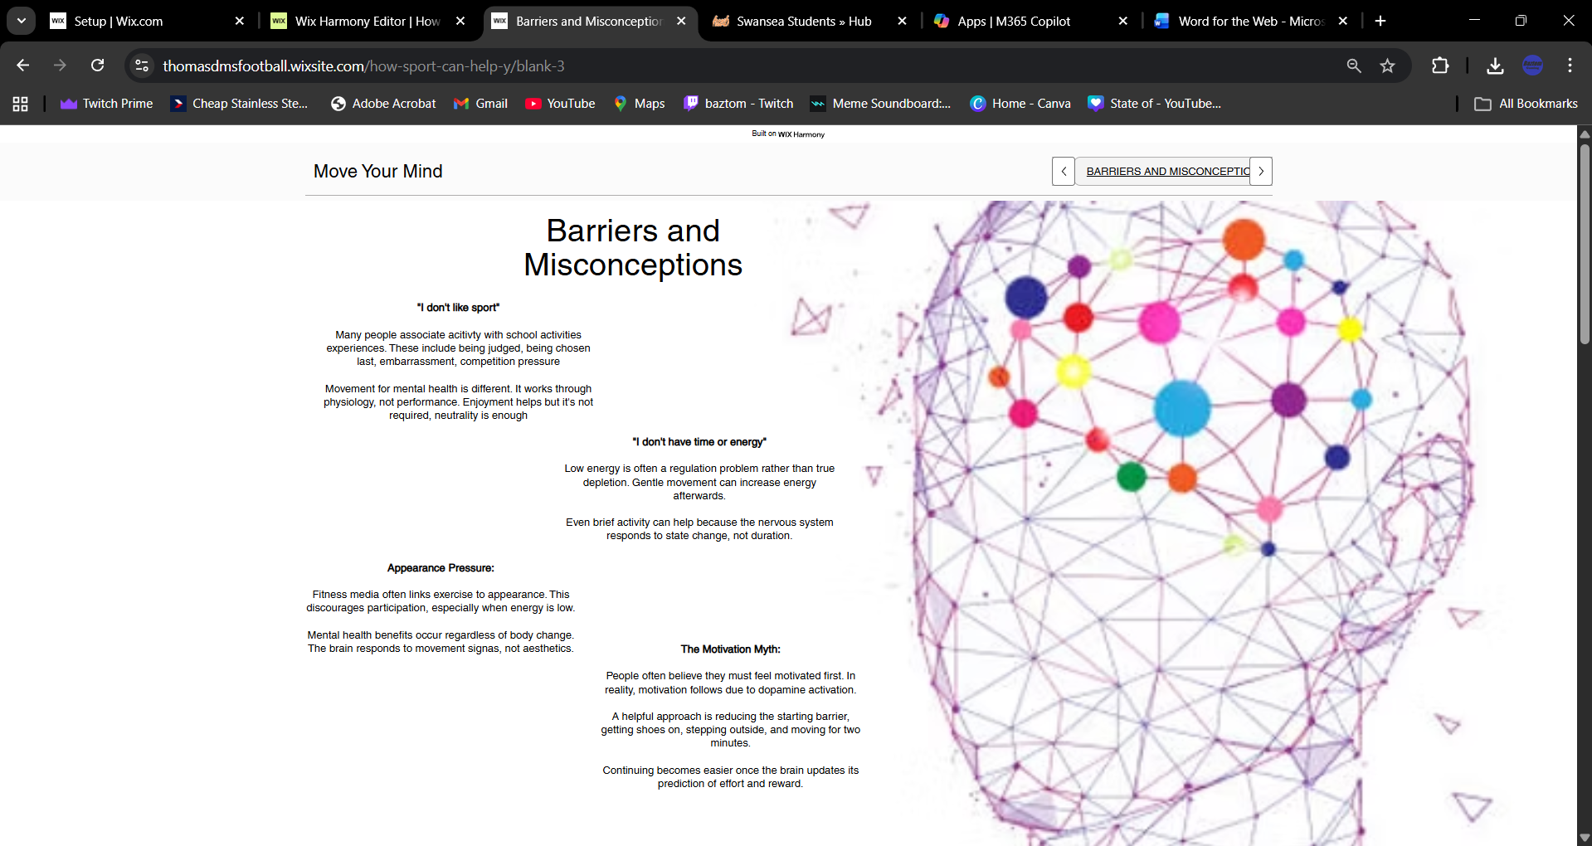
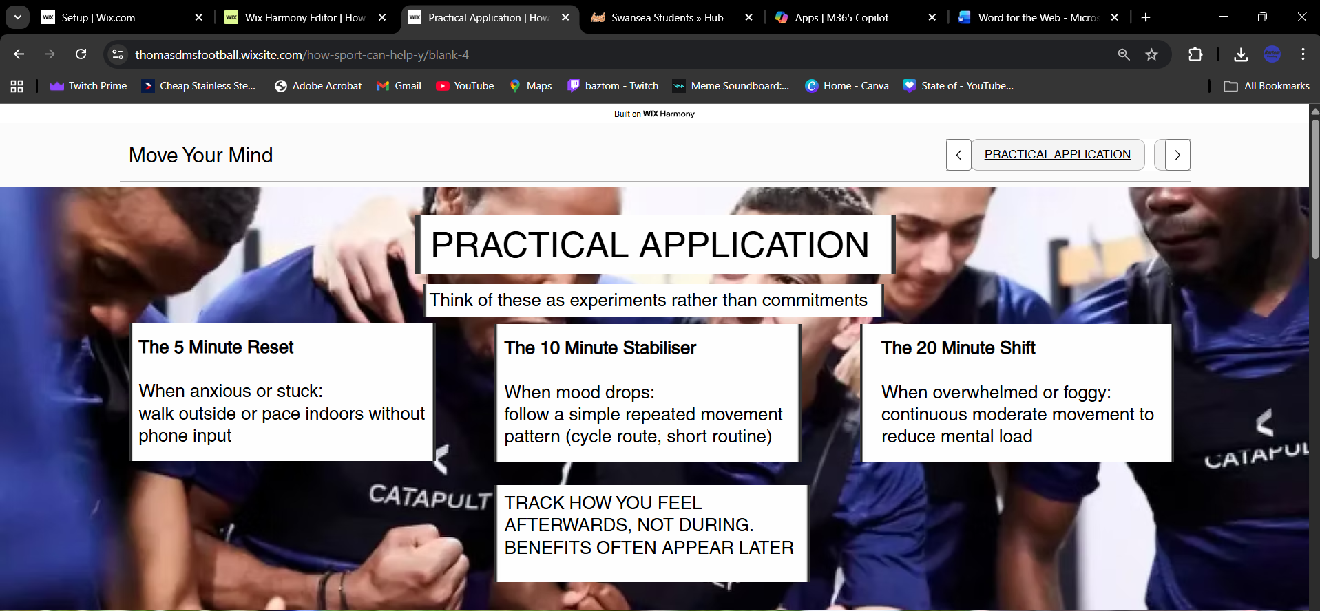

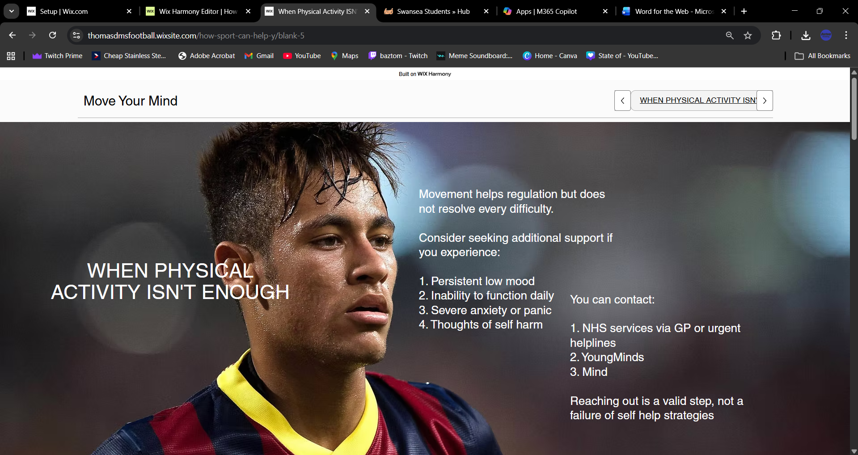
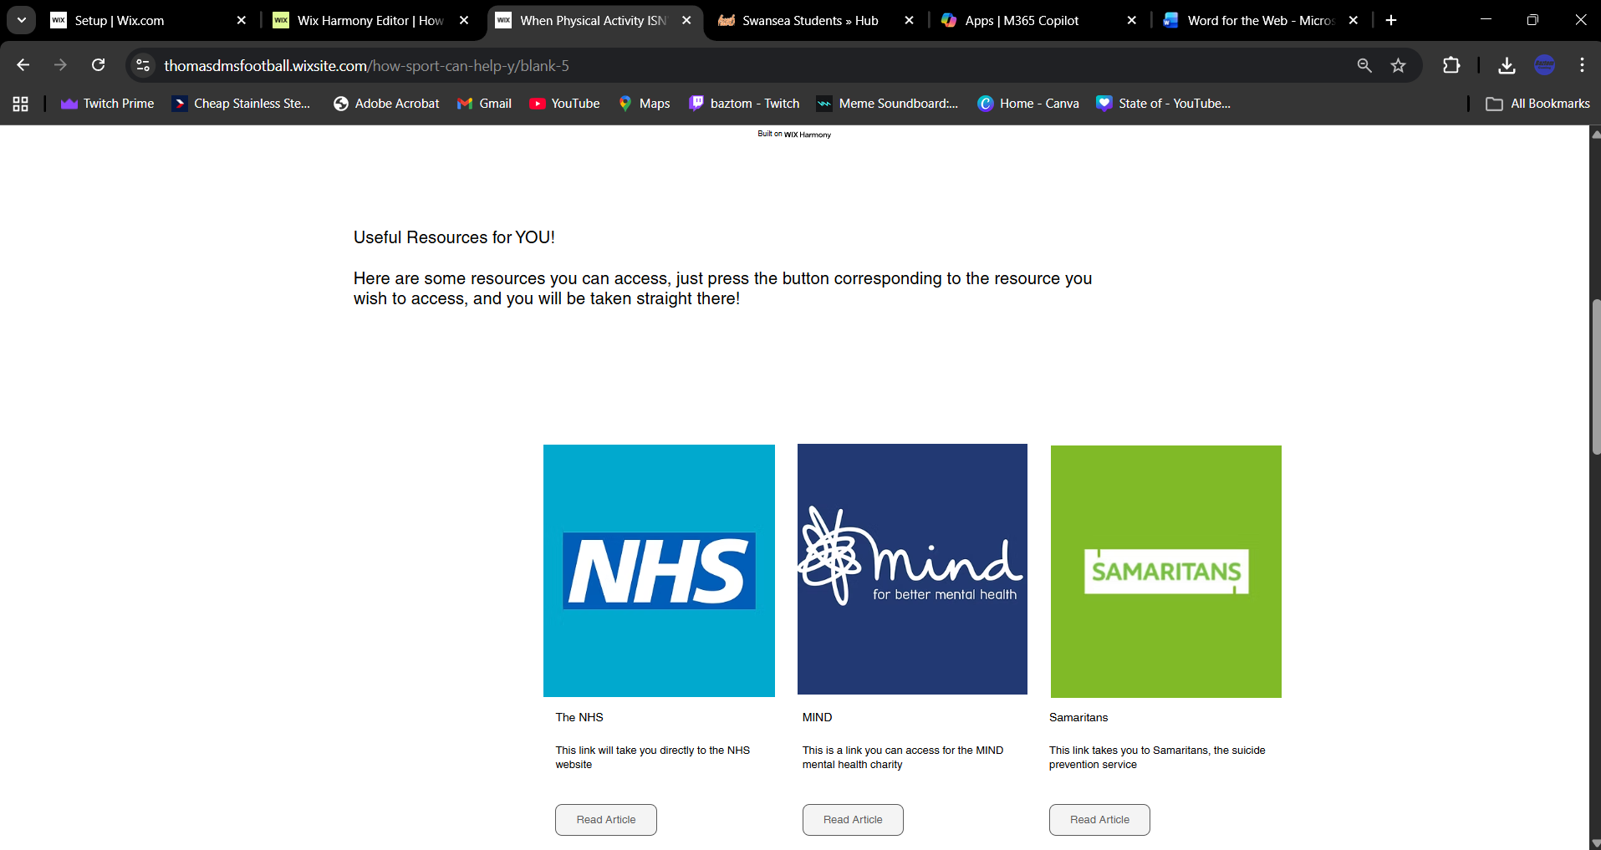

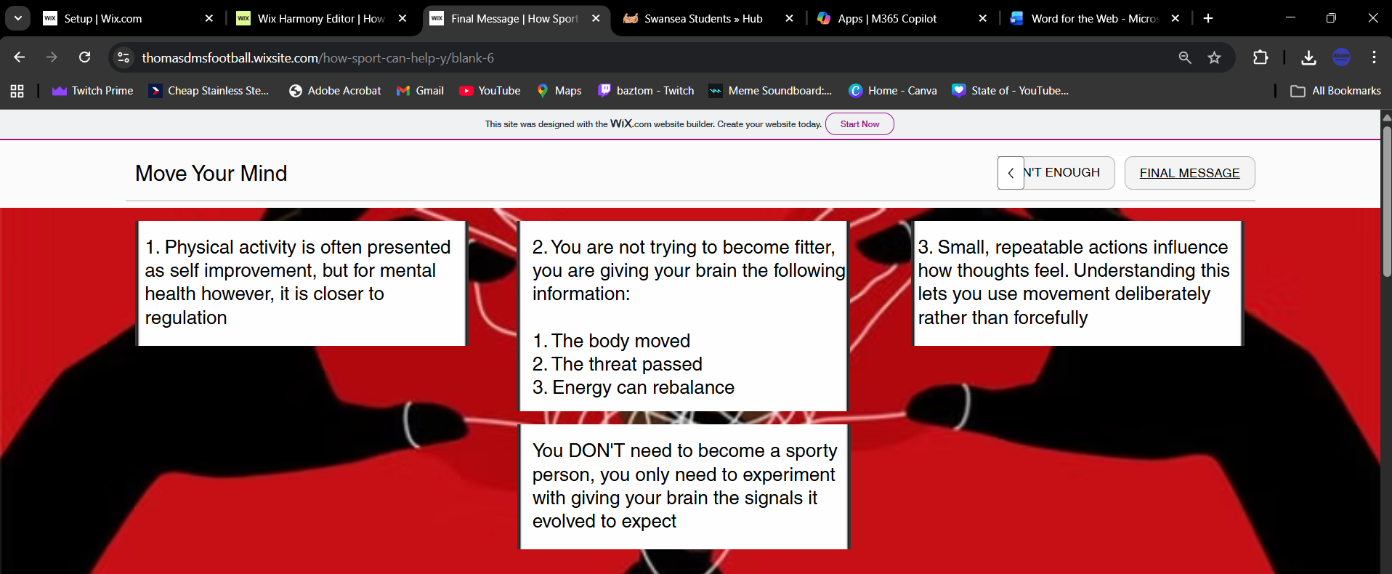

(3.2) Reflection / Conclusion / Recommendations (key learning points)

To conclude, this is an individual project of my creation of a service that young people aged between 16-24 can use to educate themselves about how sports and physical activity can impact their mental health. The literature review element of the project was backed and critically reviewed by academic research that I had access to via the university library. This research was then used as a platform to create my service, which was a freely accessible website with a user friendly interface.
I have gathered a valuable amount of learning experience from this individual project. The experience has helped me understand what is expected of university standard work, as well as the research and effort that goes behind the creation of a website.
The most important skills I have learned during the project was website creation. Before this project I had little to no knowledge of building a website. I now understand what it takes to build my own website, including the background research for information as well as the design and layout of the website. This is something I can use as a platform for future reference. This means that I now have the basic skills and knowledge to create websites within potential future career ambitions, including aspirations like coaching sports teams and creating a personal training service.
My ability to find and use academic research saw a major improvement during the project. Element 2 was a literature review of the research and findings behind the project, as well as perform critical assessments of those findings. I had the opportunity to write better evaluations of sources and use more academically underpinned sources for my information, instead of just referring to websites and freely accessible sources, I also developed better understanding of how to critically assess sources in order to build a bigger perspective and create a suitable justification with the research I used.
I learned the importance of university ethical standards. The Element 1 ethics form required me to perform data handling measures. I now fully understand how to securely store and share data across a cloud, whether that is my own information or other people’s information.

(4.0) Reference List (use relevant numbers of pages)
Elish Kelly. (2025). Playing an Amateur Sport in a Professional Context: Good for Gaelic Players Mental Health? IZA - Institute of Labor Economics. Available at : https://www-jstor-org.ezproxy.uwtsd.ac.uk/stable/resrep70720?sid=primo&seq=5 (Accessed: 7th October 2025)

NHS. (2025). Be active for your mental health. Available at: https://www.nhs.uk/every-mind-matters/mental-wellbeing-tips/be-active-for-your-mental-health/ (Accessed: 7th October 2025

Cardiff University. (6th April 2023) Nearly a quarter of young people in Wales are reporting very high levels of mental health symptoms following the pandemic. Available at: https://www.cardiff.ac.uk/news/view/2713528-nearly-a-quarter-of-young-people-in-wales-are-reporting-very-high-levels-of-mental-health-symptoms-following-the-pandemic (Accessed, 14th October 2025)

Morris, D. et al. (2025) ‘Barriers and Enablers to Implementing Community Sports‐Based Mental Health Promotion Initiatives: A Qualitative Study’, Health promotion journal of Australia, 36(3), pp. e70060-n/a. Available at: https://doi.org/10.1002/hpja.70060. (Accessed: 14th October 2025)

Macniven, R. et al. (2019) ‘The impact of physical activity and sport on social outcomes among Aboriginal and Torres Strait Islander people: A systematic scoping review’, Journal of science and medicine in sport, 22(11), pp. 1232–1242. Available at: https://doi.org/10.1016/j.jsams.2019.06.017. (Accessed: 14th October 2025)

Welsh Government. (2024) Mental well-being (National Survey for Wales): April 2022 to March 2023. Available at: https://www.gov.wales/sites/default/files/pdf-versions/2024/2/4/1709204459/mental-well-being-national-survey-wales-april-2022-march-2023.pdf (Accessed: 7th October 2025)

Mind. (2018) Sport and physical activity for people with mental health problems: A toolkit for the sport sector (Full guide). London: Mind. Available at: https://www.mind.org.uk/media-a/6169/sport-sector-toolkit-full-guide.pdf (Accessed: 21st October 2025)

Sport England. (2024) Mental health. Available at: https://www.sportengland.org/funding-and-campaigns/mental-health (Accessed: 21st October 2025).

Eather, N., Wade, L., Pankowiak, A., & Eime, R. (2023) ‘The impact of sports participation on mental health and social outcomes in adults: a systematic review and the “Mental Health through Sport” conceptual model’, Systematic Reviews, 12, Article 102. Available at: https://link.springer.com/article/10.1186/s13643-023-02264-8 (Accessed: 21st October 2025).

Quirk, H. et al. (2024) ‘S13-1: The experience of parkrun by those with mental health conditions: results from the parkrun UK Health and Wellbeing Survey 2018’, European journal of public health, 34(Supplement_2). Available at: https://doi.org/10.1093/eurpub/ckae114.255. (Accessed 29th December 2025).

O’Connor, R.C. et al. (2021) ‘Mental health and well-being during the COVID-19 pandemic: longitudinal analyses of adults in the UK COVID-19 Mental Health & Wellbeing study’, British journal of psychiatry, 218(6), pp. 326–333. Available at: https://doi.org/10.1192/bjp.2020.212. (Accessed 29th December 2025).

Office for National Statistics (ONS) (2025) UK Measures of National Well-being: February 2025. Official Statistics, 11 February 2025. Available at: https://www.gov.uk/government/statistics/uk-measures-of-national-well-being-february-2025 (Accessed 29th December 2025).

Perks, W. (2025) Wellbeing of Wales 2025: A healthier Wales. Welsh Government. Available at: https://www.gov.wales/wellbeing-wales-2025-healthier-wales-html (Accessed 30th December 2025).

James, M. et al. (2025) ‘To what extent does self-reported physical activity impact children’s wellbeing and mental health? Insights from school-aged children in Wales’, PloS one, 20(5), p. e0313970. Available at: https://doi.org/10.1371/journal.pone.0313970. (Accessed 30th December 2025).

Moore, G.F. et al. (2018) ‘School, Peer and Family Relationships and Adolescent Substance Use, Subjective Wellbeing and Mental Health Symptoms in Wales: a Cross Sectional Study’, Child indicators research, 11(6), pp. 1951–1965. Available at: https://doi.org/10.1007/s12187-017-9524-1. (Accessed 30th December 2025).

Pendell, R. (2021) Wellness vs. Wellbeing: What’s the Difference?, Gallup. Available at: https://www.gallup.com/workplace/340202/wellness-wellbeing-difference.aspx (Accessed: 31st December 2025).

Channel Creative Media, production company (2020) Mental health & wellbeing. Your own mental wellness. Workers’ edition. Dandenong, Victoria: Channel 1 Creative Media. Available at: https://video-alexanderstreet-com.ezproxy.uwtsd.ac.uk/watch/case-studies?pass=true (Accessed 31st December 2025).

Cummins, R.A. (2018) Measuring and interpreting subjective wellbeing in different cultural contexts : a review and way forward. First edition. Cambridge: Cambridge University Press. Available at: https://www-cambridge-org.ezproxy.uwtsd.ac.uk/core/elements/measuring-and-interpreting-subjective-wellbeing-in-different-cultural-contexts/81677B779218AC2B26BC9E3BF976846F (Accessed 31st December 2025)

Everyday Health, 2022, Fitness Guide [online]. Available at: https://www.everydayhealth.com/fitness/guide/ (Accessed 2nd January 2026)

Hoogen, H., Hebling Vieira, B. and Langer, N. (2025) ‘Maintaining Brain Health: The Impact of Physical Activity and Fitness on the Aging Brain—A UK Biobank Study’, The European journal of neuroscience, 61(8), pp. e70085-n/a. Available at: https://doi.org/10.1111/ejn.70085. (Accessed 2nd January 2026)

Harris, J. and Cale, L. (2018) Promoting active lifestyles in schools. Champaign, IL: Human Kinetics. Available at: https://ezproxy.uwtsd.ac.uk/login?url=https://www.vlebooks.com/product/openreader?id=TrinityStD&accId=8886856&isbn=9781492580782&uid=^u. (Accessed 2nd January 2026)

Felman, A. (2025) What is good health? Medical News Today, 15 May. Available at: https://www.medicalnewstoday.com/articles/150999 (Accessed 2nd January 2026)

UK Government (2025) Fit for the future: 10 Year Health Plan for England – executive summary. Available at: https://www.gov.uk/government/publications/10-year-health-plan-for-england-fit-for-the-future/fit-for-the-future-10-year-health-plan-for-england-executive-summary (Accessed 2nd January 2026)

McKee, M., Dunnell, K., Anderson, M., Brayne, C., Charlesworth, A., Johnston-Webber, C., Knapp, M., McGuire, A., Newton, J.N., Taylor, D. and Watt, R.G. (2021) ‘The changing health needs of the UK population’, The Lancet, Available at https://www.thelancet.com/journals/lancet/article/PIIS0140-6736(21)00229-4/abstract (Accessed 2nd January 2026)

Kramer, J. and linkedin.com (2022) Introduction to Web Design and Development. Carpenteria, CA: linkedin.com. Available at: https://www.linkedin.com/learning/introduction-to-web-design-and-development-14628245?u=77966930&auth=true. (Accessed 3rd January 2026)

Beaird, J. and Walker, A. (2020) The principles of beautiful Web design. Fourth edition / Jason Beaird, James George&Alex Walker. Fitzroy, Victoria, Australia: SitePoint. Chapter 1: Layout and Composition. Available at: https://ebookcentral.proquest.com/lib/trinity/detail.action?docID=6387757#goto_toc (Accessed 3rd January 2026)

Frain, B. (2020) Responsive Web Design with HTML5 and CSS : Develop future-proof responsive websites using the latest HTML5 and CSS techniques. Third edition. Warsaw ; Packt Publishing Limited,. Available at: https://research-ebsco-com.ezproxy.uwtsd.ac.uk/c/onvpsy/search/details/wd6jaloqbf?db=nlebk&modal=details-ebook-download (Accessed 3rd January 2026).

Jongmans, E. et al. (2022) ‘Impact of website visual design on user experience and website evaluation: the sequential mediating roles of usability and pleasure’, Journal of marketing management, 38(17–18), pp. 2078–2113. Available at: https://doi.org/10.1080/0267257X.2022.2085315. (Accessed 3rd January 2026).

Bibliography (use relevant numbers of pages)
World Health Organization (2022) Mental health: strengthening our response. Available at: https://www.who.int/news-room/fact-sheets/detail/mental-health-strengthening-our-response (Accessed: 19 March 2026).
Biddle, S.J.H. and Asare, M. (2011) ‘Physical activity and mental health in children and adolescents: a review of reviews’, British Journal of Sports Medicine, 45(11), pp. 886–895. Available at: https://doi.org/10.1136/bjsports-2011-090185 (Accessed: 19 March 2026).
Department of Health and Social Care (2019) UK Chief Medical Officers’ Physical Activity Guidelines. Available at: https://www.gov.uk (Accessed: 19 March 2026).
Mental Health Foundation (2023) Physical activity and mental health. Available at: https://www.mentalhealth.org.uk (Accessed: 19 March 2026).
Bailey, R. et al. (2013) ‘Physical activity: an underestimated investment in human capital?’, Journal of Physical Activity and Health, 10(3), pp. 289–308. Available at: https://doi.org/10.1123/jpah.10.3.289 (Accessed: 19 March 2026).
Website Information:
NHS (2022) Mental health of children and young people. Available at: https://www.nhs.uk (Accessed: 24 March 2026).
YoungMinds (2023) Young people’s mental health statistics. Available at: https://www.youngminds.org.uk (Accessed: 24 March 2026).
Mind (2023) How to improve your mental wellbeing. Available at: https://www.mind.org.uk (Accessed: 24 March 2026).
World Health Organization (2020) Guidelines on physical activity and sedentary behaviour. Geneva: WHO.
Biddle, S.J.H. and Asare, M. (2011) ‘Physical activity and mental health in children and adolescents: a review of reviews’, British Journal of Sports Medicine, 45(11), pp. 886–895.
Rebar, A.L. et al. (2015) ‘A meta-meta-analysis of the effect of physical activity on depression and anxiety’, Health Psychology Review, 9(3), pp. 366–378.
Schuch, F.B. et al. (2018) ‘Physical activity and incident depression: a meta-analysis’, American Journal of Psychiatry, 175(7), pp. 631–648.
Ratey, J.J. and Loehr, J.E. (2011) ‘The positive impact of physical activity on cognition during adulthood’, Translational Sports Medicine, 1(3), pp. 1–10.

Dishman, R.K., Berthoud, H.R. and Booth, F.W. (2006) ‘Neurobiology of exercise’, Obesity, 14(3), pp. 345–356.
Meeusen, R. and De Meirleir, K. (1995) ‘Exercise and brain neurotransmission’, Sports Medicine, 20(3), pp. 160–188.
Cotman, C.W. and Berchtold, N.C. (2002) ‘Exercise: a behavioural intervention to enhance brain health and plasticity’, Trends in Neurosciences, 25(6), pp. 295–301.
McEwen, B.S. (2007) ‘Physiology and neurobiology of stress and adaptation’, Physiological Reviews, 87(3), pp. 873–904.
Sapolsky, R.M. (2004) Why Zebras Don’t Get Ulcers. 3rd edn. New York: Holt.
Herman, J.P. et al. (2016) ‘Regulation of the hypothalamic–pituitary–adrenocortical stress response’, Comprehensive Physiology, 6(2), pp. 603–621.
Deci, E.L. and Ryan, R.M. (2000) ‘Self-determination theory and intrinsic motivation’, Psychological Inquiry, 11(4), pp. 227–268.
Rhodes, R.E. and Kates, A. (2015) ‘Can the affective response to exercise predict future motivation?’, Health Psychology Review, 9(1), pp. 129–146.
Kaushal, N. et al. (2017) ‘Exercise and dopamine: a review’, Neuroscience & Biobehavioral Reviews, 75, pp. 1–12.
Ekkekakis, P. (2013) The Measurement of Affect, Mood, and Emotion. Cambridge: Cambridge University Press.
Smith, P.J. et al. (2010) ‘Aerobic exercise and neurocognitive performance’, Psychosomatic Medicine, 72(3), pp. 239–252.
Warburton, D.E.R. and Bredin, S.S.D. (2017) ‘Health benefits of physical activity’, Current Opinion in Cardiology, 32(5), pp. 541–556.
Powell, K.E. et al. (2011) ‘Physical activity for health: what kind? how much?’, Annual Review of Public Health, 32, pp. 349–365.

Appendices (use relevant numbers of pages)
Appendix 1: Presentation of Pitch
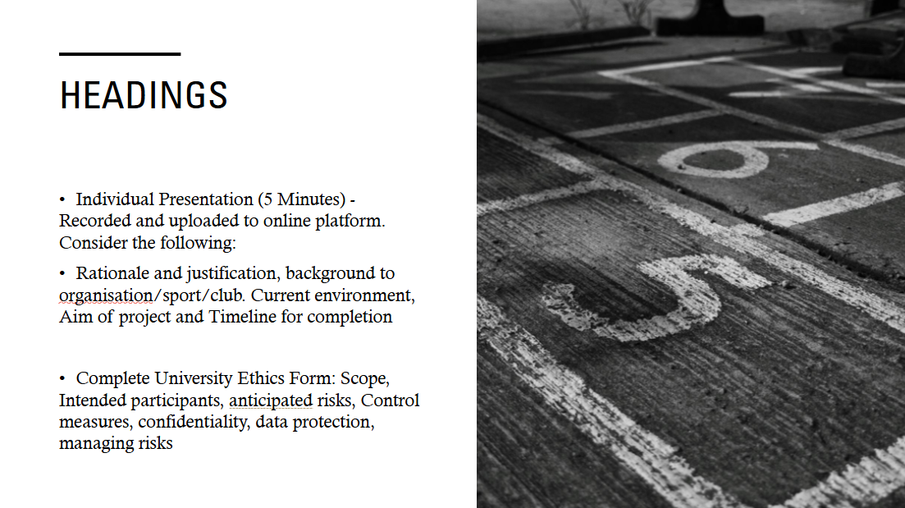
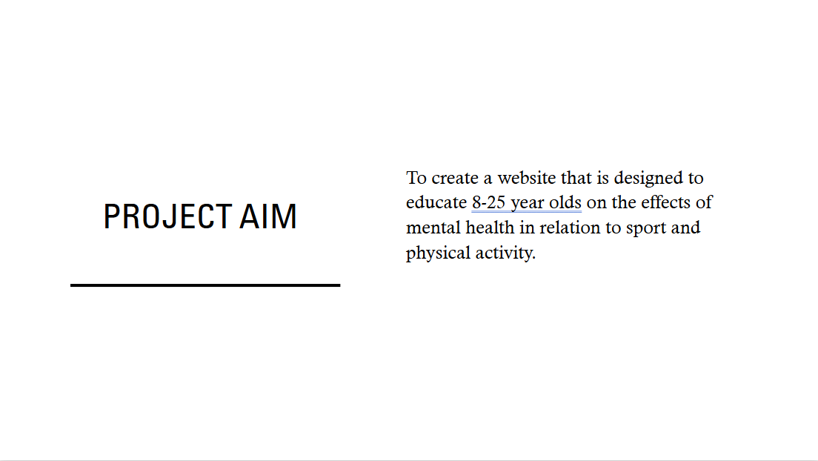

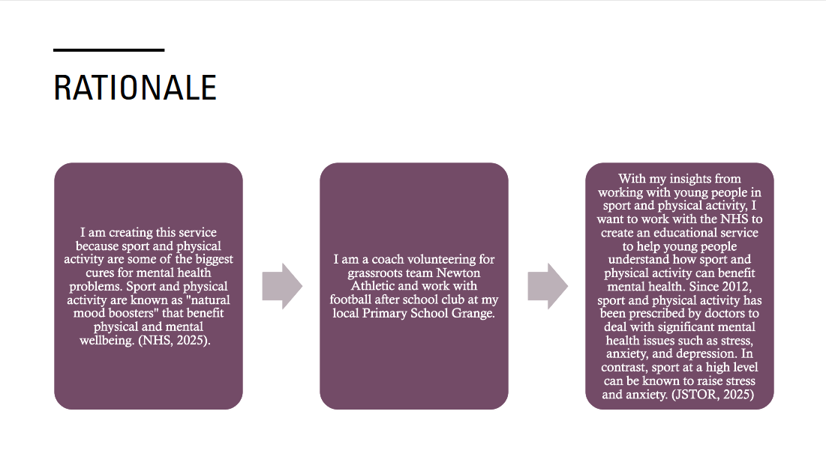
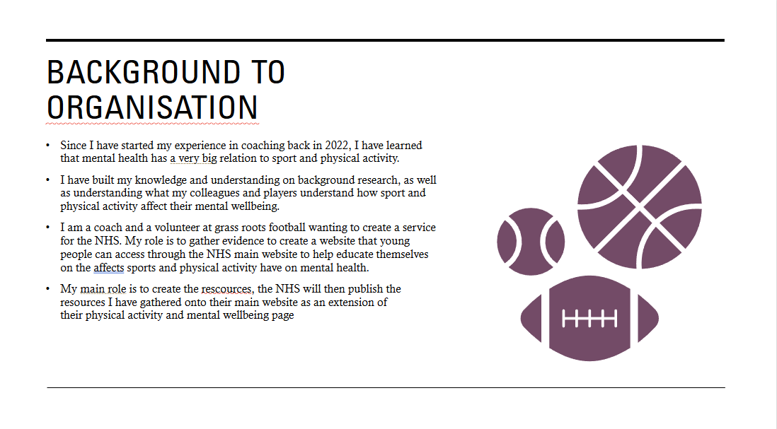

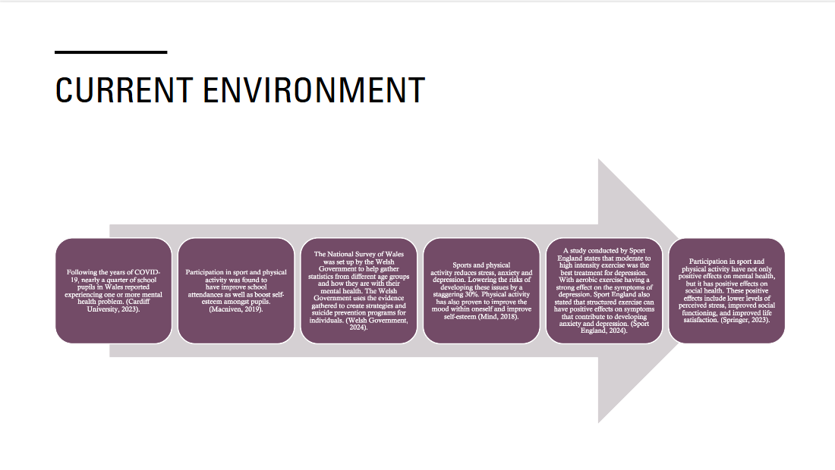
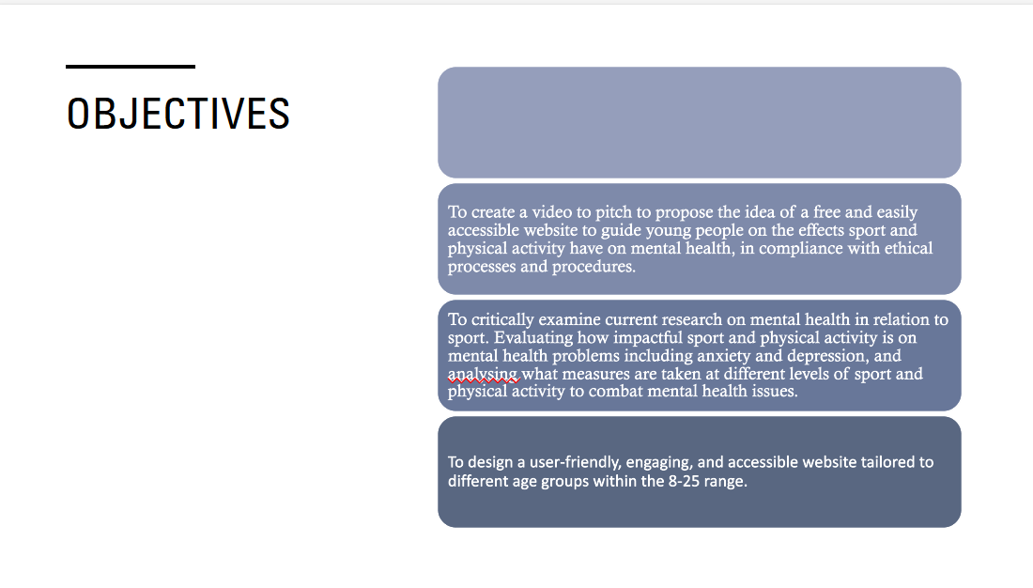

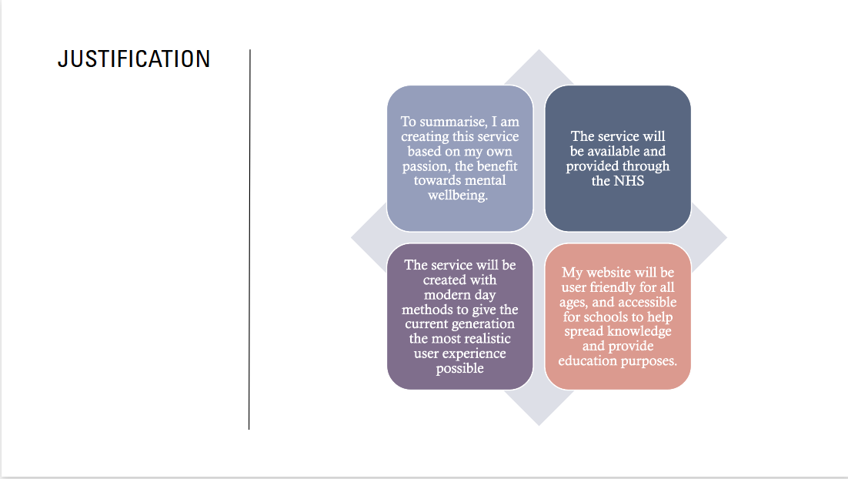
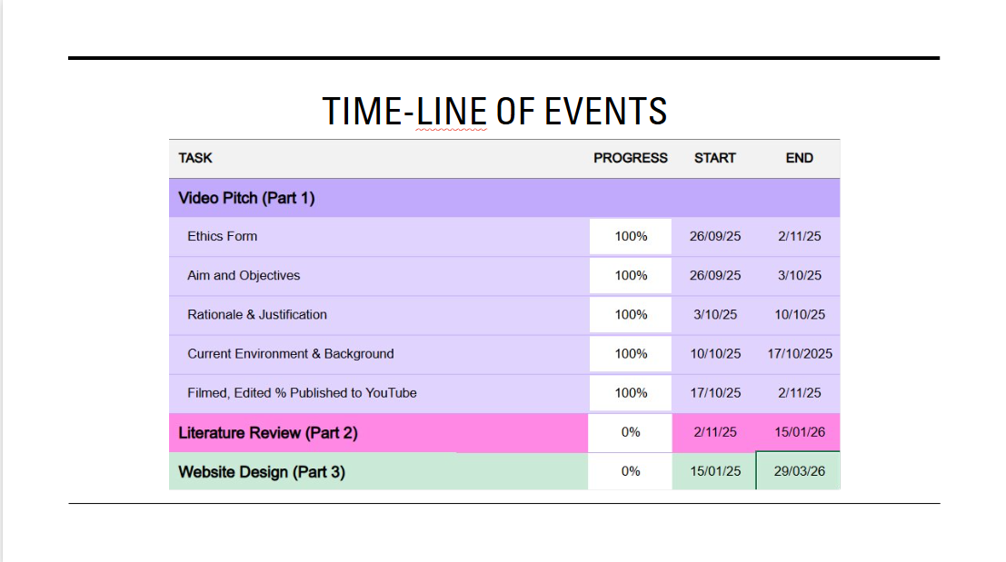

Appendix 2: Video Pitch Link: https://youtu.be/QXtI4Pv2qH0

Appendix 3: Ethics Form
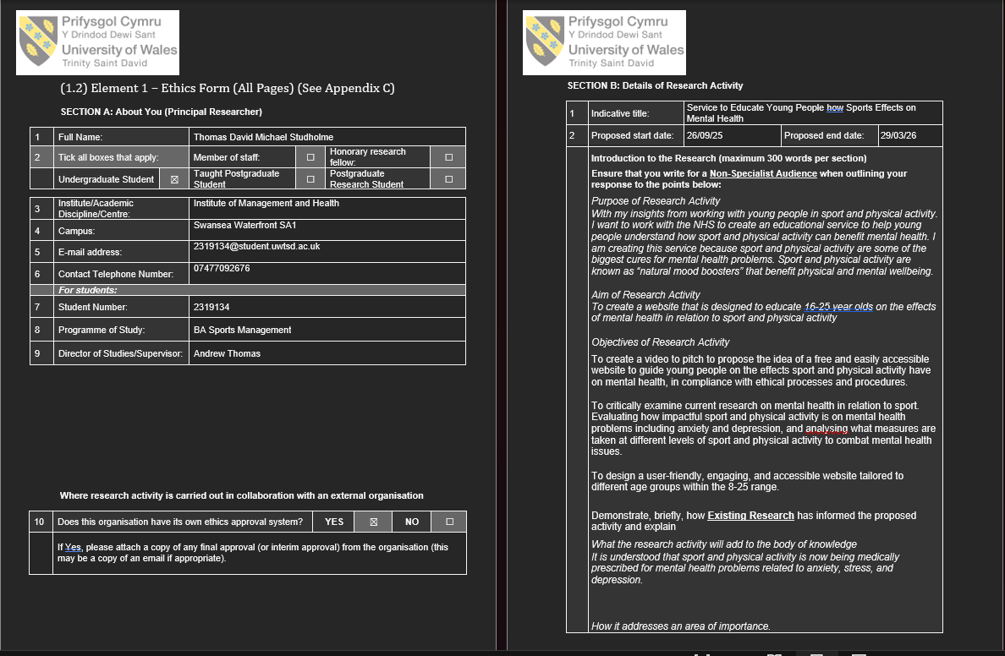
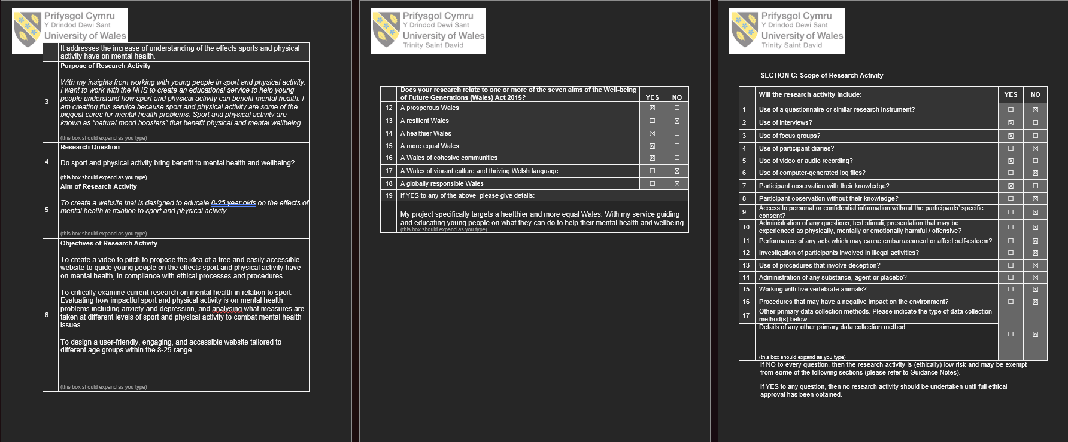

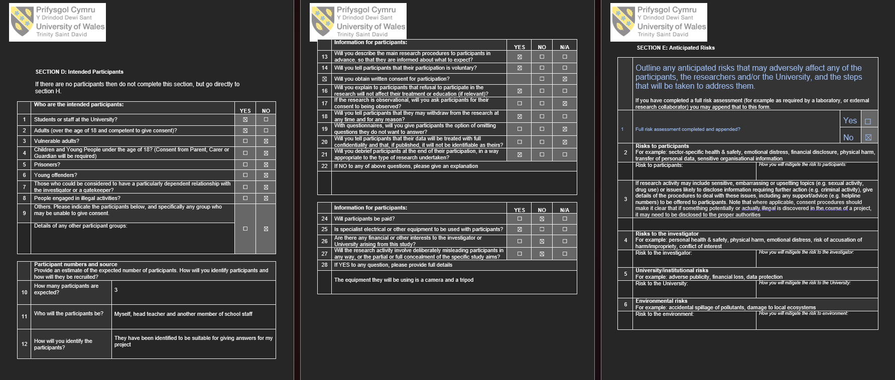
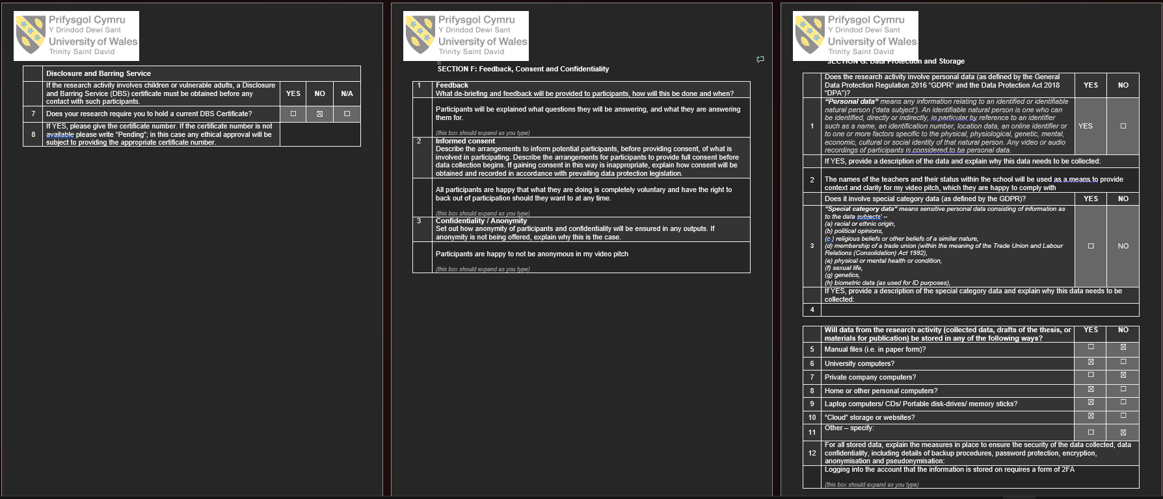

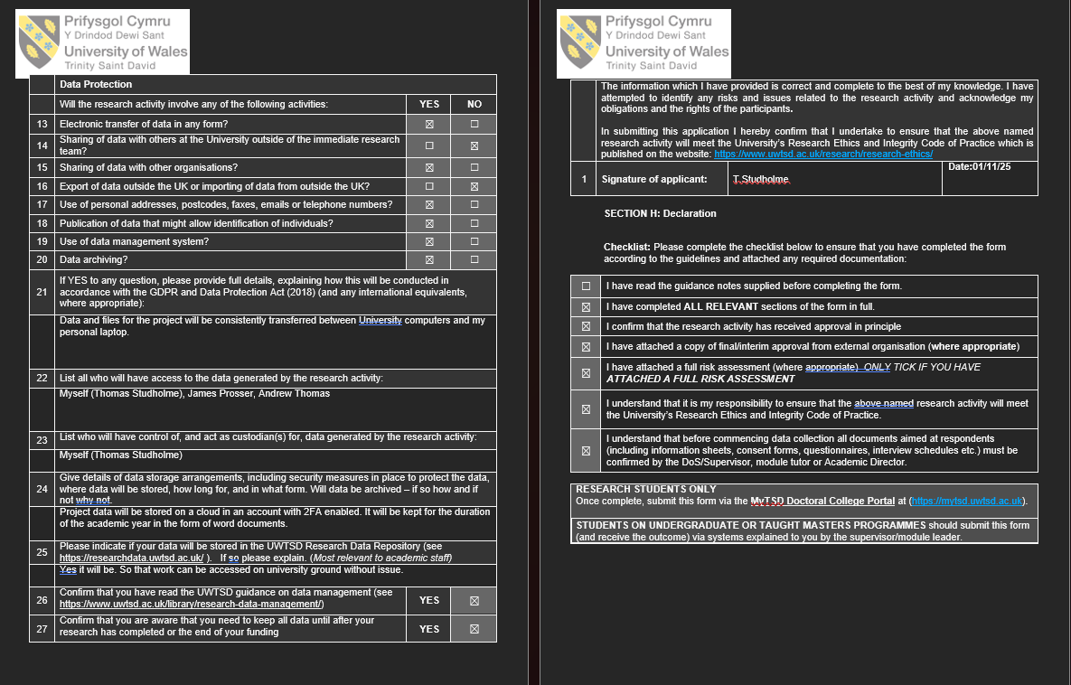

Appendix 4: Website Evidence

Appendix 5: Interview Participants and Questions
Participants:
Mr John Webb (Grange Primary School Headteacher)
Mr Tom Draper (Grange Primary School Teacher)
Questions:
1: What is your current understanding of the impact sports and physical activity have on mental health?
2: If there was a free website you could access to help your understanding of the effects sport has on mental health, how would you use that academically and would you use it personally?
Appendix 6: Supporting Material
NHS (2022) Mental health of children and young people. Available at: https://www.nhs.uk (Accessed: 24 March 2026).
YoungMinds (2023) Young people’s mental health statistics. Available at: https://www.youngminds.org.uk (Accessed: 24 March 2026).
Mind (2023) How to improve your mental wellbeing. Available at: https://www.mind.org.uk (Accessed: 24 March 2026).
World Health Organization (2020) Guidelines on physical activity and sedentary behaviour. Geneva: WHO.
Biddle, S.J.H. and Asare, M. (2011) ‘Physical activity and mental health in children and adolescents: a review of reviews’, British Journal of Sports Medicine, 45(11), pp. 886–895.
Rebar, A.L. et al. (2015) ‘A meta-meta-analysis of the effect of physical activity on depression and anxiety’, Health Psychology Review, 9(3), pp. 366–378.
Schuch, F.B. et al. (2018) ‘Physical activity and incident depression: a meta-analysis’, American Journal of Psychiatry, 175(7), pp. 631–648.
Ratey, J.J. and Loehr, J.E. (2011) ‘The positive impact of physical activity on cognition during adulthood’, Translational Sports Medicine, 1(3), pp. 1–10.

Dishman, R.K., Berthoud, H.R. and Booth, F.W. (2006) ‘Neurobiology of exercise’, Obesity, 14(3), pp. 345–356.
Meeusen, R. and De Meirleir, K. (1995) ‘Exercise and brain neurotransmission’, Sports Medicine, 20(3), pp. 160–188.
Cotman, C.W. and Berchtold, N.C. (2002) ‘Exercise: a behavioural intervention to enhance brain health and plasticity’, Trends in Neurosciences, 25(6), pp. 295–301.
McEwen, B.S. (2007) ‘Physiology and neurobiology of stress and adaptation’, Physiological Reviews, 87(3), pp. 873–904.
Sapolsky, R.M. (2004) Why Zebras Don’t Get Ulcers. 3rd edn. New York: Holt.
Herman, J.P. et al. (2016) ‘Regulation of the hypothalamic–pituitary–adrenocortical stress response’, Comprehensive Physiology, 6(2), pp. 603–621.
Deci, E.L. and Ryan, R.M. (2000) ‘Self-determination theory and intrinsic motivation’, Psychological Inquiry, 11(4), pp. 227–268.
Rhodes, R.E. and Kates, A. (2015) ‘Can the affective response to exercise predict future motivation?’, Health Psychology Review, 9(1), pp. 129–146.
Kaushal, N. et al. (2017) ‘Exercise and dopamine: a review’, Neuroscience & Biobehavioral Reviews, 75, pp. 1–12.
Ekkekakis, P. (2013) The Measurement of Affect, Mood, and Emotion. Cambridge: Cambridge University Press.
Smith, P.J. et al. (2010) ‘Aerobic exercise and neurocognitive performance’, Psychosomatic Medicine, 72(3), pp. 239–252.
Warburton, D.E.R. and Bredin, S.S.D. (2017) ‘Health benefits of physical activity’, Current Opinion in Cardiology, 32(5), pp. 541–556.
Powell, K.E. et al. (2011) ‘Physical activity for health: what kind? how much?’, Annual Review of Public Health, 32, pp. 349–365.



Sports Management Portfolio

Independent Project

UWTSDSport

