Utilisation of technology to collaborate at UWTSD by students
Student Name: Kristine Didzus
Student ID:2130588

Introduction
This study will focus on the use of technology and its influence in collaboration with UWTSD. The researcher will introduce the collaboration tools and the results of their usage. It will also focus on the student’s experiences in using the collaboration tools and technologies in UWTSD.

Research Design

Research Question
- Why do the students of UWTSD need digital tools for effective learning?
- How do the students use technologies for better collaboration at UWTSD?

Research method
UWTSD learners need the proper collaboration by using appropriate tools or technologies. In that sense, the researcher will maintain the Explanatory research design in the research. The researcher wants students to learn how to maintain collaboration in the learning place. Explanatory design research will help students or learners to understand the actual importance of collaboration (Sileyew, 2019). The researcher also uses the primary research method in this research because primary research exposes surveys, observation, data analysis, and questionnaires. These parts will help the learners to clearly understand the topic. The researcher gives better concern on the topic by using explanatory and the primary research method. The researcher also maintains all the ethics of academics, there is no academic misconduct in this research. Explanatory research occurs when there are very limited sources of the topic which expose several problems related to the topic. Thereafter the researcher can easily find out the problem and solve it through several observations, surveys, questions and many more (Abutabenjeh and Jaradat, 2018). The researcher also uses data analysis in the primary research because several important data are important in this research so the data analysing method is also used in this research. Explanatory research methods highlight several questions related to the topic which will be helpful for the learners. This research method and the entire research work are very authentic so the researcher uses the explanatory and the primary research methods. Both methods are very authentic and acceptable in this research so the researcher maintains the two methods in this research. This huge explanatory research method brings the different kinds of questionnaires to the learners and the learners understand the topic which is about collaboration (D’Alimonte, De Sio and Franklin, 2020). The researcher uses the primary method instead of the second one because the primary is genuine and is worked by one hand. The secondary sometimes depends on the primary so the researcher chooses the primary method in the research.

Ethical considerations
The researcher used an Explanatory research design for this research study on the utilisation of technologies by students to collaborate at UWTSD. The researcher wants to elaborate on the present and future of online collaboration. Explanatory research is also known as casual research which is mainly conducted to manage the impact of particular changes on various processes, existing norms and many more (Suri, 2020). This research study observed various ethical considerations including voluntary participation, informed consent and confidentiality. The researcher maintains autonomy, justice, non-malfeasance and beneficence which are the main principles of ethical consideration. Every participant in this research was very aware of the study and the essential aims and objectives of this study.
Details of every participant in this primary research were protected very carefully by the researcher. The faculties and names of the students were also not revealed which can ensure the anonymity of the participants. All data and information which are related to this research study on the utilisation of technologies for better collaboration in UWTSD are relevant and filled with authenticity. Any data or information which is majorly collected from primary sources is not easy for a researcher because every participant is always not ready to give appropriate answers through surveys (Grant et al., 2020).
The researcher used a simple random sampling method with 100 people in the population of an exact geographical region. All the references which are provided by the researcher are valid and available on the given websites. Ethical considerations are so important for primary research because it promotes the actual aims and objectives of research, like avoidance of mistakes, knowledge and truth (Grant et al., 2020). This ethics makes primary research authentic and contains lots of information.

Result
- What is your preferred digital tool for collaboration at University?
Responses | Respondents
Flow dock | 10
Go To Meeting | 3
Red Booth | 2
Wimi | 2
Cloud Storage | 10
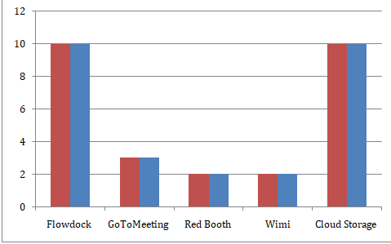
Figure 1: Rate of the digital tools uses
Source: (Self developed)
This graph shows that out of total respondents, 20 students have supported the Flow dock and Cloud storage devices in their academic studies.
- Do you think that collaboration tools help you for collaboration at University?
Responses | Respondents
Strongly disagree | 2
Disagree | 2
Neutral | 0
Agree | 3
Strongly agree | 20
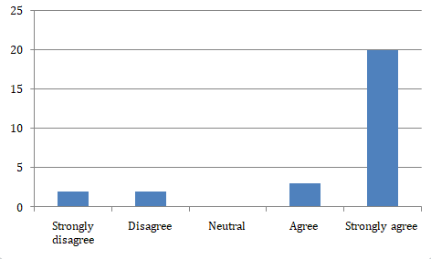
Figure 2: Rate of the respondents
Source: (Self developed)
This graph shows that out of total respondents, the maximum number of students strongly agreed with the question and others have a light view on such question.
- Do you think that digital tools make collaboration more effective in the University?
Responses | Respondents
Strongly disagree | 2
Disagree | 3
Neutral | 0
Agree | 12
Strongly agree | 10
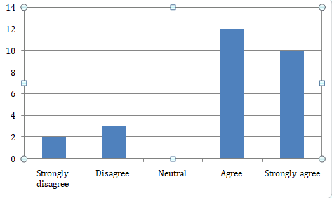
Figure 2: Rate of the effectiveness
Source: (Self developed)
The above graph shows the effectiveness of the collaboration tools and influences in the universities. Out of 27 students, the majority of them agreed with the question.
- Do you think that using digital tools for collaboration helps students to save faculty time?
Responses | Respondents
Strongly disagree | 3
Disagree | 2
Neutral | 2
Agree | 10
Strongly agree | 10
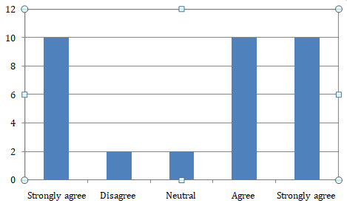
Figure 2: Responses of the participants
Source: (Self developed)
The above image shows the major focus of the students on agreeing to the provided question.
- Do you think that digital tools for collaboration are secured enough at university?
Responses | Respondents
Strongly disagree | 0
Disagree | 0
Neutral | 7
Agree | 10
Strongly agree | 10
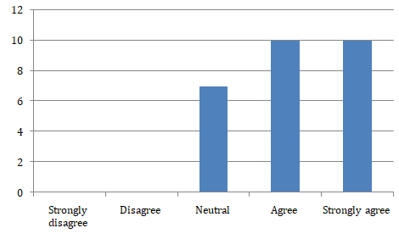
Figure 2: Security prospective of the students
Source: (Self developed)
The above graph shows the agreement of the students in secure of using collaboration tools in the university.
- How often do you interact with the students on the Blackboard/ social media?
Responses | Respondents
Often | 1
Sometimes | 6
Rarely | 0
Frequently | 5
Every time | 15
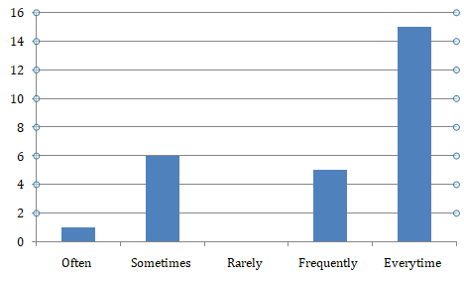
Figure 2: Customer interest
Source: (Self developed)
The above picture shows the period of using the collaboration tools in the university to enhance the study.
- How often do you interact with the students in Microsoft teams?
Responses | Respondents
Often | 1
Sometimes | 3
Rarely | 3
Frequently | 11
Sometimes | 9
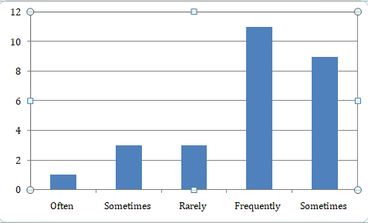
Figure 2: Rate of the respondents
Source: (Self developed)
This picture shows the frequent interaction of the students in the Microsoft team and further.
- Do you think that using digital tools helps students learn the subject easier at university?
Responses | Respondents
Yes | 20
No | 5
Neutral | 2
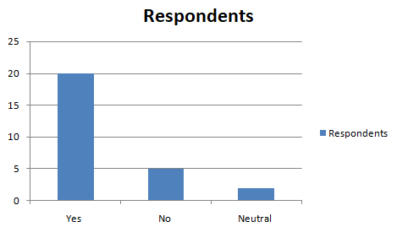
Figure 2: Student learning prospective
Source: (Self developed)
This graph shows the support of digital tools usage and their influence on the university to learn the subjects in an easier method.
- How do using collaboration tools improve your study at university?
Responses | Respondents
Productivity enhancing | 5
Creative management | 5
Leadership skills | 10
Communication skills | 5
Development of thinking | 2
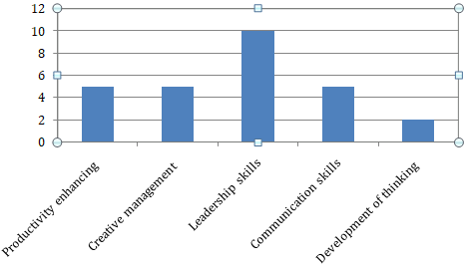
Figure 2: Collaboration tools that improved student learning
Source: (Self developed)
This graph shows the choice of the students in benefits of using the collaborating technical tools in the university; where the majority of the students have preferred the leadership skills and establishments ion advancing the technologies.
- Do you think UWTSD should invest more in digital tools for collaboration?
Responses | Respondents
Strongly disagree | 2
Disagree | 2
Neutral | 3
Agree | 10
Strongly agree | 10
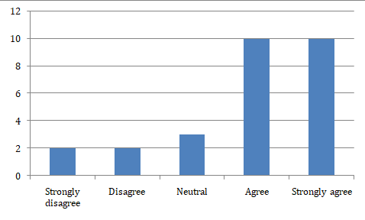
Figure 2: Uses of UWTSD
Source: (Self developed)
This graph gives the preference of the UWTSD in investing the digital tools for collaboration on university campuses.

Discussion
UWTSD uses several IT exclusives and technological tools for getting access to Office 365 applications. All of these technological tools and techniques can provide the students to communicate and collaborate effectively. It is due to these collaboration tools that students can access multiple websites and functions, UWTSD is also considered the leader of online teacher education internationally (Weicht and Jónsdóttir, 2021). However, it is also observed that the most used collaboration tool of UWTSD is the team application tool of Microsoft. All the specified digital tools will help the students in their learning and getting proper marks in the university. Automatically these digital tools will enhance the experience of the learners and will develop their confidence. Also, this type of technological tool and device has helped the students at the time submitting their assignments and presentations. UWTSD has given every possible effort to improve the learning experience of the students and also be able to participate in group projects (Khan, and Rafi, 2020). The sole purpose of these digital tools is to make the team members well-informed and connected. UWTSD has also encouraged learners to participate in offline classes to increase their learning habits. Due to the use and application of these technological tools, it will be easy to share files and documents and collaborate in the creation of well-prepared assignments. Its ideas observed that due to the use of these digital tools it will be easy to communicate with others. The overall process of teaching and learning has also become quite easy due to these digital tools (Whitehill et al., 2022). Since it takes relatively is less time and effort to use these digital tools in the overall learning of the students. Also, different types of collaboration tools have been used to encourage the students and it is essential for college-going students. It is also crucial to maintain proper care and observation at the time of using these types of technological tools. The technological tools have made the students efficient enough and played a vital role in improving accessibility. It also gives a smart way to communicate with peers and share useful feedback and so on.
It is mainly noticed after the pandemic situation many of the other learning institutions also used technological tools to improve communication with the students. UWTSD also encouraged the students and motivated them to overcome their weaknesses in their studies. Also in the workplace, these technological tools have been used to improve the thinking and ability of the students (Weicht and Jónsdóttir, 2021). However, many issues are involved in the learning regarding confidentiality and security of the information. Careful observation is needed at the time of using these tools and devices.
The utilisation of online technologies combines with online meetings, chatting, audio or video calls, files and notes such as portable document format (PDF), presentations and many more (Davies, 2021). The team Microsoft directly integrates more than 365 applications. All staff and students of UWTSD should have access to teams of Microsoft to improve collaboration and communication. The team of Microsoft is a hub for collaboration and communication which is centralised in a team (Davies, 2021). These online technologies help to discuss and support a project or assignment with a group of students.
Collaboration is the major part of any organisation so in that sense the educational institution is not an exception. Several collaboration tools will help the students in educational institutes like UWTSD. The important collaboration tool is the Microsoft team. These Microsoft team like collaboration tools will develop the self-confidence and problem-solving power in the learners. This is very vital when one does anything in the institution so collaboration is very important. Whether there is an offline or an online learning method the collaboration tools will help the learners in their learning (Hart, Bird and Farmer, 2019). The learners also should understand the actual importance of collaboration tools in learning. The researcher that is why has used several research methods like explanatory and primary research methods to give well understanding to the students of UWTSD. The collaboration tools will help in several ways like meeting, conference talking, video conferencing, audio learning and many more.

Conclusion
This study has focussed on the concept and influence of the collaboration tools in UWTSD. The study shared the effective discussions and analysis of the designing and considering approaches to advancing the technologies in the academic fields. The results and discussions have been effectively discussed with utmost importance.

Reference List
Griffiths, D.A., Inman, M., Rojas, H. and Williams, K., 2018. Transitioning student identity and sense of place: future possibilities for assessment and development of student employability skills. Studies in Higher Education, 43(5), pp.891-913.
Davis, N.L., Gough, M. and Taylor, L.L., 2019. Online teaching: advantages, obstacles and tools for getting it right. Journal of Teaching in Travel & Tourism, 19(3), pp.256-263.
Munzer, T.G., Miller, A.L., Weeks, H.M., Kaciroti, N. and Radesky, J., 2019. Differences in parent-toddler interactions with electronic versus print books. Pediatrics, 143(4)..
Weicht, R. and Jónsdóttir, S.R., 2021. Education for social change: The case of teacher education in wales. Sustainability, 13(15), p.8574.
Khan, K.A. and Rafi, S.T., 2020. Online education & MOOCs: Teacher self-disclosure in online education and a mediating role of social presence. South Asian Journal of Management, 14(1), pp.142-158.
Whitehill, S., Hayles, C.S., Jenkins, S. and Taylour, J., 2022. Engagement with Higher Education Surface Pattern Design Students as a Catalyst for Circular Economy Action. Sustainability, 14(3), p.1146. Available at: https://www.mdpi.com/2071-1050/14/3/1146/pdf
Abutabenjeh, S. and Jaradat, R., 2018. Clarification of research design, research methods, and research methodology: A guide for public administration researchers and practitioners. Teaching Public Administration, 36(3), pp.237-258.
D’Alimonte, R., De Sio, L. and Franklin, M.N., 2020. From issues to goals: A novel conceptualisation, measurement and research design for comprehensive analysis of electoral competition. West European Politics, 43(3), pp.518-542.
Hart, T., Bird, D. and Farmer, R., 2019. Using blackboard collaborate, a digital web conference tool, to support nursing students placement learning: A pilot study exploring its impact. Nurse education in practice, 38, pp.72-78.
Suri, H., 2020. Ethical considerations of conducting systematic reviews in educational research. Systematic Reviews in Educational Research, pp.41-54.
Grant, C.L., Robinson, T., Al Hinai, A., Mack, C., Guilfoyle, R. and Saleh, A., 2020. Ethical considerations in global surgery: a scoping review. BMJ global health, 5(4), p.e002319.
Davies, C., 2021. Online seminars in statistics for doctoral students: A case study. Journal of University Teaching & Learning Practice, 18(2), p.06.
Zheng, H.U. and He, W., 2021, March. Relevant Concepts, Key Technologies and Typical Application Scenarios of AI+ Education. In Journal of Physics: Conference Series (Vol. 1861, No. 1, p. 012059). IOP Publishing.
Sileyew, K.J., 2019. Research design and methodology (pp. 1-12). Rijeka: IntechOpen.

Appendix

Appendix 1: survey question
1. What is your preferred digital tool for collaboration at University?
- Flow dock
- GoToMeeting
- Red booth
- Wimi
- Cloud storage

2. Do you think that collaboration tools help you for collaboration at University?
- Strongly disagree
- Disagree
- Neutral
- Agree
- Strongly agree

3. Do you think that digital tools make collaboration more effective in the University?
- Strongly disagree
- Disagree
- Neutral
- Agree
- Strongly agree

4. Do you think that using digital tools for collaboration helps students to save faculty time?
- Strongly disagree
- Disagree
- Neutral
- Agree
- Strongly agree

5. Do you think that digital tools for collaboration are secured enough at university?
Strongly disagree
Disagree
Neutral
Agree
Strongly agree

6. How often do you interact with the students on the Blackboard/ social media?
- Often
- Sometimes
- Rarely
- Frequently
- Every time
7. How often do you interact with the students in Microsoft teams?
- Often
- Sometimes
- Rarely
- Frequently
- Every time
8. Do you think that using digital tools helps students learn the subject easier at university?
- Yes
- No
- Neutral
9. How do using collaboration tools improve your study at university?
- Productivity enhancing
- Creative engagement
- Leadership skills
- Communication skill
- Development of thinking

10. Do you think UWTSD should invest more in digital tools for collaboration?
- Strongly disagree
- Disagree
- Neutral
- Agree
- Strongly agree

