REFLECTIVE REPORT



March 2018

MODULE NAME: academic skills / M4X01434 / SBUS4108
Project Name: UNITY LGBT
Name: JENNALEIGH ELWOOD
Student Number: P149869

Table of Contents

1. eXECUTIVE sUMMARY 1
2. Introduction 2
2.1 Report Remit 2
2.2 Background of the organisation 2
2.3 Aim and Objectives 5
2.4 Project Team 2
2.5 Project implementation 6
2.6 Conclusion 12
3. References 13

List of Figures
FIGURE 2-1 - PROJECT TEAM CHART 4
FIGURE 2-2 KEY POINTS GANTT CHART 7
FIGURE 2-2 GIBBS' REFLECTIVE CYCLE MODEL ………………………………………..………………9

eXECUTIVE sUMMARY

The outline of this report is to explain, detail and discuss the impacts different factors have had on myself as an individual and in my project group. The projects contexts will be going into detail about masterclass sessions and their influences to me and my project it will also be showing Gibbs’ model of reflection and how it applied to my project. I will also give a brief background of my chosen project so you can see what we wanted to achieve for them. I will touch on my project team and what member responsibilities are and what they do for the project. Some of the key messages that I got from the masterclasses were, be mind set on what you want to achieve and anything is possible if you put your mind to it. Major ways the masterclasses influenced my personal learning and development is that even though I identify as an introvert, how I can still communicate and reach my aims effectively.

Introduction
In this report, I will be writing about my experiences and reflecting on my performance as an individual and overall performance throughout this academic year. Working in a group of four members (including myself) we all decided we wanted our project organisation to be Unity LGBT Swansea, as we felt it was a very rewarding charity to support. Throughout this report you will read about different ideas and events we planned and how I felt about the project.

Report Remit
By reading my report you will get an understanding off all the different skills and techniques I have developed throughout this academic year.

Background of the organisation
The organisation I choose for my project was Unity LGBT. The centre that is based in Swansea offers “services which include, issues around sexual orientation, gender identity, domestic violence, sexual violence, LGBT+ asylum seekers and homelessness” (Unity LGBT, 2010) The centre was founded in early 2010 by a man called Andrew Peter Davies. Just like any other organisation Unity LGBT have a mission and that is to “improve future life and later life for everyone from the LGBT community” (Unity Group Wales, 2010). The centre doesn’t have paid employees because they are a not-for-profit charity and the only money and funding they have is donations, however, the centre have a handful of volunteers that open the centre daily and are willing to help the public.

Project Team


Renèe Bailey – Project Team Leader
Renèe is the Project team leader, her responsibilities involve making sure each team member is on task and knows what they are doing. She is also reasonable to get the group together and finalise decisions with the whole group. Renèe also had the responsibility of uploading her blog posts on her agreed time and date.

Jennaleigh Elwood – Fundraising Officer
Jennaleigh (Me) is the fundraising officer and was in control of coming up with different ideas of how the group could raise money for the charity in fun, exciting and new ways. I also had responsibility of turning up to group meetings where we would discuss new ideas and agree on things. I also had the responsibility of uploading my blog posts on my agreed date and time


Shona Jones – Fundraising Officer
Like myself, Shona was also a fundraising officer and had the responsibility of coming up with different ways we could fundraise money for Unity LGBT in a SMART way. Shona also has the responsibility of turning up to group meetings and making sure she uploaded her blog posts on her agreed time and date.


Sophie Morgan – Marketing Officer
Sophie is our marketing officer and when it comes to promoting our blogs and events Sophie is in charge of the social media accounts and making sure the right message is sent across. Also, like the rest of our group, Sophie has a responsibility to attend group meetings and upload her blog posts on her agreed times and dates.

Below is a diagram of our hierarchy structure, as you can see it is a very simple structure with everybody reporting back to the same person (the team leader). Having this basic structure makes communication in the group more effective and work well.

Figure 2-1 - Project Team Chart

Aim and Objectives

Once we all got together as a group to work on Unity LGBT we set some basic aims and objectives to help the organisation out. Our aims were;
- Raise awareness for the Unity LGBT centre
- Raise money for the Unity LGBT centre
Our objectives were;
- To create a successful internet blog post creating a wide variety of blogs to widen our target audience so it can be aimed at youths and adults. We all agreed on writing a minimum of two blog posts each and we all got together to discuss what each individual was going to write about to make sure there were no repetitive blog posts. Another thing the we agreed on as a group was the times and dates the blog posts would be uploaded. We didn’t want all the blogs to be uploaded at once and not all been seen. Uploading the blogs all at different times and dates would allow readers to understand the purpose of the blogs better.

- Organise and hold a successful event to promote the location of Unity LGBT, the work they do and hopefully get some donations for the centre to be able to open more often (as we found out the centre struggles to open cause the volunteers to use their spare time) We wanted to hold this event before Christmas time.

Project implementation

My role as a fundraising officer was agreed as a whole, I was given this role as I was always coming up with ideas of things we could do to benefit Unity LGBT. When we agreed and finalised our aims and objectives I was thinking of different ideas that are realistic and manageable. Raising money for Unity LGBT was one of our aims and that Is what my role was based around. A famous quote says “And, when you want something, all the universe conspires in helping you to achieve it.” (Coelho, 1988) and I wanted to help the Unity LGBT centre in Swansea as much as I could. When producing ideas, it was the same ideas as everybody else such as cake sales and sponsored walks. Those ideas are successful and guaranteed to raise funds for our organisation so as a group we decided on holding a cake sale to raise money but also awareness for the Unity LGBT which was also one of our aims, we planned to hold the cake sale early December. However, as my role of Fundraising officer I was responsible for thinking of ways we can raise money for this amazing organisation that helps one of the world’s biggest problems. “There is some good in this world, and its worth fighting for.” (Tolkien, 1997). Trying to think of an idea that will be achievable and realistic and easy to manage, I came up with the idea of holding a “Mixer and Mingle” event where it was open to everybody of all backgrounds and sexualities. It is a chance where people can talk with other people about their experiences, gain new friends and also a chance to promote Unity LGBT’s centre in Swansea, this event is our main focus and we all wanted it to work. After agreeing with the group on the idea our Marketing Officer, Sophie Morgan, then used the social media site ‘Facebook’ to create an online event to promote our idea.
Another way we planned to achieve our aims is with a blog post. We created our website on a website called Wordpress, we created a website domain name https://unitylgbtblog.wordpress.com/ to make it recognisable to our audience. We decided to each person write a blog on the seriousness of LGBT+ and the negative side to it, however, we all are to each write a positive blog on any subject we wished. My two blog posts were about Gay Pride events here in the U.K and in the U.S.A and my more serious blog was aimed around LGBT Homelessness. All subjects and blogs are written to attract all different types of audiences because we wasn’t targeting just one age group.

Below is a Gantt chart I put together in our group to show each key point event and how long it took us against how long it should have taken the group to perform the task.

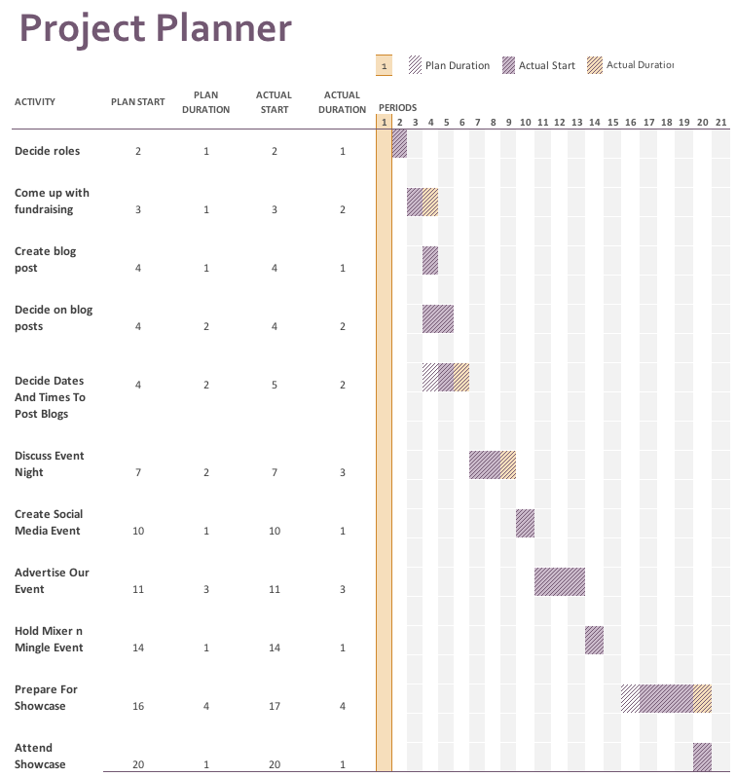
FIGURE 2-2 –KEY POINTS GANTT CHART

Models of reflection
The model of reflection I will be using to describe my experiences during the project is Gibbs reflective cycle (1988) According to the Oxford Brookes University, ‘Gibbs’ reflective cycle encourages you to think systematically about the phases of an experience or activity’ (Oxford Brookes University, N.D).

Description
As a group, we came together and held informative meetings to discuss what we were trying to achieve and how we were going to achieve it. Creating a Mixer and Mingle event was our biggest aim we wanted to achieve however, as a group we were not successful on the event as we didn’t have many people attend.
Feelings
When we first turned up to the event I was feeling excited about the difference we could potentially make “Whether you believe you can or you can’t, you are right.” (Ford, 1999). As time was going on I started to think that the event was not going to be as successful as I hoped it would be as we didn’t have as many people attend.
Evaluation
Even though we had a bad experience holding the event we did learn what we could do different next time. However, not all bad we did manage to advertise the event well through social media but as a group I feel we could have advertised it more through non-social media.
Analysis
Making sense of the situation, I was able to highlight what went wrong and how it went wrong.
Conclusion
As stated in the evaluation, other things we could have done as a group was advertise to a wider audience than just our social media accounts (which would only target a certain age range).

Action Plan

If this was to happen again, I would do a lot of things differently. First of all, I would have made sure I had plenty of time to organise and plan the event so I can give people a longer notice for the night of the event (originally, we planned the event 2 weeks before we held the event). Secondly, I would off have made more effort to get more entertainment and things to draw the attention of the public. Finally, I would off have held my event in a different location as the one we had (Town hill campus) as the set up was too casual for the event I had in mind.

Figure 2-3 – Gibbs’ Reflective Cycle Model.

  - MASTERCLASS SESSIONS
While studying throughout the academic year I attended a series of different masterclasses where people whom worked up to their success gave us an inside to how they worked up to their successes and how they got to where they are now. Out of the many people whom attended to give us a talk. The ones that inspired me the most are Andrew Roberts; Andrew gave a talk about networking for introverts. An introvert is deemed somebody who “Prefers to spend time alone in order to recharge their inner being.” According to Urban Dictionary (Sanctuary, 2015).
Roberts, specialises in dabbling in IT, creative thinking, kashflow, goal setting, forward planning and tax mitigation according to his LinkedIn profile. Roberts talked to us about how to network correctly, what not to do and what to do. Out of all the masterclasses Andrew Roberts made the biggest impact on myself as I myself am an introvert. “Introverts like being introverts. We are passionate observes, and for us, solitude is rich and generative.” (Helgoe, n.d.).
Another masterclass that inspired me was Gower Cottage Brownies owner, Kate. “As a mum to 2 small boys Kate has created the epitome of a Cottage Industry.” (Gower Cottage Brownies, 2016). Kate sold her brownies in her local village shop in 2007 (11 years ago) and sells different products and gifts from flavoured butter, brownies and hampers.

  - INFLUENCE OF MASTERCLASSES ON THE PROJECT
Out of all the masterclass sessions I attended, the one that had the most impact on my project and myself would be Andrew Roberts as networking is a very big part of everyday life. The influence it made on my project was that when I was approaching more professional people to discuss my project I knew how to approach them. Also for myself, being able to communicate with other people more confidentially made an impact on my project as I was able to help the team out more.

2.8 Conclusion
To conclude my project as a whole, I think there are many things that I could improve for next time such as my organisational skills and as a group time keeping. Working together was a very successful skill we all achieve which is a massive achievement for myself as I have never been able to work effectively as a group.

References

Gower Cottage Brownies, 2016. About Kate. [Online]
Available at: http://www.gowercottagebrownies.co.uk
[Accessed 10 03 2018].
Oxford Brookes University, N.D. Reflective Writing: About Gibbs reflective cycle. [Online]
Available at: https://www.brookes.ac.uk/students/upgrade/study-skills/reflective-writing-gibbs/
[Accessed 6 March 2018].
Roberts, A., n.d. Linkedin. [Online]
Available at: https://www.linkedin.com/in/andrew-roberts-04ab0220/
[Accessed 10 03 2018].
Sanctuary, H. I. M., 2015. Top Definition - Introverts. [Online]
Available at: https://www.urbandictionary.com/define.php?term=Introvert
[Accessed 08 03 2018].
Unity Group Wales, 2010. Unity LGBT Centre. [Online]
Available at: https://www.facebook.com/pg/UnityGroupWales/about/?ref=page_internal
[Accessed 27 February 2018].
Unity Group Wales, 2018. Unity Group Wales. [Online]
Available at: https://www.unitygroup.wales/
[Accessed 27 February 2018].
Unity LGBT, 2010. Unity Group Wales. [Online]
Available at: https://www.unitygroup.wales/
[Accessed 27 February 2018].
Wordpress, 2017. Unity LGBT Blog. [Online]
Available at: https://unitylgbtblog.wordpress.com/
[Accessed 01 March 2018].

