Module Name: Changemakers: Creativity and Value Creation
Student Name:Yasmin ramzan
Student ID:2331697

Contents
Task 1: Concept Map: Relationship between Creativity, Value Creation, and Health & Social Care Improvement 3
Task 2: Self-Reflection of Group Activity 4
Task 3: Case Study of a UK Innovation 5
Introduction 5
Main Body 5
Impact 5
Task 4: Research Task 7
Introduction 7
Article 1 7
Article 2 7
Task 5: Podcast 8
Task 6: NHS Leadership Framework Analysis 9
Task 7: Self-Reflection Journal Entry 11
Reference list 12

Task 1: Concept Map: Relationship between Creativity, Value Creation, and Health & Social Care Improvement
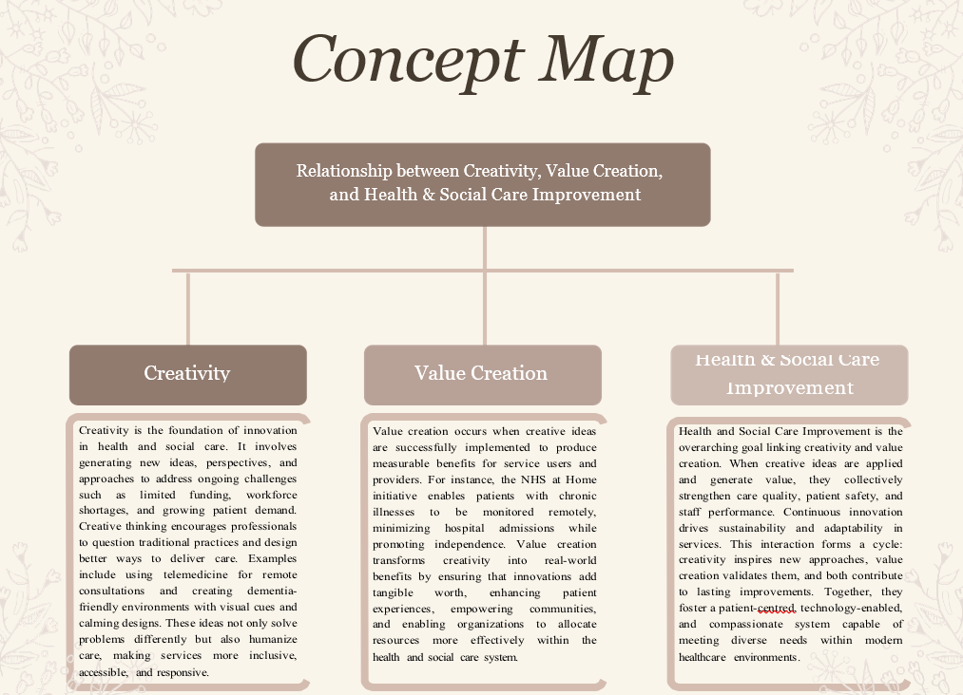

Task 2: Self-Reflection of Group Activity
Using Gibbs’ Reflective Cycle
1. Description
In our group work in class, we were on convergent and divergent thinking. We had to come up with ideas and pick the most effective ones. Initially, I was unsure about what to do. My group explained it to me. We shared ideas and made notes.
2. Feelings
I was embarrassed and somehow nervous because I was afraid that my ideas were not good. Other students were talking quickly, and I was not. But later, after that, I felt better when my group heard me and informed me that my idea was helpful (Williams, Spiro and Woolliams, 2020). I started to gain confidence.
3. Evaluation
The practice was successful as I managed to learn how people have different ways of thinking. Divergent thinking helps in the creation of many ideas. Convergent thinking helps in the process of choosing a single best idea (Morie and McCallum, 2020). I liked the time we worked together, but there were times when I thought that I was not quick at learning.
4. Analysis
I learned that teamwork is highly appreciated. Through sharing ideas, people will be in a position to solve problems in a superior manner. We need to have both forms of thinking: creative and straightforward thinking in health and social care.
5. Conclusion
The next time, I will also strive to speak and voice my opinion. I should not be afraid of errors.
6. Action Plan
I will go on with practicing speaking in groups and reflection as a way of improving. I will also read more about creative thinking to become more confident during classes, and even at work.

Task 3: Case Study of a UK Innovation

Introduction
The NHS at Home project assists patients in obtaining their care at home. It began to decrease pressure in the hospital and to make care more personal. Large numbers of individuals with chronic diseases were not able to attend hospitals frequently. Simple technology was utilized by the NHS to monitor their health at home. This was an innovation that involved nurses, managers, patients, and doctors. This was aimed at ensuring the safety of the people and reducing the number of hospital visits (Care Quality Commission, 2021).

Main Body
The concept of NHS at Home demonstrates innovation in health care. Selective monitoring devices and phone apps were used by the NHS. These were cardiac rate, oxygen, and blood pressure instruments. The information was transmitted to hospitals in order to be seen by the doctors at any time. In case the numbers were unfavourable, employees could call the patient or dispatch assistance. This came in handy during the COVID-19 period when individuals were not allowed to travel (Britain., 2011).
Creative thinking brought this innovation. Health workers posed questions: how do we provide care without actually being in contact with each other? They envisaged a new method of tracking patients. Previously, check-ups used to occur in the clinics. They are now able to take place at home (Bajwa et al., 2021).
Teamwork was also exhibited in the project. The NHS collaborated with technology corporations and community nurses. They simplified the system to an easier way of use for older people. Consistent instructions and tutorials were provided (Britain., 2011). Efforts to reduce barriers such as travel costs and lengthy waiting times were broken in the project. Innovative ideas became a practical solution that enhanced every everyday of the patients and the staff.

Impact
NHS at Home provided good value to both the patients and the system. At home, people felt safe and cared for. Serious cases saved space in hospitals. Physicians would be able to treat more patients within a shorter period (Styhre, 2022). Families saved financial resources and time for transport. The program increased patient satisfaction and lowered the stress (Care Quality Commission, 2021). It also assisted the NHS in utilizing technology more efficiently in future work. This demonstrates the potential to make an enduring value and enhance health outcomes in the UK through creativity and innovation (Bajwa et al., 2021).

Task 4: Research Task
Topic: Mental Health Stigma

Introduction
Mental health stigma is one of the major problems in health and social care. Lots of individuals do not discuss their health as they are afraid or ashamed. This issue makes people difficult to seek assistance. They also impact on their family, work, and social life (Corrigan and Watson, 2002).

Article 1
According to Corrigan and Watson (2002), stigma occurs when individuals hold misconceptions about mental illness. There is a belief that mentally ill persons are weak or dangerous. Such concepts are media and societal. Due to this, mentally ill people are perceived as being judged. They attempt to conceal their ills. The research demonstrates that stigma causes their loss of confidence. It also prevents them from seeking the assistance of doctors or friends. This leads to poor recovery. The authors indicate that stigma can be brought down through education and an open discussion (Yanos, 2018). Once people learn more about mental illness, they become kind and supportive. This makes the patients feel welcome and more likely to receive care.

Article 2
Lack of awareness and cultural attitudes, according to Henderson, Evans-Lacko, and Thornicroft (2013), also cause stigma. In certain cultures, individuals view mental illness to be an indication of weakness or poor behaviour. The researchers have discovered that individuals tend to put off treatment due to the fear of discrimination either at the workplace or in school. There is also stigma on the treatment of patients by the health workers. There are still negative attitudes among some professionals towards mental illness. This makes the problem worse. The authors indicate that training and campaigns can be used in a thinking change (Sevi?nçli?, Berfin Göksoy and Sava, 2024). The people can be made aware of the fact that mental illness is not something to be ashamed of, through more education in schools and the media. This will assist in eliminating fear and enhancing support for all.

Task 5: Podcast

Task 6: NHS Leadership Framework Analysis
Overview of the NHS Leadership Framework
The NHS Leadership Framework assists a leader in knowing how to handle individuals and enhance care. It has seven main parts. They include: Leading with care, Sharing the vision, Evaluating information, Connecting services, Engaging the team, Influencing results, and Personal resilience and integrity (NHS Leadership Academy, 2013).
Leading with care refers to being kind to the staff and patients. Sharing the vision refers to presenting a clear destination to ensure that all people operate towards the same direction. Evaluating information will assist leaders in making decisions based on information and evidence. The idea behind connecting services is collaboration between social care and hospitals (Wallace et al., 2022). Engaging the team is centered on the value and motivation of the staff. Influencing results implies influencing people to do something that they do with each other. Personal resilience and integrity refer to the ability to remain calm and honest even when things are difficult (West et al., 2015).
This framework assists the NHS leaders in supporting the staff and the patient. It establishes confidence and innovation. By adhering to these concepts, leaders will have teams that are effective and patient care that is high-quality.
The way a Leader makes use of it to promote creativity
Engaging the team can be used by a leader to make people feel as if they are part of a creative change. New ideas can be easily generated when the leader listens and involves everybody. Indicatively, a nurse can propose a quicker method of examining patients a Leader makes use of it to promote creativity (West et al., 2015). That idea will be able to enhance care in case it is backed by the leader.
The leaders are expected to allow meetings to be conducted and allow the staff to air their opinions. With small projects, they may experiment. This encourages people to venture into new things. The creative team can resolve the issues quickly and provide improved services to patients (West et al., 2015).
When leaders in the NHS employ this aspect of the framework, teamwork develops well. All people feel valued and encouraged. A Leader makes use of it to promote creativity. Energy in the form of creativity is enhanced, and patient care is safer, quicker, and more nurturing.

Task 7: Self-Reflection Journal Entry
In this module, I gained a lot of new ideas concerning creativity and value creation in health and social care. Before this, I believed that creativity was a preserve of art or design. Today I am aware that it also refers to the process of identifying new solutions to issues in care. Creativity assists in crafting improved concepts for patients and employees (González-Torres and Rodríguez-Sánchez, 2024).
I also got to know that big changes can be achieved through little ones. As an illustration, patients can be assisted quickly with the help of such technology as telemedicine or online meetings. It is time-saving and easier to care. This falls in the value creation as it will offer a superior service and save money (González-Torres and Rodríguez-Sánchez, 2024).
Team activities assisted me in learning about teamwork through group work and classroom activities (Jennings, 2017). By sharing ideas, one can discover more innovative solutions. I also got to know how to listen and be able to respect the opinions of others. This is highly significant in health and social care.
I am now confident enough to apply creativity in my future work. I will attempt to identify easy concepts that can improve the care of patients. I am also aware that reflection enables me to develop and become better. This module helped me learn that value creation and creativity are important in providing high-quality and person-centered care.

Reference list
Bajwa, J., Munir, U., Nori, A. and Williams, B. (2021) ‘Artificial Intelligence in Healthcare: Transforming the Practice of Medicine.’ Future Healthcare Journal, 8(2), pp. 188–194.
Care Quality Commission (2021) Enabling Innovation and Adoption in Health and Social Care: Developing a Shared View. Available at: https://www.cqc.org.uk/sites/default/files/20210208_InnovationPrinciples_report.pdf
Britain., G. (2011). Innovation and research strategy for growth. Norwich: Tso.
Corrigan, P.W. and Watson, A.C. (2002) ‘Understanding the impact of stigma on people with mental illness.’ World Psychiatry, 1(1), pp. 16–20.
Henderson, C., Evans-Lacko, S. and Thornicroft, G. (2013) ‘Mental illness stigma, help seeking, and public health programs.’ American Journal of Public Health, 103(5), pp. 777–780.
González-Torres, T. and Rodríguez-Sánchez, J.-L. (2024). Promoting Value Creation Through Organizational Effectiveness and Development. IGI Global.
Jennings, M. (2017). Leading effective meetings, teams, and work groups in districts and schools. Alexandria, Va: Association For Supervision And Curriculum Development.
Morie, J.F. and McCallum, K. (2020). Handbook of research on the global impacts and roles of immersive media. Hershey, PA: Information Science Reference, an imprint of IGI Global.
NHS Leadership Academy (2013) The Healthcare Leadership Model: The Nine Dimensions of Leadership Behaviour. Leeds: NHS Leadership Academy.
West, M., Eckert, R., Steward, K. and Pasmore, B. (2015) Developing Collective Leadership for Health Care. London: The King’s Fund.
Sanchez, A.R., Pepper, J., Andres, C., Anglin, S., Beckner, M., Buckingham, E., Cornell, G., Gennick, J., Hassell, J., Lowman, M., Moodie, M., Parkes, D., Pohlmann, F., Pundick, D., Renow-Clarke, B., Shakeshaft, D., Wade, M., Welsh, T., Markham, J. and Stence, K. (2010). Technical Support Essentials : Advice You Can Use to Succeed in Technical Support. Berkeley, Ca: Apress.
Sevi?nçli?, Berfin Göksoy and Sava, D.A. (2024). Effects of Climate Change on Social and Economic Factors. IGI Global.
Styhre, A. (2022). The Economics of Affordable Housing. Taylor & Francis.
Wallace, M., Reed, M., Dermot O'Reilly, Tomlinson, M., Morris, J. and Deem, R. (2022). Developing Public Service Leaders. Oxford University Press.
Williams, K., Spiro, J. and Woolliams, M. (2020). Reflective writing. 2nd ed. Houndmills, Basingstoke, Hampshire ; New York: Palgrave Macmillan.
Yanos, P.T. (2018). Written-off : mental health stigma and the loss of human potential. New York, Ny: Cambridge University Press.

