Case study : The City Hotel

Your name : Georgiana Camelia Otesanu
Your student id :2239363
Module Title :Financial Management BMIH5007
Your Lecturer name :Tristan Hawkins
Words count:2191

Declaration
I confirm that I have not used any AI tools in the research and creation of this assignment. I confirm that I have not presented any AI generated materials as my own work. I confirm I have copies of my drafts, notes, and other resources I used, which I may be asked to provide in evidence.

Table of Contents
1. Introduction 2
2. Financial Performance Analysis 3
3. Key Factors Contributing to Decline 9
4. Turnaround Strategy Proposal 11
5. Financial Outcome Scenarios 13
6. Conclusion 15
References: 16

1. Introduction
An established hospitality venue, the City Hotel offers a mix of hotel and leisure activities. It is in a busy city. It features a full restaurant, a bustling bar, and event spaces for weddings, corporate meetings, and private parties in addition to excellent accommodations. The hotel is an essential part of the local hospitality scene since it attracts business travellers and visitors due to its location (Boston University, 2021b).The City Hotel has struggled in recent years. Revenue, occupancy, and customer satisfaction are declining, which is concerning. These things indicate that the hotel is struggling to compete in the city's increasingly congested hotel industry. Being less profitable is difficult due to lower revenue, increased company expenditures, and an overall sensation of spending less. Because of this, The City Hotel's owner is anxious about the hotel's future and has recruited professionals to help him determine if a thorough turnaround plan may rescue its money and image (Assured Hotels, 2023b).
This research examined The City Hotel's finances over the past three years. This study analyses key financial data to determine the hotel's performance decline's main causes. A strategic plan to address these issues will begin with it.This analysis examines income, cost, profitability, liquidity, and solvency trends to make actionable recommendations. The research will thoroughly examine a turnaround plan that might improve the hotel's finances, attract more guests, increase revenue, and satisfy consumers. The goal is to create a feasible strategy that fits the hospitality market and economy. Find out if The City Hotel can recover its market position and become financially stable again, or if not, what the owner's best financial option is.

2. Financial Performance Analysis
Revenue and Profitability Trends
The City Hotel's income has fallen for three years, which is concerning. This is especially true in 2023. The hotel earned £5,248,290 in 2021 and £5,307,480 in 2022, up somewhat. This little gain suggests a stable but dull income stream that didn't change. Sales plummeted to £2,325,440 in 2023, less than half of the previous year. Market rivalry or consumer behaviour changes may have made it harder for the hotel to attract customers and make money (EY, 2023) This drop indicates a severe financial issue.Operating income fell, indicating that the hotel was struggling to stay profitable. Running income rose to £674,730 in 2022 from £664,160 in 2021. Hotel profits fell £1,218,850 by 2023. The hotel went from making money to losing a lot of money, indicating that its cost structure or style of running things won't function in the present market. Rising prices, reduced occupancy rates, and a lack of adaptable methods to stop income loss may be to blame (Assured Hotels, 2023c).
The hotel loses money in a few key areas when you examine its costs. Cost of products sold fell from £411,600 in 2021 to £176,250 in 2023. This could be due to cost-cutting or operational reduction. The decreased costs didn't offset the revenue drop, thus the savings weren't enough to maintain the business profitable (Boston University, 2021b).Employee prices fell from £1,724,760 in 2021 to £1,233,160 in 2023. This suggests that staffing or pay have been cut to improve cash flow while revenue falls. Lowering personnel expenditures may help with short-term money concerns, but it may also impair service quality, which could make consumers unhappy and increase money loss (Deloitte, 2021).External costs, which include numerous operational expenditures, fell from £1,894,720 in 2021 to £1,071,030 in 2023. This decline may indicate efforts to streamline operations or renegotiate vendor and provider contracts. These costs dropped significantly, but they weren't enough to make up for the lost income, suggesting that decreasing costs may not be enough to recover earnings (CoStar, 2010).Depreciation and amortisation rose from £409,190 in 2021 to £661,590 in 2023. The high cost of depreciation raises the entire cost of conducting business, whether because more money was spent on assets or because the company changed its accounting. High depreciation expenses affect net profits but not cash flow. They show that asset consumption and investment plans should be managed and possibly reevaluated (EY, 2022).
Analysis of Liquidity:The City Hotel's cash savings have dropped over the past three years, indicating a decline in bill payment. The hotel has £740,590 cash and replacements in 2021. In 2022 and 2023, it plummeted to £641,620 and £295,510, respectively. This large cash reserve decline indicates that the hotel's cash flow is deteriorating, raising concerns about its short-term financial obligations. Due to declining cash flow, EHL Insights (2024) warns that the hotel may be unable to pay bills, cover immediate operational expenditures, or make necessary adjustments.
Trade receivables fell from £691,380 in 2021 to £479,180 in 2023. Fewer sales or speedier customer collections may explain this reduction. The decline in receivables matches the revenue drop, indicating a business slowdown (Boston University, 2021a).Also, short-term loans fluctuate. Present liabilities totalled £1,957,360 in 2021. They rose to £2,107,750 in 2022 but fell to £2,014,600 in 2023. The 2023 decline may seem wonderful, but it indicates fewer firms and greater cash flow. Reduced sales and cash flow may prevent the hotel from paying payments, necessitating immediate cash flow improvement (NetSuite, 2024).
Analysis of Solvency:The City Hotel has many long-term borrowings and lease debts, making it financially unstable. With some slight revisions, long-term borrowing rose from £8,113,710 in 2021 to £8,290,570 in 2023. Long-term lease debt increased from £2,844,970 in 2022 to £3,353,260 in 2023. According to Hospitality Net (2024), the hotel may have increased lease obligations since it borrowed more money to buy more assets or facilities.The hotel has less ownership presently. Owner wealth plummeted from £2,152,750 in 2021 to £1,334,370 in 2023. This reduction in equity and mounting debt indicate a worsening financial situation. The hotel's debt-to-equity ratio rises since it has more debt than equity, making it harder to borrow more money if needed (Hospitality Net, 2023).Due to rising debt and falling shares, the City Hotel's capital structure is getting increasingly leveraged, which is harmful for its long-term finances. The hotel's declining revenue and profits make it unclear if it can service its debt. Rising rent payments strain the hotel's budget, especially if it can't afford these charges (Assured Hotels, 2023b).
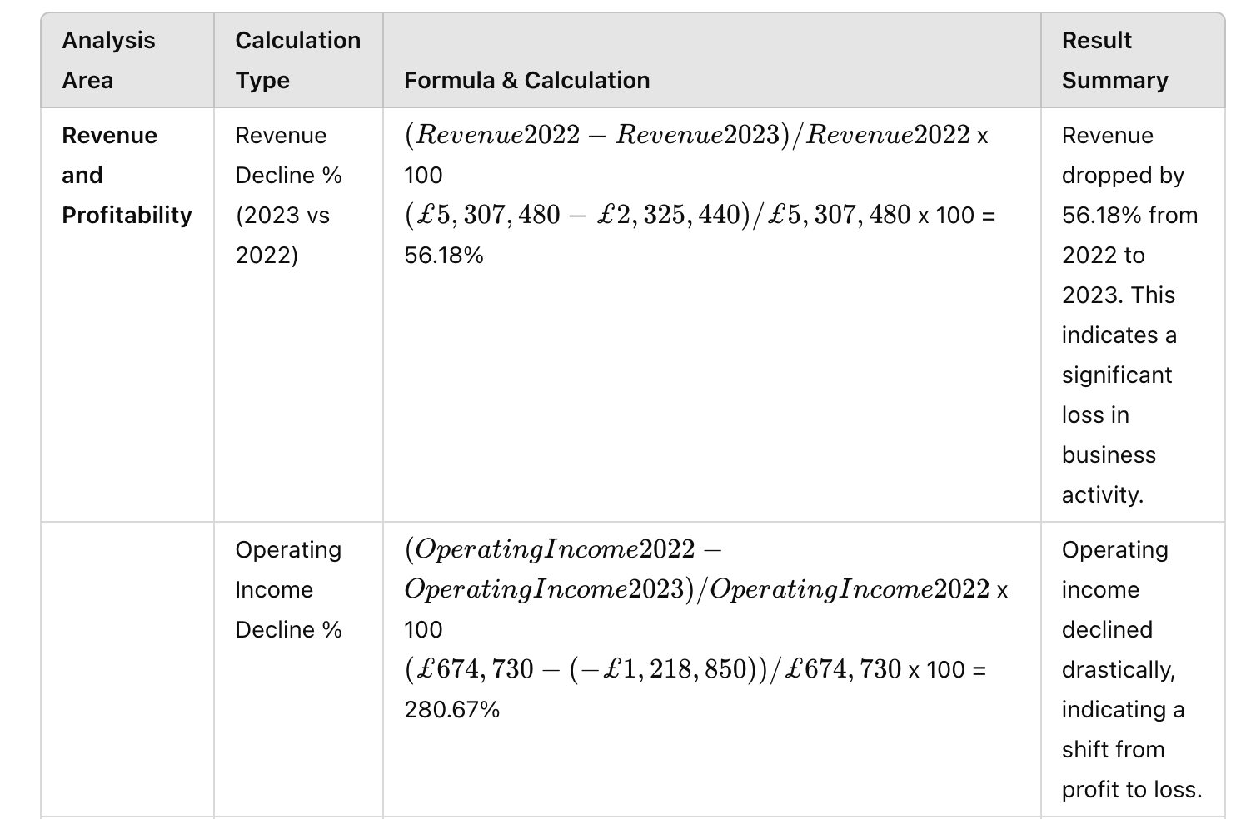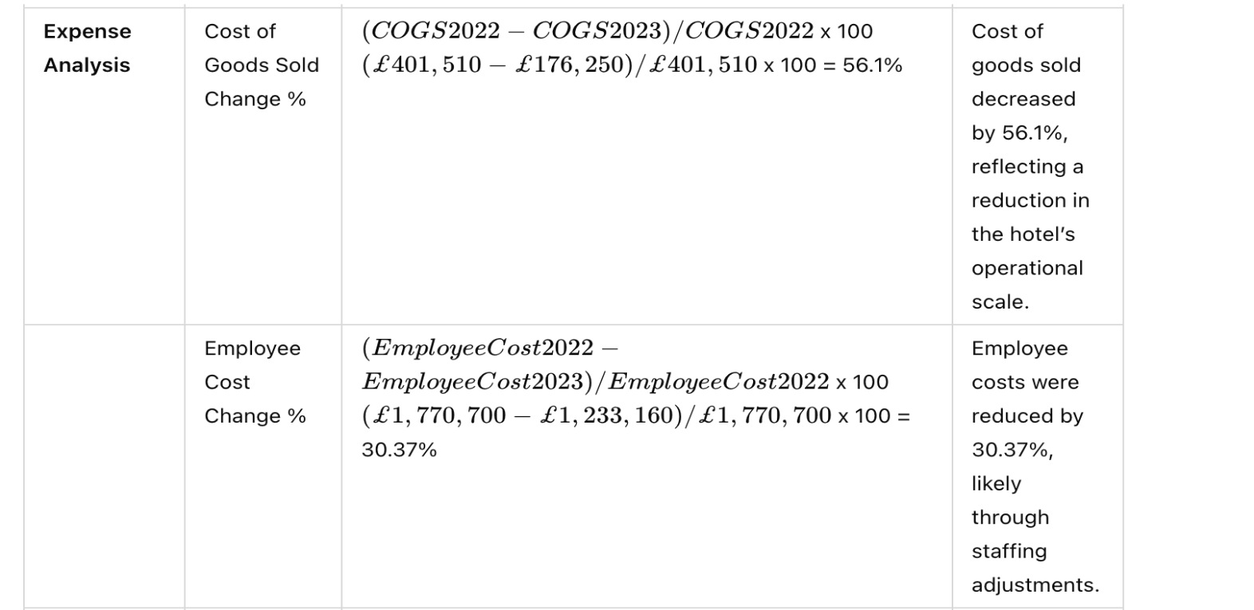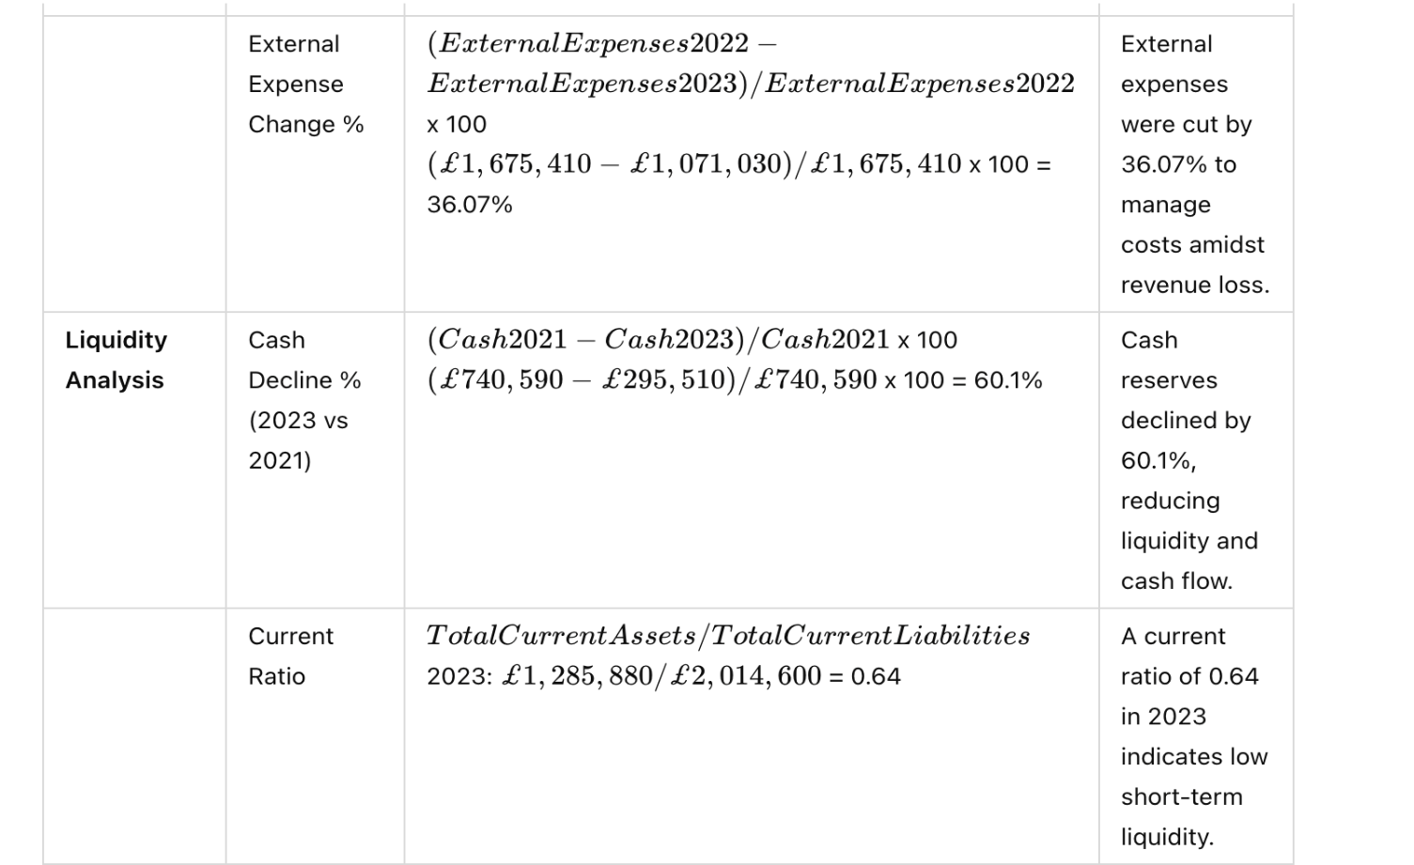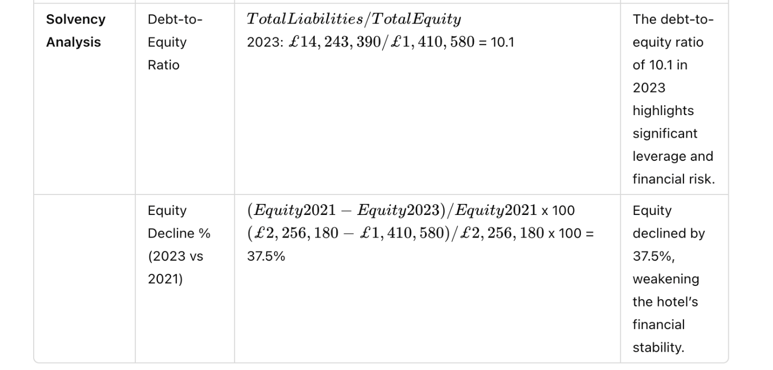

3. Key Factors Contributing to Decline
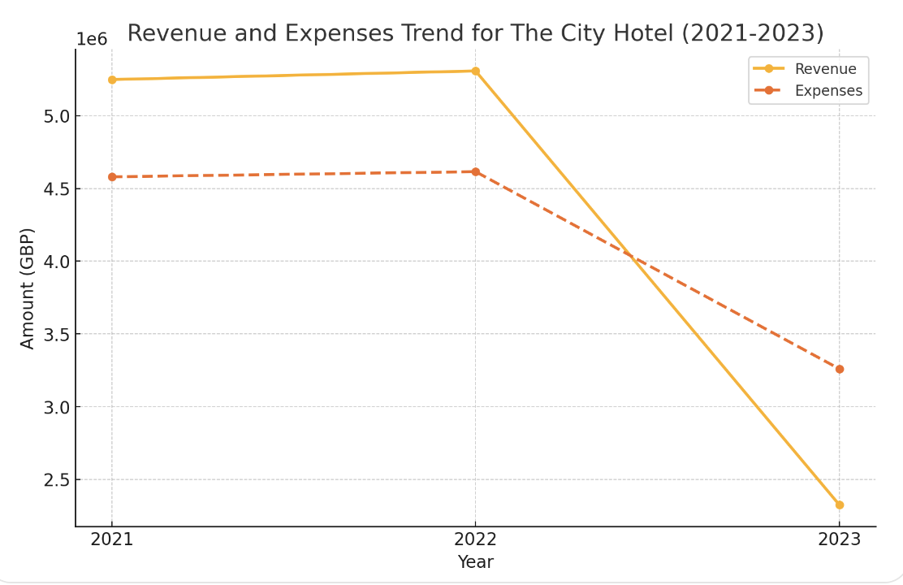

External Economic Factors
Global economic concerns affecting the hospitality industry have contributed to the City Hotel's recent commercial decline. The economic slump has made people and companies more frugal and cut unnecessary expenditure, which is crucial. Inflation has tightened UK consumer finances. This means fewer guests are willing to spend on travel and entertainment (CoStar, 2012).Tourism has also suffered from global events like travel bans and economic turmoil. These factors reduce international tourist, which urban hotels need to make money. Domestic tourism has also changed as consumers pick cheaper hotels or short-term rentals on Airbnb. All of these economic issues have reduced City Hotel attendance, lowering income (Boston University, 2021b).
Problems specific to each industry:Hospitality issues have worsened in recent years. Consumer trends demonstrate that individuals prefer unique, experience-based hotel stays. Due to increasingly small hotels and other accommodations, the City Hotel has had to work harder to attract modern travellers (Assured Hotels, 2023b).

The company has also faced increasing regulatory pressure on health and safety, environmental protection, and hiring. Meeting these government regulations has raised compliance expenses, affecting earnings. Customer expectations have shifted due to the hotel industry's digital transition. Many guests demand online booking, tailored marketing, and digitally enhanced customer experiences. The City Hotel may lose additional ground if it doesn't keep up with technology (Assured Hotels, 2023c).
Internal operational issues:Internal managerial inefficiencies worsen The City Hotel's finances. High depreciation costs indicate that a lot of money is being spent on things that may not be profitable. Even while these high fixed expenditures are necessary to maintain the hotel's infrastructure, they have impacted its earnings because they cut into income regardless of revenue (CoStar, 2010).High employee and outside costs add to the burden. Cost cuts in 2023 weren't enough to offset the income reduction. These continuous expenditures suggest that the hotel may not be employing its resources efficiently, which could increase costs and affect the bottom line (Boston University, 2021a).

4. Turnaround Strategy Proposal
Revenue Enhancement
The City Hotel needs increase guests and revenue to reverse the revenue loss (Investopedia, 2024).

1. Targeted marketing: Market to business travellers, tourists, and event planners. Hospitality Net (2023) recommends using digital marketing to promote the hotel's city location and amenities.

2. Diversified Services: Offer more services to attract more customers. The City Hotel might offer home-based workers co-working spaces or family packages. Spa services, guided city walks, and themed events can attract more customers and boost revenue (Boston University, 2021b).

3. Seasonal Promotions: Offer weekend stays, event-specific bargains, and loyalty programs to attract customers. Hospitality Net (2024) suggests offering bargains during low demand to maintain occupancy and attract budget-conscious guests.

Cost Optimisation

Profits depend on good cost control. Reduce unnecessary costs with these steps: 2024 (EHL Insights).

1. Renegotiating Supplier Contracts: Renegotiating supplier contracts can improve costs and terms. Purchasing in bulk or establishing a long-term arrangement can reduce the cost of things sold (EY, 2023)

2. Improving Staffing: Check staffing patterns to ensure labour meets demand. Use flexible staffing at slack times to cut labour costs without sacrificing quality. Cross-training can reduce the demand for extra aid during busy times (CoStar, 2010).

3. Buy energy-efficient lighting, heating, and cooling systems to minimise your utility expenditures. The hotel may pay some upfront fees, but it can save a lot of money in the long run, which helps its finances and environmental efforts (EY, 2022).

Managing debt and assets

According to NetSuite (2024), debt management helps The City Hotel stay afloat and reduce interest rates.

1. Refinancing or renegotiating debt: You can cut your interest rates by refinancing or extending your payment periods. This strategy may cut the hotel's monthly debt service costs, freeing up funds for other priorities (Boston University, 2021a).

2. Asset Management: Consider empty rooms or structures that could be rented for future events. Selling or renting unused assets can immediately generate income for running costs or debt repayment (Assured Hotels, 2023a).

3. Investigating Sale-Leaseback Agreements: The City Hotel could sell and lease back key assets to retain use. The hotel would acquire the funds it needs to recover from this arrangement without discontinuing business (Assured Hotels, 2023b).

Improvements to operations

Guest retention and acquisition depend on client satisfaction. The following practical adjustments can improve service quality (“Assured Hotels, 2023c”).

1. Train your staff: Regular training programs improve customer service, hospitality, and business operations. Training makes staff more likely to deliver good service, which makes guests happier, leads to great evaluations, and encourages repeat visits (CoStar, 2012).

2. Improve facilities by refurbishing rooms, updating communal areas, and modernising amenities. Changes can improve guest satisfaction and make the hotel more appealing to potential customers (Deloitte, 2021).

5. Financial Outcome Scenarios
Scenario 1: Successful Turnaround
If The City Hotel implements the turnaround approach, several improvements may result:
Revenue and Profitability: Seasonal sales, focused marketing, and a variety of services would increase revenue and guests. Based on demand and promotion, annual sales could progressively recover or exceed pre-2023 levels. Cost-saving strategies could boost profit margins and cut operational costs to generate an operating profit by the conclusion of the fiscal year (EHL Insights, 2024).
Higher Cash Flows: Profits and cost structures improve cash flows. Building up cash savings would help the hotel cover its short-term bills. According to Hospitality Net (2024), the hotel could invest more in enhancements and operational updates if it had more funds. Refinancing and debt management could lower the hotel's monthly debt service costs. Extra cash flow from a profitable firm could be used to gently pay down long-term bills. This would improve the hotel's debt-to-equity ratio by stabilising and reducing financial risk (Boston University, 2021a).The turnaround might make The City Hotel stable and expand again, with better finances and market position (CoStar, 2012).
Second scenario: Some Success:The City Hotel would have moderate success (EY, 2023), with only some tactics working.Higher occupancy and happy consumers may stabilise revenue sources, although revenue may not entirely recover. Slowing revenue growth would keep profitability low despite cost-cutting (Deloitte, 2021).Cash flow would improve slightly, but only enough to cover operational costs and short-term loans. It wouldn't cover large debts or fund development. To avoid cash flow issues, careful liquidity management may still be needed (Assured Hotels, 2023b).
Third Possible Outcome (If Turnaround Fails):The City Hotel may need to identify new revenue streams if the turnaround strategy fails (Assured Hotels, 2023c).The proprietor may consider selling the business. This could involve finding a buyer who wants to spruce up the hotel or use it differently. The sale may return some of the owner's investment, but if the market value is low, they may not (Boston University, 2021b).

6. Conclusion
The City Hotel's financial data shows diminishing income, growing costs, less cash, and greater debt. These issues have hurt the hotel's finances and raised concerns about its survival. External economic conditions, business issues, and inefficiencies in internal operations caused this reduction.
A thorough turnaround plan includes generating revenue, cutting costs, managing debt, and improving operations to address these issues.

References:

- Assured Hotels (2023) Reviving Hospitality: Key Strategies for a Successful Hotel Turnaround. Available at: https://assuredhotels.co.uk/reviving-hospitality-key-strategies-for-a-successful-hotel-turnaround/(Accessed: 11 November 2024).
- Assured Hotels (2023) Hotel Turnaround Project. Available at: https://assuredhotels.co.uk/hotel-turnaround-project/(Accessed: 11 November 2024).
- Assured Hotels (2023) Hotel Turnaround. Available at: https://assuredhotels.co.uk/hotel-turnaround-project/
(Accessed: 10 November 2024).
- Boston University (2021) Hotels in Financial Distress and Their Resolution. Available at:
https://www.bu.edu/bhr/2021/05/31/hotels-in-financial-distress-and-their-resolution/
(Accessed: 9 November 2024).
- Boston University (2021) Asset-light Business Model Strategies for Hotels During the Pandemic. Available at: https://www.bu.edu/bhr/2021/05/31/hotels-in-financial-distress-and-their-resolution/
(Accessed: 9 November 2024).
- CoStar (2012) 5 Ways to Turn Around Distressed Hotels. Available at:
https://www.costar.com/article/478895381/5-ways-to-turn-around-distressed-hotels
(Accessed: 8 November 2024).
- CoStar (2010) 8 Tips to Manage, Turnaround, and Sell Distressed Hotels. Available at:
https://www.costar.com/article/478895381/5-ways-to-turn-around-distressed-hotels
(Accessed: 11 November 2024).
- Deloitte (2021) The Hospitality Industry: Time for Recovery. Available at:
https://www.deloitte.com/an/en/services/financial-advisory/perspectives/the-hospitality-industry-time-for-recovery.html
(Accessed: 7 November 2024).
- EHL Insights (2024) Hospitality Industry Data and Key Statistics: 2024 Update. Available at:
Hospitality Insights(Accessed: 11 November 2024).
- EY (2022) Hospitality Industry Makes a Strong Comeback, but Face Key Challenges. Available at:
Ernst & Young(Accessed: 11 November 2024).
- EY (2023) How CFOs Are Forecasting the Financial State of the Hospitality Industry. Available at: https://www.ey.com/en_us/insights/real-estate-hospitality-construction/how-cfos-are-forecasting-the-financial-state-of-the-hospitality-industry(Accessed: 11 November 2024).
- Hospitality Net (2023) 5 Strategies for Navigating Financial Challenges in the Hospitality Industry. Available at:
Hospitality Net(Accessed: 11 November 2024).
- Hospitality Net (2024) 2023: A Year of New Challenges and Opportunities for Hoteliers. Available at:
Hospitality Net(Accessed: 11 November 2024).
- Investopedia (2024) Key Financial Ratios to Analyze the Hospitality Industry. Available at:
Investopedia(Accessed: 11 November 2024).
- NetSuite (2024) 7 Trends Driving the Hospitality Industry in 2024. Available at:
NetSuite(Accessed: 11 November 2024).

